

SECP1513-08 - Technology And Information System

ASSIGNMENT :

ROBOKAR PROGRAMMING WORKSHOP REPORT

NO. | NAMA | STUDENT ID
1 | NUR AZIZAH BINTI MOHAMMAD MOKHTAR | A17KM0351
2 | NURUL ISMAT TANNI | A18CS4052
3 | NUR NABILAH BT YUSMAN | A19EC0136
4 | NUR MINHALINA BINTI ABDUL RAZAK | A19EC0135
5 | NOR FARAHZIBA BINTI HAMADUN | A19EC0123
6 | PRAVEEN A/L HARIKRISHNAN | A19EC0149

SECTION : 08

LECTURER’S NAME : Dr. Haswadi Bin Hasan
DATE OF SUBMISSION : 19th December 2019
TABLE OF CONTENTS

1.0 Introduction…………………………………………………………………… 3 - 4
1.1 Applications…………………………………………………………………….3
1.2 Agenda………………………………………………………………………….4
2.0 Detail of The Industry Visit…………………………………………………… 5 - 8
2.1 Before the Robokar setup……………………………………………………….5
2.2 During the Robokar setup……………………………………………………….6
2.3 After the Robokar setup…………………………………………………………8
3.0 Reflection……………………………………………………………………………9
4.0 Task to Each Member……………………………………………………………….10

1.0 INTRODUCTION

Robokar Programming Workshop is a First Year Student’s Robokar Programme. This document reviews the first year Programming in C language base where we introduce new apps Arduino. Using this apps we learned how to Robokar movement and explains how the part learned in first year in Programming.
Such techniques are used in the production of computers which can replace human beings. Robots can also be used in any conditions, in every purpose but most are used now in unsafe conditions, manufacturing processes or in conditions that are unable to survive. So, this workshop purposes how can our critical life make it easy are using Robot Programming.
The one day workshop was held on 8th December, 2019 at 2 pm to 5pm under on Universiti Teknologi Malaysia Robokar Programming Workshop for first level students in UTM. This workshop includes of giving the participating students an idea about Robots, Robot Forms and their apps, Robotics Career, Arduino coding base robokar’s Introduction, Arduino coding base Robokar Live Demo, Robokar running, forward, move, backward and so on. That time have question confirmation session, practical session, 3 minutes competition, prize given ceremony and photo session. Arduino coding was the first new coding application for first level students of UTM.

1.1 Applications
Current and potential applications include:
- Arduino
- Line following robot
- Junction Robot

1.2 Agenda
Time | Activities
2.00PM | Arrival of Participants and Registration
2.20PM | RoboKar : Introduction  Presentor: Nurul Nazihah binti Jamal & Muhammad Irsyad bin Kamil Riadz
2.40PM | RoboKar : Programming  Presentor: Nurul Nazihah binti Jamal & Muhammad Irsyad bin Kamil Riadz
3.00 PM | Practical Session
4.00 PM | Robokar : Game  Moderator: Ahmad Syahir bin Abdul Hanim & Ahmad Nazri bin Abdullah
4.30 PM | Prize Giving Ceremony
5.00PM | Closing Ceremony and Photo session

2.0 DETAILS OF THE INDUSTRY VISIT

2.1 Before the Robokar setup

First of all, we have given a time limit to practice our program on our Robokar for about 50 minutes. Each team was given a box that contains all the items used to move the Robokar. Before we began the practice, we were provided with two modules as a guide during the execution. In the modules, it provides us with a list of instruction and functions that can be used. Other than that, it also shows the error to prevent us from mistakes.
Besides that, the facilitators give us a short briefing on how to do the coding to ensure the movement of the Robokar. The difficult one was already done by the facilitators, our task was to do the coding to command the Robokar. The examples of the command were roboForward, roboTurnRight, roboTurnLeft and many more.
After that, they went to each group to explain the items in the box. The items consist of a cable that connects between laptop and Robokar, a Robokar and Pendrive that contains the program. Then, we were allowed to start the execution within the time given.
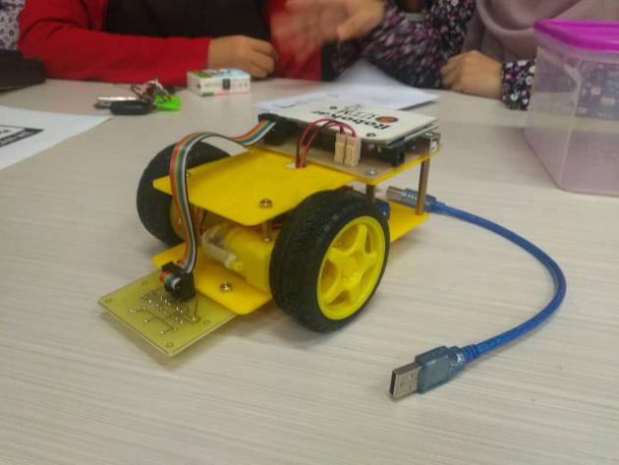
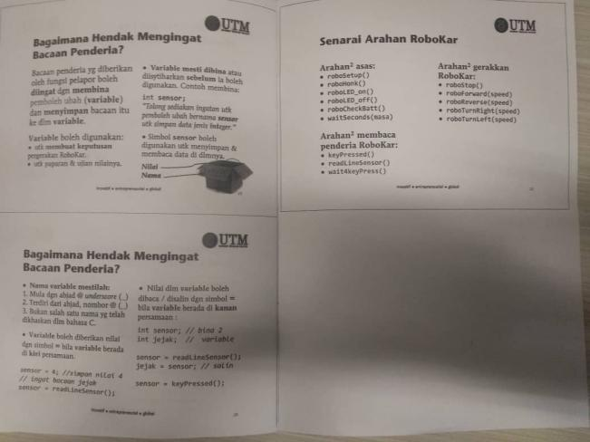
This is the example of the modules This are the items in the box

2.2 During the Robokar setup

Each group is provided with Robokar and an Arduino IDE. After installing the software in our laptop, we started doing coding using C. By using if else loop, we need to ensure that the sensors detect the correct code based on the trail given. With guidance from the crews, we manage to complete the coding few minutes before the competition starts. Our coding are as below :

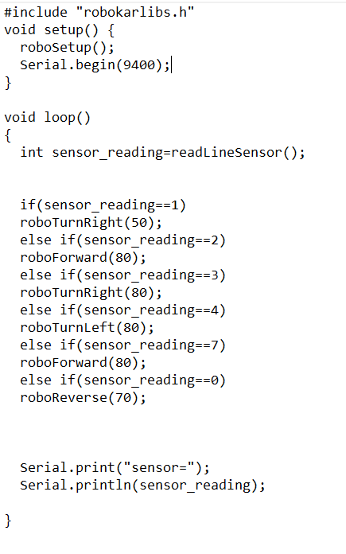
On the bottom of the Robokar, there are three sensors use to detect the trail. Each command detects different sensors label as 1, 2 and 4. The sensors can read from 0 to 7 except 5. If the sensors read 1 on the trail, it will execute the function roboTurnRight which command the Robokar to turn right. Reading 3 also command the Robokar to turn right but slightly different from before. It allow the Robokar to turn at the curve trail. Next, reading 2 will executes function roboForward which asks the Robokar to go straight. For roboTurnLeft, the sensors read 4 and command the Robokar to turn left. Reading 6 also give the same command but similar with reading 3. To reverse, the sensors read 0 which execute function roboReverse. Lastly, if the sensors read 7, it allow optional function whether to go straight, reverse, turn right or left because the Robokar stops at the junction on the trail. In our case, we ask the Robokar to go straight depending on the trail.

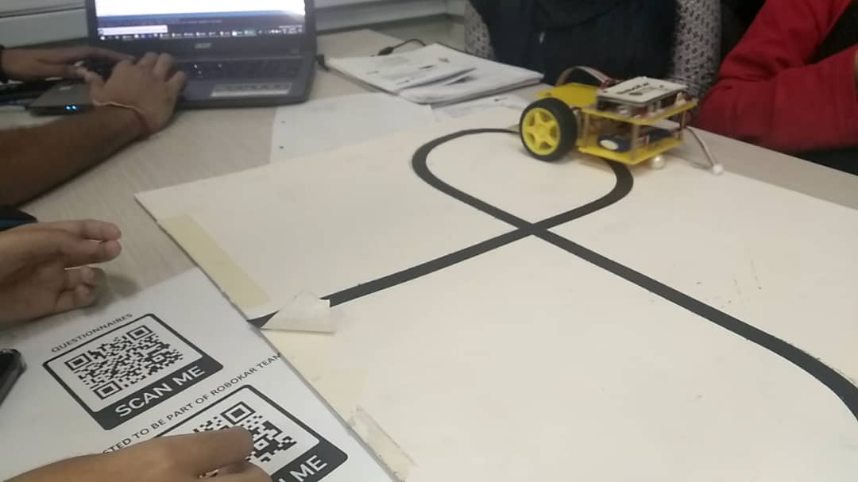
Testing phase during the Robokar setup

2.3 After the Robokar setup

All six groups that was participated went together to the competition ground. All of us were seated and waited for the competition to start. Basically, the Robokar which finishes the track in shorter period of time will be selected as winner. Besides, if Robokar stops in the middle of track then it would be recorded according to the checkpoint and time. During the competition everyone was so excited to watch this nerve wrecking competition. My group went up to the checkpoint 6 and finished around two minutes. Most of the group manage to finish less then two minutes.
After all, six groups completed the tournament, the members of Robokar announced the winner and gave prices to the groups who got first and second. My group got forth placing which wasn’t a disappointment because after all those teamwork and effort we put to learn the coding to command the Robokar was very fun and it was a new experience learning it in a short period of time. After the price giving, we had a photo session with everyone who was involved in the Robokar tournament.
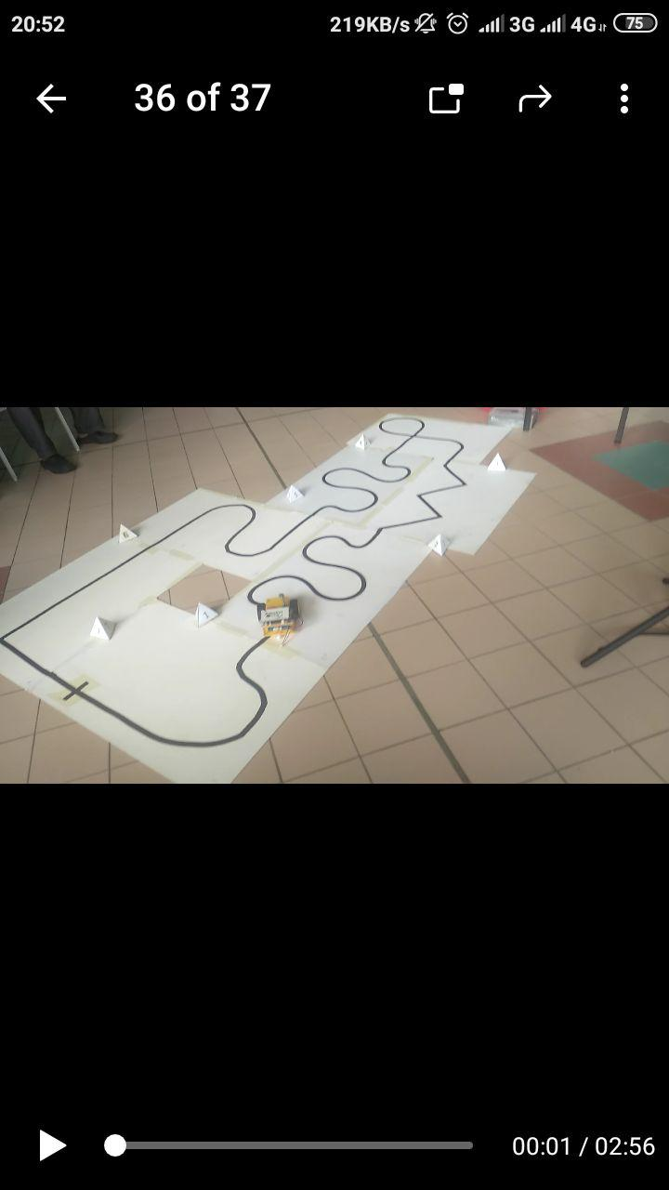

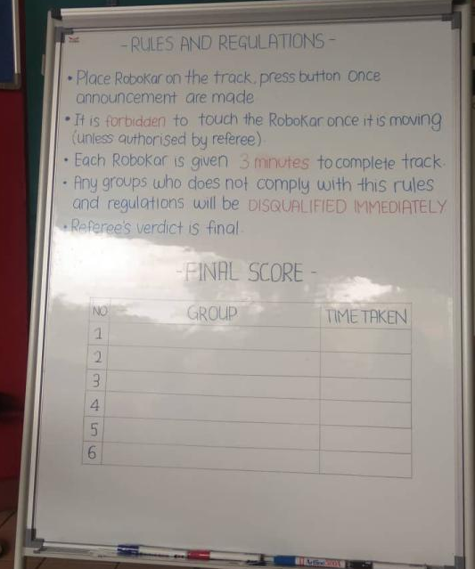
Our group Robokar during the competition
The competition rules and regulations

3.0 REFLECTION

To this present day, an era of technology globalisation is taking part all around the globe. This include all aspect of life such as education, medication, transportation, communication and many more. Therefore, it is important for us to put ourselves in a place whereas we are growing together with the time. In a few years’ time, we want to achieve our goal in being on of individual who can contribute to country development regarding technology.
As looking forward to the goal, this program was actually giving major impact on ourselves. It made we think how adaptability skill is important in order to succeed as it shows to evolution and changes that technology has made only in a couple of decades. Our goals and dreams with regard to this course have only been strengthened by this realization.
The action that is necessary to be done is being aware about the industry which is computer security industry where almost every aspect of life in this current age is revolving around this industry and an awareness is necessary to improve our potential in the industry.

Task | Person in Charge | Time completed
Collect information and write notes | Everyone | 8 December 2019
Write the robokar coding | Praveen and Minhalina | 8 December 2019
Discussing about the correct coding to move the robokar | Everyone | 8 December 2019
Testing the robokar | Nabila | 8 December 2019
Prepare and guide the robokar into the competition | Praveen | 8 December 2019
Take picture and record video during the workshop process | Farahziba | 8 December 2019
Introduction of the report | Tanni | 15 December 2019
Detail of the robokar workshop | Minhalina, Azizah, Praveen | 15 December 2019
Reflections about the workshop | Nabila | 15 December 2019
Compiling and grammar check | Farahziba and Tanni | 17 December 2019
4.0 Task For Each Member

