

--------------------------------------------------------------------------------------------------------------------------------------

SECP1513 SECTION 8

TECHNOLOGY AND INFORMATION SYSTEM

DESIGN THINKING ASSIGNMENT

LECTURER’S NAME: DR HASWADI HASAN

SUBMISSION DATE: 20 OCTOBER 2019

No. | Name | Matric ID
1 | Nor Farahziba binti Hamadun | A19EC0123
2 | Angelica | A19EC0181
3 | Muhammad ‘Afif Azhan bin Mohd Ismail | A19EC0092

Table of Contents

Introduction 1

Application of Design Thinking in Information System 2

Empathize 2

Define 4

Ideate 5

Prototype 6

Test 7

Reflection 8

Introduction

Design thinking is a process of critical thinking used to develop solutions to problems through collaboration, innovation and design. Design thinking helps prepare student for a world where skills such as teamwork, problem solving, communication, analysis, creativity and the ability to influence others is important in the work force. The process consists of 5 steps which are empathize, define, ideate, prototype and test.

For our assignment, we are going to apply the design thinking process to solve other people’s problems that is related to Information System topic.
The objectives of our assignment are:
- To give students a deeper understanding on how design thinking works.
- To enhance compulsory skills such as teamwork and communication skills among students.
- To acknowledge student on how to invent new innovation more effectively.
- To broaden students’ way of thinking in finding a way to solve problems in the daily life.

Application of Design Thinking in Information System

An information system is a software system that is used to capture, transmit, store, manipulate, or display information. The main purpose of the system is to support people and organizations to perform basic task in the daily life. For example, word processing systems such as Microsoft Office had made writing books and reports easier since it will eliminate the need to write using pens and pencils. This system had helped users save a lot of time when writing essays and assignments.
For our assignment, we had applied design thinking process to fulfil the task related to Information System.

Empathy

To gain better understanding on the problems we are trying to solve, interviews were compulsory. We had interview some students in Universiti Teknologi Malaysia (UTM) to identify their problems when using computer in the laboratory.


Figure 1. Interviewing Ahmad Fahmi Bin Zainol Badli,19

One of our clients stated that he was having problem to log in to UTM Wi-Fi because sometimes he had forgotten his username and password. Other than that, we also made a survey using Google Form for the UTM students to ask some questions related to the issue. Below is the table for the questions and response that were mentioned in the survey.

Question | Response (among 13 respondents)
How often do you use your matric card? | Once a week: 23.1%  Once a month: 23.1%  Sometimes: 53.8%  Every day: 0%
Did you often change seat and change computer in the lab? | Yes:46.2%  No:15.4%  Maybe:38.5%
When you browse something in the Internet using lab computer, did you clear the browsing history? | Yes:15.4%  No:76.9%  Maybe:7.7%
Have you ever forgot your UTM Wi-Fi username or password? | Often:7.7%  Sometimes:15.4%  Maybe:7.7%  No:69.2%

Figure 2 Response for the Google Form survey
Other students also mentioned that they often change seat and computer in lab which resulted them to lost their saved files. So, it was hard for them to get it back since other people can delete them. Moreover, if they log in their email and forgot to log out, it can be read by unknown people and will disrespect the owner privacy.
From the empathy process, we had realized that good communication skills are needed to make an interview more effective. In our opinion, we have to imagine ourselves as being a user itself se we will not judge the others’ problems.


Define
Figure 3.Our group discussing users problems
We combined all the information we had collected in empathize step. By putting all the data together, we can observe and analyze the problems.
Problem | Explanation
Login access denied | - User always forgot his username and password for the UTM Wi-Fi.
Unauthorized user access | - Some user wrote their username and password on a note, but sometimes someone stole the note and accessed his Wi-Fi using his account without permission.  - Users always forgot to log out from their e-learning account and email lab session, so other students can access his personal information  .
Risk of information loss | - User always forget to save and copy his assignments and the information that he gained in the lab session into a hard disk.

From the empathize results, the users need something that can allow them to connect to UTM Wi-Fi without having to enter username and password due to their forgetful habit. Furthermore, the computer in the laboratory need something to prevent from unauthorized access. For the user who forgot to log out their email in that computer, an unknown people can read their email without permission. Sometimes, their files were left in the previous computer and it is hard for them to get it back.
From our perspective, we agreed that defining the core problems of users’ is the main key to create an effective system. We had to think thoroughly and professionally to make sure that the system that we are making can be a solution to their problems.

Ideate

During this brainstorm process, we used all the information from stage two that had been analyzed to generate relevant ideas. We had stated a lot of ideas by thinking outside the box to find the best solution to solve the problems.
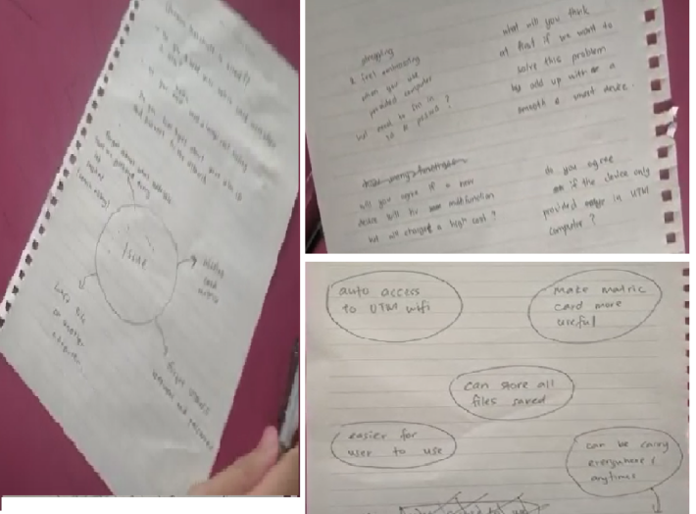
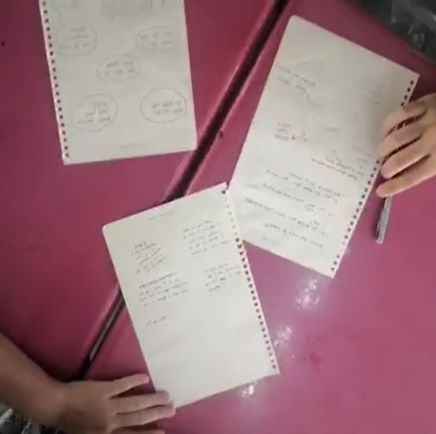
Figure 4 Brainstorming session
In that picture, we were doing this step on a table by writing our ideas on a piece of paper. We wrote anything that come through our mind that can be a solution. After we done thinking and writing, we had shown our ideas and give some opinion to each other. Below is the proposed solution after the brainstorming session.

We came out with a conclusion to create a system called Storage Browsing Security (SBS) that connect to the UTM Wi-Fi by scanning the student matric card through a scanner. It can also automatically store all the files and search history in a cloud storage to prevent them from losing their files. After using, user only need to rescan to logout from the Wi-Fi.
From our point of view, we need to develop a lot of ideas in this process. Then, we should try to combine the ideas since each of them maybe can cover up the others’ weaknesses. We believed that a combination of weak but relevant ideas, can be a solid and impactful idea.

Prototype

The forth step is making a prototype to help the users to visualize on how the SBS works. We decided to make a computer with a scanner using boxes with various sizes. The scanner purpose was to read user’s identity by scanning their matric card. Whenever the user’s identity had been recognized, the computer will start by itself and the UTM Wi-Fi will be automatically connected.
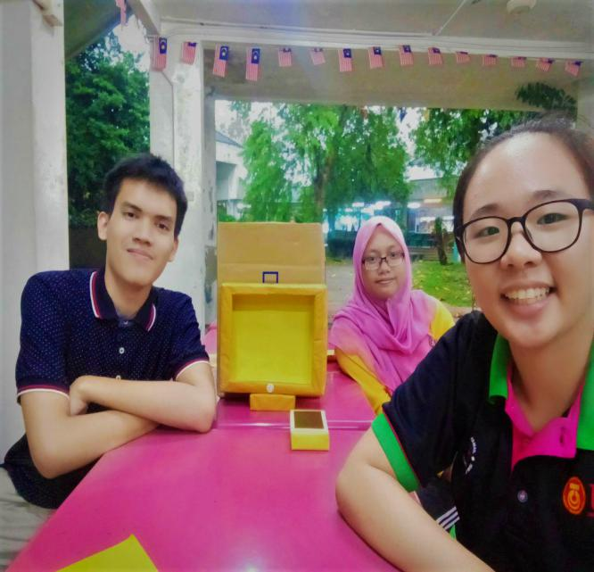
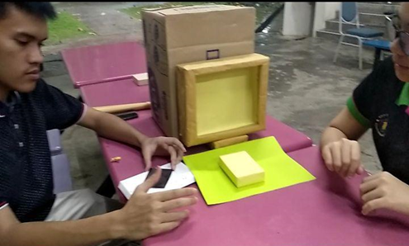
Figure 5 Making prototype for the project

In our opinion, a good design for the prototype is essential to help the users’ to understand on how the system works. Through a proper design and presentation, users will be more confident with our project and willing to use it in the future without a doubt.

Test

The last step for the design thinking process is testing the prototype that we had made. Through testing, we can gain users’ feedbacks for our prototype, so we can upgrade it to a better version in the future. During this part, we had asked some students to test it. First, they have to scan their matric card to access the computer. Most of them find it is very convenient to access the UTM Wi-Fi without entering the username and password. Below were some of the people that had tried the prototype for the SBS.
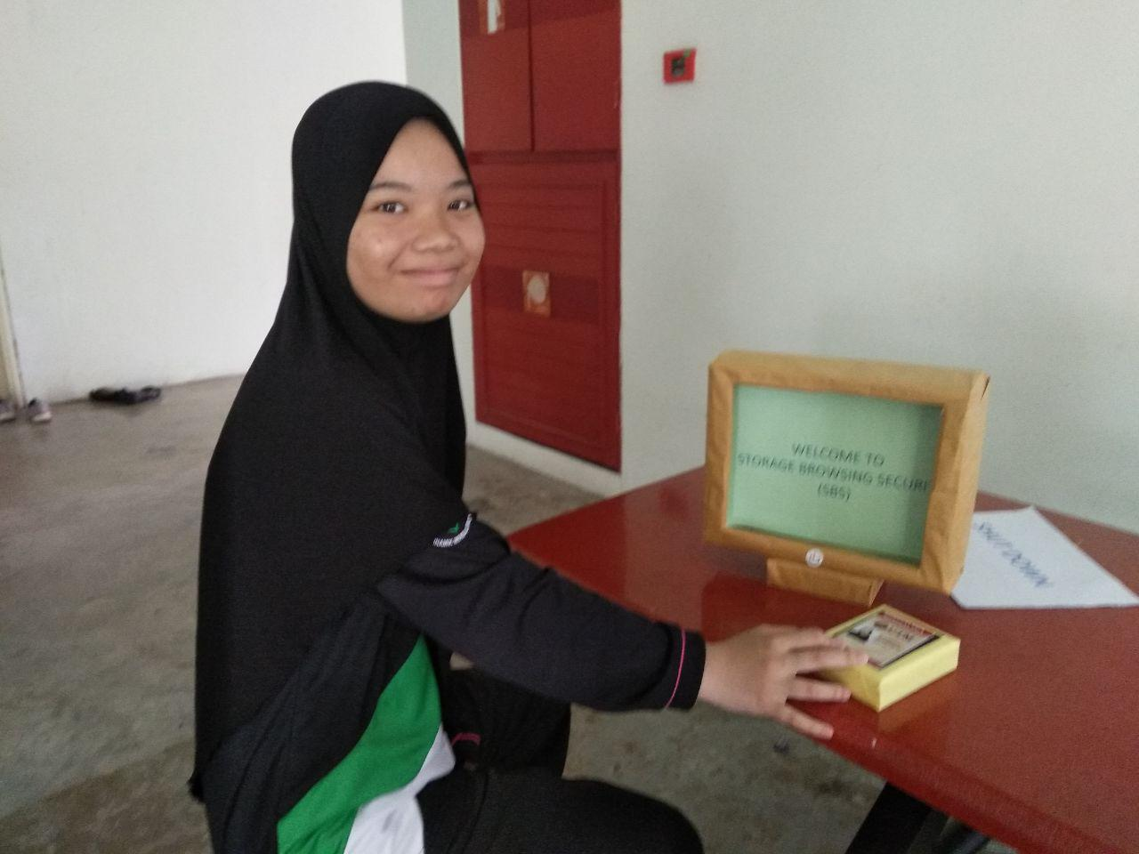
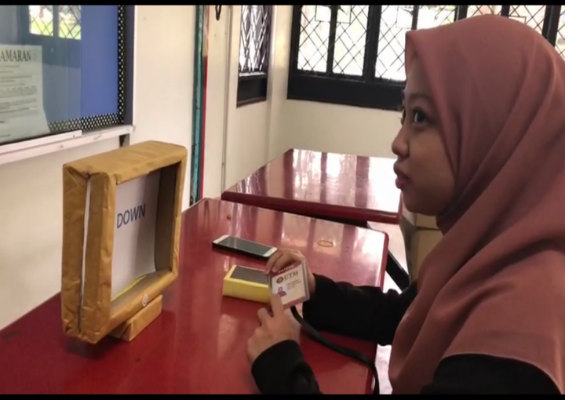
They hope a lot that our project will be implemented in the nearest time because it could be easier for them when using the computer in the lab.
Lastly, testing part is of the way for the users to comment and give feedback for our project. It can help us to develop new ideas that can be implemented to the project. From users’ feedback we can upgrade our system to be more efficient and useful before it being released to the industry.
In conclusion, design thinking surely had helped us to develop the SBS that can aid users’ accessing the UTM Wi-Fi during the lab session. Using only 5 easy steps, we will be able to create a better idea to find the solution for the problems nowadays. So, we hope that design thinking process can be applied in students’ daily life so we will be more creative in solving problems.

Reflection

Our main goal for this subject is to learn on each purposes of the current technology so we will be able to utilize each device or system that has been invented to make daily life easier. Therefore, we will be more appreciative towards the existence of technology thus can broaden our way of thinking so we can invent new technology to solve various problems in the current days.
The design thinking method sure help us to understand why such devices and systems exist. It helps to understand more about the purpose of technologies in the real life. Now, we know that technology exists just to make our life easier, thanks to the design thinking method. Other than that, we able to understand the flow and steps on how some invention and innovation being created. Such knowledge will be going to be extra useful whenever we are going to develop a new system in the future. Therefore, design thinking is very essential in Technology and Information System subject.
In our opinion, our project has a big potential to enter the industry. However, there are few improvements that need to be implemented to make the SBS better. One of the steps we are going to do in the future is to upgrade the system to cover up it weakness. We are going to set the system to send a mail to our personal email or messages to our phone number whenever someone logged in for authentication purpose. Therefore, we will be able to lock the access to the internet although when our matric card went missing.
To make this improvement happen, we will be needing financial support to bring the SBS enter the industry. We are going to make fundraising event in the future such as selling to local universities to gain some extra income and gain recognition in the market. We hope that our idea will make it to the market so it will make people’s life easier.

Work Plan
Task | Person in Charge | Time completed
Preparing suitable questions for the design thinking assignment | Farahziba | 9 October 2019
Interviewing students to gain information | Angelica and Afif | 10 October 2019
Discussing and brainstorming to obtain suitable solution for the problems | Everyone | 11 October 2019
Searching suitable materials for the prototype | Angelica | 11 October 2019
Testing the prototype with users | Farahziba and Angelica | 14 October 2019
Video editing for the design thinking assignment | Farahziba | 18 October 2019
Compiling and rearrange report to a suitable format | Afif | 19 October 2019
Preparing Design Thinking PowerPoint for presentation | Afif | 20 October 2019

