

Technology and Information System
GROUP PROJECT

Industrial Visit: MagicX UTM

LECTURER
Dr. Aryati binti Bakri
SECTION 05
BRIAN TRACIA BAHAGIA A18CS3008
WILLIAM LAU A18CS3039
SHADMAN RAHMAN A18CS3032
SARIM ALI GHAZI A18CS3031
A NAHDA LA ROIBA A18CS3001
Table of Content
Introduction ……....…………………………………………………………………… 3
Detailed Description …….......………………………………………………………… 3
MagicX …….......………………………………………………………………...……4
3D Printer …….......………...…………………………………………………...……5
Kinect Interactive Wall …….......…………………………………….………...……6
VR …...…….......………………………………………………………………...……7
AR Technology..………………………………………………………………...……8
Driving Car Simulation ...……………………………………………………...……9
Reflection ……....…………………...………………………………………………… 10
Task of Each Member ……....…………………………………………………..…… 11
Photos of Our Member ..…………………………………………………………….. 12
References ……....……………………………………………………………………. 12

Introduction

As our passion for computer science who studied in UTM, Technology and Information System is very important as the basic foundation to prepare our individual skills toward the real computer life experiences. So, because of this lesson is basic things on computer. We did some industrial visit to some events and organization to looking for knowledge about how the technology can be improved by human to reach the next level of current technology.
At the visit, we came to the MagicX which located at T03 University Industry ResearchLaboratory (UIRL) Universiti Teknologi Malaysia. At that time, we visited five booth that prepared by them. At that booth, we are not only just watching their explanation but also they ask us to try their technology.
Five booth that we visited are AR technology, Kinect interactive wall, Virtual Reality (VR) of Oculus Quest, 3D printer technology, and Driving car simulation.

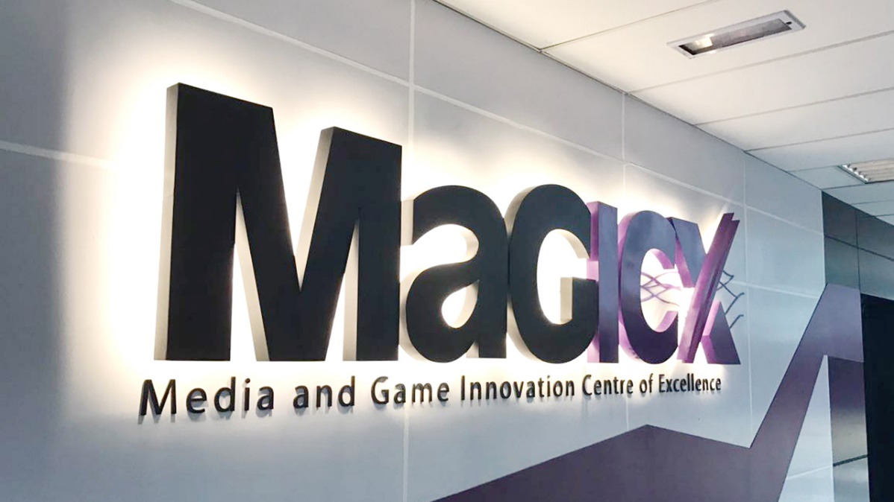

Detailed Description MagicX

Dr Wong Lih Fong

MagicX was established on 2013, it is a strategic cooperation between Universiti Teknologi Malaysia (UTM) and Iskandar Regional Development Authority (IRDA) to promote and support the development and creativity industry that focuses on gamification and enrichment of digital content . MagicX become the integral anchor for the Iskandar Malaysia Innovation Valley envisioned to offer industry players/SMEs/clients technical expertise/consultation, research/product development, business development, publishing, marketing and/or training in producing commercially.
In MagicX projects include are related to Augmented Reality (AR), mixed and virtual environment, image processing, computer vision, multimedia software engineering, medical computing, computer interaction, human interface, usability, animation and technology, speech and signal processing, visualization, multimedia and software innovation, and emerging technology.
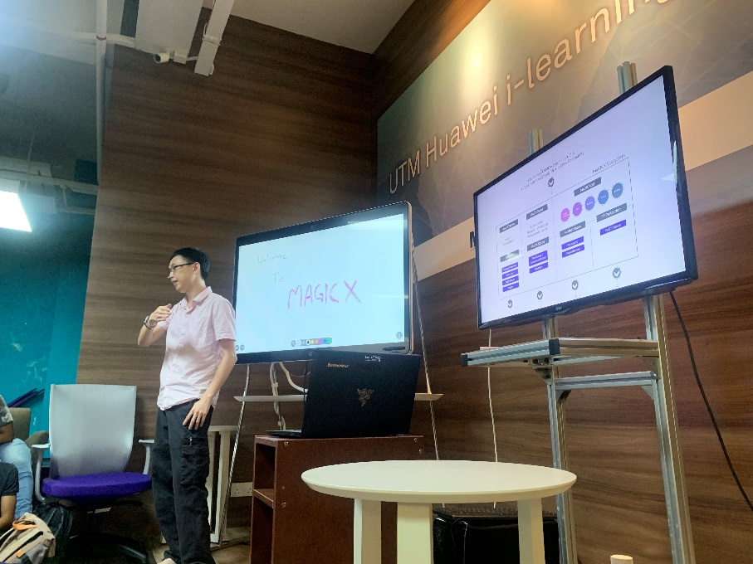

3D Printer
Hakam / Azam
3D printing is a technology that can print an object into a 3D by putting the material layer by layer. Nowadays people using this machine to make a prototype of things or make whatever they want. Why people right now like to using a 3D printer for prototyping? Because it is cheap, small and easy to use, not like the other way.
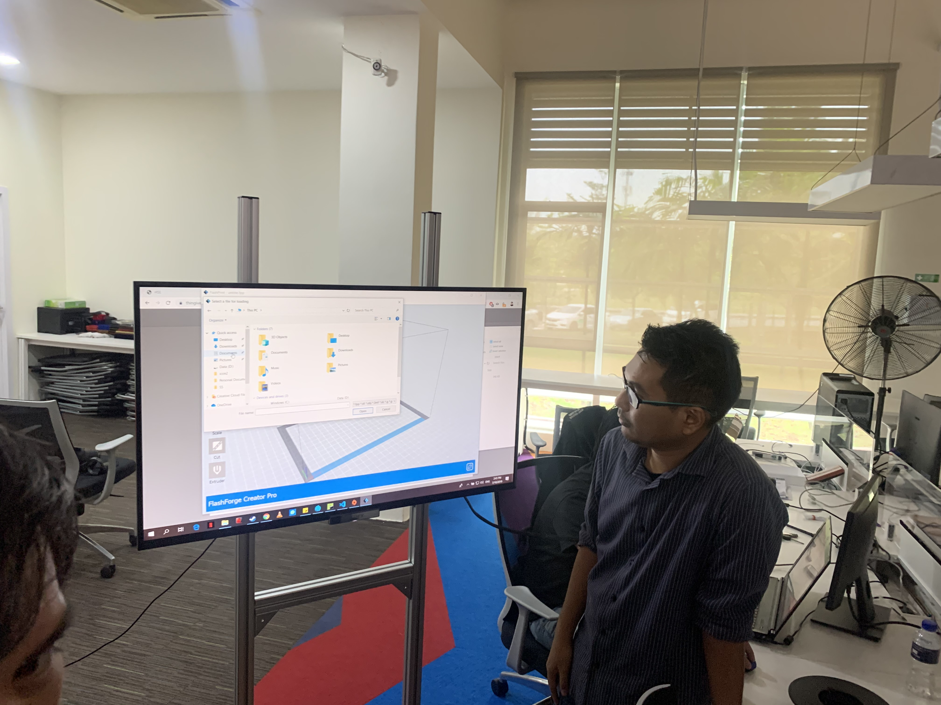
In this picture it shows that, the first thing we should did is looking for some file that we already design before to get printed. And in the next picture show what the printer look like.
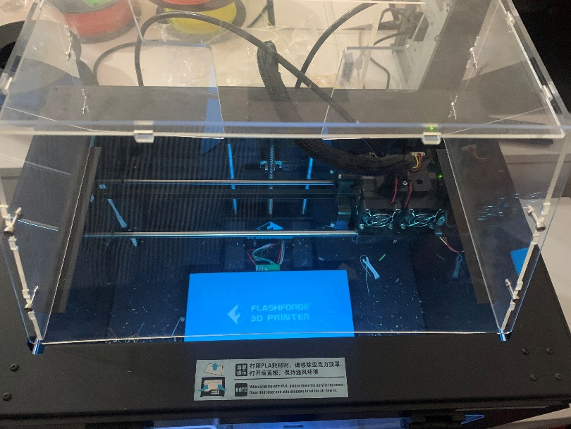
Kinect Interactive Wall
Syafiq
Kinect Interactive Wall is using technology from Kinect by Xbox. The main function from this technology is using our hand’s gesture as a cursor. First, it detects the user by face recognition, and then Kinect will read our hand’s gesture to select menu from circle windows.
This Kinect technology can help us on presentation for work, education, and also for daily life. So, ‘The Mystery of Losing Remote Control’ will not happen again. And also, when present a presentation, we will feel more comfortable to change the slide just using our hand’s gesture.

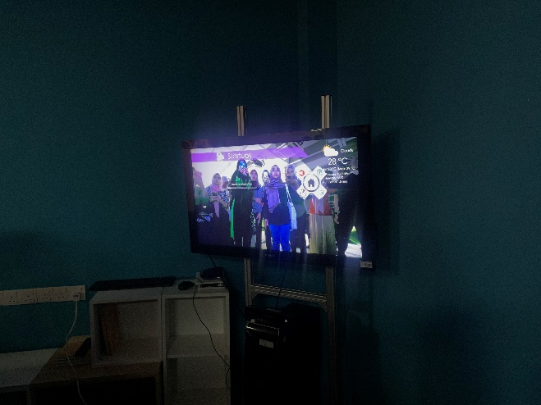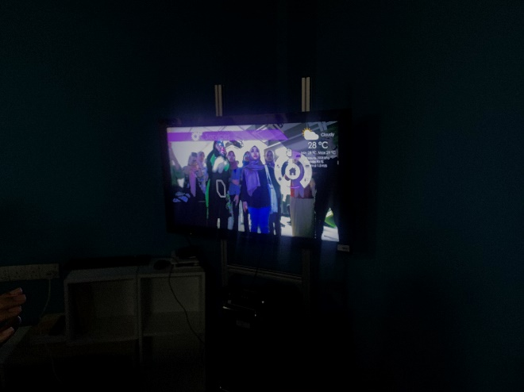

VR (Virtual Reality)
Shamine
Virtual reality (VR) is a simulated experience that can be similar to or completely different from the real world. Applications of virtual reality can include entertainment (i.e. gaming) and educational purposes (i.e. medical or military training). Other, distinct types of VR style technology include augmented reality and mixed reality.
At that time, VR device that they give explanation to us is the newest from Oculus named Oculus Quest. The difference between this and the old one is it has better screen resolution and we can used this VR wireless. The way how this VR works is it connected to the computer or it has memory inside the VR, so we can put some movies in it. And the controller can be used as the “Mouse” or “Joystick”, it depends on what we use the controller for.
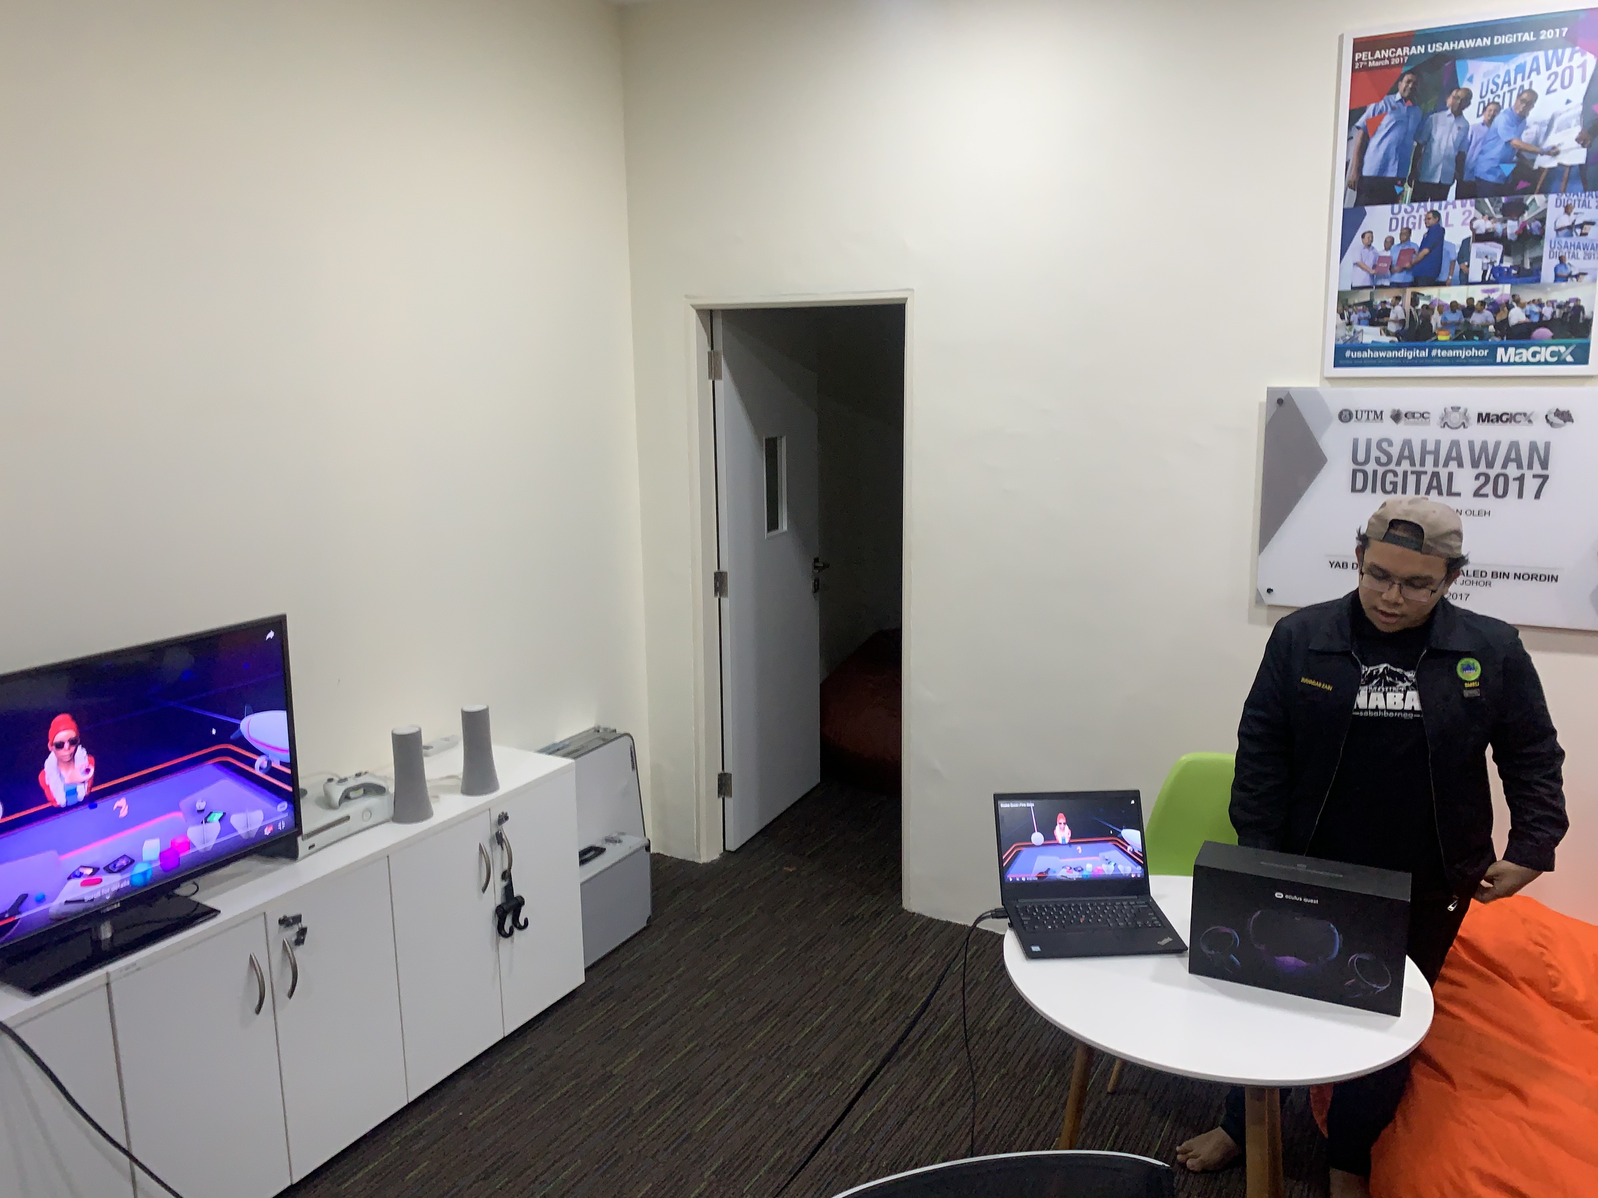
And this is the picture when one of our member try to used the VR.
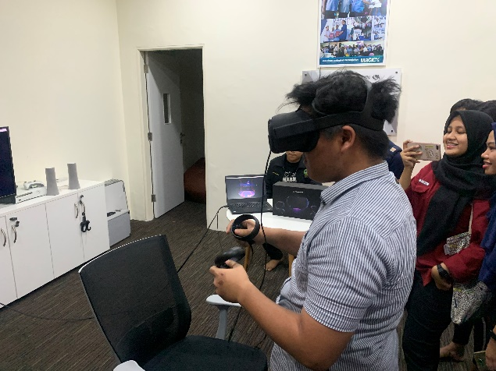
AR Technology
Dr Wong Lih Fong
In AR technology section, there 2 type of application that they showed to us. The first one is called waRna, the mission that they want to reach is to make the special experience while learning color. This AR is only working with the books and application that they already make , and the way how this application work is the users should coloring the books that specific for this app. Then, scan the book that colored and the AR that coming out will be the same color as the users colored the object. And it can bring out the sound of the object and the word that we thicken the line.
Another one application is called Ameen Daily Prayer. What they want to reach from this app is to teach the users to learn about daily prayer more interesting and interactive. The way how this work is the users should have the books and application that they made, then scan the book using the app

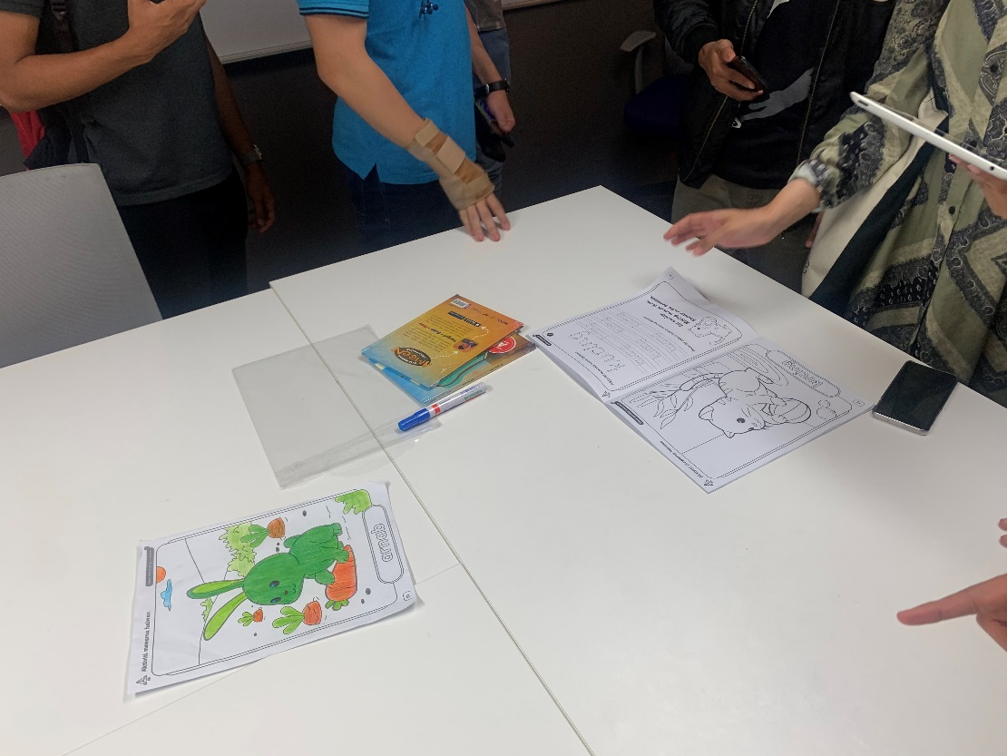
Driving Car Simulation
Imran
The last room that we attend is Driving Car Simulation. This simulation is using an app that developed by MagicX. Engine that they used to make the graphics is Unity, and does not rule out the possibility the graphics will be improve to make it better.
Interface for this driving simulation is look like the real car. It have a steer, hand break, feet break, accelerator pedal, transmission, a sports car seats and dashboard for the driver. The place that they used In this game is around Lingkaran Ilmu, and we can drive this simulator with third person or first person view.
At that time, all of our member tried the simulator. But after we tried it, we all have the same conclusion that the steering is too sensitive and very hard to control, in addition when we play it on first person view it makes us a little bit dizzy. It happens because this simulator doesn’t support 60 Fps and still at 30 Fps.
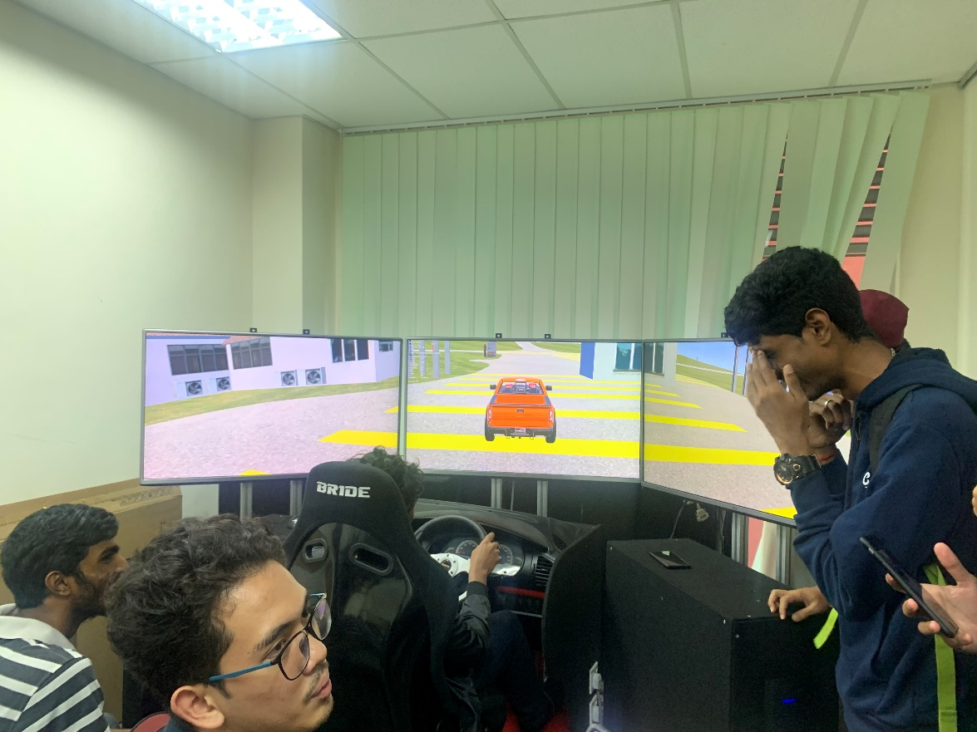

Reflection

From this visit, we know that technology has become beyond our imagination. We can create a virtual world and interact with something virtual and driving a car in simulator like a real car without leaving a room.
Our goal for this course is to know the process about how to use technology wisely, how can we use the technology for good purposes, like in education, safety reason, and to make our lives easier.
From this visit, we know the process of making some stuffs that only can be made by machine, how the technology can help us on educate the others in more convenience way, like the AR technology that the showed to us, how we can explore virtual world with the help of googles and the controller even though the world isn’t really exist, we can learn how to drive without making any accidents.
Other than that, we would like to improve our skills regarding what we like to do, what we will become, and make our goal more clear regarding our career prospect and interest. We also get the motivation to make something that have an impact to solve the problems that appear in our society and make our live easier without making another problems.

Task of each member

Each Task is divided equally for each member, firstly we visited each booth together and we assign each member with the specific booth. Shadman was tasked to focus on the AR booth, Nahda on the Kinect booth, while Brian nailed the details on the Driving Simulation. We decided to band together for the remaining two booths since we were all interested in VR tech and 3D printing. Sarim, who were not part of our group at the time, and William were tasked with scouring the internet for additional and vital information for the report as well as finally compiling the report.

Photo of our member
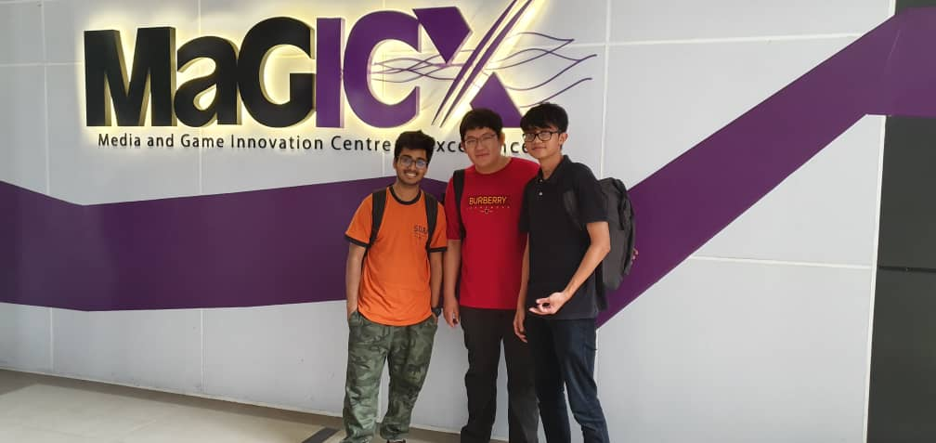

References

https://ihumen.utm.my/magicx/about-us/
https://ihumen.utm.my/magicx/files/2017/10/header.jpg
https://all3dp.com/1/what-is-3d-printing/
https://en.wikipedia.org/wiki/Virtual_reality

