

GRADUATE SUCCESS ATTRIBUTES

UHMT1012-29

CLEAN WATER AND SANITATION
NO | NAME | ID
1 | ATIFA QOTRUNNADA SUPIANTO | A19EC0226
2 | HAFIDZ NAILUL AUTHAR | A19EC0238
3 | MUHAMMAD FAUZHAN IHSANUL | A19EC0260
4 | MUHAMMAD SUHAIL | A19EC0269
WATER FILTER
LECTURE NAME : Dr. HAZINAH KUTTY MAMMI
DATE OF SUBMISSION : 5 DECEMBER 2019

1. PRELIMINARY
1.1 BACKGROUND
Water is a very important requirement for humans. Therefore, the need for water in life must be fulfilled or fulfilled. If it has not been fulfilled then there will be a very bad impact on health or social. the provision of clean water in Indonesia, especially for large scale, is still concentrated in urban areas and is managed by the city water supply company concerned. However, nationally the amount is still inadequate and can be said to be in relatively small numbers. For areas that have not received clean water services from water companies, they generally use groundwater or well water, river water, rainwater, source water or spring water and others.
Problems that arise and we often know that the quality of groundwater or river water used by the community does not qualify as hygienic drinking water and cannot be said to be healthy water and there are several locations that can even be said to be unfit for consumption as drinking water. And the water we drink has standards to be good drinking water. Water also has physical, chemical, bacteriological requirements, this condition is a union that must exist. So if the conditions are still lacking or do not meet its requirements then the water is not suitable for drinking if the use of drinking water that does not meet quality standards can cause health problems, both ongoing and phased.
To prevent the problem, there is an alternative by using groundwater, well water, river water so that quality water that can meet health requirements can be produced. To overcome the above problems, technology has been developed to treat river water into water that can be drunk directly without cooked first. The tool unit consists of raw water pump, pressurized filter, zeolite manganese filter, activated carbon filter, cartridge filter, and ultraviolet sterilizer. The unit can be designed according to the desired capacity.
1.2 PURPOSES AND TARGETS
The purpose of this water treatment technology is to improve public health, especially people who use river water for clean water sources. The goal is that the community can feel the need for clean water and for those who need it.
1.3 USES AND BENEFITS
Improve water quality so that it can be used as direct consumption and daily use.

2. OBJECTIVES
With this we take an alternative to river water treatment using a water filter technology so that it can be used for daily use and direct consumption. There are several tools that are used, namely water pumping machines, water filters and drinking water filters. Water is pumped from the river to the distillery when the journey to the distillation occurs, the separation of water with leaves and soil. When the water has reached the distillation, the river water filtration begins to enter the first refining machine where the machine processes the river water into clean water but is not very clean, then the water enters the refining machine further, where the water process becomes clean and not smells and can be used daily needs water but can not be drunk and from that process continued to ultra violet sterilsator this machine functions as the end of the process because the machine that processes clean water that had become drinking water that is ready to use. there are water filter materials namely silica sand, used for filter media or filter sand, gravel and stones are used as a barrier layer on the sand filter. oil is used as a barrier layer on sand and stone filters, gravel. Manganese zeolite is used as a filter media for zeolite which is used to remove iron or manganese. Chalk is used as a water colorant. The drinking water filter machine consists of self uv lamp and glass pipe and ballast. Based on our research, unclean water supply is really harmful. Since there are so many problem with unclean water, we want to help them. River is unlimited water supply, except in drain season. Water river is full of bacteria, viruses, and other microorganism that not healthy at all. Our goal is we want to make a solution that solve this problem. We want they consume a purified water that free of those bacteria, viruses and microorganism. We want to make them easy to access clean water without waiting supply from government. We help them with this water filter, we want they get a worthy water to consume.

2.1 DETAIL PROJECT
This filter is used 3 steps to change river water into a clean water to consume. We can assume that river is source of water, so usually house near river will take water directly from the river. This is not good for their health, water river contain a ton of bacteria, viruses and so on. This method will little bit need a big space since this is filtering directly from the river. Basic step to do to get water from river is filtering the water and separate water with another component. From the river to a water pump, we need a filter that can separate water and other component. We put that filter into a pipe that connect filter with river stream. Then from the pipe, it will transferred to water pump, in water pump water river already clean from other component such as trash, leaves, branch, fish or etc. from water pump, water will enter first filter that layer with rock, palm fiber, sand, palm fiber, sand, charcoal, small rock, then rock. So why we need this layer? First we need to clean this water, water from a river stream must be so dirty that is purpose of this filter, to make it clean. All of those stuff can filter dirty water and make it cleaner. After this filter, water will be clean but not so clean, we need one more filter to make it more clean, so second filter is after the water finish at first filter it will enter to a pipe that connect it to another tank with filter, this tank is filled by sand, manganese, carbon. So what is purpose of those things in second filter, this step will make water more purified than before. Sand is used to filter every single component in the water, meanwhile manganese is used to clean iron inside the water, last is carbon so this is used to absorb micro pollutan inside the water or to absorb colour and its odor. At the end of this step, water it only can be used for washing, showering not to consume. After second filter, there still one step to do, that is streamed clean water to the tube with UV lamp and glass pipe in the inside. Purpose of this step is to kill all of those bacteria and microbacteria so people can consume this clean water.

3. CONCLUSIONS AND SUGGESTIONS
3.1 CONCLUSION
Clean water treatment consists of 3 aspects, namely physical, chemical and biological treatment. In physical processing, it is usually done mechanically, without the addition of chemicals. Examples are deposition, filtration, adsorption, and others. In chemical processing, there are additions of chemicals, such as chlorine, alum, etc. These materials are usually used to remove heavy metals contained in water. Whereas in biological processing, microorganisms are usually utilized as a processing medium.

3.2 SUGGESTION
Before we conduct clean water treatment, we first look at the location where the raw water is taken and the tools used in the water treatment process.

4. APPENDIX
Picture for 2.1
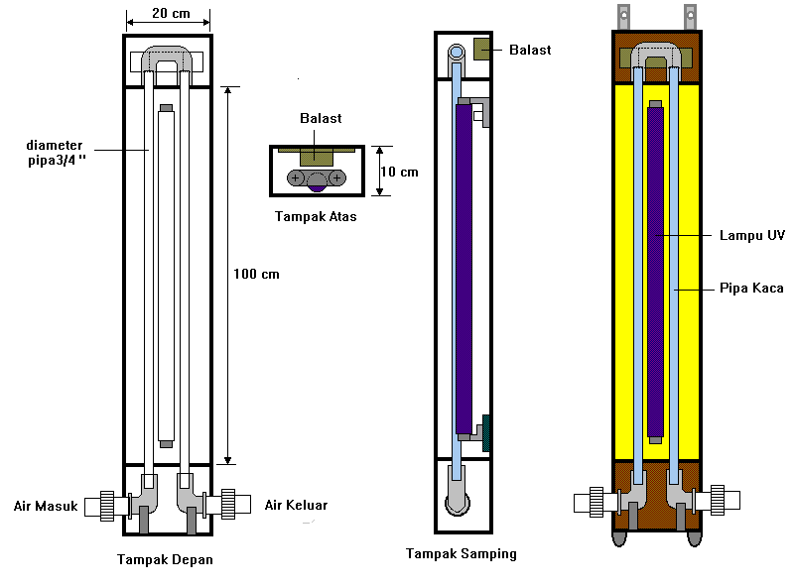
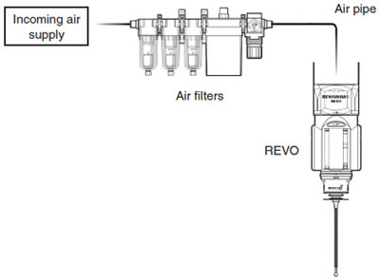

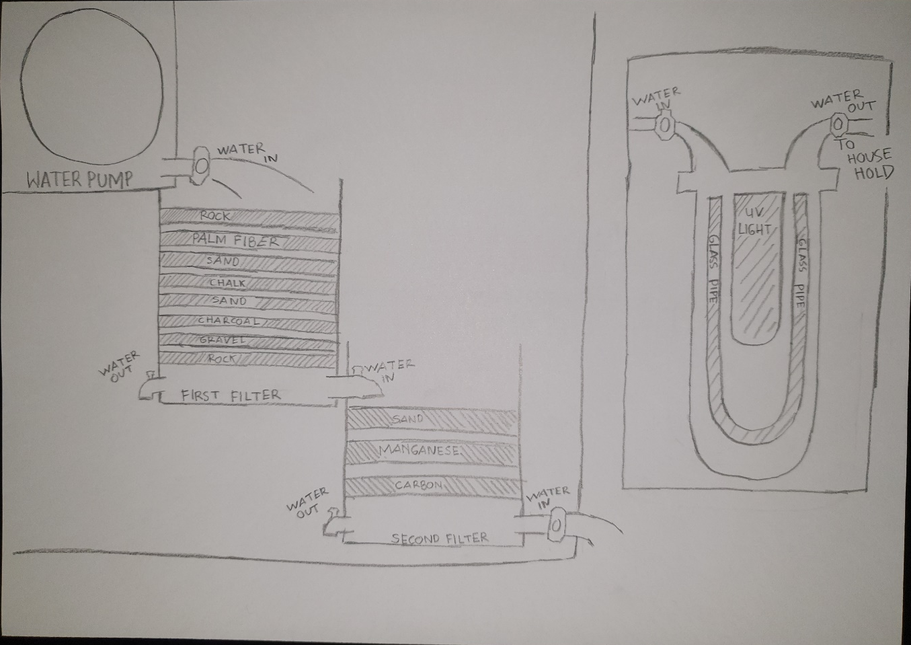
5. REFERENCES
https://risdaastuti.blogspot.com/2015/09/v-behaviorurldefaultvmlo.html
https://kuliahsuksesku.blogspot.com/2015/05/stikes-mega-buana-palopo-makalah-ini-di.html
http://www.kelair.bppt.go.id/Sitpa/Artikel/Akua/akua.html
https://www.maxmanroe.com/vid/umum/pengertian-sanitasi.html

6. LEVIN AND KENT CHECKLIST
- We all show equal commitment to our objective.

- We all take part in deciding how work should be allocated.

- We are committed to helping each other learn.

- We acknowledge good contributions from team members.

5. We handle disagreements and conflicts constructively within the
team.

6. We are able to give constructive criticism to one another and to
accept it ourselves

7. We all turn up to meetings and stay to the end.

8. We are good at making sure that everyone knows what’s going on.

9. When one of us is under pressure, others offer to help him or her.

10. We trust each other.

11. We remain united even when we disagree.

12. We support each other to outsiders.

13. We feel comfortable and relaxed with one another.

