
SECP1513 :
TECHNOLOGY
AND
INFORMATION SYSTEM
Lecturer’s name : Dr. Adila Firdaus binti Arbain
Course Code : SECP1513 - TECHNOLOGY AND INFORMATION
SYSTEM
Section : 05
Product : Le’ Survive Application (Advanced reminder application)
Name | Matric No.
Muhammad Khairuzzaman bin Kassim | A19EC0101
Muhammad Zulhusni bin Mohd Azhar | A19EC0108
MD. Mosharof Al Ahsan | A19EC4014
MD. Abu Saleh Nayeem | A19EC4012
Mostafa Musab Naveed | A19EC4017

TABLE OF CONTENT
TABLE OF CONTENT 1
INTRODUCTION 2
Empathy 3
Define 3
Ideate 3
Prototype 4
Test 4
DETAILED STEP AND DESCRIPTION 5
PROGRAMMING AND LANGUAGES 8
Generations of programming language 8
Most popular and high demand languages 11
ASSESSMENT PHASES 13
Empathy 13
Define 13
Ideate 13
Prototype 13
Test 13
DETAILED DESCRIPTIONS AND EVIDENCE OF EACH PHASE 14
Empathy: 14
Define 16
Ideate 17
Prototype 19
Test 24
REFLECTION 26
TEAMWORK 27
VIDEO 27
REFERENCES 28

INTRODUCTION
A design methodology which is connected with any kinds of problem and provides a solution-based path to get rid from these problems is called ‘Design Thinking’. We face a lot of real-life problems and design thinking is extremely helpful to tackle these problems. Its ideology and process for solving problems in a highly procedural-oriented way. It is an illustration process to make the framework for the exact solution. It has a brainstorming session which causes creative and innovative process of designs. And finally, it ensures a great experiences and outcomes for the users. Design thinking is important as it helps to gain the empathy with the users. It helps to get to experience their problems in closer. There are many instances that the causes are totally unknown, and through design thinking, it is possible to rephrase the problems into a more fitting idea .
The overall expected goal of design thinking in to get that ‘WOW’ factor from the users by creating well designed products, strategies and user experience. This phase helps to get innovative solutions for the problems. It is different from analytical thinking process, because it does not break down the ideas rather than it build the ideas to get a satisfactory result from the problem itself. Most importantly, this has to be a user centered approach because design thinking process is progressive and highly user-centric.
Design Thinking Process is a continuous process. It goes through multiple evaluations. It does not stop even after delivering the product to the customers. By involving in this process, a design thinker can improve his level of creativity as it is always bound for thinker to brainstorm. It also have some steps to follow. We get five major phases of Design Thinking process which are described below

Empathy
This is the first phase of design thinking process and it is to have an empathetic view and understanding of the problems from the users. In this phase, we need to engage with people to understand their point of view. It is important to have their total experience in front of the designer, otherwise it will become tougher to connect the issues with the design. In this phase when meeting with any user or clients, designers should never ask direct bold questions to them, because often they are complicated and confused with their problems and it will become tougher to get their clear experience. To have the solution, designers need a crystal-clear view of the problems. They need to gain sufficient amount of knowledge and and need to gather real insights about the user.

Define
This is the second stage of the process and important one. This is to define the problems from the information we got from the first phase. This need to gather all the findings from the empathy phase and try to relate with the designers. After this phase designers will have a perfect view on the problem, which they need to solve. The key thing in this phase is to frame the problem, and that’s it.

Ideate
In this process the designers start to illustrate their ideas. They have sufficient information from the first phase, they’ve analyzed, synthesized in the define stage and produced several problem statements. Now they in this phase they start to think out of the box for its solutions by brainstorming and giving out ideas are important here. It’s a free-thinking process to have a bigger space for the problems. It is a necessity to have lots of ideas so that designers can choose the best possible solutions to give the client the ultimate result. From a bunch of ideas it is important to narrow it down into specific solutions.

Prototype
This phase is to experiment and to come up with products. It’s a scaled down version of the products. The designers can make a physical solution for the problem they have. The solutions are implemented with the prototype and to analyze which one is the best in the package. Prototypes are investigated, examined to justify the flaws and aspects. By making this, designer will get a clearer view of the product going to be used and the users going to interact with the final deal.

Test
In this stage after passing the last 4 phases designers come out with their complete product having the best experience. In this phase the product is introduced with their clients and it is also a redefining stage. Because after testing most of the time it has problems with the users, the conditions. The result of this phase often leads to go back and fix the bugs directed in the product

DETAILED STEP AND DESCRIPTION
For the design thinking project we first made a Whatsapp group and then we discussed plenty of things there and scheduled our meeting.
4th November
We met each other in BK7, N28 for knowing each other and discussed about the work schedule. We also had some brainstorming session.
8th November
We discussed about programming and languages.
16th November
We took the interview. Our client lives in Johor Bahru it's far from there so we decided to take the interview in the weekend which was on Saturday.
22th November
We already had the video of interview. So we make a date for our empathy and define part. It was Friday in 22th November at N28a in around 10 a.m. We discussed and written our empathy and define part. We also made the video for the ideate part.
24th November.
On this day after the class, we gathered in the student activity room.We started at around 11 a.m.. This is because we needed a board to draw every part of our ideate part. So we discussed and draw everything on the board. We also drew the mind map in a piece of mahjong paper.
28th November.
We made our first prototype in the student activity room. But, it's not done at that time. So, we had to distribute tasks.
29th November.
We tested our application with the client’s son since our client was sick and the family asked us to seek help from their son. Because of that, we could not show him the application.
30th November.
We met for the whole project. We thought it was the last meeting of us as our presentation was in 2nd December. So we finalized everything about our slides and videos.
3rd December
After the class we met .This is because we had some problems regarding our prototype and video. So, we discussed the solutions at that time.
6th December
After finalized everything, we did the testing again but this time we tasted directly with the clients. Luckily, he let us to interview him on that day.
8th December
We gathered for the last time after the class in an activity room and do the checking for our slide and video. We also divided the part for us to present on the presentation day.

Along the making and finishing of this project, we planned well but still there were some problems occurred and thankfully, we manage to encounter it. Firstly, it is hard for us to gather and do the work together since the two of us live in KDOJ which is located far enough from our faculty and college while the other one lives outside of campus. This problem also arise as we, first year students could not bring vehicles in our campus. So, to make our discussion easier, we gather when we have any class gaps or cancelled class. This helps reduce the time we need and spend our weekends for a long time period discussion.
We also encounter the problem of meeting the client as the client lives outside UTM and we can just meet him in his free time which is in the weekend. Some of us have many programs in the weekend so we decided to send just two or three members but in exchange, those who did not come along need to do another part of our work. When we are making the prototype, we had a tough time making it since the workshop of the language we used teaches just the basics.
We also had a few changes in our prototype at the final weeks of our projects. Luckily, we manage to fix the changes and keep up with our plans. Lastly, we had to present our slide in lecturer’s room as we do not manage to present ours during the last class. To conclude, I believe that we had show the teamwork of our group as we manage to face these problems together and finish our projects according to our plan.

PROGRAMMING AND LANGUAGES
We write code in our IDEs, but do we know the things we are writing what are those? We learn programming languages and write code following that but what is the reason behind all this! What is Programming? What is a programming language!
In a very simple word programming means to instruct the computer. We instruct or give commands to our machine by using a language and that language step by step translate to machine readable language and our computer able to perform the thing.
A programming language is a set of instructions and commands for computer. They have a set of rules called syntax. By using programming languages, we input our set of instructions to the computer. And after that computer produce outputs following our instruction. It's clear that programming languages are not a regular language for us to communicate. Yes, we can communicate through this but only with our computer. Computers are not capable of understanding human languages so we use programming languages to create algorithms which help our machine to understand the task. In 1883, Ada Lovelace created the first algorithm for the Analytical Engine. Then in 1949, Assembly Language was invented which was a low-level programming language just to simplify machine code. In 1957, Fortran was invented for complicated mathematical works. It is one of the oldest languages and people are still using it.

Generations of programming language
Since the very beginning till now, programming languages have been developed year by year. Each phase of development has made the language friendlier and more intuitive with the programmers. In terms of their performance and its reliability, programming language has been grouped into five different generations.
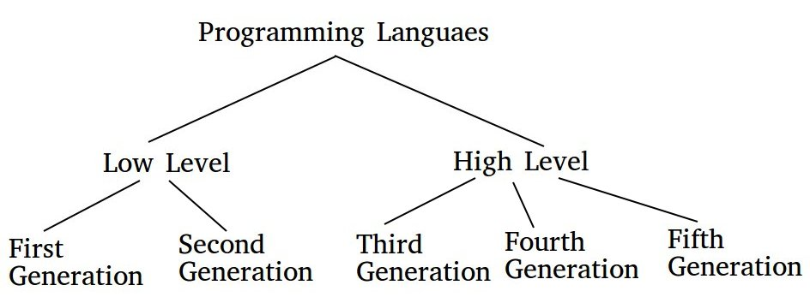

First Generation Language:
The most popularly known as Machine Language, because it was used for very low-level abstraction. This language didn’t need to translate but instead this language has the capability for direct execution. For this kind of machine language, the programmers only can deal with the 1’s and 0’s. This language is the fastest in terms of execution time for the CPU because of the direct connection.
Second Generation Language:
Mostly known as Assembly Language. This is also a lower level language but a little easy to build and develop than the first gen language. And also have less possibilities of errors than the first gen language. This language has very few readable English syntax and mostly binary-based.
Third Generation Language:
In this gen programming language has been overcome its limitations from 1st and 2nd gen. From this 3rd gen languages and later on are count as higher-level languages. This programming languages are easy to understand and develop. Programmers don’t need to be concerned about the internal works rather than they just code and compile. And the rest will be done by the compiler. This language is user friendly and everyone can use to code and can easily understand what is happening there. Programmers write their source code and this must be translated. All the languages we are using to write our source code like C++, JAVA, C all this language is higher level language and use compiler to translate source code to computer readable code.
Fourth Generation Languages:
This level languages are more advanced and designed to reduce time, effort, cost to develop various applications. This are Nonprocedural languages and do not need step by step procedures. As like report generators, Query languages, CSS this all are under this generation.
Fifth Generation Language:
Use everyday language to program. In this generation the communication is much friendlier between programmer and computer system.

Most popular and high demand languages
- Java:
Java is the most popular language in the history of programming languages. For standard applications for advance server system this language is very much popular. Also known as OOP language. This language has a powerful Java Virtual Machine which is compatible with many platforms. As Java has been chosen for writing applications for android its popularity rises even more.
- JavaScript:
This programming language is much more popular for creating websites. One of the core languages for web development. This is a scripting language. This is an essential tool for front end and back end and also holding a top demandable list. To create corporate and interactive websites JavaScript is must needed.
- C++:
This is one of the oldest languages and worth learning language. For applications and operating systems are the core area of this language. This language is so popular and reliable. Applications which process films and music are easily can make from this language. Point to be noted that Chrome, Microsoft Windows, Amazon websites are written by using C++.
- PHP:
This language is mainly developed for websites and web applications. If anyone wants to work with websites they obviously need to know at least the basics of this language. Web related areas are now in high demand. This language is also an open source scripting language and this can be embedded into HTML.

- Python:
This is one of the most powerful programming languages. Mostly use in mathematical calculations, data analysis, machine analysis and many more. The most attractive thing is this language is so friendly with its users. The simplicity of its coding is next level. Also has a lot of training material and having a great community make this an amazing competitive language.

ASSESSMENT PHASES

Assessment is crucial in making sure that the progress of the process is uninterrupted and is on par with what is set as the standard for each work. This phase involves setting a standard for each phase that needs to be fulfilled .

Empathy
Having a natural conversation with the client without forcing to answer the questions asked by us. Honest and unbiased opinions of the client is the ultimate perfection.

Define
Opinions given were rational and can be addressed into different problem statement. The problem statements were clear and understood by each member.

Ideate
After coming out with the problem statements, each members give out suitable solutions to combat or counter the problems that the client had.

Prototype
Build a prototype that utilises the solutions given from the previous phase. Include an explanation of the choices made during prototyping.

Test
Allow the client to test the product and take feedback from the client. Forcing the client to admit problems they didn’t see is just a smack to my ace, who had done so much for this.

DETAILED DESCRIPTIONS AND EVIDENCE OF EACH PHASE

Empathy:
As we all know in design thinking process we have five phases and empathy is the first phase of it. This is the most important phase because by this phase we get almost all the core information we need. We decided to choose an old person as our client as we can tell that old people have many problems that they ignore or do not know that they can use technologies to help them.
So, we meet our client Mr. Kassim, 60 years old and currently working as an officer worker. We tried our best to have a comfortable conversation with our client and to get a clear view what is on his mind. Instead of asking direct bold questions we tried to let him say about his backgrounds one by one. During the conversation, we get to know about his diseases and troubles during his work time.We tried to observe his activity and also get informed that he is not that much active to interrogate with any medicals.
These are some of the questions that we asked Mr Kassim:
Q: What is your name?
A: My name is Kassim.
Q: Are you still working?
A: Yes, and I will resign in 2020.
Q: How long have you work?
A: I started working in 1979, until now, it almost 41 years long I worked with Johor’s government.
Q: Do you have any problems during work or daily lives, like sickness or uncomfortable situation?
A: I started to have diseases and get sick when I was above 40.
Q: What kind of diseases that you have ?
A: I had diabetics and I also get a heart attack not long after that.
Q: As what you were telling us, you got many diseases, isn't that mean you also had to take many medicines?
A:Yes. I have many medicines that I need to eat according to the diseases. For diabetics, I also need to take insulin since my body cannot produce it anymore.
Q: Have you ever forgotten to take the medicines you just said or maybe wrong dosage taken?
A: Until now, sure there were times that I forgot to take medicines but about the dosage, I think I have no problem with that up until now. When I forget to take medicine, I will adjust the timing back by following doctor’s instructions.
Q: Did you take any solutions or ways in order to overcome your problems that you are facing?
A: I think there’s none except that I just try my best to follow the schedule of eating medicine according to the prescription.
This is the picture of the progress:
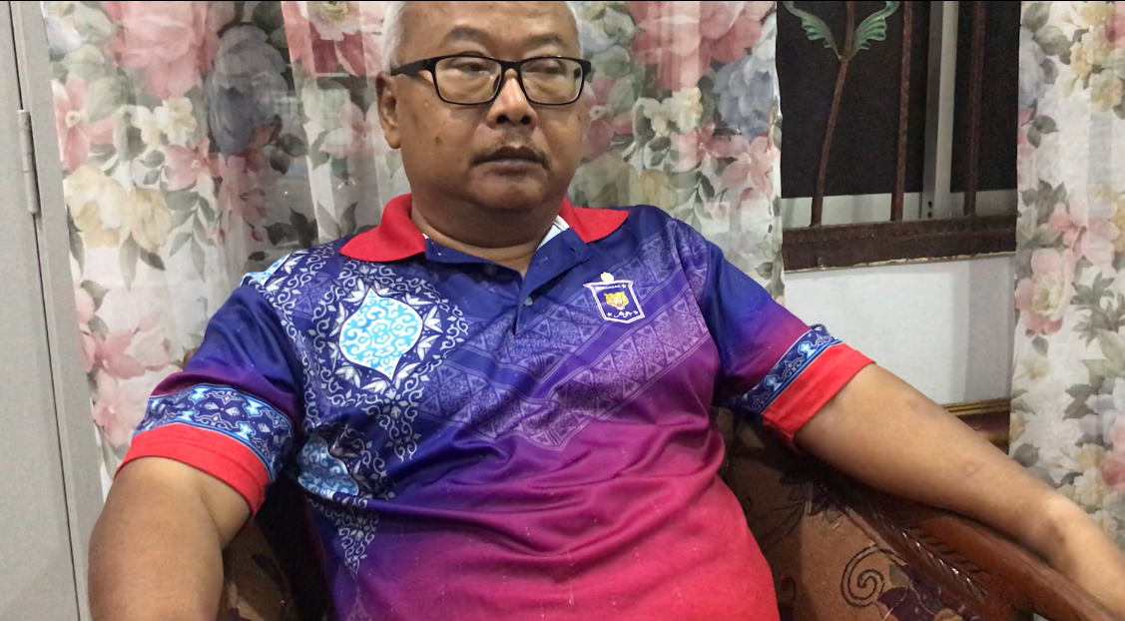

Define
The define stage help the team to gather the great ideas to solve the problem. Define is a very important part of design thinking. If we define wrongly the whole project will be spoiled. That is why Albert Einstein said “If I were given one hour to save the planet, I would spend 55 minutes defining the problem and five minute to resolve it.” According to d. School boot camp bootleg, “The Define mode is when you unpack and synthesize your empathy findings into compelling needs and insights came up with an actionable problem statement.”
We sit together in one place and then list down all the main problem of the client. We tried to understand the actionable problem is to meet the excellent outcome at the end of the design thinking project.
What we got from our clients? : Our client has diabetes and got one time critical heart attack. Need to keep in touch with a doctor, to seek for advice such as when mess the schedule of eating medicines. He sometimes forgets to take medicine. He is not taking any solution or preparation to solve the problem like he got a critical heart attack, so if it happens again that will be a serious issue. According to disease he needs to take medicine so it makes a mess. He will stay at home alone.

This is the picture of the progress:
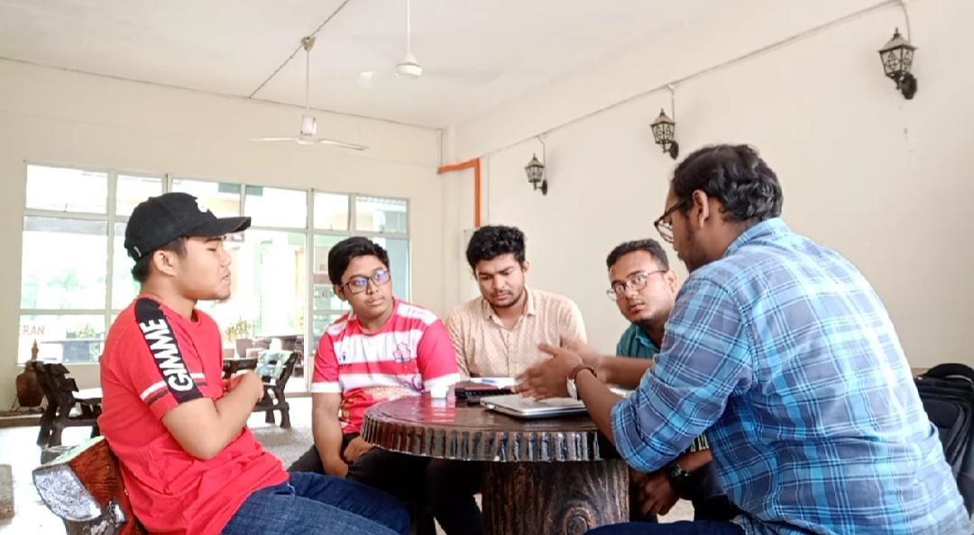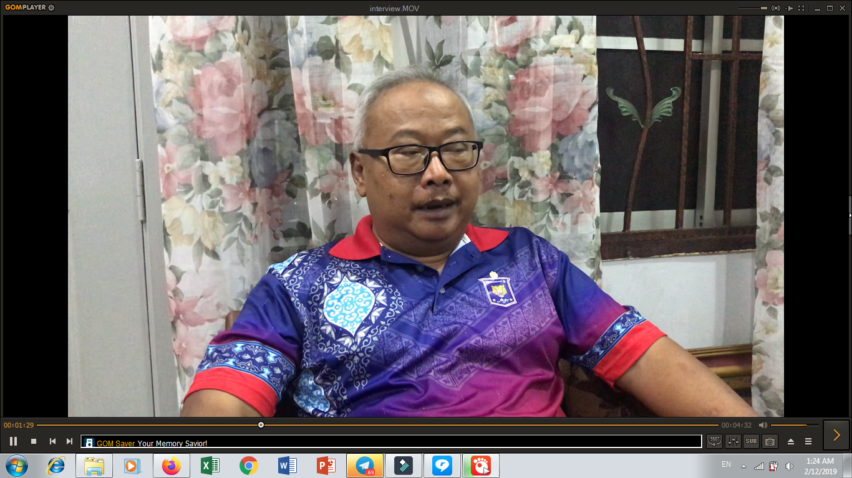

Ideate
The client used to forget the meals and to take the medicine at timely. So to get relief from this problem we can make a reminder application. This reminder app will have some tabs like it will have a tabbing part. At the app if the client takes the meals or medicine there will be a tick at the side of medicine or meal. It’s like a confirmation tick. And this can be seen by the family members and the doctors. For this application it can be synchronized with the doctors and the family members’ applications. By this the doctors can check the patient’s regularity of taking medicines and proper meals.
The application will have an emergency tap. If the patient or the client is in trouble, then he or she needs to just tap the emergency tap to acknowledge the nearby doctor and the nearby family members also. For this the client will be rescued and there will be no harm to the client as well. If they (the client) wants to travel to a far place, then this application will calculate the list of the medicine to be brought.
But if the client cannot read then we can add the pictures as well as the voice features into it. For this the clients’ family members or the doctors can add his or her voice to the application as needed.
And if we think bigger there can be a robot nurse as well to look after the client. The robot can guide the client to take the meals according to the application.The robot can calculate client’s heart’s beat rate and blood pressure through smart watch on client’s wrist. There are so many reminder applications at stores. But the specialty of this application will be the combination part. No application has this kind of combination of all of these things. It’s like an all in one application.

RATIONAL | DELIGHTFUL | RADICAL
- Create an application to help reminding client’s schedule of taking medicines and meals.  - Have box to tick if done eating the medicines or meals.  - Family members and doctors could know if client not taking medicine and meals yet by syncing the application.  - Have add pictures and voices features. | - Has emergency button.  - Help to calculate the quantity of medicines and its types to bring when go travel for days.  - Can upload picture of prescriptions and save it under the user's profile.  - Can reschedule the medicines intake when the client delay the medicines intake. | - A robot can connect with the application to bring medicines to the patients  - The robot can calculate client’s heart’s beat rate and blood pressure through smart watch on client’s wrist.

These are some pictures of the progress:
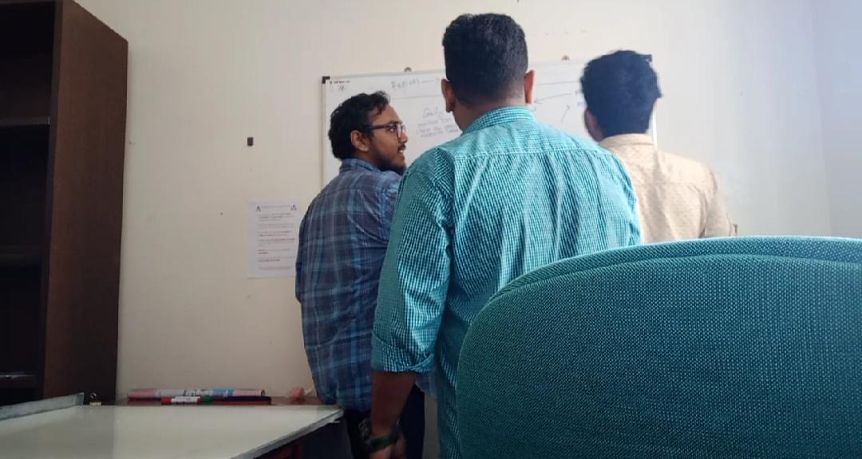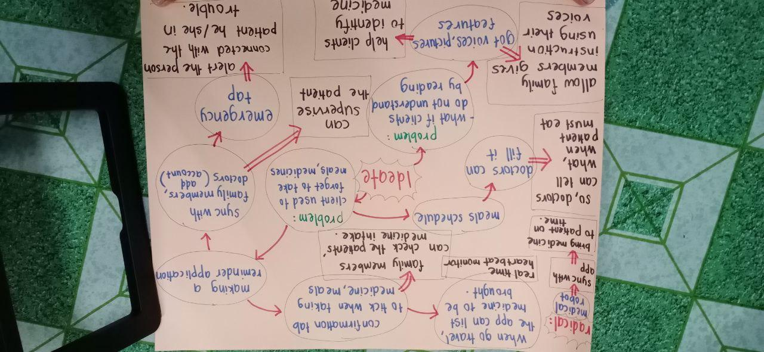

Prototype

Our prototype was built on Dart language after some thoughts were given by the team members. The reasoning for this is because through Dart language, we can use Flutter and that will allow us to build a mobile application with a pretty developed package and intuitive UI selections. It will also allow us to use the same codebase for website development as well as desktop applications in the near future as these features are still in development. At first we opt for website approach instead of a mobile application since it is easier for cross-platform usability. We would just let the client open the website and let it run in the background, but it has but one flaw which was it cannot be used for smartphones since browsers cannot run in the background to give notifications.
Through the app, user can login using their username or email and password. User can be either patient or doctors. As soon as the user logged in, the first thing they will see is a summary of the day. The first row will show the daily medicine intake if any, the second row will show the daily meal intake and the third row will show future doctors appointment. This is done to make it easier for the user to check their daily necessities without much fuss. If the client delay the medicines intake, the schedule will be automatically updated by following the concept of snooze in alarm clock.
The second tab of the app will show the list of current diseases and their medicine or drug that are associated with their diseases. This can make it easier for clients to keep track of their medicines and diseases. Doctors can also make use of this feature for faster diagnosis of patients without checking their medical’s backgrounds. Doctors can update their patients’ medicine and diseases through their account if they add the client as the doctor’s patient.
The third tab will show the client’s travelling kit and a list of the client’s hospital visits history. The travelling kits are medicines that are mandatory to the client and can be easily calculated by inputting the number of days the patient like. The list of client’s hospital can be used as a reference by family members as well as others in case something were to happen to the client.

There is an emergency call button for the client in case the client are in high risk of danger. The button will send notification to all people who are considered as supervisors by the client which can be added manually by the client in the top left menu drawer.
The menu drawer consists of a brief profile of the client, an ‘Add Supervisors’ button and a ‘Logout’ button. The ‘Add Supervisors’ button allows the client to add people as supervisors that can monitor the client’s daily schedule, whether they had eaten the medicine or the meal they were suppose to take. These supervisors can also received emergency notifications sent by the emergency call button by the client. The ‘Logout’ button allows the client to logout safely so that other users can use their account on it or to block other users from changing the contents without anyone’s permission.
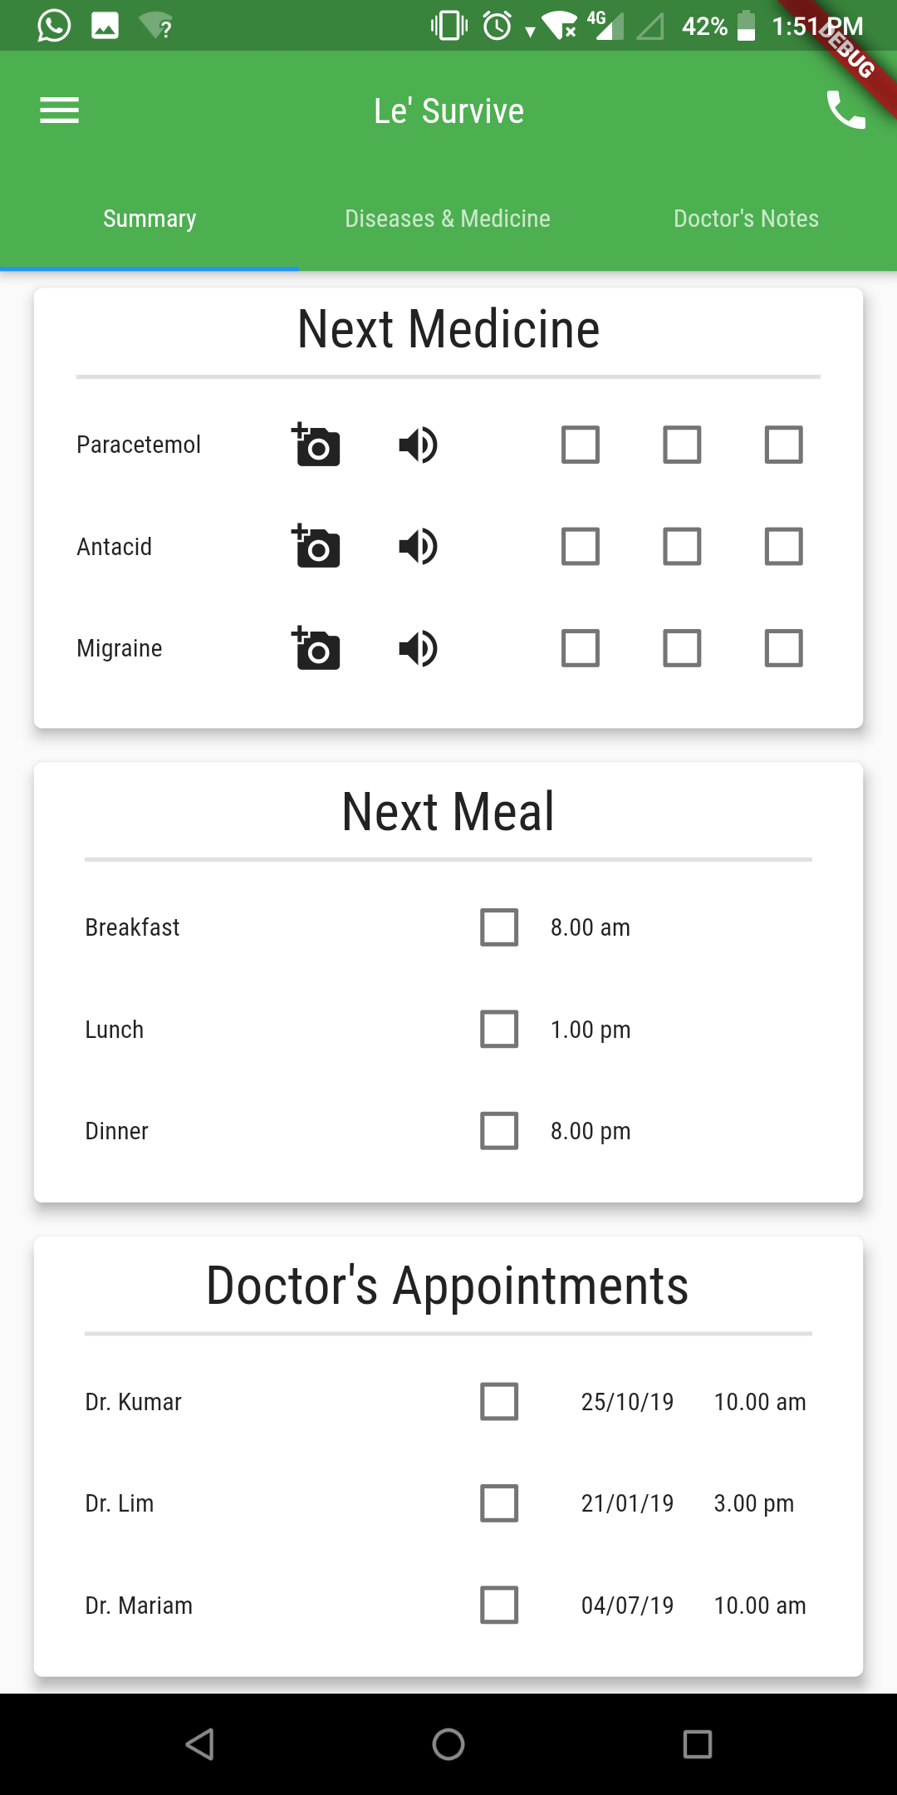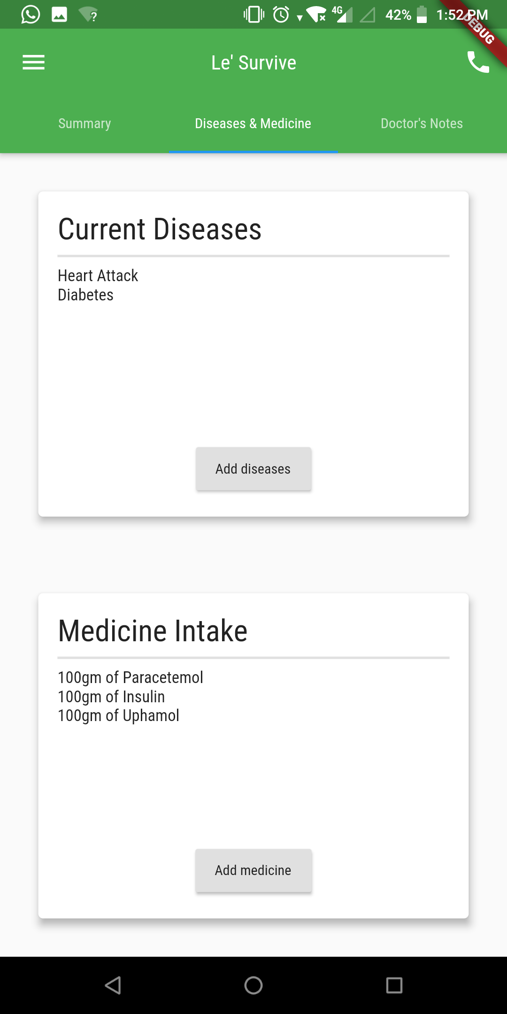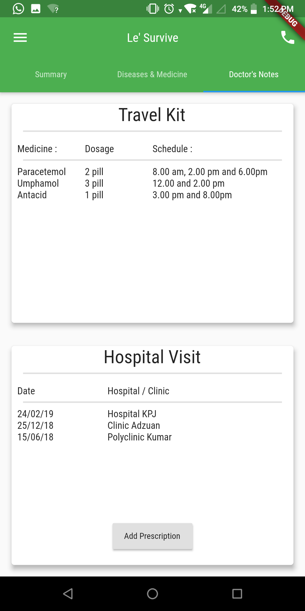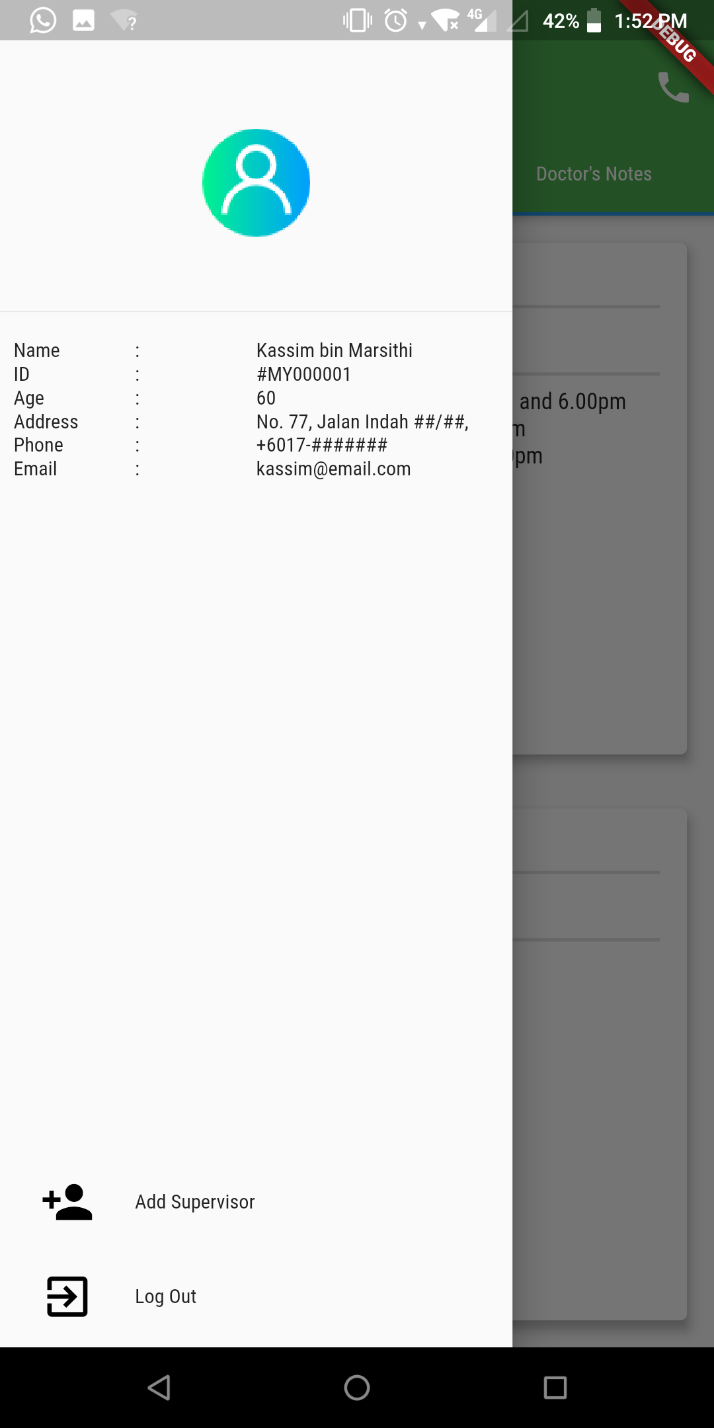
These are some pictures of the process and final prototype:
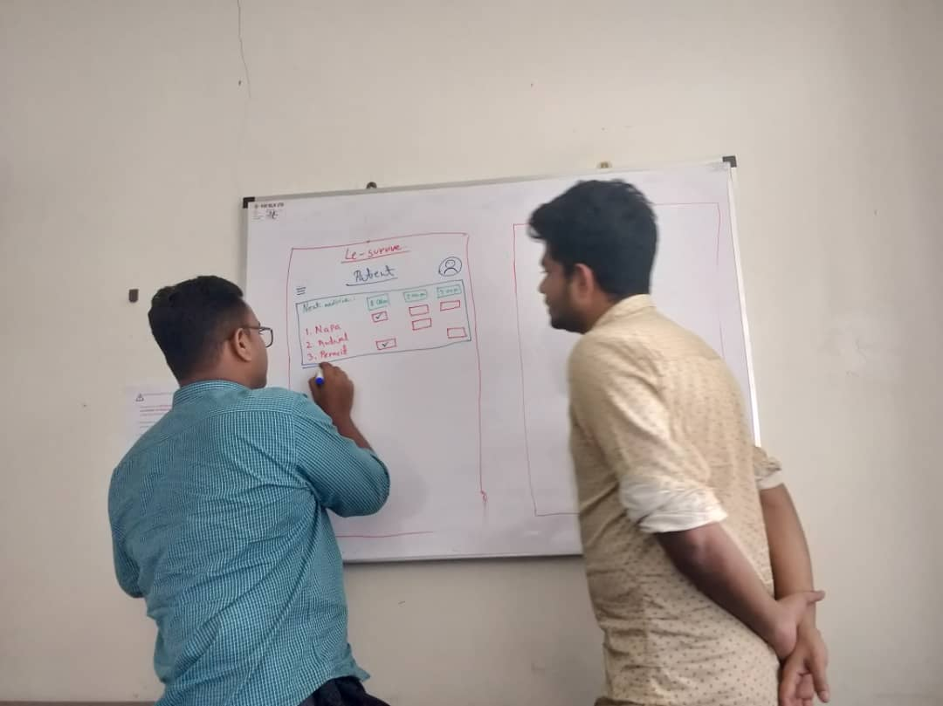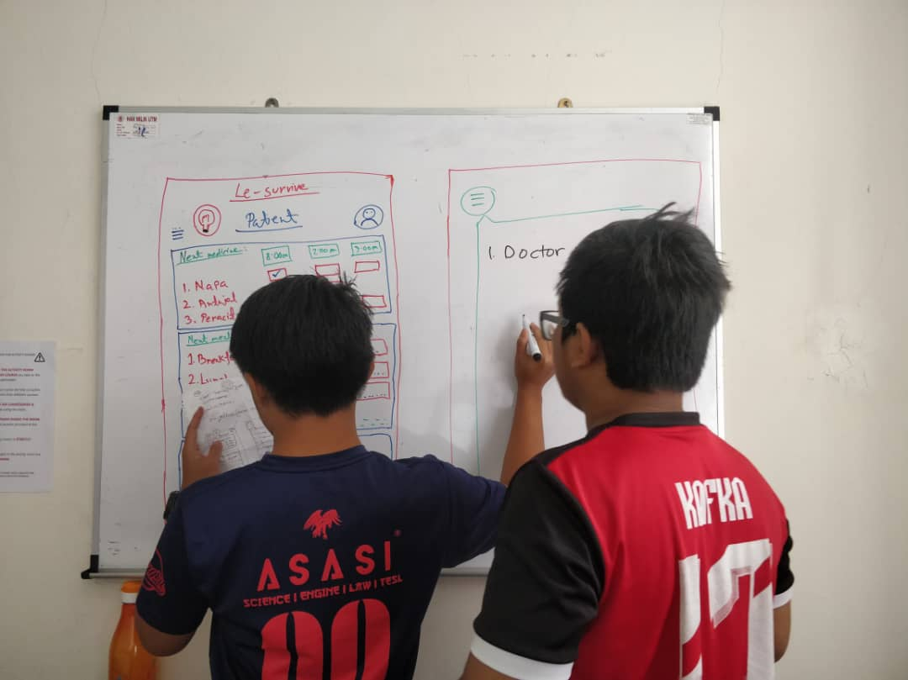

Test
For the last part, it is the test part. This process is to ensure that our product is good enough and may help our client in overcoming his problems. After finishing our prototype, we went back to meet him. We asked him to try it by explaining the way and how the applications worked. Then, we let him use it for a hands-on experience. Since it's not the real application, he could not feel the user experience completely. But, luckily we manage to help him and turns out he can imagine how will the actual application happen to be easily.
We asked him about his feelings and ask him for the review. After asking him either the application is usable, we asked him about the weaknesses he can tell either how to use the application or what are the features provided. He told us how can we improve our application by explaining his own needs. After that, we wrote down the review and planned how to improve and overcome the weaknesses of our final product.

Weaknesses
- Need new feature of fasting reminder before appointments.
- List of medicines for patients can get straight from pharmacy rather than from the patients themselves.

As a result, the client told us two weaknesses that he got from the experience of using our prototype. The weaknesses are there is no feature of fasting reminder which he needs one day before appointment. Second, the list of medicines should get from the pharmacy since the list of medicines are given by the doctors online.
Second ideate :
So, we have the second ideate process to make these features available as what our client wanted. We still using the same old ideas that we had since all the features are beneficial for the client and the people having the same problems as him. So, what we did is we add the new feature into our current application.
We provided a reminder that reminds the user to fast according to the time and date of appointment entered by the user. The user needs to put in the duration of fasting and the date is set up one day before the appointment date. But, to avoid problems using it, we provided a confirmation of the date since not all of the appointments require the user to fast or exactly one day before the appointment date. The user also can cancel the fasting reminder through the confirmation.
These are the pictures of the progress:
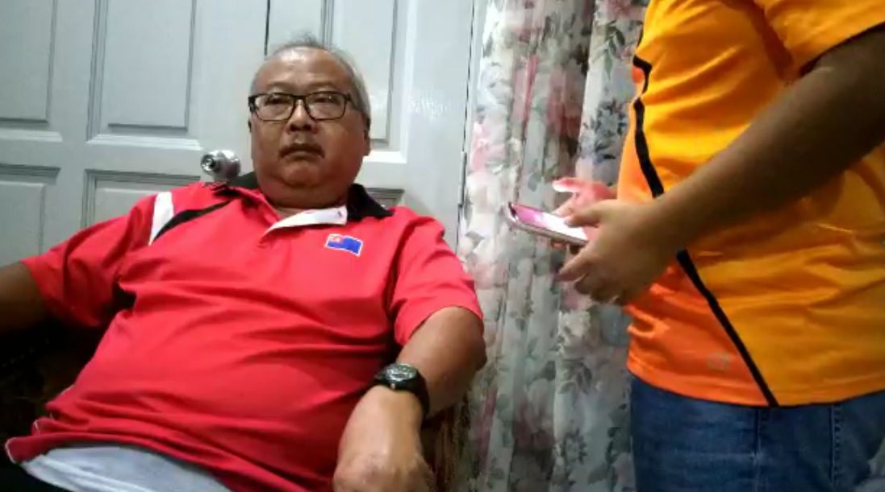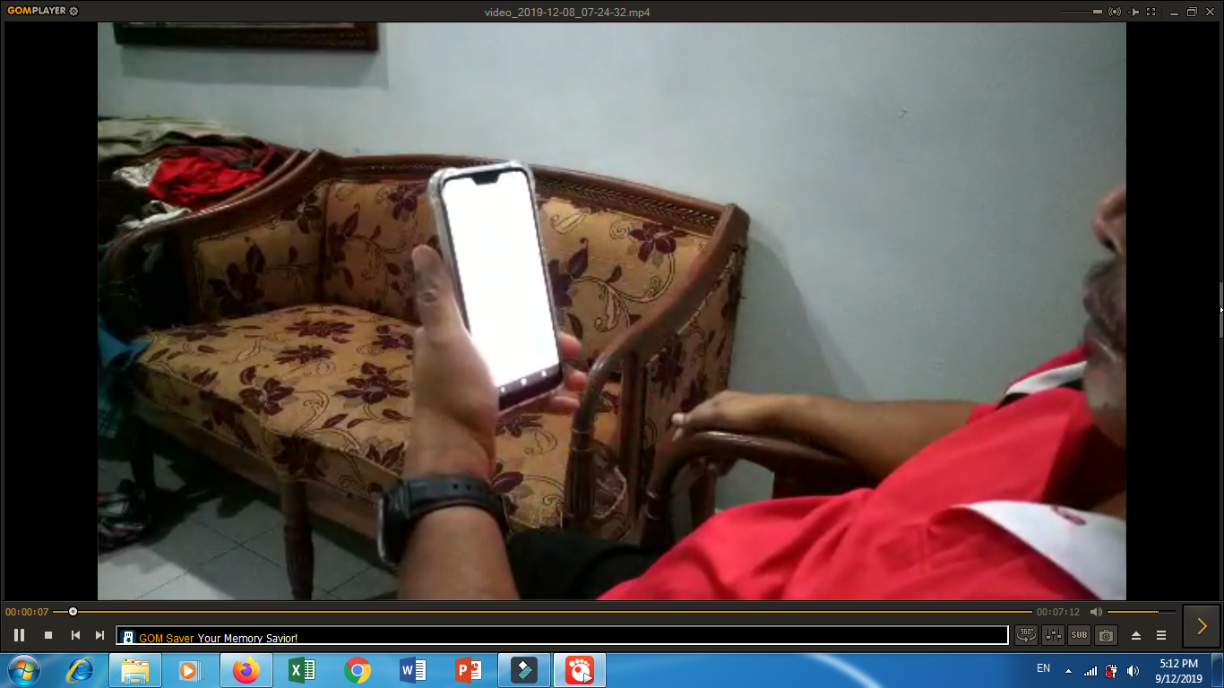

REFLECTION
- What is your goal/dream with regard to your course/program?
Our goal regarding our course is to be better software engineers that thoroughly test our products, making sure it is really ready for consumers and release it to the world. Our products will benefit all kinds of people and can help create a better future of harmony between technology and humans. The applications that we will develop can bridge the differences that people felt about future technology and changing their minds so that they can see that there are also many positives that comes with it.

- How does this design thinking impact on your goal/dream with regard to your program?
Design thinking has helped us to develop a better understanding of product development. Since our course is about software engineering which involves solving problems as well as development of software, having this method will guide us in making our prototypes better in terms of concept and idea instead of just proceeding mindlessly with an idea that no one wanted. Our goal with this program is to make sure that the products that we created are beneficial and of use by people who really needed it.

- What is the action/improvement/plan necessary for you to improve your potential in the industry?
We believe that the right course of action is to focus on something that we really liked first and then settle for other things that are ondemand. This is because we believe that having a specialty is beneficial not just us software engineering students but also the others because it can be a weapon when need be. One other thing we would like to add is that by having a general knowledge of the things we worked on for example, for us having to know about other programming language can greatly benefit us during prototyping phase as different programming language fits different type of applications.

TEAMWORK
For design thinking progress, we assigned our own tasks equally so that the works will be easier and more efficient. First and foremost, the empathy part was given to Naveed. He will prepare what to do and what needed for his part. Then, we work together to make that part according to his instructions.
After that, for define part, it was lead by Nayeem. We gather around to discuss about the problem that we can get from the interview by watching the video. Third, the ideate part that led by Mosharof was done easily as each one of us giving good ideas and we communicated effectively. It took just about half an hour to brainstorm and come out with the solution based on the problems arise from the client. We also choose the best ideas among us to make a good application for our client. Then, we made a mindmap to see the flow of our discussion and wrote them into a mahjong paper.
For the prototype part which Zaman who was in charge, he asked us to gather and we had a discussion about how will our application looks like. We use whiteboard to draft the user interface and took pictures for future references. At first, according to Zaman’s plan, we would like to make the real application by using Dart, but it will take too much time since we had not mastered in that yet. So, Zaman asked to make just the user interface and we agreed with that. Last but not least, the test part was led by Zulhusni. We brought the prototype to the client to try it. We asked the client about his feelings and what he thinks about it. We wrote down all the comments, so that we can improve our product.
The slide and the report were finished by dividing the tasks according to our own parts. The one responsible for compiling the slide is Zulhusni while for the report are Zulhusni and Zaman.

VIDEO
We uploaded a video into youtube as a proof.
Video link: https://drive.google.com/open?id=1LZ-_rTfZX6uYnMwr-MLZqsIR9V671dEr

REFERENCES
Introduction to design thinking (2012, 12 September). Retrieved 11 November 2019, from User Experience Community: https://experience.sap.com/skillup/introduction-to-design-thinking/
Siang, R. D. (n.d.). What is Design Thinking and Why Is It So Popular? Retrieved from Interaction Design Foundation: https://www.interaction-design.org/literature/article/what-is-design-thinking-and-why-is-it-so-popular
Naiman,L, (n.d.). Design Thinking as a Strategy for Innovation. Retrieve from Creativity at Work: https://www.creativityatwork.com/design-thinking-strategy-for-innovation/
Liedtka, J. (2018, September-October). Why Design Thinking Works. Retrieved from Harvard Business Review: https://hbr.org/2018/09/why-design-thinking-works
Rikke Dam, T. S. (2019). 5 Stages in the Design Thinking Process. Retrieved from The Interaction Design Foundation: https://www.interaction-design.org/literature/article/5-stages-in-the-design-thinking-process
Goel, A. (2019, October 19). What is Programming. Retrieved from hackr.io: https://hackr.io/blog/what-is-programming
10 Most Popular and Highly Paid Programming Language to Learn (2019, May 23). Retrieved from Software development academy: https://sdacademy.dev/10-most-popular-and-highly-paid-programming-languages-to-learn/
Jain, P. (2018, June 26). Generations of Programming Language . Retrieved from Include help: https://www.includehelp.com/basics/generations-of-programming-language.aspx
I would spend 55 minutes defining the problem and 5 minutes solving it (2014, May 22). Retrieved from Quote Investigator : https://quoteinvestigator.com/2014/05/22/solve/

