
SCHOOL OF COMPUTING
FACULTY OF ENGINEERING

GRADUATE SUCCESS ATRIBUTES

ASSIGNMENT 3 “NASI LEMAK CHALLENGE”

SECTION : 29 – UHMT1012
COURSE NAME : BACHELOR OF COMPUTER SCIENCE (COMPUTER NETWORK & SECURITY)

NO | NAME | MATRIC CARD NUMBER
 | ATIFAH QOTHRUNNADA SUPIANTO | A19EC0226
 | FATHIMAH HASANTI | A19EC0235
 | NG PEI WEN | A19EC0117

LECTURER’S NAME : MS. HAZINAH BINTI KUTTY MAMMI
DATE OF SUBMISSION : 16 OCT 2019
The “Nasi Lemak” Challenge
Introduction
This report is about the “nasi lemak” challenge assignment given by lecturer. We have discussed to choose the best nasi lemak from 4 canteen inside UTM (University Teknologi Malaysia). The problem statement is which nasi lemak is the most delicious nasi lemak in between Angkasa, Mak Ngah, Cengal, and N24 canteen. To get the result, each member does a research on a good nasi lemak characteristic and taste the nasi lemak.

Literature review
Nasi Lemak is the national dish of Malaysia which is loved by Malaysians. Its rice is cooked in coconut milk and there is also an option to add pandanus leaf as for the fragrant. Nasi lemak is also served with anchovy sambal, roasted peanut, boiled or fried egg, fried anchovy and cucumber. It is a healthy dish as it contains nutrients, we need such as carbohydrate, protein, fiber, vitamin, mineral and also fats.
The characteristics for a good nasi lemak are:
- Crispy anchovy
- Rice with taste of coconut milk (fragrant of pandanus is an option)
- The color of sambal which is dark red
- Nasi Lemak which is serve with banana leaf

Work, Survey, Experiment, Observation
Our group members decide to taste the nasi lemak at Arked Cengal, Mak Ngah, Angkasa and also N24 canteen in UTM. After that, we recorded the reviews and comments to determine which nasi lemak is the best nasi lemak in UTM. The best nasi lemak and the comments is given according to the characteristics we surf through internet.

Observation:
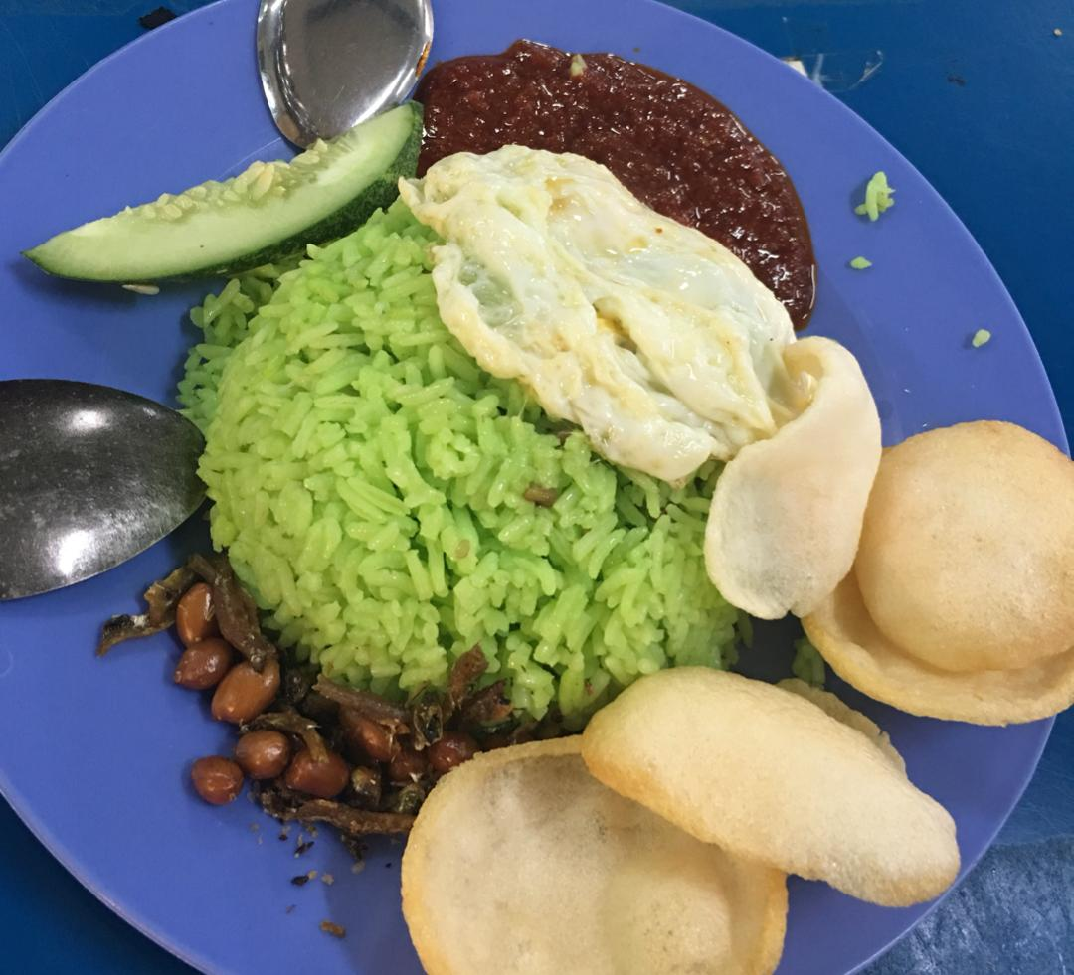
Picture 1: Nasi Lemak at Angkasa

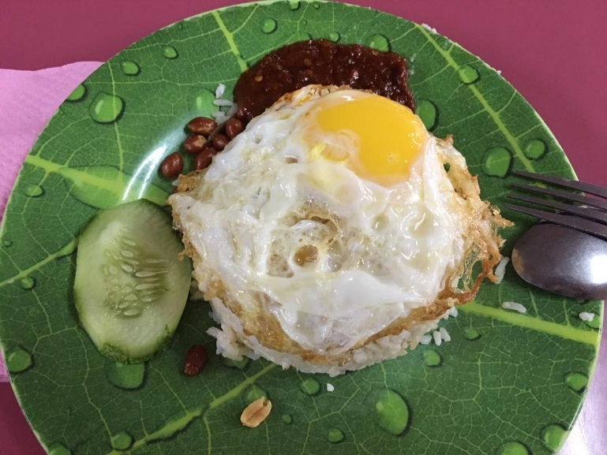
Picture 2: Nasi Lemak at Mak Ngah

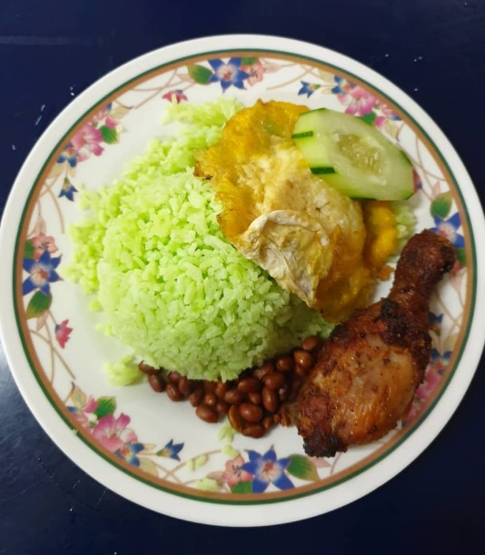
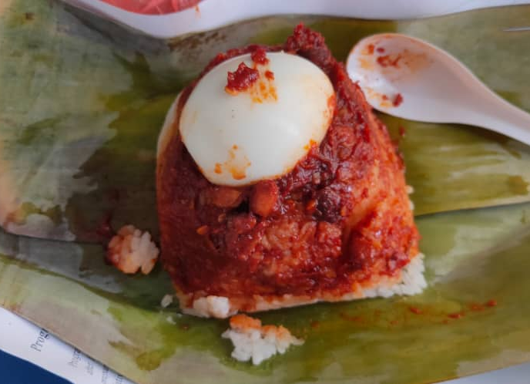

Picture 3: Nasi Lemak at Arked Cengal Picture 4: Nasi Lemak at Arked Cengal
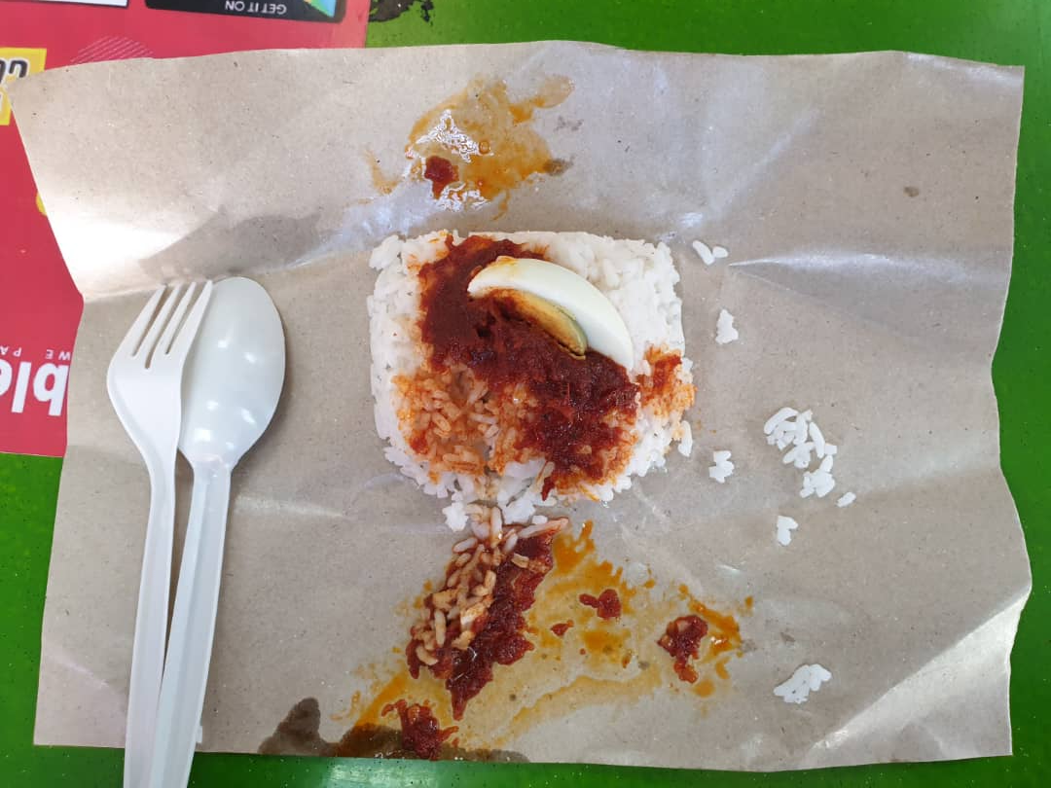
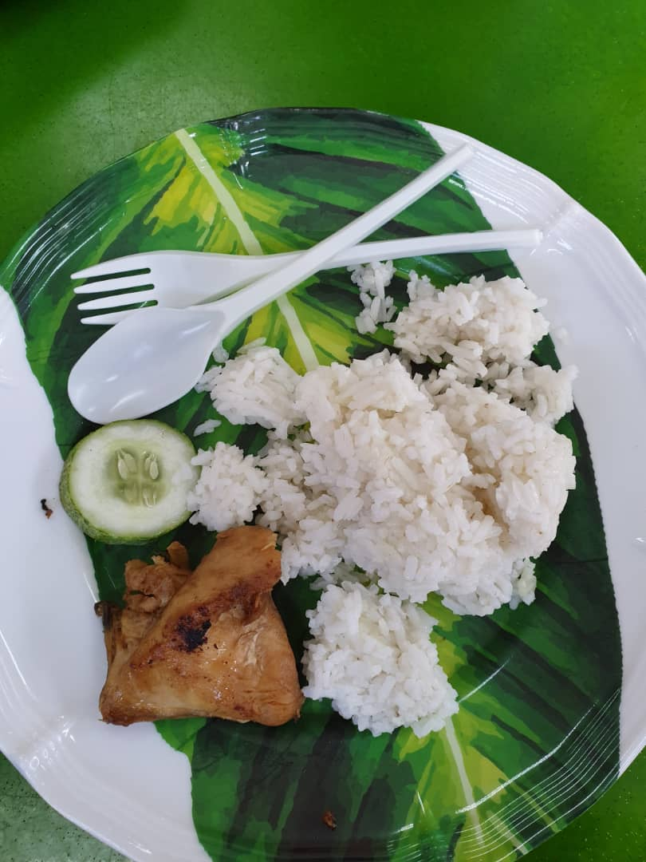
(without pandanus leaf) (with pandanus leaf)

Picture 5 : Nasi Lemak N24 Street Café Picture 6 : Nasi Lemak N24 Street Café
(without pandanus leaf) (at the corner of the canteen)
(without pandanus leaf)

Review:
Atifa
When lecture told us to do “Nasi Lemak Challenge” actually I little bit confused because in my mind what is the difference between all the nasi lemak around the Malaysia, I thought they would be the same.
Then, I tried one Nasi Lemak at Arked Cengal surprisingly its comes with green colour, to be honest that was my first time to saw “green” nasi lemak. After I received it from the seller, I tried to ate it I thought it will be a new experience for me, but don’t it still feels like regular Nasi Lemak. The green Nasi Lemak at the price of RM5 you’ll get peanut, some vegetables, fried egg, fried chicken but for me to be honest it taste almost tasteless its only has a really little bit sweet and savory and then rice texture its like grain rice but not dried.
Second Nasi Lemak that I ate is regular Nasi lemak at N24 street café, I think this nasi lemak is the best nasi lemak that I’ve ever taste, the rice has white colour and mushy texture which is I love any kind of rice with mushy texture, also it has sweet and savory flavor that is not overrated this nasi lemak is delicious with a cheap price which is only RM3 you’ll get delicious nasi lemak, a cucumber, and small fried chicken.
Another one is Nasi Lemak at N24 street café (at the corner one), for me it not delicious like the previous one that I review. This one is really small nasi lemak inside a brown paper, it only RM1 and you’ll get Nasi Lemak with boiled egg also bunch of ‘sambal’. I think this nasi lemak have taste like regular white rice because I really cant feel any taste inside the rice. Since I cant eat spicy food, I let my friend eat this nasi lemak and she said it will be good if you combine nasi lemak with the sambal because of sambal has strong taste then it will cover up this “tasteless” nasi lemak. At the end, I will say this is worthy if you only have RM2 in you pocket.
Arrive at my overview opinion, I would like to suggest everyone to eat Nasi Lemak at 24 street café beside the waffle stall but not in the stall at the corner. I love that kind of Nasi Lemak since it only cost RM3 and you’ll get one bunch of Nasi Lemak and a piece of Fried chicken and that is very worth it. This is my really honest review, they are not pay me to promote their Nasi Lemak.
Fathimah:
The only thing at Angkasa’s nasi lemak that I like is the anchovy sambal. The taste is just right, not too spicy at not too sweet and also not too salty. For the rice does not really has the coconut milk taste it is rather plain although I can smell the pandanus leaf fragrant. By eating the rice together with anchovy sambal make the rice tasted good by cause of the flavory sambal covers the plain taste of the rice. Other than that, everything just good as it is, crispy and tasty.
For nasi lemak at Cengal the taste of the rice was fine, not like nasi lemak at Angkasa, this time I can taste the coconut milk mixed with the rice. Surprisingly, for the anchovy sambal is a bit spicy and I like spicy food. For the rest which is fried anchovy, fried peanuts, boiled egg, and cucumber were fine.
Nasi lemak at N24 canteen is ordinary by meaning it is not good enough as the others. Although I can taste the coconut milk from the rice, the sambal is a bit salty and makes the taste not as good as I hope it would be. Also minus for every missing side dish ingredient, there is no anchovy and no fried peanuts too. The price is pretty cheap, it only cost RM 3 so it is worth it.
Mak Ngah’s nasi lemak was okay for me. The fact that they give half fried egg to me is a good thing for me. The rice and anchovy sambal are good even better than Cengal’s nasi lemak.
For a spicy food lover like me, Cengal’s nasi lemak is my favorite.
Ng Pei Wen:
The first nasi lemak I ate was the nasi lemak at Angkasa. The green rice they served had catch my attention as I have not seen green nasi lemak before. The sambal is the best part of the whole dish as it has a good smell and taste moreover it is also not too spicy. The bad experience part is the fried egg served contains egg shell where it is a bit terrible. The second nasi lemak I taste is nasi lemak at Cengal. The nasi lemak is just ordinary where the rice and boiled egg is normal but the sambal is too spicy for me that I cannot finished the nasi lemak. The third nasi lemak I taste is the nasi lemak at Mak Ngah canteen. The nasi lemak served there is quite good, it tasted better than nasi lemak in Cengal. The last nasi lemak I had tried is nasi lemak at N24 café. The nasi lemak there has a very good taste as the rice served is warm with the sambal, cucumber and also a piece of chicken. Although it looks simple without roasted peanut or fried egg but it has a unique taste.
The best nasi lemak for me is the nasi lemak sell at N24 café. This is because the rice served is warm and has a fragrant smell, the sambal served is quite nice where it is not too spicy for me. The most important thing is it is very cheap as it only cost RM3 for nasi lemak with a small chicken.
Result
We choose N24 café as the best canteen that provide nasi lemak among the other canteen that we pick. We agree that the prize and also the taste of nasi lemak that makes N24 café as the best canteen that sell nasi lemak inside UTM.
Conclusion
Each canteen inside UTM cooked nasi lemak in different ways and use different ingredients. And among all of the canteen that we tried, we choose N24 café as the best canteen that provide nasi lemak inside UTM for the taste and the cheapest prize just perfect for the college student. Even though every member in the team has difference likes in nasi lemak taste. For instance, some of us like spicy and some of us does not like it. We manage to choose one canteen that provides nasi lemak which is N24 café.

Reference
https://www.thestar.com.my/lifestyle/food/news/2014/11/19/nasi-lemak-once-a-farmers-meal-now-malaysias-favourite
http://www.enyabdullah.com/2017/12/tips-nasi-lemak-sedap.html

