
SEMESTER 1
SESSION 2019/2020

DISCRETE STRUCTURE
SECI 1013

TUTORIAL 4

NAME | MATRICS NUMBER
NUR IRDEENA BINTI CHE MOHAMAD | A19EC0130
NURUL ALIS ALIA BINTI MOHAMAD ZAMRI | A19EC0141
HAM JING YI | A19EC0048

LECTURER’S NAME: DR. NOORFA HASZLINNA BINTI
MUSTAFFA

SUBMISSION DATE: 22 DECEMBER 2019

TUTORIAL 4
FINITE AUTOMATA
DUE DATE: 19th DECEMBER 2019

- Construct a state transition diagram of a DFA that accepts all strings over {a, b, c} that begin with a, contain exactly two b's, and end with c.

- Construct a state transition diagram of a DFA that accepts the given set of strings over {0, 1}:
a) contain the substring 00 or 11.
b) begin AND end with 00.
c) begin OR end with 00.

- Construct a state transition diagram of a FSM that accepts the given set of strings over {a, b}:
- contain exactly two b’s.
- at least one b.
- odd number of a’s

- Suppose that a language, L, is a C programing language style comment such that L = { w | w is a C-style comment} with input alphabet, Σ={ a, b, c, …, z, * , / }. Examples of accepted and rejected strings are shown in Table 1:
Table 1
Accepted Strings | Rejected Strings
/*abcz*/ | /**
/**/ | /**/bca/*aaz*/
/***/ | aab/**/
/*abc*xyz*/ | /*/
/*a/b*/ | /ab*/
Design a DFA that accepts language, L.

- A description of an automatic telephone answering machine is shown in Table 2. When a call arrives, the phone rings. If the phone is not picked up, then on the third ring, the machine answers. It plays a pre-recorded greeting requesting that the caller leave a message, then records the caller’s message, and then automatically hangs up. If the phone is answered before the third ring, the machine does nothing. (

Table 2c)*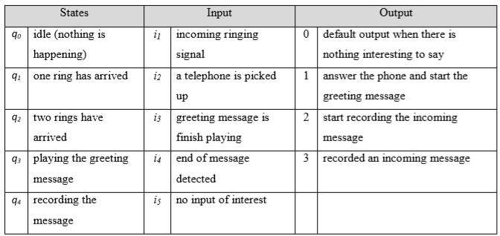

- Construct a state transition table by completing table below.

 | f_{s} |  |  |  |  | f_{o}
 | i₁ | i₂ | i₃ | i₄ | i₅ | i₁ | i₂ | i₃ | i₄ | i₅
q₀
q₁
q₂
q₃
q₄

- Based on answer in (a), construct a state transition diagram for the telephone answering machine.

