INDUSTRIAL EXHIBITION VISIT:
International Conference and Exposition on Inventions by Institutions of Higher Learning (PECIPTA) 2019

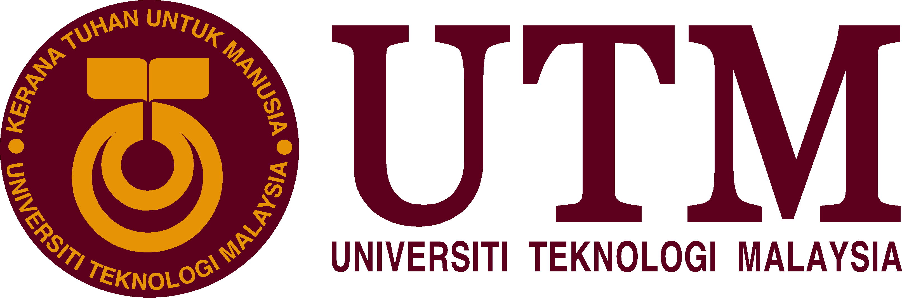

A NAHDA LA ROIBA A18CS3001
BRIAN TRACIA BAHAGIA A18CS3008
SHADMAN RAHMAN A18CS3032
WILLIAM LAU A18CS3039

SCSP1513 TECHNOLOGY AND INFORMATION SYSTEM-05
SCHOOL OF COMPUTING
FACULTY OF ENGINEERING
UNIVERSITI TEKNOLOGI MALAYSIA
EXECUTIVE SUMMARY

This report is made based on our visit to International Conference and Exposition on Inventions by Institutions of Higher Learning 2019 (PECIPTA’19) which we visited on Monday, September 23rd 2019 in Dewan Sultan Ibrahim, Universiti Tun Hissein Onn Malaysia (UTHM). This report contains a brief summary of the report, and introduction of the exhibition, the report itself, reflection, as well as task division among the members of the group.
PECIPTA’19 is a program organized by the Ministry of Higher Education, Malaysia to showcase innovative products. These products were segmented into 3 categories based on its readiness for commercialization. The innovations were also grouped into different cluster based on what fields they belong to.
Our visit to PECIPTA’19 is part of our compulsory industrial visits for our course Technology and Information System. During the visit, we were tasked with finding information about the exhibitions as well as the innovations that were exhibited and analysing the trends that are apparent in the exhibition. After the visit we were required to reflect upon our visit to PECIPTA’19 in terms of how it affects teaching and learning and then create a report and poster based on the information and data that we got from the visit and reflection.

INTRODUCTION
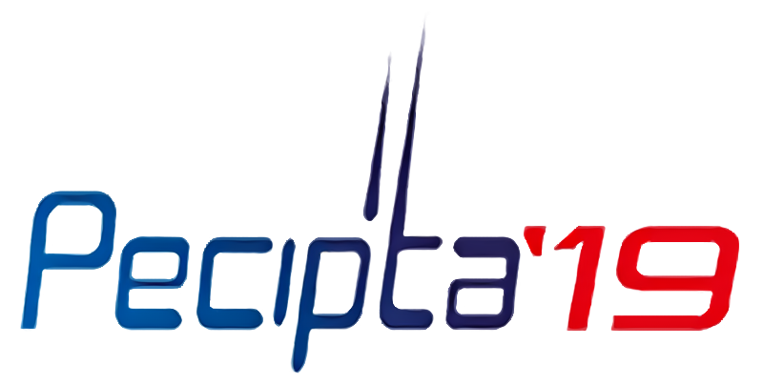

International Conference and Exposition on Inventions by Institutions of Higher Learning (PECIPTA) is a biannual program organised by the Ministry of Higher Education, Malaysia together with its partner institutions since 2001. PECIPTA aims to showcase innovative products and services from institutions of higher learning (IHL). (PECIPTA’19, n.d.). This year Universiti Tun Hussein Onn Malaysia (UTHM) was selected as the host of the event which was held in Dewan Sultan Ibrahim UTHM from 22nd to 23rd September 2019.
There are four categories of exhibition in PECIPTA’19 based on product feasibility: Fundamental, Innovation, Commercialization, and STEM Young Inventors. The Fundamental category covers researches that have yielded feasibility in their theories and have been validated through laboratory experimentations. The Innovation category focuses on products that are still under development to be commercially ready, while the Commercialization category focuses on products that are commercially ready. The last category, the STEM Young Inventors, acted as a platform for younger innovators from secondary schools to present their innovations on the fields of Science, Technology, Engineering, and Mathematics (STEM).
According to the website, the innovations are grouped into clusters depending on their field of specialization. There are 10 groups of innovation in total, namely: Environment & Renewable Energy (ERE), Agriculture & Aquaculture (AA), Industrial Design, Building Engineering & Architecture (IDBEE), Disaster Management (DM), Education, Community Development & Social Innovation (ECDSI), Health, Medical, Pharmaceutical, Food & Supplement (HMPFS), Digital Era, Data Analytics & Automation Revolution (DEDAAR), Manufacturing Technologies, Food Processing & Mechanization (MTFPM), Automobile, Aeronautical & Maritime Technology (AAMT), Tourism, Travel & Tours (TTT), Rural Innovation (RI).
The event also invited many VIPs Director General of Ministry of Education Malaysia (Higher Education), YBHG. Datin Paduka Ir. Dr. Siti Hamisah binri Tapsir, Minister of Energy, Science, Technology, Environment and Climate Change (MESTECC), YB Yeo Bee Yin, and Minister of Education Malaysia, YB Dr. Maszlee bin Malik among others.

REPORT

Our visit to PECIPTA’19 was done as part of our compulsory industrial visit programme in our section of the Technology and Information System course (SCSP1513-05). It was set to replace our initial industrial visit to the NALI Symposium Exhibition.
Since the event, PECIPTA’19, was held outside the UTM campus, we went to the venue (Dewan Sultan Ibrahim UTHM) using a bus that had previously been reserved by our lecturer, Dr. Adila Firdaus binti Arbain. On Monday, September 23rd 2019, we departed at around 1 PM from the C.I.C.T. bus stop near N24. It took us circa an hour and a half to go from UTM to UTHM and we arrived at around 2.30 PM.
Once we had arrived, Dr. Adila briefed us once more about what we are supposed to do in the exhibition and that we had to come back to the drop off place before 5 PM. After that we went straight to the venue in which the exhibition was held.
We found out that the closing ceremony and awarding was being held as we browsed through different innovation exhibits. Seeing that we only have little time and that the place was teeming with agriculture and botanical innovation that had very little to do with us, Computer Science students, we split to scour the exhibitions in search of a booth that exhibited innovations in the field of Computer Science, or at least something that is not agricultural, and then to regroup at 4 PM at our designated rendezvous point.
The event was almost over and many booths had been left empty as the tenant made their way back home. We were left with few options to choose from. At the end of the day, we only get to interview two innovators about their products. The first product is iSparks, an outdoor smart parking system, and the second one is Climbark, a multipurpose tree climbing robot.
The first product, iSparks, was designed by innovators from Faculty of Engineering of Multimedia University. The system detects parking vacancy status as well as illegal parking in real time. Its purpose is to provide better parking experience and prevent illegal parking. It utilizes an IP Camera that provides real time video feeds an AI processing unit which will detect a vacant parking spot or an illegal parking. There are two types of AI processing unit that can be paired with the IP Camera, a local unit or a remote unit. The local unit utilizes physical connection, such as Ethernet cable, to connect with the IP Camera. On the other hand, the remote unit utilizes Wi-Fi to get live feeds form the IP Camera. The AI-processed information will be then displayed on a companion app. There are two apps of different functions available. A driver app is designed to relay information about available parking spots to drivers who intend to park their cars. An enforcer app is available to help law enforcers to combat illegal parking that has always been a source of complaints.
The second product is Climbark which is designed by a team from Faculty of Mechanical Engineering Universiti Malaysia Pahang. Although the device has little to do with Computer Science, it still attracts our attention due to it being an engineering product and us being students belonging to the Faculty of Engineering. Climbark’s true purpose is to help with the process of agarwood inoculation which is essential in the production of gaharu aromatic resin. In the past people need to wait for the tree to naturally produce the resin. It takes years for the resin to form without human intervention, since agarwood or gaharu tree will only form resin due natural reaction to nature such as trees struck by lightning, animal & insect attacks, forest fire, wind or storm damage and tree invaded by fungus. (Formation of Gaharu Aromatic Resin. Retrieved from http://www.tanali.my/Gaharu-Inoculation.html). Starting from the 19th century, people found a way to produce resin at a higher rate by purposefully damaging the physical structure of the tree using nails, hammers, drills, and even fire. But doing so is full of risk to the worker and this method yields lower quality resin. Climbark is equipped with a drill and can be operated remotely, thus enabling remote inoculation process via drilling without putting any human resource at risk.
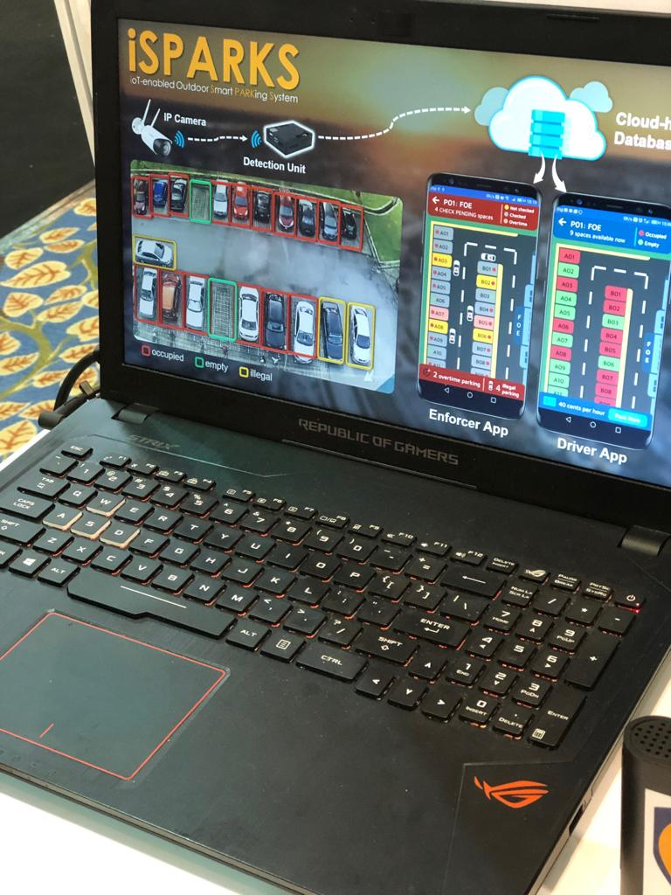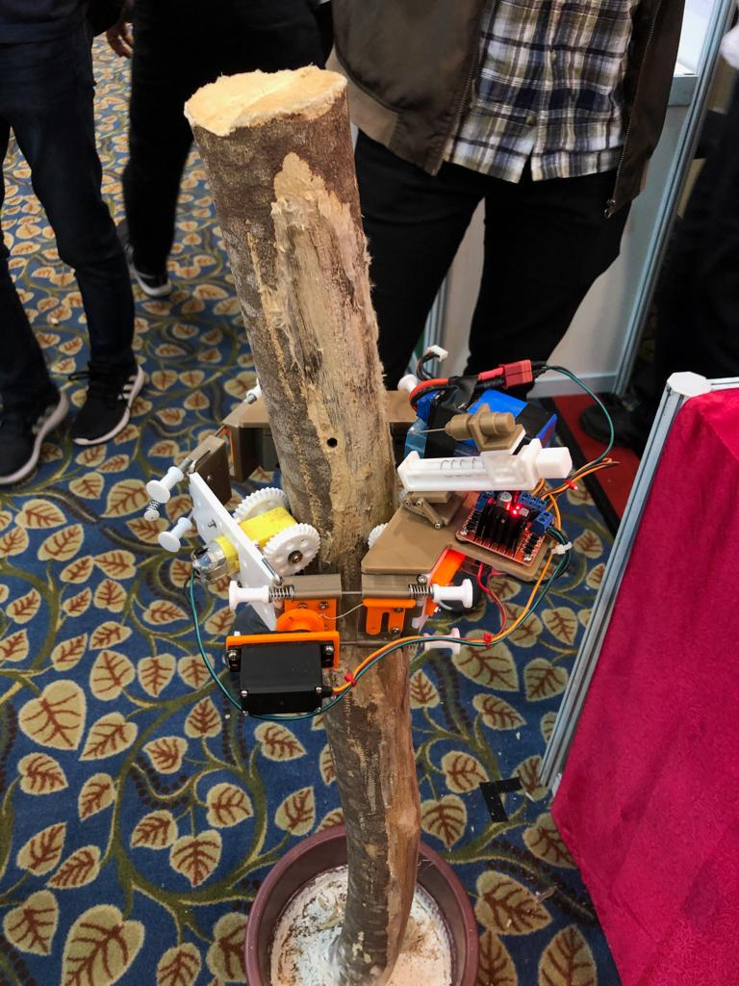

REFLECTION

Visiting innovation exhibitions such as PECIPTA’19 is an experience to which every scientists, researchers, and engineers should look forward. It shows us what kind of advancement the technological world has made and how far have we progressed. It can also be a platform for sharing and exchanging ideas. And by looking at the trends in the exhibition, we can get a glimpse of what problem the world is currently facing or find a certain field in which to innovate. For us, these innovations provide us with the ground upon which we can build an idea as well as perspective from which we can learn.

TASK DIVISION

We divide the task in our group based on the result from our visit. Brian and Shadman found the two innovations that are reported in this report, so they are tasked with relaying the information that they got from the booth into the report. While also taking part during the visit, Nahda couldn’t find any products or information leading him to be responsible for compiling the information provided by Shadman and Brian into the report. William couldn’t make the visit due to having prior arrangements before the announcement of the visit and is also in charge of compiling the report as well as creating the poster.

APPENDIX
