GROUP REPORT ON INDUSTRIAL VISIT TO CICT

An industrial visit to CICT of University tenchnology Malaysia ,Johor Bahru campus was organized by the computer science faculty lecturers. We were divided into several groups ; each group consisting of three to five students. Due to unavoidable circumstances visit to the CICT was not unfortunately successful, but our lecturers came out with an alternative plan to make us visit Perpustakaan Sultanah Zanariah (PSZ) also knows as Central library. PSZ holds a lot of information and technology related devices whichd did serve us the same way that CICT could do. We were supposed to set ourselves for the visit by 3:30pm.As a result I already went to the library by 3:00 pm and waited for rest of my friends.
By 4:00 we gathered at the foyer and waited for the lecturer to guide us all together inside. Sooner or later we went in with the lecturer and started our industrial visit.
We followed the lecturer to the first floor of the library where there was this more or less was a sort of small tech museum. Basically it had a lot of technical devices that dates back to late 1900s.

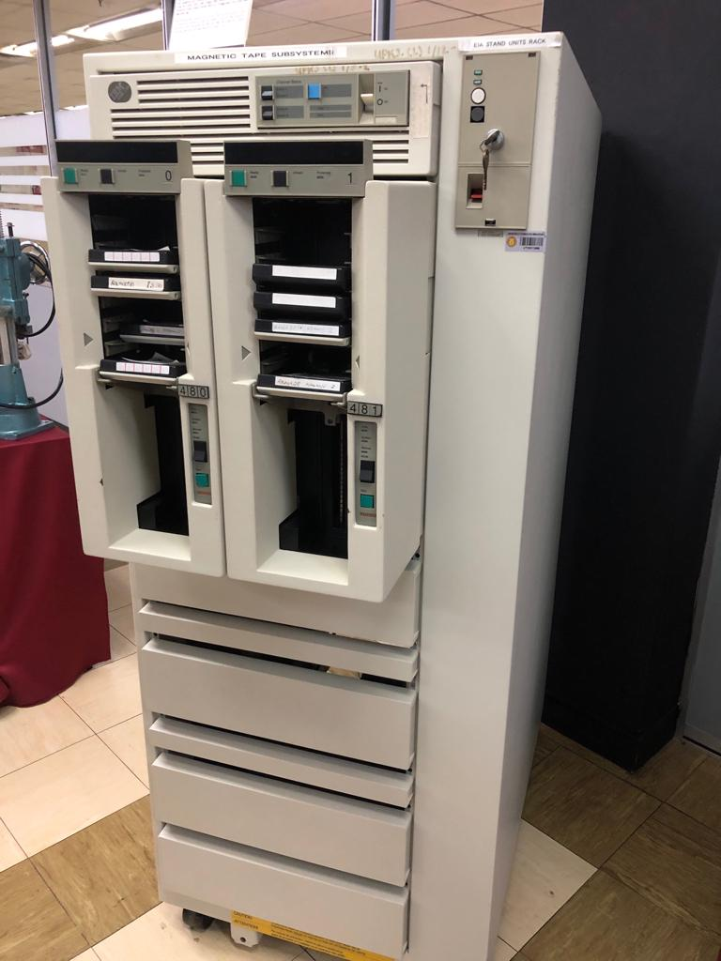 FIG 1: The magnetic tape subsystem.
Figure 1 shows a magnetic tape subsystem. This device was first introduced in 1984 and replaced the large magnetic reel tapes that is known have size of about 10.5 inch. This device was basically was used in cimputer systems.It accepts and trasnport a reel of tape from library to a machine reel to generate information. Nowadays the magnetic tape drive has taken an alternative option to the magnetic tape subsytem. Magnetic tape drive stores information on its tape digitally.

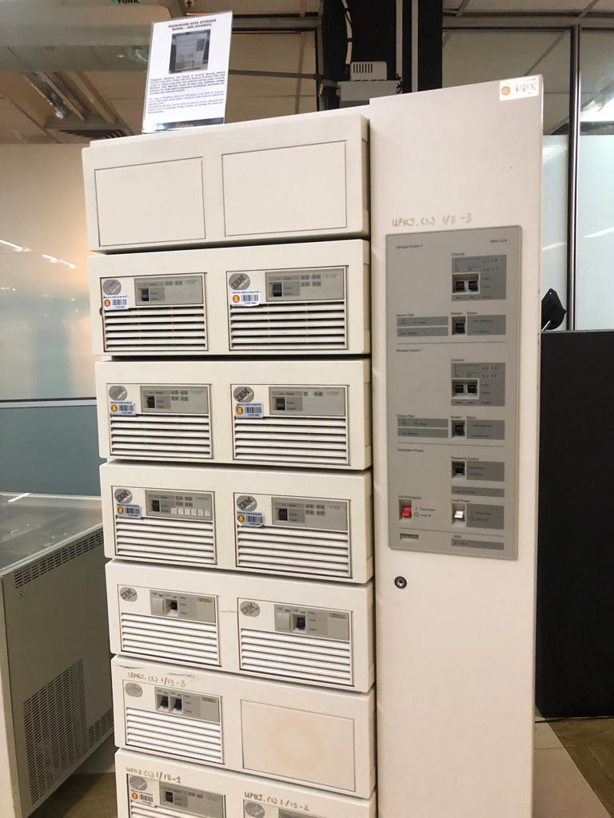
FIG 2 : The mainframe data storage.

Fig 2 shows a Mainframe Data Storage. This device was introduced by IBM in 1970. This is the IBM 9345B22 which was basically used by large organization for critical application , large data processing such as census, consummer statistics and industry. For the 20th century people are now using the hardrive or solid state drive as an alternative to mainframe data storage system that almost occupied a room.These hardrives can store upto 1 terabytes of data and would weigh only around a few kilograms.

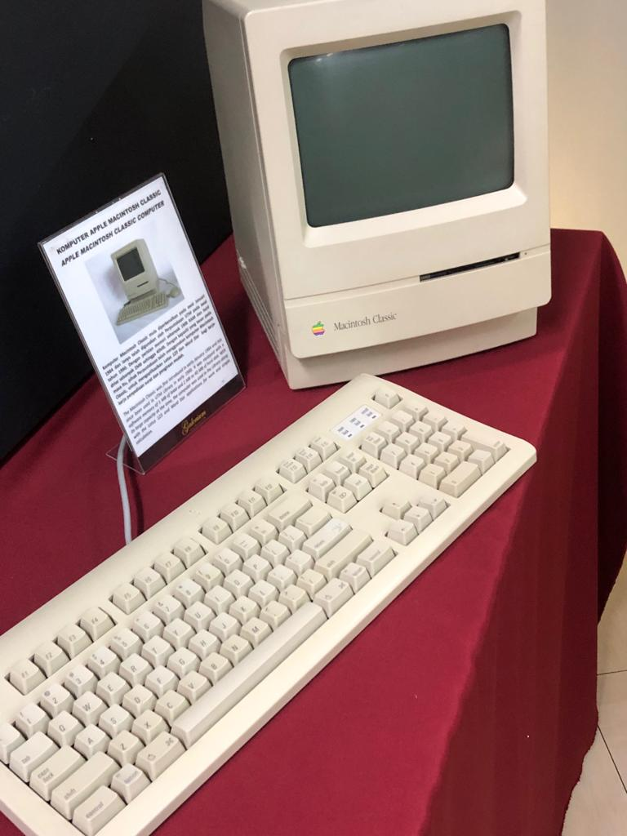
FIG 3: The Macintosh classic.
Fig 3 shows a Macintosh classic which was origanally created by Apple .Inc and sold as a personal computer during the 90s. These computers would cost around USD1000.It features an 8Mhz 68000 proccessor, 2Mb of RAM, and a 1.44Mb of disk drive. The MacBook pro 2019 series now offers a 2.4Ghz intel core i9 proccessor, 32GB of 24000 Mhz DDR4 RAM
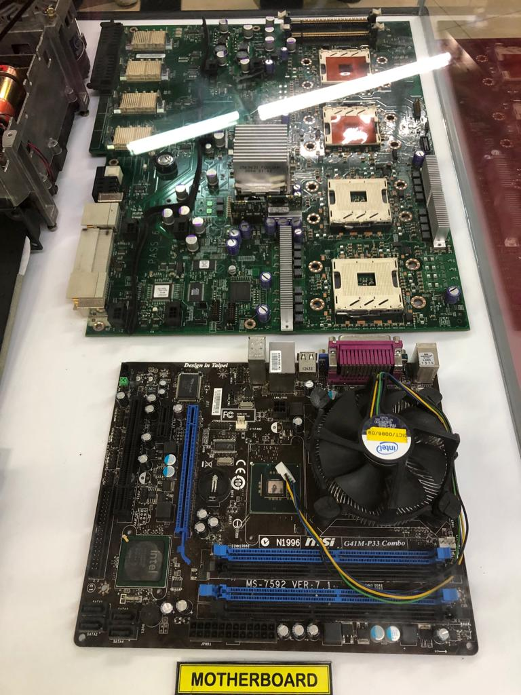
FIG 4: Msi g44-p33 Combo
Figure 4 shows an Msi G41-p33 combo which is basically a motherboard designed for use with Micro ATX systems.It features the LGA775 socket proccessor, the mainboard works with CPUs such as Pentium, Celeron. It supports upto 8Gb DDR2,DDR3 memory type.
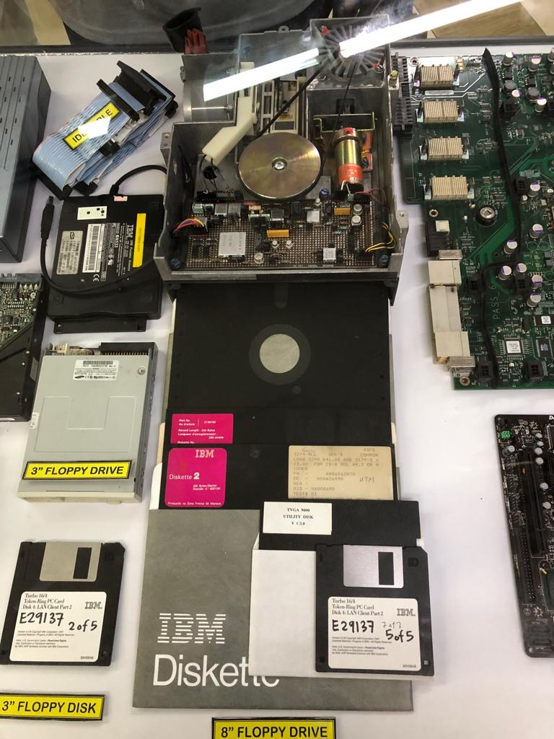
FIG 5: Floppy disks
Fig 5 shows a couple of different floppy disks such as a 3inch disk , an 8inch IBM Diskette.In 1971 IBM started to produce computer systems using magnetic storage device.They were basically used for either to read and write informtion to floppy disk drive or drive on IBM compatible device. Floppy disks were uiniversal data format from the late 1970s into the1990s, used at first as a primary data storage mechanism and later mostly as a file transfer system.Now for file transferring we most commonly use pendrive that can store upto minimun 4gb of data; or we can share our file online using whatsapp,email,shareit or through bluetooth as well.

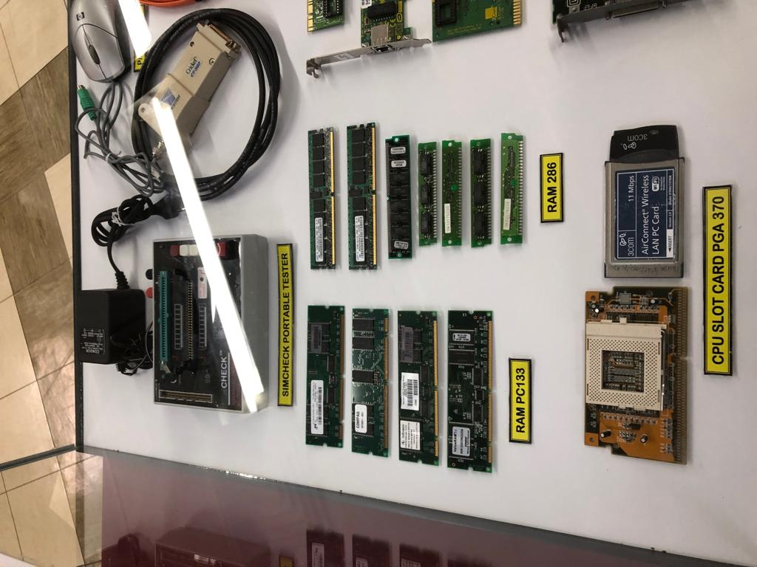
FIG 6 : CPU card PGA 370
Figure 6 shows a cpu slot card PGA 370.It is a cpu socket first used by intel or pentium 3 and celeron processors.The “370” refers to the number of pins. The dimension of the processors is 1.95X1.95 inches.It has an FSB frequency of about 66,100 and 133Mhz.

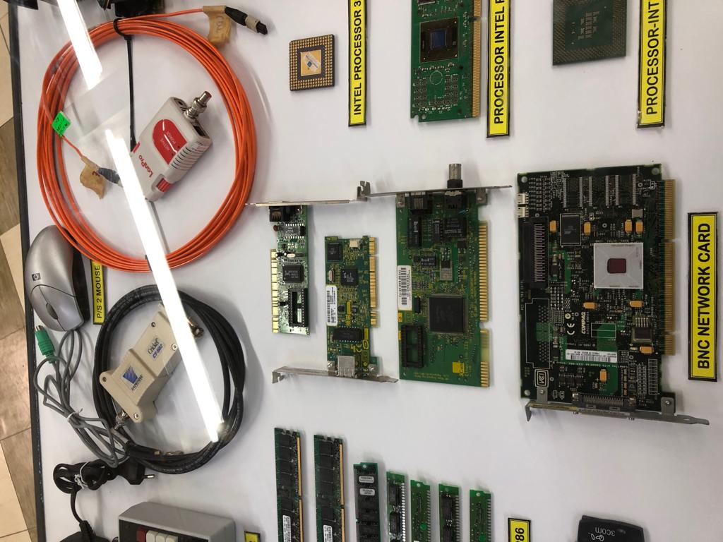
FIG 7 :BNC networkcard
BNC network connector is a miniature quick connect or disconnect radio frequency connector used for coaxial cable . It is used with miniature to sub-miniature coaxial cable in radio,television,and other radio frequency electronic equipment.The BNC was commonly used for early computer networks during the early 1900s.Nowadays computer systems use ethernet cable, wifi and many other systems to connect to the network.

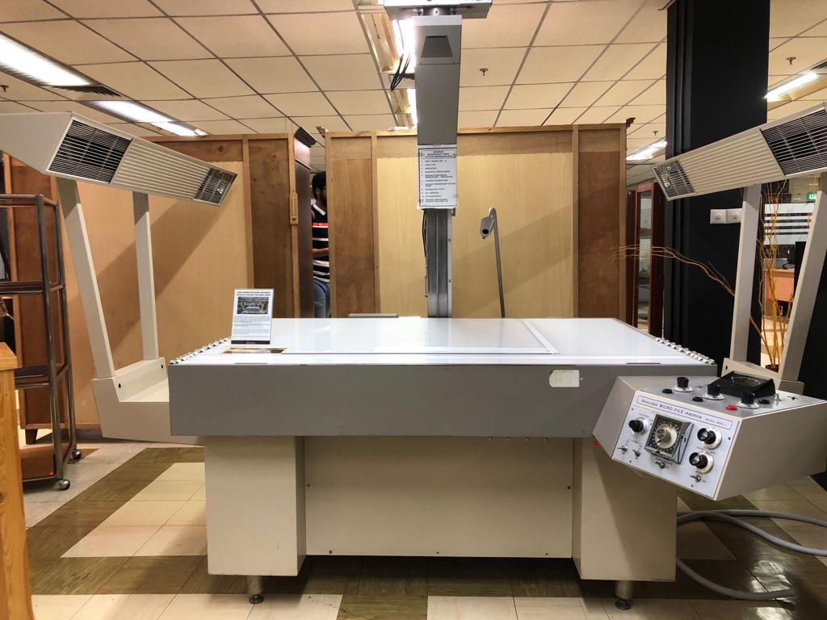
FIG 8: Recordak Micro File machine.
Figure 8 shows the Recordak Micro File machine.It allows copying of 15 or more documents.Quality multiple copies can be made of any document.This system was most likely introduced by the Eastman Kodak company in 1928.

Requirements and spcecification for a career in IT

- As a fresher having a basic knowledge on programming is a must.
- One should have the caliber to make proper and sufficient communication within his or her group members.

- You should know how to use Git. Git is a distributed version control system for tracking changes in source code during software development. Knowing how to operate this is a must because it is designed for coordinating work among programmers.

- Employee should always have a practice of learning new technologies since IT is evolving itself every now and then. Consumers come with new technical problems and engineers have to always come up with something new as well.

- For programmers who are fresher they should have a high caliber for programming on C++ .

ORGANIZATION STRUCTURE OF CICT
What is an organization structure? An organization structure defines how all the tasks of an organization are divided among each and every member of the organization. Such as task allocation, supervision. Organizational structure affects organizational action. It provides the platform on which every procedures of actions are taking place.
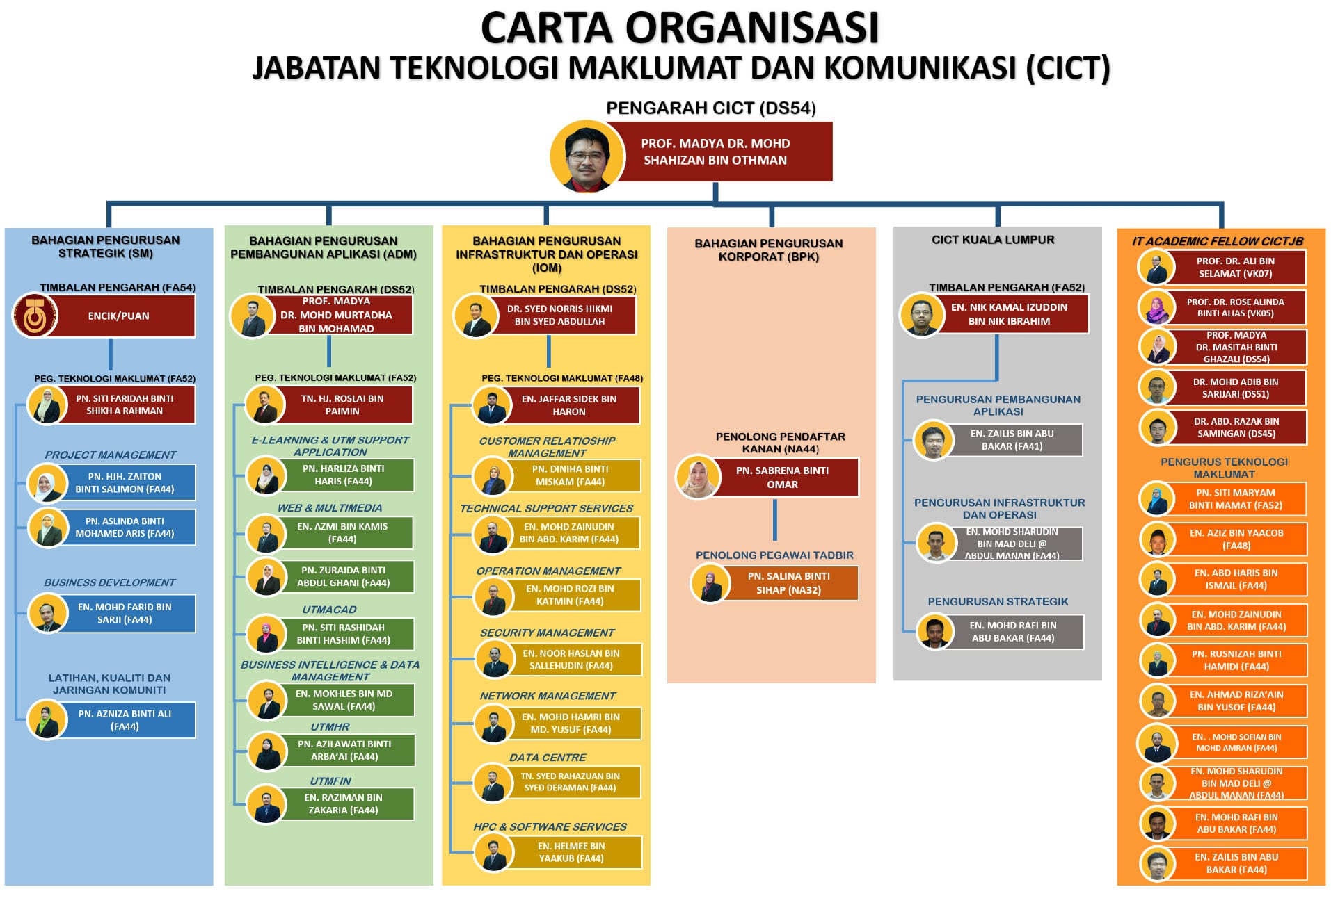
FIG 9:Organizational structure for CICT.

SERVICES PROVIDED BY CICT

CICT provides four different types of services to the UTM staffs and students.
Infrastructure and security
This part of the service consist of ID account and access, E-mail, UTM hosting, UTM Ads and much more. For instance UTM provides wifi hotspot system all over the campus and they have some key features regarding this. Such as :
- Unified Login Portal
- Using ACID account for Login
- Guest account available upon request.

APPLICATION DEVELOPMEMT

Application development consists of system development, web development, mobile apps and more. Here they build and manage the Multimedia, Administration, Learning applications to improve the learning methods of students.

ACHIEVEMENTS

UTM is among 59 of 416 agencies that have successfully received the SAGA compliance certificate. CICT team have won this certificate in 2017.
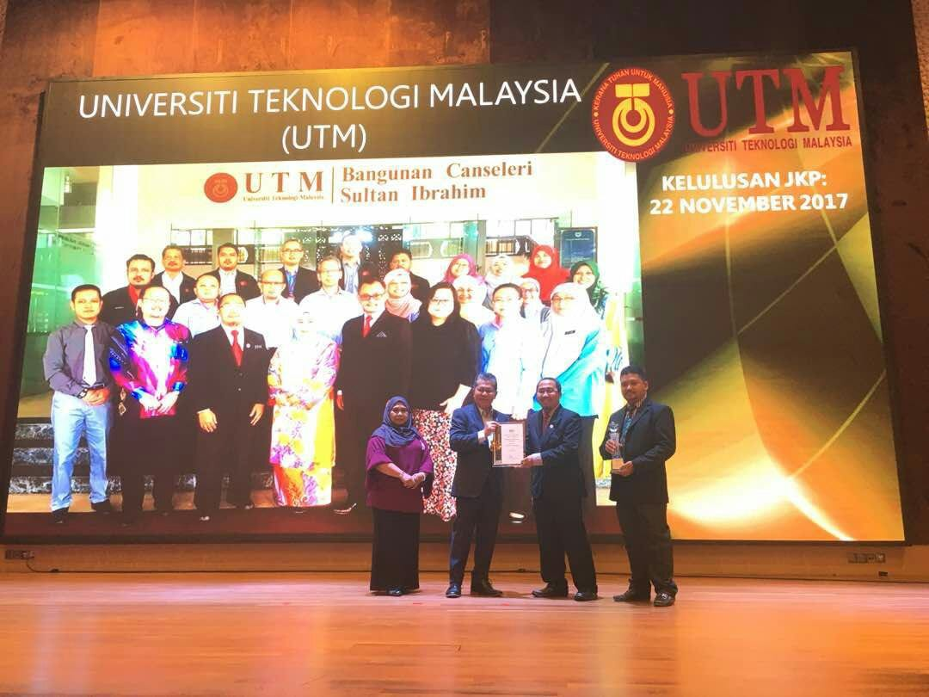
FIG 9 : CICT team won the SAGA compliance in 2017.

INFORMATION SYSTEM

What is information system? Information system is formal organizational system designed to collect, process, store and distribute information. Such as CICT stores email address and password for every student who has an account on E-learning. Besides that CICT keep records of our course progression such as how many semesters we have completed or what is our CGPA.

REFLECTION ON OUR GOAL

Since we are computer science students we have a lot of dream on becoming a very skillful software engineer. But most importantly we just don’t dream about being a software engineer, we dream about how do we become a software engineer in order to develop this world and create a better place to live here. In a nutshell, we want this world to be a better place to every day and we believe we shall have the caliber of achieving our goal from a software engineer perspective. For instance , we want to improve the life style of people on roads. How can we do this? Well we have heard about Airplane mode. We want to make a better mobile application that can be called the driving mode. Here we want to install such systems which can assure a safety trip for users when they are driving.

THE IMPACT ON GOAL FROM RECENT INDUSTRIAL VISIT

The recent industrial visit had a lot of impact on our goal. It just showed us having a constant dedication and with consistency we definitely can achieve our goal of becoming a true software engineer. Suppose we have seen how big the photocopy machines are and apparently taking the size of a room. Whereas now a photocopy machine is just as small as the size of a table. Interestingly we do not need a photocopy machine nowadays when me send photos and files online through email, whatsapp, Shareit and much more. This shows us how technology is advancing at an unstoppable rate. This teaches us if we stick to our goal together as team we can achieve whatever we dream to.

WAYS TO IMPROVE THE POTENTIAL IN THE INDUSTRY

Since we are computer science students we have a lot to do in order to sufficiently increase our potential in the IT industry.
Some of the ways we can improve ourselves are :
- First and foremost is to read and learn. We have to read a lot of reference book on engineering.
- Start building side projects. This gives us a clear visualization of where the market is going and how to cope up with it. Besides that it definitely boost our confidence on coding and improve our skill at the same time.
- Start building personal projects. Once we are confident enough to work as a professional we should start our work firstly by working with some clients. We should search online about software projects, communicate with the clients and work for a few of them with their project.

- At the end of our day we should never forget to discuss and share our concepts on the field with our course mates and friends. This will allow us to have a wider spectrum of thoughts on engineering and give us a lot of experience on the field at the same time

TASK FOR EACH MEMBER

Shadman has sorted out the organizational structure by CICT and the introduction part of the industrial visit.
Nahda sorted out about information system of CICT and contributed into introductory portion as well.
William has gathered information about achievements of CICT
Brian gathered information about services provided by the CICT.
Finally we all contributed together collaboratively about our reflections on the visit to CICT and how does this has a positive impact to successfully achieve our goal as a career in IT department and how do we establish ourselves as an improved and experienced engineer.

PARTICIPANTS :
- Shadman Rahman(A18CS3032)
- Brian Tracia Bahagia (A18CS3008)
- William Lau (A18CS3039)
- A Nahda La Roiba (A18CS3001)

