
TECHNOLOGY AND INFORMATION SYSTEM
SEMESTER I 2019/2020
SECP1513-01
DESIGN THINKING REPORT GROUP 1 APPLICATION SOFTWARE
NAME OF STUDENTS | MATRIC NO.
TAN LI MIN | A19EC0169
MUHAMMAD NAJIB FIQRI BIN SULAIMAN | A19EC0103
NURUL EZZATI BINTI HARUDIN | A19EC0142
MA SIRUI | X19EC0024
TASNIA HOQUE NIDHI | A18CS9010

LECTURER : DR. ZURAINI BINTI ALI SHAH
SUBMISSION DATE : 13th OCTOBER 2019

- Introduction
Application software is an operating system that is designed to be less stressful than traditional software to be used by the computer’s operator. It is also can be defined as a software that perform a single or more specific task. There are four types of application software; general purposes, custom written, integrated and specialized. In information technology, an application program or software application can manipulate text, numbers, audio, graphics and a combination of these elements depends on the programming tools and the activity it was designed.

Software that can be installed is called installed software and there is also Web-based software. For installed software, it needs to be installed on the computer first before it can run. Meanwhile, Web-based software is delivered on-demand via the Web. The good thing about Web-based software is that files can be accessed from any computer if you have an internet connection. The implementation is also easy and the collaboration capabilities can always be improved. In contrast, online application tends to run more slowly compared to installed software and the cost may eventually exceed the cost of purchasing a similar installed version of the software.

People use application software according to their needs. Application software may consist of a collection of programs that is called as a software package and a single program. Software package are used by most businesses or individuals to produce documents and typically included Word processing software, Spreadsheet software, Database software, Presentation graphics software and additional productivity tools like calendars, messaging programs, or collaboration tools. A common interface is provided among programs in the package.

At University Technology Malaysia (UTM), the authorities already provided the students with free buses rides so that the students can go from one place to another place easier. We found that although the application software, UTM Fleet is provided, but the system of the application is not stable enough to make sure students can track the bus, and it is very hard to understand and use the application. We as students find that it is very helpful that we can ride the bus to anywhere inside the UTM, but we always very anxious about the time of arrival of the buses. After interviewing some people about their opinion on the UTM buses, we decided to do an application where the user can track the UTM buses easily just by downloading our app. This app is a single program where people can track the buses, see the schedule of the buses and estimate the arrival of the buses.

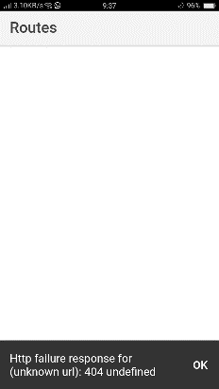

Figure1 : The unstable of UTM Fleet

Stages of Software Development Cycle :

The development of software is a complex process. All the stages in software development are crucial in order to provide a high quality services in the development of all sort of application software.

- Detail Steps and Descriptions
We had took notes about our process and steps in table form. The details of our steps and description can be seen in the table below:
Date and Time | Descriptions
23 September 2019  (Monday) | ▶ Assignment design thinking was briefed by Dr.Zuraini and group members were arranged by Diviya.  ▶ First group meeting after class to discuss about the assignment
30 September 2019  (Monday) | ▶ Second group meeting to decide our idea of application software and the applicable users.  ▶ Discussed the functions of the application.
4 October 2019  (Friday) | ▶ Interview random college students at the bus stop to find out their problems when waiting fo bus.  ▶ Do some improvements on our idea based on their problems.  ▶ Designed the interface of our application software and our prototype.
7 October 2019  (Monday) | ▶Prototype done.  ▶Group meeting to work on our report.
12 October 2019  ( Saturday) | ▶ Group meeting to finalize our report and check if any mistake on our report.  ▶ Report done and ready to be submitted.

3.0 Detail Descriptions: Problem, Solution and Team Working
3.1 Problem:
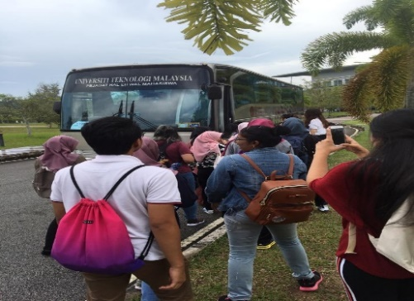
Most students in UTM, especially the ones who's using the public transport such as utm bus, they always tend to miss their buses and take a long time to wait for the buses to pick them up. This problem occured because sometimes bus do not arrive at the right timing same as the schedule showed.
Figure2 : Students taking their bus to their faculties.

3.2 Solution
So, after a couple of discussions and brainstorming ideas among me and my teammates, we had decided to create and introduce this application, "bus tracker" which can help the students to detect the location of the bus lively. Instead of spending their time and energy to wait for an unknown bus, the application can help them to track the buses, hence they can be ready and prepared when the bus their wanted is coming to the nearest bus stop. We named this application as MyBusUTM.
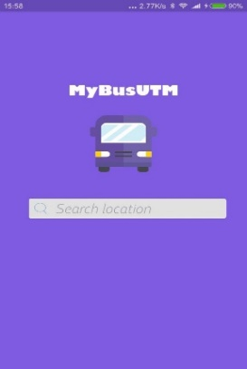
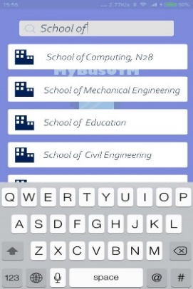
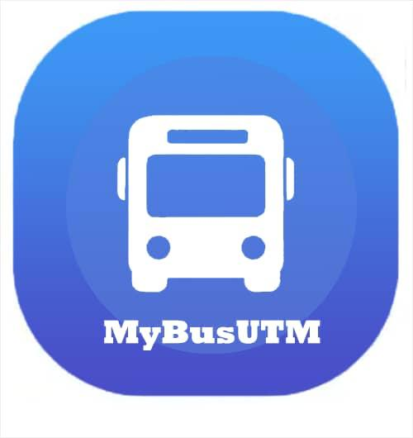

Figure3 : The logo of MyBusUTM Figure4 : The interface of MyBusUTM

3.1 Team Working
We divided our group task into several parts, which is prototype making, interviewing, video recording and video editing. We were having meeting 5 times throughout the process of the assignment in order to ensure our project assessment can be finished with a successful result. Each of the tasks were divided among the members according to what they're expertise in. We were having fun when we work together and all of us gave the full commitment throughout the process of our group project.

4.0 Assessment Point
a) THE PROJECT DEMONSTRATION:
The word application software is an end user software which is accomplished by various of tasks. Students in UTM always suffering from waiting buses to go from a place to another place since our university has a large area. So that, 5 of us decided to create this application to help the students in UTM. We gave the name of the bus tracker app as MY BUS UTM. We had made 5 meetings and took time for brainstorming of how are we going to make our application more suitable and easy to use. Therefore we tried to design this app according to demands of users, this application software is very user friendly and can be used with a little data usage. Despite UTM provides bus, they mostly doesn’t come on exact time, that’s why this bus tracking would be a great solution for the students who waiting for bus.

b) The transition between design thinking phases:
From our very first meeting we were so tensed about what kind of application software to make to help the students as students tends to sit in the bus stop for 30 to 40 minutes for the bus.
We took some interviews from bus stop to find out what are the problems they suffered, so that we can make an improvement on our application. It took a day to collect information from centre point bus stop to KTDI bus stop. Then again we started our journey from cluster road.
In this way we made our transition of 1 week to make our application more user friendly and efficient app to solve their problems

5.0 Design Thinking Evidence
a.) The sample work by students working to solve the design challenge
We had go through the steps of design thinking which are are empathise, define, ideate, prototype and test to solve our challenges. In the first meeting, we do not even know what to do, but after we interview some of our friends, we found their problems and this is how our application software bornt.
b.) Record for Each Phase
i.) Empathy: The possible question and answer for user, and the composite character.
We do some interviews to collect information and their problems based on our topic. We had interviewed some of the UTM students and asked about their problems when choosing bus as transportation.

Q: What is the main function of this application?
A: This application is to help the students in UTM to identify the locations of the buses.

Q: From where do this idea come from?
A: The idea of this application were found out by looking at the Grab applications, which in Grab, you can identify when and where the Grab drivers are now.

Q: Who needs to download this application?
A: The person who needs to download this application are the bus driver and the students who'll used the bus service.

Q:What is the difference between MyBus UTM and Grab applications?
A: MyBusUTM applications are more to identify the location of the buses in UTM only. The user or students function it same as book a Grab because this app just to track the bus in UTM.

Q: What are the advantages of this application?
A: Firstly, this application is free for the UTM students, hence everyone can afford it. Moreover, students can manage their time wisely to do something else since they can track the buses without wasting time to wait for it.

5.2 Define
First of all, we had concluded the problems that we got from our interviews. The problems are stated below:
- UTM Fleet is unstable to be used, so that the user cannot track their buses.
- Sometimes bus cannot arrive in the promised time as the schedule that cause students to wait for a long time.

5.3 Ideate
After that, we tried to figure out how to help the students that facing with problems. We had some meeting and brainstorming together to get the best solution. Based on their problem, we finally came out with our application that can help them to track the buses. We plan to use GPS on our application to track the buses, so that the users can be prepared.

5.4 Prototype
In this stage, we design an application that can help the students to save their time on waiting for bus. The interface and function of our application are as below:
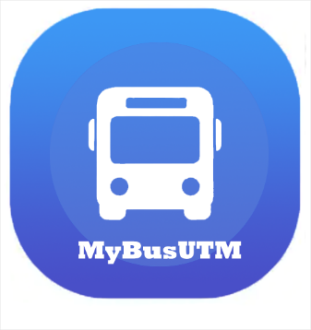 | This is the logo of our application software that will appear on their phone if they download our application.
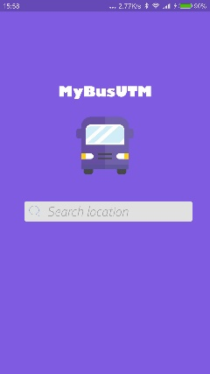 | This is the page that can search the destination of the users. After they click on the logo, this page will be seen.
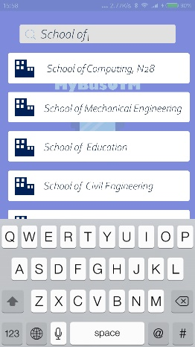 | This is the interface when the user search for their destination.
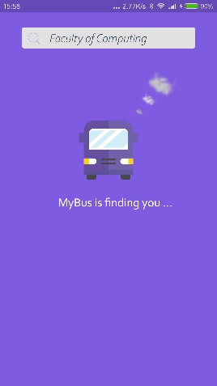 | Our application will try to find the user’s location and give him/her location of the most suitable bus.
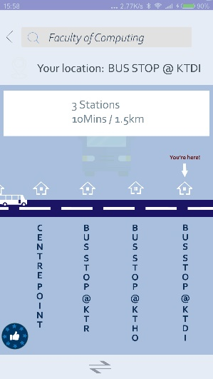 | This is the interface that the application show the user the location of bus.
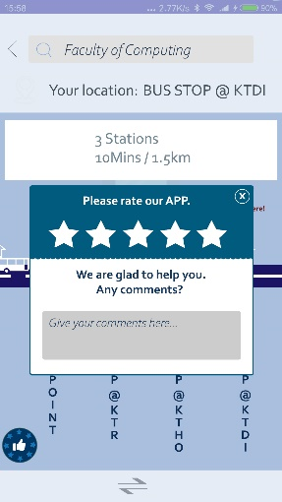 | This is the page that the user can give any comment for this application so that we can make an improvement to make the application better.

5.5 Test
When we finish our prototype, we make a test to check whether any improvement is needed, so that we can make sure our user can use the application conveniently and count on our application when they want to take the bus. We found some random students to ask for some comment for our prototype, therefore we can do it in a better way.

- Reflection

- What is your goal/dream with regard to your course/program?
As for our program, we hope that we help students in UTM to take the bus, without waiting too long at the bus stop and worrying about missing the bus. We would like to let our application’s users to know the approximate position of the buses on each route at the current time and they can be prepared if the buses will be delayed due to traffic jam. We also hope that our application can help them to take their buses at the right place and appropriate time. We hope that we can help them to safe their time, improves life efficiency and happiness.

- How does this design thinking impact on your goal/dream with regard to your program?
The design thinking process help us to complete our design and idea systematically as it has five stages which are empathise, define , ideate, prototype and test. When we follow the steps to create our product, we found that the process is smooth and we would not mess up everything.

- What is the action/improvement/plan necessary for you to improve your potential in the industry?
To increase the potential, we need to make more detailed improvements such as the road conditions from station to station in our application. For example, We can use colour such as red, yellow and green to indicate the situation of the bus, whether the bus will be late or not. In this way, the user's will be prepared if any late of bus so as to reduce their anxiety.

- Task for Each Members
The tasks for each members is shown in the figure below:
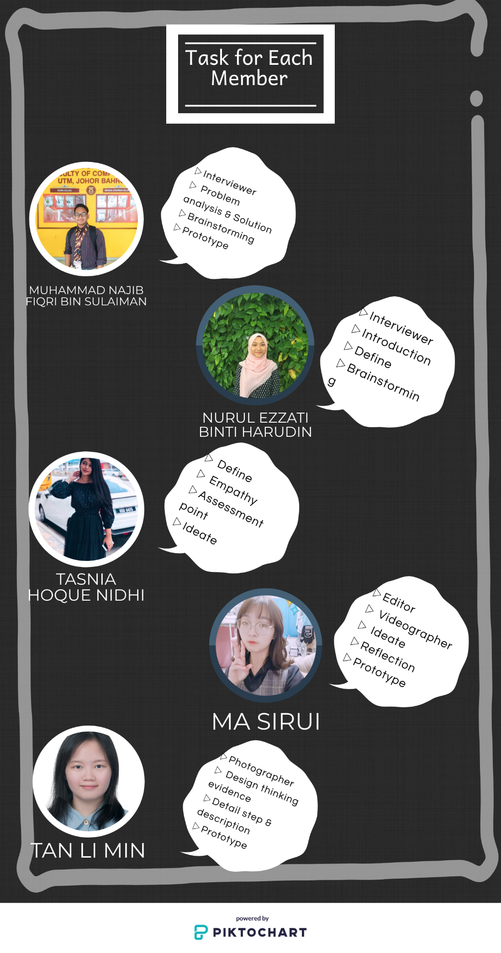

- Reference
- Sami, Mohamed. (2018, July 2). 3 types of application software you should know. Retrieved October 10 2019 from melsatarblog : https://melsatar.blog/2018/07/02/3-types-of-application-software-you-should-know/
- Teo Yu Siang and Interaction Design Foundation. Design thinking: https://www.interaction-design.org/literature/topics/design-thinking

Link of our video: https://www.youtube.com/watch?v=q4Pzl9WPDDI

