Amelioration of technology with data engineers
On 11th of September 2019, the data engineering undergraduates of UTM participated in the Industrial exhibition held in Kuala Lumpur Convention Center.The AI and Data Week 2019 was organized by Malaysian Digital Economy Corporation Private Limited (MDEC) and the parent of MDEC would be Minister of Finance Incoporated.Only the undergraduates from College Tun Doctor Ismail and the faculty of engineering joined this exhibition.Around 38 people joined this exhibition which consisted of 36 undergraduates and 2 faculty member.Dr Muhammad Iqbal Tariq Bin Idris accompanied us from UTM, Skudai and later apart Dr.Aryati Binti Bakri joined us in Kuala Lumpur.The foremost motive to provoke exposure and acquired direct grasp in data industry.Over and above it also exposes students to new technology circumstancing data and Artificial Intelligence Industry.
University delegates left to UTMKL around 10pm and reached the destination 3 in the morning.After resting ,we had our breakfast and made our move to Twin Tower and had a briefing session with the higher authority . 11am we entered the exhibition hall and start to exploring new informations.The type of industries present are public sector,detail and consumer brands,software,computer hardware electronics and the list goes on.We were given opportunity to check the number of cars using the system, trying age determining software using face recognition and we made the hay while the sun shined.

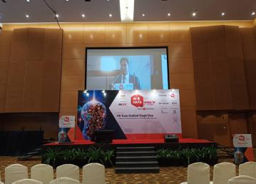

made the hay while the sun shined.
intelligence is the major trend observed across industry and the public sector. It is plays an important part in any journey of digital transformation. The trend grew, providing a customer-centric view of data and often involved using data as part of the product or service. Data enrichment with data from multiple sources assumes this consumer- or customer-centric model.However, fundamentally, it divides the data into two main areas. Real-time data and historic data. Whose initial research forms the basis of this thinking, names this as “fast” data and “big” data. (Brook, 19 0ctober 2018).
Edge computing and real-time intelligence where the internet of things is just only driven by data. Data collection, sending and processing in massive quantities allows companies to Artificial act more intelligently, swiftly and make better-informed decisions. But latency is often which is mean delay before a transfer of data when such massive amounts of data are being sent to the cloud network.Edge computing is expanding around and the developing need to move more of the data processing nearer to sensors themselves in order to decrease that latency and enhance efficiency. Those owners can collect data in real time near their location with edge computing.

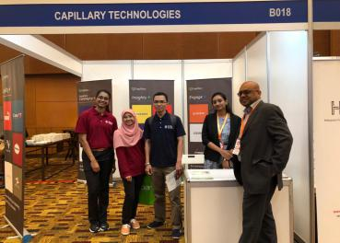

Applying advanced analytics and artificial intelligence algorithms mean they can provoke predictions that can help to saving money and improving safety. (Herbert, 2019).
The impact of automation is the machine learning and artificial intelligence at scale and with a commodity price has driven the need for the “corporate memory” as the advent of advanced predictive analytics to be rapidly adopted in many organizations. Finance sector saw the early beginnings of heavily automated trading. The corporate memory model is extended now as a means of preventing fiscal losses due to a flash crash. Artificial Intelligence contribute significantly to the automation and world that is rapidly emerging within the digital transformation of many businesses. (Brook, 19 0ctober 2018).
In fact, make no suggestion of where or indeed how to store data. Neither do the charts suggest one type of data storage is more preferred. Corporate memory is a highly personal thing. Therefore, having different parts of the corporate memory in different silos may make perfect sense. It may be for security purposes may be a very practical way of segmenting elements that have different corporate levels of security

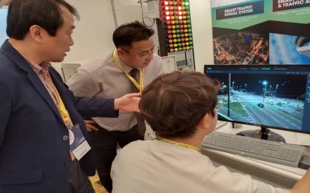
applied. Indeed, not all data are identical in value and makes sense to the automated world of Artificial Intelligence. (LeBlanc, 2018)
MDEC is the Malaysia Digital Economy Corporation Sendirian Berhad which was established in 1996. The Government’s response to the then new concept of “Digital Economy”. Today, the global Digital Economy is estimated to be worth USD3 trillion, and Malaysia’s Digital Economy Corporation will be lead forward as MDEC continues its role. MDEC has driven digital transformation and adoption across the public and private sectors in Malaysia since our establishment in 1996. As the world moves rapidly into the Fourth Industrial Revolution (Team, 2019).The “Artificial Intelligence and Data Week 2019” is a week-long annual event that aims to position Malaysia as the regional digital hub for Artificial Intelligence and Data. (Team, 2019).The purpose of the “Artificial Intelligence and Data Week” is to help catalyze the integration and adoption of Artificial Intelligence and Data among the participants of the various events which would be happening during the whole week of 9th to 15th September 2019.It is a very big opportunity for data engineering students like us.Some recent efforts by MDEC is to promote more vigilant and

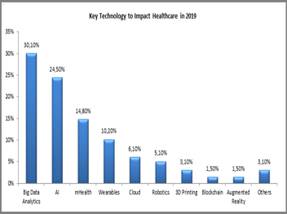
involvement in Big Data Analytics included organising the National Big App Challenge and showcase emerged talent in the field. MDEC will be responsible for driving three high impact Big Data Analytics projects by setting up an Asian Data Science Institute, developing open government data and establishing a network of Big Data Analytics Innovation Centres of Excellence. MDEC also consist of Multimedia Super Corridor (MSC), Facilities & Programmes and Malaysia Tech Entrepreneur Programme (MTEP).
Fusionex is a company that specialize in Analytics, Big Data, the Internet of Things (IoT), Artificial Intelligence and Deep Learning. Fusionex has earned many credit and have many partnership with big company which are Microsoft, HP, DELL EMC, IBM, Alibaba Cloud and AWS. Fusionex also have a collaboration with Big Data specialists such as Hortonworks and Cloudera. Based on their vision, “Our vision is to be a world-renowned IT brand of quality and distinction” they had mainly aim on company from various market and provide them with a different and positive views for those company to be more advance. Hence it will help in getting close the gap between business and technology. Fusionex produce many product for their client based on their need. Data analyticights and 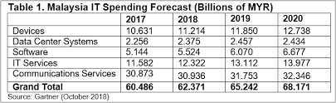foresight.s is one of the branch in this industry that provide by Fusionex. Fusionex Big Data Analytics is a powerful tool that used to

gained, manipulate and derived the data into meaningful value. The system will allow user to analyze and process the data based on their need and help to be discover in real-time insights of the data. This will make the data to be organize, easy to be access and be more efficient. Fusionex Big Data Analytics able to be used in many types of industry and field as it provide end-to-end solution from data and help in visualize to predict and prescript analytics. It is powerful as it can process petabytes of different data beside it connecting dots to gain ins.
Data analyticights and foresight.s is one of the branch in this industry that provide by Fusionex. Fusionex Big Data Analytics is a powerful tool that used to gained, manipulate and derived the data into meaningful value. The system will allow user to analyze and process the data based on their need and help to be discover in real-time insights of the data. This will make the data to be organize, easy to be access and be more efficient. Fusionex Big Data Analytics able to be used in many types of industry and field as it provide end-to-end solution from data and help in visualize to predict and prescript analytics. It is powerful as it can process petabytes of different data beside it connecting dots to gain ins
Beside data analytics, Fusionex provide Giant Internet of Things (IoT) that provide complete and sustainable solution for the user. IoT is a gadget or machines communication device that will connect to network and it can work automatic anytime and anywhere without being monitor by human. It able to be left to be in charge of your company due to it intelligent and adaptive. Giant IoT help in reporting data in real-time. Hence, it allow users able to compare data within the timeframe, countrywide and globally. It will make the things become easier and more accurate data-driven decision as the data being process from billion of sensors. There consist a lot of process happen when IoT is working to prevent any error happen. Giant IoT will capture data in various form, shape or size and it will be manage into specific data based on it category. The data will be used in future with intelligence and augmented analytics to be extract by data scientist.
The reflection from the visit is we are motivated with the requirement of data engineers fits in Artificial Intelligence because it requires strong knowledge of engineering and machine learning principles and depending on specific skills. Data engineers will design robust and scalable infrastructure or scalable data architectures to enable the functionality of data teams and product. To construct these systems, data engineers have to think wisely about the current and future demands the business will need. Besides they also should to compromises need to be made for different serve rates, provide real-time streams to customers and efficiently query the data.This visit impact on our dream to continue to solve new project challenges, improving and maintaining existing architectures, integrating systems better tools and work in team with team members to make sure quality work and product is the best as a data engineer.We realised that we need to keep on reading articles and books on artificial intelligence and also do a lot of practices so that we’ll be fully prepared in every aspects to enter the industry as it’s crucial nowadays in applying job.
To put it in a nutshell,we’re inspired by the immense growth of technology which helping the mankind to do their work way more easier with AI and data in it.This visit helped us to improve our knowledge but not the thirst towards our knowledge.Technology is the campfire around which we tell our stories and now it’s the era where things are going beyond it.

Nalini Vijayan Mohammad Amin Hazeeq Bin Hisham Shakirah Binti Mohd Shukur

