

Technology and Information Systems (SCSP1513)

Section 2

Industrial Visit – CICT UTM
NO | GROUP MEMBERS | MATRIC NO.
1 | LOH YEW CHONG | A19EC0076
2 | MUHAMMAD ARIFF FANSURI ABDUL RAZAK BIN ROHAIZAD | A19EC0194
3 | NOR ARMIRANI BINTI MOHD MAZLAN | A19EC0122

Contents
Introduction 2
The Visit 3
Projector 3
Motherboard 4
Random Access Memory 5
CICT Servers 6
Reflections 7
References 8

Figure 1 3
Figure 2 4
Figure 3 5
Figure 4 6
Figure 5 7

Introduction
On 21st of October 2019, the SECP Data Engineering students of the School of Computing, Faculty of Engineering conducted an industrial visit to the Gallerium UTM at Sultanah Zanariah Library, UTM Johor.
This visit was conducted under the purview of Dr. Aryati binti Bakri who is the lecturer for the Technology and Information Systems (SCSP1513) subject. The visit involves a majority of first year Computing students, including other students from different courses such as software engineering and cybersecurity. This visit was held with the express purpose of introducing the student to the CICT and their functions to the UTM community.
The industrial visit began with a briefing by Encik Zahari. The talk mainly encompassed the history of CICT, the equipment they use and the techniques they use to keep UTM operational, CICT’s role in UTM cybersecurity and the various digital services they offer.

The Visit
On the day of the visit, the students of SECP gathered at the foyer of Sultanah Zanariah Library while waiting for Dr. Aryati to arrive. The visit to CICT began with a warm welcome from Encik Zahari, caretaker of the Gallerium. Around 2.30 pm, the students accompanied by Dr. Aryati entered the gallerium while listening to the briefing given. The students were given chances to observe and explore the devices in the gallerium.
The students were brought around from one device to another while Encik Zahari talked about the history of the devices. Gallerium UTM functions as a museum of UTM equipments and histories, displaying various paraphernalia such as old computers and projectors that did and has served its duty at some point of its time in UTM.During the visit,we listen to what Encik Zahari and at the same time fansuri and mira jot down some notes while yew chong took picture.

Projector
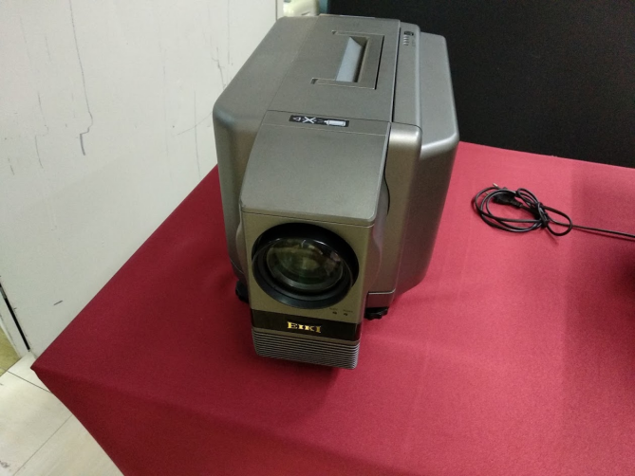
Figure 1
A portable projector used from the late 90’s
Projector is an optical device that projects a figure or picture onto a surface which usually light in colour for example white wall, projection screen, and even white screen. In order a object to be seen on onto a projection screen and other surface, the object should place in front of a light source. Then the with the reflection of the light, the image of the object will be shown on the surface. If you move an object, it will produced an animated image. In picture above, those are the equipments that were used by library staff during 1980s until 1990s to support learning and teaching. With the projector, lecturer able to teach better as their students able to have better view of what lecturer trying to teach because projector can be used to demonstrate a presentation on a big screen. It made the life of all lecturer and student easier. It also allows presentation to become more interesting and meaningful. Nowadays, the projector can be connected to the computer or laptop with the HDMI cable. We even able to project a video on the projection screen.
In UTM, the early models of projectors were heavy and bulky, rendering it unable to be used outside of lecture halls. Those models also used specially prepared transparent sheets to provide a base image for the mirrors and light to reflect to a screen. Eventually, UTM moved to use film rolls that projected images at 24 frames per second. Succeeding the film roll projectors are the modern-day projectors that are directly connected to the computer’s VGA or HDMI output ports that we commonly see in almost all lecture halls in UTM.

Motherboard
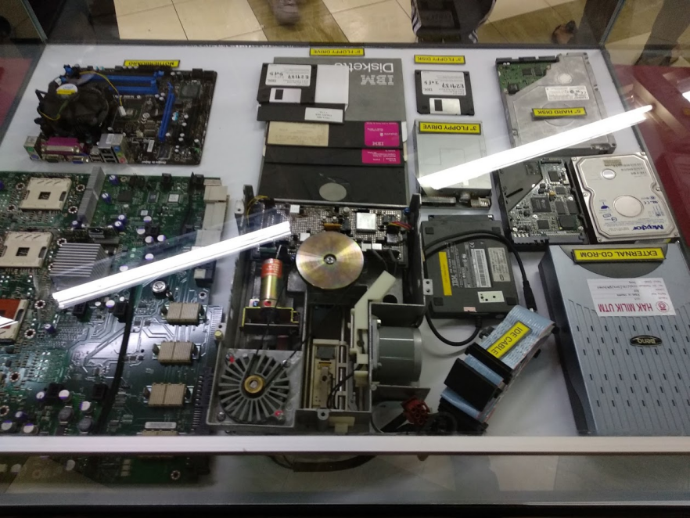
Figure 2
Motherboards and hard drives on display
Motherboard is a printed circuit board that contains many principal components of a computer or other device and with connectors that allows other circuit boards to be slotted into it. It also known as main board and system board. Motherboard usually found in general uses computer and other expandable system. Motherboard is one of the most essential parts of a computer system. It holds together many of the crucial components of a computer, including the central processing unit (CPU), memory and connectors for input and output devices. The base of a motherboard consists of a firm sheet which made from some sort of rigid plastic. Thin layers of copper or aluminium foil which referred as traces are printed onto the sheet. These traces which are very narrow will form the circuits between the various components. There is a lot of sockets and slots on motherboard that allow other components to connect the circuits and the motherboard.
Motherboards on display in the Gallerium has a number or antiquated ports that we don’t normally seen in laptops or computers today. To name a few, they have P/S2 input ports, RS-232 serial ports, and in certain Apple ports in FireWire ports. Alongside the motherboard are some old hard drives larger than 3.5 inch that were gradually phased out of use by UTM.

Random Access Memory
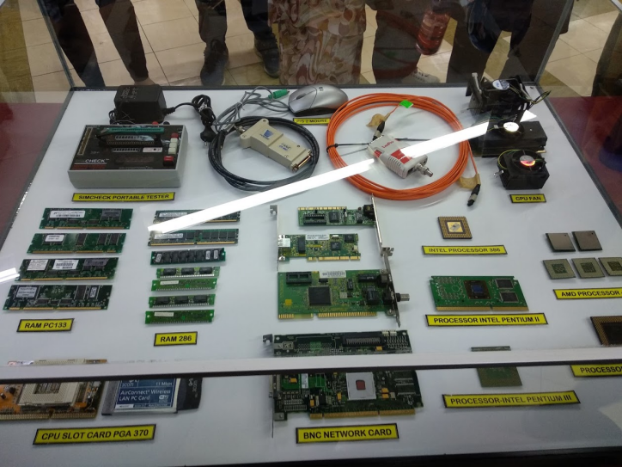
Figure 3
Some RAM sticks on display
Random Access Memory which is also known as RAM is a type of computer memory that can be accessed randomly. Any byte of memory can be accessed without touching the preceding bytes. It can hold programs and data that the CPU is presently processing when their device is still in the on mode. RAM can be found in personal computers PCs, tablets, smartphones and other devices for example printers.RAM is volatile or temporary which means the data will lost when computer is powered off .Additional RAM can be added using an expansion module which is known as Dual in-line memory module (DIMM).

Impact Printer

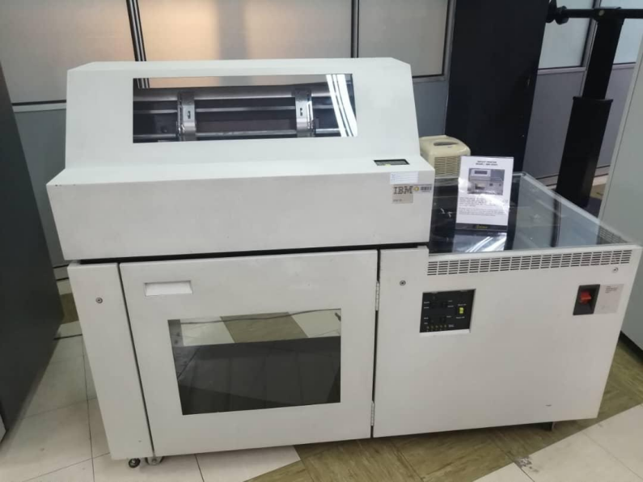
Figure 4
Impact printer on display

Figure above is an impact printer and it is a Dot Matrix Printer which is one of the commonly used type of impact printer. Impact printer works by direct contact of an ink ribbon with paper. A metal or plastic head strikes the ink ribbon, whereby the ribbon is pressed against the paper and the desired character impression such as letter, digit, dot, or line is printed on the paper sheet. The printer above had been used to print data information of students and stuff in order to meet the University’s requirement in UTM during 1980s until 2011. This impact printer was capable to print in high volumes and non-stop for 48 hours, as proven by Encik Zahari at some point of time. Impact printer tend to be noisier than other printers, but it is very useful for multipart forms such as invoices.

Magnetic Tape Unit

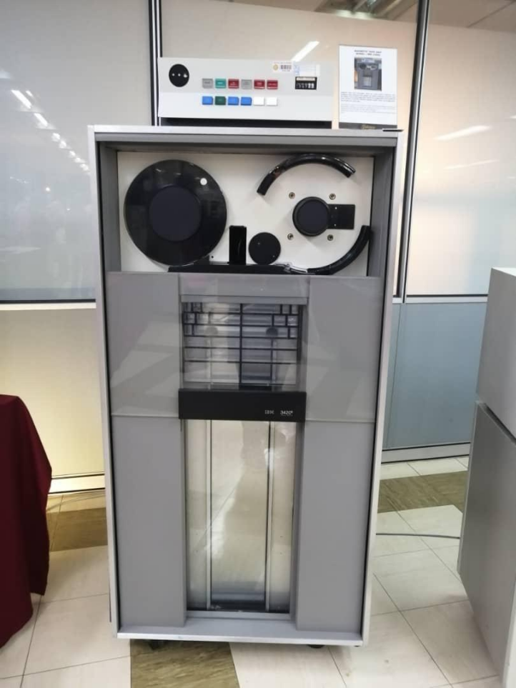
Figure 5
Magnetic Tape Reader

Figure above is a magnetic tape unit. It is a computer unit that consist of a tape transport, reading and recording heads as well as associated electric, electronic and electronic equipment. It will move the reels of magnetic tape past-write heads so that data is transferred to computer or from computer. The magnetic tape unit above was used as a “back up” for the mainframe system and information system database of staff and students as well as other University’s information system in UTM during the year 1976 until 2010. At first, this model used a round shape tape before converting to square shape. The magnetic tape used in the magnetic tape unit is a medium for magnetic recording which made of a thin and magnetizable coating on long narrow strip plastic film. It allows unparalleled amounts of data to be mechanically created and stored for long periods as well as able to access it in a rapid manner.

CICT Servers
The CICT operates a Tier 3 Datacentre (has 99.982% server uptime, meaning on average their online services are unavailable with a 0.018 percent of the time and has multiple power sources, uplinks and more). The datacentre has two separate power sources, drawing it from Cluster One and Two power sources which provides alternate power sources if UTM experiences a blackout. When a blackout happens, the CICT Datacentre can simply switch the power supply it is drawing from and maintain operations even when the entire Johor Bahru campus completely loses electrical power.
CICT also operates somewhere around 700 servers specifically for the use of cloud computing. Those servers are spread around the UTM Johor Bahru campus, UTM Kuala Lumpur campus, and another in an affiliated local university somewhere at Kedah. At any given time, data processed by any UTM Online programs for example, myutm.com maybe held in any one of these servers. The reason is the servers automatically process the user’s location and allocates the nearest server for faster service. For this reason, the Ministry of Education uses UTM cloud servers to process local university (IPT) intake, as the sheer number of people around Malaysia trying to access the intake website would overwhelm a normal server, but the automatic load balancing helps the user to maintain a usable speed to the nearest server without any complications in the user’s end.
CICT proudly notes that its Internet connection speeds are one of the fastest currently available in Malaysia (2Gbps). However, even with the fastest speed in Malaysia, the CICT safeguards the usage of Internet by implementing a Fair Usage policy. The policy allows everyone in UTM to use the fast Internet speeds within reasonable limits. If a person is found to be using a disproportionate amount of bandwidth, CICT reserves the right to limit the person’s Internet usage to maintain a usable speed for other users.

Reflections
From this visit to the Gallerium of UTM, there were a lot of information that I obtained as I can know about the evolution of our electrical devices such as computer, camera, media player and many more. Not just that, I also can see the older version of the devices by myself as they were kept in the gallerium. From that, I can experience how to use the old devices and compare them with the version that we use now. So, I can know how the devices changed and whether it is so different from the other version. From this experience, it can give me ideas on how to make current devices better and more efficient in the future based on the comparison made from this visit. So, not only this visit good for us to look back on how the older devices, but it also can make a difference on how we create a better device in the future.
The visit also taught me the importance of managing your assets well. In a perfect world, there is enough resources for everyone to use for their own ends. But in real life, there are finite limits to be respected, so that other people can also use the resources. Internet bandwidth is a very important commodity, especially nowadays, where everything is done online, so using is appropriately is very important so that other people may use it too. CICT takes its responsibility seriously in order to make sure its services run at the right time and at a suitable speed so students may carry out their task quickly and efficiently.

References
Pusat Teknologi Maklumat & Komunikasi. (2019). Retrieved from CICT UTM: https://cict.utm.my/
UTM. (2017). UTM Gallerium | Gallerium UTM. Retrieved from UTM Library website: http://library.utm.my/utmgallerium/galerium-utm/

