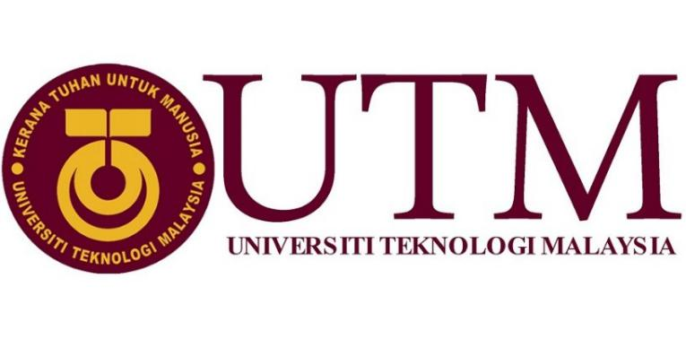
FACULTY OF ENGINEERING: SCHOOL OF COMPUTING
REPORT OF VISIT TO GALLERIUM

PREPARED BY:
- MOHAMAD AMIN HAZEEQ BIN HISHAM (A19EC0087)
- NALINI A/P VIJAYAN (A19EC0112)
- SHAKIRAH BINTI MOHD SHUKUR (A19EC0159)

SUBMITTED TO: DR. ARYATI BINTI BAKRI
DATE OF SUBMISSION: 11 NOVEMBER 2019

Table of Contents

1 INRODUCTION 2

2 CONTENT 3

3 TASK OF EACH MEMBER 17

4 REFLECTION 18

INRODUCTION

On 21st of October 2019, we went for a short visit to Perpustakaan Sultanah Zanariah (PSZ) to learn the progress of IT as the time changed. We had the tour at Gallerium at Level 2. The tour was conducted by En Khalid Bin Hj Jaafar. He was the conservator that handle the gallerium.

At the Gallerium, there are various types of computer components were preserved. Some of the components were some old versions of computer, typewriter and projector. Those were the technology used by the University during 19th century.

Computer was developed at beginning of 19th century. Computer consist of 3 generation where the first generation’s period was from 1937 until 1946.That’s when first electronic computer that was invented by DR. John V. Atanasoff and Clifford Berry. During that time, computer weighed about 40 tons and consist of 18000 vacuum tubes that used for processing. Hence it only can perform single task and had no operating system.

The second generation’s timeline started at 1947 and ended around 1962. Over 100 programming languages were developed during this time and each computer had their own memory, operating system, storage device and ability to connect to the output device.

The third generation started at 1963 and up to today’s date. Invention of the integrated circuit brought us to the third generation of computer. At this time, computers have shrink and even more powerful as it can run many different program at a time. We can see an immense evolution of computer as the years passing by. As a result, many different types of computers been invented and becoming an useful tool that is required by everyone.

CONTENT

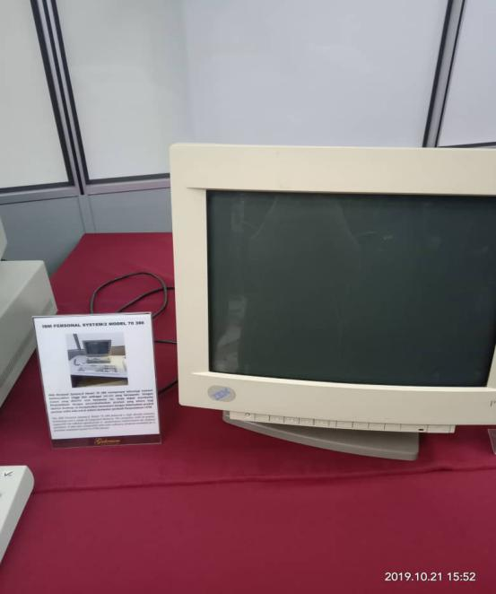
FIGURE (1) IBM PERSONAL SYSTEM /2 MODEL 70 386

Based on Figure (1) shows the model of computer that has high density of memory technology and consist more integrated features, the IBM PERSONAL SYSTEM/2 MODEL 70 386. With this advantages, the system supported the library significantly in performance improvement in desktop operation. It’s also maintaining the compatibility with most software products that suits for personal computer system in UTM library.

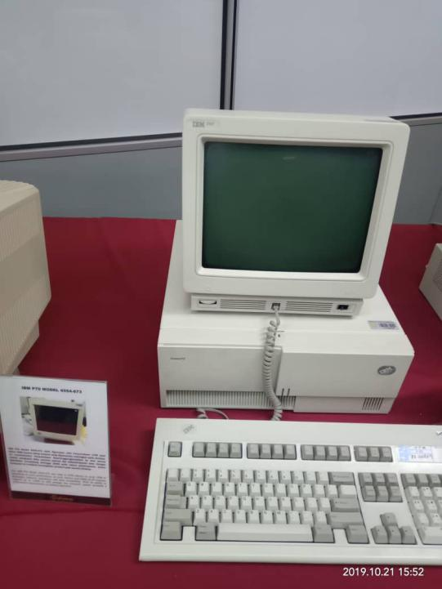
FIGURE (2) IBM P70 MODEL 6554-673

The figure (2) shows the old computer model that has been used in UTM Library since early 1998 because of its work performances and the prestige level shows by the desktop. This allowed the UTM Library as the library was liable of all modules, software operations, databases and data accessibility. This model has ability to support up to 16MB on disk storage. Plus the system also provided the prestige performances enhancement on desktop operation.

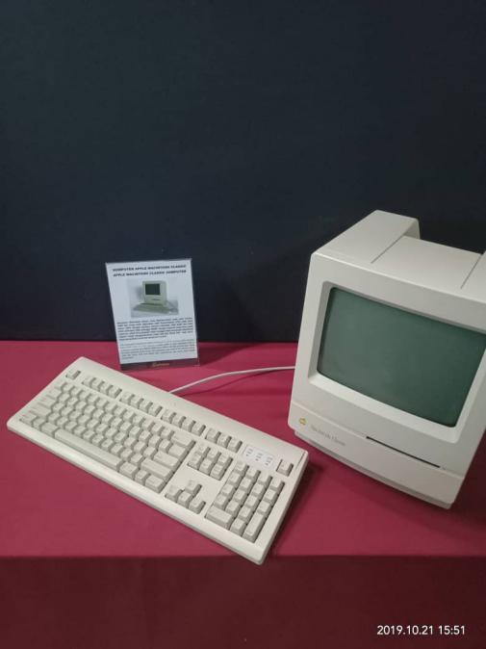
FIGURE (3) APPLE MACINTOSH CLASSIC COMPUTER

Based on figure (3) it shows the branded classic computer, produced by Apple Company. This Apple Macintosh computer first launched in early 1984 and has been used in UTM Library in early 1990. Equipped with software memory of 1MB RAM and ROM as much as 2MB until 40 MB. At that time the capacity more than enough for the computer that was used in the UTM Library to use the Lotus 123 and Word Star for work and to do simple calculation.
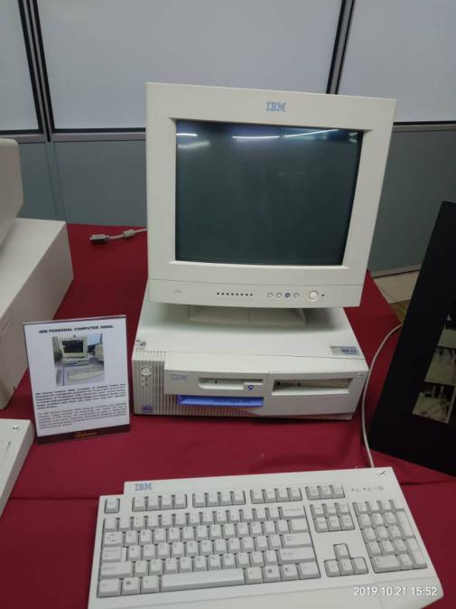
FIGURE (4) SHOWS IBM PERSONAL COMPUTER 300GL

Based on figure (4) shows IBM PERSONAL COMPUTER 300GL. The computer known as a complete set of computer and also affordable. The transformation of system is taking place constantly in UTM Library. Apparently, technological revolution of computer usage coincides with system change and this was the evident of Dynix system that has been in for the past 10 years.

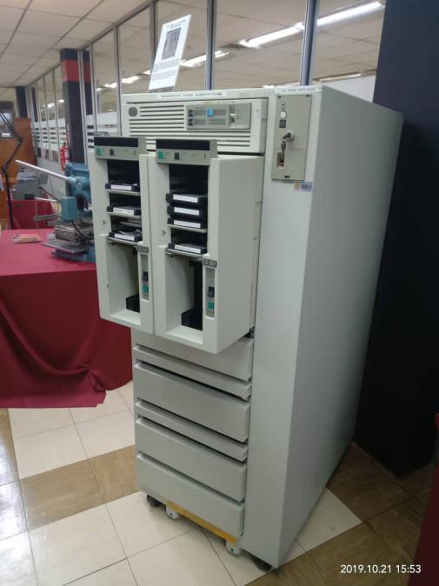
FIGURE (5) MAINFRAME TAPE SUBSYSTEM MODEL: IBM 9309

Based on figure (5), Mainframe Tape Subsystem was mainly used to store any files especially for the “back up” data stuffs especially database of UTM’s staffs, students and system information UTM around 1987 until 1995.

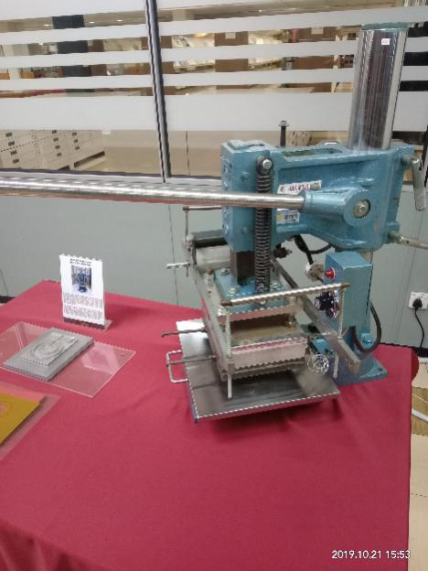
FIGURE (6) BLOCK HOT STAMPING

The first block hot stamping in 1978 shown in figure (6) featuring UTM logo and previous motto ‘Untuk Tuhan Dan Manusia’. The logo was printed basically on official document or publication of university. It’s oblivious that its clearly visible against ‘buckram’ surfaces (type of cotton fabric the buckram is hidden between layers of fabric to help the pleats keep in their form) and on golden pieces. The motto on the logo since been changed to ‘ Kerana Tuhan Untuk Manusia’. Here is the example of the results using block hot stamping on figure (7) down below:

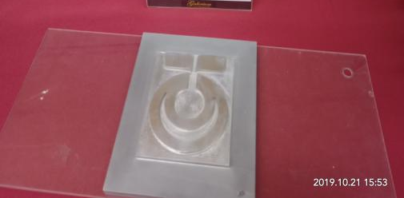

FIGURE (7) RESULTS OF THE USE OF BLOCK HOT STAMPING

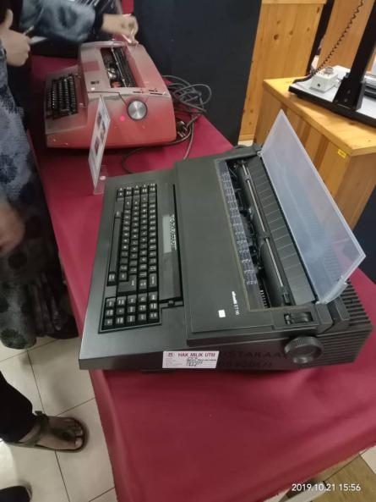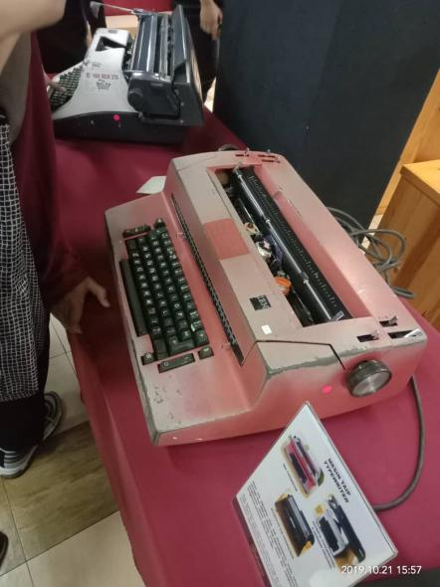
FIGURE (8) OLIVETTI ET 116 TYPEWRITER
FIGURE (9) IBM TYPEWRITER

Nowadays the typewriters has evolved to a printers where details are typed in the computer or laptop and then printed out through a printer. Unlikely, typewriters where we have to type out the details straight and its being inked straight on the paper. Figure (9) shows IBM Typewriters are electric typewriters were a series of electric typewriters that IBM manufactured since mid-1930s. Mr. Edison built a typewriter which was operated electrically with the typewriter found by Mr. Sholes. Finally, Olivetti ET 116 Typewriter shown in figure (8) was found by famed Italian engineer Camillo Olivetti rose to the forefront of typewriter history in the early 1900s.After receiving his pattern his typewriter started to be manufactured and sold to the Italian Navy. This is how his typewriters slowly become renowned worldwide because of its simplicity, portability and a handy device.
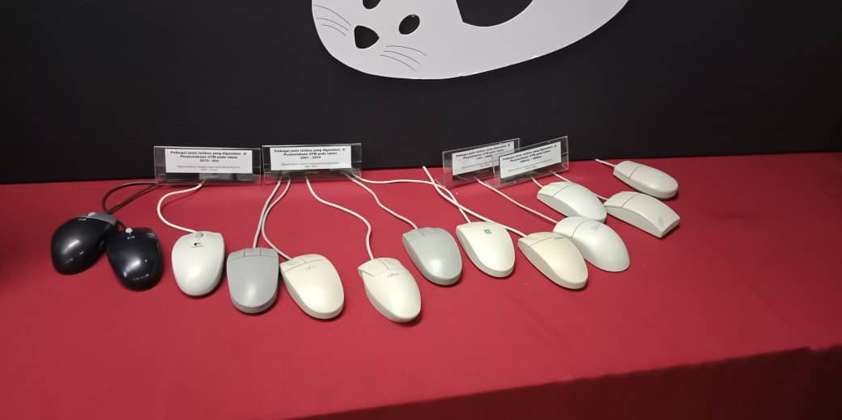
FIGURE (10) TYPES OF MOUSE

Figure (10) shows all the mouse that they used before in UTM. Start from the square-shaped of mouse and use ‘ball’ in the mouse until the latest type of mouse in use. The current mouse is improved in way that’s a easy usage which are wireless and fit our palm.
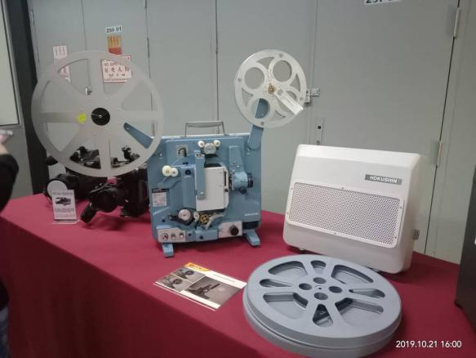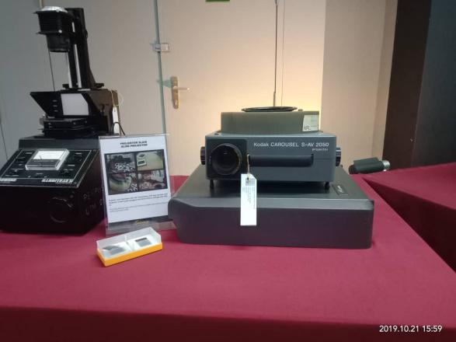
FIGURE (12) FROM LEFT SLIDE PROJECTOR, CAROUSEL S-AV 2050 PROJECTOR
FIGURE (11) FILM PROJECTOR 16MM HOKUSHIN PROJECTION

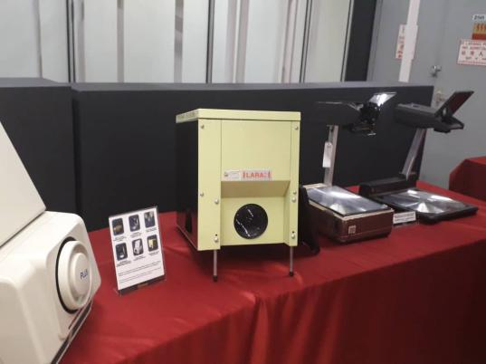
FIGURE (13) FROM LEFT PLUS DIRECT PROJECTOR PAXISCOPE LARA PROJECTION, OVERHEAD PROJECTOR AND TRAGBARER
OVERHEAD PROJECTOR

The above picture shows various types of projector that have been in use in our institution UTM throughout the past decades. As you see in the pictures projectors evolved by years. Figure (11) is film Projector 16mm Hokushin normally used for non-theatrical such as for industrial and educational purposes or sometimes for film-making and for low-budget motion pictures. Next, figure (12) is slide Projectors widespread use during the 1950s as a form of occasional home entertainment. For instance family members and friends would gather to view slide shows of the pictures taken during the holiday. Carousel S-AV 2050 Projector is a 51mm lens very wide angle for a Carousel projector. This projector enables larger screen to be filled at a shorter distance. Inventor of overhead projector is Roger Appledorn. Although he invented it, it’s the reincarnation of episcope .The projector directs light on the object and forms the image on the slide. While, tragbarer overhead projector shown in figure (13) more likely got the same function as overhead projector but it’s more portable friendly. This are the history and functions of some projectors shown above.

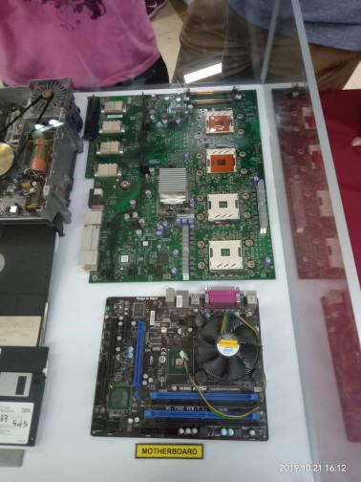
FIGURE (14) MOTHERBOARD

Motherboard shown in figure (14), is a very important component of the computer. Motherboard hold the CPU and also consist a lot of slot such as CPU socket, memory slot and provide connector to the hardware of the computer. Motherboard consist many slots that allows the connectors of device to be slotted into it. It allocates the power supply and allows communication between the CPU, ROM drives, DVD drives, RAM and all other computer hardware components. Each types of motherboard is designed to work with specific types of processors and memory type but hardware is compatible with majority of motherboard despite different of type or brand.

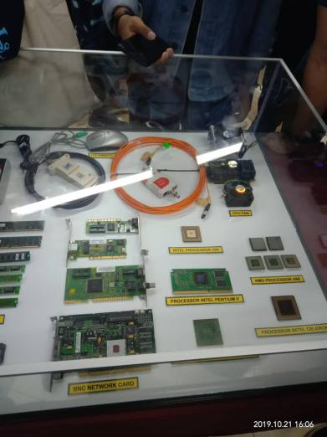
FIGURE (15) FROM LEFT BNC NETWORK CARD, PROCESSOR, CPU FAN

BNC Network card was embedded in the motherboard. It provides internal network interface to connect to the network. Network card also enable the computer to exchange data with a network. Processor used to manage all the data in the computer. It will control all the input, output and perform basic calculation. In Figure (15), there are INTEL PROCESSOR 386, PROCESSOR INTEL PENTIUM II, PROCESSOR INTEL PREMIUM III, AMD PROCESSOR 486 and PROCESSOR INTEL CELERON. CPU fan will help from overheating of the chips.
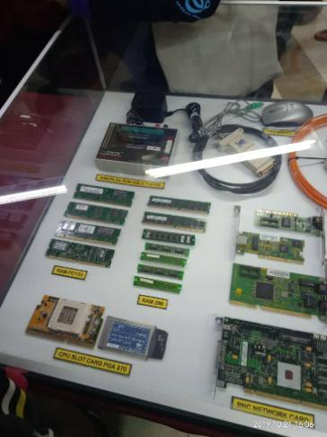
FIGURE (16) FROM LEFT SIMCHECK PORTABLE TESTER, RAM PC 133, CPU SLOT CARD PGA 370, RAM 286

Figure (16) shows the (RAM) stands for random access memory, (RAM) is the volatile memory for computer use. RAM that shows in UTM Gallerium are RAM PC133 and RAM 286. RAM can be also found in personal computer, tablet, laptop, and smart phones. It requires power maintenance to maintain the stored information. When there is no power supply, all the information will get lost at the moment. As it is volatile memory, so it can store information temporarily. Additional RAM also can be added to give better performance in the device which i can read files and information in a short time. Simcheck portable tester was used to prevent hazards such as short-circuit. RAM was used to stored information during the computer running. CPU slot will hold the CPU at the motherboard and produce electric interface to contact with the CPU.

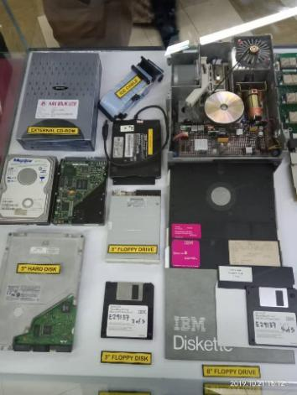
FIGURE (17) TYPES OF STORAGE DEVICE
In Figure (17) there are various types of storage device which are external CD-ROM, 5” Hard Disk, 3” Floppy Drive, 3’ Floppy Disk and 8” Floppy Drive.

TASK OF EACH MEMBER

NAME | TASK
MOHAMAD AMIN HAZEEQ BIN HISHAM  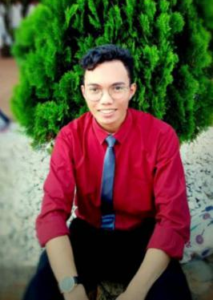 | - Recording audio  - Collect information  - Making report content
NALINI A/P VIJAYAN  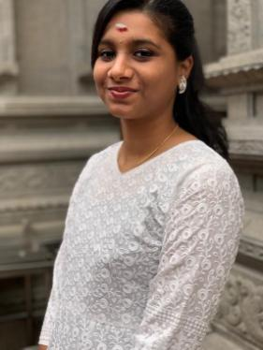 | - Taking the picture  - Collect information  - Making report content
SHAKIRAH BINTI MOHD SHUKUR  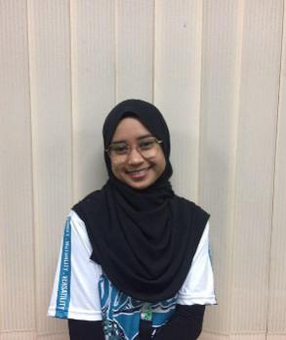 | - Collect information  - Making report introduction  - Editing report

REFLECTION

Me, Mohamad Amin Hazeeq Bin Hisham as a student in faculty engineering and School of Computing, I can say that my lesson in computer hardware and other type of technological devices such a Hot Block Stamping is related to our present generation because we can see the how to deal with these technology which is very demand on these day. The deal to make things easier and simple for human usage but at the same time have the high performance features. In fact, technology is growing fast nowadays and I would be the one who give the idea on improving the better technology in the future regards to my data engineering course. I keep searching on the pros and contrast of the previous and present technology and always creating new imagination to get the creative design in the future.

Myself Nalini d/o Vijayan always had a vision that I would contribute big in this course that I’m currently undertaking. visiting CICT helped me a little in being in line with my vision. To love something is to know it. Learning the history and evolution of those pieces of technology restored my passion in it and gave me insight on how we have evolved. From the way we think and solve problems. We have come a long way and still have a long way to go. Seeing how technology has changed through the eras gives me hope that one day even I can be a changing factor in technology. That I can come up with the next revolutionary idea that changes the frontier of technology.
Besides that, visiting CICT helped me feel more motivated towards my end goal. It made me realize that it is not impossible to create something new. Every invention was once an idea and this visit has made me realize that ideas are possible. Similarly, this can be said about my course too. The ability to formulate solutions and ideas are crucial for my working environment and this visit has made me realize that.
Lastly, as for the future I think that doing more Studies on the history of technological evolution will help me greatly. By doing so, insight on how people think can be acquired and this is crucial information. To know how to think is better than to know what to think. Being able to think independently but in the right way is a good skill to have and that should be worked on.

I, Shakirah Binti Mohd Shukur think this industry is not an easy path as this industry keep growing and always improving the technology as the time fly. Hence, this make me want to be one of person that can produce a good technology based on user preference because it make me wants to challenge myself. It would be great if I manage to do it.
As the journey is not easy I need to keep polishing my skills and gain more knowledge to achieve my ambition. It is not an easy path so I need to always prepare myself to keep strong mentally and physically. Through the short visit, I able to know more about the transformation of the technology including the computer’s component. This show that each era had discover a new thing to develop the technology to be more advance and able to be use for all. From this also teach me to keep improving myself to be a better person and discover the best for future. It makes me feel I’m capable to achieve my goals and be a successful person in future.
All the technology should be keep so our young generation could see the transformation of the technology as the time pass by. This shows that how people before invent the technology and evaluate it into many type of computer that we have now. This also can make them able to think creatively and able to enhance them to think something new.

