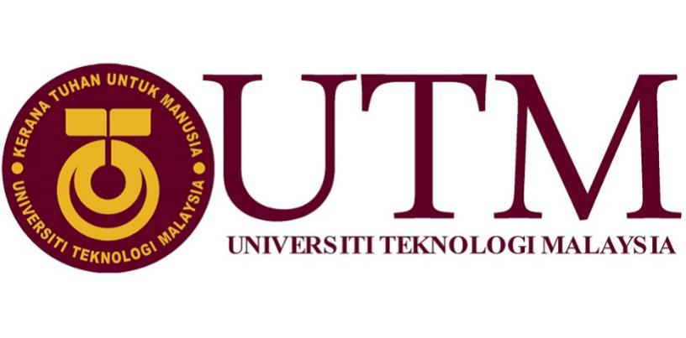

FACULTY OF ENGINEERING: SCHOOL OF COMPUTING

REPORT OF VISITING TO PETRONAS

PREPARED BY:
- MOHAMAD AMIN HAZEEQ BIN HISHAM (A19EC0087)
- NALINI A/P VIJAYAN (A19EC0112)
- SHAKIRAH BINTI MOHD SHUKUR (A19EC0159)

SUBMITTED TO: DR. ARYATI BINTI BAKRI
DATE OF SUBMISSION: 30 SEPTEMBER 2019

Table of Contents

1.0 INTRODUCTION 1

2.0 CONTENT 2

3.0 OUR VISIT 3

4.0 REFLECTION 4

5.0 CHALLENGES 5

6.0 CONCLUSION 5

7.0 REFERENCES 6

- INTRODUCTION

On 11th of September 2019, about 36 students of Data Engineering from School of Computing who were accompanied by 2 lecturers went on an industrial visit to PETRONAS located at Kuala Lumpur. The main objective of our visit is to learn and gain more information about Group Technical Data (GTD). There was a short presentation from PETRONAS’s staff that explained us what were their scope of work, their achievements from the past years and their future planning to upgrade their system. Due to lack of grasp and knowledge about the group of organization, it provoked the thirst of our knowledge and urged us to know more about them and their system that carried out by them successfully for all these years. Hence, this industrial visit enhanced our interest and understanding about what we will be learning in the coming years and venture with all the knowledge that was fed to us throughout this journey.

During the trip, we were given a short overview of Group Technical Data (GTD) and PETRONAS. Some of the GTD personnel shared their working experience and explained more details about they actually do. Q and A (question and ask) session were allowed to answer our curiosity about GTD and PETRONAS and it helped us to gain more information about GTD. We also had a short visit with few of our seniors that had being intern there and they advised us on how to survive and able to manage ourselves in this course and industry. We were given an opportunity to look at the working environment and we’re utterly blessed as not all and sundry get the opportunity.

2.0 CONTENT

Atikah, a PETRONAS’s staff in KLCC said that moving forward from the change onward, they became a group which is called “Group Technical Data” where the scope has been widened, which means that they don’t only take care of upstream data but also downstream and other technical data. Starting 2016, they also look into what else can be done with the data that they have. Initially it is just nearly managing the data submission of the data from their partners. They print in the database and whenever people want to use it, they prepare and provide them. This made it their work much easier. But since 2016, they start to actually think about how they can call the data, what else they can do with it to give more value to the PETRONAS. So that is basically the starting point they go to the data analytics. They also look into the possibility of treating value from data, so it is no longer just from the technical services.

Next, Atikah also shared that GTD (Group Technical Data) is basically custodian of the PETRONAS technical data. They act on behalf of the PETRONAS to manage and safeguard technical data. They also do some data analytics come out with insight the governance for technical data by establishing standards and also solutions development.

3.0 OUR VISIT
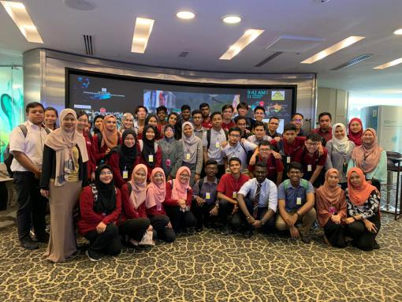
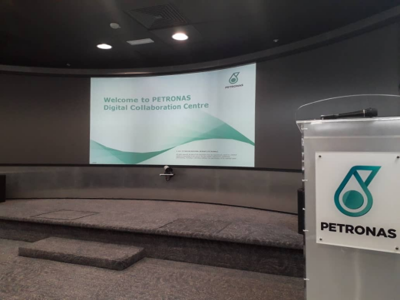
Figure 1: PETRONAS Slide Room Figure 2: Tower 2 Hall

Based on Figure 1 & Figure 2, we were given a talk in the studio at Tower 2 of PETRONAS .Madam Niza Adila binti Hamzah was in charged to give us a talk about PETRONAS and took us to have a look around PETRONAS Tower 2. Before we were able to enter the tower, we needed to register at entrance to gain our visitor pass and undergo security checking.

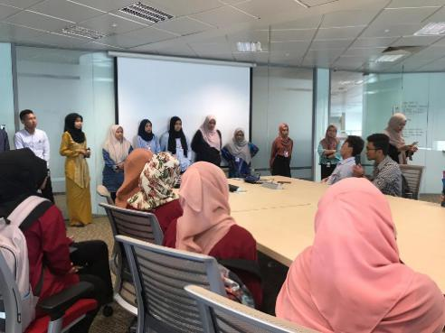
Figure 3: Senior share experiences

Based on Figure 3, later, we were brought to 44th floor of Tower 3 of PETRONAS to have a session with our seniors that being intern to share their experiences being in the industry. We also asked questions and viewpoint to the staffs and seniors about our course and future. Besides that we could see how they do their work as we went for a short tour around the office.

4.0 REFLECTION

Mohamad Amin Hazeeq Bin Hisham reflects from the visit is I am motivated with the general conditions of data engineers fit in industry because it needs strong logical thinking and depending on our unique skills. Data engineers have to think creatively about the marketing of business needed nowadays and to make more industries interested. The impact is actually makes me more excited to take the challenge basically in logical thinking and soft-skills as it is the fundamental for every student in data engineering course. I need to keep on reading many revision books and do a lot of exercises in programming from any sources that relates to data engineers so I can prepare myself to involve in the professional world and easy to adapt especially in the industry.

Nalini A/P Vijayan reflects the visit by itself was an eye opener to everyone who attended. All information that was shared with us carried more value than we could ever have known. Information is wealth and we returned from the visit priceless. We learned what it truly means to be a data engineer and the responsibilities that come with it. Just like the words of uncle ben, with great power comes great responsibility. To be a successful data engineer, we were given the chance to speak with our seniors that shed even more light on what we should do to become a good data engineers. Basic qualities of a good employee should be mastered. For example we have to be disciplined and have to be accountable of our own actions. With these qualities, we can strive to be a great data engineer as well as a better human in general.

Shakirah Binti Mohd Shukur reflects that Industrial visit to PETRONAS was an amazing opportunity because PETRONAS is a well-known company. I had learned how a big industry handling with a large number of data does. Start from gaining, analysis and recorded to be used the data. Being a data engineer is a challenging job as it required a lot of knowledge and skills to be used. This make me more eager to learn deeper in my studies to be one of the successful data engineer.

5.0 CHALLENGES

Staff of PETRONAS named Akmal & Atikah also shared that physical data that has been managed, it is at least 40 petabytes which is stored offline and only around 10% from those data actually it become online on our server. The challenge from their side is to make sure that those data actually being recorded will be prioritized to be put online and also understanding which data which grows in industry is one of the challenge because of the subsurface despite being the most numerous data being created in PETRONAS, they have data since 1970, they do not actually harassed a lot of insight from them. Usually, nowadays user will still call from the data as late as 1970, so the challenge is to prepare those data into the format because application that they have nowadays and they do not have the back dated formats (PETRONAS, 2019). They can be late in industry so that is why the formats maintenance on metadata is a big challenge when they have to use the well-equipped technical applications. They don’t have many analytics applications in house because they are quite driven from what the industry already have purpose on subsurface.

6.0 CONCLUSION

To put it in a nutshell, from the data that they have, couple with information and also knowledge that from the past experience, they do some analysis and analytic to come out with insight what does the data and the past experience told them. They basically work together with the experts to come out with some solutions. That solution need to be apply by business and it is actually need to be proven via verification that the business basically realized .That is how they contribute to PETRONAS success. The staffs shared a lot of experiences and ideas about what they do during their working hours and helps in giving us a positive views how we should equip and prepare ourselves to have a bright future. This words will help us to keep upgrading just like PETRONAS that began as an oil and gas and now grown into an immense diverse industry.

7.0 REFERENCES

- PETRONAS, T. (2019). Students & Graduates. Malaysia: Petroliam Nasional Berhad (PETRONAS).

