
TECHNOLOGY AND INFORMATION SYSTEM
SEMESTER I 2019/2020
SECP1513-01
INDUSTRIAL VISIT REPORT GROUP 1
NAME OF STUDENTS | MATRIC NO.
TAN LI MIN | A19EC0169
MUHAMMAD NAJIB FIQRI BIN SULAIMAN | A19EC0103
NURUL EZZATI BINTI HARUDIN | A19EC0142
MA SIRUI | X19EC0024
TASNIA HOQUE NIDHI | A18CS9010

LECTURER : DR. ZURAINI BINTI ALI SHAH
SUBMISSION DATE : 11th NOVEMBER 2019

Table of Contents
- Introduction -------------------------------------------------------------------- pg3
- Detailed descriptions include the history component related to computing as show in the Gallerium, PSZ.----------------------------------------------- pg4
- Reflection -------------------------------------------------------------------- pg 15
  - What is your goal/dream with regard to your course/program?
  - How does this visit impact on your goal/dream with regard to your program?
  - What is the action/improvement/plan necessary for you to improve your potential in the industry?
- Task for Each Member ------------------------------------------------------ pg 16

1.0 Introduction and details of the visits.

For this industrial visit, our group visited the Centre for Information and Communication Technology (CICT) in the UTM Library Area.

In advance, we can learn from the official website: CICT is a support unit that offers and delivers ICT services for the university (staffs and students) especially in ICT infrastructure, system development and academic / administrative activities. It specifically provides: Administrative and academic computing, ICT infrastructure and training, research and consultancy and other services. CICT can also be seen as "CREATIVE, INNOVATIVE, COHESIVE, TECHNOPRENEUR" shorthand. It is an information and communications technology (ICT) service provider for university students.

During the visit on October 21, we saw and learned a lot. Listen to the staff talk about the historical components related to computers. Learn about the development of various components and systems, such as cameras, sliders, printer models, slide projects that make us understand the service culture of CICT.

We took pictures and recorded the whole process of the visit. Now put all the contents into a report, as follows:

- Detailed descriptions include the history component related to computing as show in the Gallerium, PSZ.

Film copy machine ‘ EXTER 2102 Model’
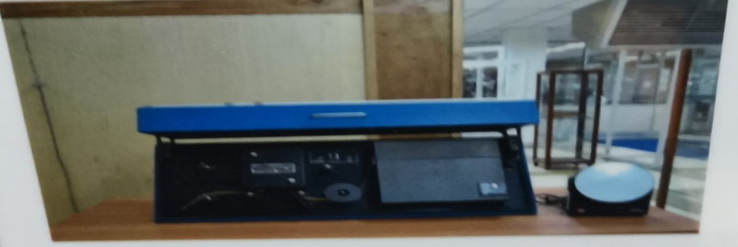
The ‘Silver Film Duplicator’ is used to produce negative to positive microfilm copies. Microfilm copy is a film bearing a miniature photographic copy of printed or other graphic matter. According to its functions, the microfilm negative copies served as references to users while the positive copies were stored in UTM Library special collection. The main reasons of this machine is to ensure that the master copies of each UTM thesis is preserved and traceable in UTM Library collections.

Microfilm Processor ‘ Kodak Prostar Model’
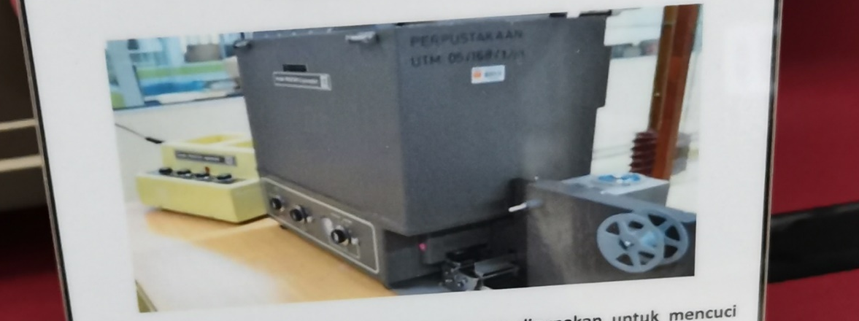
The ‘Kodak Prostar II Processor’ is used to cleanse the 16mm and 35mm sized microfilm of ‘Recordak Micro-File’ machine and the ‘ Zeutschel’ microfilm camera machine.It also produced negative microfilms for UTM theses.
It was capable of processing microfilms with a speed of up to 10 feet per minute.

Kodak Prostar Replenisher Machine
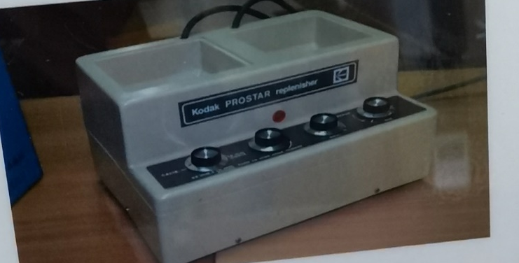
The ‘Kodak Prostar Replenisher’ was used to mix ‘Kodak Developer’ and ‘Kodak Fixer’ which are two different types of chemical compound.
The mixture was then transferred into the ‘Kodak Prostar II Processor’ machine to be used during the microfilm washing process.

Image magnifying machine ‘DUNCO 67C Model’
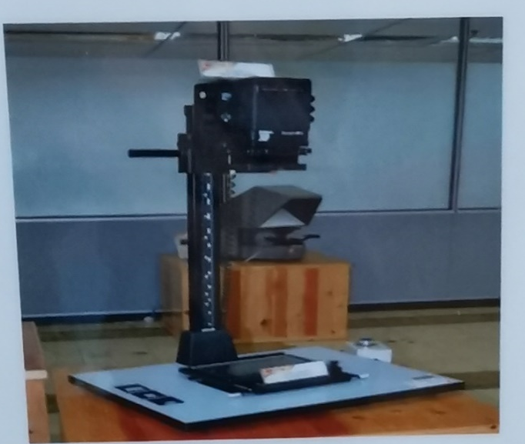
The Film Enlarger is a tool used to enlarge images to produce photo prints from negative films.It could be modified according to a preferred image size.The film magnifier is only use in the darkroom to prevent light from entering.
It was first used in UTM Library around 1985 until 2007.

Microfilm machine ‘Recordak model’
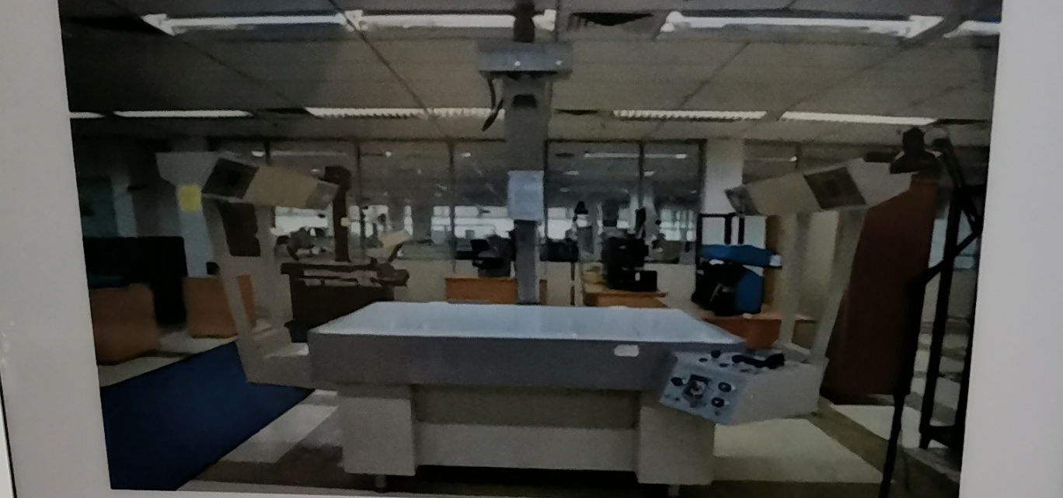
The Recordak Micro-File machine is one of the machine that used to capture small images of UTM theses.The image was recorded into microfilms or microfiche.It utilised a special film; the size of Kodak Ektacrhrome was 35mm , and with a capacity of 100 feet per film roll.
This machine was first used in UTM Library around early 1980’s until around 2007.

Microfilm Camera Zeutshel OK 102
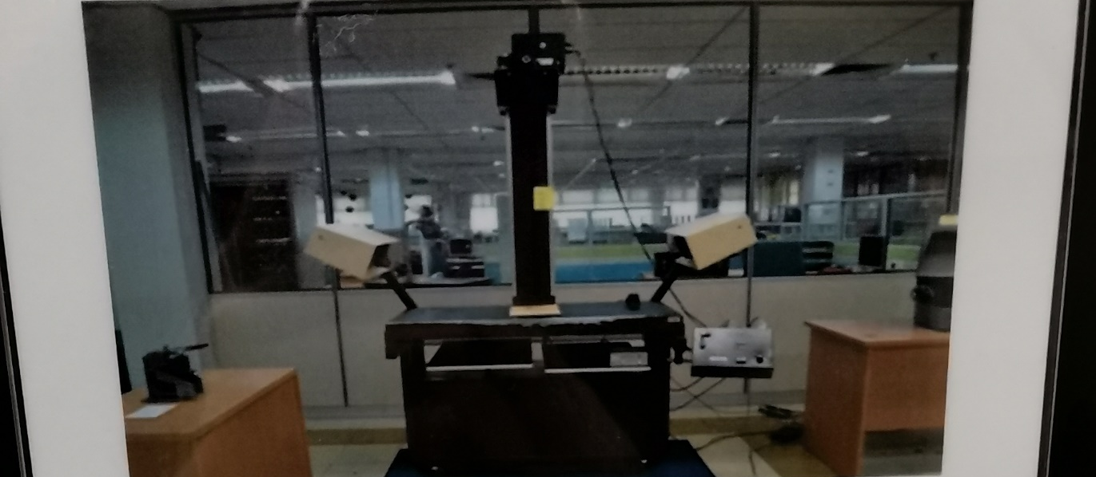
The Microfilm Camera Zeutschel OK 102’s is a high accuracy camera that use to photograph small images of UTM these. The images were recorded into microfilms or microfiche.It utilized a special film; Kodak Ektacrhrome which was 35mm in size with a capacity of 100 feet per film roll.
This machine was first used in UTM Library in 1986 until around 2007.

Mainframe Tape Subsystem IBM Power server 550
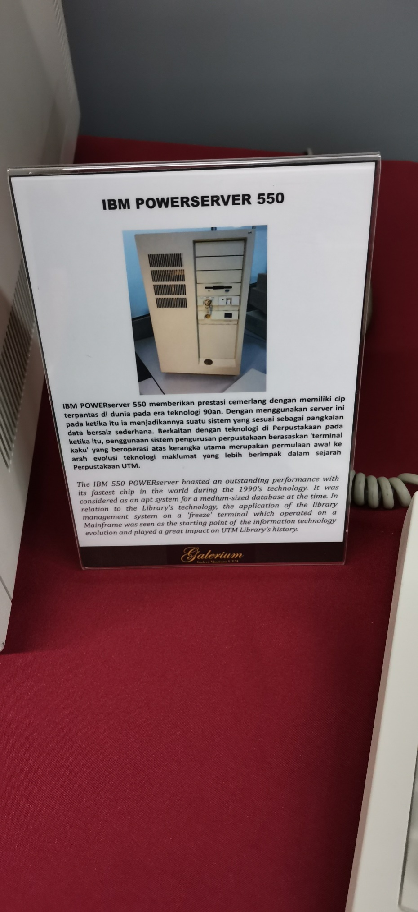
IBM Power server unifies the value of their servers into a solitary and powerful lineup of servers. The technology which was built on 90s is considered as a really great technology at that time as it can be as a database for medium size data. This management system that is very useful at that moment in the library is the start of the information technology contributes to the modern world today.

Magnetic Tape Unit Model: IBM (3420)
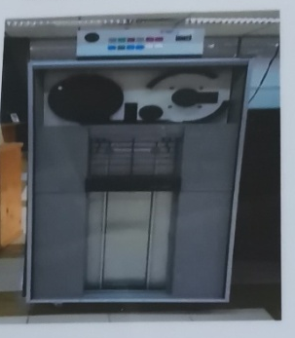
Magnetic tape is used for recording audio or video or computer data storage. Magnetic tape recording uses magnetic tape which moves on a footage start. This magnetic tape was used from 1976 to 2010 as a backup for the mainframe system and information database of UTM’s information system as well as staff and students. Before converting to square shape tape like how this model looks like, it was originally in a round shape.

Mainframe Data Storage Model : IBM (9345B22)
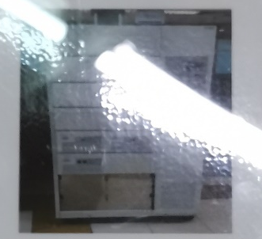
Back in 1970s, Mainframe Data Storage was used at UTM campus, Kuala Lumpur as it served as a data control of students and staff information. Mainframe data storage is capable of efficiently handling the huge volume of transactions because it has so many functions and various components such as processing, storing, securing and printing the University’s information. This is likely the main reason why this was used for over 20 years in UTM.

Microfilm Reader ‘allen micro model’
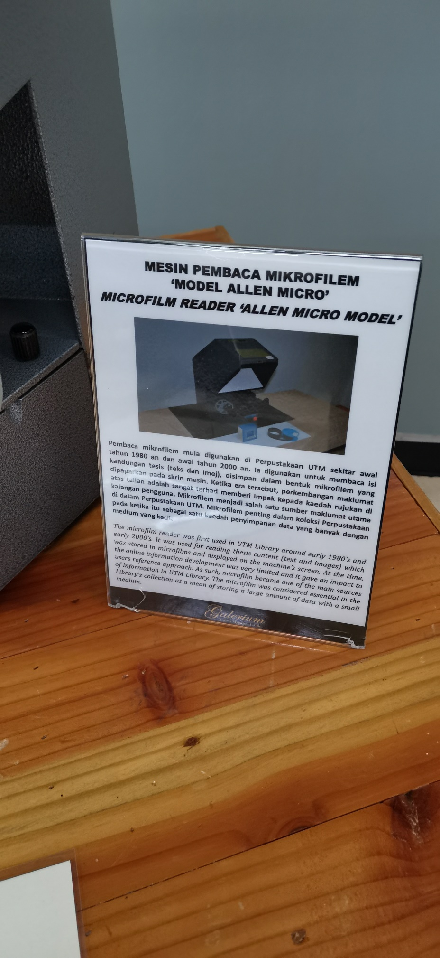
Microfilm reader was used in UTM library for over 20 years since the early of 1980s until early 2000s. The purpose of microfilm reader is to magnifying images stored in microform to readable proportions. It can interpret words from text and images. As the source of technology was very limited during that time, microfilm reader is one of the main sources in UTM library to the consumer. The medium that is tiny but can stored huge quantity of data makes it a really fundamental in the library collection.

Microfiche Reader’ Micron 750 Model’

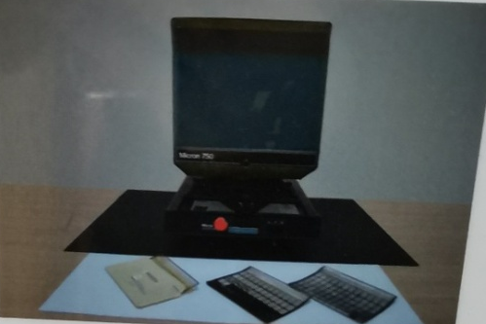
Microfiche reader is a device that read the content of a microfiche. Similar to microfilm, microfiche is a storage medium but can storage and update data more easily compared to microfilm. Microfiche reader is a special piece of equipment that can read microfiche film which contains a collection of single sheets of film, filled with tiny images of documents or reports. There are about 500 of microfiches in UTM library collection most likely consist of journals, technical reports, proceedings and other general references.

IBM Personal System/2 Model 70 386
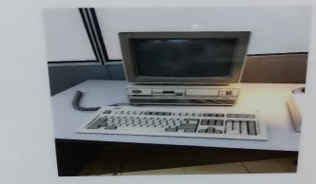

This computer is established in the late 1980s , and basically at 1989 one of the most expensive and powerful computers back then because the 386D , it has feature of floppy drive which is a three and half quarter , the floppy drive a new name in the whole computer system bake 80s . The Personal System/2 Model 70 enhances the systems by offering a new level of performance in a desktop unit. The system is highlighted by the Micro Channel™ Architecture with a 16 or 20MHz 80386 32-bit microprocessor, high density memory technology, and a wide range of integrated features. With the capability of supporting up to 16MB of high speed real memory, 60MB (Model E61) or 120MB (Model 121) of disk storage.

IBM P70 Model 6554-673
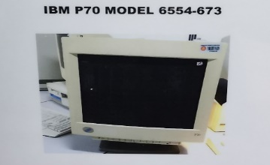
This model of the monitor is the invention of the 1998 which was also in 1998 in the UTM library and helped to work function. Then again it was liable of making database, data accessibility and software application. With its 16 MB on disk storage the computer system provided perform on desk operation.

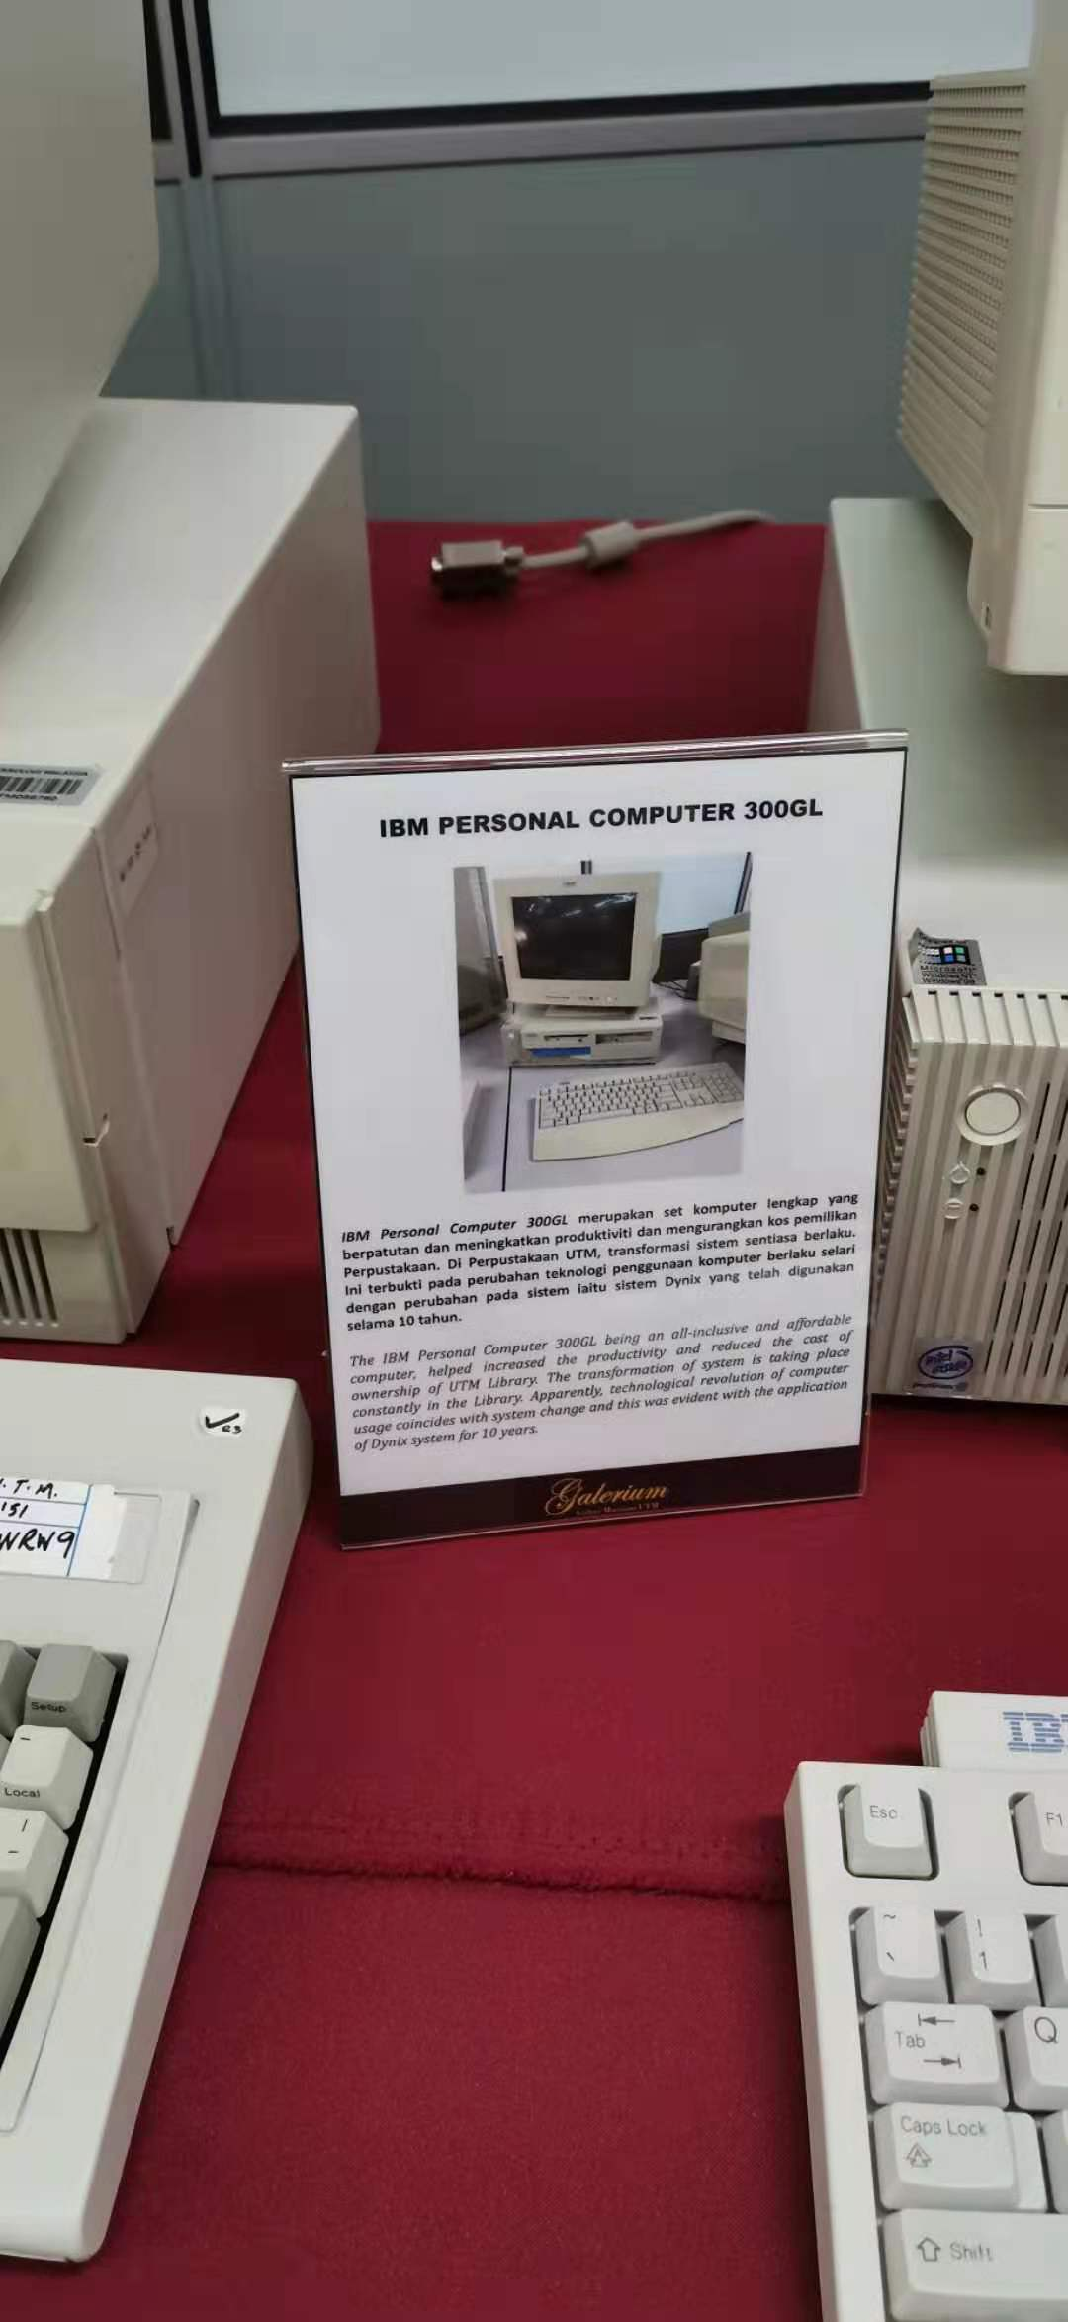
IBM personal computer 300GL
The IBM PC 300GL offers a wide range of processors. The beneficial part of this computer is that it has affordable , processor running at 400MHz, he IBM PC 300GL is loaded with AGP graphics, generous amounts of RAM, and plenty of hard drive storage space it was in our UTM library , the system transformation and the technological revolution of computer usage of Dynix system of over 10 years . These features are designed to make it easier than ever to take care and protect your systems and data.

Computer APPLE Macintosh Classic
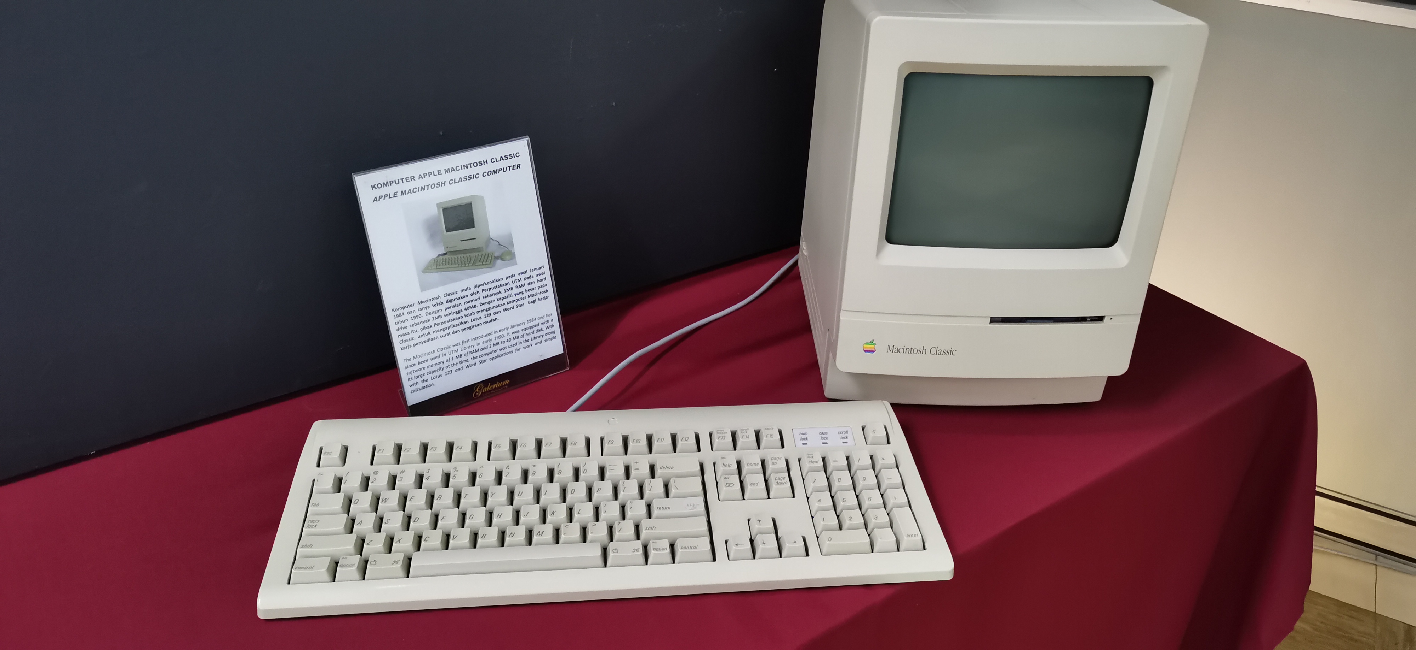
The Macintosh Classic is a personal computer designed, manufactured and sold by Apple Computer, Inc. from 1984 and again in 1990. Which was designed and manufactured and sold by the customer of apple. The was equipped with a memory of 1 MB RAM and 2 MB to 40 MB .The colour classic was the final model of the original Compact family . The combination of the low-cost colour Macintosh and Apple compatibility was intended to encourage the education market's transition.

Block Hot Stamping
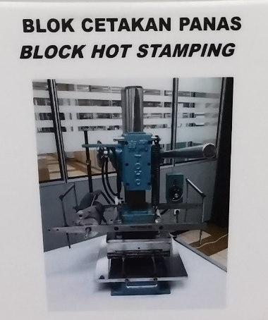
In 1978, the Block Hot Sampling had been used to feature UTM logo and “ Untuk Tuhan Dan Manusia “ , the previous motto. The motto on logo had been changed to “Kerana Tuhan Untuk Manusia”. The golden hot stamping is used on official documents or publications and can be seen clearly against buckram which is a type of cloth commonly used as book covers.

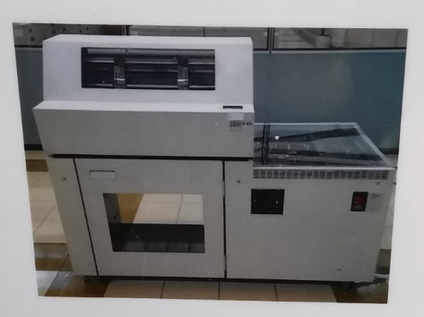
Impact Printer Model: IBM (4245)
The Impact Printer Model: IBM (4245) or Dot Matrix Printer had been used in UTM during the 1990s until 2011. The printer is used to print the information of students and staffs to meet the University’s requirements. The printer is capable to print in high volumes and non-stop for 48 hours.

Projectors
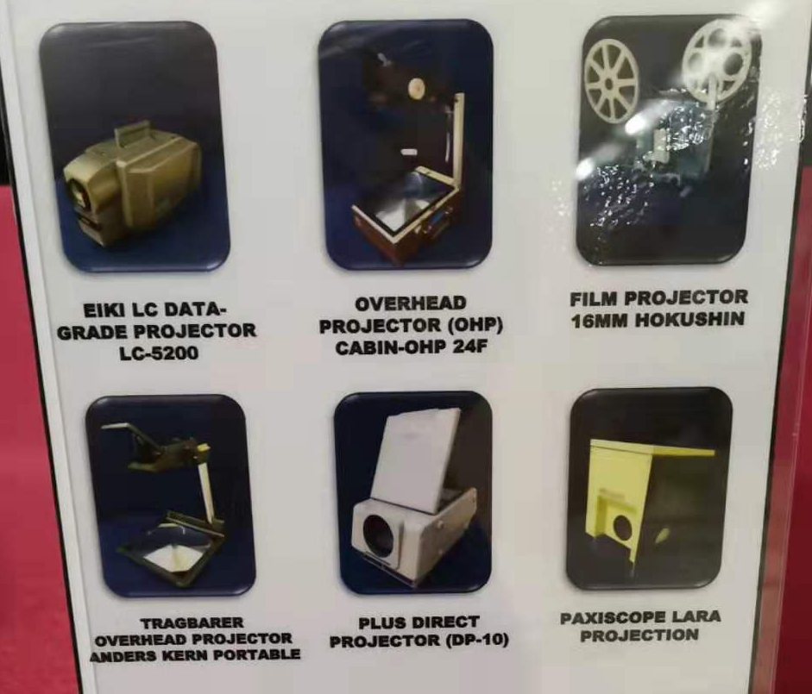
During 1980s until 1990s, there were some projector been used to support the learning and teaching activities. Those projectors were EIKI LC DATA-GRADE Projector LC-5200, Overhead Projector (OHP) Cabin-OHP 24F, Film Projector 13mm Hokushin, Tragberer Overhead Projector Anders Kern Portable, Plus Direct Projector (DP-10) and Plaxiscope Lara Projection.

Slide projector
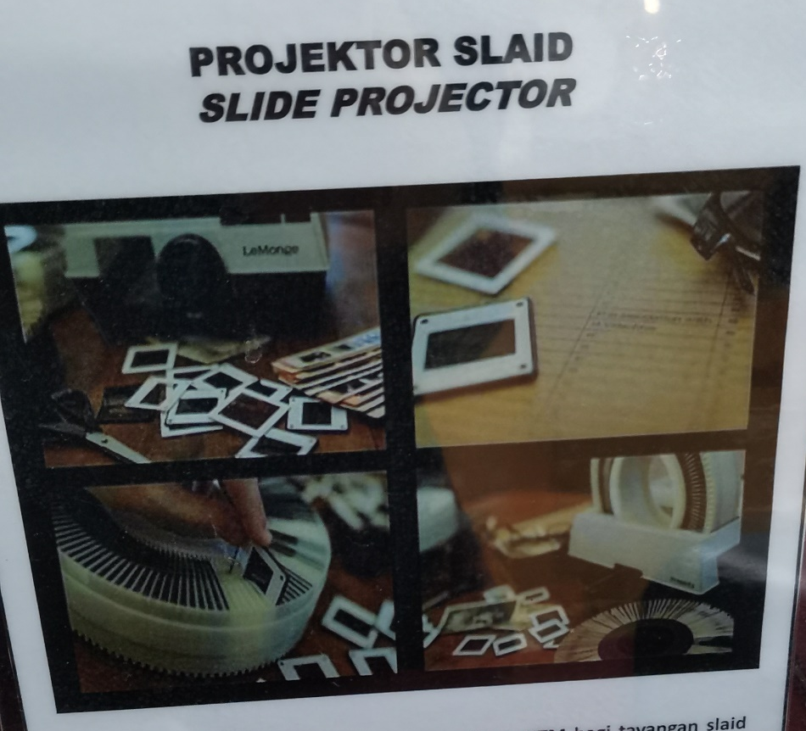
The slide projector had been used by UTM during 1970s until early 1990s to display the slide shows.

Time control device’ Gralab Model’
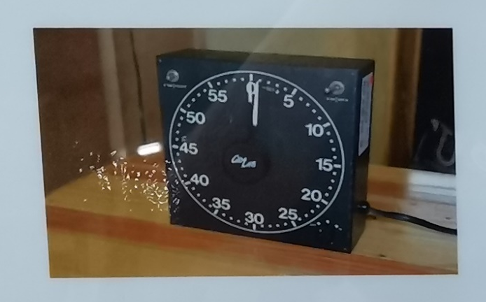
The ‘Darkroom Timer’ is a time control tool used in the darkroom. The time control process was carried out during the process of soaking the microfilms manually in the chemical mixture. This tool was need to control the period of soaking in accordance with the procedure so as not to affect the quality of the microfilm.

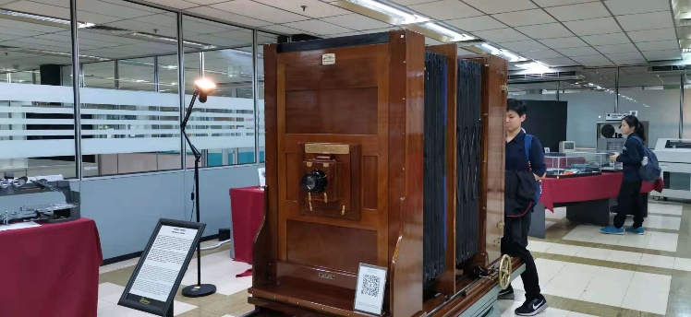
Camera

The Camera Process was manufactured by Hunter Person Ltd.,a company which was based in the United Kingdom where thousands of these devices were sold worldwide in 1890 until1962.This camera which was a gift from the Department of Survey and Mapping Malaysia (JUPEM) was used since the British colonial.This initial model is fully mechanical and it has been used to facilitate students in understanding the principles and procedures of photography production .It is a KLIMCH 'horizontal process camera' and was used in the Cartography Department,Faculty of Surveying during the early 1980s until the late 1990s.The students who undertook land surveying course drew map sketches on papers or tracing papers using technical pens to produce maps and graphics in a conventional method.
This final drawing or manuscript is considered as a scientific document which can be used for various application specifically in the planning and development of land or landfill.The result of the sketch is displayed onto a specific location which is the focal point of camera lens.Plates and films containing terracotta contour images were processed to produce black-and-white maps or colored maps.Printed topographic maps were treated as 'CONFIDENTIAL' and 'LIMITED' and used only for teaching and learning purposes in the faculty.The application of this camera was ceased in early 2004 due ti the advent of digital technology.

Multi TV-VCR Combination
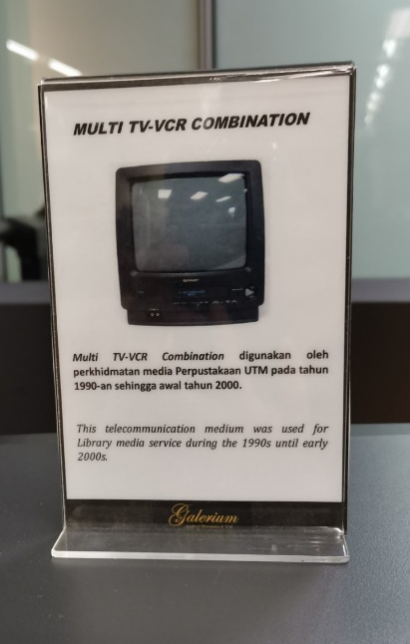
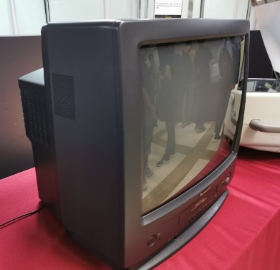

This telecommunication medium was used for Library media service during the 1990s until early 2000s.

This movie camera was used for Library media service to record Library programmes /activities during the 1990s until early 2000s.

Slide film and slide mounting ‘Model Seary’
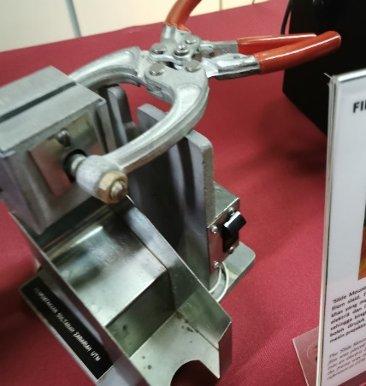
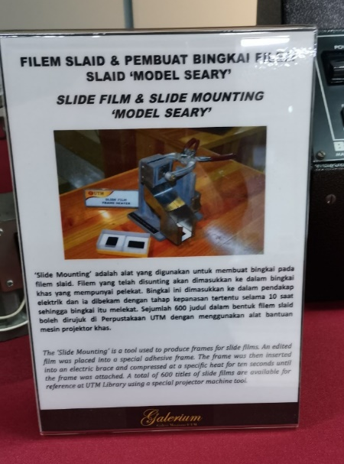

The ‘Slide Mounting’ is a tool used to produce frames for slide films. An edited films was placed into a special adhesive frame. The frame was then inserted into an electric brace and compressed at a special heat for ten seconds until the frame was attached. A total of 600 titles of slide films are available for reference at UTM Library using a special projector machine tool.

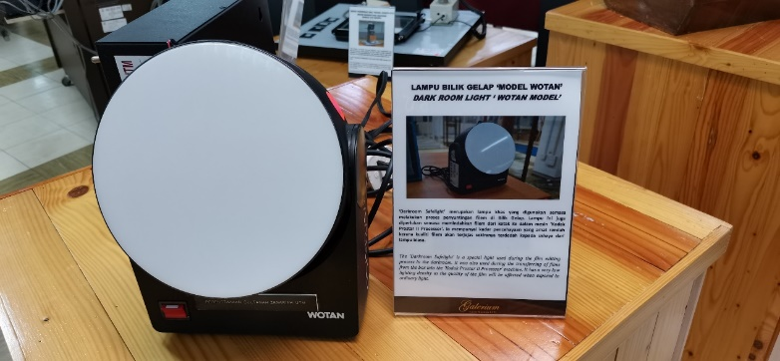
DARK ROOM LIGHT’ WOTAN MODEL’

The ‘Darkroom Safelight’ is a special light used during the film editing process in the darkroom. It was also used during the transferring of films from the box into the ‘Kodak Prostar Ⅱ Processor’ machine. It has a very low lighting density as the quality of the film will be affected when exposed to ordinary light.

- Reflection
  - What is your goal/dream with regard to your course/program?
I hope I can use the knowledge that I had learnt in this course to perform in my future career and to me more knowledgeable in this field. I will be hard-working to increase my information about technology, so I will try to get full attendance in this program because I need this knowledge in the future of my life.

3.2 How does this visit impact on your goal/dream with regard to your program?
This visit gives us a chance to open an eye to different types of the history components related to computing. The visit lets us more interesting in computer when we have a chance to get to understand and observe the components especially those history components. The sightsman had explain the uses and the functions of this history component and how they used it during that time that makes us more understand and surprise about the changing of technologies.

3.3 What are the improvement/ action / plan necessary for you to improve your
potential in the industry?
To be able to assemble something for the benefits of mankind, we need to increase our potential and widen my prospective by constantly exquisite knowledge and experiences. It is very important to have good soft skills and the ability to influence others when we are working in a group as it determines the success of a project. We must know the development of technologies as it will aid us when we are working in the industries.

Task for each members

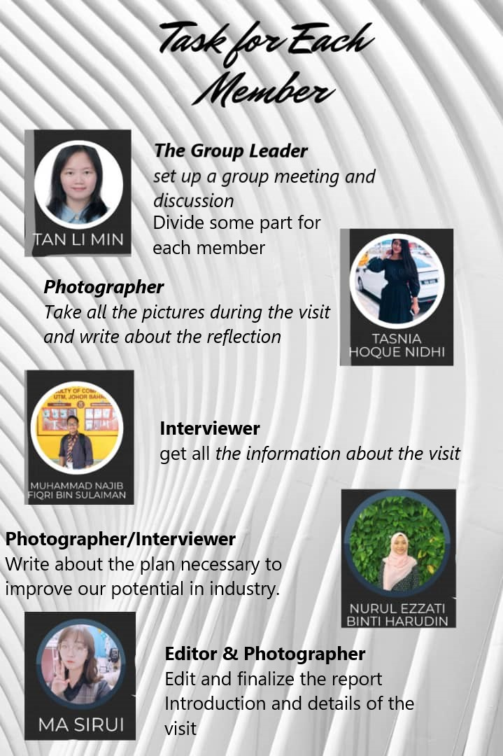

Reference
- https://cict.utm.my/

