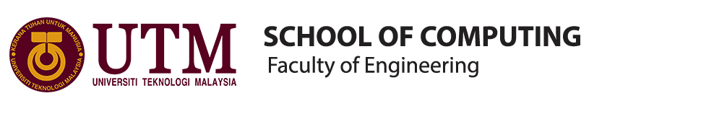
INDUSTRIAL VISIT 1-CICT UTM

TITLE : INDUSTRIAL VISIT 1 –CICT UTM
COURSE/SECTION : SECP
LECTURER : DR. ARYATI BT. BAKRI
GROUP MEMBERS : 1) AZRIANA BT. ZAINAL ABIDIN (A19EC0027)
2) MIRZA SABRINA MOHD SALMI (A19EC0086)
3) CHIA WEI HONG (A19EC0033)

Table of Contents
EXECUTIVE SUMMARY 3
INTRODUCTION 3
DETAIL OF JOURNEY 4
DESCRIPTION ABOUT CICT-HISTORY COMPONENT RELATED TO COMPUTING 5
REFLECTION 12
TASK BY EACH MEMBER 13
CONCLUSION 14
REFERENCES 14

EXECUTIVE SUMMARY
We can summarize that technology improves very fast. The improvement of technology makes mankind’s work easier and faster. Technology devices become smaller and light which make them portable. From the evolution of the technology, it let us know that there is nothing impossible we can’t do in the world.

INTRODUCTION
On 21 October 2019, we went to the Perpustakaan Sultanah Zanariah,UTM for our CICT industry visit. This industry visit was organised by Dr. Aryati Bt. Bakri for data engineering students from school of computing. There were 37 data engineering students and escorted by 2 lecturers during the whole visit. The purpose of this trip is to give the exposure about the history of the CICT in UTM.

DETAIL OF JOURNEY

TIME | EVENT
03.15 P.M | Arrived at the CICT
03.30 P.M | Welcome & Talk Sessions
03.45 P.M | Having tour around CICT
04.00 P.M | Q&A Sessions and Closing
04.15 P.M | Leave CICT
Table 1: Tentative Program of the Visit to CICT

DESCRIPTION ABOUT CICT-HISTORY COMPONENT RELATED TO COMPUTING

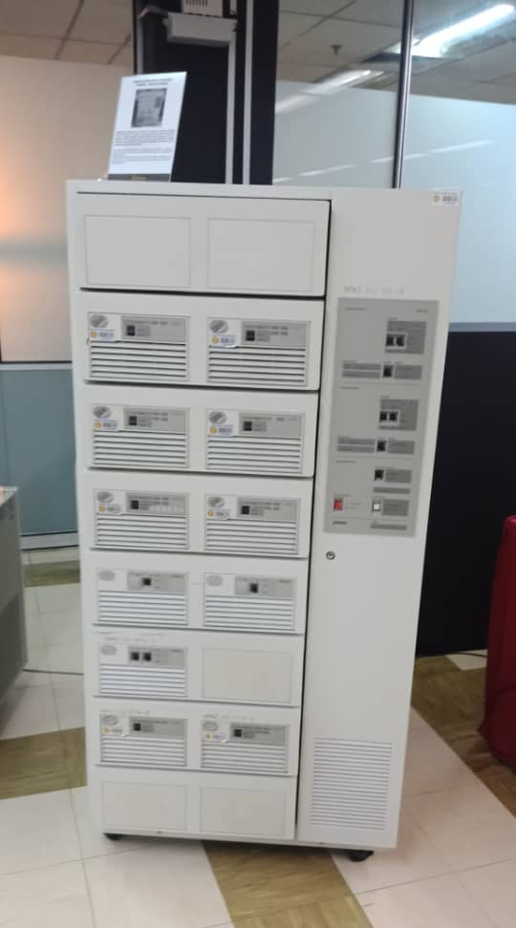
Figure 1.0 is the Mainframe Data Storage model (IBM 9345B22). The Mainframe System began to use in UTM in the 1970s at Computer Centre, UTM campus, Kuala Lumpur. It was used for almost 20 years for various components and function such as processing, storing, securing and printing the University’s information data.

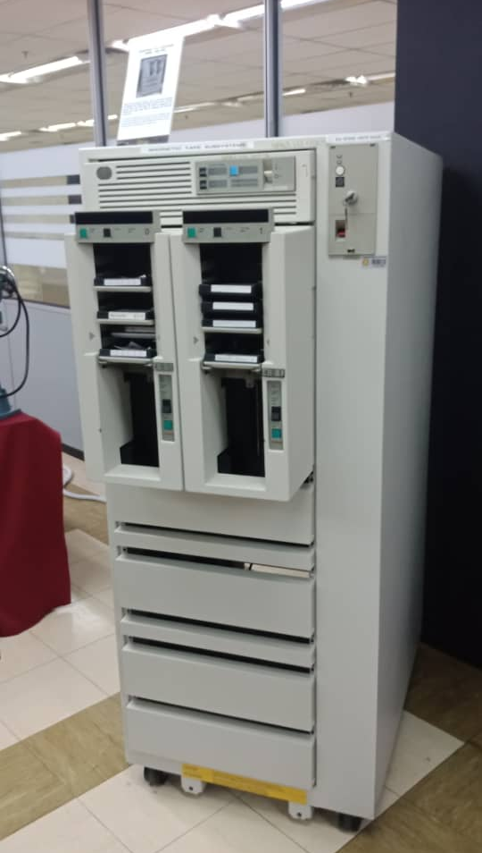

Figure 1.0

Figure 2.0 is the Mainframe Tape Subsystem. During year 1987 until 1995, it was used as a ‘back up’ for mainframe system and information database of staff and students as well as other University’s information system. After the round shape tape was no longer in use, this model replaced it with a square shape tape.
Figure 2.0

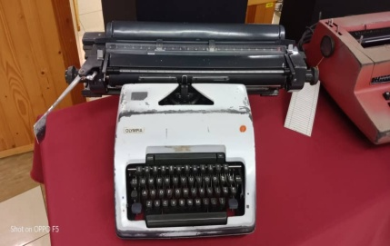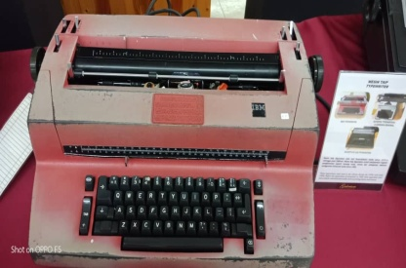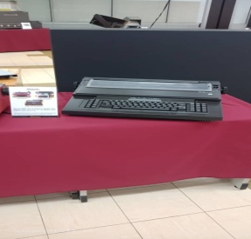
Figure 3.0
Figure 3.0 show three types of typewriter used by the library staff during 1970s until early 1980s to do administrative tasks such as printing letters and memos. The red colour typewriter is IBM typewriter, while the black one is OLIVETT ET 116 Typewriters. The grey one is the Olympia Typewriter which origin from German.

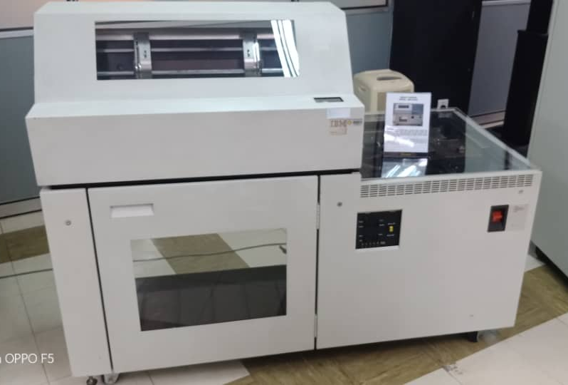
Figure 4.0
Figure 4.0 is the Impact Printer or known as Dot Matrix Printer. Impact Printer is a printing machine used in UTM from the 1990s until 2011. It was used to print the data information of the students and staff to meet the University’s requirements and it can be used non-stop for 48 hours to print large volumes of data information.

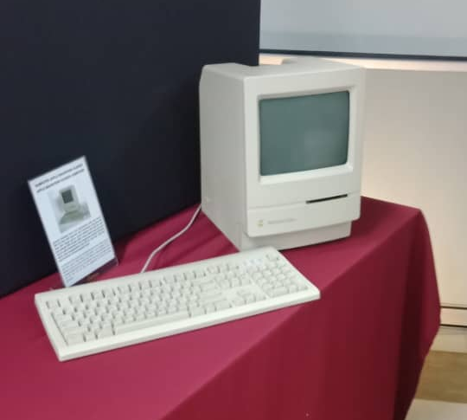
Figure 5.0
Figure 5.0 is the Macintosh Classic Computer. This computer was first introduced in early January 1984 and has been used in UTM Library in early 1990. This computer was equipped with a software memory of 1 MB of RAM and 2 MB to 40 MB of hard disk. This computer was used in the Library along with Lotus 123 and Word Star applications for work and simple calculation.
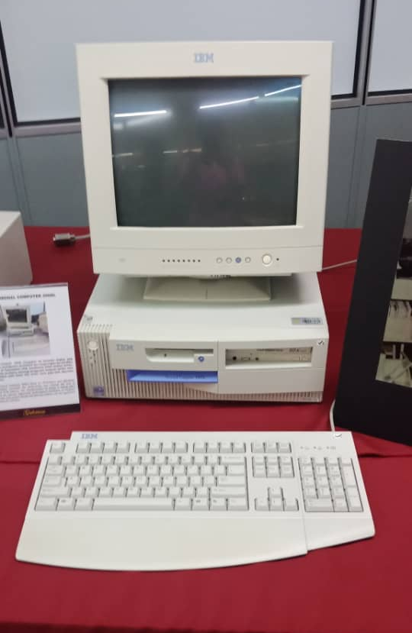
Figure 6.0
Figure 6.0 is the IBM Personal Computer 300GL. Due to IBM Personal Computer 300GL is an all-inclusive and affordable computer, it helps the Library to increase the productivity and reduced the cost. Apparently, technological revolution of computer usage coincides with system change and this was evident with the application of Dynix system for 10 years.

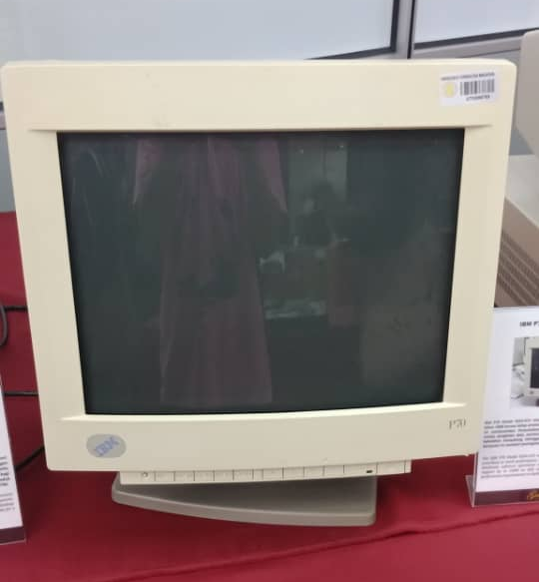
Figure 7.0
Figure 7.0 is the IBM P70 Model 6554-673. IBM P70 Model 6554-673 was used in UTM library in early 1998 and give contribution to the work performance. Due to this computer, Library was liable of all modules, databases, software operations and data accessibility. With its ability to support up to 16MB on disk storage, the computer system provided a performance improvement on desktop operation.
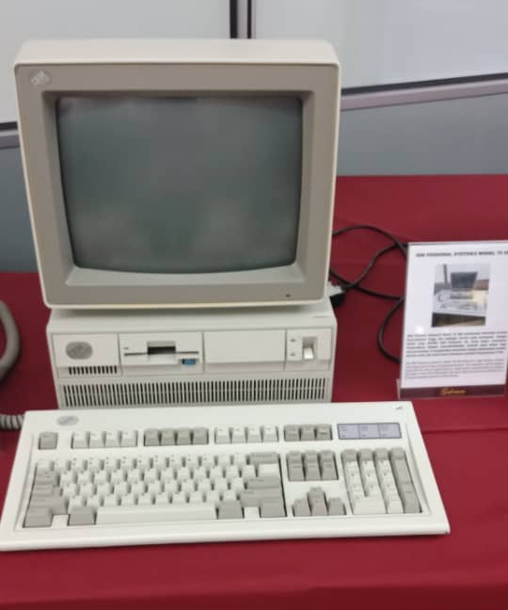
Figure 8.0
Figure 8.0 is IBM Personal System /2 Model 70 386. IBM Personal System/2 Model 70 386 featured a high density memory technology and range of integrated features. This computer with its system supported the Library significantly in performance improvement for desktop operation. It was also compatible with most software products available for a personal computer system in UTM library.

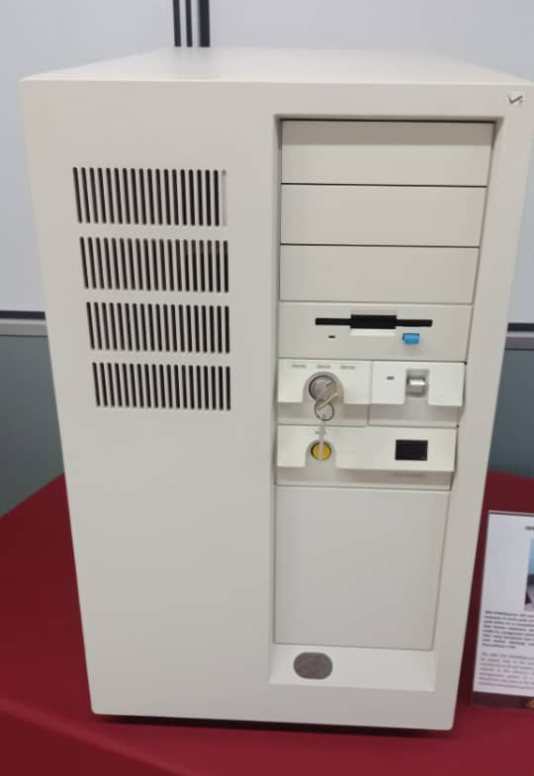
Figure 9.0
Figure 9.0 is IBM Powerserver 550. The IBM 550 Powerserver boasted an outstanding performance with its fastest chip in the world during 1990’s technology. It was considered as an apt system for a medium-sized database at the time. In relation to the Library’s technology, the application of the library management system on a ‘freeze’ terminal which operated on a Mainframe was seen as the starting point of the information technology evolution and played a great impact on UTM Library’s history.

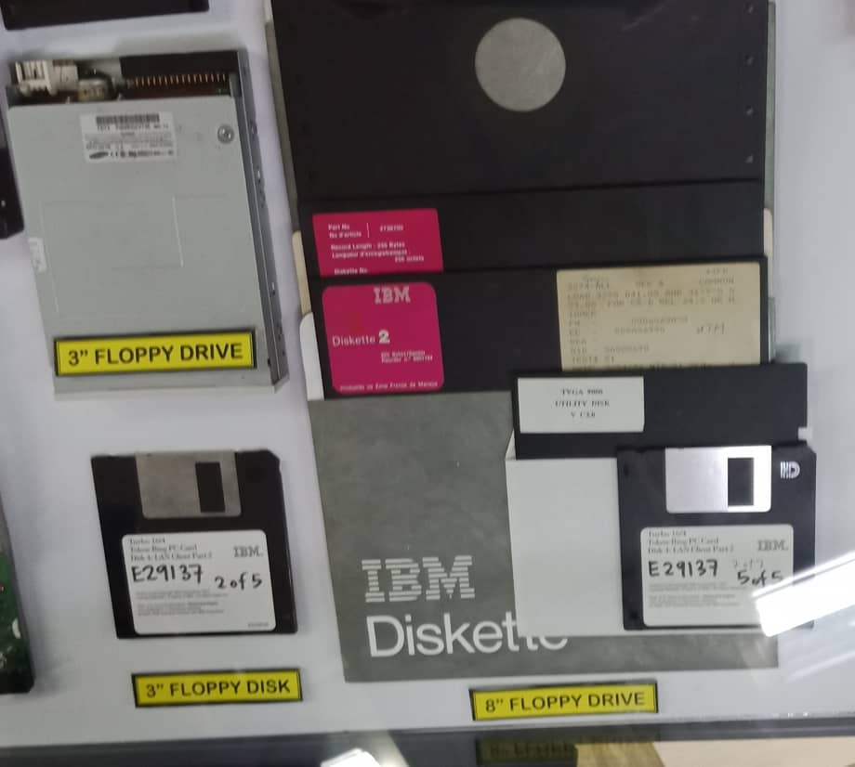
figure 10.0
The component inside figure 10.0 is 8’’ Floppy Drive which is at the right side of the figure, while the component on the left of the figure is 3’’ Floppy Drive and 3’’ Floppy Disk. The function of the floppy disk drive is to reads and writes the data into a small, circular piece of metal-coated plastic which is similar to the function of the audio cassette tape. In 1967, Alan Shugart had invented the first floppy disk drive (FDD) at IBM and the size of the disk used is an 8-inch disk which you can see at the right side of the figure 10.0. By the mid-1980s, due to the improvements of the magnetic recording media, a 3.5-inch, 1.44-megabyte (MB) capacity FDD (at the left side of the figure) was invented and be used until now0

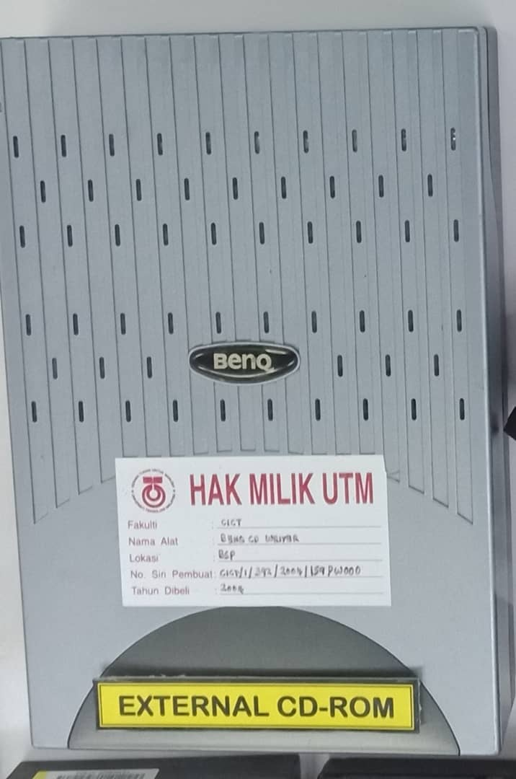
Figure 11.0
The component show in the Figure 11.0 is a CD-ROM drive. CD-ROM drive is a device that can read information from a CD-ROM. ROM stands for Read Only Memory. CD-ROM is bought with pre-load data already on them which cannot be removed or changed and new data cannot be written over. External CD-ROM drive generally is connected to the computer's SCSI interface or parallel port.

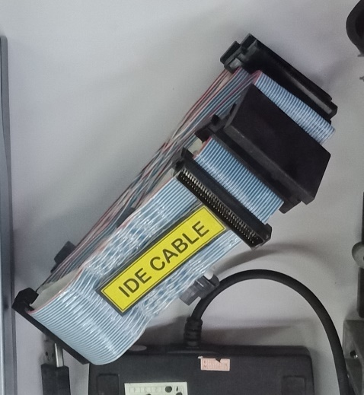
Figure 12.0
Figure 12.0 show the IDE Cable. IDE (Integrated Drive Electronics) cable, is a type of connection for storage devices in a computer. Function of IDE cable is used to connect some hard drives and optical drives to each other and to the motherboard. And it normally can be found at the end of the two connection IDE cable in the computer.

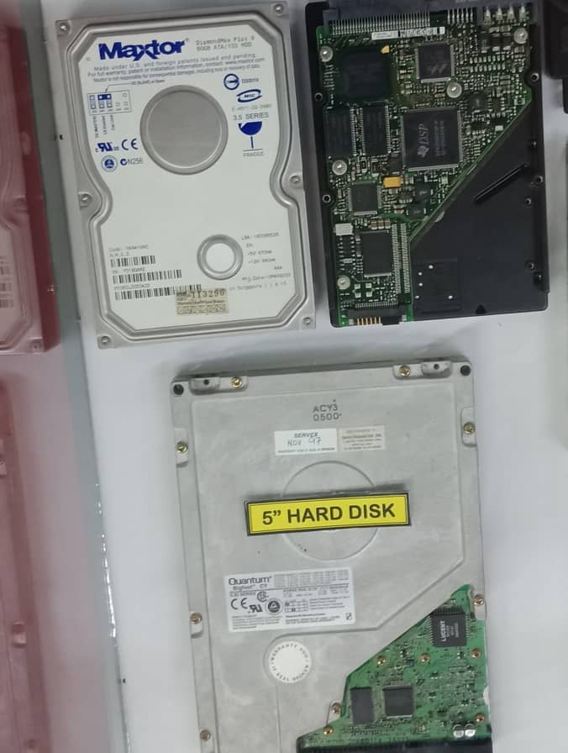
Figure 13.0
The component inside the Figure 13.0 is hard disk. Hard disk is an electro-mechanical data storage device that uses magnetic storage to store and retrieve digital information. It is a non-volatile data storage device that can retrieve stored information even after having been power cycled. The 5inches hard disk with capacity of 4.3 GB once used in UTM before they changed to secondary storage device.
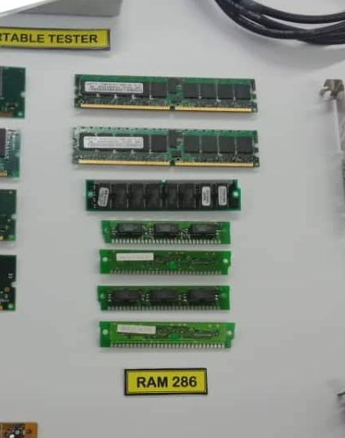
Figure 14.0
Figure 14.0 shows the RAM 286(random access memory 286).RAM is called volatile memory because if the computer loses its power,all data that stored in RAM will be lost.RAM is much faster to read and to write compare to than other kinds of storage in computer.Mostly, the second generation PC used 80286 processor.The computer usually just called a 286 computer,because it used 80286 processor (RAM 286).

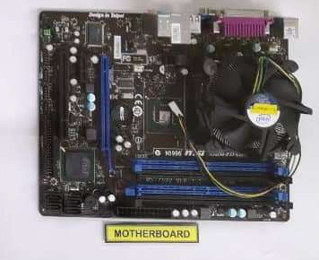

FIGURE 15.0
Figure 15.0 shows motherboard.Motherboard is the most important part in computer system.It is known as the main board that allows connection between all component to attach with the computer.First motherboard was realesed in 1981.The most important part in motherboard are power pots,battery,PCI and RAM slots.All major computing proccesess are carry out in motherboard

REFLECTION
Wei Hong
My dream is to become a data engineer that give a lot of contribution to our country and society through data storage and data analysis. This is because I can see that by using data, we can do a lot of things to improve the economy and development of Malaysia. For example, we can analysis the data of average salary and the living expenses of the people in Malaysia and find the solution to solve the economic crisis in Malaysia such as poverty, and the oversupply real estate property.
Through the visit from CICT, I saw that the evolution of the technology from time to time such as from a super big camera to a small camera that every can bring with them easily and the evolution of the computer from the super big computer in the past until the small and light laptop nowadays. From the evolution of the technology, it let me know that there is nothing impossible we can’t do in the world. Therefore, I believe that by using the source and power of data we can give a lot of contribution to our lovely country and earth. As conclusion, I need to study hard and practice more by joining competition and talk to increase my experience so that I can give my contribution to the country and society.
Mirza Sabrina
My goal is to get a job easily after I graduated. I’ve read some news which stated that data analytic is the most demanding job in future. This is the main reason why I choose data engineering course for my degree program. I realize that a company can improve a lot from analysed data. Through the visit to CICT, I can see the evolution of technology from decades ago until now. It makes me realized that technology improvement will always accelerate from time to time. Thus, I need to always update and upgrade my digital skills in order to survive in competitive era.
Azriana
My dream is to get a job and become a CEO in a data business company. I choose this Data Engineering course because nowadays it is about technology. Everybody uses data in their daily work. Everybody use technology in their daily life. To conclude,that data employees highly demand through this era. Big Data is everywhere and for the fear of missing the data. This is why Data Analytics is really important in IT. Besides that, working as an analytic role in IT can gain much more salary than other jobs.
Through the visit from CICT, I saw the evolution of technology since the life of Henry Gurney that put his signature on the assignment book by UTM. From the evolution, it shows that a long time ago our machine has a bigger size than now. Our era has a much smaller size but advanced in their functioning. As conclusion. I realized that I have a lot more things to improve in my IT knowledge so that I can survive in this technology era.

TASK BY EACH MEMBER
Mirza | Photographer  Detailed descriptions of history of component  Reflection  Task by each member
Azriana | Recorder  Detailed descriptions of history of component  Reflection  Introduction
Wei Hong | Interviewer  Detailed descriptions of history of component  Reflection  Details of Journey

CONCLUSION
In conclusion, we realized that technology is growing up fast until this 21st century being called as the era of science and technology. The latest technology of artificial intelligence (AI) might bring a whole new era of revolution. Besides AI System can communicate with human, it might be able to think like human’s brain about how to improve themselves.

REFERENCES
- Margaret R.(2014, August).Volatile Memory.
Retrieved from https://whatis.techtarget.com/definition/volatile-memory
- Phill.(1998, December 26).286 and 386 PC Hardware.
Retrieved from http://philipstorr.id.au/pcbook/showtell/show3.htm
- Computer.H.(2019,July 10).CD_ROM.
Retrieved from https://www.computerhope.com/jargon/c/cdrom.htm
- Tim.F(2019, May 14).What is an IDE cable?.
Retrieved from https://www.lifewire.com/what-is-an-ide-cable-2625908
- Tim.F(2019,May 23).What is a Floopy Drive?.
Retrieved from https://www.lifewire.com/what-is-a-floppy-drive-2618151

