
TECHNOLOGY INFORMATION SYSTEM (TIS)
SESSION 2019/2020 SEMESTER 1


PROJECT REPORT
INDUSTRIAL VISIT MAGICX

GROUP 6
AARON RYAN SHAMIKA (A19EC0001)
YU KAH WEI (A19EC0178)
CHONG HONG LEI (A19EC0035)
NUR SYAFRINA BINTI AHMAD (A19EC0149)

LECTURER
DR. SARINA BINTI SULAIMAN

DATE OF VISIT
6TH OCTOBER 2019

DATE OF SUBMISSION
15TH OCTOBER 2019

Table of Contents
INTRODUCTION 2
3D PRINTING 4
DRIVING SIMULATION 5
KINECTIVE INTERACTIVE WALL 8
DEMO ON VIRTUAL REALITY OF ORCULUS QUEST 9
AUGMENTED REALITY (AR) 11
REFLECTION 13

INTRODUCTION
An industrial visit to MAGICX at T03, Level 1, University Industry Research Laboratory (UIRL), Universiti Teknologi Malaysia, 81310 Johor Bahru, on Sunday, 6th October 2019. A minimum of two sections visited the MAGICX, along with their TIS lecturer to interact with some projects developed by the team in MAGICX, called the MAGICXian to expose ourselves with the technologies that could change the way we study in the coming future. In this visit, the students were divided into 5 groups rotating from one project to another to make sure all students were given the chance to test the project.

Media and Game Innovation Centre of Excellence (MaGICX) is a strategic cooperation between Universiti Teknologi Malaysia (UTM) and Iskandar Regional Development Authority (IRDA) to support and promote the development and ecosystem of creative industry that focuses on gamification and enrichment of digital content. MaGICX will play an integral part as the anchor for the Iskandar Malaysia Innovation Valley envisioned to offer industry players/SMEs/clients technical expertise/consultation, research/product development, business development, publishing, marketing and/or training in producing commercially.

ORGANIZATION STRUCTURE

Assoc. Prof. Dr. Mohd Yazid Idris

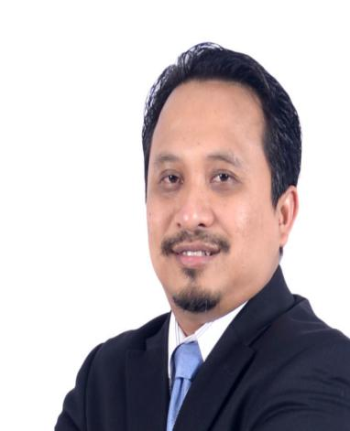
Prof. Dr. Mohd Shahrizal Sunar, Prof. Dr. Ali Selamat, Prof. Dr. Mohd. Shafry bin Mohd Rahim


Assoc. Prof. Dr. Shukor Abd Rzak, Dr. Farhan Mohamed, Azizul Azman

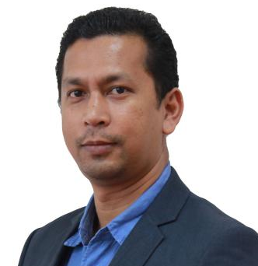
Dr. Kamarulafizam Ismail
3D PRINTING
3D printing has been around for more than 30 years but has only now appeared itself to the public as it is now possible to have a 3D printer on your own. A 3D printer is quite expensive to get so not everyone are able to buy it with their own money. Here in MAGICX, they have their own 3D printer and we get to see how it actually works with our own eyes as one of the MAGICXian show us that we can create anything we want, with the proper procedure. The material they were using for the object printed is Polylactic Acid (PLA) filament as this is one of the common materials used in 3D printing.
The 3D printer shown were small and can only build objects smaller than the printer, thus limits the scale of the object we intended to make. 3D printing is a faster way for production, since there is no need to build dedicated conveyor belt production line, saving time and earn more money if it were for business purposes. It also allows any kind of ideas and innovation to be tested by building it using the 3D printer, that might be a breakthrough UTM should be able to get. Almost all companies uses 3D printer to test their prototypes and so should we.
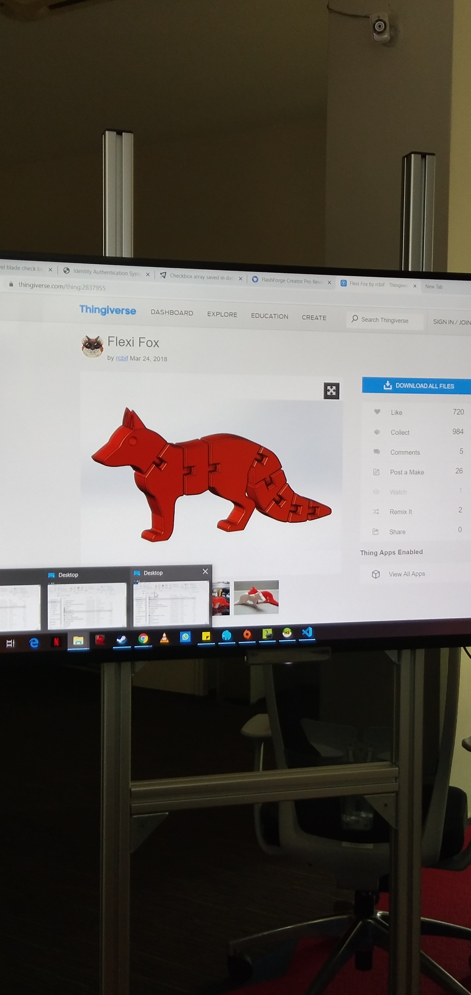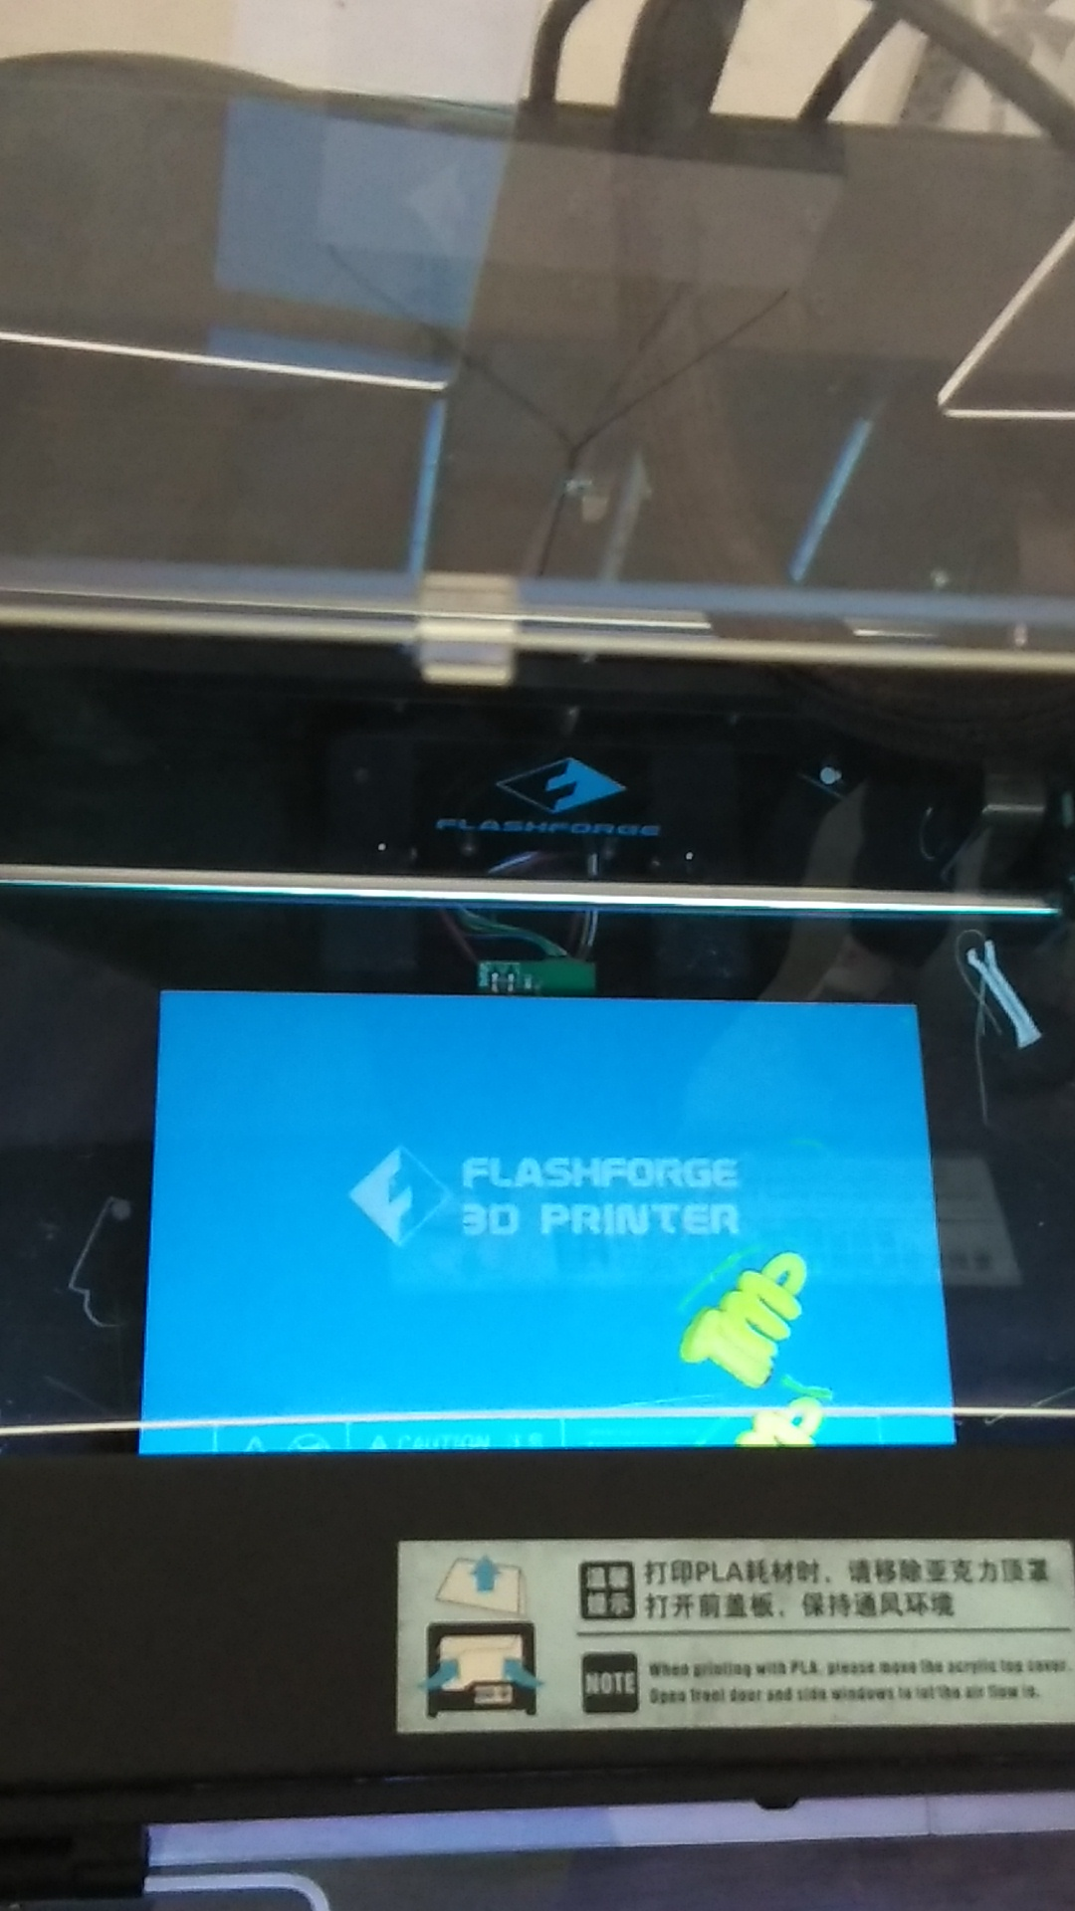

DRIVING SIMULATION
Driving simulators are probably the most sophisticated application of computer-aided kinematic and dynamic simulations, which is studying the vehicle engineering, traffics flow, and driver behavioral issues. Driving simulators were initially designed at full-scale by the car manufacturers and the authorities of transportation with which a complex instrumentation system was directly connected to a real car cockpit. The UTM driving simulator for vehicle engineering research is designed in a collaborative simulation with which is consisted of two computers connected over a Local Area Network (LAN) and interact in real time to share the simulation information.

The use of driving simulators has evolved from the first applications related to driver training or analysis of the effect of impairment on driver performance such as alcohol or drugs, to more complex research studies focused on human factors and driver behavior during primary and secondary driving tasks. Besides that, driving simulator is used to train and test novice drivers in all the skills required to pass a driver’s license road test as well as hazard perception and crash risk mitigation.

There are some technical difficulties in the development of Virtual Environment(VE) for driving simulation. Firstly, the human driver needs feel that the entire VE is in good accessibility and any maneuvering actions can directly and immediately affect the VE []. Secondly, differences in graphical capabilities of the interface attributes in VE and the real world may cause dissimilarity. Thirdly, the number of objects that may simultaneously participate in the system is important in order to create a comprehensive VE. The complexity of VE increases exponentially with the number of participating objects because of the possible interactions among them. Fourthly, graphical generation in automotive driving simulator must occur at frame rate with high sufficiency. The real-time processing of human driver’s interaction in VE is needed to maintain its immersion.
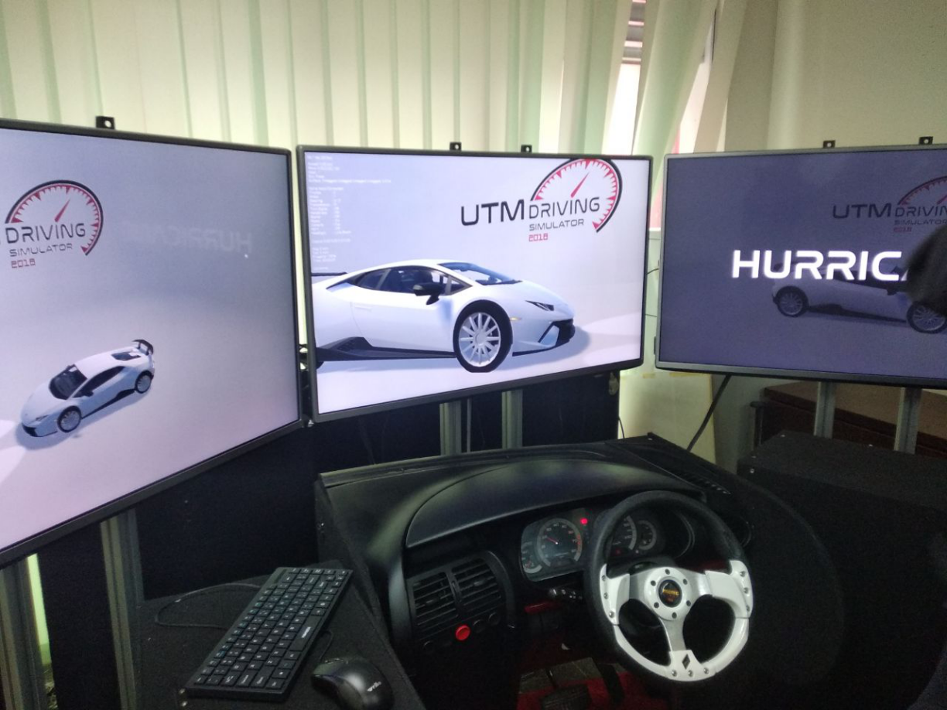

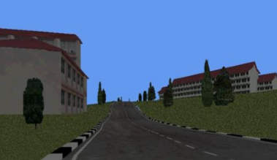

KINECTIVE INTERACTIVE WALL
MAGICX created an interactive wall powered by the microsoft kinect system. It allows user to use the computer without the need for mouse and keyboard. The idea came from the Iron Man movies, like how Tony Stark access the computer uses only hand gestures and voice commands. At first, when we think of kinect, it was only special for Xbox for playing games and found no more use for it but the team here in MAGICX showed us more than one uses of kinect. The kinect interactive wall is still under developed so it has limited interaction to mess around with, it can only detect one user at a time and it was slow to react to our hands as everyone has different sizes for their hands.
The kinect interactive wall has the biggest potential in the future in my opinion, Just getting the kinect system is enough to use the computer if it was perfected and no longer need to use mouse nor keyboard. We could add voice and face recognition for more interaction and security purposes instead of only motion sensors. By combining augmented reality and virtual reality with the kinect, we can make the whole room our computer.
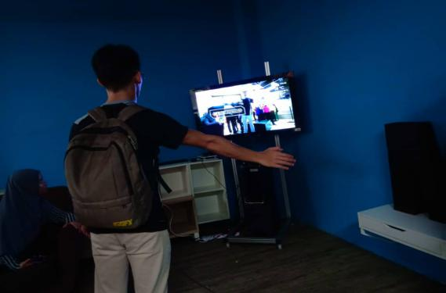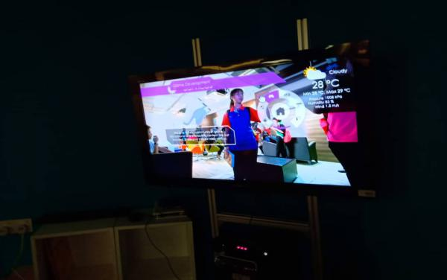

DEMO ON VIRTUAL REALITY OF ORCULUS QUEST
Demo on Virtual Reality of Oculus Quest is one of the projects that have been developed by MAGICX. Virtual Reality or simply we call it VR is a computer-generated simulation of a three-dimensional image or environment that can be interacted with in a seemingly real or physical way by a person using special electronic equipment, such as a helmet with a screen inside or gloves fitted with sensors. [1] Whereas Oculus Quest is a standalone, mobile, powerful VR headset with two hand controllers and six degrees of freedom. It costs approximately $400 (RM1700.00).
Compare Oculus Quest with Oculus Go and Rift, the most obvious difference is the spatial tracking built into the headset. Unlike the Rift, we do not need to set up cameras in a room to convey our physical position to the headset. In that respect, the Quest truly is special. Whereas the Go allows you to look up-down-left-right, the Quest lets you physically “move” around the VR space. Besides that, Oculus Quest has a built-in Qualcomm Snapdragon powerful processor. This level of power is probably more applicable to gamers than most of our user. Moreover, Oculus Quest has strong visuals and audio. It has built-in speakers that reportedly deliver solid audio. Also, each eye delivers 1,600 x 1,440 pixels, a meaningfully crisper visual than the Go. (i.e. more “lifelike”)

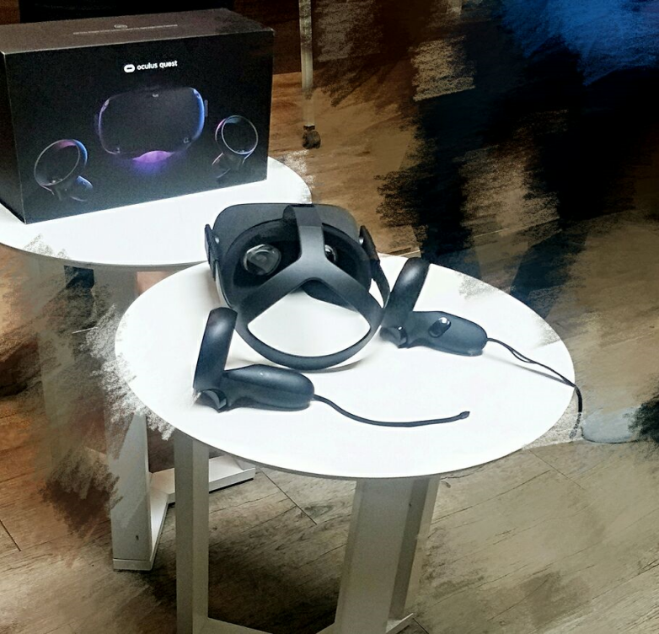

There are some of the best VR games capable on the market. For example, Beat Saber (a rhythm game), Drop Dead: Dual Strike Edition(an action game) and Moss(an adventure and puzzle game).

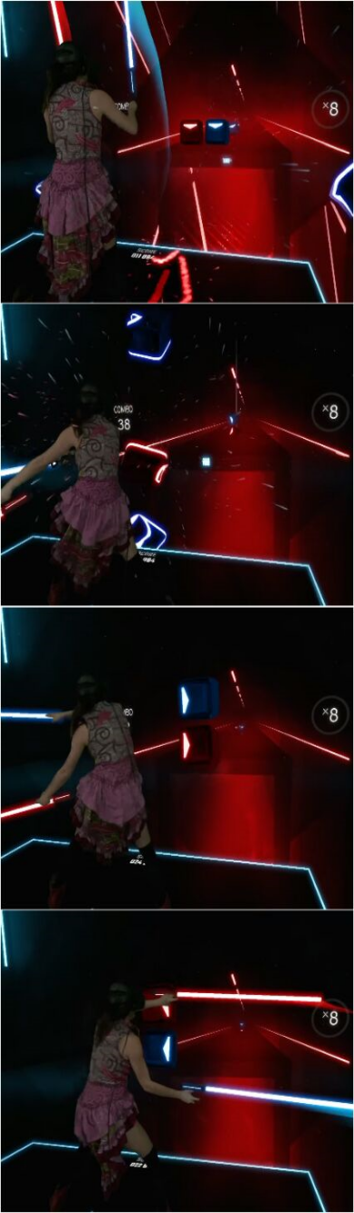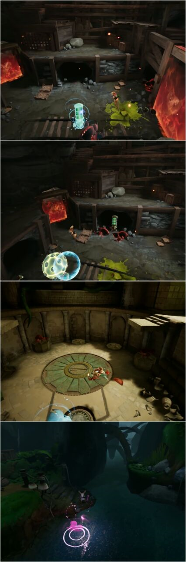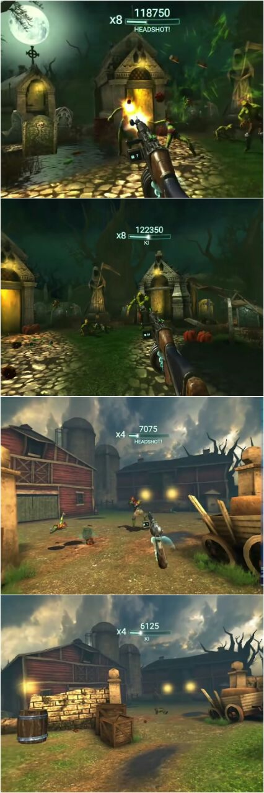

AUGMENTED REALITY (AR)
Augmented Reality (AR) is a technology that superimposes a computer-generated image on a user's view of the real world, thus providing a composite view. [6]
One of the products under MAGICX is Ameen Daily Prayer. This is an application using AR technology to provide new way on learning. To show Ameen in 3D, it requires users to scan specific marker using camera application. This will attract users to learn through play. They will be able to memorize the prayers easily as learning through AR technology is more entertaining. Different from reading books which is dull and bored. [7]
Other than Ameen Daily Prayer, they also developed a product called wARna. It is an application combines coloring activities with AR technology to give users a magical experience. It provides an interactive coloring book to children and also emphasizes the introductory learning aspect of each colored object. Each page that has been colored and scanned using this application, a 3D model will appear on the screen of your device according to the color you have created. [8]

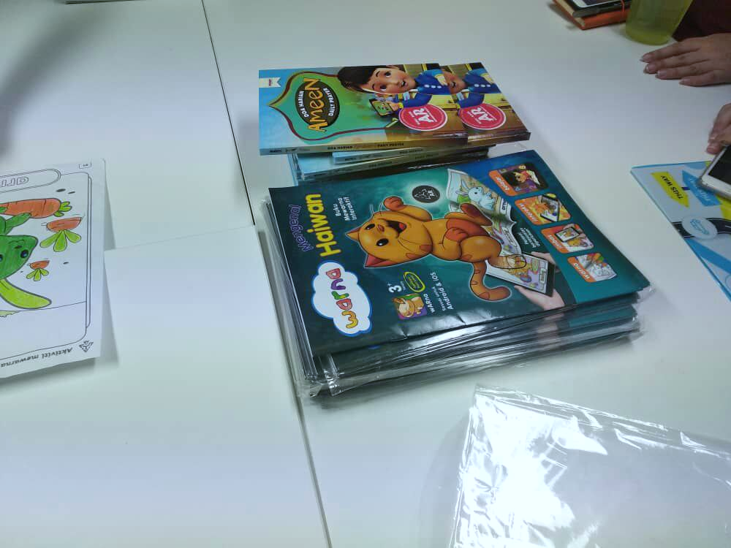
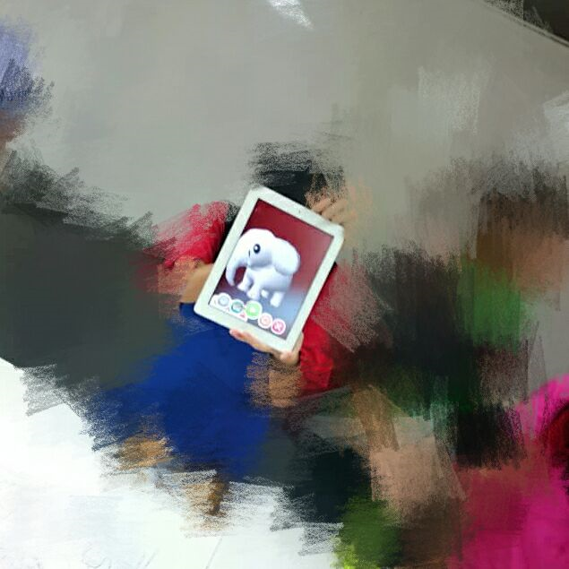

Example of AR games: Pokemon Go, Real Strike – The Original 3D Augmented Reality FPS Gun App, ARBasketball – Augmented Reality Basketball Game.

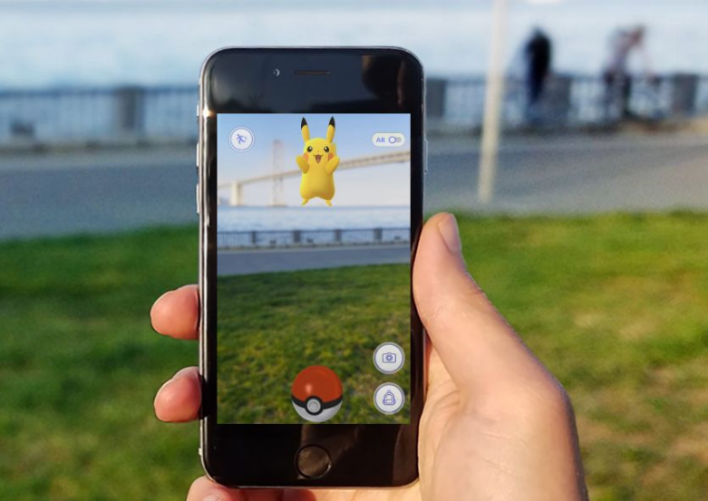

REFLECTION
The industrial visit were quite fun and interesting. The underdeveloped projects we get to tested were actually working, serving its purposes, although its not near perfection. MAGICX should be given a little bit more funding because if one of the project were to be given a priority to be perfected, it would change the way the world works and change the way we study as well. Our goals as a computer science students majoring in graphics can be found here in MAGICX and would not mind joining the research team if given the opportunity because I believe the projects in MAGICX are revolutionary and necessary for the world, for mankind to evolve to a better phase.
Now that MAGICX showed us some promising projects, we are all eager to improve our soft skills in designing, programming and other skills involving computer science, in order to join hands in making the project a success. Overall, the industrial visit to MAGICX were quite insightful and hope to hear its progress in the near future.

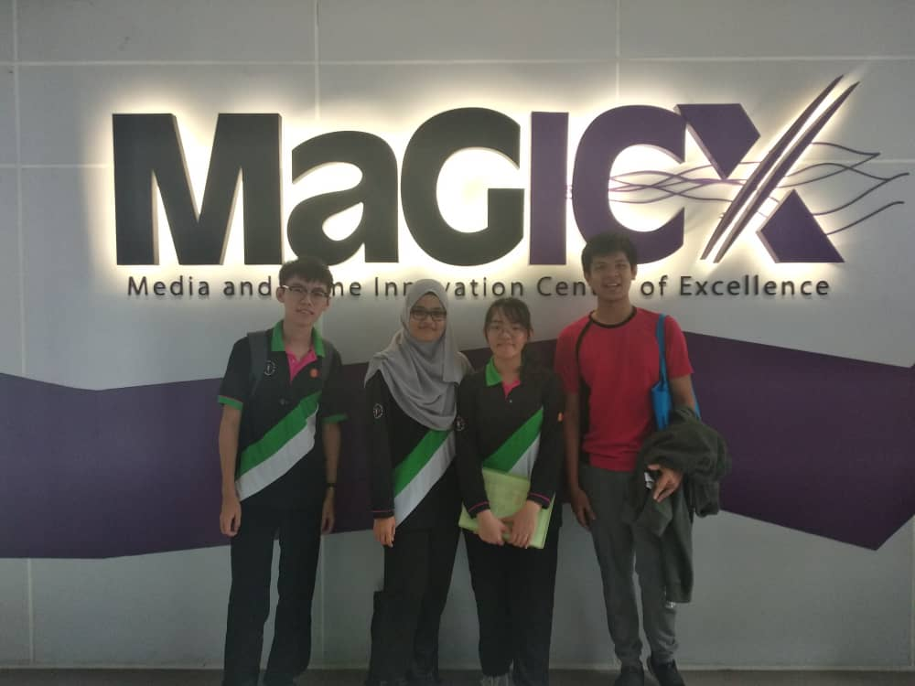
Each of us were separated to each of the section of projects to test all the projects presented by MAGICX.
Aaron - Kinect Interactive Wall
Yu - Driving Simulation
Chong - AR and VR
Syafrina - 3D printer

