

TECHNOLOGY AND INFORMATION SYSTEM
SECP1513 – SECTION 7

REPORT OF DESIGN THINKING

LECTURER: DR. SARINA BINTI SULAIMAN

NO. | GROUP MEMBERS | MATRIC NO.
1. | ROSHANDEV DANIEL A/L | A19EC0156
2. | NUR LYNNDA BINTI ROSLIZAN | A19EC0134
3. | KOH XIN YI | A19EC0064
4. | NG JING ER | A19EC0115

INTRODUCTION
Design thinking is a process which encourages the students to think critically to develop solutions for the problems. Design thinking consists of five stages which are empathize, define, ideate, prototype and the last is test. None of these five stages is dispensable to get our project done. Throughout the process of design thinking, students are encouraged to think out of the box and generate creative ideas to create a hands-on approach in order to complete the task.
The topic we used in this design thinking assignment is about input and output. Here’s a short introduction about input and output. Input is any data or instruction used by a computer. Input devices translate data into a form that the system unit can process. There are a few examples of input devices such as keyboards, mice, scanner, mic, and so on. Output is the processed data or information. There are a few types of output such as text, graphic or photos, audio & video. And the examples of output devices are monitors, printer and speaker.
For the task that given based on our topic which is input and output, our group had gone through a multiple of discussions. We had prepared a series of questions to interview a few UTM students. Based on the content of the interview, we had analysed and identified the problems. The great ideas were gathered among the members based on the needs of users and to solve the problems faced by the students we interviewed. At last, a protype is formed based on the ideas that gathered and the feedbacks of the users are collected.

STEPS AND DESCRIPTION
Date | Activity
18/10/2019 | - Group discussion about the contents of the assignment.
19/10/2019 | - Group discussion about the contents of the report and the details of every part.  - Prepare interview questions.  - Work distribution for every member.
23/10/2019 | - Interview students based on the questions prepared.  - The entire process of interview is recorded in the form of video.
3/11/2019 | - Discussion about the problems stated by the students we interviewed.  - Define the problems.  - Discussion about the solutions for the problems.
5/11/2019 | - Discussion about the solutions for the problems.  - Discussion about the design of prototype.  - Start to make a prototype  - Discussion is made to improve the prototype that designed.
7/11/2019 | - Testing the prototype  - Collect the feedback from the users
7/11/2019 – 9/11/2019 | - Complete the report, video and slideshow

- EMPATHIZE
Basically, empathize can be split and divided or categorized into 3 different parts which are observe, engage, and immerse.

OBSERVE:
Based on our interview and research, we managed to concluded from data collected that most students face the issue of not having a wide and big enough screen to do a group discussion and this becomes a huge inconvenience to them to carry out group discussions or activities conveniently. As we can see the screen of our laptops or phones do not project a wide or large enough screen for everyone to see and commute together as group. As group we decided to observe, as well as look at the problems we suffer when carrying out group discussions as well and using a projector is difficult and inconvenient for everyone as it is bulky and huge. Therefore, we decided to brainstorm as well as interview students to have a better view on the issue based on the questions we asked them.

ENGAGE
We carried out interviews with students around University Technology Malaysia Johor, based on questions that we had brainstormed earlier. Our questioned were based mostly on problems faced by students while carrying out group discussions or activities. Our questions were mainly focused on what are the issues with using phones, laptop, projector and other methods to carry out group discussions or large group activities. Based on their replies and reviews we were able to conclude the main issue which enabled us to carry out the next step and brainstorm ideas to overcome it and were able to come up with a solution to the issue.

IMMERSE
From the responses we were able to precisely see and engage with issue and see the pattern of problems faced by students in carrying out group discussions and activities. Based on that we brainstormed solutions to overcome these issues and problems that are causing inconvenience to the students.
- DEFINE
Based on the interviews we carried out based on the questions drafted during our group discussion we received many feedbacks as to the issue faced by students here in UTM Johor during group discussions and activities. There are some who said using phones and laptops are not sufficient enough as the screen isn’t wide or big enough to carry out the discussions as not all group members are able to view the slides or presentation. Some of them stated that finding and using projectors were inconvenient as it is bulky and requires plugs and socket to be used.
After thoroughly going through the responses we analysed the issue and had a goal which was to create and design a prototype that would make the life of these students easier and simple so that when they carry out group discussion or activities everybody is able to engage and take part in the activity and discussions. We decided to come up with the best solution possible that will result in a great prototype.

3. IDEATE
In this process and phase, we brainstormed ideas for our prototype as well as the solution and everyone was flowing with ideas and we had a long discussion on which idea suited the solution and prototype better. We listed all the ideas down before making the final decision which we based on a few criteria which were rational choice, most likely to succeed, the long term effect, and expenditure on building the prototype.

4. PROTOTYPE
In this phase we carried out the process to create and make the prototype. We made the prototype based on the drafts and ideas we collected. We made the prototype from scratch and tried using recyclable items as we wanted it to be eco-friendly. We made it public to enable students to take a look at it and explained the mechanism and how it works to them. Our prototype’s main purpose is to help students have a better group discussion and activity experience. We made it simple to use and easy to access as well as made it convenient to carry around and bring along as students may not all be located at the same place. We also managed to come up with more ideas along the way as we were building this prototype to make it more simple and easier to use.
5. TEST
By reaching this state and process only then we will know if our prototype works perfectly or not. From there we evaluated according to our effort and idea to produce the prototype as well as its capability and our goal. If it achieved all that we set it out too means that it passed and that it was ready to be used by students.

DETAILED DESCRIPTION
The problems we faced during this process was the issue of head butting and clash between ideas of each and every team member as well as being able to finish this assignment and project in time as time management was a huge factor. If we just focused on giving our ideas and not choosing one, we will mostly crash into issues, so what we did was we let every team member to give their point of view personally and basically listed them out before we made a decision based on the criteria we set. We worked as a group throughout the whole process to prevent from errors and issues to occur along the way as when we worked together as one we were able to complete the prototype and this assignment quickly.

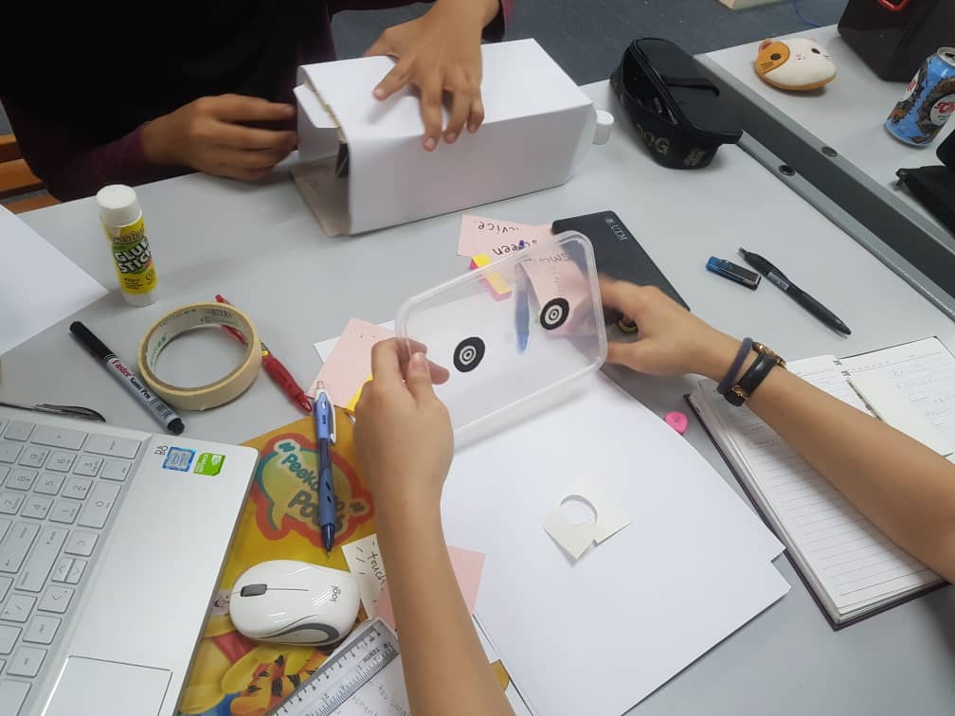
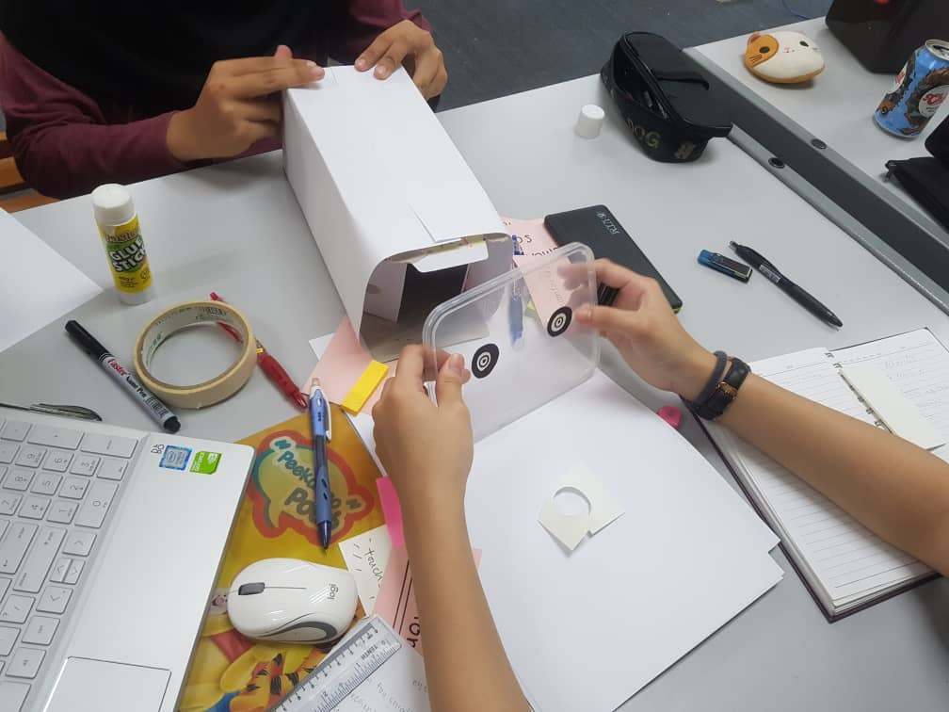

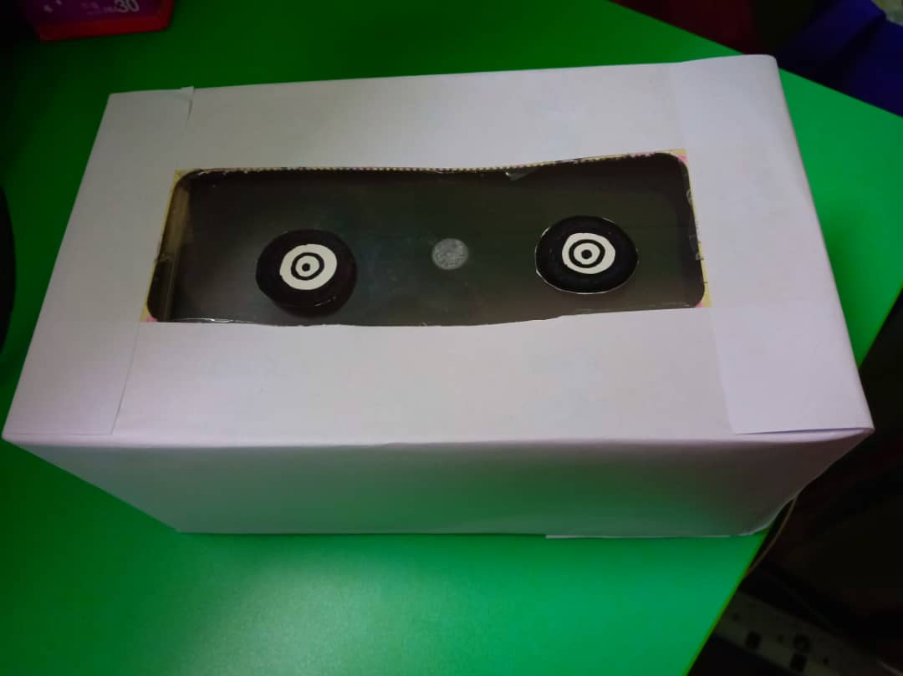

PROBLEM
We have interviewed a few students in UTM to ask them about the problems regarding input and output they faced during their university life. Based on the content of the interview, the problems are defined.
- Size of the screen
The size of the screen brings inconvenient to her while having a group discussion. The screen of the devices (smartphone) is too small for them which make them unable to see a good display of image or video.
- Uncomfortable during group discussion
Due to the small display of the device, it is uncomfortable and inconvenient to share a small screen with the group members when the number of members is relatively large. The devices such as projector is too heavy and inconvenient to bring. And it is also wasting time to set up the projector.

SOLUTION
Based on the problems defined, we figured out a few solutions to solve the problems.
- A larger screen to display the image or video
Based on the problem stated by the first respondent, that is the size of the screen of the device is too small, the pre-solution is provide a larger screen to display the image or video. A larger screen enables all the members of the group to watch the screen at the same time.
- Minimize the size of the device
While according to the problems stated by the second respondent, the pre-solution is to decrease the weight and size of the device and make it easier and convenient to bring.
- Easy to set up, turn any surface into a touchscreen
The device can be connected with any device using Bluetooth without the troublesome wires. The device is able to turn any surface into a touchscreen which brings a lot of convenient to the users.

A prototype of the device is made based on the solutions. The device is such that can provide a larger screen to see a clearer image or video and it allows all the people to watch on the screen at the same time. Its simple design allows the user to bring to anywhere easily and easy to set-up. The device can also turn any surface into a touchscreen which brings a lot of convenient to the users.

TEAMWORKING
Our group members show the spirit of teamworking throughout the process of discussion until completed the project although there are a few problems faced by team members. We had been facing the problem of time management. At the beginning of the discussion, the progress was slow and not according to the planning. Besides, all members have different perspective and see things in different ways. So, clash of ideas usually happens when every member came out with various ideas. And it is difficult for us to choose the best solution. However, we distributed the tasks for each member so that we can focus on the tasks that given. Discussion is made after each of the task given is completed to reach consensus. It is important that every member to be tolerant and willing to accept others’ opinion. So, after the first discussion, all members participated in the discussion and giving their own opinion but also willing to listen to others’ suggestion. Although sometimes clash of ideas may occur but we can resolve the conflicts successfully. We distributed the tasks to speed up the progress. And finally, a prototype is successfully made with cooperation from all the group members. Every member gave their best cooperation and fulfil the responsibility of a team member.

DESIGN THINKING ASSESSMENT
We are glad that our project prototype is completed smoothly although we did face some problem during the process. At the end of the project demonstration, our prototype receives good feedback and support from our friends. We explain our problem solution in detail to our respondent and they are surprised with our problem solution. This prototype is designed for more efficient discussion. It has a touchscreen that can be projected at every flat surface and you can manipulate the screen on the surface you project. Every member in the discussion can see the report clearly because you will not miss any point in the discussion. There is some improvement could be made for our prototype. For example, our ideal prototype able to adjust the screen size, but we cannot find a suitable way to show this function using the instruments and materials on our hands. Base on the feedback of our respondents, this product is convenient and easy to carry everywhere.

During the transition between design thinking phases, all of us give cooperation in the project. Although this project clash with our mid-semester break, we complete it in time. We had a brainstorming to identify our target respondent and subject we want to emphasize on. Before semester break, we interviewed 2 students in UTM to determine their problem and we gather together to make the prototype. Our project cannot be done well if we do not have good time management. Thanks to the opinions and ideas of everyone during the discussion, we had come out with a prototype that perfectly solve all of the respondents’ problems.

DESIGN THINKING EVIDENCE
- EMPATHIZE
We have asked a few questions on a few random UTM students about what their facing regarding the input and output devices for their studies. Here some of the interview session we have recorded:
Interview content for Person A:
Q: Hello, can we take a bit of your time to have a short interview session regarding input and output devices?
A: Yes, Sure.
Q: Can you tell a little bit about yourself? Your name, the course you take in UTM and what year you are now?
A: My name is Chong Li Ling. I’m from school of computing, and I’m the first-year student.
Q: Do you know any device related to input and output?
A: I think the input-devices I know including keyboard, joystick, mouse, scanner. And the output-devices including monitor, printer, speaker. Then the devices that using both input and output is smartphone.
Q: What problem you face regarding one of the devices you mentioned just now? Why?
A: I think the screen of the smartphone is too small for me and it is hard for me to do a group discussion. I have to share the screen with other group members. And it is very uncomfortable and inconvenient to share a small screen with more than 2 people in one time.
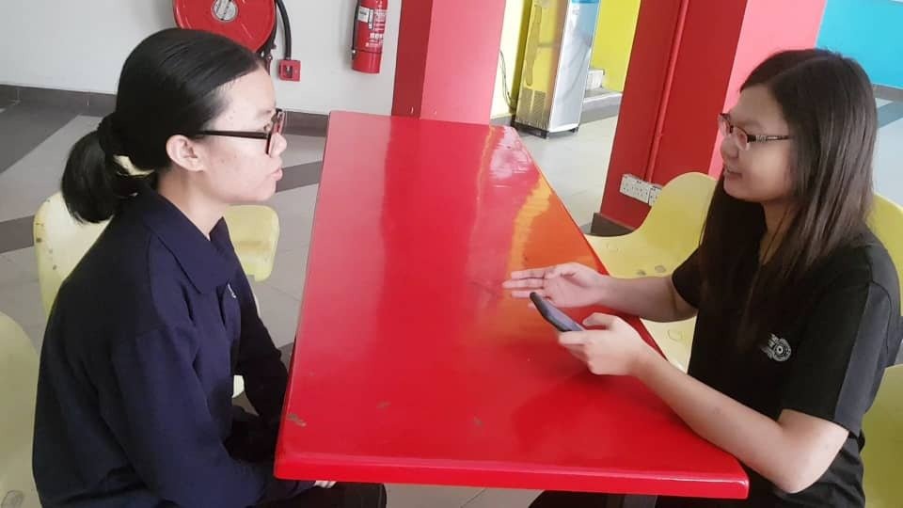

Interview content for Person B:
Q: Good morning, I’m jinger. Can you introduce yourself.
A: My name is Jing Yi, just call me Jingyi. I am a first-year student from Data Engineering SECP.
Q: Here’s the question. As a student, we will have group discussions with our members or friends, so do you face any problem during the group discussion?
A: We really face a lot of problems during the group discussion. When we are discussing something and we sit in a big group, the phone screens are too small. The projector certainly helps to solve the problems but it is difficult to bring it everywhere, and it’s a kind of wasting time to set it up. It will be a big help if there was a device or screen that is accessible, compatible with any device, and convenient for everyone to use.

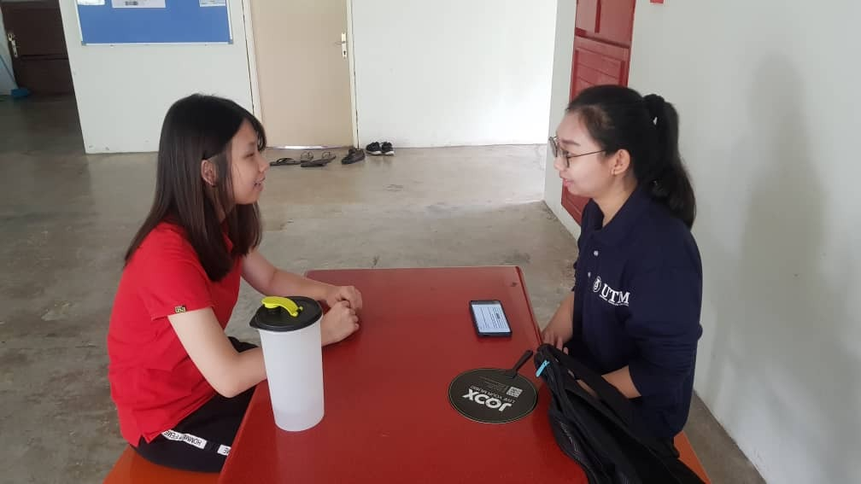

- DEFINE
From the data we have collected in a short interview of two UTM students, we have concluded that most of the students have the same issues which they don’t have a bigger display to present their idea among their groupmates that makes the group discussion took a very long time. We have born this idea that compatible to everyone which it is like a projector but more advance, it can make any surface touchable.

- IDEATE
During the brainstorming session, there were many creative ideas generated by every member. Based on the problems, we figured a few solutions to tackle the problem stated by the respondents. We exchanged our opinions and select the best solution for the task and the ideas are listed down.

- PROTOTYPE
The idea of the prototype is to make the invention lighter, smaller and easy to bring anywhere. We have done brainstorming and created a few drafts of prototype so we have a rough picture on how our prototype is going to look like.
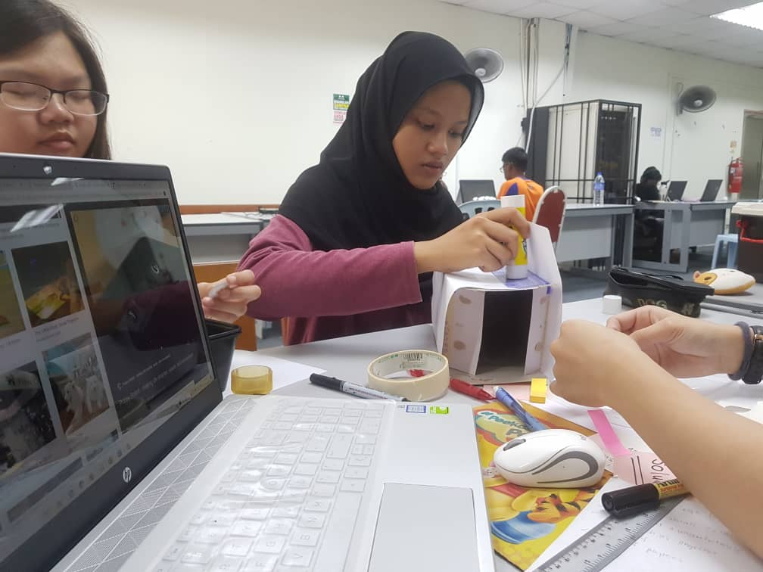
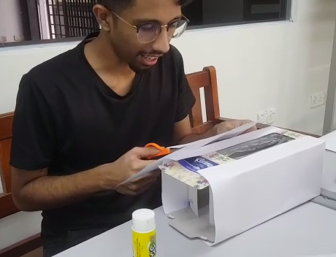
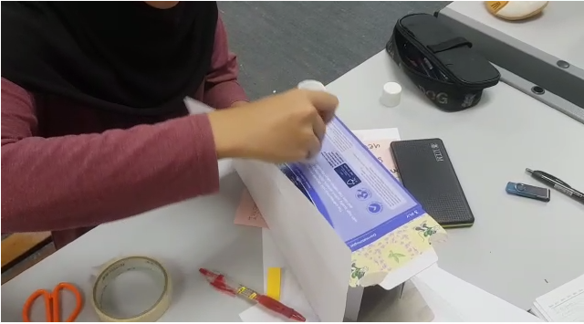
- TEST
We have tested our prototype to few students and ourselves before we present it in front of the lecturer. We have got a good feedback about our prototype which it is very light, convenient, user friendly, and environment friendly because we are going to use less of paper when need to present an idea. Thus, it is very helpful to carry a group discussion or a meeting because they can be held it anywhere.
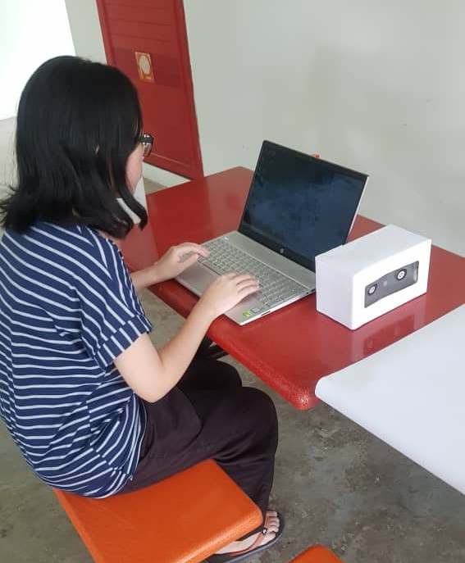

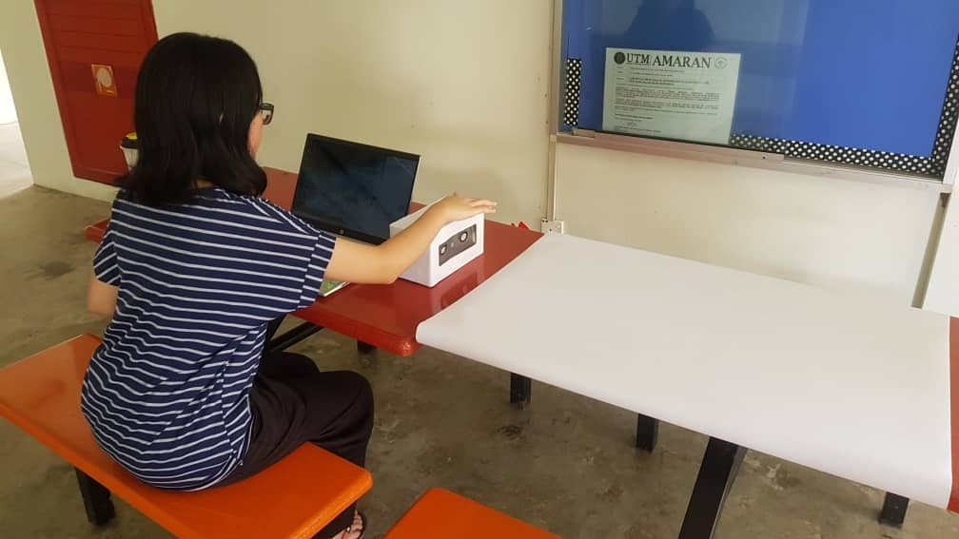

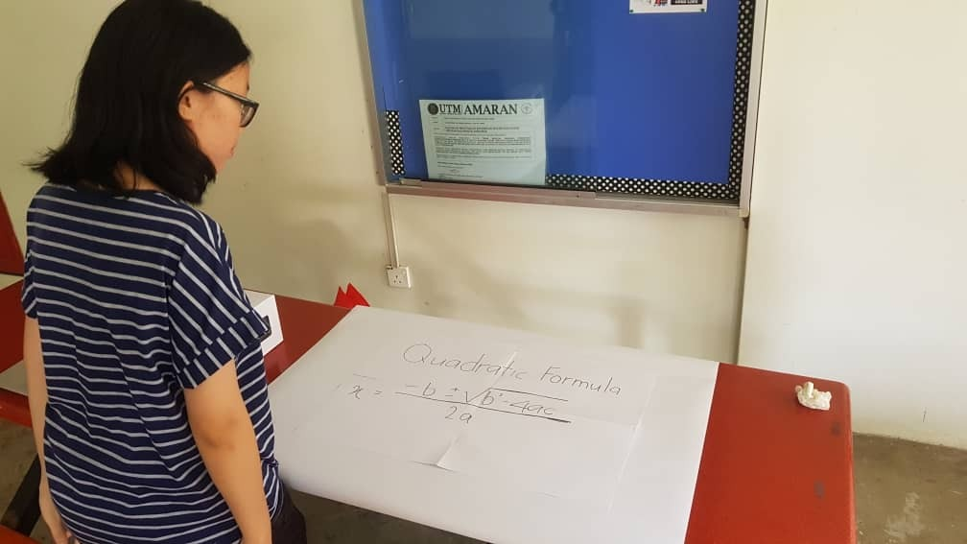
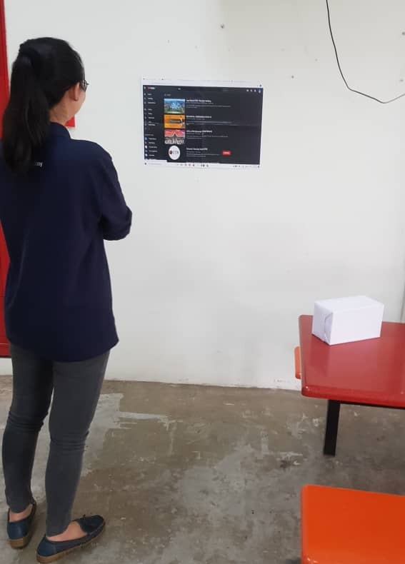
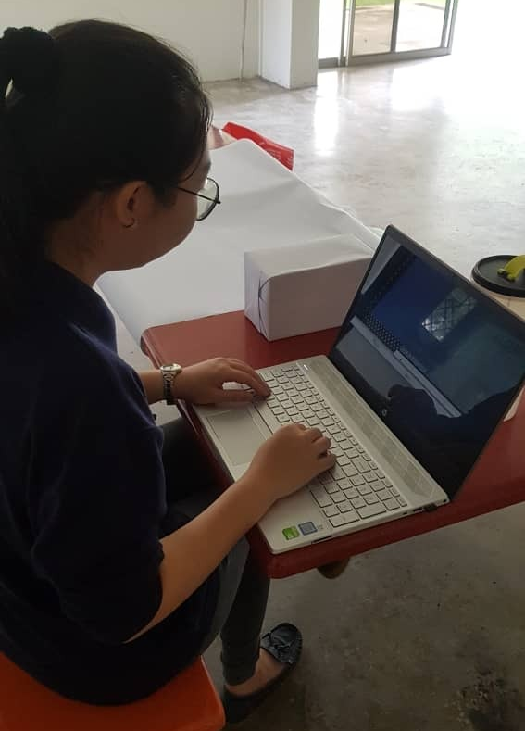
REFLECTION
Based on the prototype we made, we found that there are still a lot of improvements can be made. A good teamwork is very important for every member to complete the tasks. Therefore, healthy conflict resolutions are encouraged to make sure the progress of discussion can be more effective. Throughout this project, we also noticed that design thinking is important as it helps students to develop the ability of develop critical thinking skills, problem solving skills, creativity and the most important is teamwork skill. We need to understand the problems faced by the users, create many ideas during the brainstorming sessions and figure out alternative solutions and strategies to tackle the problems that defined. It is an effective way to find a solution for the problems that we faced in our daily lives. It’s also enables the group members to exchange their ideas during the groupwork discussion and learn to work as a team. Therefore, I think we are actually improving ourselves in every stage of design thinking and it is a path that bring you to success.

TASK FOR EACH MEMBER
No. | Members | Task
1. | ROSHANDEV DANIEL | - Steps and Detailed description (report)  - Editing the video  - Slideshow
2. | NUR LYNNDA BINTI ROSLAN | - Design thinking evidence (report)  - Slideshow
3. | KOH XIN YI | - Design thinking Assessment (report)  - Interview  - Slideshow
4. | NG JING ER | - Introduction  - Problems, solution, teamworking  - Reflection (report)  - Slideshow

