

TECHNOLOGY AND INFORMATION SYSTEM
SECP1513 – SECTION 7

INDUSTRIAL VISIT
MEDIA AND GAME INNOVATION CENTRE EXCELLENCE
(MAGICX) UTM



LECTURER: DR. SARINA BINTI SULAIMAN

NO | NAME | MATRIC NUMBER
1 | PG. KHAIRIL QAYYIZ BIN PG PUTRA | A19EC0147
2 | ELMIRA AKMA BINTI RAMAN | A19EC0042
3 | LIM CHIN QING | A19EC0071
4 | ILIMBEK ISMANOV | A19EC4029

INTRODUCTION
The MAGICX is Media and Game Innovation Centre of Excellence where is a collaboration between Universiti Teknologi Malaysia (UTM) and Iskandar Regional Development Authority (IRDA) to support and promote the development and ecosystem of ecosystem of creative industry that focuses on gamification and enrichment of digital content. We visit the MAGICX on 6th October 2019 at 2:00p.m at T03 level 1 University Industry Research Laboratory (UIRL), Universiti Teknologi Malaysia 81310 Johor Bahru. The presenter introduce us what is MAGICX the vision and mission why they build up this research.So basically the MAGICX are majorly focusing on media and game development.Anything related to media such as AR,KINECT,VR,CAR SIMULATOR and 3D PRINTING.So most of them are for learning process for example they put a sound effect and some game in e-learning for some assignment to make the e-learning become more effective since some student can easily get bored while doing the assignment where who gets the higher mark can get higher point and they also provide some reward to the winner,so MAGICX came out with this idea to show that the e-learning are much fun than others.They specialize the media and game development to the kids since kids are very fast in learning something new.In MAGICX also they have some expertise where they can train a new developer in this research,and the trainer or expertise and a certified trainer.

MAGICX ORGANIZATION


Assoc. Prof. Dr. Mohd Yazid Prof. Dr. Mohd Shahrizal Sunar Prof. Dr. Ali Idris Selamat


Prof. Dr. Mohd. Shafry bin Mohd Rahim Assoc. Prof. Dr. Shukor Abd Rzak


Dr. Farhan Mohamed Azizul Azman Dr. Kamarulafizam Ismail

AUGMENTED REALITY (AR)
Augmented Reality is an interactive experience of real world environment where the object is enhanced by computer-generated perceptual information. So MAGICX uses this alternative to create some interesting learning through AR since kids nowadays are expose to the world of technology, the presenter showed us the apps where a teacher and parents can install it to teach their kids. Usually these apps are for kindergarten and primary school, so most of the time kids love to play with coloring book, so the first app that the presenter show us is WARNA, where they provide a book for the kids to color so when the app is use by either parents or teacher in school the image will appear according which color kids prefer and the also can play along with the image.
Other than that, they also come out with an Islamic one where the kids can also learn the routine dua’s in daily life so that at the same time they can learn to recite a dua’s earlier, so the apps to use the books of daily routine dua’s is AMEEN. While the are kids using it, parents also can learn together with them accidentally it will make a strong bond relationship between the parents and child.
Reflection
In my point of view, I think that MAGICX should upgrade more apps and more books of AR since they only provide for kindergarten and primary school because of kids nowadays love gadget rather than the books. Furthermore, the MAGICX also need to provide the AR to secondary school and high-school for students.So my last point or goal is I hope that other than kindergarten and primary school students,they can also provide and build some interesting game for secondary and high-school students.
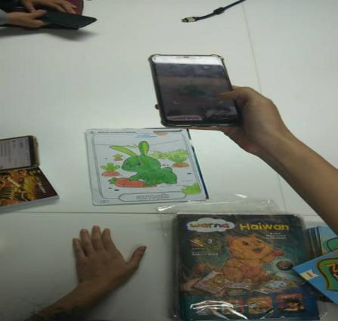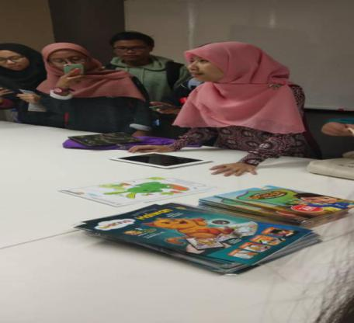
3D PRINTER
At the MAGICX exhibition, there was also a presentation of the 3D printer. They showed the basic functions of the technology together with the design result: several pieces of the same figure, which tend to assemble like a puzzle. They also mentioned that it is possible to design any form, from the simplest to the most jewelry, where accuracy is extremely important. Depending on the final product, it is also important to choose the material for the 3D printer. The strength and stability of the future prototype depends on this.
This innovation is a huge breakthrough for the university, thanks to the 3D printer it is now possible to create projection models of buildings, which saves time and money, and also improves productivity. This technology is designed to perform useful tasks in science, art, education, jewelry and many other industries. The presence of a 3D printer in the new MAGICX class will allow students to test their skills in the exact design of prototypes that can already be converted into a three-dimensional model.
From now on, students are allowed to have new experiences in working with design and literally hold in hands the result of their work. This will increase not only the quality of work, but will also interest many creative people, due to the wide possibilities of a 3D printer open a separate platform for imagination and experimentation. Create a model of a building or apparatus for presentation, come up with a new style of clothing or make a new mask for Halloween. Regardless of the specifications, a lot of things can be experienced here. You no longer need to constantly keep the images in your head, because you can immediately materialize the project and continue to keep operating while the costs are miserable.
  - What is your goal / dream with regard to your course / program? What is the action / improvement / plan necessary for you to improve your potential in the industry?
My goal at the end of the course is to become a professional graphic designer, certainly not an artist, but to create and program electronic graphics. My dream is to create a new graphic engine as a new generation of visualization of reality more or less close to the laws of physics.

  - How does this visit impact on your goal / dream with regard to your program?
This exhibition showed me the technology of materialization and visualization of creative ideas and the fact that the range of implementation is very huge.
  - What is the action / improvement / plan necessary for you to improve your potential in the industry?
To improve potential, first of all, an interest in constant innovations and new approaches to education. As a rule, the attitude to a particular science depends on the methods of interaction between teachers and students. Different approaches allow you to reconsider your attitude to many things and this is what develops curiosity.
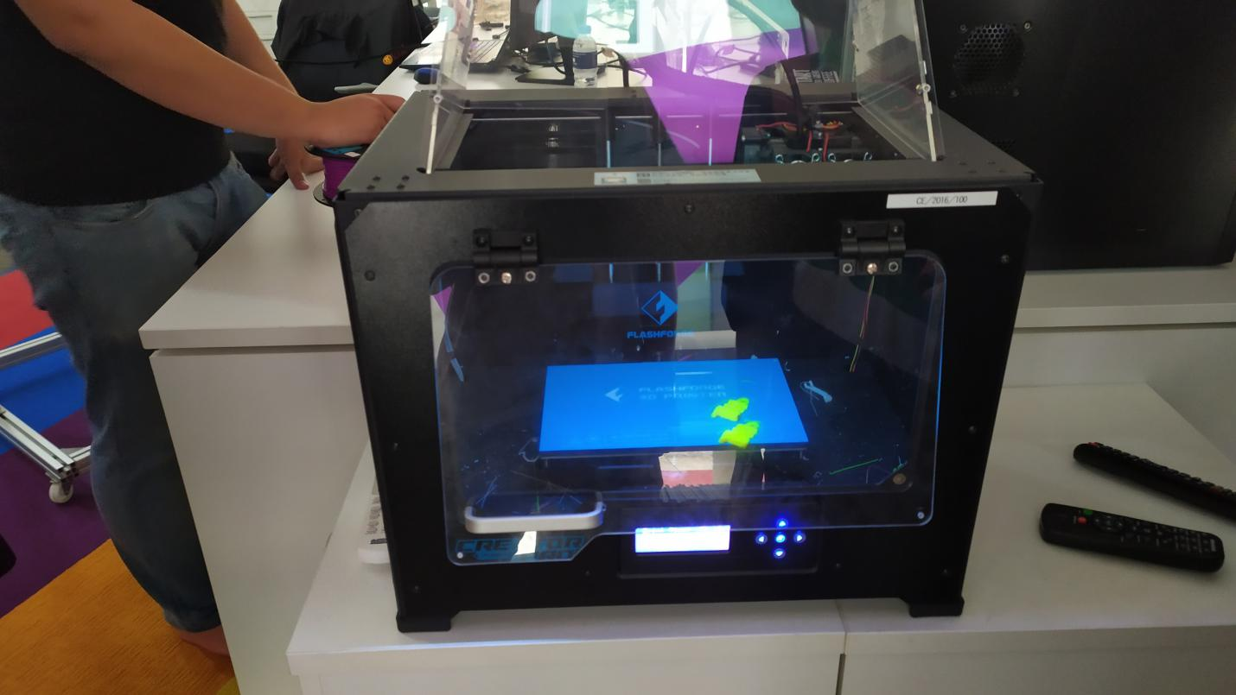

VIRTUAL REALITY
Media and Game Innovation Centre of Excellence (MAGICX) been working on virtual reality technology which functioned in different ways. During our industrial visit, the MAGICX introduced us to their virtual reality product, the Oculus Quest, which were demonstrated and briefed by their crew, Shamine. First of all, what is Virtual Reality (VR)? Virtual Reality is an artificial invention that is created with software and presented to the user in 3-D interface which the users experiencing being in a real environment. Usually, VR is programmed into a computer and connected to a specially made VR headset, but the latest one that was created by MAGICX (Oculus Quest) is being categorise as a standalone VR headset as it is do not require computer to run it. The Oculus Quest device is equipped with an OLED display panel with 1440 x 1600 resolution and powered by a Snapdragon 835 chip processor. The Oculus Quest device can be remotely controlled by a pair of VR controllers, so the users can experience more as being in the real environment.
Reflection
I, personally, tried playing with the Oculus Quest during our visit, so in my point of view, the Oculus Quest is an excellent product which have its own special features and that is the ease of using it as it is a standalone VR headset which does not require computer to run it. Although, there are a few flaws that I would like to pin point and those are the battery like is not sufficient and a slight light leakage. So, the team who developed the Oculus Quest can improvise their product in the next version, like equip their product with a bigger battery capacity and they could adjust the sizing for the headset, so it is suitable to users.
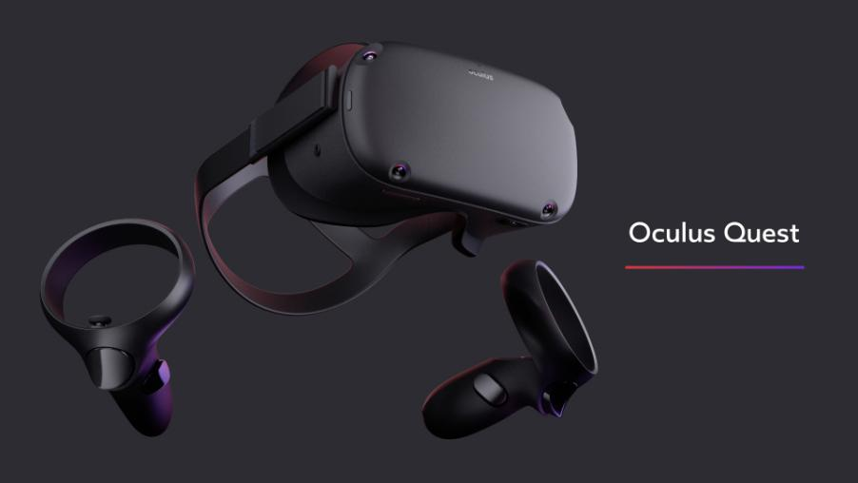
KINECT
During the next section of our industry visit, one of the crew from MAGICX, Syafiq, brief us about Kinect Interactive Wall. Kinect was called Project Natal as a codename during development, but Kinect was the final name given when the product being launched. Initially, Kinect was developed as a gaming accessory for Xbox 360 gaming which produced by Microsoft. The Kinect was invented for Xbox 360, but with a few modifications and changes by MAGICX, the Kinect was compatible and able to be used along with the computer as part of the program. The Kinect equipped with three important parts (video camera, depth sensor and multi-array microphone) which work together to detect motion and create physical image on the screen. The Kinect enables the user to control and interact with computer without the need for a mouse as it functions through a natural user interface using motions and voice commands.
Reflection
Overall, the Kinect by MAGICX is a solid product but of course every product has its own weakness which include the Kinect. In my opinion, there were certain difficulties while using the Kinect simulator as there was a delay in action of the Kinect and it was not able to recognise certain movements and actions were causing confusion and having to wait for some time.

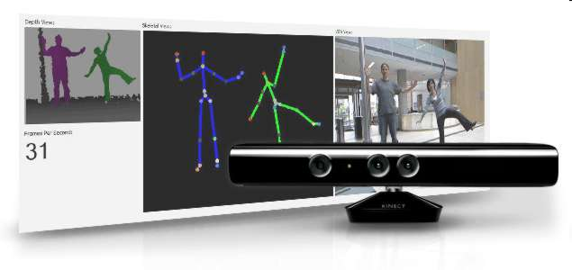
CAR DRIVING SIMULATOR
Car driving simulator, also known as light vehicle driver simulator is a tool that designed exclusively for people to learn, practice or carry out indoor training session especially in driving schools. It is ideal for driving institutes to provide basic training for new drivers as it can reduce danger and the risk of causing damage to the vehicles when training on road. The driving simulator uses a real car to simulate the actual conditions of driving on road in order to enhance new driver’s experience of driving.
During this visit, I realized that there are some weaknesses of this car driving simulator, which one of the most important part of the car, the steering wheel was not functioning well, causing it hard to control the direction of the car while driving. Besides that, the driving simulator and its display of the visual is also out of synchronization. This truly affects the user’s experience. Next, the seat for driver is also uncomfortable and the quality of the visual displayed is poor.
Reflection
Overall, in my opinion, I think that this driving simulator should allow the incorporation of environmental conditions like rain, fog, snowfall and light intensity to improve the lifelikeness of driving on road. Apart from that, it could also include the critical conditions to analyze the driver’s responses towards emergencies.

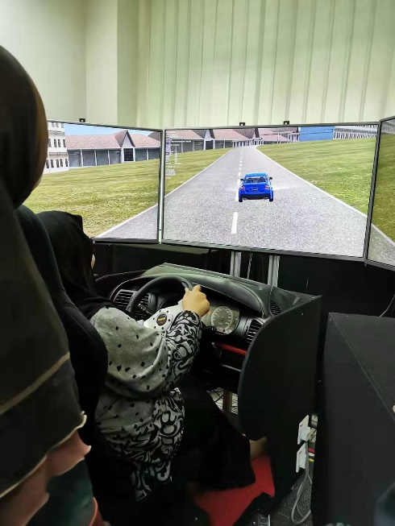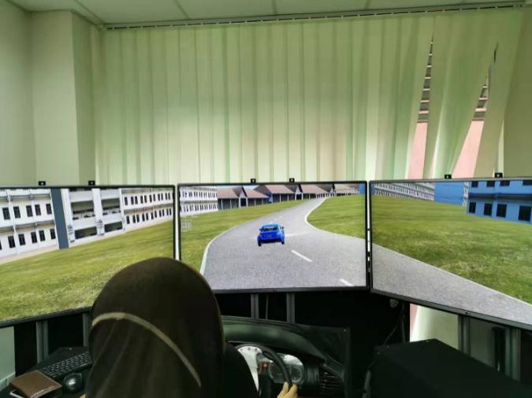
GROUP PHOTO
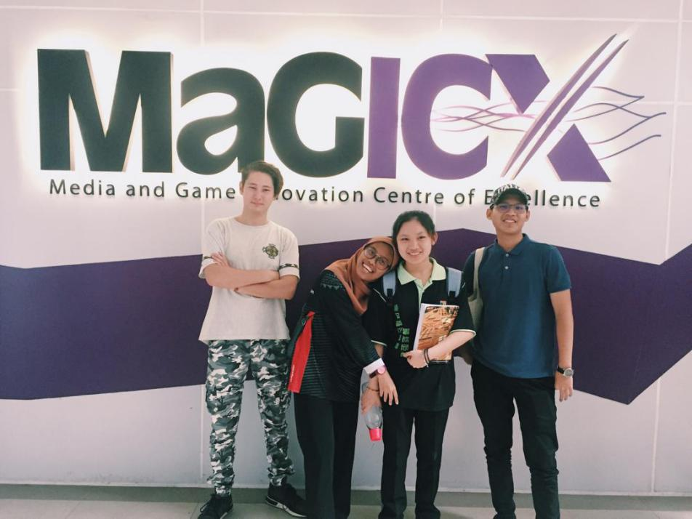
From left : Ilimbek Ismanov(Greg), Elmira Akma, Lim Chin Qhing, PG. Khairil Qayyiz

REFERENCES
- https://ihumen.utm.my/magicx/project/mosti-interactive-wall/
- Becca Caddy, Mei 23 2019,
https://www.techradar.com/reviews/oculus-quest-review

GROUP MEMBERS
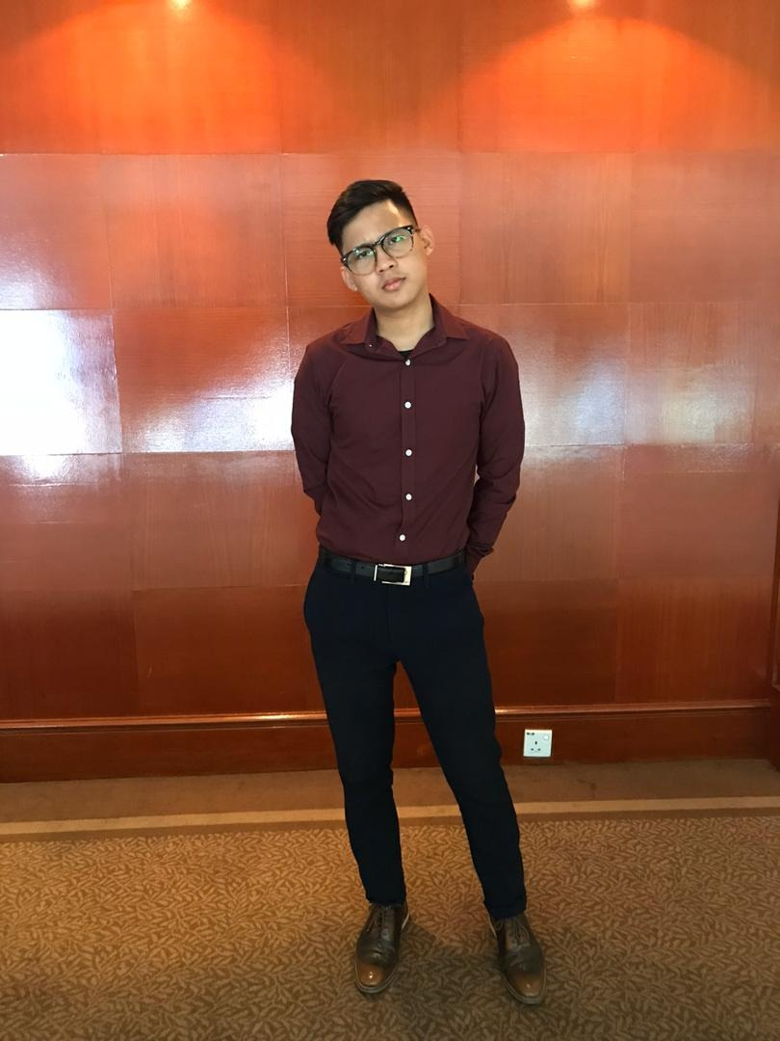 | PG. KHAIRIL QAYYIZ BIN PG PUTRA  VIRTUAL REALITY AND REFLECTION  KINECT AND REFLECTION
 | ELMIRA AKMA BINTI RAMAN  AUGMENTED REALITY AND REFLECTION  INTRODUCTION
 | LIM CHIN QING  CAR SIMULATOR AND REFLECTION
 | ILIMBEK ISMANOV  3D PRINTING AND REFLECTION

