
SEMESTER 1
SESSION 2019/2020
SECP1513

DESIGN THINKING:
COMMUNICATION AND NETWORK

Prepared By :
- Muhammad Mukhlis Bin Mohd Feris Halmy (A19EC5225)
- Rifadul Islam ( A18CS4050)
- Md Shakil Chowdhury (A18CS4047)

Lecturer Name : Dr. Aryati Binti Bakri

CONTENTS

NO. | CONTENT | PAGE
1 | INTRODUCTION | 3
2 | EMPATHISE | 4
3 | DEFINE | 4
4 | IDEATE | 5
5 | PROTOTYPE | 6
6 | REFLECTIONS | 10
7 | TASK FOR EACH MEMBER | 11
8 | VIDEO LINK | 12

Introduction

Design thinking is now part of education where we use this skill to analyze problem and we apply this design thinking to create new and can help people better.

As the world keeps evolving, communication and network also keeps changing and changing without we knowing it. As to what to communication is the imparting or exchanging of information by speaking, writing, or using some other medium such software, phone and etc.
On the other hand network is a communication system that connects two or more computers so they can exchange information and share resources. So, as we know before people, communicate using paper where there write on it and pass it to the postmen to deliver it. People wait for a few days waiting for their message to arrive and after that the same thing repeats. Before this network, is still not that good. But nowadays with network has increasingly develop, many things change same goes for the communication. Network now can be connected wirelessly without wired connection and the speed also increase. For communication, people can now communicate with people from around the world. It is because we manage to create a communication software where people can instantly message their friend, family or relative.

It is clear that communication and network has undergoes many transformations that have improved our lives and make life easier for us. We can see how design thinking skills make us.

Empathy

Communication networks are regular patterns of person-to-person relationships through which information flows in an organization. This means that the flow of information is managed, regulated. and structured. Communication networks may be formal or informal.

When you have empathy, it means you can understand what a person is feeling in a given moment, and understand why other people's actions made sense to them. Empathy helps us to communicate our ideas in a way that makes sense to others, and it helps us understand others when they communicate with us.

Its simplest, awareness of the feelings and emotions of other people. It is a key element of Emotional Intelligence, the link between self and others, because it is how we as individuals understand what others are experiencing as if we were feeling it ourselves.

Define

In defining, we put together the information what we’ve created and gathered during out empathize stage. Based on this part actually the ideate part is created. We should seek to define the problem as a problem statement in a human-centered manner.

In this define stage will help us gather great innovative ideas to establish features, functions and any other elements that will allow to solve our problems in very easy and effective way.

Communications networks are changing rapidly, opening the door to a whole new swath of competitors. Network communication Today it owns the country's largest mobile communications network, and its businesses span oil and gas exploration and production, textiles, financial services, power and insurance.

Ideate

Ideate is the space in design thinking where individuals and teams elevate and celebrate the power of possibility. It is the transition from identifying a particular question or problem to generating a wide variety of potential answers and solutions.

Actually, ideate is the mode during designing process where we can focus on idea generation.
It is the creative process of generating, developing and innovating new ideas, where an idea is understanding as a basic element of thought that can be either visual, concrete, or abstract.

One of the most important aspects of a home network is the ability to share network resources. There are a variety of ways to accomplish this. A server is the best solution, but not many home users will have one. Network Attached Storage or NAS devices are more cost effective and easier to use in this environment. To learn more about NAS, read The 10 Best NAS Devices. As an alternative, many routers have built-in USB ports which can be used to share hard drives or printers among all network users.

Mobile broadband is a really simple idea and it comes in two different varieties: it's either delivered over a cellphone network or via Wi-Fi from what is, essentially, just a landline or cable broadband link to the Internet. As we've already covered the latter up above, the rest of this article focuses on how cellphone networks deliver mobile broadband. The technical nitty-gritty of how that works gets quite complex; we'll give you a quick and simple overview for starters, followed by a more detailed technical explanation at the end.

Prototype

Prototype is the preliminary version of a system which is used to explain the idea and also to design the other forms. To design the prototype, at first we held a meeting. We researched about some existing systems including the softwares and hardwares which relates to our project. Then we designed our prototype with the help of the knowledge we got from our research. We used different stationery products to make the prototype. That is how we developed the prototype.

Prototype testing for user :

- The user is connecting the router :
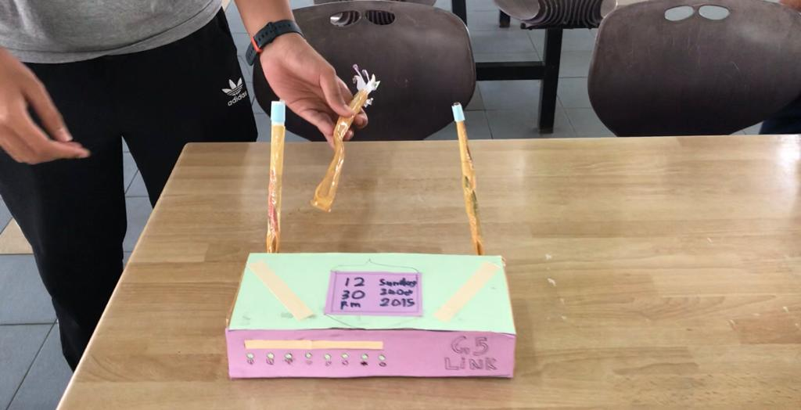

- The user is connecting his device to the network :

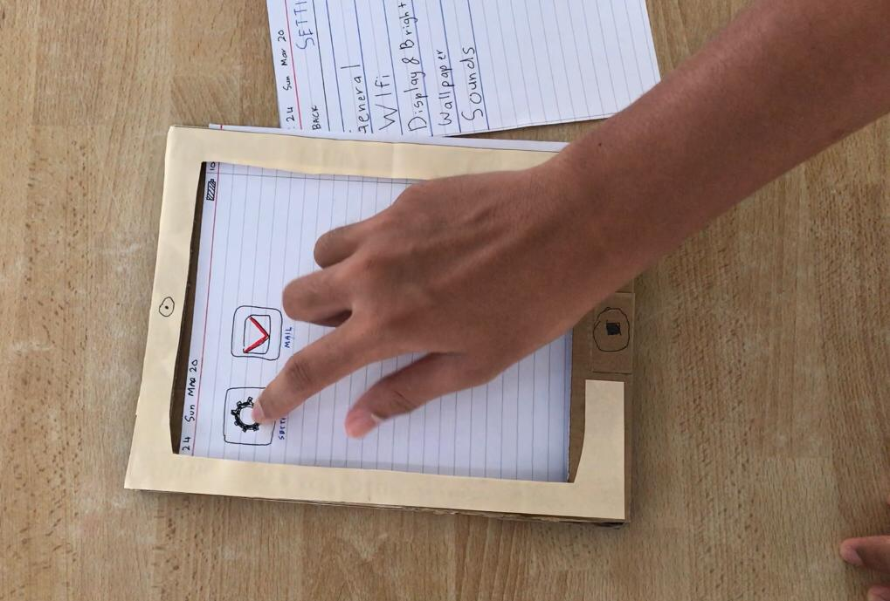
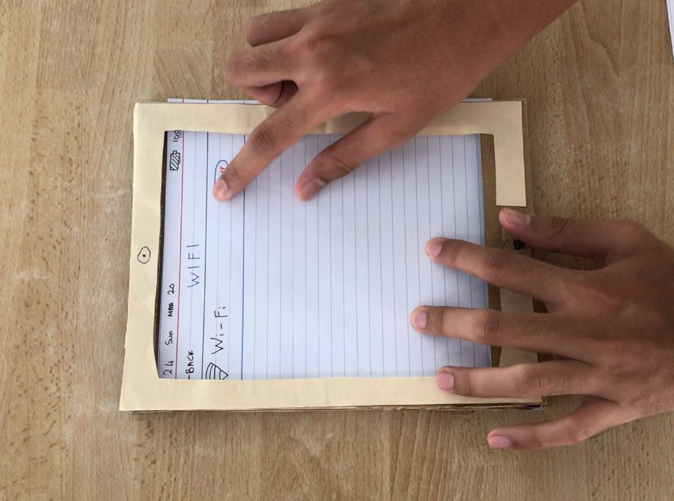

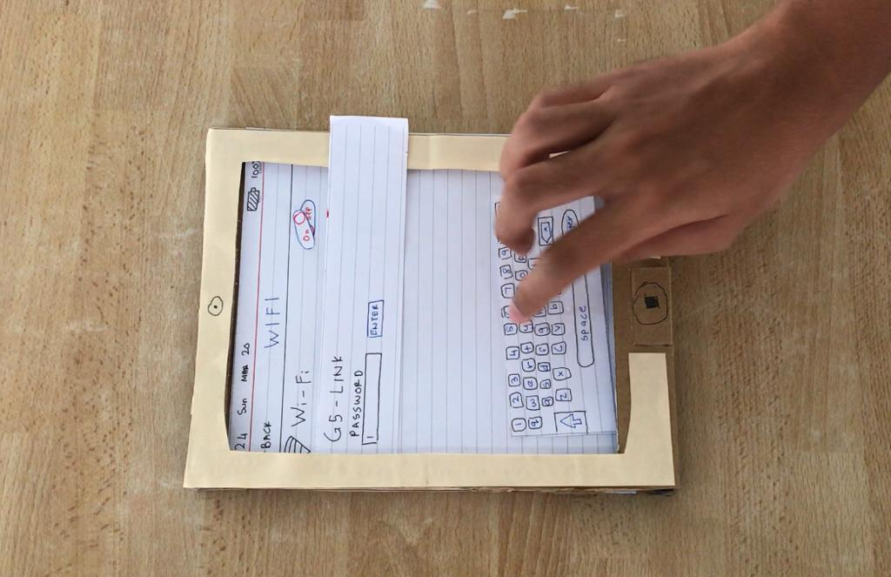

- The user is sending an email using the router’s wifi connection:
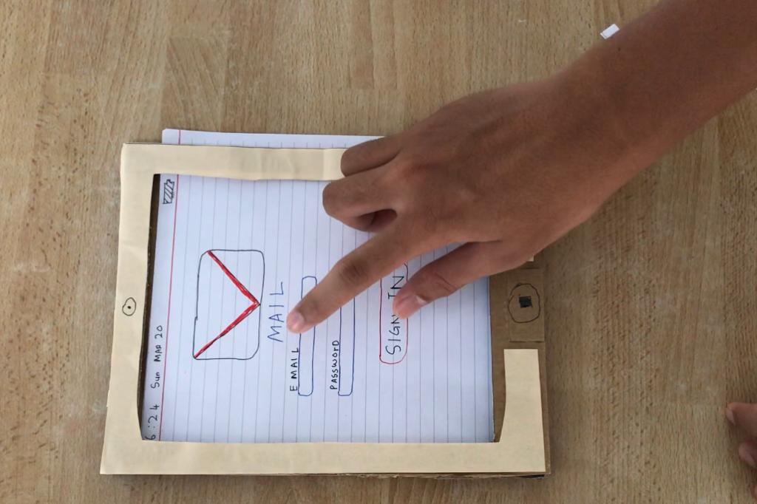

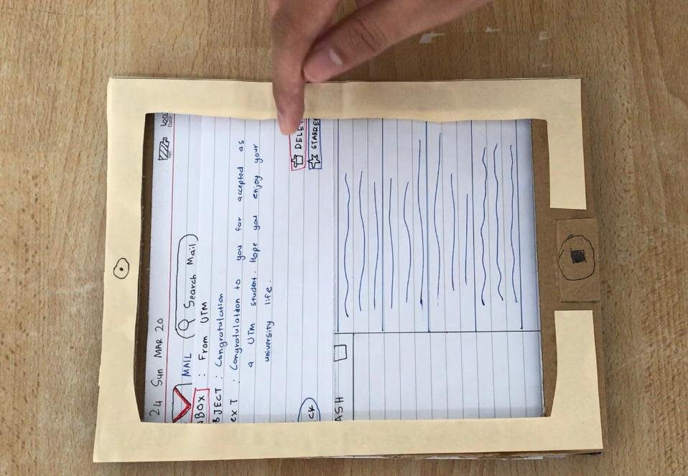

Reflection

As we can see, design thinking has a big impact on how we approach something. For example on how we approach the problem, how we want to get it and how we solve it. Design thinking taught us that we need to approach something step by step as in design thinking that are start from empathy until prototype phase. This design thinking skill have make people become critical thinking and adaptable person. This can be related to the course that we are taking that is Technology And Information System where the goal is to make sure student become a capable and useful graduate that can improve our society. Other than, design thinking teaches us that we should study and learn only for exam but it also can apply to our everyday lives.

With this Industrial Revolution 4.0(IR 4.0) , employers today are looking for graduates who are capable of critical thinking, responsible and have the other skills. Why did they want this graduates? Employers want a graduate that can apply this skill in their field and bring something new to their company. They will not take the graduate who is only excel in studies and have a good pointer, instead they want graduates who have the design thinking skills. The pointer or CGPA may be their 2nd choice. That’s why design thinking crucial if we want to have our dream come true and help us manage our goal.

Regardless of that, we also need to improve ourselves before we entering the industry work. What we can do is to have more experience. For example we can volunteer ourselves to join their company to get experience on our jobs or join any available projects so we can sharpen our leadership skills and team working skills.Moreover, we can learn how to interact with people and improve our communication skills. Lastly, it help us face any kind of situations and problems in the future.

TASK FOR EACH MEMBER

NO. | NAME OF MEMBER | TASK
1 | Muhammad Mukhlis | ● Writes report  ● build prototypes  - Wireless Modem router  - Mobile Broadband  - Communication Device  ● helping with edit video  ● idea generation
2 | Rifadul Islam | - Video Editing  - Recording video  - Taking Interview  - Idea generation  - Report writing  - Helping with prototype
3 | Md Shakil Chowdhury | - Report Writing  - Video Editing  - Taking Interview

VIDEO LINK

https://youtu.be/s6npKWXA3zg

