
SEMESTER 1
SESSION 2019/2020
SECP1513

INDUSTRIAL VISIT TO CICT

VENUE: Gallerium, Perpustakaan Sultanah Zanariah, Unitversiti Teknologi Malaysia Skudai
DATE OF VISIT: 21 OCTOBER 2019

PREPARED BY:
- NUR ALEEYA SYAKILA BINTI MUHAMAD SUBIAN (A19EC0127)
- NUR IRDEENA BINTI CHE MOHAMAD ZULKEPLI (A19EC0130)
- KHOR YONG XIN (A19EC0061)

LECTURER’S NAME: DR. ARYATI BINTI BAKRI
SUBMITTED ON: 11 NOVEMBER 2019

TABLE OF CONTENTS

TABLE OF CONTENTS 1
DESCRIPTION 2
DATA STORAGE 3
PROCESSORS 4
EXTERNAL MEMORY 5
MOTHERBOARD 6
RAM 7
REFLECTION 8
REFERENCE 12

DESCRIPTION

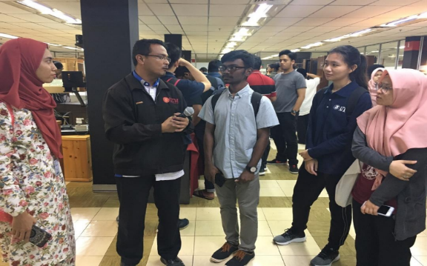
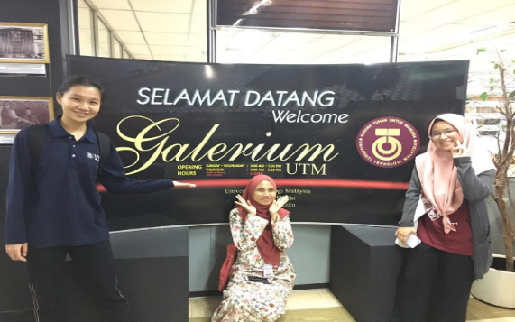
An industrial visit to Centre for Information and Communication Technology (CICT) UTM Skudai was held on 21 October 2019. The Gallerium in CICT was moved to Perpustakaan Sultanah Zanariah which located at level 2. All first-year students from Faculty of Computing were involved in this visit. The presenter that was involved is Mr. Mohd. Zahari bin Zainal Abidin (Pen. Pegawai Teknologi Maklumat Kanan Kump. F32). Table 1 describes the details of the visit.
Figure 1: Group members at the Gallerium

Figure 2: Group members listening to Mr. Zahari's explanation

Table 1: Details of Journey to Gallerium
DATE | TIME | ACTIVITY
Monday  (21/10/2019) | 3:00 PM | Students gathered at Perpustakaan Sultanah Zanariah while waiting for Dr. Aryati Bt Bakri
Monday  (21/10/2019) | 3:15 PM | Students moved to Gallerium which is located on the second floor of Perpustakaan Sultanah Zanariah
Monday  (21/10/2019) | 3:30 PM | Students listened passionately to the presenter
Monday  (21/10/2019) | 4:30 PM | End of visit

DATA STORAGE
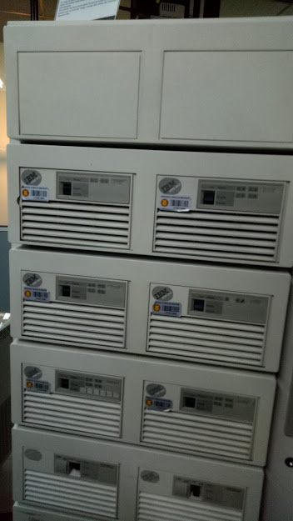
There are several information systems that CICT have either developed or maintained. One of them is data storage devices. In the 1970s, the usage of Mainframe Data Storage System started at Computer Centre, UTM Kuala Lumpur and has been used for more than 20 years since. The system functions in controlling data consists of students and staff information. Other than that, it also plays a major role in processing, storing, securing and printing information data of the university. Unlike personal computers, mainframes typically have more than one component which are able to ensure the system to work efficiently. Figure 3 shows a mainframe data storage used in UTM.
Figure 3: Mainframe Data Storage used in UTM
One of the components mentioned is Operating System which is responsible in running the system generally and provide conditions in which the applications or programs can work to fulfill the users’ needs. Another component is Central Processing Unit which is similar to what most PCs have. Central Processing Unit or CPU gives instructions to other components and it can also perform calculations.
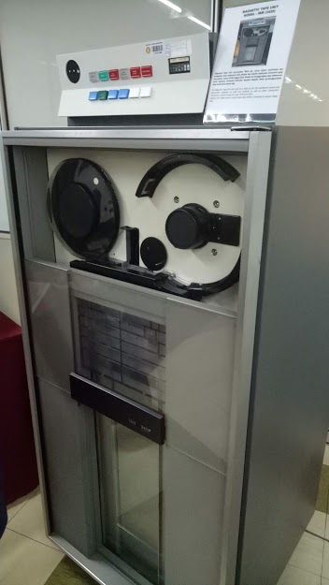
Mainframe Data Storage System also has other components such as disk storage subsystems, mass storage devices, communication controllers, line printers and channels which all have their own role to play to make sure the mainframe system can be executed systematically.
Figure 4: Magnetic Tape Unit
During the year 1976 until 2010, UTM had a backup for the Mainframe Data Storage System. A Magnetic Tape Unit was used for this purpose. It was also used for information database of staff and students and other University’s vital information systems. Magnetic Tape Unit uses digital recording to store all the information and data on magnetic tape. A round magnetic tape was used in this model before the usage of square-shaped magnetic tapes was initialized. Figure 4 shows a magnetic tape unit displayed at the Gallerium.
Magnetic Tape Unit has become outdated as it takes longer time to back up and restore data as the data in the tapes would be packed in cartridges and cassettes. However, Magnetic Tape Unit was used to back up huge amounts of data as it is cost-effective and way cheaper than other models. Also, the data in the magnetic tapes must be encrypted even if they are no longer important, thus making the data safe for a longer period of time.

PROCESSORS
Figure 5
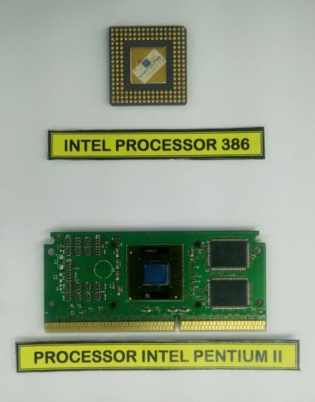
A processor is an electronic component, more like a small chip inside a computer that can receive input and generate output. Figure 10 and 11 display several types of processors used in UTM. Processors were invented by engineers from Intel in 1971, Ted Hoff, Federico Faggin, and Stan Mazor. Students’ and staff’s information and data must be stored and processed in a computer, thus processor have been used in UTM since the early stage of its invention.

A processor is able to perform millions of calculations per second, which ensures the computer to run smoothly. A processor is also known as the Central Processing Unit (CPU) as it can be considered as the ‘brain’ of a computer. Every input will go through the CPU first before an output can be generated. A newer processor can perform more calculations per second, thus the input can be processed faster compared to the older versions of processor.

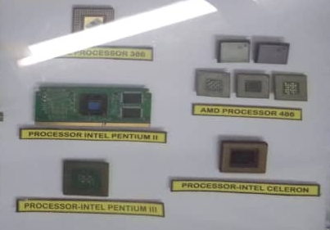
Inside a processor, there are several components. Firstly, a processor must have an arithmetic logic unit. This component is the one responsible to perform the calculations or arithmetic operations. Next, a processor also has a control unit which controls the activity of other components inside the processor. Another component is the cache that functions as a high-speed memory and copying and retrieving instructions can be made inside a cache. An older version of a processor commonly has diverse types of components however, when the generations passed by, those components have been assembled into a single unit called microprocessor.
Figure 6

EXTERNAL MEMORY
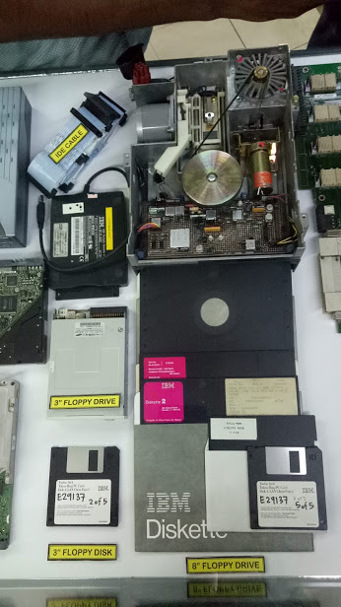
At the Gallerium, we can also see a collection of external memory such as hard disks, floppy disks and floppy drive. The first floppy disk was invented by Alan Shugart in 1967. In the early 1970s, floppy disk is a medium for storage that is been used by most people. As the years passed, the floppy disk gets smaller in size. Floppy disk has various sizes which are 8-inch, 5.25-inch, 3.5-inch. The disk size 3.5-inch was the most popular size in the 1990s. Disks and drives both play a major role in ensuring a computer can function normally. Basically, a disk is a round, thin and magnetic plate that is able to receive or present data and information from it. A drive, on the other hand, is a mass data storage where information or data inside it is harder to be modified or removed compared to disks.
Figure 7

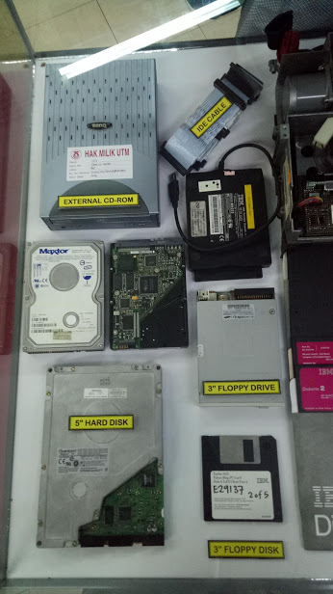
There are two types of disks that are commonly used in computers which are floppy and hard. A floppy disk was developed in 1967 and is a small removable disk. This means that floppy disks is usually used to store small amount of data. Floppy disks have been used in UTM since the 1990s. However nowadays, the use of floppy disks can rarely be seen due to the existence and invention of other removable data storage such as digital versatile disks (DVDs) and compact disks (CDs). On the contrary, a hard disk was while a hard disk is a fixed disk. Figure 15 and 16 display several types of disks and drives used in UTM.
Figure 8

MOTHERBOARD
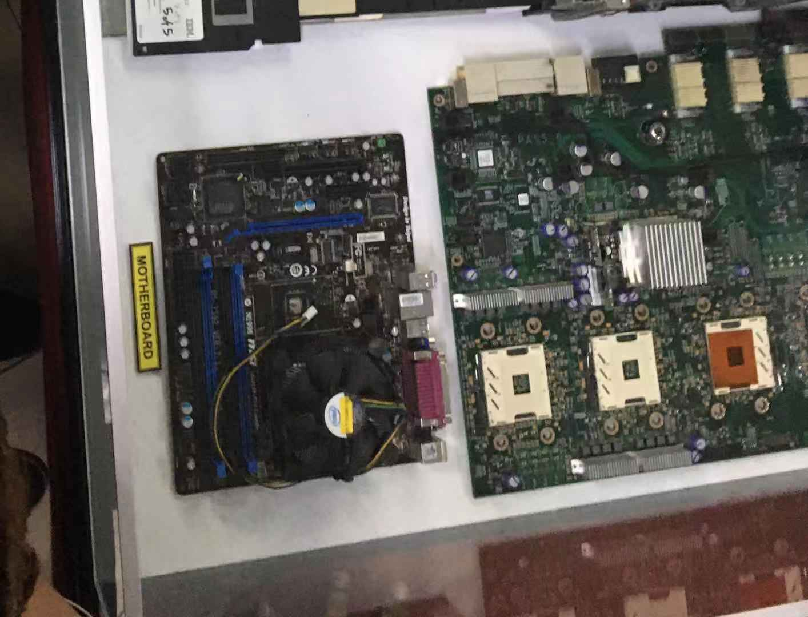
A motherboard is a printed circuit board (PCB) which is occupied by a lot of components such as RAM, microprocessor, chipset and others. It is a significant core in electronic devices for instance, mouse, PCs and even in smart watches and so on. It is able to connect with the components such as external storage, power supply by using cables. Before the present of motherboard, the capacitors, resistances and other components in an electronic device were connected using wires and the components were in full-sized. These made the devices to be heavier and the circuit was complicated. Hence, the advantages of using a printed circuit board are that it cost effectively, the components in it can be arranged neatly which help a technician or a user to identify and less time consuming when handled with the board. Figure 17 shows the motherboard display in Gallerium at Perpustakaan Sultanah Zanariah in UTM.
Figure 9: A model of motherboard
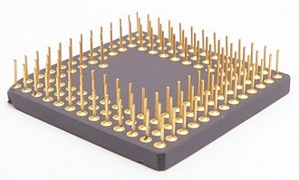
After explaining about the functions of a motherboard, here i would like to emphasize the history of a motherboard. The first motherboard was invented by IBM (International Business Machines) and was named as “Planar” in 1981. In 1986, Yeh Pei Cheng who was a taiwanese managed to develop gigabyte technology and inserted to the motherboard which function to store data. After that, Plastic Pin Grid Array (PPGA) was established by Intel in 1993. Figure 18 shows the prototype of Motorola 68020 microprocessor. In 2009, VIA Mobile-ITX is the world’s smallest size of compliant motherboard with the measurement of 6cm x 6cm.
Figure 10

RAM
RAM (Random Access Memory) is a device used to store data and retrieve on computer. It is memory is volatile and power is required to store the memories otherwise, the data will not be saved. Figure 19 shows two types of RAM which are displayed in the Gallerium.

In 1947, Williams tube was the first form of RAM device, it works in CRT (Cathode Ray Tube). It is memory is accessed randomly due to the electron beam of CRT get and display the data in any order. It can only store hundred up to a thousand bits of data which is not very large. Apart from that, in the same year, Magnetic-core memory was also established. It is benefit is one bit of data can be stored per ring, so it is possible to access those data in any ways. But Magnetic core memory is then replaced by solid state semiconductor memory which also can be called as RAM in 1970s.

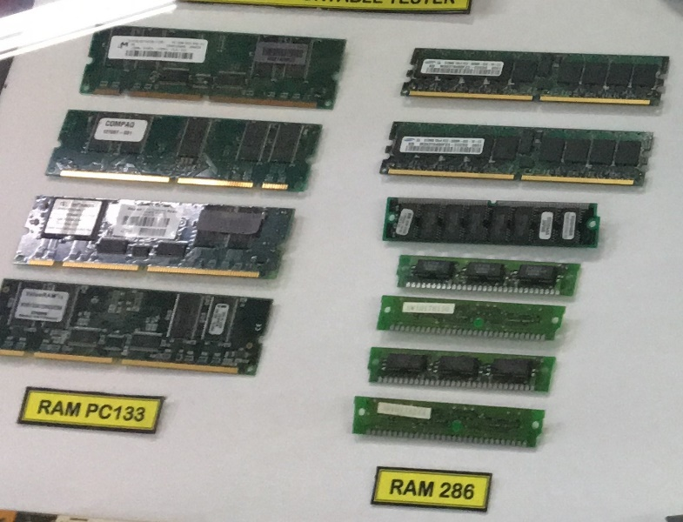
Figure 11

REFLECTION
Table 2
NAME | REFLECTION
NUR ALEEYA SYAKILA | By taking Data Engineering, I knew that I should prepare myself with a lot of knowledge especially in the Computing field.  This subject, Technology Information System allows me to be exposed to various information about anything related to Computing field through various industrial visits. In this visit to Gallerium CICT, I got to see the revolution in computer devices such as mouse, data storage either in size, function, quality and else. I am so grateful towards my lecturer, Dr. Aryati Bt Bakri for giving me the chance to get to know well about the history of every computer device that has been displayed at the Gallerium. The history of computer devices should not be forgotten as it could inspire us to invent a better model from time to time.
KHOR YONG XIN | My dream with regard to my program which is Bachelor of Computer Science (Data Engineering) is to become an excellent data engineer. My goal is to excel at analysis data which can contribute me to become a professional data engineer. Additionally, I must be a passion and attentive person as a data engineer need to be very sensitive to numbers, if the input has a wrong digit, it may cause inaccurate results.  As a computer science’s student, it is a must for me to understand and know the generation of the computer and other components. Through this visit, I’ve learnt that technology plays a significant role in transforming a computer to higher standard of computer with more data storage and so on. Besides, data can also be transmitted and processed in a faster way. Furthermore, instead of using a typewriter in the pass, people nowadays are using printer which is connected to the computer to print their paperwork. Thus, we can see that this is how technology improve humans work to become more effective and efficient.  The action I need to improve my potential in industry is learnt to be responsible to the tasks given or the mistake that I have done. The tasks given have to be done before the date line so that others can rely on me as I can promise them to do the jobs well and on time. Apart from that, I need to have good leadership skills to conduct my team when completing a project. Hence, a good result can be formed and help the company to increase their profit as well as their client’s recognition.
NUR IRDEENA | With regard to the course that I am currently taking, I dream to be a victorious data professional. I aim to master every skill required so that I can achieve my dream. Some of the skills are the ability to analyses and interpret data, potentiality to think critically to solve problems and ability to use programming languages such as Python and Java.  By joining the visit, I get to learn that there are various types of devices or machines that have been used to process large amounts of data at the university itself since the early stage of its operation, and have been developed and maintained as the years go by. This proves that it is crucial to process the data by using the right method and store the data in a safe place, which is why the skills that I described earlier are very essential for a data professional-to-be like me, to acquire. This motivates and drives me to study hard to achieve my dreams and goals. Other than that, I was very inspired by the way they came up with the ideas to improve the information systems and devices so that they will be capable to handle the quantity of data that is increasing year by year. This makes me realize that I need to brush up my thinking skills so that I can approach and solve any problems regarding data just like they did.  Apart from getting a hang of the necessary skills that I have already stated, I also must groom myself with more general knowledge about current issues, especially those that are related to data. This is important so that I will always be up-to-date about what is going on in this technology world and keep up with the rapid progress of technology. This way, I can help the company or industry I will be working for to observe customers’ needs and expectations that are constantly changing so that the company can provide better services for them.

TASKS OF EACH MEMBER
Table 3 describes the tasks of each member in completing this report.
Table 3
NO. | NAME | TASK
1 | NUR ALEEYA SYAKILA | - Jot down every important note  - Do research about external memory
2 | KHOR YONG XIN | - Ask the presenter some questions  - Do research about CICT, motherboard and RAM
3 | NUR IRDEENA | - Take photos of the components displayed at the Gallerium  - Do research about data storage

REFERENCE

BROWN, G. (n.d.). How Floppy Disk Drives Work. From HOW STUFF WORKS: https://computer.howstuffworks.com/floppy-disk-drive1.htm
HOPE, C. (2019, 02 04). Computer motherboard history. From COMPUTER HOPE: https://www.computerhope.com/history/motherboard.htm
HOPE, C. (2019, 03 09). COMPUTER MOUSE. From COMPUTER HOPE: https://www.computerhope.com/jargon/m/mouse.htm
HOPE, C. (2019, 03 09). RAM. From COMPUET HOPE: https://www.computerhope.com/jargon/r/ram.htm
HUGHES, C. (2014, 09 30). What to know about mainframe storage media. From ASPG.COM: http://aspg.com/know-mainframe-storage-media/#.XceBLDMzY2x
KHAN, S. (n.d.). What Is the Purpose of a Floppy Disk Drive? From Techwalla: https://www.techwalla.com/articles/what-is-the-purpose-of-a-floppy-disk-drive
MASON, H. (2015, 05 19). THE HISTORY OF THE FLOPPY DISK. From GEEK & SUNDRY: https://geekandsundry.com/the-history-of-the-floppy-disk/
PALICOMP. (2012, 09 24). HISTORY COMPUTER MOTHERBOARD. From VISUALLY: https://visual.ly/community/infographic/computers/history-computer-motherboard
Patterson, K. D. (2019, 10 30). MAINFRAME. From ENCYCLOPEDIA.COM: https://www.encyclopedia.com/science-and-technology/computers-and-electrical-engineering/computers-and-computing/mainframes
PROCESSOR. (2012, 04 09). From TECHTERMS.COM: https://techterms.com/definition/processor
Zandbergen, P. (n.d.). Central Processing Unit (CPU): Parts, Definition & Function. From STUDY.COM: https://study.com/academy/lesson/central-processing-unit-cpu-parts-definition-function.html

