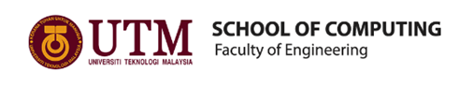

SEMESTER 1
SESSION 2019/2020
SECP1513

INDUSTRIAL VISIT TO

PETRONAS

VENUE: PETRONAS TWIN TOWERS, KUALA LUMPUR CONVENTION CENTRE, KUALA LUMPUR
DATE: 11 SEPTEMBER 2019

PREPARED BY:

- NUR ALEEYA SYAKILA BINTI MUHAMAD SUBIAN (A19EC0127)
- NUR IRDEENA BINTI CHE MOHAMAD ZULKEPLI (A19EC0130)
- KHOR YONG XIN (A19EC0061)

LECTURER'S NAME: DR. ARYATI BINTI BAKRI
SUBMISSION DATE: 29 SEPTEMBER 2019

TABLE OF CONTENTS

INTRODUCTION 2
DESCRIPTION 5
GROUP TECHNICAL DATA 9
REFLECTION 10
REFERENCES 11

LIST OF TABLES AND FIGURES

Figure 1 3
Figure 2 3
Figure 3 3
Figure 4 4
Figure 5 4
Figure 6 5
Figure 7 7
Figure 8 8

Table 1: Board of Directors in PETRONAS (3) 6

INTRODUCTION

An industrial visit to Petroliam Nasional Berhad (PETRONAS) was held on $11^{th}$ September 2019, Wednesday. About 36 students from Bachelor of Data Engineering under School of Computing were involved in this visit. Students were accompanied by Dr. Muhammad Iqbal Tariq Bin Idris and Dr. Aryati Binti Bakri during the visit. Table 1 describes the details of the visit.

Table 1: Summary of the activities during industrial visit to PETRONAS
DATE | TIME | ACTIVITY
Tuesday  10/09/2019 | 10:00 PM | Gather at Dataran Resak Kolej Tun Dr Ismail, attendance taking
Tuesday  10/09/2019 | 10:30 PM | Start the journey to Kuala Lumpur
Wednesday  11/09/2019 | 03:40 AM | Arrive at Universiti Teknologi Malaysia Kuala Lumpur.
Wednesday  11/09/2019 | 07:00 AM | Breakfast
Wednesday  11/09/2019 | 07:30 AM | Depart to PETRONAS Twin Towers, Kuala Lumpur
Wednesday  11/09/2019 | 07:50 AM | Registration to get the visitor pass
Wednesday  11/09/2019 | 08:30 AM | Light refreshment
Wednesday  11/09/2019 | 09:00 AM | Welcoming remarks, overview of Group Technical Data and experience sharing by GTD Data Operation
Wednesday  11/09/2019 | 09:45 AM | Q&A session
Wednesday  11/09/2019 | 10.15 AM | Walk around, meeting with 11 interns from UTM

On the night before the visit, at 10:00 P.M., we were asked to gather at Dataran Resak Kolej Tun Dr Ismail to take attendance. After taking the attendance, Dr. Muhammad Iqbal Tariq Bin Idris gave some briefing and rules about the visit. At 10:30 P.M., our bus arrived and we started our journey to Kuala Lumpur. We arrived at Universiti Teknologi Malaysia Kuala Lumpur at 03:40 A.M. After performing Subuh prayer at the mosque, we had breakfast at the nearest cafe and departed to PETRONAS Twin Towers at 7:30 A.M. Figure 1 is a picture of us at PETRONAS Twin Towers.

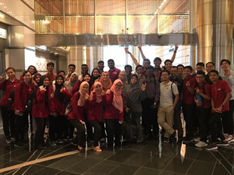
Figure 1

After receiving our visitor pass, we went to PETRONAS Digital Collaboration Centre where the sharing session was held. Figure 2 and 3 are pictures of us at PETRONAS Digital Collaboration Centre (PDCC).
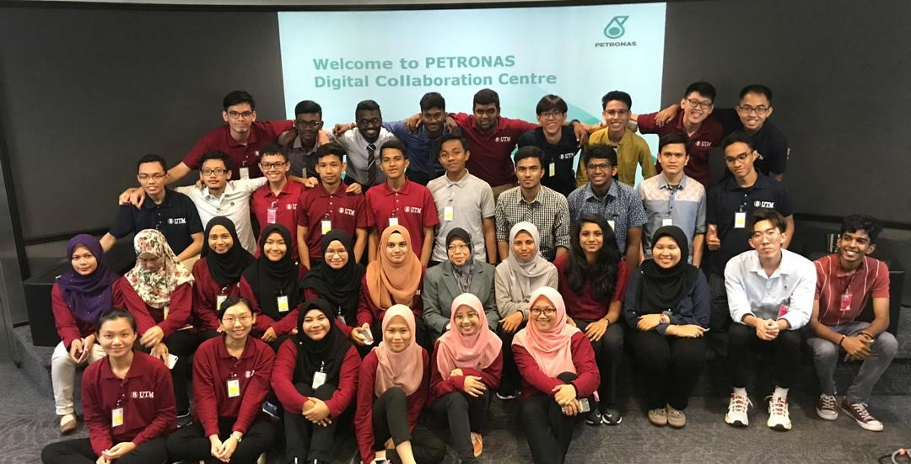
Figure 2
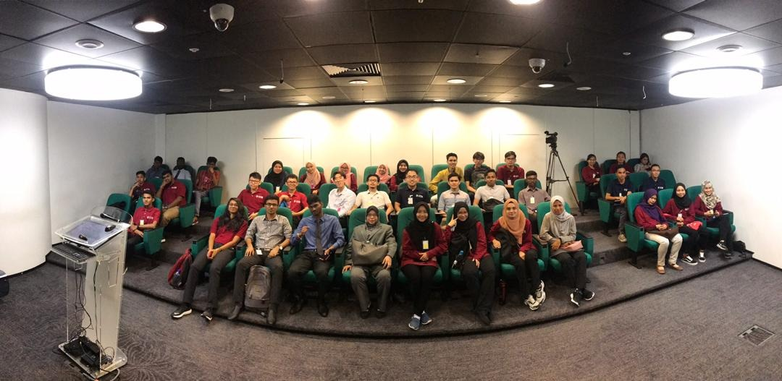
Figure 3

During the sharing session, we were prohibited to take any photos. The sharing session started at 9:00 A.M. and ended with Q&A session at 9:45 A.M. Then, we were taken to PETRONAS Tower 3 to visit our fellow seniors who are currently doing their internship at PETRONAS. Our seniors shared their experiences with us. They also gave us some useful tips and motivations. Figure 4 and Figure 5 shows our meeting session with 11 4th year Data Engineering students who are also interns at PETRONAS.

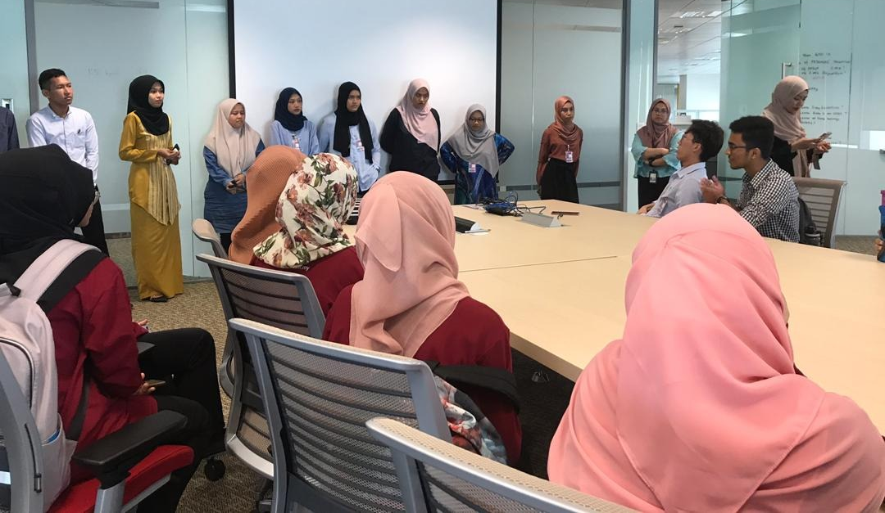
Figure 4
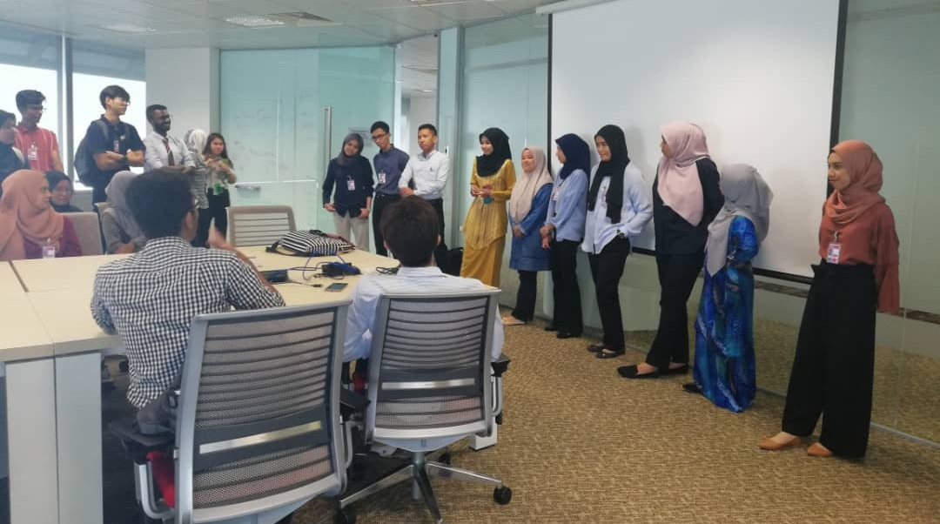
Figure 5

DESCRIPTION
Petroliam Nasional Berhad (PETRONAS) was founded on 17 August 1974 which is Malaysian oil and gas company (1). PETRONAS plays an important role in petroleum activities to meet social needs by research, produce and deliver quality energy to consumer. PETRONAS has been ranked consistently as one of the top corporations in the Fortune Global 500 list (2). Figure 6 is the official logo of PETRONAS.

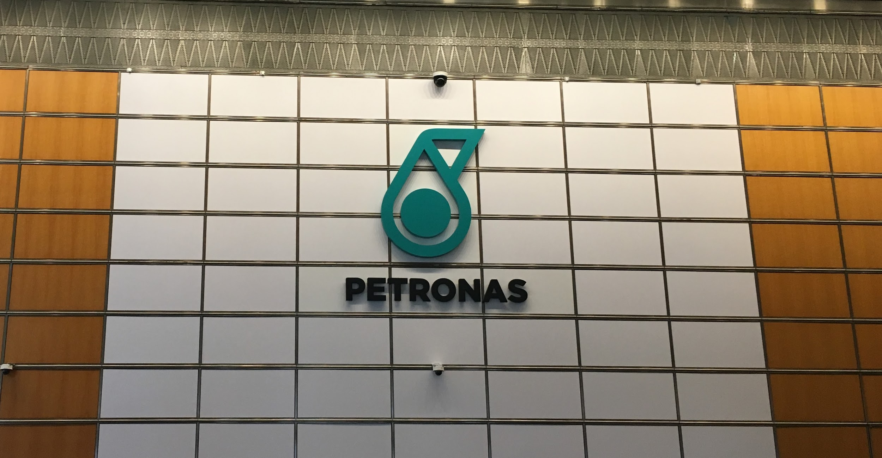
Figure 6
Source: Photo taken by group members

Table 1: Board of Directors in PETRONAS (3)
Board of Directors in PETRONAS
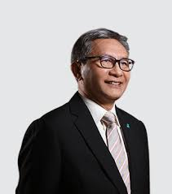 | Name: Datuk Ahmad Nizam Salleh  Position: Chairman
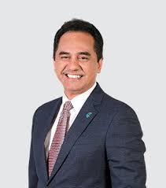 | Name: Tun Sri Wan Zulkiflee Wan Ariffin  Position: President and Group Chief Executive Officer, Executive Director
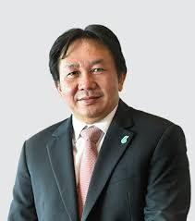 | Name: Ainul Azhar Ainul Jamar  Position: Chairman of the Board Audit Committee, Member of Board Remuneration Committee, Independent Non-Executive DIrector
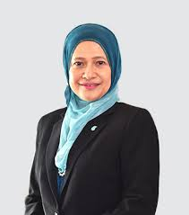 | Name: Datuk Siti Zauyah MD Desa  Position: Member of Board Audit Committee, Non-Independent Non-Executive Director
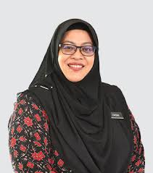 | Name: Zakiah Jaafar  Position: Member of Board Remuneration Committee, Member of Board Governance & Risk Committee, Non-Independent Non-Executive Director

Table 2 above shows the directors in PETRONAS. First, Datuk Ahmad Nizam Salleh who started to work in PETRONAS since 1987 was assigned to be PETRONAS’S chairman by Prime MInister’s Office (PMO) (4). Next, Tun Sri Wan Zulkiflee Wan Ariffin is the President and Group Chief Executive Officer of PETRONAS. Wan Zulkiflee is the first Malaysian CEO to be listed on the list of 100 Global Brand Guardians for 2019 (5). To be proud, he is the first in Asean to be listed in the list (5). Furthermore, Ainul Azhar Ainul Jamar is the Member of Board Remuneration Committee and Independent Non-Executive Director. He is also the Chairman of Board Audit Committee while Datuk Siti Zauyah MD Desa is the Member of Board Audit Committee. Datuk Siti Zauyah MD Desa and Zakiah Jaafar are Non-Independent Non-Executive Director. Last but not least, Zakiah Jaafar is also one of the Member of Board Remuneration Committee and Member of Board Governance & Risk Committee.
PETRONAS has established Petronas Digital Collaboration Centre (PDCC) which is located at VIZ 2, Level 2, Tower 2. PDCC is a collaboration facility housed within their headquarters at PETRONAS Twin Towers. It serves as a data operator and data analyst for the company. They generate data and display the data in chart or table to reflect the company’s innovative vision. To collect data, the researcher will obtain data from other sources for data analyst methodologies to analyse the data so that the researcher’s objectivity and understanding of the investigation can be maximized due to the qualitative and quantitative methods. In PDCC, they will know the crisis faced by the company by interpreting the data and find the solution for the company to solve the problem. Figure 7 is a photo of PETRONAS Collaboration Centre.

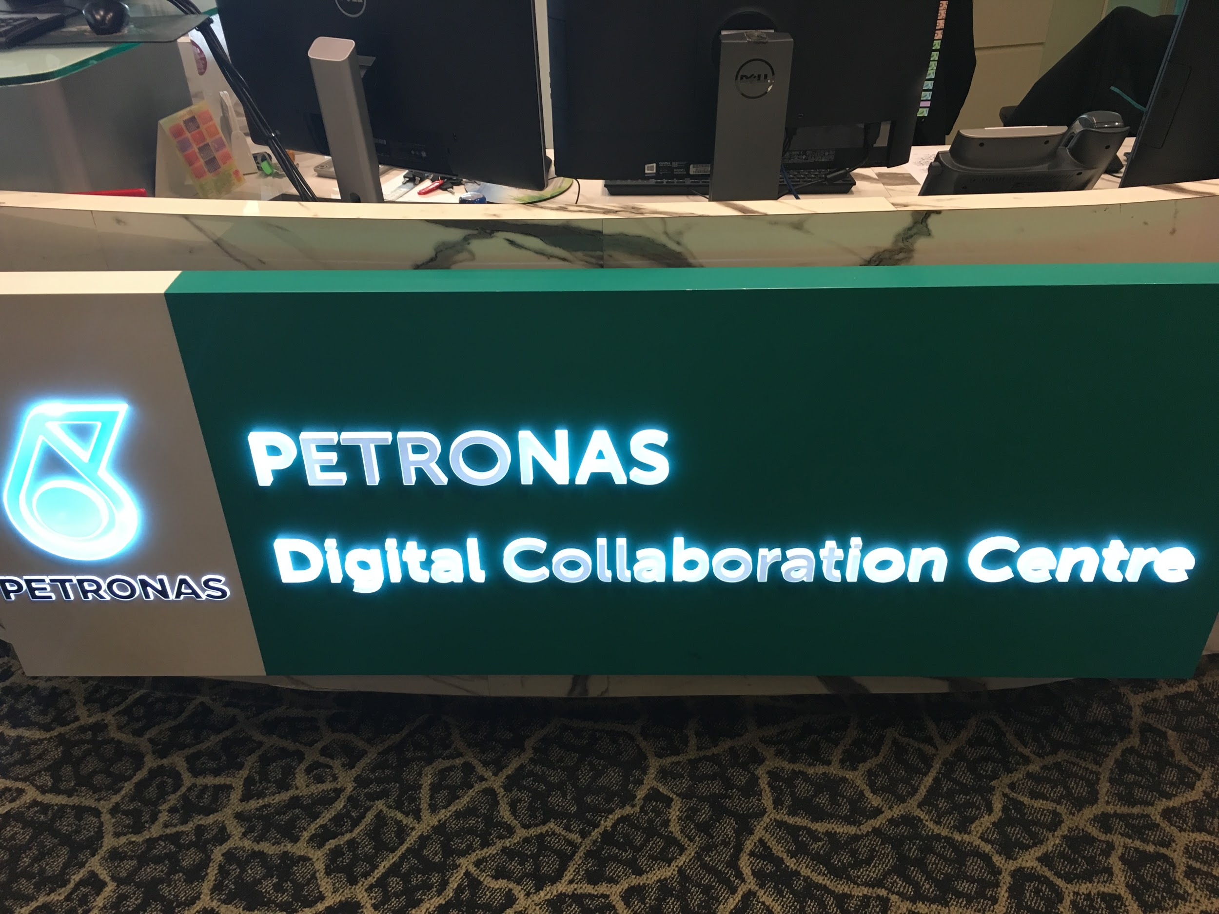
Figure 7
Source: Photo taken by group members

On 25th April 2018, PETRONAS and Telekom Malaysia Bhd (TM) inked a Memorandum of Understanding (MoU) to collaborate to increase both of their companies’ operational. Apart from that, by digitising PETRONAS’ data assets, they are able to enhance their data security as well as to increase customers’ experience. Furthermore, Petronas and TM would like to extend the SMARTPay services for TM staff. The impact of this is to allow cashless payment and increase the efficiency of the process and the most important is to save on fuel costs each year. Besides, this partnership would also like to do a research on the smart park concept for KLCC so that this may ensure the facilities are safe and secure to use as well as to increase customers’ trust and experience (6). Figure 8 show PETRONAS and TM embarking on Digital Collaboration Centre.

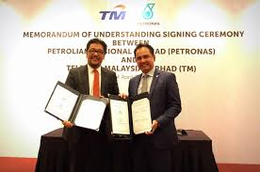
Figure 8
Source: New Straits Times

GROUP TECHNICAL DATA

During the visit, we had the chance to know more about Group Technical Data in PETRONAS which was explained by one of the staff members, Puan Niza, who leads the Planning & Performance department in Group Technical Data.
One of the main functions of Group Technical Data is it serves as the custodian of PETRONAS Technical Data. This means that Group Technical Data has access to every technical data, and it supervises every fundamental for any strategic and technical decisions. Other than that, Group Technical Data also governs and steers technical data especially when it is related to data architecture, which focuses on data processing. Furthermore, Group Technical Data guards and safekeeps every relevant technical data. This is crucial to minimize the loss of valuable data that has been processed.
Beside technical data, Group Technical Data also handles executing data analytics and leading insights to achieve standards and enhance solution development in the unit. Data analytics, technical insights and values provide a sounding board for accurate analysis. Additionally, Group Technical Data is responsible in conducting data services for business units.
Generally, up until today, Group Technical Data has stored more than 70 petabytes of data, which is worth more than ringgit Malaysia 80 billions. They have also purchased data from at least 37 different countries, which costs minimum ringgit Malaysia 2.6 billions.
On top of that, they told us that data covers several disciplines such as asset integrity, production operation and projects. They then briefly described day-to-day operations of Data Operation Surface which consists of data capture, data quality control, data integration and data delivery. (7)
At the end of the sharing session, one of the students asked about how Group Technical Data manages the countless data properly. They explained to us that they normally will carefully structure the data, and that the facilities play an important role in order to enhance the process.

REFLECTION

After the visit to PETRONAS, we found out that it is vital to plan our future wisely. We, as Data Engineering students of UTM, know that this course will not be easy if we do not put any effort into it. Our visions are very clear now after involving in the sharing session by Group Technical Data (GTD) of PETRONAS. It was an honour to get the chance to hear the sharing session by GTD. At the end of the visit, we felt encouraged to be as successful as the members of PETRONAS Group Technical Data.
Besides, we had the chance to meet our seniors who are also Data Engineering students of UTM. There are 11 of them in total. They are currently undergoing their internship at PETRONAS. They welcomed us brightly and we were so proud to see them as they are representing Universiti Teknologi Malaysia. They shared their experience and obstacles in facing the ‘Data’ world. They also shared useful tips for us to use in our studies. The exchange of ideas are helping us a lot to set our vision clearer.
One of the points that was mentioned many times by our seniors is that teamwork is very important. We should not leave others behind and succeed alone by ourselves. We shall rise and fall together as one team. We were truly overwhelmed by the beautiful reminder from them. We gained more confident with our choice in choosing Data Engineering as our course in Universiti Teknologi Malaysia after meeting them.
Lastly, we are very grateful and thankful to our Course Lecturer, Dr. Aryati Binti Bakri for giving us the chance to be exposed to the world of data in real lifetime.

REFERENCES

(1) Case Study - Enterprise. (n.d.). Retrieved from crestron: https://www.crestron.com/getattachment/a74e0dc9-fdd3-43e1-8535-d3bfb6490f1e/CS-Petronas-Centre-HR-v2.pdf?lang=en-US&ext=.pdf
(2) Armenia. (2010, March 24). Fortune Global 500: The World's Largest Companies By Revenues In 2013. Retrieved from economywatch: https://www.economywatch.com/fortune-global-500
(3) Board Of Directors. (n.d.). Retrieved from PETRONAS: https://www.petronas.com/about-us/our-leaders
(4) Ahmad Nizam is the new chairman of Petronas. (2018, August 02). Retrieved from thestar: https://www.thestar.com.my/business/business-news/2018/08/02/ahmad-nizam-is-new-chairman-of-petronas
(5) Wai, W. C. (2019, March 07). Toast to an outstanding leader. Retrieved from thestar: https://www.thestar.com.my/news/nation/2019/03/07/toast-to-an-outstanding-leader-when-petronas-ceo-tan-sri-wan-zulkiflee-wan-ariffin-was-named-one-of
(6) Business, N. (2018, April 25). Petronas and TM embark on cross-industry digital collaboration. Retrieved from New Straits Times: https://www.nst.com.my/business/2018/04/361561/petronas-and-tm-embark-cross-industry-digital-collaboration
(7) Annual Report 2017. (2018, August). Retrieved from PETRONAS: https://www.petronas.com/ws/sites/default/files/2018-08/petronas-annual-report-2017_0.pdf

