

DESIGN THINKING

Course/ Section: SECP/ Section 02

Lecturer’s Name: Dr. ARYATI

Group Members: Jeggean a/l Rajendran (A19EC0059)
Alvin Hee Jun Sheung (A19EC0015)
AINA ALIAH BINTI RUSLAN (A19EC0012)
AHMAH ZULHAKIM BIN ZAINAL (A19EC0179)

Table of Contents
DESIGN THINKING 0
Introduction 2
Detailed Step 3
Empathize 5
Define 6
Ideate 7
Prototype 8
Problems of System Software 9
Solution 10
Team Working 11
Design Thinking Assessment Point 12
Design Thinking Evidence 14
Reflection (Each Member) 16
What is your goal/dream with regarding to your course/program? 16
How does this design thinking impact on your goal/dream with regard to your program? 16
What is the action/improvement/plan necessary for you to improve your potential in the industry? 16
Task of each member 20
References 20

Introduction
Have you ever noticed that our world is full of problems in single day, we have big problems like poverty, starvation in third countries that has to be nip in the bud quickly or even small annoying problems that you would be probably facing every day ,all day long but geniuses from Stanford university, Tim Brown and David Kelly have come out an awesome idea that will widen your perspective of thinking and most important is helping you to create better solutions. This process is known as design thinking and will totally change the way on how you tackle problems. Design thinking not only provides a method for us but also a unifying language for multi-national collaboration leading to faster solution and greater creativity.

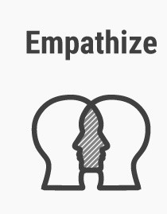 | Empathy is the process where it starts. Without having this initial step, design thinkers would not be able to understand the needs of users. This understanding is done by direct observation, engage with the users face to face or even getting into the mind of users by seeing things from their perspective of view and knowing how they feel.
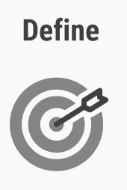 | Define the real problem exists. After gathering all the information from the empathize phase, this information is then being analysed, interpreted by design thinkers. This step provides an reflection that has been confirmed in order to create a plan to address the users’ need.
 | After diagnosing the true problem is, ideate plays a role of coming up with new and creative ideas without the constraints of existing solutions and this is where brainstorming, mind mapping or even bodystorming (role play scenario) play a part in the ideate stage. When it comes to end of ideate stage, design thinkers will narrow down to few options out of all suggested ideas and proceed to next level of stage.
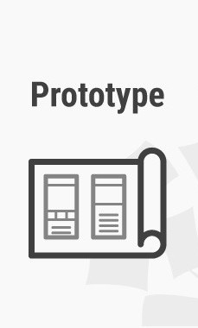 | At this stage, design thinkers learn by transforming these radical ideas into small prototypes into physical form that test possible outcomes. Rapid prototyping can speed up the innovation process because they only learn the quality of their ideas by putting it into the real world.

Detailed Step

On 23 September 2019, we were given a task about the solving the problems regarding the system software. We found that there are three major accessories play major role in the people’s life which are mobile phones, desktop and server pc. All the system software is there but it is not smart enough to keep up with our work and time before the latest upgrade. The IT professional also facing the problem connecting the server to pc and mobile devices like mobile phone. So, we decided to use the design thinking process to solve the problem.

DATE | ACTIVITIES
23 SEPTEMBER 2019 | - Dr. Aryati give the assignment to the students.  - She also gives the briefing about the assignment.
24 SEP 2019 | - First meeting with our group mates. Discuss and understand the task and problem about system software.  - Split the task between the group members.  - Prepare the questions for the interview.
26 SEPTEMBER 2019  THURSDAY | - Interview the Technician and lecturer about their background, experience working in this field and their experience using different system software
27 SEPTEMBER 2019  SUNDAY | - Second meeting with our group mates.  - Discuss the reason for the evolution of system software with the result of our interview.  - Start to brainstorm the problems faced by the user and the solution that fixed by the upgrade of the system software.  - Start researching about the history of the system software.  - Start doing the rough sketch for the report.
30 SEPTEMBER 2019 | - Third meeting with the group mates.  - Discuss the progress they make with the given task for each of them.  - Start to do the report and the idea for the prototype was decided.  - The budget was fixed and assign a member to go to shopping and buy some things for the prototype.
3 OCTOBER 2019 | - Fourth meeting with our group mates.  - Stared doing the prototype.  - Demonstrate the prototype to the user.
5 OCTOBER 2019 | - Each member writes their own reflection based on their experience in this assignment  - A conclusion is finalized and the report was completed.
(Diagram 1: The activity we do across the design thinking process.)

Empathize
We had some interviews to the lecturer who are involved in computer field for than 20 years. Through these interviews, we get to know the problems that they faced with different version of system software. Fortunately, we were able to have some interview with the technician from the CICT unit get more information from him though an appointment. Through these interviews, we have some minds about the problems they faced during using the different version of system software
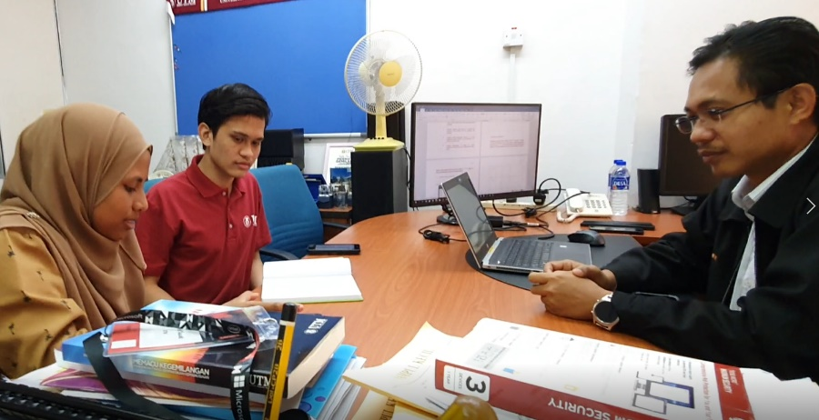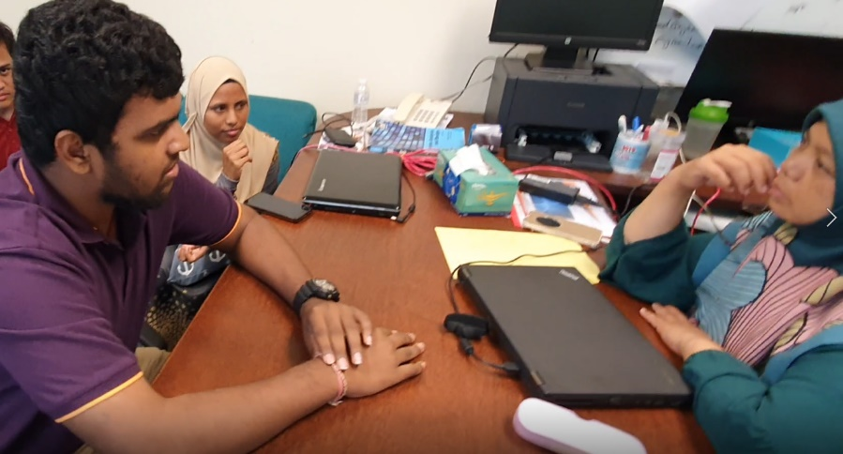
(Diagram 1: Face-to-face interview with the lecturer and technician)

Define
After the empathize process, we try to gather all the findings from different aspects such as lecturers and students. Some the common problem faced by the lecturers are typing the command in MS-DOS and always had to install drivers when using new keyboard or some another component. We also record our interview video and rematch if we miss any important points. We list all the problems from different lecturer and try to categorized it according to their platform.
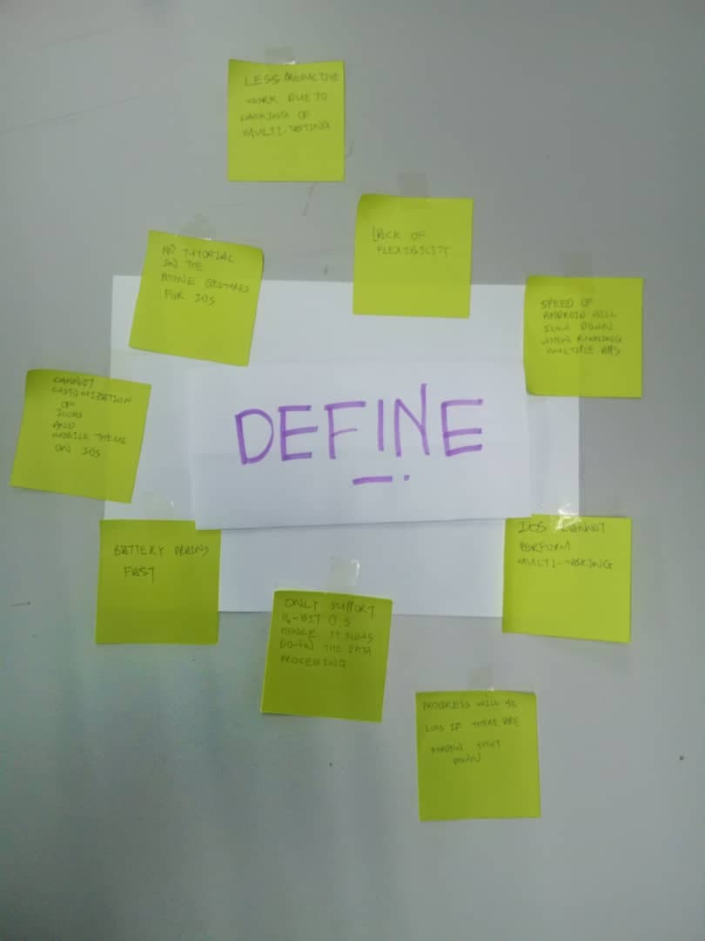
(Diagram 3: we listed out all the problems form the empathy phase)

Ideate
After the problems is clearing framed, we start to search the methods to solve it by brainstorming, mind-mapping and bodystorming. We try to explore as many as we can to come out the solution that they dad receive to handle the problems in system software throughout the years. After that, we shortlist the best solutions for the problems. These are the examples of the solutions such as the introduction of GUI in windows 95 makes the usage of computer much
easier.
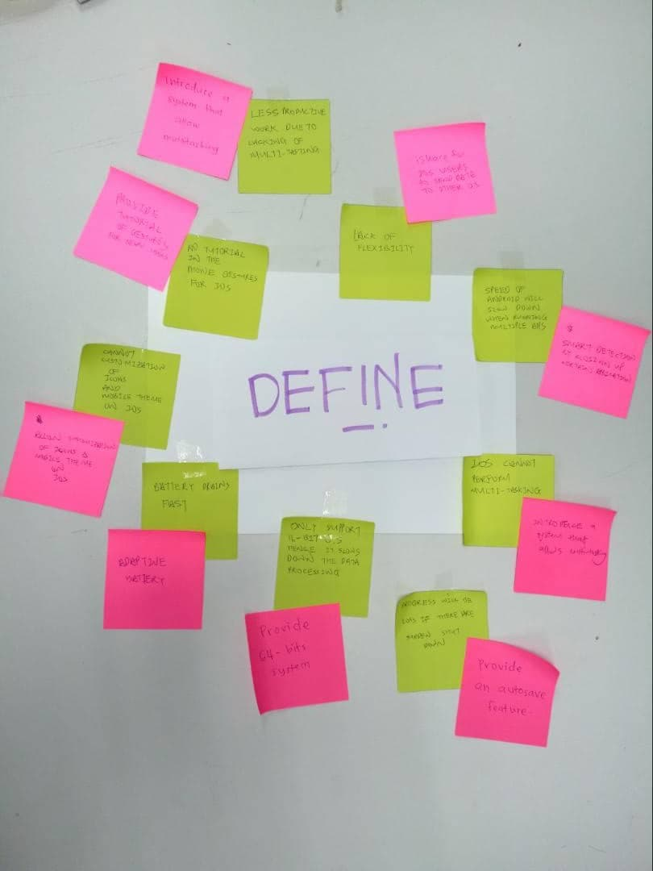
(Diagram 4: Solutions of the problem)

Prototype

After we got the solutions, we started to bring out the solutions into version by design the system software used by the lecturer and technician to overcome their problems. We create a rough prototype with different version of system software according to the lecturer and technician by putting in the solutions to the test and highlighting any constraints and flaws. In our prototype, we create two model, one is laptop and the another one is smartphone. This device system software is the most influenced the lecturer and the technician. So, we decided to do the prototype and try the different version of the system software and in it and experienced the different between the old and new system software in both platforms.

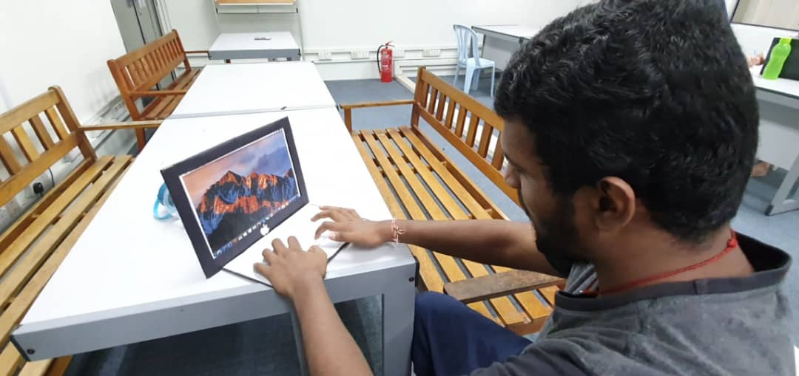
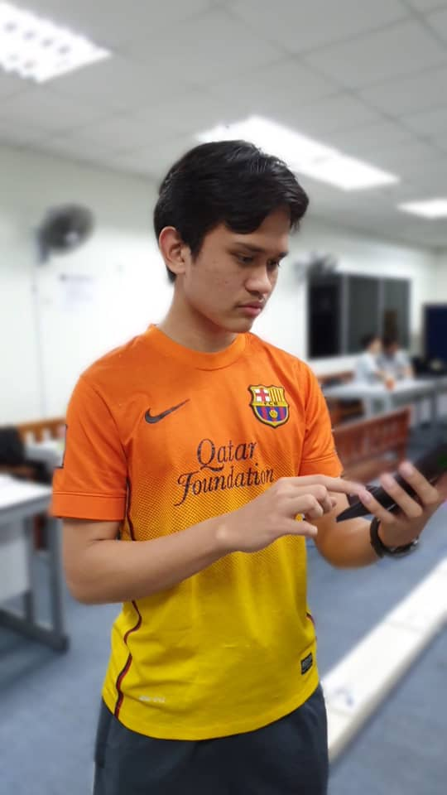
(Diagram 5: The Prototype)

Detailed Description (Problem, Solution and Team Working)

Problems of System Software

MOBILE SYSTEM SOFTWARE | PC SYSTEM SOFTWARE
Not secure enough in terms of security | Less productive work due to lacking of multitasking
Tends to slow down in terms of speed when running multiple applications | Only able to support 16-bit operating system
Drains battery at a faster rate | Progress will loss if there are a sudden shut down
Flexibility of is not big it only allows to transfer file to own apple devices | Have to type every command to execute a software.
Doesn’t support multitasking | Doesn’t support multitasking
Lack of customization on icons and mobile theme | A long boot up time

Solution
After defined all the problems, all of the members brainstorm together to find out the suitable ways and solutions to solve these problems faced by our lecturer and technician. Since our main focus is on lecturers and technicians so our ideas of solving are based on the system software that is used by them. The solution that we prefer is creating the old and new system software. This is because different software system has their different and unique properties. The system software was an improvement an old system software. So, by making both old and new system software we were fully understand the solution that they came up with in the upgrade. After we had
analyzed all the possibility of problem and solution, we finally came out a final decision which is creating a laptop and mobile to with the respective the system software for the solution to our
lecturer and technician.

Solution
MOBILE SYSTEM SOFTWARE | PC SYSTEM SOFTWARE
We introduce smart-touch by long pressing on the icons of control panel will direct users into setting function. | Introduce a system that allows multitasking
Introduce tutorial gestures for the first-time users or enable users to create their own gestures instead of following the default gestures from IOS. | Windows 10 server provides 64 bits system
We make IOS to able to support multitasking view and split screens into two areas which can run to different apps. | Mac OS provide an autosave feature
We tend to add more choices on the selection of icons or mobile theme according to user’s preference, by doing this kind of customization it turns their phone more likely the users. | Able to support multitasking view and split screens into two areas which can run to different software.
iShare by providing IOS users to send or receive their files to another mobile operating system easily | Introduce icons in desktop to simply the execution of a software.
We launch a cloud-based security system whose name is play safe. It enables users to scan an application before downloading it form various possible access. | Decrease the boot up of computer.
We implement smart detection by closing up the running apps but didn’t activate by the users by a certain period of time.

Team Working
Teamwork is one of the determining factors that help us succeed in doing this assignment. Task division is what we implement the idea of teamworking. Everyone in the group gets to handle each part of the assignment. Since design thinking involves 5 phases, each phase requires at least one member to carry out. For the empathy phase, some of the group members with certain experiences in interviewing people will become the interviewers and the rest will in charge the editing or filming part. Second phase is defined which requires us to identify the problems faced by the interviewees form their own perspective regarding to the way how they use system software or the characteristics of the job. On the ideate stage, our group members have to brainstorm the solutions as much as possible regarding to our interviewees problems and filter the best solution that we think is applicable to solve their problems. Prototype phase is where we turn our ideas into a physical solution. There was a time where all of us have contrast between each other’s but is what teamworking helps to put us together again on the track.

Design Thinking Assessment Point

If we conducted a design thinking without any assessment or evaluating our outcome of discussions, we may end up with a poor decision or product. Especially, when we work as a team which may lead to groupthink. Groupthink is a phenomenon that occurs when the members are desire for group harmony but result in dysfunctional decision-making outcome which does not align with the original problem statement. Hence, allocation of assessment point is very important to encounter this problem. Assessment point can be conducted during the end of the project demonstration or the transition between design thinking phrases. In our case, assessment point was being conducted in between the phrases.

Our target audience for this system software is leaning more towards technical staff, lecturers and anyone who have experienced multiple generation of SYSTEM SOFTWARE. Hence, we decided to interview a lecturer and a technical staff to deeper understand what their problems that they had faced and the upgrade that solved their problems.

During this phrase, we should analysis and synthesis the problems that were gathered after doing empathize phrase in order to make a clear problem statement. Initially, we decided what are services that SYSTEM SOFTWARE has to offer for our target audience to solve their problems? But after the empathize phase we change the question to, what are the upgrades receive by our target audience to solve all their problems?
During the ideate phrase, we firstly brainstorm to come out the solution and then filter off irrational ideas. For example, we were unable to find the solution for some problems by using the old system software. However, we can find the ways to solve the problems by upgrading our system software which is system software to the latest version.
After that, we started to make our prototype which is the all three type of SYSTEM SOFTWARE which consists of different types of platform. In the process of making, we make sure that the product is align with our main ideas and it is functioned according to the outline.
(Table 2: The Assessment Point during The Transition of the Phrases)

During the end of the project, reflections are being carried out to verify whether the results and outcomes were hit our initial intention and problems.
In a conclusion, assessment point is very essential in a group thinking or design thinking so it can be functioned as a guideline for us to make sure that we are on the right track.

Design Thinking Evidence

a. The sample work by students working to solve the design challenge

Through our investigation, we found out that lecturer and technician nowadays are too
much depend technology gadgets. They spend a lot of times of digital gadgets such as smartphones and PC doing their and for entertainment. Therefore, we decided to do the laptop and smartphone with different software system not only to understand the features that they added to solve the problem, but also to understand the evolution of system software.

b. Record of each phase
During the first phase of design thinking which is the empathy phase, we prioritise on the problems that have been faced by our interviewees from different background of job scopes. Through our interview section with them, we clearly identify their obstacles when using system software. Table below shows the frequent asked questions during the interview section.

Questions

1.What is your name and job in UTM
2.How many years of you have been working in UTM
3.What do you think about the first system software that you ever used
- What are the latest version of system software that you are using currently and you thoughts on the current system software?
- What is the difference of current system software compared to the past
- What are the good things and bad things for the latest system software
- What kind of improvement do you hope to be done in the current system software?

In the define phase, we listed out all the problems mentioned by the interviewees and we started to define the true problems of the system software.

Problems
MOBILE SYSTEM SOFTWARE | PC SYSTEM SOFTWARE
Not secure enough in terms of security | Less productive work due to lacking of multitasking
Tends to slow down in terms of speed when running multiple applications | Only able to support 16-bit operating system
Drains battery at a faster rate | Progress will loss if there are a sudden shut down
Flexibility of is not big it only allows to transfer file to own apple devices | Have to type every command to execute a software.
Doesn’t support multitasking | Doesn’t support multitasking
Lack of customization on icons and mobile theme | A long boot up time

In phase 3, we started to have brainstorm to think about the best solution. All the ideas are written on the blue color memo and put it around the question’s memo. After that, we refine the ideas we have using memos, and come out with the solution (system software) for each problem.

In phase 4, we created a prototype. We made a tablet case with cardboards and print the a interfaces We decided to use smartphone and laptop as our selected “digital gadget” just to improve the visualization of the interface

As an evidence, a short video clip on the whole process of design thinking have been made. We took some footages when going through all the process of design thinking, from empathy until the prototype test. Most of the video is recorded and edited by Jegan.
Link youtube:
https://youtu.be/NTSpf3pTwj4

Reflection (Each Member)
Jegan

What is your goal/dream with regarding to your course/program?
My course Data Engineering is a course that I choose out love and passion in this field. I want to learn more about this course and became a successful Data Engineer in the future. For that, I have to prepare myself by learning all the things regarding this course whether it is SQL or Python. The most interesting thing about this course is that it will never get boring because the technology kept growing so new things will keep pop up every day. I want to take advantage of that and want to contribute to my country in this technological field by being the one of the best Data Engineer. I still believe that I make the right choice by choosing this course and I hope I can attain my goal someday

How does this design thinking impact on your goal/dream with regard to your program?
My goal and aim are to be an excellent Data engineer and for I think that design thinking one of the most important things that I have to master in order to became a good data engineer. By mastering all phases empathize, define and prototype I can say for sure that I will make a big difference in my career .Design Thinking also help me to became a much more of a team player because it let me to mingle with my groupmates and I get a chance to know my classmates even more better. In the near future, when I became a data engineer, Design thinking will play a major role when doing project with my fellow teammates in that respective company. So, I think it is important to fully master the Design Thinking in order to achieve my dreams.

What is the action/improvement/plan necessary for you to improve your potential in the industry?
I think the action that is most important to improve my potential in the industry is never stop self-learning. As I mention above, this is a industry that will never stop growing. So, have to keep myself update by reading news and articles. SQL, data architecture, data warehousing and database solutions are some of the skills that I need to master in order to improve my potential in this industry. But, if I just learning the things only in the box and not the things out of the box, then there nothing that can differentiate me from a robot. So, in conclusion, self-learning is an important action I have to in order to improve my potential in this industry

Alvin Hee Jun Sheung

What is your goal/dream with regarding to your course/program?
My goal which regard to the program SECP is to study hard within the upcoming years, build a strong foundation of knowledge which related to the program, get myself know more about information in the field of data science. Apart from that, I hope to utilize the knowledge that I have learnt throughout this 4 year in UTM, doing something big in the field of data engineering and putting the name of Malaysia shine bright on the stage of international.

How does this design thinking impact on your goal/dream with regard to your program?
Design thinking, a process or cycle that enables different people put different ideas together through having communication among each other, modifying the solutions creatively by first identifying the problems occur. I think by mastering the skills of design thinking, it impacts me in a way that how I see problems from different perspectives, come out different solutions by following the different stages mentioned in design thinking. Among the five stages in design thinking. When reaching the level of university, what are we all planning to carry out is actually an vital trial for us, that prepares us to gain experiences in the real life industry, even when we make mistakes at this point of stage no one will blame us, what we need to do is move on and correct the mistakes but when entering the real industry, one small mistakes might be risking it out your stakes. Hence mastering skills of design thinking can shape my thoughts into what it should be in the field of data engineering.

What is the action/improvement/plan necessary for you to improve your potential in the industry?
What I plan to improve my potential in the industry is to fully utilize things that I have learnt in this course letting it become a wisdom to earn money yet helping more people to ease their life using big data and AI instead of becoming just a knowledge that is only for the purposes to sit in exam and pass with flying colors. Endless of studying in terms of new computing skills or knowledge no matter at what stage or age is another element that I think it helps me to stay competitive all the time. Last but not least, it is crucial to stay humble and hungry all the time. Humble for obtaining good results instead of being arrogant thus resulting in stop learning. Hungry to keep on striving for greatness, breaking through the limits or hurdle around me.

Zulhakim
What is your goal/dream with regarding to your course/program?
Since I was a child, I had never thought thoroughly about what I want to be in the future and what is my goal that I want to achieve. But as time goes, I started to realise what are my pros and cons, my interests and after I partake in UTM for degree studies in Data Engineering, I know what I want to be in the future. I want to be a certified Data Scientist. To achieve my dream, I need to start from now by achieving at least GPA 3.5 for every semester to maintain good pointer. By the end of my studies, I should be able to graduate with honour and present myself to future employer with my achievements.

How does this design thinking impact on your goal/dream with regard to your program?
This design thinking that I recently did had taught me one of the necessaries skills for data engineer; teamwork. For every group task given, all team members must contribute to the team by completing what has been assigned to them. The members also must be able to communicate, tolerate, and help each other. All of these, to ensure a smooth workflow and the task given completed. Furthermore, the design thinking process also helps me to innovate things that are needed by users. By following the process, I would be able to identify what users wanted, analyse, and come up with solutions by brainstorming ideas that can be developed into prototype later. An efficient and simple work yet derives effective results by following this design concept. So, I think that every knowledges and assignments that was given to me would help develop myself in becoming a full-fledge data engineer after graduate.
What is the action/improvement/plan necessary for you to improve your potential in the industry?
What are my plans in order to improve my potential in the industry I must make sure that I’m able to get good result in my degree studies so I would be recognised by companies with my excellency? I should also partake in teambuilding or leadership program to develop my teamworking skills and to nurture the sense of leadership in me. If I’m able to do these, I would be able to gather as many as experiences I could to increase my value in the industry and achieve the certificates needed to become a data scientist.

Aina Aliah Binti Ruslan
What is your goal/dream with regarding to your course/program?
My dream is to become an excellent student in this subject and also on another subject. I choose this course mainly because I want to explore more about the computer and the other matter that related to computer. I started to develop this passion to learn about computer since I am at matriculation level. By choosing this course, I hope that I will get a good result and become a successful data engineer or data scientist. Also, I hope that I will understand the computer more than before. There are more good things that I need and can explore in this course which can be useful in the future.

How does this design thinking impact on your goal/dream with regard to your program?
What I get from doing this project is I get to learn more about the operating system that was used in desktop, mobile phone and also for networking. Before this, I only know some information regarding this operating system. But after doing these projects, I can get to know the revolution of these operating system, why they update to the new version and also what’s the difference between the old version of operating system compare to the new one. So, generally this will increase my knowledge about the operating system. Secondly, after doing this project, I can say that teamwork is a must and very necessary in order to make the works successful. Everyone has their own responsible to do the work. It wouldn’t be fair if some teammate is not doing their work and only some do the work because this project was mainly to do in group. Also, every decision made must discuss with each of the group members so everyone can give their own opinion about this project. By doing this, everyone will be satisfied with the output. This one is also part of the teamwork. Third, as we know, the operating system keeps on updating to the newest version and of course to the better one. It shows me that we also must keep on upgrading or improve our self to a better person in this life. Improve our self doesn’t give any bad effects towards us but in fact, it will make our self-better in this life.

What is the action/improvement/plan necessary for you to improve your potential in the industry?

As for the improvement and action can be taken to improve my potential in the industry is to build more soft skills. What I can do is to become more confident in myself especially during communicate with others. I think my weakness is during communicate with others people since I do not have any courage or confident in myself to talk with others. So, I must build that confident because it is really necessary for the upcoming time. Second, I must practice what I learn at university in my daily life and make it familiar with my life. All the knowledge I learn will be useless if I just practically learn it but don’t apply it in my life. Our lecturers teach us something with hoping that the knowledge will be useful to us and we can practice it in our real life. So, in order to make it become true, we must take the initiative to apply it in our life and this thing will bring more benefits to us

Task of each member

Name | Responsibility
Alvin Hee Jun Sheung | Video recorder & Report
Jeggean a/l Rajendran | Video editor & Director
Ahmad Zulhakim Zainal | Interviewers
Aina Aliah Binti Ruslan | Interviewers

References
What is Design Thinking. (n.d.). From https://careerfoundry.com/en/blog/ux-design/what-is-design-thinking-everything-you-need-to-know-to-get-started/.
What is design Thinking and Design Thinking Process. (n.d.). From https://think360studio.com/what-is-design-thinking-and-design-thinking-process/.

