

TECHNOLOGY AND INFORMATION SYSTEMS
(SECP1513)

INDUSTRIAL VISIT – CICT UTM

NAME | MATRIC’S NUMBER
NURUL ALIS ALIA BINTI MOHAMAD ZAMRI | A19EC0141
SAHARULNIZAM HAKIMY BIN SHOBRI | A19EC0205
JEGGEAN A/L RAJENDRAN | A19EC0059

LECTURER’S NAME: DR. ARYATI BINTI BAKRI
SUBMISSION DATE: 11th NOVEMBER 2019

Table of Contents
Table of Contents i
Table of Figures ii
Table of Tables ii
1.0 Introduction 1
2.0 Details of Visit 1
3.0 History Components Related to Computing 2
3.1 RAM 2
3.2 Hard Disk Drive(HDD) and Solid State Drive(SSD) 2
3.3 Printer 3
3.4 Mainframe 4
3.5 Processor 5
3.6 IDE Cable 6
3.7 External CD-ROM 6
3.8 CPU Slot Card 7
3.9 Floppy Disk 7
3.10 The Floppy Drive 8
3.11 The Motherboard 8
3.12 The Mouse 9
3.13 The Coaxial Cable 9
4.0 Reflections 10
4.1 Nurul Alis Alia Binti Mohamad Zamri 10
4.2 Saharulnizam Hakimy Bin Shobri 10
4.3 Jeggean A/L Rajendran 11
5.0 The Task for Each Member 12
6.0 References 13

Table of Figures
Figure 1: RAM and Simcheck Portable Tester. 2
Figure 2: 5 inch and 2.5 inch hard drive 2
Figure 3: The impact printer. 3
Figure 4: Magnetic tape unit with square shape tape. 4
Figure 5: Magnetic tape unit with round shape tape. 4
Figure 6: Mainframe Data Storage. 4
Figure 7: Different types of processers. 5
Figure 8: IDE cable. 6
Figure 9: External CD-ROM. 6
Figure 10: CPU slot card. 7
Figure 11: Floppy disk. 7
Figure 12: Floppy drive. 8
Figure 13: Motherboard. 8
Figure 14: The evolution of computer mouse (from right to left). 9
Figure 15: Coaxial cable. 9

Table of Tables
Table 1: The full itinerary of the visit. 1

Introduction

This industrial visit was held on 21st October 2019. We visited Perpustakaan Sultanah Zanariah (PSZ) instead of Centre for Information and Communication Technology (CICT) UTM as the gallerium was moved there. All first year students from School of Computing under the Industrial Visit Program for Technology and Information System Course participated in this visit. Our section which is section 2 was accompanied by our lecturer, Dr. Aryati Bakri. The purpose of this visit is to learn about the evolution of computing devices and components.

Details of Visit

The itinerary of the visits are illustrated in Table 1.

Table 1: The full itinerary of the visit.
Time | Venue | Agenda
3:15 pm | Foyer, Third Floor of Perpustakaan Sultan Zanariah | All Section 2 students gather.
3:30 – 3:45 pm | Gallerium, Second Floor of Perpustakkan Sultan Zanariah | Opening talk by Mr. Mohd Zahari bin Zainal Abidin, Senior Information Technology Officer, Infrastructure Management and Operations Division, Department of Information Technology and Communication
3:45 – 4:15 pm | Gallerium, Second Floor of Perpustakkan Sultan Zanariah | Detailed explanation about the evolution of computing technology by Mr. Mohd Zahari bin Zainal Abidin.

3.0 History Components Related to Computing
The components that are explained by Mr. Mohd Zahari are as below.

3.1 RAM
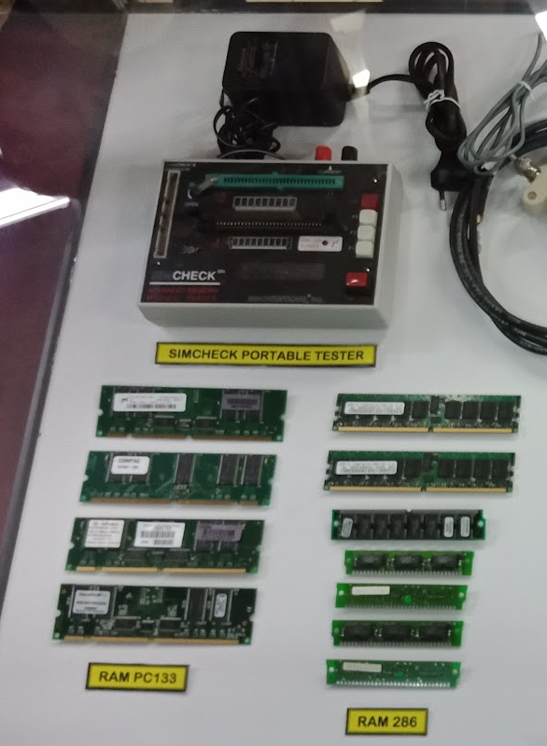
RAM is a type of computer memory that temporarily stores all information our PC might need now or in the future. [2] Just like other components, RAM was bigger back in the days. There were SDRAM and DDR SDRAM. The first SDRAM was developed in 1993 by Samsung with the capacity of 16 MB. [2] One of the most common type of SDRAM is the PC133 (Figure 1). The next generation is the DDR SDRAM, it was developed in the year 1997 with the capacity of 64 MB and it works faster. Nowadays, the latest RAM is the DDR4 SDRAM with the capacity of 16 GB. Before this, people had to solder the needed components on the circuit board to make their own RAM which is different from our generation. The Simcheck Portable Tester (Figure 1) was used to test the memory capacity of a RAM and it was developed in 1987.
Figure 1: RAM and Simcheck Portable Tester.

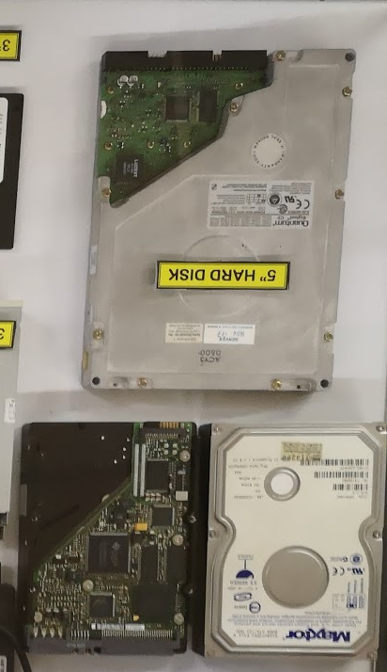
3.2 Hard Disk Drive(HDD) and Solid State Drive(SSD)
The hard disk drive (HDD) is the main data storage device in a computer that stores the operating system, software titles and most of other files. The first hard drive was invented in the year 1957 by IBM. Each generation of hard drive becomes smaller, less sensitive and have larger capacity. The 5 inch hard drive (figure) was introduced in the year 1970 and it is bigger compared to the 3.5 inch and 2.5 inch hard drive nowadays. Despite that, it is a powerful hard drive that can be used until now. The capacity of the hard disk back then was very small which was 5GB, nowadays there are even hard disk with the capacity of 6TB. Nowadays, some computers use Solid State Drive (SSD) instead of HDD now because they are smaller and much faster.SSD is was in 1981.During its introduction the SSD was very expensive and many people cannot afford to buy it.But as the time flows the SSD price continued decline over time and many people became more affordable to buy it.SSD is also became more famous due to its space occupied and its resistance.SSD nowadays can be found in card form so it’s consume less space and it’s is more resistance towards the physical shock like falling.SSD is much more faster than HDD because it does not have any mechanical movement to process the data as it has integrated circuit assemblies to store data persistently. Typically using flash memory such as thumb drive, flash drive and pen drive. HDD are cheaper and you can get more storage space. On the other hand, SSD are faster, lighter, more durable, and use less energy.
Figure 2: 5 inch and 2.5 inch hard drive

3.3 Printer
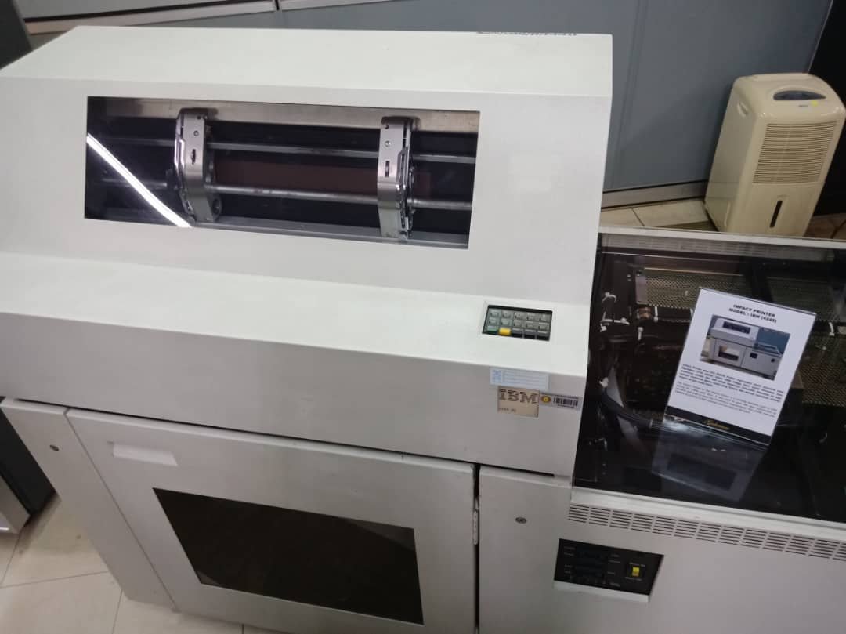
The impact printer or Dot Matrix Printer (Figure 3) are much bigger compared to the printers now. Dot matrix printing uses impact to move the head back and forth to print dots.[4] It is more versatile than typewriter as it allows more types of fonts and they can print ASCII graphics.[4] It also makes a lot of noise while printing. This printer was considered high speed as it can print over 10000 copies in one hour. This printer was used in UTM from year 1990 to 2011 to print data information of students and staff, they were also used to print students’ assignments, examination slips and result slips. This printer was replaced by inkjet and laser printers which are the type of printers we are using now.
Figure 3: The impact printer.

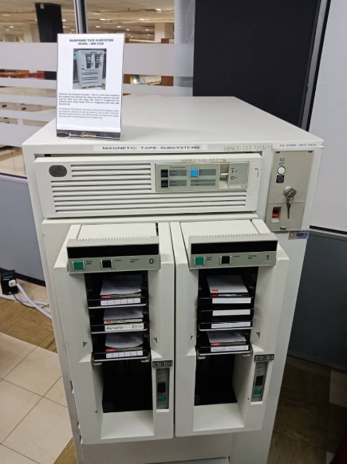
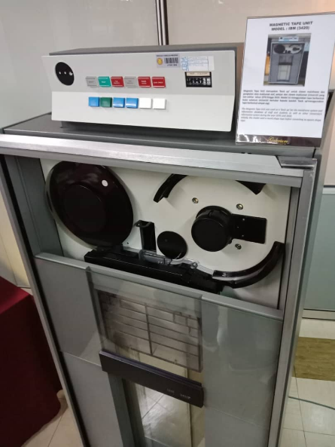
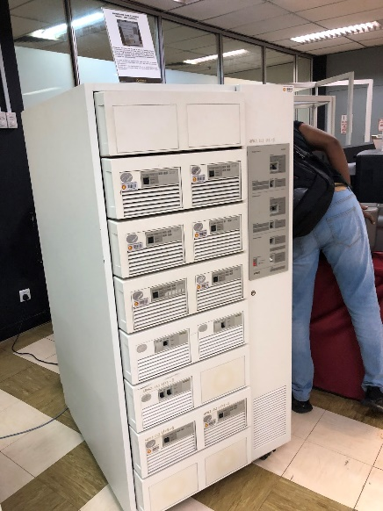
3.4 Mainframe
Figure 4: Magnetic tape unit with square shape tape.
Figure 5: Magnetic tape unit with round shape tape.
Figure 6: Mainframe Data Storage.

Mainframes are a type of computer used by large organizations like companies and universities for applications that requires a lot of data processing. [3] Unlike personal computers, the CPU, hard disk and other components of mainframes are separated and all the components had its own frame. Mainframes back in the time occupies a lot of space. UTM started using mainframe System (Figure 6) in the 1970s at Computer Centre, UTM Kuala Lumpur. It manages data like information of staffs and students. It was used for almost 20 years for processing, storing, securing and printing the University’s information data. The ‘back up’ for the mainframe system and the university’s databases was the magnetic tape unit (Figure 5). The round shape tape used in the magnetic tape unit later switched to square shape tape (Figure 4). This technology was used for almost 25 years.
Nowadays, instead of mainframes UTM uses servers. The Data Centre at CICT UTM has over 700 servers. They have a lot of servers to prevent the server from crashing as UTM has more 28000 students.

3.5 Processor
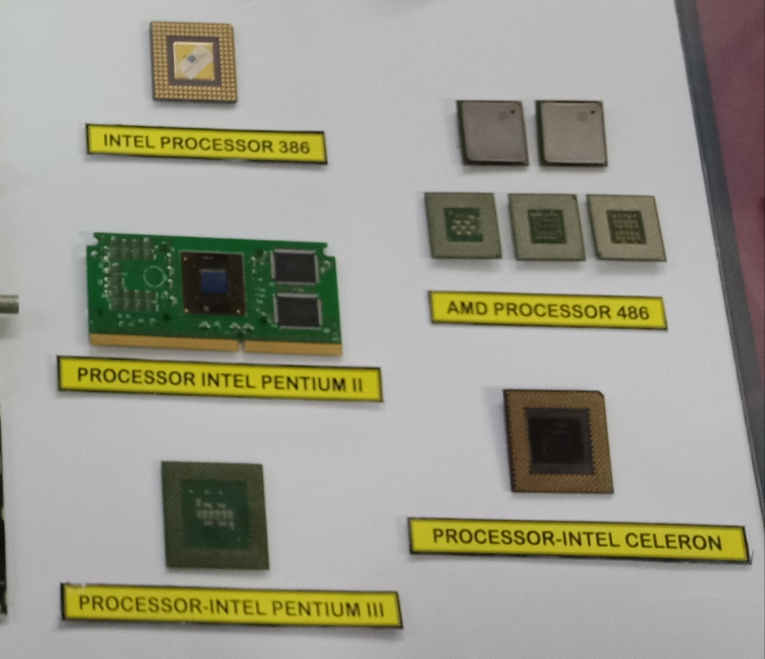
Figure 7: Different types of processers.

CPU (pronounced as separate letter) is the abbreviation for central processing unit. The CPU (Figure 7) is the brain of the computer where most calculations take place. It is responsible for telling all of the other components in a computer what to do, according to the instructions given by the programs (software) running on that computer. There are a lot of version of the processor such as Processor Intel Pentium II, Processor Intel Pentium III, AMD Processor, Processor Intel Celeron and many more. Each of the processor has their own specifications towards the performance they can bring to the computer. Till now we have most powerful CPU for the time being is Intel Core i9-9900K. The fastest Intel processor for games, streaming, and more.

3.6 IDE Cable
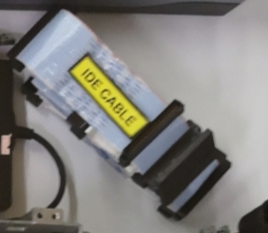
Figure 8: IDE cable.
IDE (Figure 8) is the abbreviation of integrated development environment. IDE is a standard interface that connect the computer motherboard to storage device. The most common of these types of cables are the 34-pin floppy drive cable that connect from the motherboard to the floppy drive and the 40-pin ribbon cable that connect from the motherboard to the hard drive and/or the cd drive. IDE and SATA are different type of interfaces to connect storage devices like hard drives to a computer's system bus. SATA stands for Serial Advanced Technology Attachment (or Serial ATA) and IDE is also called Parallel ATA or PATA. Basically, SATA is the newer standard and SATA drives are faster than PATA (IDE) drives.

3.7 External CD-ROM
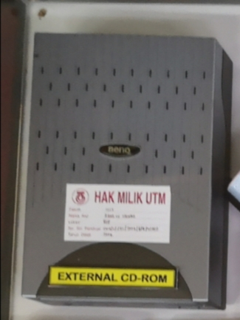
Short for Compact Disc Read-Only Memory, a CD-ROM (Figure 9) is an optical disc that contain audio or software data whose memory is read-only. A CD-ROM Drive is the device used to read them. A CD-ROM drive cannot read DVD, including movie DVDs and data DVDs. The format of a DVD is different from CD, and a CD-ROM drive is not designed to read the format of a DVD. A DVD-ROM drive is required to read a DVD. CD-ROM drive have speeds ranging from 1x to 72x, meaning it reads the CD roughly 72 times faster than the 1x version.
Figure 9: External CD-ROM.

3.8 CPU Slot Card
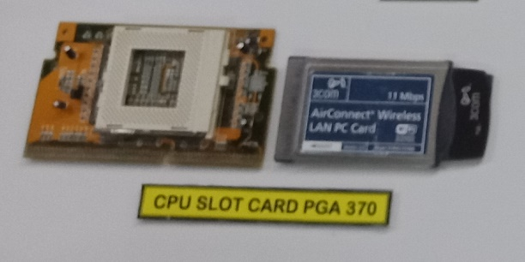
Figure 10: CPU slot card.
The CPU slot (Figure 10) locks the central processing unit into place, preventing it from moving or being damaged. It also establishes the connection between the CPU and motherboard so data can transfer to the CPU for processing and return. Different models and types of computers require different types of CPU slot, as not all CPUs are compatible with every kind of slot. The main difference between CPU slot is how and where they connect to CPUs. These are some of the types which is pin grid array (PGA) , zero insertion force (ZIF), land grid array (LGA) and ball grid array (BGA). Each type of this slot have their own specifications on what performance they will bring. Also what types of input that they support. Some might be better than the other but still they are useful in their own way and each of them has their own role.

3.9 Floppy Disk
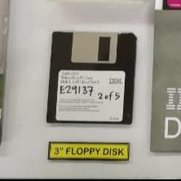
Figure 11: Floppy disk.
A floppy disk (Figure 11), also known as floppy is one of the storage devices back in the 70's until 90’s. The floppy is composed of a disk of thin and flexible magnetic storage medium, sealed in a rectangular plastic. Floppy disks are read and written by a floppy disk drive (FDD). Floppy disk initially was bigger in size which is it was a 8-inch media and later as time progressed the size of the disk became smaller with the size 5 ¼ inch and 3 ½ inch in later times. We can say that mid 70’s until first years were of the 21st century was the golden age of the floppy disks. They can be found in everywhere. We can even see the impact of the floppy disks today as we can even see the save icon in Microsoft word software has the floppy disks icon. While floppy disk drives still have some limited uses, especially with legacy industrial computer equipment, they have been overtaken by data storage methods with much greater capacity and transfer speeds, such as USB flash drives and CD and DVD.

3.10 The Floppy Drive
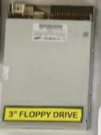
The floppy drive (Figure 12) is a piece of computer hardware that reads data from floppy disks and also write and transfer data to the floppy disks. The most common type of floppy drive was in the 3.5-inch drive, followed by the 2.5-inch drive, among other sizes. The floppy disk was the main method that can transfer data between computer because the price and flexibility. All the computers and laptops in 1900’s until early 21st century cannot be seen without the floppy disk drive preinstalled in it. But as time grew and the introduction of flash drives and optical drives make the floppy disk drive became less popular due to its less transfer rate and capacity.
Figure 12: Floppy drive.

3.11 The Motherboard
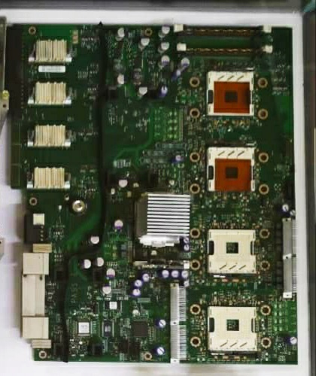
A motherboard (Figure 13) is the PCB (Printed circuit board) found in general purpose computers. It holds, and allows the communication between the computer components of the computer, such as the central processing unit (CPU) and memory like RAM. Unlike a backplane where only one system controls all the system, a motherboard usually contains significant sub-systems such as the central processor, the chipset's input/output and memory to divide the tasks and make the task became much easier and faster to complete. Motherboard usually refers as the PCB with expansion capability as it can attached all the components into it and control it. That is also one of the reasons it is called the motherboard. The motherboard also provide the VGA, HDMI and USB slots to input and the computer components and a variety of other custom components.
Figure 13: Motherboard.

3.12 The Mouse
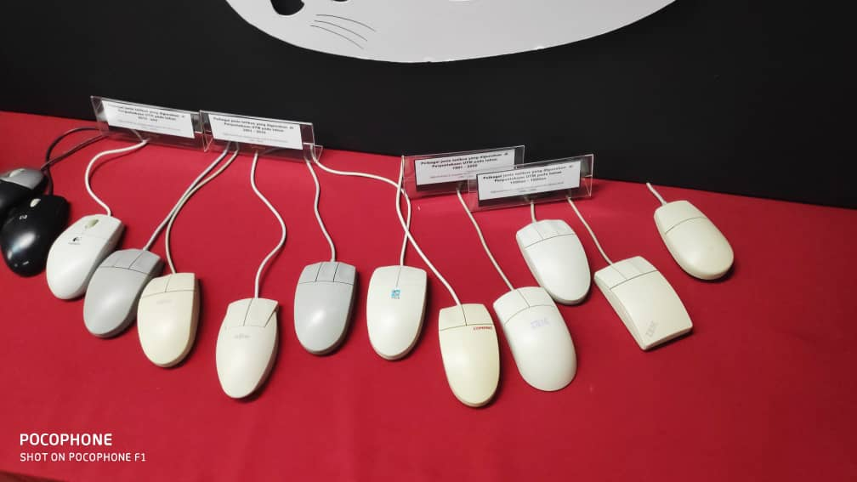
A mouse is a hand-held pointing input device that controls the cursor in a GUI (graphical user interface) and can move and select text, icons, files on your computer. The first mouse demonstration was in 1968 with the mouse controlling the computer system for the first time. Originally, many pointing devices before mouse was tested but all of them ended up in a failure until the mouse came around. The most of the mouse nowadays tend to be cordless, relying short -range radio communication with the connected system to work with the computer but before the mouse was originally used the wire to connect to computer. The mouse originally used to have a ball rolling on a flat surface such as a mouse pad or a desk in front of your computer to detect the position with the x and y values or the motion, but the modern mouse have the optical sensor and laser that have no moving parts. The modern mouse now all have different shapes and sizes to comfort the user hands like ergonomic and gaming mouse. The see the difference, please refer Figure 14.
Figure 14: The evolution of computer mouse (from right to left).

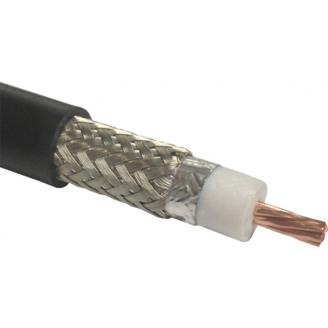
3.13 The Coaxial Cable
Coaxial cable (Figure 15) is a type of electrical and transmission cable that used to carry high frequency electrical signal with low losses. Each component in the coaxial cable has some function like in inner part there is a copper wire, which serves as the primary channel, dielectric plastic insulator, which surrounds the copper, aluminium sheath beneath the insulator that is used to protect from external electromagnetic interference and the last layer which is Teflon or plastic coating, is used to protect the inner layers from physical damage, such as fire and water. The coaxial cable was first used in 1858.The coaxial was most used in broadband internet networking cable, carrying Television signals and more.
Figure 15: Coaxial cable.

4.0 Reflections
The reflection of each member of the group are as below.

4.1 Nurul Alis Alia Binti Mohamad Zamri
After graduating with Data Engineering degree, I want to involve myself in the related industry. My goal is to thrive in my career and contribute to the development of Big Data Technology like the software used to extract, analyse and process the large amount of data. After a few years in the industry, I would like to further my studies to broaden my knowledge so that I can make more contributions in this industry.
After this visit, I realized that the evolution of the above components all have the same goals which is to make the component more powerful, smaller and easier to use with every generation invented. This also gives me desire to make better changes or new inventions to the current software for data engineering right now instead of after graduating. It makes me think why I should wait when I can make changes now. I also learned before a new invention was introduced the inventor actually fails a lot of times in the process of making the device. It teaches me not to give up and try again until I succeed.
To improve my potential in the industry, I will equip myself with extra knowledge that is not related to my course but are essential for careers in the industry. I will identify my weaknesses and improve on them so that I can an all rounder. I will not let my curiosity die down because curiosity in the engine of achievement.

4.2 Saharulnizam Hakimy Bin Shobri
I hope that I can make a better technology as how the component has been developed by the developers. I can see that Big Data can bring a huge change towards our trend of technology that we are developing right now. By minimizing the sizes in the same time increasing the performance is such a great idea and it is not easy to achieve. I believe I can bring a new vibe on technology.
As time passes, a lot of things have change and evolve. The industrial revolution has gives new chances towards technology development. Now, man life is easier with technology. I become more motivated to make man lifestyle become more prosperous with the help of technology. I believe I can help in this field starring from now by gaining a lot of knowledge so that I can be fully prepared in the future.
I wish to improve my potential in this industry by joining a lot of competition related to the field, getting involved and keep updated to the changes or development of technology and also started to follow or join prime figure in this field such Bill Gates, Elon Musk and Steve Jobs. I will spend my time wisely to make sure that I will be ready to contribute in the future.

4.3 Jeggean A/L Rajendran
My goal/dreams with regard for my course SECP is an easy one but hard to fulfil which is to be a Data Engineer. My course Data Engineering is a course that I choose out love and passion in this field. I want to learn more about this course and became a successful Data Engineer in the future. For that, I have to prepare myself by learning all the things regarding this course whether it is SQL or Python. The most interesting thing about this course is that it will never get boring because the technology kept growing so new things will keep pop up every day. I want to take advantage of that and want to contribute to my country in this technological field by being the one of the best Data Engineer. I still believe that I make the right choice by choosing this course and I hope I can attain my goal someday.
The impact on my goal/dream with regard to my program is that it teaches me the importance of step by step progression. A great man has once said that the man who forget the history tend to repeat its again. During my visit I can clearly see the that they didn’t make the same mistake as the last component. They learn from the past mistake make the component to became even more better. The take one step at a time to complete the component. It’s a long step but they managed to after facing many failures. For example, the mouse. Even though many pointing device has become failure, they still didn’t give up on the pointing device and finally the mouse came up to this world. From this historical visit, I learned that step by step progression can make the result became much better. I also learn that we have to never give with just a few failures. This can help me when I want to create something that can contribute to my country.
I think the action that is most important to improve my potential in the industry is never stop self-learning. As I mention above, this is a industry that will never stop growing. So, have to keep myself update by reading news and articles. SQL, data architecture, data warehousing and database solutions are some of the skills that I need to master in order to improve my potential in this industry. But, if I just learning the things only in the box and not the things out of the box, then there nothing that can differentiate me from a robot. So, in conclusion, self-learning is an important action I have to in order to improve my potential in this industry.

5.0 The Task for Each Member

6.0 References
- Fisher, T. (1 July, 2019). What Is a Hard Disk Drive? Retrieved 9 November,2019 from Lifewire: https://www.lifewire.com/what-is-a-hard-disk-drive-2618152
- Sajid, U. (24 September, 2009). The History of RAM: A Trip down Memory Lane. Retrieved 9 November,2019 from Wccftech: https://wccftech.com/history-ram-trip-memory-lane/
- Thakur, D. (n.d.). What is mainframe computer? definition. Retrieved 10 November,2019 from Ecomputer notes: http://ecomputernotes.com/fundamental/introduction-to-computer/mainframe
- Why Dot Matrix Printers Are Still Being Used Today? (28 August, 2019). Retrieved 11 November,2019 from Smart Print Supplies: https://smartprintsupplies.com/blogs/news/why-dot-matrix-printers-are-still-being-used-today

