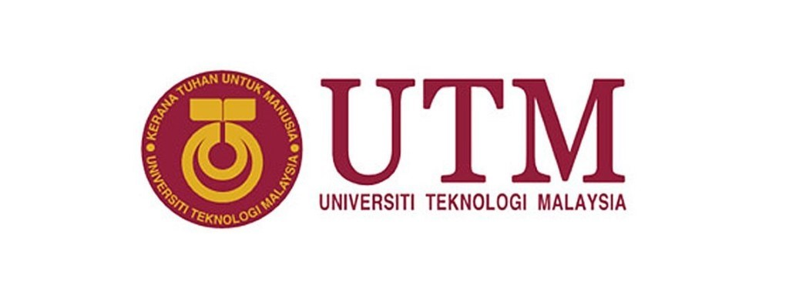
GROUP MEMBERS:
NAME | MATRIC NO
LEE SZE YUAN | A19EC0068
MUHAMMAD IRFAN DANIEL BIN ABD KARIM | A19EC0197
MOHAMMAD SAFWAN BIN AZHAR | A19EC0191

TOPIC :VISIT TO GALLERIUM CICT
NAME OF LECTURER: Dr Aryati Bakri
SUBJECT : SCSP 1513-02 TECHNOLOGY AND INFORMATION SYSTEM

Table of Contents
1
INTRODUCTION 1
DETAILS DESCRIPTION OF THE VISIT 3
LIST OF COMPONENTS 3
1. Random-Access Memory (RAM) 3
2. Read-Only Memory (ROM) 5
3. Hard Disk Drive (HDD) 7
4. Processor 9
5.Computer Monitor 11
6.Motherboard 13
7.Computer Mouse 14
8.Printer. 16
REFLECTION 17
1.0 Lee Sze Yuan 17
2.0 Mohammad Safwan Bin Azhar 19
3.0 Muhammad Irfan Daniel Bin Abd Karim 21
REFERENCE 22
Task for Each Member 26

INTRODUCTION
On 21th September 2019, School of Computing in University of Technology, Malaysia(UTM) held an industrial visit to Centre for Information and Communication Technology (CICT) gallerium for every first-year student of computer science. CICT has been playing a vital role in UTM. It supports, offers and delivers ICT services for every staffs and students in this university. So, inside CICT, there is various devices and gadgets that has been used by former and also current staff in CICT.
The aim of this visit is to let every Computer Science undergraduate student to learn about the history of CICT and get to know past technologies that had already disappeared from human’s life. During that day, at 2.30pm, our class assembled at the foyer of Sultanah Zaraniah Library. After that, we move to the CICT gallerium which display all the old computer devices and gadgets. In the gallerium, we are welcomed by the keeper of Gallerium. He greet us and start to give us a simple briefing about visit today. Then, without further delay, we started our industrial visit today.
First, he introduced to us a few art piece that are displayed in CICT. For example, there is portrait art of our UTM chancellor, the ancient writing, the traditional clothes. After that, he brought us and let us see various kind of projector machine. Then, he showed us to various kind of video recorder and even show us one of the largest and the first camera in this world. He opened the camera and let us have a look of its inside structure. He also showed us a big photocopy machine and how to operate it. He doesn’t only give us a informative explanation, but also told us a lot of funny story that happened with those devices
After that, he brought us to a section that display every classic computer that used before in CICT. Some significant example is Apple Macintosh. Then, he explained to us every pc components and how they evolved and developed until what they look like nowadays.
Finally, like in figure 1.1, my team and I take a group photo at the gallerium.
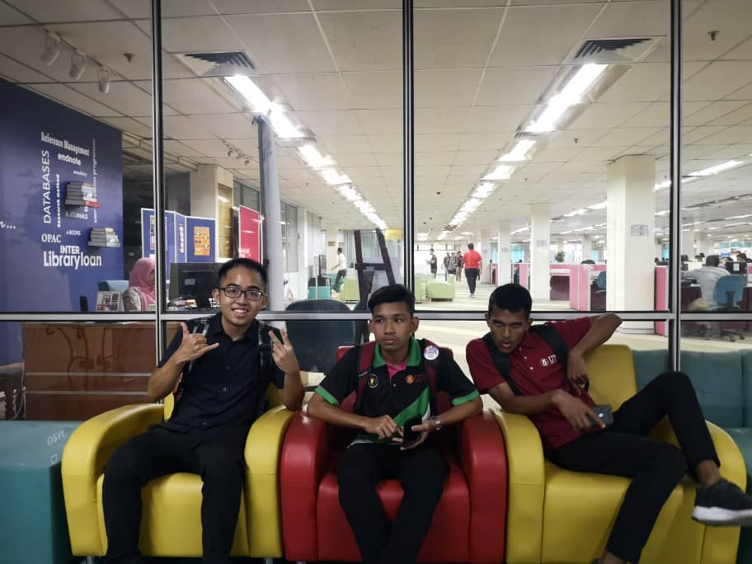
Figure 1.1 Our Team Photo

DETAILS DESCRIPTION OF THE VISIT
Venue :Sultanah Zanariah Library, University Technology Malaysia.
Date :October 21st 2019
Time :3.15_{p.m} - 5.00_{p.m}
Name of Lecturer :Dr Aryati Binti Bakri.

LIST OF COMPONENTS

1. Random-Access Memory (RAM)
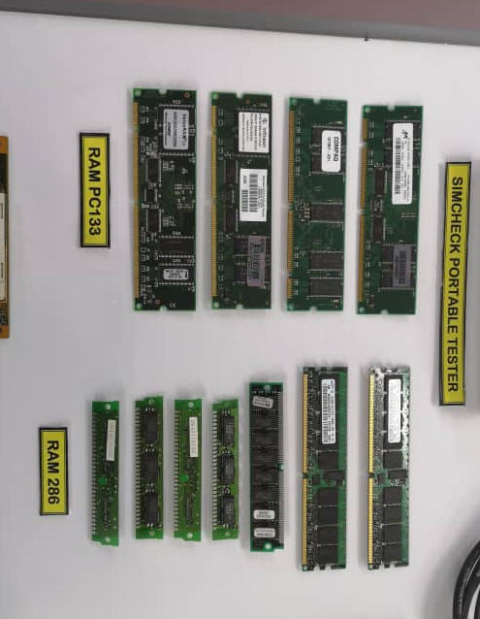
RAM is one of the computer component that stores data for a certain time. It is known as volatile memory where the stored information is lost after power is removed. In 1930, computers use relays, mechanical counters or delay lines for main memory function. (Cambridge English Dictionary) Starting in 1947, the Williams tube was the first practical type of random access memory. It stored information on the face of a cathode ray tube as electrically charged points. Because the CRT's electron beam was able to read and write in any order the spots on the tube, the memory was random access. Even the Williams tube's size was a few hundred to around a thousand bits, but it was much smaller, quicker and more power-efficient than using individual vacuum tube slots. Then in 1947, magnetic-core memory was discovered and improved through the mid-1970s. It became a common form of memory with random access, relying on a series of magnetized rings. The evolution continues in 1963, Robert H. Norman invented an integrated bipolar Static Random Access Memory (SRAM) at Fairchild Semiconductor. .(Robert H. Norman, "Solid State Switching and Memory Apparatus", 1971 It became an alternative to magnetic-core memory. Then, Dynamic Random Access Memory (DRAM) allowed a 4 or 6-transistor latch circuit to be replaced. After that, Samsung Electronics has developed synchronous dynamic random access memory (SDRAM) with size of 16 MB in 1992. Another use of RAM is as virtual memory, RAM disk and shadow RAM.

Figure 1.2: RAM PC213 and RAM 286

2. Read-Only Memory (ROM)
A type of non-volatile memory used in computers and other electronic devices is read-only memory (ROM). After manufacturing the memory device, data stored in ROM can not be modified electronically. Sometimes the word "ROM" means a ROM unit that contains specific software, or a directory that contains information to be stored in EEPROM or Flash Memory. (flash ROM Definition from PC Magazine Encyclopedia, 2013) For example, users who update or replace the Android operating system identify files that contain a modified or replaced operating system as "custom ROMs" following the form of storage to which the file was written. The simplest type of solid-state ROM is as old as the technology of semiconductors itself. It is possible to manually join combinational logic gates to map n-bit address input to arbitrary m-bit data output values (a look-up table). ("Combinational Digital Circuit" and "Sequential Digital Circuits" in Millman & Grable, Microelectronics, 2nd ed) ROM also be used for storing programs and data because it is a form of non-volatile storage (storage that retains its data when power is removed). There are 3 types of ROM which is Programmable read-only memory (PROM), erasable programmable read-only memory (EPROM) and electrically erasable programmable read-only memory (EEPROM).

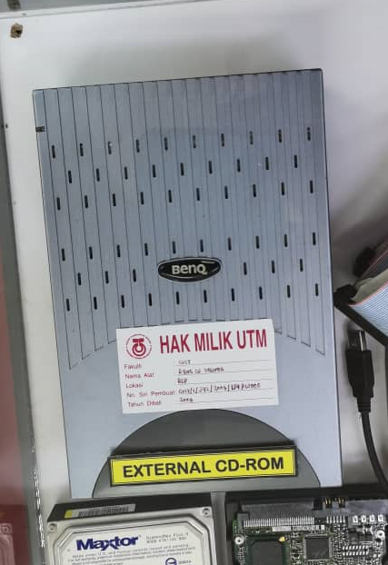
Figure 1.3: the CD-ROM

3. Hard Disk Drive (HDD)
A hard disk drive (HDD), hard disk or hard drive is an electromechanical data storage device that uses magnetic storage to store and retrieve digital information using one or more rigid rapidly rotating disks (platters) coated with magnetic material. (Arpaci-Dusseau & Arpaci-Dusseau) The first IBM hard disk drive output, the 350 disk memory, was shipped as part of the IBM 305 RAMAC system in 1957. At that time, the storage capacity of HDD was only 3.75 MB. ("Time Capsule, 1956 Hard Disk". Oracle Magazine. Oracle, 2014)Then In 1973, IBM introduced a new form of "Winchester" HDD script. The primary feature was that when the drive was powered down, the disk heads were not completely removed from the stack of disk platters. HDD was a rare and very costly additional feature in PCs as the 1980 started, but their price had been reduced by the late 1980s to the point where they were common on all computers except the cheapest. After that, HDD exists as an external component of a computer. External HDDs remained popular on the Apple Macintosh for a long time. But in today’s world, HDD markets are challenged by the SSD market, which is faster, more efficient and use less energy to write or read the data. In 2018, The biggest hard drive storage had a size of 15 TB in while the largest SSD storage was 30.72 TB.
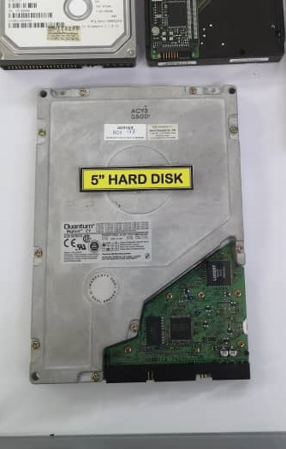
Figure 1.4: Hard Disk Drive

4. Processor
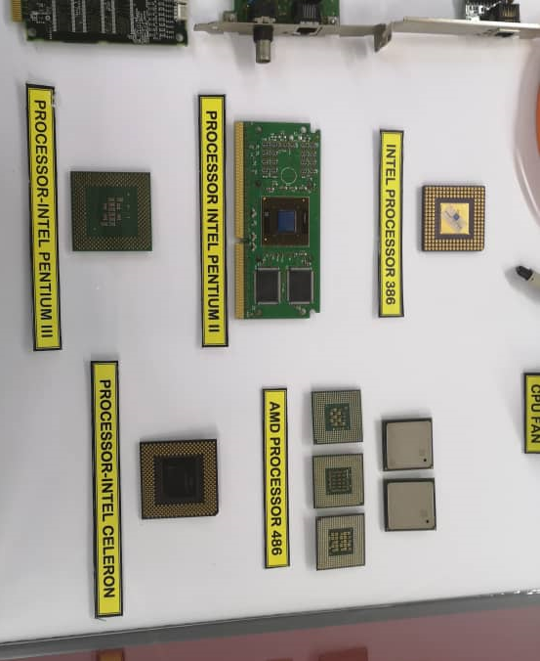
There are many types of processor such as microprocessor, Central Processing Unit (CPU), Graphics processing unit (GPU) and Digital signal processor (DSP). The type of processor that our group got from the visit is microprocessor. A microprocessor is a computer processor that integrates a central processing unit's functions on a single integrated circuit (IC) (Osborne, Adam (1980). An Introduction to Microcomputers. Volume 1: Basic Concepts (2nd ed.), 1980) or at most a few integrated circuits. (Krishna Kant Microprocessors And Microcontrollers: Architecture Programming And System Design, PHI Learning Pvt. Ltd, 2007) The microprocessor is a multi-purpose, clock-driven, register-based, digital integrated circuit which accepts binary data as input, processes it according to memory instructions, and produces results as output. The microprocessor originates from the invention of the MOSFET (metal-oxide-semiconductor field-effect transistor, or MOS transistor) (Shirriff, Ken "The Surprising Story of the First Microprocessors, 2016), which was first demonstrated in 1960 by Bell Labs ' Mohamed M. Atalla and Dawon Kahng.. (The Silicon Engine A Timeline of Semiconductor in Computers, n.d.)Then in 1971, the first multi-chip microprocessors (Four-Phase Systems AL and Garrett AiResearch MP944), built with multiple MOS LSI chips. The Intel 4004 was the first single-chip microprocessor. (1970: SEMICONDUCTORS COMPETE WITH MAGNETIC CORES, n.d.)) After the 1970s, many design of microprocessors were invented such as 8-bit design, 12-bit, 16-bit, 32-bit and 64-bit. Since the early 1990s, 64-bit microprocessor models have been in use in many markets (including the Nintendo 64 gaming console in 1996), 64-bit microprocessors aimed at the PC market were introduced in the early 2000s.
Figure 1.5: Intel and AMD microprocessors

5.Computer Monitor
A computer monitor is one of the output devices that can display the data or information for the user to see. Earlier, computer monitors were mainly used only for data processing. Monitors are connected to the computer via VGA, Digital Visual Interface (DVI), HDMI, DisplayPort, Thunderbolt, low-voltage differential signaling (LVDS) or other connectors and signals. Monitors back then can only display a number amount of information and is limited, they were rarely considered as an output component (Difference Between TV and Computer Monitor). The main output device was actually a line printer as the monitors were limited in displaying and running the operation of the program. Years passed by, more engineers started to realize that the usage of cathode ray tubes can produce a more flexible output than the old panels of light bulb. It can ensure a more controlled output from the monitor. High-resolution CRT displays were improved to be used in many sectors specifically military, industrial and scientific applications but they were too expensive for general use (Cathode Ray Tube(CRT) Monitors, 2011). The monitor itself became a powerful output device in its own right. In the gallery, one model of monitor is displayed as it was once used by the UTM library back in the early 1998. IBM P-70 Model 6554-673 was used because of its performance that has been developed onto a desktop. This made the library to become responsible on all modules, databases systems, software operation and data accessibility. With its 16 MB ability on disk storage, the computer performance has become greater on desktop operation.
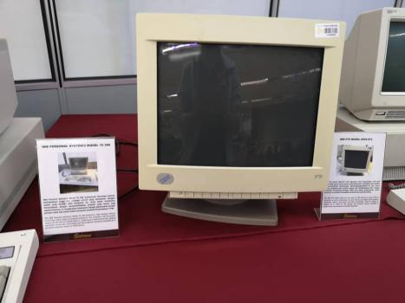

Figure 1.6: The IBM P70 MODEL 6554-673 used by the UTM Library in the early 1998

6.Motherboard
A motherboard is the main printed circuit board (PCB) that can be found in general purpose computers and other expandable systems. The function of a motherboard is actually to allow, connect or become a communication component for all other important electronic components in a computer. For instance, the central processing units (CPU) and the random access memory (RAM) are installed onto a motherboard so they can be connected to other components. In the first place, motherboard was called as “planar” and was primarily used by a personal IBM computer. Before the invention of motherboard, people used backplane which is a set of interconnected sockets.(Computer Motherboard History, 2017)The CPU, RAM were installed into their individual circuit board which are then connected into the backplane. During the late 1980s and early 1990s, it has become usual that a lot more components are connected to a motherboard.
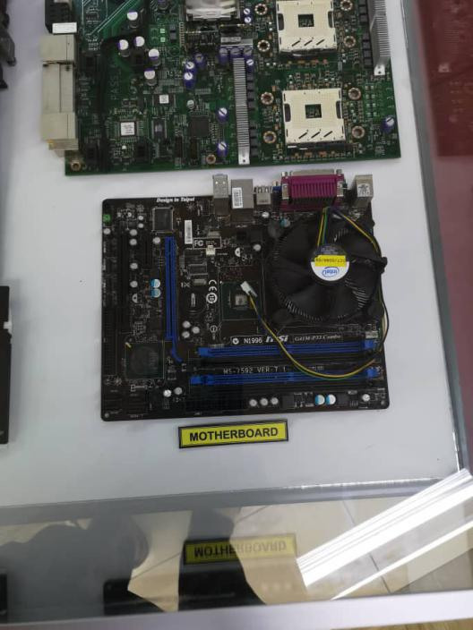

Figure 1.7: motherboard that can be found in the gallery

7.Computer Mouse
A computer mouse is a hand-held pointing device that senses a surface-related two-dimensional movement. This movement is usually converted into a display’s gesture of a marker which enables the graphical user interface to become more manageable. Before the electronic mouse was used, people typed in command into the computers only by using keyboard. The first computer mouse was constructed as a wooden box with two wheels and only one key making contact with the floor. (Fire-Control and Human-Computer Interaction: Towards a History of the Computer Mouse (1940-1965), 1965)
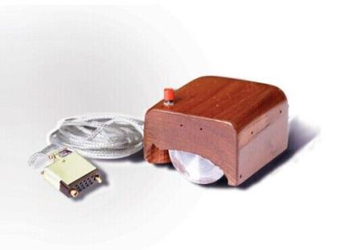

Figure 1.7 shows the first computer mouse that was invented by Douglas Engelbart

Bill English has invented the “Ball Mouse” in 1972 where the ball is used to replace the wheels so the mouse can move in all directions. (50 JAHRE MENSCH-MASCHINE-INTERAKTION: FINGER ODER KUGEL?, 2016) Current mice have non-moving optical sensors. Typically wired to a computer, most modern computer mouse are cordless and rely on the linked device for short-range wireless communication.
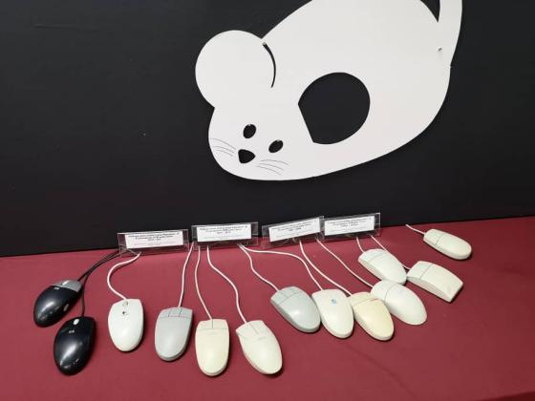

Figure 1.8: the types of mouse that can be found in the gallery

8.Printer.
Digital printer history started in 1938 when Seattle pioneer developed a dry printing process call digital photography which is commonly called as Xerox. It was also has become the base for the laser printer technology for decades to come. Two options were available to replicate literature or photographs by employing a Scribe. This costly and time-consuming process involved a scribe reproducing and illustrating a complete manual book or document. In addition, block printing often included carving letters and pictures on the face of a block of wood, coating it with ink, and pressing it onto a medium such as paper. The blocks would wear out easily and the need for one block per page were the disadvantages of this approach. If a copied book had 200 pages, it would require 200 blocks to reproduce it. (Ngeow, 2008)
The IBM 3800 printing system was the first high-speed laser printer in the industry. It was a laser printer running at speed of over 100 impressions-per-minute. It also was the first printer to merge laser technology with electrophotography. (History, Timeline, and Evolution of computer printers, 2019) Most modern 3Dprinters use a technology that was designed and developed by Scott Crump in 1988 called fused deposition modelling (FDM).

REFLECTION

1.0 Lee Sze Yuan
Like most of the passionate and hard-working students out there, I pay all full attention to my life in UTM, I spent time in study and practise as much skills as I could. I hope and pray all the knowledge, experience and skills and the effort I give in is to achieve my dream. My dream regards to this course, Data Engineering is that I can master all the necessary skills in this field and become a professional data engineer in the future.

Like I mentioned just now, I strongly believe my experience of life in UTM will help me a lot in my future. So, this time, this visit to CICT has became a very important experience to me. This visit expose me to all the classic computer devices used by our ancestors. I learned the difference of the early stage of IT with IT nowadays. From the speaker, I also learned that how IT improve from time to time, what is the challenges that our ancestors met during their time. However, the most important thing I learned in this visit, we should value all these history components and try our best to keep them. How these will impact my dream? From the perspective of data engineer, I learned that the importance of keeping record of everything. For example, although data from the past may differ a lot from recent data, both are valuable source of information and knowledge, we need to appreciate both. Besides, this visit, the knowledge about the history components related to computing will help me to have better potential in the industry.

Through this visit, I realise I also need to spend more time to study things that are taught in the class only. I should spend more time in learning computer components too, these components are the basic of computing. I believe with a better knowledge and understanding about the components, I can handle tasks related to computer better in future. Besides, I need to learn more how these components will help me to do my job which is data engineering better. I believe by using these way can increase my potential in the industry.

2.0 Mohammad Safwan Bin Azhar
As a data engineering student, I have always dreamed of myself sitting around a table with other data engineers where we share a lot information about technology and our inventions in the future. Besides, my goal with regard to my program is that I can always learn new things and explore more about the basic skills needed for me to become a better data engineer. The visit to CICT gallery has undeniably given me an inspiring motion on how I should keep on moving forward and try my best if I want to contribute something to the technology world. From the visit, I can conclude that innovations in this Information Technology (IT) field is endless as we cannot predict what could be invented next. All the IT components shown in the gallery can be the greatest examples on how the technology world has expanded and become like how it is now. The speaker who is one of the IT technicians in UTM also has given us, the computer science students explained clearly to us how they used the old components before and how they transited them to the new ones. It is so fascinating to learn that some of the components can still function very well.
This visit obviously gave me some new perspective in regard to my program. With that being said, while at the gallery, I learn that as a Data Engineering student, I have to bare in mind that I have to become more proactive in finding solutions to all problems that can be found in the program or innovation that i want to make. This can be proven as I learn about the pros and cons of all components, the inventors back then really had tried their best in improving all the components to become more user-friendly and can make our life a lot easier. For instance, the camera back then was really large and hard to carry together. But, cameras nowadays are small but can give a better resolution. The same thing as data engineers, they have to always think on how to give advancement to a system or program so it can be easily used by all people.
Lastly, this visit also has made me realize that there is a lot of things that I still yet to learn. The necessary action that I need to take is that I should not stop learning and should start doing researches about the IT field in order to become a great data engineer. In addition, in order to learn new things, I have to pay attention closely to the things that happen in my life. Innovations are always far from over. That being said, a lot of things I can do if I pay more attention to all things and look on the data engineers’ side.

3.0 Muhammad Irfan Daniel Bin Abd Karim
I gained a lot of things from the CICT visit at Perpustakaan Sultanah Zanariah. From collecting information regarding our course to receiving information and history from the CICT technician. For me, the technician was very friendly and the way he explained was understandable. From the visit, I learned that good computer components are very important to make a good computer because all the activities and data processing are run by the components. When we want to buy a computer or a PC, we should know their basic specifications to make sure the PC works well while doing our daily routines such as editing videos in Vegas Pro, editing photos in Adobe Photoshop and playing game. In addition, through this visit, I have a chance to see the antique components such as RAM, ROM, keyboard, monitor, microprocessors and even the world’s first camera. I was so inspired by the inventors who invented and innovated the computer components until it becomes so powerful and nowadays, people are using their products every day. This visit dedicates me to invent more useful products in my field like creating an intelligent system to collect and interpret data. In the middle of the visit, I wondered how the size of the components can be minimised from the size of the room until the size of the grain. Talking about innovation, I amazed by Google because recently they just invented the “Quantum Supremacy”. They claimed that the time needed for the world’s best supercomputer to complete a certain calculation is 10000 years while the quantum computer can complete it within 200 seconds. I also learned that I should never give up especially in making new inventions because the failures are the new knowledge we learned to create something better. If the innovator of the computer’s component gave up in past, I am very sure that we cannot feel the advancement of our PC nowadays. To sum up, this CICT visit helped me a lot in becoming a better data engineer so that I could contribute something in the future.

REFERENCE
(1970: SEMICONDUCTORS COMPETE WITH MAGNETIC CORES, n.d.)
Retrieved from https://www.computerhistory.org/storageengine/semiconductors-compete-with-magnetic-cores/

(50 JAHRE MENSCH-MASCHINE-INTERAKTION: FINGER ODER KUGEL?, 2016)
Retrieved from https://www.heise.de/newsticker/meldung/50-Jahre-Mensch-Maschine-Interaktion-Finger-oder-Kugel-3567899.html

(Arpaci-Dusseau & Arpaci-Dusseau)
Retrieved from http://pages.cs.wisc.edu/~remzi/OSTEP/file-disks.pdf

(Cambridge English Dictionary)
Retrieved from https://en.wikipedia.org/wiki/Cambridge_Advanced_Learner%27s_Dictionary
(Cathode Ray Tube(CRT) Monitors, 2011)
Retrieved from Infodingo.com

("Combinational Digital Circuit" and "Sequential Digital Circuits" in Millman & Grable, Microelectronics, 2nd ed)
Retrieved from https://en.wikipedia.org/wiki/Read-only_memory

(Computer Motherboard History, 2017)
Retrieved from https://www.computerhope.com/history/motherboard.htm

(Computer Organization and Design, 1971)
Retrieved from http://ac.aua.am/arm/public/2017-Spring-Computer-Organization/Textbooks/ComputerOrganizationAndDesign5thEdition2014.pdf

(Computer Processor History, 2019).
Retrieved from https://www.computerhope.com/history/motherboard.htm

(Difference Between TV and Computer Monitor)
Retrieved from http://www.differencebetween.net/technology/difference-between-tv-and-computer-monitor/

(Fire-Control and Human-Computer Interaction: Towards a History of the Computer Mouse (1940-1965), 1965)
Retrieved from http://web.stanford.edu/dept/SUL/library/prod/siliconbase/wip/control.html

(flash ROM Definition from PC Magazine Encyclopedia, 2013)
Retrieved from https://www.pcmag.com/encyclopedia/term/43279/flash-rom

(Google and IBM Clash Over Milestone Quantum Computing Experiment, 2019)
Retrieved from https://www.quantamagazine.org/google-and-ibm-clash-over-quantum-supremacy-claim-20191023/

(Google LLC, 2019)
Retrieved from https://www.quantamagazine.org/google-and-ibm-clash-over-quantum-supremacy-claim-20191023/

(History, Timeline, and Evolution of computer printers, 2019)
Retrieved from https://www.clashgraphics.com/printing-tips/history-timeline-evolution-computer-printers/

(Ngeow, 2008)
Ngeow, Evelyn, ed. New York: Marshall Cavendish

(Krishna Kant Microprocessors And Microcontrollers: Architecture Programming And System Design, PHI Learning Pvt. Ltd, 2007)
Retrieved from https://en.wikipedia.org/wiki/Microprocessor

(Osborne, Adam (1980). An Introduction to Microcomputers. Volume 1: Basic Concepts (2nd ed.), 1980)
Retrieved from https://archive.org/details/introductiontomi00adam

(Shirriff, Ken "The Surprising Story of the First Microprocessors, 2016)
Retrieved from https://spectrum.ieee.org/tech-history/silicon-revolution/the-surprising-story-of-the-first-microprocessors

(Robert H. Norman, "Solid State Switching and Memory Apparatus, 1971)
Retrieved from https://worldwide.espacenet.com/publicationDetails/biblio?CC=US&NR=3562721&KC=&FT=E&locale=en_EP

(SSD vs. HDD: What's the Difference?, 2018)
Retrieved from https://uk.pcmag.com/ssd/8061/ssd-vs-hdd-whats-the-difference

(The Silicon Engine A Timeline of Semiconductor in Computers, n.d.)
Retrieved from https://www.computerhistory.org/siliconengine/

("Time Capsule, 1956 Hard Disk". Oracle Magazine. Oracle, 2014)
Retrieved from https://blogs.oracle.com/oraclemagazine/time-capsule-v7

Task for Each Member

LEE SZE YUAN:
Photo Taking, Wrote the Introduction, RAM and Printer part

MOHAMMAD SAFWAN BIN AZHAR:
Audio Recording, Wrote the ROM, HDD, Processor part

MUHAMMAD IRFAN DANIEL BIN ABD KARIM:
Taking note, computer monitor, motherboard, mouse part

