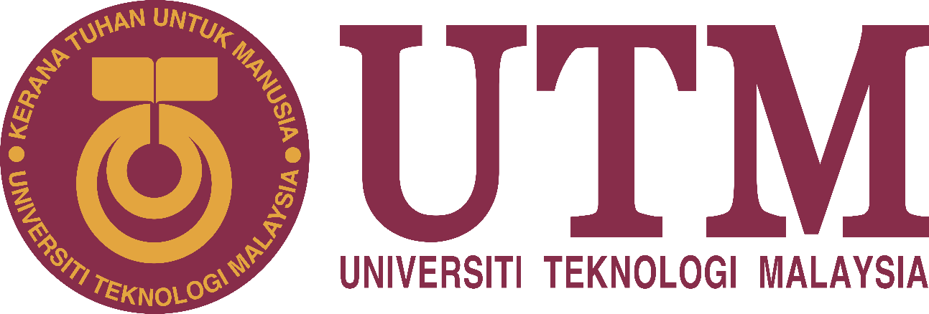
SCHOOL OF COMPUTING
Faculty of Engineering
_______________________________________
SECP1513 – TECHNOLOGY AND INFORMATION SYSTEM
__________________________________________
INDUSTRIAL VISIT 1 REPORT
____________________________________________________
SECTION: 8 – 1SECR
COURSE NAME: BACHELOR OF COMPUTER SCIENCE – NETWORK AND SYSTEM SECURITY
NO. | NAME | STUDENT ID
1 | NICHOLAS PANG JIA CHERN | A19EC0118
2 | IURII KUTIN | A19EC0245
3 | NURUL ISMAT TANNI | A18CS4052
4 | AMMAR KHALED OMAR BA MUQADM | A19EC0306
LECTURER’S NAME: DR. HASWADI HASAN
DATE OF VISIT: 20TH OCTOBER 2019
PLACE OF VISIT: PSZ UTM
DATE OF SUBMISSION: 11th November 2019
GROUP NO. : 6
CICT VISIT REPORT
The visit was on the 20th of October 2019 which is a Sunday. The visit was organized and prepared by University Teknologi Malaysia’s Center for Information and Communications. Our lecturer Dr. Haswadi Hasan brought us to the venue of the visit. Our guide for the visit was Mohd Zahari Zainal Abidin. Our tour group consists of 36 students, 1 lecturer and 3 people that is in charged on helping and guiding us through the gallery. The place we are visiting is the Perpustakaan Sultanah Zanariah (PSZ) gallery. It is located on the lower ground of the library. We reached the gallery at 3.15pm, but we have to wait for the other session to end their tour before we do conduct ours as this would congest the gallery and could have caused incident that may involve breaking priceless artefacts. Our tour guide Mohd Zahari Zainal Abidin guide us throughout the gallery showing us and gave us description on the items. We first start the tour with the technology section which is filled with computer, mainframe and typewriters. Our guide explain about some of the artefacts there for around 20 miunutes. After that, we were given time to explore the other parts of the gallery which is filled with old artefacts such as the cameras, microfilm and hot press machine. The gallery was not only filled old and priceless technology but also filled with the university’s historical items such as the book of names of student graduated from the university that is written by hand. The tour lasted around 1 hour and 45 minutes. We learned that all this artefacts were the foundation and the building blocks of the technologies we have today and we are thrilled to have seen such priceless items in our times. We also learned not just about the history of our technologies but also the history of the university.

Among all of the artefacts and items inside the gallery, there is one items that stood out the most for us. The first one is one of the earlier model of the computer. In the old days, the computer were not like what we have today. The size of the PC is relatively smaller than an average PC nowadays in terms of width. But nowadays computer tend have more components that are bigger and better than the older type of PC which makes sense for it to be bigger. The older model of the monitor which is mostly used by our parents back in their days is a big cube box. The monitor is also a cathode-ray tube (CRT) screen. The computer uses a frame buffer that is video graphics array (VGA). It also have a type of stand underneath which is connected to the monitor which is used to read floppy disk and other output devices. Although the computer is old and never used nowadays, it is still a good computer when it is first released at its time, it is the third generation of personal computer. The model for this computer would be the IBM personal computer/2 Model 70 386. It is released back at 1987. The computer helped the university library sort out their system more effectively and improve their performance. The company that release the exact model in the gallery is IBM or known as International Business Machines Corporation. The input of mouse and keyboard is slightly different from as they use the 6-pin interface. Only mouse and keyboard with the pin can connect and be used using the computer. The special key feature on this model compare to other older model is that it have the cable-less internal design which make the disassembly and assembly easier without. Another feature is that it have a parallel port which allow new hardware such as Scanners and CD-ROM drives to be inserted. It also enhance the capabilities of printing as it communicate with the PC instead of just being a passive output device. The keyboard of this computer does not have the windows keys because Microsoft windows was not out a few months after the release of this model. The computer was not turned on for us to see but judging from the computer, the boot up time would most likely be slower than our average computer nowadays. Given the time it was released, the internet connectivity is most likely be dial up as it was not listed or written down.

Our dream in future is to further innovate the world of computer and technologies. The technology we have right now is only the starting point of what is more to come in the future with quantum computers which we have only touch the surface of. We would also like to improve the security of a server or privacy of organization. Hackers are always finding a new way to break into servers and steals private information of users and we have counter this with better or more efficient and effective way to stop these hackers. This visit deeply impact our goals and dream in our program. This visit tells us more about the history of our technologies. It teach us that our technology have come a long way from what it was before. This visit leaves an impact that even though technology have come on a long way but it have many ways more to go in the future and it leaves to us to push forward to a better and more efficient and innovative way of technological ideas and creations. Our course of action to improve our potential in the computer and technology industry are study more on computers not just physically but also in depth on it. We could also join more activities planned and organized by the school of computing as they bring a lot of benefit towards our future goal in working in a highly respected company in the technology world.

Our group consists of four people which is Nicholas Pang Jia Chern, Iurii Kutin, Nurul Ismat Tanni and Ammar Khaled Omar Ba Muqadm. We divided the task equally among ourselves as this would equally divide the workload. Iurii Kutin and Ammar Khaled Omar Ba Muqadm would be in charge of taking down notes on the artefacts and important points said by our guide. This is a two man job as there is many things to take list of. Nurul Ismat Tanni would be in charge of finding the historical facts and points on the artefact that we were interested in. Lastly, Nicholas would be in charge of compiling the notes and points into the report.

Prepared By
Nicholas Pang Jia Chern

