
Universiti Teknologi Malaysia, 81310
UTM Johor Bahru, Johor Malaysia

TECHNOLOGY
&
INFORMATION SYSTEM

GROUP  MEMBERS | - CHIN WEI XIANG (A19EC0187)  - Huang Xiaoshan (X19EC0018)  - Narendran A/L Rammudo (A19EC0113)  - Kishen A/L Prekash (A19EC0063)
TOPIC | - Robotic Wheelchair  - OneSol bionanocomposite coating lacquer  - Smart E-Learning System Using AR Technology  - IQ Stick Game

Content | Pages
Summary | 1
Introduction | 2
First booth:  Robotic Wheelchair | 3-6
Second Booth:  OneSol bionanocomposite  coating lacquer | 7-9
Third Booth:  Smart E-Learning System Using AR Technology | 10-14
Fourth Booth:  IQ Stick Game | 15-17
Conclusion | 18

SUMMARY
The aim of this report is to introduce people, especially educators to International Conference and Exposition on Inventions by Institutions of Higher Learning (PECIPTA) which is a biannual program organized by the Ministry of Higher Education. Main purpose of PECIPTA is to showcase innovative products and services form higher learning institutions. Our group members had been given the opportunity to visit the PECIPTA booths on 22nd September 2019. These new learning methods are to prevent the students from becoming bored in class and to expand the ideas of the theory in the book itself and to get some idea for the final year projects. PECIPTA is also a method to sharpen the skill for entrepreneurial. The most significant part is to emulate the best teaching and learning practices from the world’s best research university.

INTRODUCTION
International Conference and Exposition on Inventions by Institutions of Higher Learning (PECIPTA) is a program that emphasize on creations and innovative products and services by targeting to enhance networking and collaboration among participants like universities, industries, agencies and other potential players. This can help them to improve and ensure the technologies to transferred to industries and communities. In conjunction with that, University Tun Hussein Onn Malaysia (UTHM) is selected to co-host for 10th PECIPTA from 22nd to 23rd September 2019. This year’s theme was “Innovation Beyond Imagination”, PECIPTA has brought various type of technologies, inventions and innovations for the benefit of mankind.

Robotic
Wheelchair

robotic wheelchair
Aims

- Maximize the manipulation and mobility functions of persons with disabilities.

How it is Design
- The original purpose of the KINOVA JACO service robot is the same today as it was back then, but our signature arm has only evolved and become more refined over time. Each arm features six-axis movement corresponding to shoulder, elbow and wrist, allowing 16 movements in all to mimic the smoothness and versatility of a fully functioning human arm. Made from lightweight carbon fibre, our robotic arm is durable, light to the touch and weather-resistant, and comes standard with our grippers, meaning its three flexible fingers will firmly grasp objects of varying shapes and sizes.
​
- Almost any power wheelchair is capable of full robotic arm integration, and uses its own accumulator to provide energy to the arm. The KINOVA JACO service robot can be mounted on your wheelchair and controlled using the chair’s joystick, head control, sip-and-puff/head array systems or almost any other interface, in any combination. The arm is mounted on your wheelchair to minimize overall width, allowing all seat movements to ensure clearance for transfer and other equipment, as well as maximizing the arm’s reach to access even the floor.

Function
- Robotic arms aids patient in eat and drink independently.
- Robotic arms aids patient in picking something without needs to stand up from wheelchair.

Features
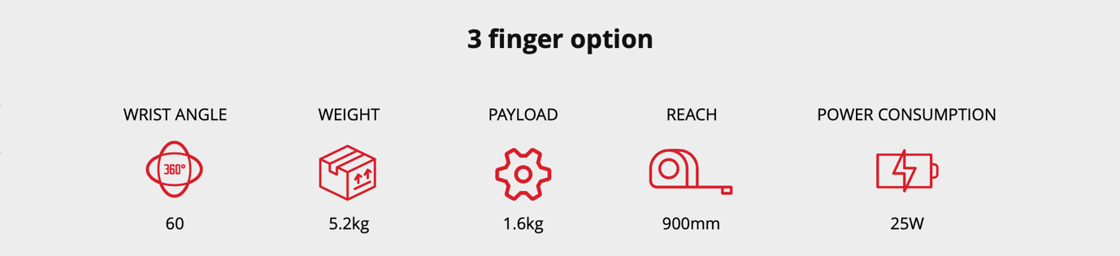

Reflection

It is really creative idea that wheelchair mounted by a robotic arm and it Is designed as a personal assistant for people with several disabilities. Mostly are the people who can’t easily stand up from wheelchair, with the help of robotic arm it can help the patient pick their desire things does not matter because of it can expand till 900 mm and pick up things up to 5 kg. This make the patient can live more independently by doing the things what they want especially when they get hungry, they can feed themselves instead of calling other people to assist them. About this invention I felt interesting because of I see a lot of potential in the future. we could improve it by adding other functionalities such as Artificial Intelligence ( AI ) because of before that patient could be manually
Control the robotic arm to do their stuff , and what it today the patient had some problem with their hands , with the help of AI system on robotic arm , patient can just control the robotic arm by their voice, and we call that voice control. Example of patient could say “Help me take the red color bottle on the refrigerator ” and robotic analysis the command by AI system and proceed patient’s command immediately. At the end, this was still the one great invention I saw in Pecipta Event.

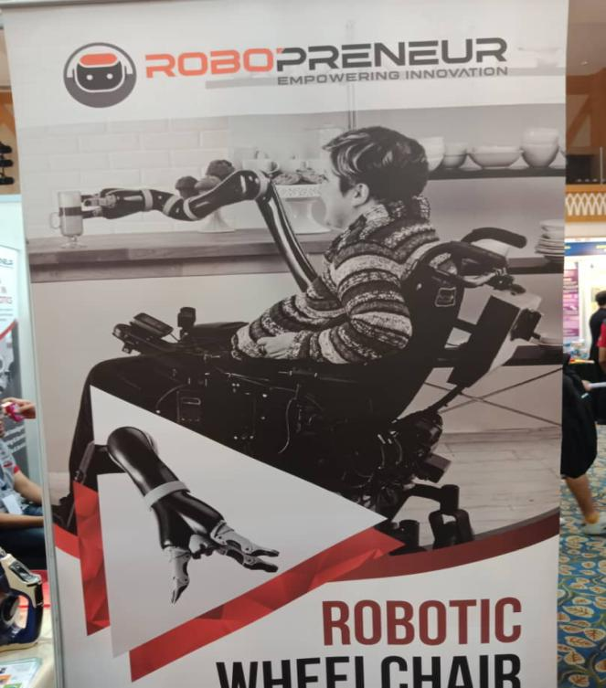
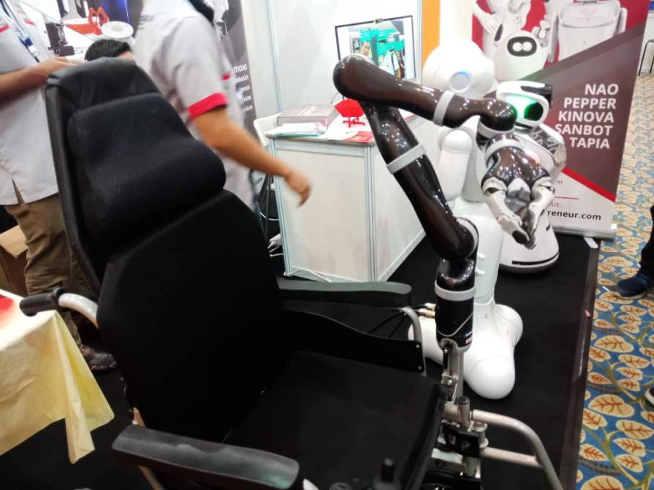
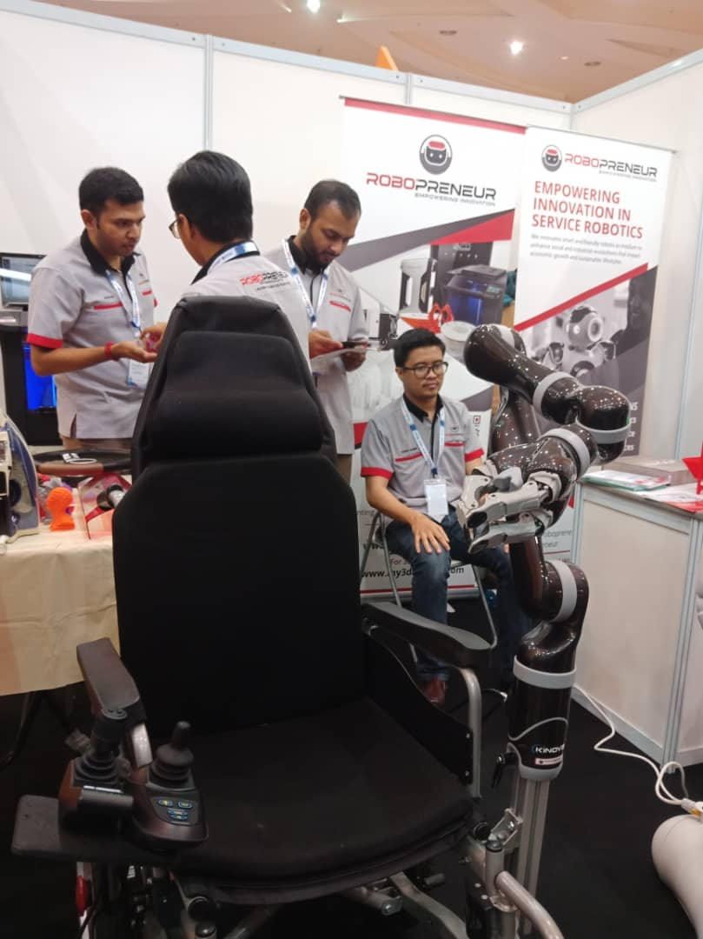

Onesol
Bionanocomposite
Coating
Lacquer

OneSol bionanocomposite coating lacquer

Aims
- Increase production of harvests by stay away from beings damaged by UV rays.

How it is Design
- It is invented by University of Malaya, the OneSol bionanocomposite coating lacquer with complex nanomaterials in an effective for infrared absorber and UV blocker for agricultural thermic film. OneSol lacquer has provide the thermic film its unique properties such as light diffusion, and blocking of UV radiation.

Features
- IR-Thermal effect: Stores heat and saves energy during cold night
- Optimized optical properties: high light transmittance & high light
- UV stabilized for up to four years of film life.
- Abundance sunlight to crop

Problem if without OneSol bionanocomposite coating lacquer
- UV-ray harmful to crops that damaging DNA that lead to abnormal growth.
- Continuously changes temperature in cultivation room effect growth of crop.
- Lack of Visible light that diffuse widely to crop, make it hard to occur photosynthesis
thus effect the production of crops.

Commercial Value
- Can be widely use in Agriculture Industry
- Can be widely use in Greenhouse Solar Plant
- Can be widely use in Horticulture & Botanical Garden

This figure show that OneSol coating bring abundance sunlight to crops

Reflection
This was a great invention for the people especially the farmer, with the help of OneSol coating it create a constant temperature environment around 20 Celsius which is the suitable temperature for crops to maximize the process of photosynthesis and during that time I tried it by putting my hand inside the “cultivation room” with coating by OneSol material on the booth, I felt really cold inside compare to the temperature surrounding I was amazed by that. I think this will help farmer by boosting the production of crops. I see the potential because of the following countries which have the highest UV levels in the world which is Peru, Bolivia, Chile and Argentina and New Zealand, those are the countries that face crops shortage problems because of the high UV rays damaged their crops, So I saw a great potential market value on those countries and also it can be one best solution to solve crops shortage problems to a country as well. To summary that it is a great invention for the future because of it can be the one best solution to solve food shortage in the future that Scientists predict that we will face overpopulation in the future and the first problem will be face by us is the food shortage.

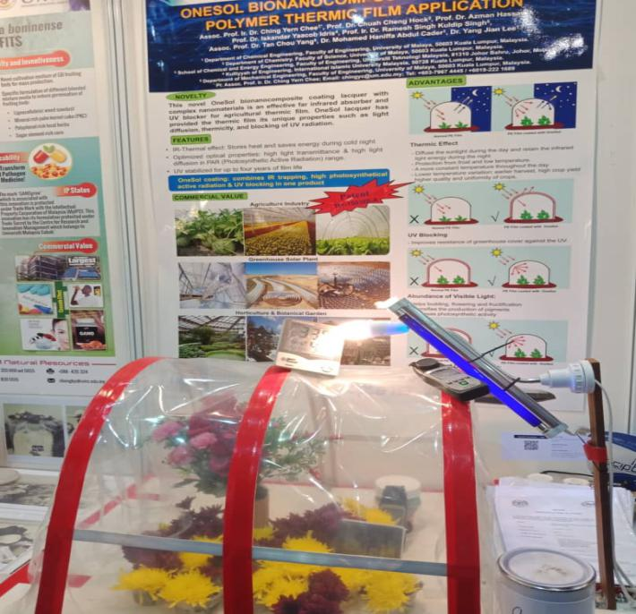

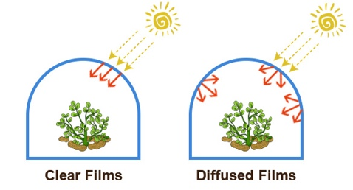

Smart E-Learning System
Using AR Technology

Smart E-Learning System Using AR Technology

On the 22th September 2019, our group members have visited this booth in the PECIPTA event at Dewan Sultan Ibrahim, UTHM.
Skills Profession Career Focus Industry Guide is to interact Government, private, college and oldsters to collaborate and empowers students to spot the proper talent set and develop the competencies to meet the local workforce and global markets. One of the main objective is to design and develop an interactive smart e-learning system on TVET in Malaysia using Augmented Reality Technology. Secondly, to investigate whether the learners able to adopt AR as their learning tool and identify the level of their self-directed learning readiness.
60 participants, who were illiterate in computer subjects were selected. This experiment was guided by Cognitive Task Analysis and User Modelling Techniques. The results shown AR technology is effective tool for promoting TVET skill learning and training and the paradigm of AR TVET, in terms of HCI methodology. The results also suggest that a successful learning process was a join product of learners’ cognition and learning environment.

Applicability
- Students can explore the system and visualize the 3D contents and objects, practice and enhance their performance in a practical way.
- Innovate Curriculum and teaching for TVET using latest industry 4.0 technology.
- To educate teachers, parents and students on the current situation, capability, gaps and challenges faced by the industries’ human resources needs.
- To assist educators and students to understand the concepts of abstract and how to enhance visualization objects.
- To identify the impact of the strides in science and technology, the challenges and impact taken in the Higher Education structure.

Contribution to Environment
The application is applied with minimal tools to bring during the learning class. Its goal is the seamless presentation of computer-driven information with a user’s natural perspective of the world. The book is printed with vegetable based ink which is ECO environmental friendly technology. It is also suitable and safe to use for students.

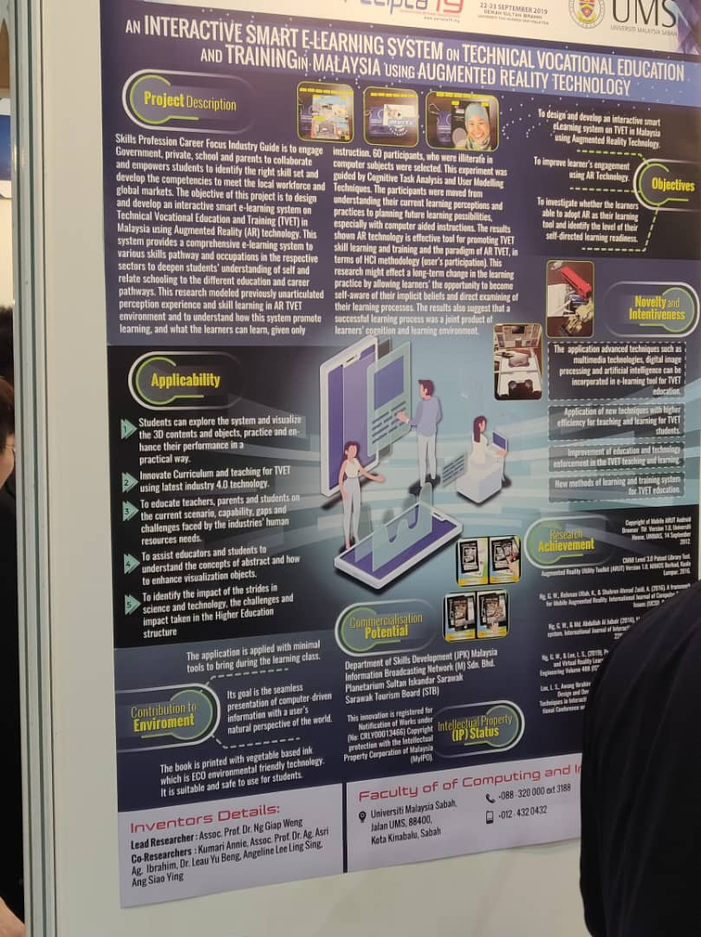

Reflection
In my opinion, E-learning system using AR technology, is very interactive and creates interest to learn. Regardless of the age learners, it will create the eagerness among learners to learn that topic. Moreover, this technology is very useful for kinder garden and primary students. So, this will smooth the teaching and learning process in the class. This is because it helps them to create that remarkable experience which could never be lived in real life scenarios. Apart from that, this kind of technology will help the environment by going paperless. Most of the AR technologies using electronic devices as smart phones, tablets and laptop. This will reduce the usage of paper and pencil as well. In addition, AR technology help the government and private sectors to reduce the cost of printing papers. This is because this technology is reusable and easily can update according to the situations. So, this will be beneficial especially university students because they no need waste a lot of money to buy text book and reference books. And they also will have the passion to study that subject. Eventually they can do very well in their exams. Another reason why they will enjoy having this technology is because it is paper less. Since university students nowadays are feeling so lazy to read books, they could use this technology to study , moreover university students and smart phones and like finger and nail nowadays.So they can access their notes and exercises from there and they can study in more attractive way.
IQ
Stick
Game

IQ-Stick Game
To pull students’ interest in learning and understanding the taught skills, mainly teaching methods such as games are the one of the effective way. So, this research examines the effectiveness of IQ Stick Game on student interest in learning, the benefits of IQ Stick Game and the applications of the IQ Stick Game in student’s daily life. Potential to be marketed in schools as a medium in teaching and learning of various subjects. In accordance with the latest teaching methods to a more student-centered teaching and learning through game-based concept.

Benefit
- Able to attract interest and attention of the students to understand a concept and subject matter easily, creating active learning environment and attractive.
- Able to create a generation that develops holistic.
- Improve the quality of education the National.
- Maneuverable and easy to carry anywhere.
- Lessons more enjoyable.
- Low cost High impact.

Impact Toward Society and Nation
- Teaching tool that is user friendly with the concept of student- centered learning through play as well as implementation.
- IQ Stick Game a renewable product and modified from existing instruments.
- Learning medium that can be used for all subjects.
- Reducing the consumption of papers.
- Save human energy.
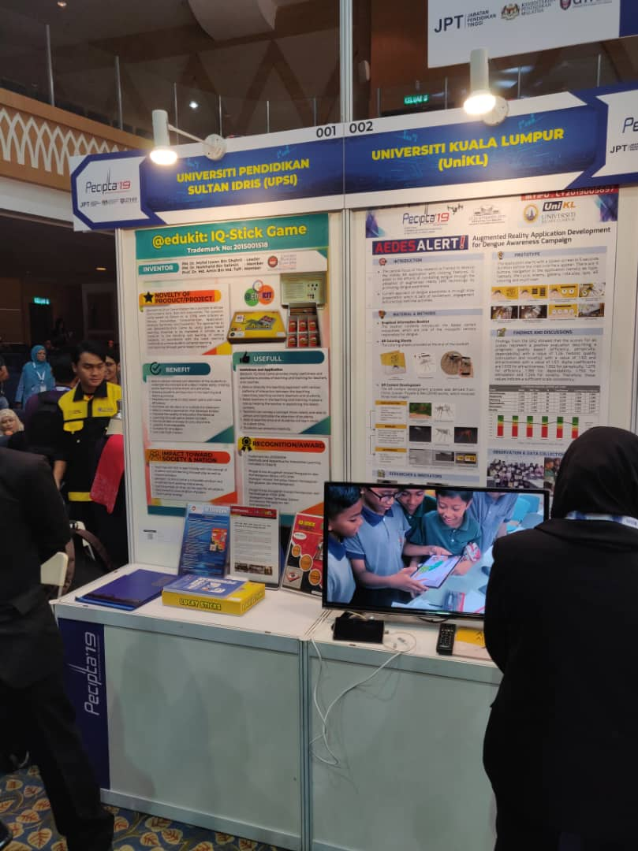

CONCLUSION
For this visit, I benefited a lot. These works integrate technology into life, make life very interesting and improve efficiency. These works are very excellent. We can use our professional knowledge to improve our life, which is a good learning opportunity for us and makes our future learning goals more clear. Let us in the social practice to broaden the vision, increase the ability, and further clarify the way of our young students and shoulder the historical mission.

