

SCSI2143: Probability & Statistical Data Analysis
2018/2019 – Semester 2

GROUP ASSIGNMENT 1

Due date – 9th April 2019

STUDENTS
- MUHAMMAD FIKRI BIN ISMAIL (A18CS0139)
- AFIF HAFIZIN BIN HAMIZAN (A18CS0008)
- HARIS HASHEEMEN BIN ALIAS (A18CS0070)
- LEE CHEN HONG (A18CS0094)
- FATHI MOHAMED FATHI REZQ BEKHIT (A18CS0301)

LECTURER

Assoc. Prof Dr. Azlan bin Mohd Zain

Table of Contents
Introduction 3
Hypothesis Testing 4
Chi – Square Independence Test 6
Correlations 8
ANOVA Test 10
Regression 12
Conclusion 14

Introduction
Malaysia is well known as a country that are full of various of races which live in harmony throughout all of the years in peace. In Malaysia, there are many exchange students and foreigners who study in the country and work in the country’s industries sector. In University of Technology Malaysia itself, a lot of foreigners come from various of country such as Nigeria, Egypt and others. We want to conduct a study about multiracial and cultures among students of computing in UTM.
From our views, we think that there is going to be more Malaysian compare to foreigners in the school of computing since from facts that local students are going to be more than other students. Therefore, among local there are Malay, Indian and Chinese where usually Malays will out numbers Chinese and Indians because the population of Malays itself are more than others. Others fact stated that some of Indian and Chinese parent sending their children to private and abroad to continue theirs studies. So, from this studies we can learn about the multiracial of students in school of computing.

Hypothesis Testing
Hypothesis 1: Years stayed of students in Malaysia using (hypothesis one sample test). A study was conducted to see how many years have the students stay in Malaysia between all races.
Years stayed in Malaysia | Frequency
1 | 3
2 | 1
3 | 1
4 | 1
5 | 1
19 | 4
20 | 9
21 | 12
22 | 5
23 | 2
24 | 1

In the study, we use the average years stayed of students which is 20 years because from the observation of the study, most of the respondents are from 1st year students. So, the average should be used is 20 years.
Hypothesis:
H_{0 :} μ = 20 years
H1: μ > 20 years
Using confidence level, α = 0.05

By using the formula:
z = $\frac{20-17.63}{\frac{7.199}{\sqrt{40}}}$  $$z = 2.08$$ | P-value for the z = 2.08  P(z>2.08) = 0.0188

Information using SPSS:
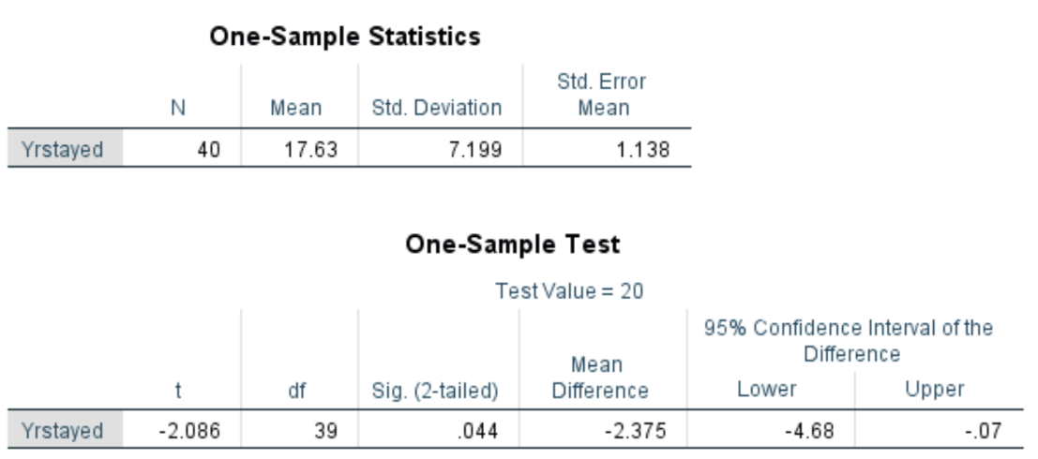

Conclusion:
Since the P- value is less than the confidence level which is 0.0188 < 0.05, so the null hypothesis, H₀ was rejected and we accepted the alternate hypothesis, H1. Because there is enough evidence to conclude that μ > 20 years.

Chi – Square Independence Test
Hypothesis 2: Races of students according to gender using (Chi – Square independence test). To study how many races and does the number students from each races are the same or different. The study was conducted in the Faculty of Computer with 40 number of respondents.

Hypothesis:
H0: All of the number of students in each races independent.
H1: All of the number of students in each races dependent.
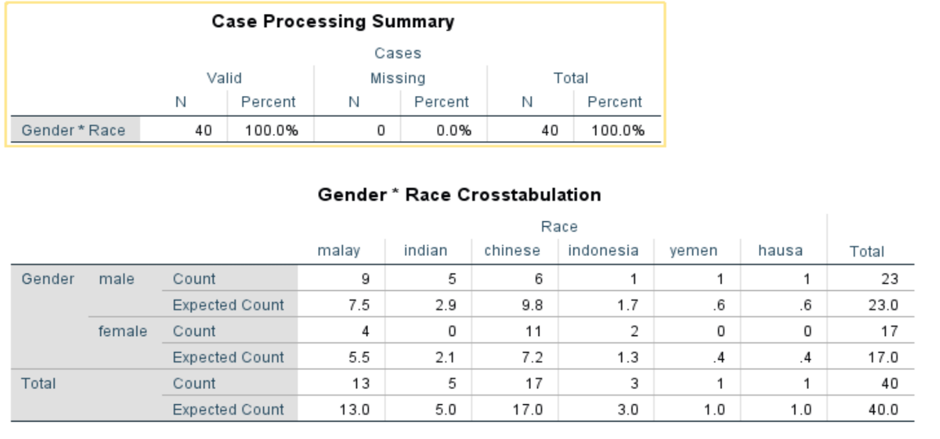
Table of the data:

Cell, ij | Observed  Count, oij | Expected  Count, eij | [oij-eij]2/ eij
1,1 | 9 | 7.5 | 0.3
1,2 | 4 | 5.5 | 0.4
2,1 | 5 | 2.9 | 1.5
2,2 | 0 | 2.1 | 2.1
3,1 | 6 | 9.8 | 1.5
3,2 | 11 | 7.2 | 2.0
4,1 | 1 | 1.7 | 0.3
4,2 | 2 | 1.3 | 0.4
5,1 | 1 | 0.6 | 0.3
5,2 | 0 | 0.4 | 0.4
6,1 | 1 | 0.6 | 0.3
6,2 | 0 | 0.4 | 0.4
 |  | X² = | 9.9

Test Statistic: X² = 9.9
Critical value: X² _{k=5, a = 0.05} = 11.071
Sample data = 9.9
Reject
Fail to Reject
X² = 11.071
α = 0.05

Conclusion:
The test statistic value doesn’t fall within the critical region, so we fail to reject the null hypothesis. There insufficient evidence to support that all of the number of students in each races are dependent.

Correlations
Introduction
The two most correlation coefficients are Pearson's product-moment correlation coefficient and Spearman's rank correlation coefficient. In this test Pearson's product-moment correlation coefficient is used since both of the variable using ratio type of data. The variable is races and the number of years stayed. The Pearson's product-moment correlation coefficient is a measure of the strength of the linear relationship. In the case, the purpose is to measure the strength of linear relationship between the number of years stayed and the number of participations.

Participations  (y) | Year stayed  (x) | (x * y) | x² | y² | $$\hat{y}$$ | ($y_{i}-\hat{y}$)²
1 | 5 | 5 | 25 | 1 | 14.18 | 173.71
3 | 5 | 15 | 25 | 9 | 14.18 | 124.99
4 | 5 | 20 | 25 | 16 | 14.18 | 103.63
19 | 27 | 513 | 729 | 361 | 17.55 | 2.10
20 | 39 | 780 | 1521 | 400 | 19.39 | 0.37
21 | 31 | 651 | 961 | 441 | 18.16 | 8.07
22 | 19 | 418 | 361 | 484 | 16.32 | 32.26
23 | 18 | 414 | 324 | 529 | 16.17 | 46.65
24 | 3 | 72 | 9 | 576 | 13.87 | 102.62
∑y = 144 | ∑x = 152 | ∑xy =2888 | ∑x² = 3980 | ∑y² = 2817 | ∑$\hat{y}$ = 144 | ∑($y_{i}-\hat{y}$)² = 594.40

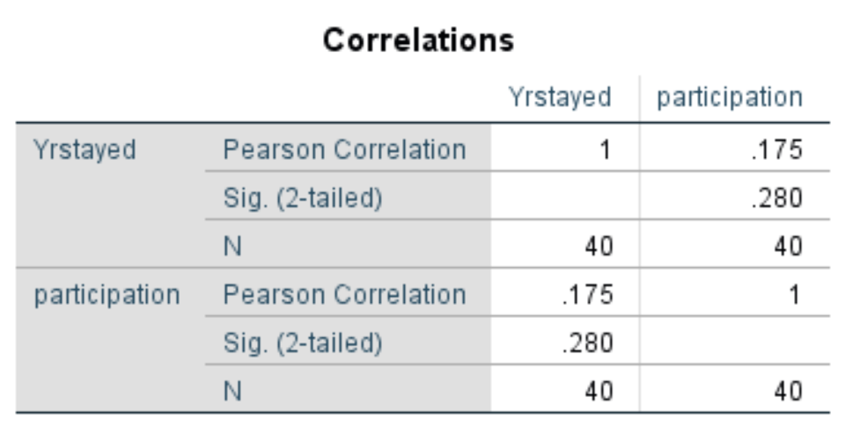
Hypothesis
H_{o}: ρ = 0 (No linear correlation)
H₁: ρ ≠ 0 (linear correlation exists)

Scatter Plot between the number of year stayed against participation

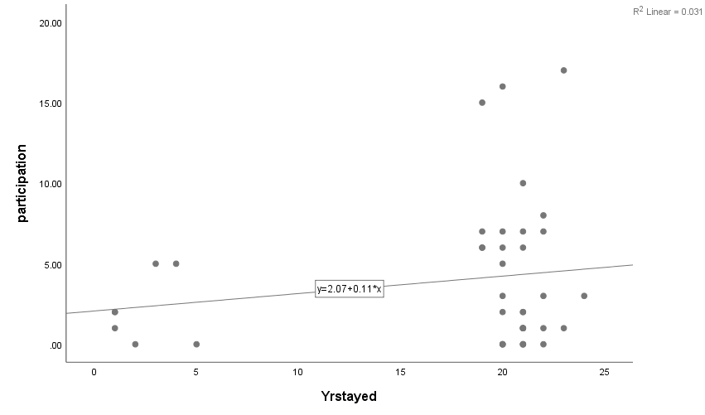

Conclusion
Since, 0.175 < 0.280, we fail to reject H₀. There was unsufficient evidence to show that there is linear correlation between the number of year stayed and participations.

ANOVA Test
HYPOTHESIS 4: The study of Years stayed of student in Malaysia between the number of participation in cultural event and the number of visit to historical places in Malaysia (applying ANOVA Test).

Using our data:
H_{0:} µ₁ = µ₂ = µ₃
H₁: at least one mean is difference

X₁: Years stayed of student in Malaysia.
X₂: Number of participation in cultural event in Malaysia.
X_{3:} Number of visit to historical places in Malaysia.

 | ∑ X_{n} | µ_{n} | S_{n}
1 | 705 | 17.625 | 7.199
2 | 159 | 3.975 | 4.446
3 | 210 | 5.25 | 2.284

AVG µ =$\frac{17.625 + 3.975 + 5.25}{3}$
= 8.950

S_{µ} = $\sqrt{\frac{{\left(17.625-8.950\right)}^{2}+{\left(3.975-8.950\right)}^{2}+{(5.25-8.950)}^{2}}{(3-1)}}$

= 7.54

n.S_{µ}² = 40 (7.54)²
= 2274.064

S²_{P} = $\frac{{(7.1993)}^{2}+{(4.4462)}^{2}+{(2.2843)}^{2}}{3}$ = 25.61
F = $\frac{n.Sµ2}{S2P }$

= 88.79

F_{statistic} = 88.79
For F-table:

Numerator = k-1
= 2

Denominator = k (n – 1)
= 3 (40 – 1)
= 117
From F-table:
The critical value is 3.07.

Conclusion:
Since F_{statistic} > F _{critical value} (88.79 > 3.07), we reject H₀ which means there is at least 1 mean difference based on the data available.

Regression
While calculating the culture about UTM, we identified that we only can use the data from number of year stayed and the number of participation in festival culture per year. By this way, we can identify the people that live in Malaysia that the level of their interest to visit culture festivals neither increase nor decrease linearly.
In this part will discuss the relationship between the number of year stayed and the number of participation in festival culture per year.

Coefficients ª
Model |  | Unstandardized Coefficients |  | Standardized Coefficients | t | Sig.
 |  | B | Std. Error | Beta | t | Sig.
1 | (Constant) | 2.069 | 1.875 |  | 1.104 | .277
1 | Yrstayed | .108 | .099 | .175 | 1.097 | .280
a. Dependent Variable: participation

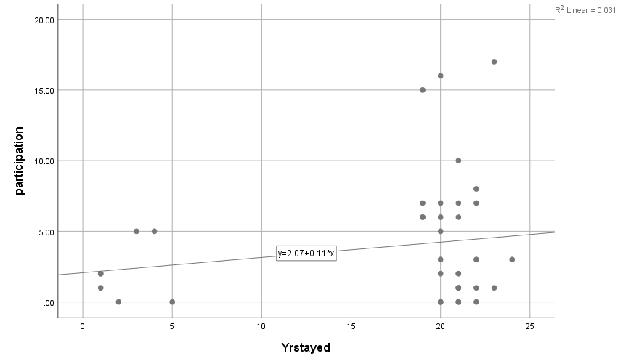
Conclusion:
The linear relationship between x(Yrstayed) and y(Participation) is weak because the R² is less than 1 and more than 0. Therefore, some but not all of the variation in y is explained by variation in x.

Conclusion
Based on the conducted test about multiracial among students of computing in UTM, there were 40 respondents that responded to our google form that we spread throughout the social media which were WhatsApp, Facebook and Twitter. By using the data given, we carried out few types of calculation which are hypothesis one sample test, correlation, regression, ANOVA and chi-square test. From all of the calculations that are stated, we can make some conclusion from it.
From the calculation of the hypothesis test on one sample (Hypothesis 1), we can conclude that the H₀ which stated that the µ=20 is rejected and we accepted the alternate hypothesis, H₁ which is µ>20. The reason for this is because from the calculation we had obtained enough evidence to show that the μ > 20 years.
Next, we carried out chi-square independence test for the Hypothesis 2, from this calculation. The test statistic value doesn’t fall within the critical region, so we fail to reject the null hypothesis. There insufficient evidence to support that all of the number of students in each races are dependent.
Besides that, Pearson's product-moment correlation coefficient was also being applied for the data that we obtained. In the end of the calculation, we found out that the H₀ is failed to be rejected. This prove that there was unsufficient evidence to show that there is linear correlation between the number of year stayed and participations.
After that, we use our data to do the ANOVA test. The calculation shows that the
F_{statistic} > F_{critical value} (88.79 > 3.07). Therefore, we have to reject the H₀ which means and prove that there is at least 1 mean difference based on the data available.

Last but not least, regression. The linear relationship between x(Yrstayed) and y(Participation) is weak because the R² is less than 1 and more than 0. Therefore, some but not all of the variation in y is explained by variation in x.

