UTM Computing Proceedings
Innovations in Computing Technology and Applications
Semester 2 | Year: 2019

The statistic of students going to library

Muhammad Amirul Bin Ismail
A18CS0126,
School of Computing,
University Teknologi Malaysia,
Johor, Malaysia

Tan Wei Kok
A18CS0258
School of Computing,
University Teknologi Malaysia,
Johor, Malaysia

Nur Syafiqah Binti Taserip
A18CS0201
School of Computing,
University Teknologi Malaysia,
Johor Malaysia

Jasmin Farena Binti Muhammad Kamarul
A18CS0082
School of Computing,
University Teknologi Malaysia,
Johor, Malaysia
Cheng Shin Wei
A18CS0046
School of Computing,
University Teknologi Malaysia,
Johor, Malaysia

Abstract— The objective of this study is to investigate the relationship between the time spend in the library and preferred time to the library by performing and finding the inferential statistics such as hypothesis testing, correlation, regression and Chi square test of independent between these relations.

Introduction
Library is a place that houses and lends books to its members. But in this age of digital information, e-books and the internet becoming a new trend as each person will have smartphone and internet service. Will these issue decrease the number of student go to the library. Statistic shows that because of increase in student numbers, university libraries are seeing more students come through the door than ever before. The SCONUL statistics show that the average number of journals bought by a university library has increased from 7,000 to 30,000(99% is provided electronically) [1]. This giving a fact that students may be a heavy user of the library.
It is a fact that students will have their own time and factor to the library. Some student would like to go to library in the early morning as that time is a best study time for them, some would like to visit to library at evening due to class starts at morning. Moreover, there are a lot of activities could be done in the library likes study with friends, make a discussion with group members, do revision for upcoming tests and others. These factors will affect the time spend by students in the library.
This study aims to figure out the relationship between the time spend in the library and preferred time to the library.

Mehodology

The data in this study is obtained from the dataset “The statistic of students go to the library.” This dataset contain the data of time spend of students in the library and preferred time of students go to the library. The data also provide the number of respondents who involve in this statistic.
The 50 data which are respective to the 50 respondents are selected from the database and use for hypothesis testing to determine whether there is enough evidence to support the null hypothesis. The sample is normally distributed and plotted with RStudio.

Results and discussion

Hypothesis testing

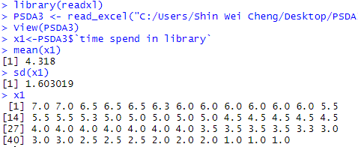
Figure 1 Sample data obtained from dataset "time spend in the library"

Based on the sample data obtain form the dataset “Time spend in the library”, we claim that the average time spend by students in the library is less than 4.5 hours. Hence the null hypothesis, H₀ and alternative hypothesis H₁ is as follows:
H₀ : µ = 4.5
H₁ : µ < 4.5
Where µ is the population mean of students who spend time is the library. N is the number of data. A simple random sample of 50 data are used to figure out the Z-score of the sample population. The sample mean and standard deviation can be calculated using the formula:
$$Sample mean,\overline{x} = ∑X / N$$
$$Standard deviation,σ= \frac{\sqrt{(∑\left(X-\overline{x}\right)2)}}{(N-1)}$$
After calculated, the sample mean is 4.318 while standard deviation is 1.603019.
A significant level of 0.10 is used to test the claim of this study that the time spend in the library is less than 4.5 hours. The critical value of 0.10 significant level is -1.282. The Z-value of the sample mean is 4.318 can be calculated by
Figure 3 Scatter plot of time spend in the library and preferred time to the library
$Z= \frac{\overline{x}-µ}{\frac{σ}{\sqrt{N}}}$ , which is -0.8028.

Table 1 Z-value and Critical value table
$$\overline{x}$$ | µ | Σ | Z-value | Critical value
4.318 | 4.5 | 1.603019 | -0.8028 | -1.282
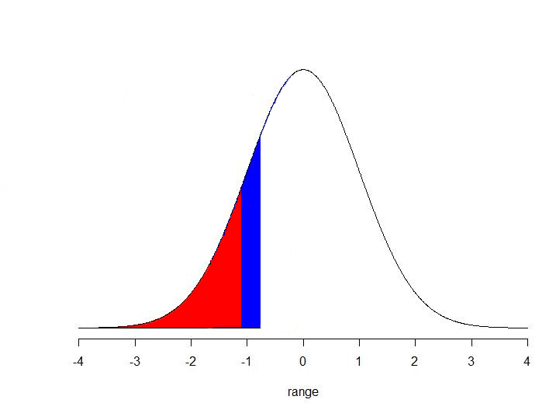
Figure 2 Normal distribution graph
Figure 2 Normal distribution graph

Since the Z-value > critical value, the Z-value does not fall in the critical region, and we can say that fail to reject null hypothesis.
Hence, there is insufficient evidence to reject the null hypothesis where the average time spend of students in the library is equal to 4.5 hours. According to the result, the study still holds true.

Correlation
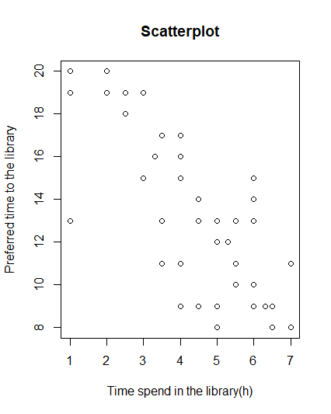

In the correlation test, we analyse the strength and relationship between the time spend of students in the library and preferred time to the library with a sample size of 50. The correlation coefficient is calculated to test the relationship between these two variables.
The correlation coefficient, r is calculated using the Pearson’s technique since the data being tested is a ratio-type data. The independent variable, x is the time spend in the library while y is the preferred time to the library. The correlation coefficient is then calculated using RStudio based on the formula:
$$r=\frac{∑xy-(∑x∑y)/n}{\sqrt{[\left(∑x^{2}\right)-\frac{(∑{x)}^{2}}{n}][\left(∑y^{2}\right)-\frac{(∑{y)}^{2}}{n}]}}$$

Table 2 Pearson’s correlation coefficient table
∑X | ∑Y | ∑X² | ∑Y² | ∑XY | r
215.9 | 670 | 1058.17 | 9710 | 2662.1 | -0.7608

The correlation coefficient is calculated using Pearson’s technique, r is found to be -0.7608. The results show that time spend of students in the library and preferred time to the library has a strong negative correlation, which means that high x variable go with low y variable. This can be seen in the scatter plot graph as shown in figure 3, where the dots form a negative slope.

B.1. Significant Test for Correlation
The two variables are then tested to see if there is any evidence of linear relationship between time spend of students in the library and preferred time to the library at 0.10 level of significance using the significant test where H₀ is assume to be that the two variables had no linear correlation.
H₀ : p = 0 (no linear correlation)
H₁ : p ≠ 0 (linear correlation exists)
The test statistic, t is used and data sample, n =50. We obtain t equals to -8.1219 with the value r = -0.7608. The critical value was found using the t-table with degree of freedom, df = 50 - 2 = 48. The critical value is found to be
± 1.645.

Table 2 critical value and t-value table
α | df | Critical value | t-value
0.10 | 48 | ± 1.645 | -8.1219

Since the t-value < critical region, the test statistic is fall in the critical region, we reject the null hypothesis, H_{0.} Hence, there is sufficient evidence of a linear relationship between time spend of students in the library and preferred time to the library at the 10% level of significance.

Regression
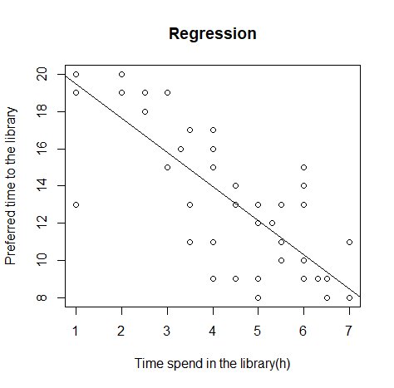
Figure 4 Scatter plot of time spend in the library against preferred time to the library with regression line

The regression of the two variables are analysed to predict the value of time spend of students in the library and preferred time to the library. The independent variable, x is time spend in the library(h) while the dependent variable, y is the preferred time to the library.Estimated regression model is used.
$$Y=b_{0}+b_{1}X$$
Y= estimated y value
b₀ = estimate of the regression intercept
b₁ = estimate of the regression slope
x = independent variable
The estimated regression model is calculated using RStudio, where we obtain Y= 21.3204 - 1.8343x. Based on the result, since the preferred time to the library had no 0 time spend in the library, so b₀ = 21.3204 just indicate that, for preferred time to the library within the time spend in the library, 21.32 is the time of students preferred not explained by the time spend in the library. Then, b₀ = -1.8343 tells us that the average preferred time of students to the library decrease by -1.8343 on average for each increment on time spend in the library as shown in figure 4.
Moreover, the coefficient of determination, R² is calculated to see the portion of the total variation in the dependent variable, preferred time to the library is explained by the variation in the time spend in the library. R-Square (R²⁾ is then calculated using RStudio in which we obtain, R² = 0.5787 which show that only 57.87 % of the variation in preferred time to the library is explained by the variation in the time spend in the library.

Goodess of fit test (Chi Square test of k proportion)
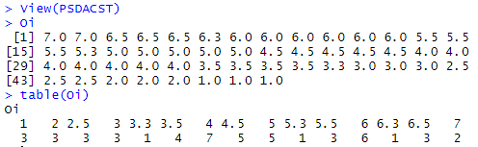
Figure 5 Dataset of observed frequency for Chi-Square Test
Goodness of fit test performed to test the hypothesis that the observed proportion for the time spend in the library fit the claim that the average time spends students in the library should be equal for all students at a significant of 0.10. The observed values were compared to the corresponding expected values. The null hypothesis H₀ and alternative hypothesis H₁ is as follows:

H₀ : The proportions for the average time spend for students in the library is the same for all students

H₁ : At least one of the proportions for average time spend for student in the library is different from others.

The observed values and expected values are shown as figure 5. The expected value is set to equal probability which use the formula; expected frequency $Ei=\frac{n}{k}$. Since n = 50 and k = 12, thus Ei = 3.33. The test statistic, chi-square value is then calculated using RStudio with Ei=3.33 by the test statistic, X² formula:
$$X^{2}= \frac{{(Oi-Ei)}^{2}}{Ei}$$
The X² = 13.6136. The degree of freedom k-1 is 11. The critical value can be found in the Chi-Square Distribution table with degree of freedom equals to 11 and significant level of 0.10. The critical value is found to be approximately 17.275.

Since the test statistic does not falls within the critical region, therefore we fail to reject the null hypothesis. There is insufficient evidence to warrant rejection of the claims that the proportions for the average time spend for students in the library is the same for all students.

Chi Square test of independent
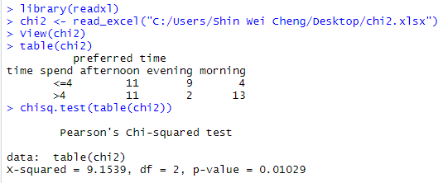
Figure 6 Chi Square test of independent by RStudio

Chi Square test of independent is used to test whether relationship is exists between time spend in the library and preferred time to the library. 50 data sample is used and the preferred time to the library is divided into group of morning, afternoon and evening while time spend is distributed into at least 4 hours and more than 4 hours. We claim that the at 0.10 significant level, the time spend in the library is independent to the preferred time to the library. The null hypothesis and alternative hypothesis are as follow:

H₀ : time spend in the library is independent to the preferred time to the library

H₁ : time spend in the library is dependent to the preferred time to the library

The expected count E_{ij} is calculated using this formula:
$$E_{ij}= \frac{(i^{th}Row total)(j^{th}Column total)}{Total sample size}$$
The observed value is as shown in figure 6, the test statistic x² is calculated using RStudio.
$$test statistic, x^{2}= \frac{{∑(O_{ij}-E_{ij})}^{2}}{E_{ij}}$$

Table 3 Expected frequency of independent test table
 | Preferred time to the library
Time spend | morning | Afternoon | evening | total
≤ 4 | 4 (8.16) | 11 (10.56) | 9 (5.28) | 24
> 4 | 13 (8.84) | 11 (11.44) | 2 (5.72) | 26
total | 17 | 22 | 11 | 50

The x² = 9.1539, the degree of freedom: (r-1) (c-1) = 2. The critical region could be finds in the Chi-Square Distribution table with degree of freedom equal to 2 and significant level of 0.10. The critical values are found to be approximately 4.605.

Since the test statistic, x² > critical value (9.1539 > 4.605), the test statistic, x² fall within the critical region, therefore we reject the null hypothesis. There is insufficient evidence to show that the time spend in the library is independent to the preferred time to the library.

Anova
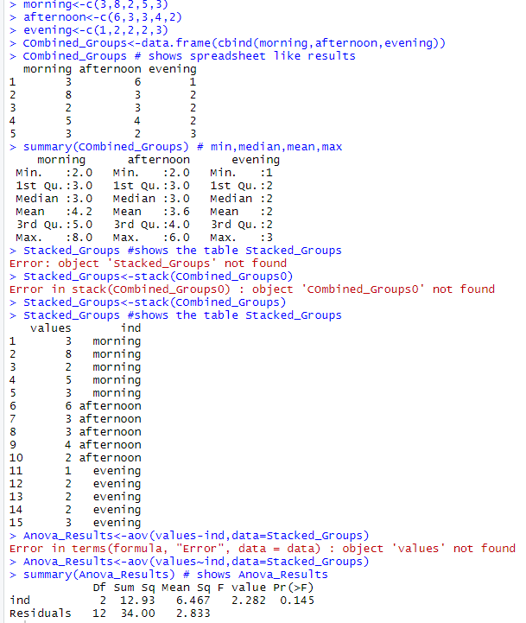
Figure 7 ANOVA test by RStudio

ANOVA method of testing is used to analyze for the significant differences between means. One-way ANOVA with equal sample size method is used and assumption likes the populations have normal distribution, same variance and samples are random and independent of each other is concerned. Figure shows the list data of preferred time for students to the library. The dataset “Preferred time for students to the library” is distributed into 3 different categories which are morning, afternoon and evening and each category are classific into one hour likes students who preferred morning are divided into preferred 8.00am, 9.00am, 10.00am and so on . We use 0.05 significant level to test the null hypothesis that the different time to the library has the same mean. The null hypothesis and alternative hypothesis is as below:
H₀ : µ₁ = µ₂ = µ₃
H₁ : at least one mean is different

Table 4 Mean and standard deviation of preferred time to the library table
morning | afternoon | Evening
$\overline{x}$=4.2 | $\overline{x}$=3.6 | $\overline{x}$=2
N=5 | N=5 | N=5
S=2.38747 | S=1.51658 | S=0.70711

Test statistic, F is calculated using RStudio and the formula is as below:
$$F= \frac{variance between sample (nS\frac{2}{x})}{variance within sample (S_{p}^{2})}$$
We obtain variance between sample,$nS\frac{2}{x}$ = 6.467 while variance within sample,$S_{p}^{2}$= 2.833. Then test statistic,
F = 2.282. The numerator, k-1 =3-1 =2, while the denominator, k (n-1) = 3(5-1) =12, then F (2,12) = 2.282. The critical value of F with α =0.05 from F-distribution table is F (2,12) = 3.885.
Since F _{test statistic} < F _{critical value} (2.282 < 3.885), the test statistic does not fall within the critical region, therefore we fail to reject the null hypothesis. There is sufficient evidence to claim that the different sessions of time have the same mean for preferred time for students to the library.

Conclusion
Based on the hypothesis, we fail to reject the null hypothesis of 4.5 hours based on the previous study.
Besides that, from the analysis, we found that there is a strong negative relationship between time spend for students in the library and preferred time to the library with a correlation coefficient of -8.1219. The estimated regression model we obtained is Y= 21.3204 - 1.8343x. This regression is important for the prediction on the preferred time for students to the library based on their time spend in library.
The Goodness of fit test show that there is insufficient evidence to reject the claim that the proportions for the average time spend for students in the library is the same for all students. The Chi-Square test of independent show that the time spend in the library is dependent to the preferred time to the library. The ANOVA test told us that different sessions of time have the same mean for preferred time for students to the library.

Acknowledgment
We would like to express special thanks of gratitude to our lecturer (Assoc. Prof Azlan bin Mohd Zain) who gave us an opportunity do this wonderful project on the topic (The statistic of students go to library). Dr also helped us a lot in doing Research and we came to know about behavior of students going to the library.

References

- Frankie Wilson, “Hard Evidence: how many people actually use libraries?”, Bodleian Education Library, Bodleian Libraries, University of Oxford, CC BY-ND, March 14, 2016 7.46pm AEDT
[2] Esther Lombardi, “Top Reason to visit Your local Library”,unpublished.

