
SCHOOL OF COMPUTING,
FACULTY OF ENGINEERING,
UNIVERSITI TEKNOLOGI MALAYSIA,
81310 UTM JOHOR BAHRU, JOHOR.
___________________________________________________________________________

SECOND SEMESTER SESSION 2018/2019

SCSI2143
PROBABILITY & STATISTICAL DATA ANALYSIS

TITLE:
USAGE OF UTM WIFI
___________________________________________________________________________

LECTURER: DR ERNE NAZIRA BINTI BAZIN
(SECTION 09)

PREPARED BY:
ANIQ ZUMARZIYAD BIN MOHAMAD HAIRUDIN (A18CS0032)
MUHAMMAD FAKHRUL HADI BIN NORAINI (A18CS0136)
FITRI ZULKARNAIN BIN ZAHAREN (A18CS0063)
MUHAMMAD DANIAL BIN JEFRI (A18CS0131)

DEADLINE: 10 APRIL 2019

Abstract

We were given a task to conduct a survey on certain issues or topic within UTM. Our chosen topic to focus on is UTM Wifi and we want to know exactly how the user felt about its quality or performance. In addition to this, we will be using R Studio software to support us with creating the charts and support our explanation/conclusion.

I. Introduction

After a brief discussion with our group members and our lecturer Dr Erne, we have agreed and decided to conduct a survey on the “Usage of UTM Wifi” in Universiti Teknologi Malaysia’. We choose this topic because we heard some complaints regarding the performance of our University’s wifi and due to that, we have planned to gather their opinion about UTM Wifi by providing a questionnaire to students and staffs in UTM.

II. Methodology

The method that we plan to use to conduct the research on “Usage of UTM Wifi” is an online survey. In order to create a survey, we must first create several questions surrounding factor relating to UTM wifi and customers’ feedback on it. We have created a total of twelve questions and each question are grouped into 4 different types of data measurement, which are nominal, ordinal, interval or ratio. Once we have finalized the question, we created the survey with ‘Google Form’. This Google form will later be submitted through UTM for people to give their honest opinion and/or view regarding UTM’s wifi and its quality.

III. Results
- Nominal
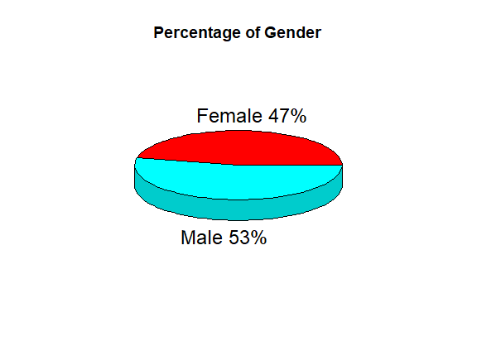
Within our survey, there are several questions that provide nominal data for our research. The first question that we asked was “what is your gender?” and there is only two possible answer that the respondent can choose, either male or female. Based on the survey collected, it shows that out of 60 respondent, 53.3% are male and the other 46.7% are female. From this data, we can know what gender is our respondent and is it distribute evenly throughout both gender. This factor is important because we want to keep the case study as accurate and unbiased as possible and each gender has different requirement or expectation from their wifi performance.

Coding used:
>library(plotrix)
>pie3D(Usage_of_UTM_Wifi2$‘Percentage of Gender?’,main= “Percentage of Gender”)

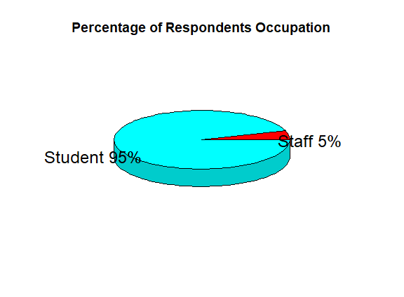
In addition to asking their gender, we also asked if they are a “student” or “staff” in UTM. It was important for asked to know the number of staff that asked our survey because we didn’t want to just focus on student as it is not only student that uses the UTM wifi.The data collected showed that 95% that answered our survey was student and only 5% was staff, which may include both lecturers and office staff. This is massive difference between the number of student and staff that answered our survey. Granted, there are a lot more students than staffs, however we would think wish for a more even spread amongst the number of students and staff, to ensure a better and more reliable statistic for everyone that uses the UTM wifi.

Coding used:
>library(plotrix)
>pie3D(Usage_of_UTM_Wifi2$‘Percentage of Respondent Occupation?’,main= “Percentage of Respondent Occupation?”)

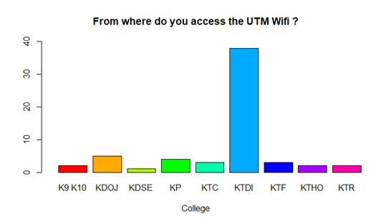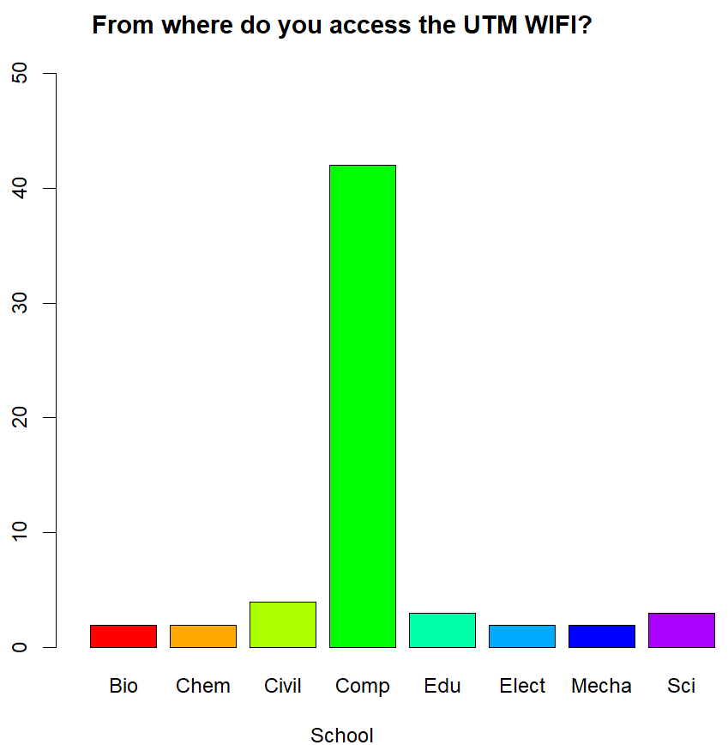
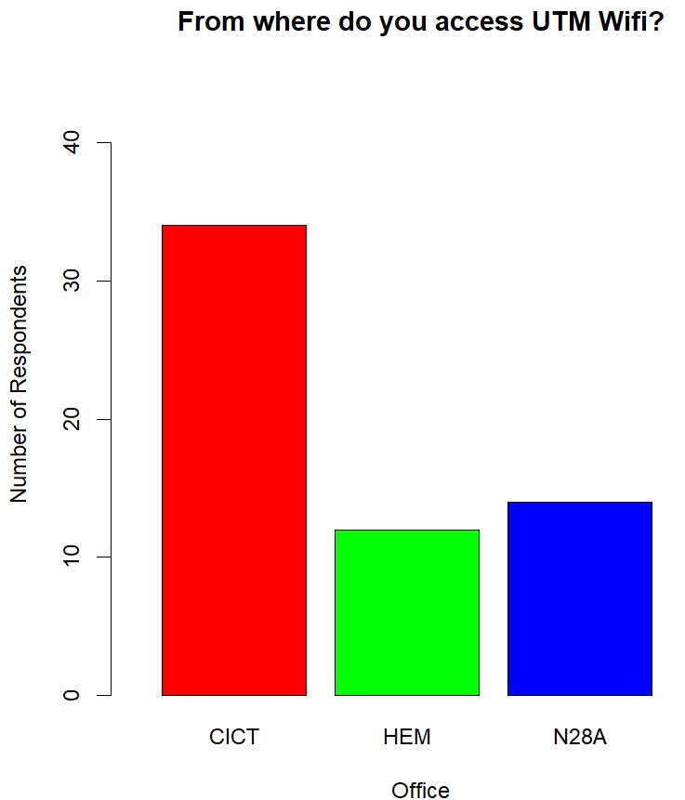

We would like to know exactly where these respondent are accessing their wifi from, whether that would be from their colleges, faculty/school or other location. Based on our survey, total of 62.5% respondent are accessing their wifi from college Tun Dr Ismail or “KTDI”, followed by KDOJ with 8.9%. Some also include from which faculty/school they access UTM wifi and 31.1% are access from “School of Computing”. It is important to noted that this statistic does not represent the overall number of users within UTM Skudai. The reason why KTDI or School of Computing had the highest percentage is because we live at KTDI and study at the School of Computing and due to this, most of the respondent are our friends and lecturers, who lives and/or study at the same school and colleges.

Coding used:
>barplot(Usage_of_UTM_Wifi2$‘From where do you access?’,main= “From where do you access?” , xlab=”College” ,ylab= “Number of Respondent” , ylim=c(0,40))
>barplot(Usage_of_UTM_Wifi2$‘From where do you access?’,main= “From where do you access?” , xlab=”School” ,ylab= “Number of Respondent” , ylim=c(0,50))
>barplot(Usage_of_UTM_Wifi2$‘From where do you access?’,main= “From where do you access?” , xlab=”Office” ,ylab= “Number of Respondent” , ylim=c(0,40))

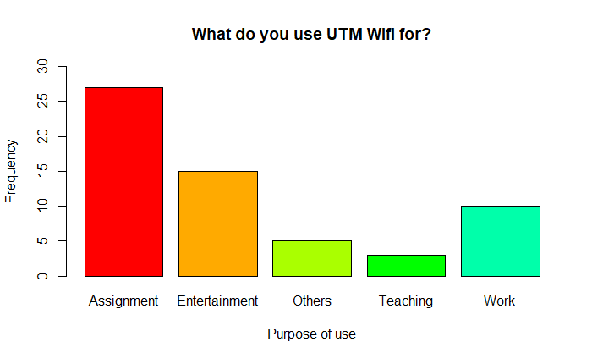
The last nominal questions that we asked was “What do you use UTM wifi for?” This question was important to us as we wanted to do exactly what or how each student and staff use the wifi. We gave several options include “others” for the respondent to choose and not surprisingly, 63.3% says they used the wifi for “assignment”. Coming just short of this, “entertainment” had a percentage of 53.3%. We had enable the respondent to choose more that one option as it would be slightly unrealistic for the respondent to use wifi for one and one factor only especially for the students.

Coding used:
>barplot((Usage_of_UTM_Wifi2$‘What do you use UTM Wifi for?’,main= “What do you use UTM Wifi for?” , xlab=”Purpose of use” ,ylab= “Frequency” , ylim=c(0,30))

b. Ordinal and Interval

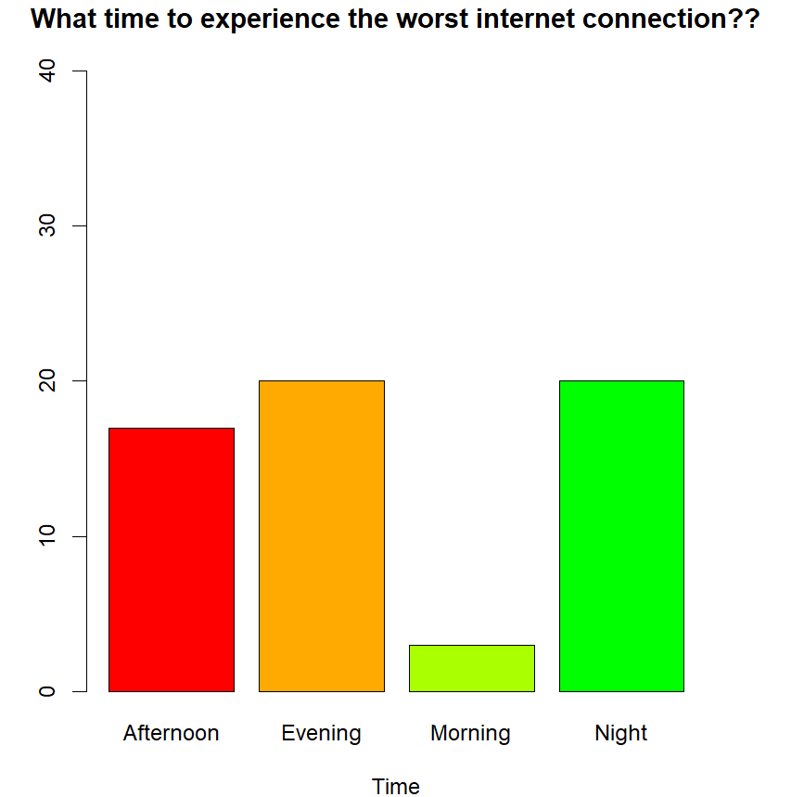
Included in our survey are questions that will provide ordinal and interval data, For ordinal, we asked respondent about when they experience the best as well as the worst internet connection. Based on the statistic, 51.7% says they experienced the best internet connection in the morning and 33.3% says they experienced the worst internet connection in the evening or night. There are many factors that can affect the internet connection, some due to hardware limitation and some due to external factor like extreme weather.

Coding used:
>barplot((Usage_of_UTM_Wifi2$‘What time to experience the worst internet connection’,main= “What time to experience the worst internet connection” , xlab=”Time” ,ylab= “Number of Respondents” , ylim=c(0,40))

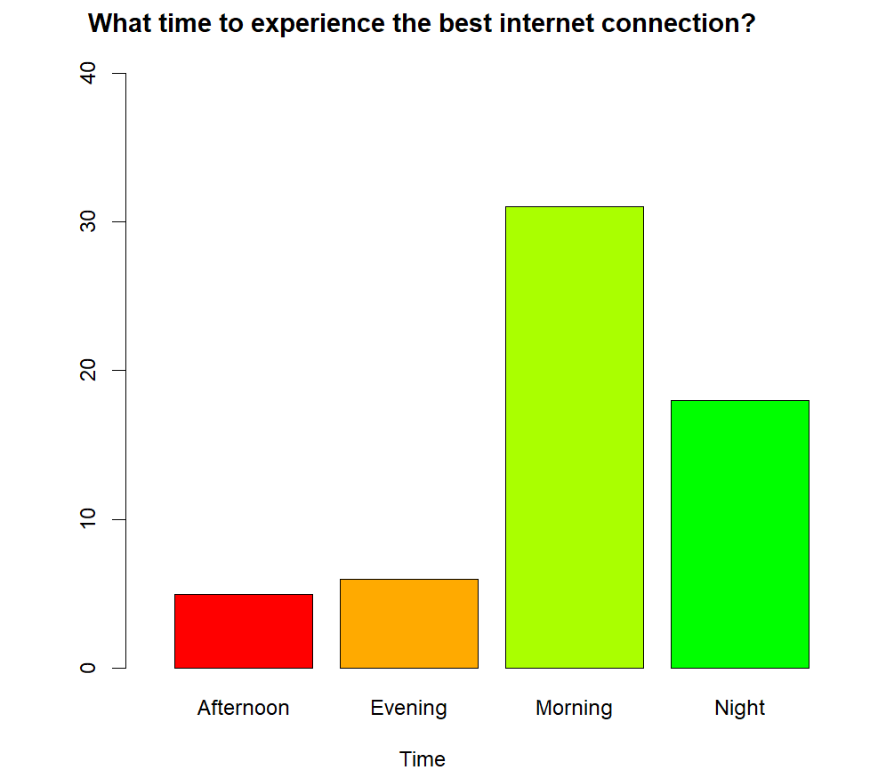
However, we concluded that the reason why majority says that they experienced the “best” connection in the morning because most people had gone to their classes and not using their college wifi and even if they are using the internet at their specific schools, they are not using the wifi but rather the ethernet to connect to the internet. As for the “worst” connection, they are experiencing terrible connect at night because most of us does not have class during that hour and we are using the wifi to do assignment or watching video for entertainment. Due to these factors, the internet bandwidth is being flooded by requests and thus slowing the performance tremendously.

Coding used:
>barplot((Usage_of_UTM_Wifi2$‘What time to experience the best internet connection’,main= “What time to experience the best internet connection” , xlab=”Time” ,ylab= “Number of Respondents” , ylim=c(0,40))

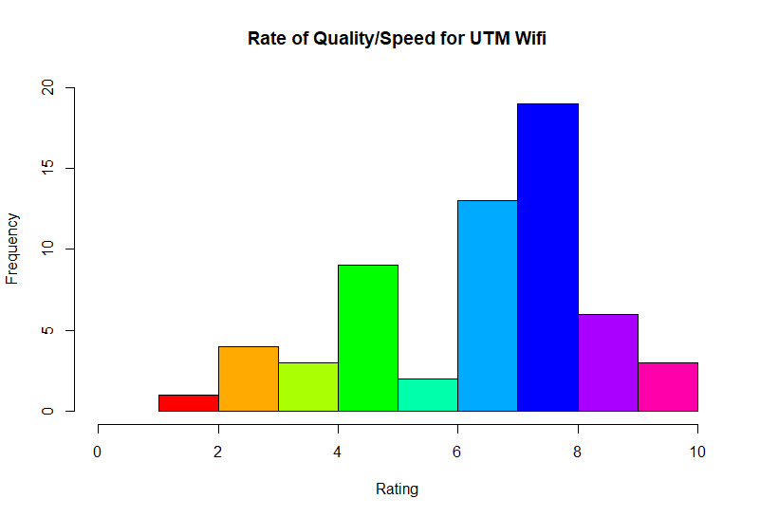
Besides that, we wants to know what the respondents feels about our University wifi connection speed so we provide a question that lets the respondents rates the speed of the UTMwifi. We give them a scale from 1, which is very poor until 10 which is very good to describe their experience with the performance of the UTMwifi. Based on the data collected, 31.7% of the respondent gives a rating of 8 on the UTMwifi’s performance but there is 1.7% respondent who gives the rating a one. It is safe to say that most of the people are satisfied with UTMwifi’s as many of the respondent gives a high rating.

Coding used:
>hist(Usage_of_UTM_Wifi2$‘Rate of Quality/Speed for UTM WIFI’, main="Rate of Quality/Speed for UTM WIFI", xlab="Rating" , ylim=c(0,20) , xlim=c(0,10))

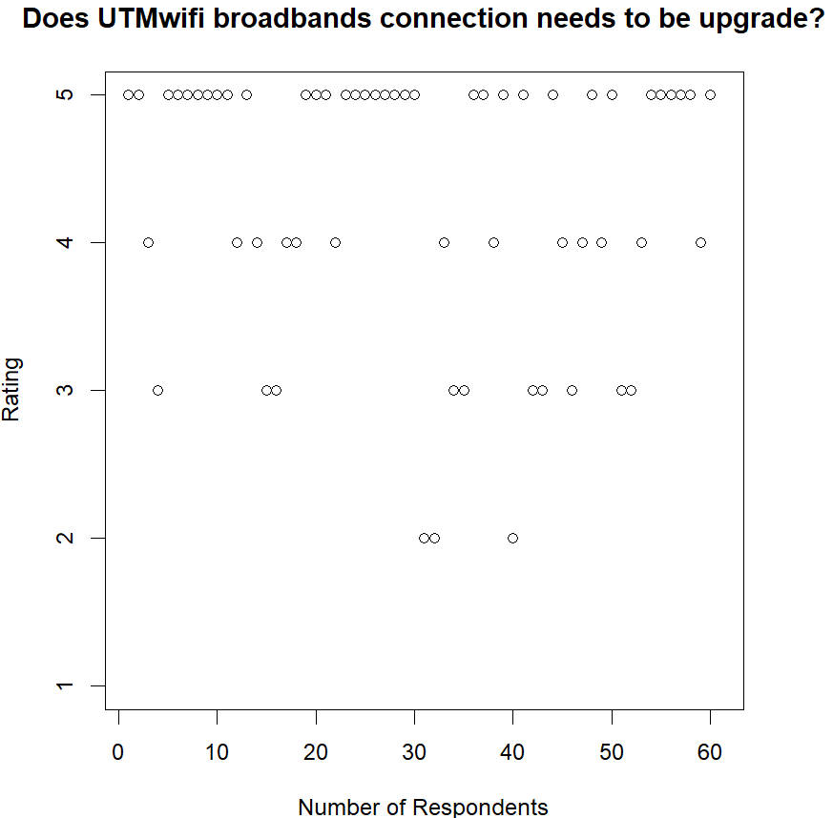

Lastly, corresponding to our previous question, we asked the respondents whether there should be an improvement made in terms of broadbands connection speed on our UTMwifi or not. A scale of one until five from strongly disagree to strongly agree was provided for respondents to choose from. Over 56.7% of the respondents strongly agree that the UTMwifi needs to be upgrade in terms of broadbands connection speed. Meanwhile, none of the respondent strongly disagree 0% with the question. Based on the data collected, we can conclude that the respondents answer in this question contradicts with the previous question. Although the respondents gives a high rating for the UTMwifi, they feel that the connection speed could be better.

Coding used:
>plot(Usage_of_UTM_Wifi2$‘Does UTMwifi broadbands connection needs to be upgrade’, main = "Does UTMwifi broadbands connection needs to be upgrade", ylab = c(0,5), xlab = "Number of Respondents", ylab=“Rating”, ylim = c(1,5), xlim = c(0,60))

c. Ratio

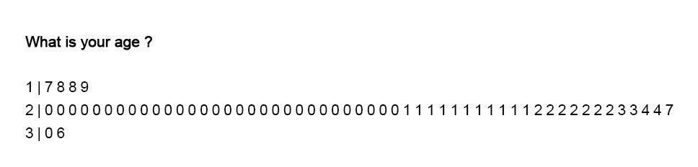

In our survey, there are also a various type of question that provides ratio data. The question that we asked is how old is the respondent. The data that we collected shows that the average respondents is 20 years old. The oldest respondent is 36 years old meanwhile the youngest is 17 years old. We want to make sure we conduct this survey to different kind of ages as they have different opinions and amount of usage between the young and the old ones.

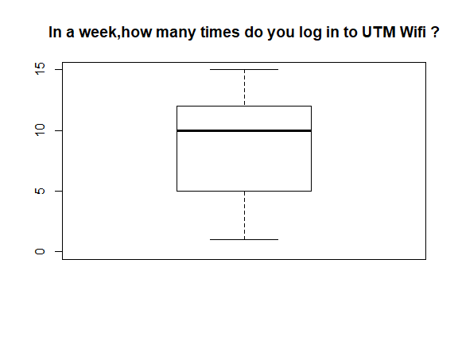
In order to calculate the amount of usage of UTMwifi in a week by students and staff we provide a question that let the respondents choose the scale of 1 until more than 10 that represent the number of times they log in to UTM in a week. The result of the data collected show us that 51.7% of the respondents log in more than ten times in a week and respondents log in to UTMwifi as least once a week. From this results, we can conclude that respondents log in to UTMwifi quite frequently which might be the cause of poor internet performance.

Coding used:
>boxplot(Usage_of_UTM_Wifi2$ ‘In a week,how many times do you log in to UTM Wifi’,main= “In a week,how many times do you log in to UTM Wifi”, xlim=c(0,15))
>box()
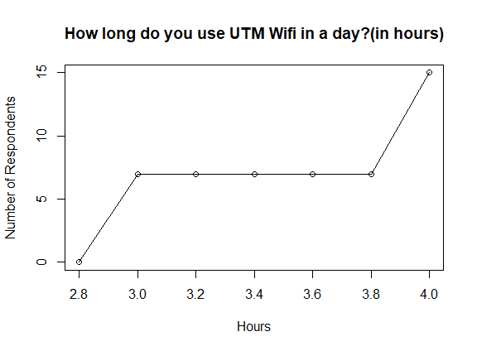
Besides that, we also provide a question that ask the amount of time the respondents use the UTMwifi in a day. The answer that is available on the answer is from less than 1 hour to 24 hours. The results that we obtained tell us that (25%) many of the respondent uses the UTMwifi for 15 hours a day. Many of the respondent uses the UTMwifi for a chunk of time that consume roughly more than 3 hours everyday.

Coding used:
>plot(breaks, distribute.cs,main = "How long do you use UTM Wifi in a day?(in hours)" , xlab = "Hours", ylab = "Number of Respondents")
lines(breaks, distribute.cs)
>datfd <- Usage_of_UTM_Wifi2$‘How long do you use UTM Wifi in a day?(in hours)’
breaks = seq(6,112,20)
>datfd.cut <- cut(datfd, breaks)
>datfd.freq <- table(datfd.cut)
>datfd.cs <- c(0, cumsum(datfd.freq))

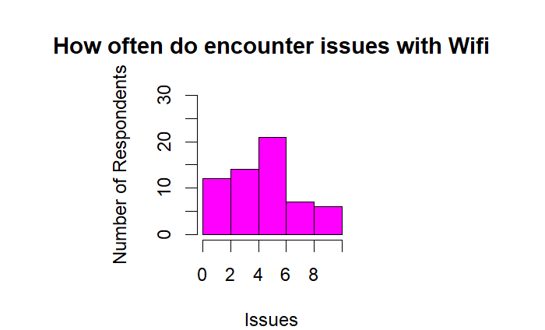

Finally, the last question that we provide ratio data is the number of times the respondent encounter problem or issue with the UTMwifi. Examples that can encounter when they are using the UTMwifi is disconnecting, webpage not responding and slow connection. Respondents can choose the number of times they encounter a problem from 1 until 10. The data that we collected shows that respondents (40%) usually encounter problem 5 times when they are using the UTMwifi. This data is vital to support our survey as the longer the respondents surf the internet, the higher the chance thay might encounter a problem.

Coding used:
>hist(Usage_of_UTM_Wifi2$‘How often do encounter issues with Wifi’, main="How often do encounter issues with Wifi", xlab="Issues" , ylim=c(0,30) , xlim=c(0,10))

IV. REFERENCES
- Dr Azizah Ali & Dr Nor Erne Nazira
- Lecture Notes Probability Statistical Data and Analysis Chapter (1 - 3)
- Survey collected using Google Form

V. ACKNOWLEDGEMENT

We would like to thank to our family, friends, lecturers and everyone who have their hand in this survey. This research have been made possible with their help and support. We are highly indebted to both of our lecturers Dr Nor Azizah Ali and Dr Nor Erne Nazira for giving us guidance and tips throughout this survey. To all our friends in UTM who helped us distribute this survey to reach beyond our expected target, we could not stressed how thankful we are to you.

