
UNIVERSITI TEKNOLOGI MALAYSIA, JOHOR BAHRU
FACULTY OF COMPUTING,
SEMESTER 1, SESSION 2018/2019

PROJECT LAB 4

TOPIC : MINI PROJECT PHOTOCOPYING (XEROX) MACHINE
NAME : CHENG SHIN WEI ( A18CS0046 )
HOW KAH HUI ( A18CS0074 )
YEAR/COURSE : 2018/2019 SEMESTER 1
SCSV – BACHELOR OF COMPUTER SCIENCE
(GRAPHIC AND MULTIMEDIA SOFTWARE)
SUBJECT : SCSR 1013 – 10 DIGITAL LOGIC
LECTURER : MR. FIROZ BIN YUSUF PATEL DAWOODI

Dedication & Acknowledgement

Firstly, we have done this final project with the dedication to our lecturer, Mr. Firoz Bin Yusuf Patel Dawoodi and we would like to express our gratitude towards him. He not only taught us the knowledge about digital logic instead he also taught us the knowledge about digital application in our real life. He patiently explained and answered all the difficulties we encountered and sometime guide us to find the solution. He provided a lot of help and guidance throughout the project so that we managed to complete the final project on time.
Next, we would like to thank to our lab assistants who help us much during the lab works. They provided guidance and convenience when we encountered difficulties without any complaints. They managed to identify the problem that we facing in conducting the circuit and quickly guide us to solve it. They were very patient during the lab session, which contributed a lot to our completion of the project.
Finally, we would like to thank to our course mate and friends who helped us in this final project. We share information with each other and discuss the 3-bit PLD's program together to make it effective. We also shared our ideas with each other to modify the Xerox Machine in this project.

Table of Contents

Dedication & Acknowledgement i
Objective 1
Materials 1
Background 1
The Problem 2
Proposed Solution 2
System Implementation 5
Conclusion 8
Reference 9
Appendix 9

Table of
Figure 1 Block diagram of a complete system of the machine. 3
Figure 2 The Drawing of Deeds 7

Objective
The objectives of this laboratory are to introduce the students to:
- Understand the development of a PLD device.
- Learn a simple Hardware Description Language.

Materials
The materials of this laboratory are:
- Breadboard
- ATMEL 22V10 – 1 unit
- ETS-5000 Digital Training Kit
- Wellon Universal Programmer & Tester
- WinCUPL 5.0 Software
- Handouts:
  - “WinCUPL user manual”
  - “ATMEL 22V10 Data Sheet"
  - “How to use Wellon Programmer”
  - “How to use Win CUPL 5”

Background
In this project, we will implement 4 different components on a single ATMEL device.
These components including:
- 4-bit Decoder
- 3-bit Count up Counter
- 3-bit Comparator
- Clock Disabler

The Problem
To initialise or close the Xerox machine, a switch is required to power on the xerox machine. Then, user is required to input a password to active the xerox machine component. This is due to private safety to prevent unauthorised usage of the machine. An output component is used to implement that the entered password is true. If entered an invalid password, the machine will not proceed to the next step. Then, the user is required to select the properties of printing. The properties are printing properties which include colour print and black and white print while the layout properties are portrait and landscape. An output component is required to verify this process. After that, the users have to input the number of copies they want to print, which the range starts from 0 to 7. Next, user need to set the PRESET and CLEAR button to reset the counter. The photocopy machine contains a counter to count the number of copies that have been photocopied. Two 7-segment display is used to show the amount of required copies and photocopied copies. A comparator will compare the number of required copies and photocopied copies. The machine will stop once the required number of copied produced.

Proposed Solution

The block diagram of a component required is shown in Figure 1. Firstly, to initialise the photocopy machine, user is required to turn on the power button to power on the photocopied machine components. Then, user is required to input a 4-bit password before starting to use this photocopying machine. This is to prevent unauthorised usage of the machine. If the entered password is incorrect, the user cannot proceed to the next step. Once the password is correct, the LED will light up to indicate that the machine is ready for use.
Then, the users have to select the properties of printing. The properties are printing properties which include colour print, black and white print, portrait and landscape. The properties are either colour printing with portrait or landscape or black and white with portrait or landscape. A multiplexer is use to let user select the choice of properties and a demultiplexer is use to indicate the choice that the user had chosen. LED light will be light up complement to the arrangement of the printing properties to implement that the properties selection process has been done. Three core component that used in counting the copied required are 3-bit comparator, 3-bit JK positive edge count up counter and a clock enable. Counter is used to determine the number of copied that has been print. Comparator will compare the number of copied required with number of printed copied. Once the number of copied are equal to number of printed copies. The clock disable will disable the clock and stop counter from counting.
To implement this, user has to input the number of required copies by using 3 input switches. Those switches allow user to enter 3 bits digit which is from 0 to 7. Next, user need to set the PRESET to 1 and follow by CLEAR to reset the counter. Two 7-segment LEDs will be connected to the device to show both the amount of required copies and photocopied copies. If the amount is different, then it will continue photocopy until both the values are same. After that, the photocopy machine will stop printing and counting. The printing process has been ended. If the user wants to continue the use of the xerox machine, he or she just need to repeat the step of choosing properties, input number of copies required and reset the PRESET and CLEAR to 1.
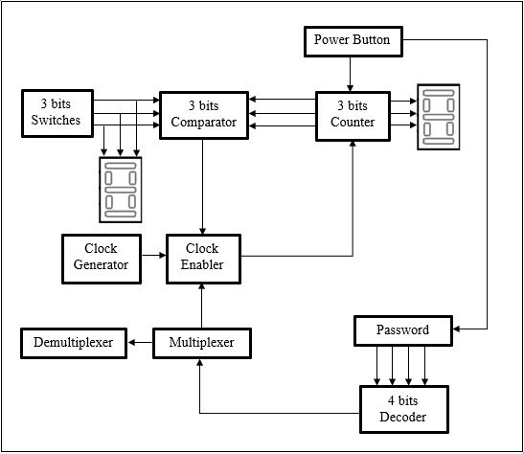
Figure 1 Block diagram of a complete system of the machine.

Components & Requirement

- 4-bit Decoder
- To determine the password entered is correct or not.
- A type of security to the machine.

- Multiplexer
- To let the user select the printing properties.

- Demultiplexer
- To determine which properties of printing that user had select.

- Input Switches
- To set the initial amount of copies that user want to print

- 3-bit JK positive edge count-up Counter
- To count the amount of copies that has been printed.

- 3-bit Comparator
- To compare whether the amount of copies required and also the amount of printed copies has been met

- Clock Disabler
- To stop the operation of the counter when the amount of copies and printed copies has been met.

- 7-Segment Display
- To display the required number of copies and amounts of printed copies.

System Implementation

- Decoder
We use a 4-bit decoder to decode the set of binary passwords. The enable pin of 4-bit decoder is connected to power button by which mean the decoder will only activate when the power button is activate. The output of the decoder is connected to a LED. Once the LED light up, it will allow the photocopy machine to work. The output of decoder is connected to multiplexer, this mean in order to activate the properties selection state, the password had to be correct.

- Multiplexer
A multiplexer is use to let the user choose the printing properties that the user wants. User input S0 and S1 to choose the properties that the user need. For both S0 and S1 is 0, the user will select the black and white with portrait printing, S1=0 and S0=1 the user will select the black and white with landscape printing, S1=1 and S0=0, the user will select the colour printing with portrait properties while both S1 and S0 = 1 the user will select the colour print with landscape properties. All these properties are connected will 3-bit decoder, if the user enter an invalid password then it can’t proceed to this step.

- Demultiplexer
Demultiplexer are connect to output of multiplexer thus this component is use to determine the properties that the user had chosen.

- Input Switch
There are 3 switches for the user to input the number of copies they required. Each of the switches represents a single bit respectively, which are A0, A1 and A2. A0 represent LSB and A2 represent MSB. Hence, the user can input value ranging from 0 to 7 only. The output of input switch is connect 7-segment display and comparator

- 3-bit count-up Counter
The 3-bit counter that we use is 3-bit JK positive edge count-up counter. The counter starts to count based on the clock enabler. It will start counting if the J and K input are connected to high input. In our case we use power button to implement the active high input, if password entered is correct and the clock enabler is being active. It will stop when the clock pulse is no longer received or reached the number of counts initialised by the user. By using WINCUPL code, we program the condition on it. Then, the PLD program is burned into PLD ATMEL 22V10 by using Wellon Universal Programmer.

- 3-bit Comparator
The comparator uses three 2-input XOR gates to compare value from 2 sources, which are the input switches and the counter. The first XOR gate compare the least significant bit (LSB) of the 2 sources. If they are same, the output will be 0 and it is sent to the NOT gate and convert it into 1. The same principle applies for the second and the third XOR gate. Then the signal from all the three gates will be sent to a NAND gate to convert it into opposite signal. Therefore, when all the XOR gate received the same input from input switches and the counter, it will send an output 0 to clock enabler to stop the photocopying machine.

- Clock Enabler
The clock enabler is set up by using a 3-input AND gate. The input of the AND gate is the clock source, signal sent by the properties and a signal sent by the comparator. The enabler can only be active when all three inputs are high. It use to stop the operation of the counter when the amount of copies and printed copies has been met.

- 7-Segment Display
This component displays the number by converting the binary code received and into decimal. Two 7-segment displays are used where one of them shows the required copies and the other show printed copies. Since we use 7-segment display but just connected to 3 input thus the 4th input will connect to ground.

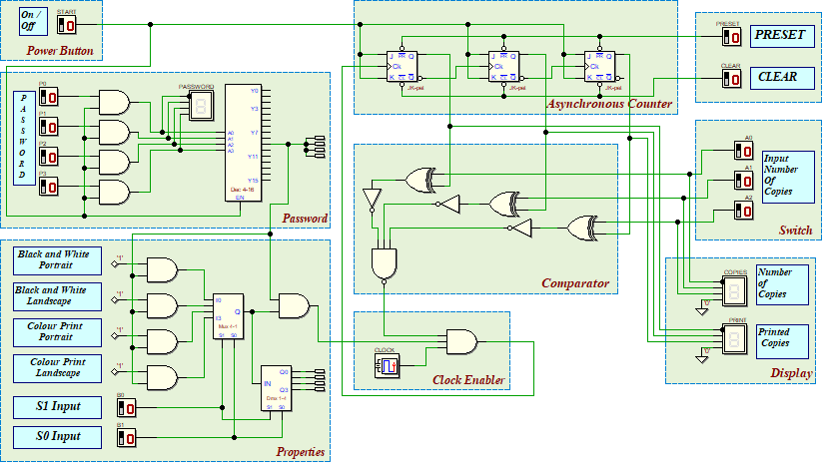

Figure 2 The Drawing of Deeds

Conclusion

In a nutshell, we successfully completed the project. We able to propose a solution based on the problem that we figure out and the circuit can function well. Is a fact that, real xerox machine will has a more complex circuit design inside it but this project increases our knowledge on how does the xerox machine work and the simple circuit inside it. Now we know that the main design of xerox machine are consist of decoder, counter, comparator and clock disable.
After this project, we realise that we lack of knowledge on conducting practical circuit project. Although we know the theory but if we lack on practical we still not able to conduct a complex circuit. The weakness of us on this project is not able to implement adder on this circuit design. This is because we do not have the idea on how to design adder in our circuit and how it would count the money for us. If we manage to design the adder in our circuit then our circuit will be more
Although we encountered some problems but fortunately we managed to solve these problems. We also gained a lot of experience from this project. We understand that practical applications are as important as studying the theory because it provides better understanding on how the components functioning. Besides, we have learned a how to use WinCUPL software and Wellon Universal Programmer & Tester to overwrite or program the PLA.
If we manage to design the adder circuit then our circuit will be better, as this imply that we know how to use the adder. Although we had finished our project, we will still figure out how to use the adder component.
Lastly, we would like to thank to Mr Firoz, lab assistants, friends and senior who gives advises and guidance to us.

Reference
- Abd. Bahrim Yusoff, Mazleena Salleh, Mohd Fo'ad Rohani, Ismail Fauzi Isnin. (2017). Digital Logic (Fourth Edition). Johor, Malaysia. Desktop Publisher.

- Abd. Bahrim Yusoff, Mazleena Salleh, Mohd Foad Rohani, Ismail Fauzi Isnin, Marina Arshad, Raja Zahilah Raja Mohd Radzi, Firoz Yusuf Patel Dawoodi, Siti Hajar Othman, Mohd Murtadha Mohamad, Muhalim Mojamed Amin. (2018). Laboratory Manual Digital Logic (Fifth Edition). Johor, Malaysia. Desktop Publisher.

Appendix
      - Basic Photocopying Machine Coding
Name Xerox3 ;
PartNo 00 ;
Date 10/12/2018 ;
Revision 01 ;
Designer Engineer ;
Company UTM ;
Assembly None ;
Location ;
Device g22v10;

/* *************** INPUT PINS *********************/
PIN 1 = clk ; /* clock */
PIN 2 = reset ; /* reset */
PIN 3 = preset ; /* preset */
PIN 4 = a0 ; /* Comparator A */
PIN 5 = a1 ; /* */
PIN 6 = a2 ; /* */
PIN 7 = b0 ; /* Comparator B */
PIN 8 = b1 ; /* */
PIN 9 = b2 ; /* */
PIN 10 = startPrt ; /* Start Printing */

/* *************** OUTPUT PINS *********************/
PIN 17 = diffCmp ;/* XOR (A B not equal HIGH) */
PIN 18 = sameCmp ;/* XNOR (A B equal HIGH) */
PIN 21 = q0 ;/* output counter */
PIN 22 = q1 ;/* output counter */
PIN 23 = q2 ;/* output counter */

/***** Function Comparator************************/
sameCmp = !(a0$b0)&!(a1$b1)&!(a2$b2);
diffCmp = !sameCmp ;

/**** Function Clock Enabler *********************/
clkEn=startPrt & diffCmp;

/*** Function Counter 2 Bit UP ***************/
field count =[q2..0];
$define s0 'b' 000
$define s1 'b' 001
$define s2 'b' 010
$define s3 'b' 011
$define s4 'b' 100
$define s5 'b' 101
$define s6 'b' 110
$define s7 'b' 111

/**Define Asynchoronous Input: Asynchronous Input Active High**/
count.ar=reset; /* connect reg AR to reset (Asyn Mode) */
count.sp=preset; /* connect reg AR to preset (Syn Mode) */

/**State Counter Sequence**/
sequence count{
present s0 if clkEn next s1;
default next s0;
present s1 if clkEn next s2;
default next s1;
present s2 if clkEn next s3;
default next s2;
present s3 if clkEn next s4;
default next s3;
present s4 if clkEn next s5;
default next s4;
present s5 if clkEn next s6;
default next s5;
present s6 if clkEn next s7;
default next s6;
present s7 if clkEn next s7;
default next s7;
}
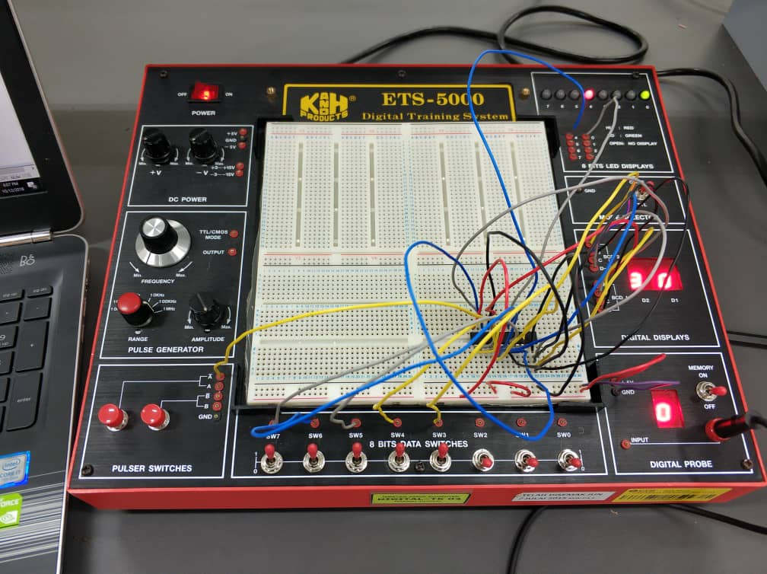
2. Practical work in lab

- Deeds drawing

