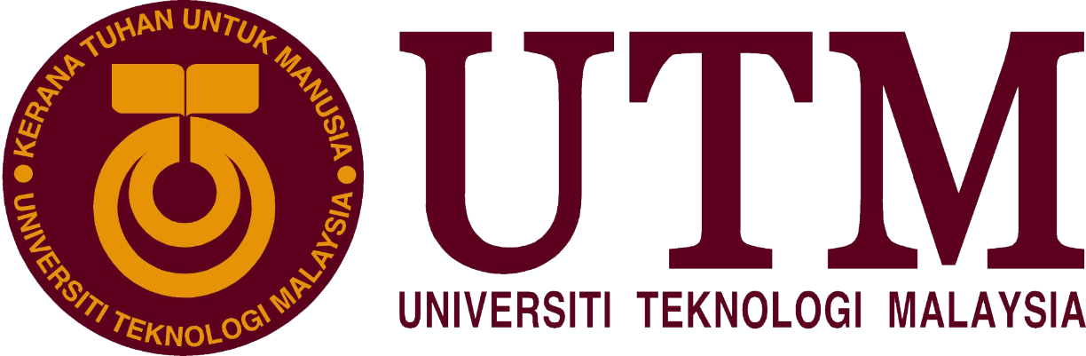

FACULTY OF ENGINEERING,
SCHOOL OF COMPUTING
UNIVERSITY TECHNOLOGY OF MALAYSIA

TECHNOLOGY INFORMATION & SYSTEM
(SCSP1513-08)

INDUSTRIAL VISIT
SENAI INTERNATIONAL AIRPORT

NAME: NURUL HUDA BINTI SHAIJI
LECTURER: DR AZURAH BINTI A SAMAH
SECTION: 08

- INTRODUCTION

Senai International Airport, formerly known as Sultan Ismail International Airport is an international airport in the town of Senai, Kulai District, Johor, Malaysia. The airport is located approximately 32 km north-west of the Johor Bahru city centre. In 2017, Senai International Airport reached a total of 3,124,799 passengers and 7,614 tons of freight with a combination of 42,744 schedule and non-schedule commercial aircraft movements. The airport is a hub for AirAsia.
Opened in 1974, it serves the state of Johor as well as people from the southern states of Peninsular Malaysia. Senai International Airport is the hub of AirAsia. It was a domestic hub of Malaysia Airlines until the rationalisation of its domestic routes to cut the company's losses. After the rationalisation, Malaysia Airlines only served two destinations from Senai.
Today, the airport is managed by Senai Airport Terminal Services Sdn Bhd, which took over the operations from Malaysia Airports Holdings Berhad (MAHB) in 2003. Senai International Airport is capable to handle up to 3.5 million passengers and 80,000 tonnes of cargo per annum. There are plans to increase the capacity of the airport to 10 million passengers in the long term and turn the airport into a cargo hub. Recent expansions and upgrades include lengthening of the runway to 3800m and building a parallel taxiway to increase runway capacity.

- DETAILS

On 3rd December 2018, all students from section 8 of Technology Information & System went to Senai International Airport for second industrial visit. We departed from UTM by bus at around 1.45 p.m and we arrived at the airport around 2.30 p.m. We were invited by Mrs. Fatin Binti Zulkiflee, the Corporate Communication Executive who was on duty that day. We were brought to a meeting room for a short brief about Senai International Airport (SIA). Mrs. Fatin introduced herself and welcomed us before she let Miss Mazwa Binti Hamdan continued with the briefing. Miss Mazwa is the Executive IT(programmer) at SIA. Currently she was the only programmer at SIA.

At the beginning of the briefing, Mrs. Fatin also explained that Senai Airport Terminal Services Sdn. Bhd is a member of MMC Group owns and manages the operations of Senai International Airport. MMC is belong to Tan Sri Syed Mokhar Al-Bukhary. MMC Corporation Berhad is a leading utilities and infrastructure grou with diversified business under four divisions namely port & logistics, energy & utilities, engineering & construction and industrial property.

As the airport operator and a licensed ground handler, SIA offer flexibility and efficiency to the valuable customers. SIA also specialized cargo handling services provide customized solutions to cater to customer logstics needs. Senai Business Aviation Terminal (SBAT) is a private jet terminal designed to complement the growing demand of business and high-net worth individuals to Iskandar Malaysia. Senai Airport Aviation Park (SAAP) is a dedicated area for business and general activities. Senai Free Zone (SFZ) is a land development with basic infrastructure and ready-built space ideal for logistics warehouse and manufacturing activities. Senai Airport houses more than 50 international and local retail F&B and services outlet to serve not only the passengers but the rapidly expanding Senai-Kulai commercial, industrial and residential hub.There are 5 airlines which are operating in SIA namely Malaysian Airlines (MAS), Malindo Air, Air Asia, Fire Fly and Jin Air.

Later, Miss Mazwa also added that she is our UTM super senior and she had been working at SIA for four years at IT Services Department as an Executive IT and basically a programmer. IT Services Department mission is to deliver the technology and information services to respective department and needed to fulfill the requirements from business needs while the vision of the department is ensuring the integrity of data, improving the delivery of information and fostering a bright technological future. There are many services provided in SIA. One of it is they provide WiFi at the airport not just for the workers but also for the passengers. The wifi is mainly for the office uses for the SBAT but passengers also can connect to it at the first floor. In addition, they also do the maintenances of IT hardware for the PC, notebook, UPS and printer.

The airport also comply with ISO27001 Information security management system and ISO9001 Quality Management System. The example of the policy that enforce in SIA are Ani-Malware policy, Cryptographic Controls policy, Back Up and Restoration policy, Removal and Disposal Policy, Patch Management policy and Firewall policy. After that, for application and system, SATSSB have the Flight Information Display System (FIDS) that is very useful for the passengers as it displays the departure time, arrival time and the information about the baggage. They also own the Passenger and Cargo Data System (Statistic) that usually to calculate on how many passenger departures or arrives in the airport. SATSSB is currently uses attendance system for their staffs with fingerprint scanner and also use the Maintenances System to check the maintenance flow. Electronic Document Management System (eDMS) is use by the compliance for the document control in and out or versioning. The database used in SIA are mainly Microsoft SQL Server and MySQL. FIDS and Passenger and Cargo Data System are both actually did by the previous programmer then recently maintain by the current programmer which is Miss Mazwa.

The most official department in SIA is the aviation security. The safety and Security of airport users is our outmost priority. SATSSB is committed to provide the standard in accordance to the regulatory recommendations. Our AVSEC personnel are well-trained and constantly undergone aviation security program to enhance the security service level which aims for safe travel and operations SIA. SATSSB also got an achievement since it opened on 1974. Day by day, visit after visit it’s becoming more obvious that the role of IT in different areas is solid and unshakable. The role the IT team in Senai Airport is playing is probably the most important part in the operation of the facility.

After the briefing session ended, we were shown around the airport by Mrs. Fatin. We could visit so many important departments in the airport and most importantly we were shown step by step from the beginning how the airport works and experiences like a customer on how they need to get through before boarding. This industrial visit ended at around 4.30 p.m.
- CONCLUSION AND REFLECTION

So overall, industrial visit to Senai International Airport has opened my eyes about so many things. I could understand better about how my future career would looks like. I could know what are the requirements to become a specialist in career related with IT. Based on this visit, I can now identify my weaknesses and can try to improve it to prepare for my future career. I saw how all the workers collaborate with each other and this inspire me a lot. I am so excited to finished my studies and then after I’ve become a specialist in this field I will try to improve the security of the airport networks and protect the data of the airports all over Malaysia.
