

DESIGN THINKING

Course/ Section : SCSP/ Section 03
Lecturer’s Name : Dr. Sharin Hazlin Huspi
Group Members : Ng Jing Jie (A18CS0172)
Rachel Lim Jia Chyi (A18CS0236)
Tan Rouxuen (A18CS0257)
You Kah Hoo (A18CS0281)

Contents

No | Title | Page
1. | Introduction | 2-3
2. | Detailed Step | 4-7
3. | Detailed Descriptions | 8-9
4. | Design Thinking Assessment Point | 10-11
5 | Design Thinking Evidence | 12-14
6. | Reflections | 15-16
7 | Reference | 17

Introduction

Design Thinking is process that creating some new and innovative ideas and solving problems. Design Thinking can be applied in any field such as technology, education, and business and it does not necessarily have to be design-specific. It focuses on humans needs and will come up with effective solutions to meet those needs. It also can improve the products by analyzing and understanding how users interact with products and investigating the conditions in which they operate. In Design Thinking process has five phases that are Empathise, Define, Ideate, Prototype and Test.

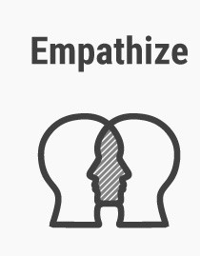 | Empathy is a starting point for Design Thinking. It is getting to know the user and understanding their wants, needs and objectives by observing and engaging with people to understand their needs.
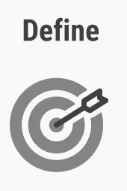 | Define the problem.Gathering all the problem from empathise phase and start to make sense of them: what difficulties are your users coming up against? What patterns do you observe? What is the user’s problem that you and your team needs to solve? In the end, you will have a clear problem statement.
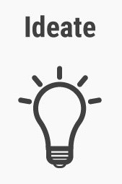 | Ideate is where the creativity happens. Some ideation techniques can be used by designer are brainstorming, mindmapping, bodystorming (roleplay scenarios) and provocation. It is trying to explore new solutions and towards the end of this phase, designers will narrow few ideas with which to move forward to next stage.
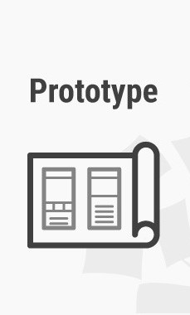 | Prototype brings the solutions into version of the product. It is a rough drafts of solutions to decide if these will prove beneficial for the problem. Prototype can be an app or a model to display.
 | After prototyping comes testing, the results of the testing phase will often lead you back prototyping stage in reality. So, you need to redefine the original problem statement or to come up with new ideas you hadn’t thought of before.

( Table 1 : 5 stages of Design Thinking )

Detail Step

On 11 November 2018, we were given a task about the problems of learning Mathematics in primary school. We found that students in primary school have some problems when learn mathematics and cause them did not get good result in their exam. So, we decide to solve their problem through Design Thinking process.

Empathize
We had some interviews to the person who are involved in the teaching and learning Mathematics process such as teachers ,parents and students. Through these interviews, we get to know why they will having problems in this subject. Fortunately, we were able to have some phone interviews with a students who is 10 years old and studying Standard 4 in primary school and his parents. Besides, we also have face-to-face interviews with some people who had teached Mathematics in primary school . Through these interviews, we have some minds about what are the problems they faced in the teaching and learning Mathematics subject.

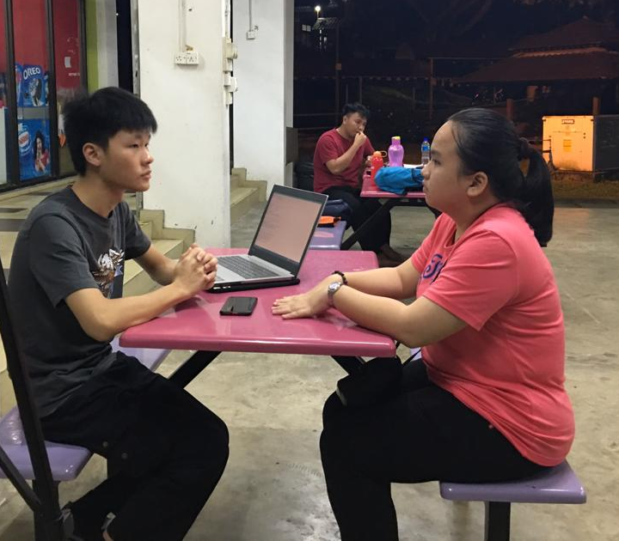
( Diagram 1 : Face-to-face interview with people who taught Mathematics in primary school )

( Diagram 2 : Phone interview with parent and student )

Define
After the empathize process, we try to gather all the findings from differents aspects such as teachers, parents and students. Some of the problems faced by students are they do not understand their teacher teached, syllabus are too difficult for them and they lack of interest and patience in this subject.

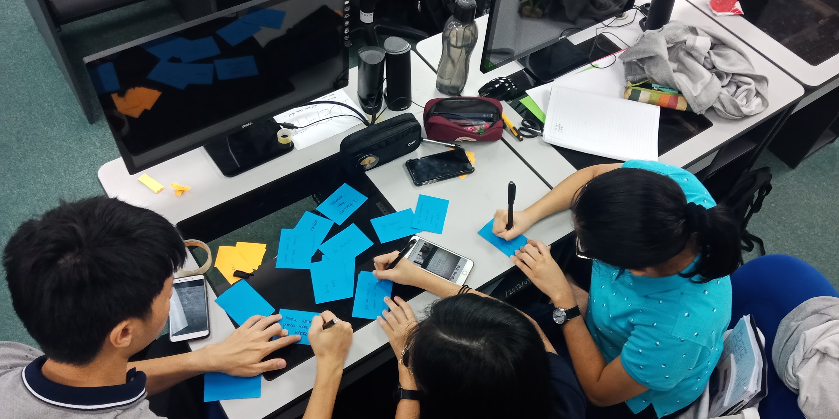
( Diagram 3 : Gathering all the findings after empathize phase )
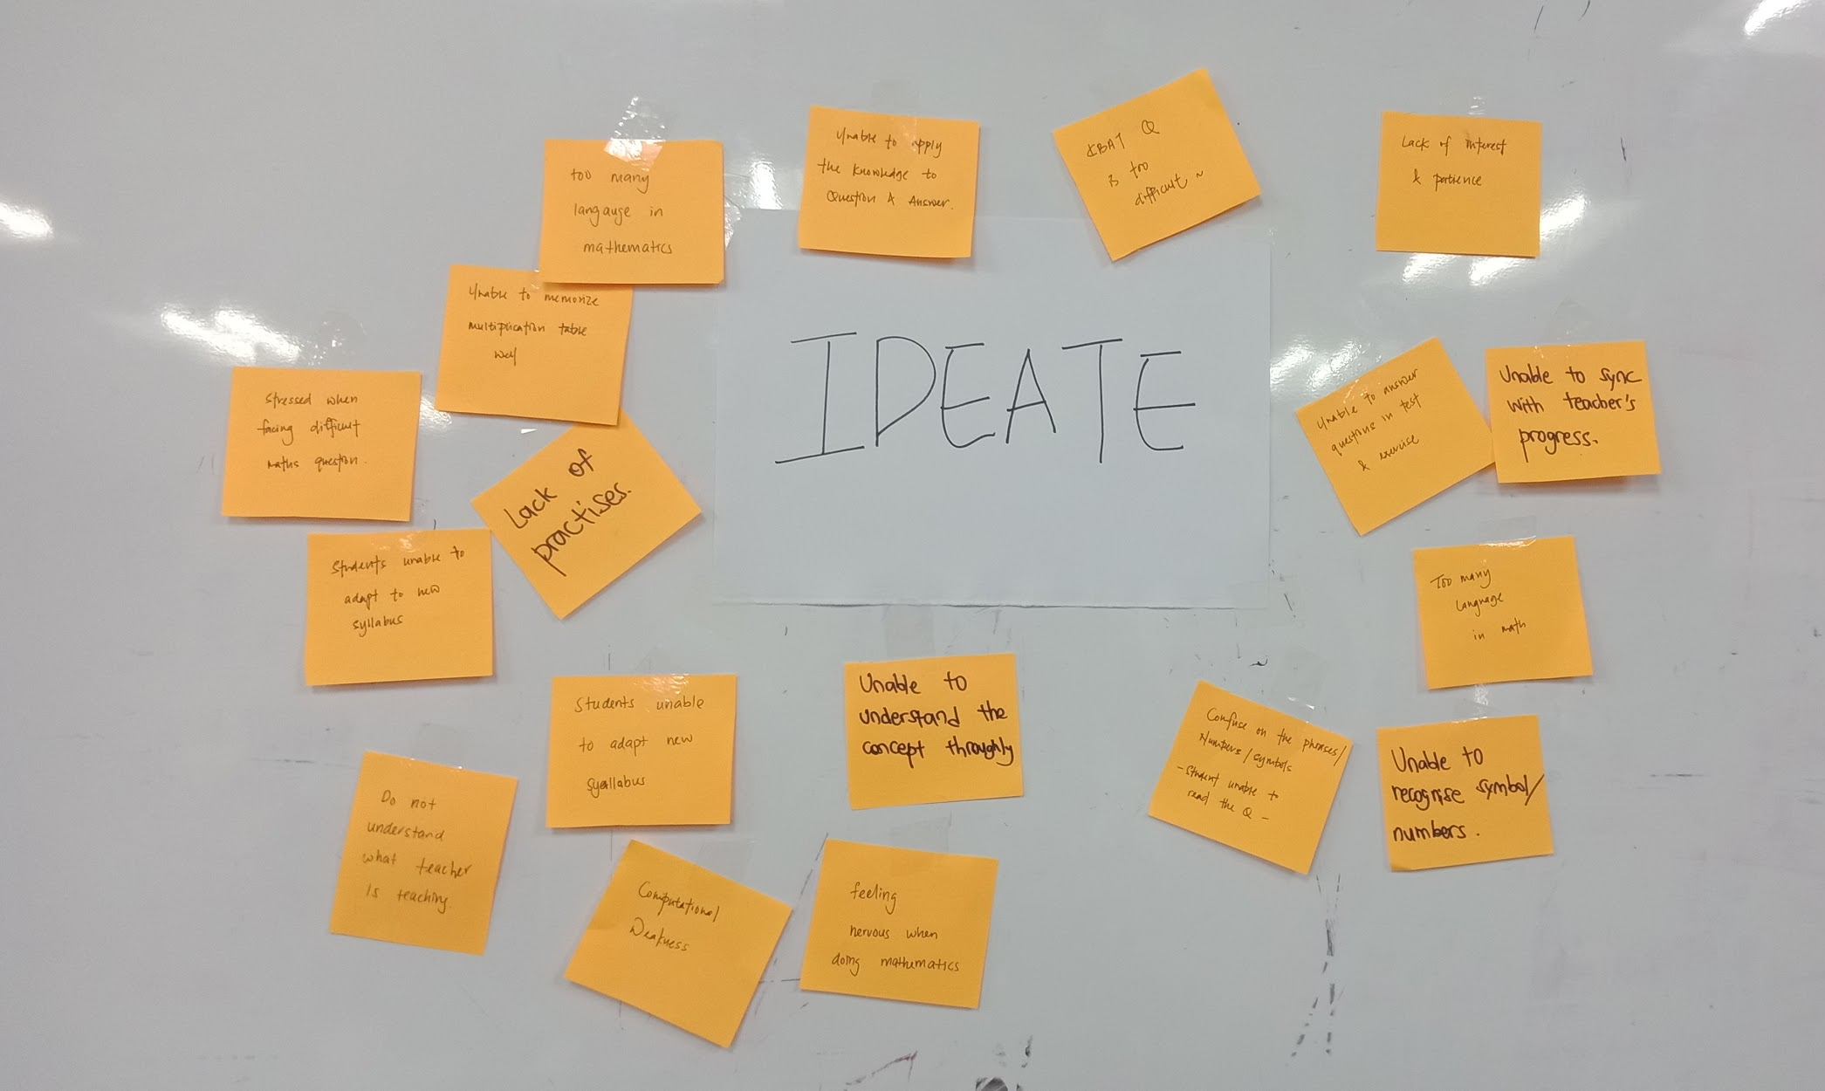
( Diagram 4 : Problems in learning Mathematics )

Ideate
After the problems is clearing framed, we start to search the methods to solve it by brainstorming, mind-mapping and bodystorming. We try to explore as many as we can to come out the solution to handle the problems in learning Mathematics throughout the students. After that , we shortlist the best solutions for the problems and leave the rest is try to produce a good prototype for our users. These are the examples of the solutions such as students have to practice more, parents can become their mentor to teach their children Mathematics and teacher can try some interesting teaching techniques in Mathematics subject.

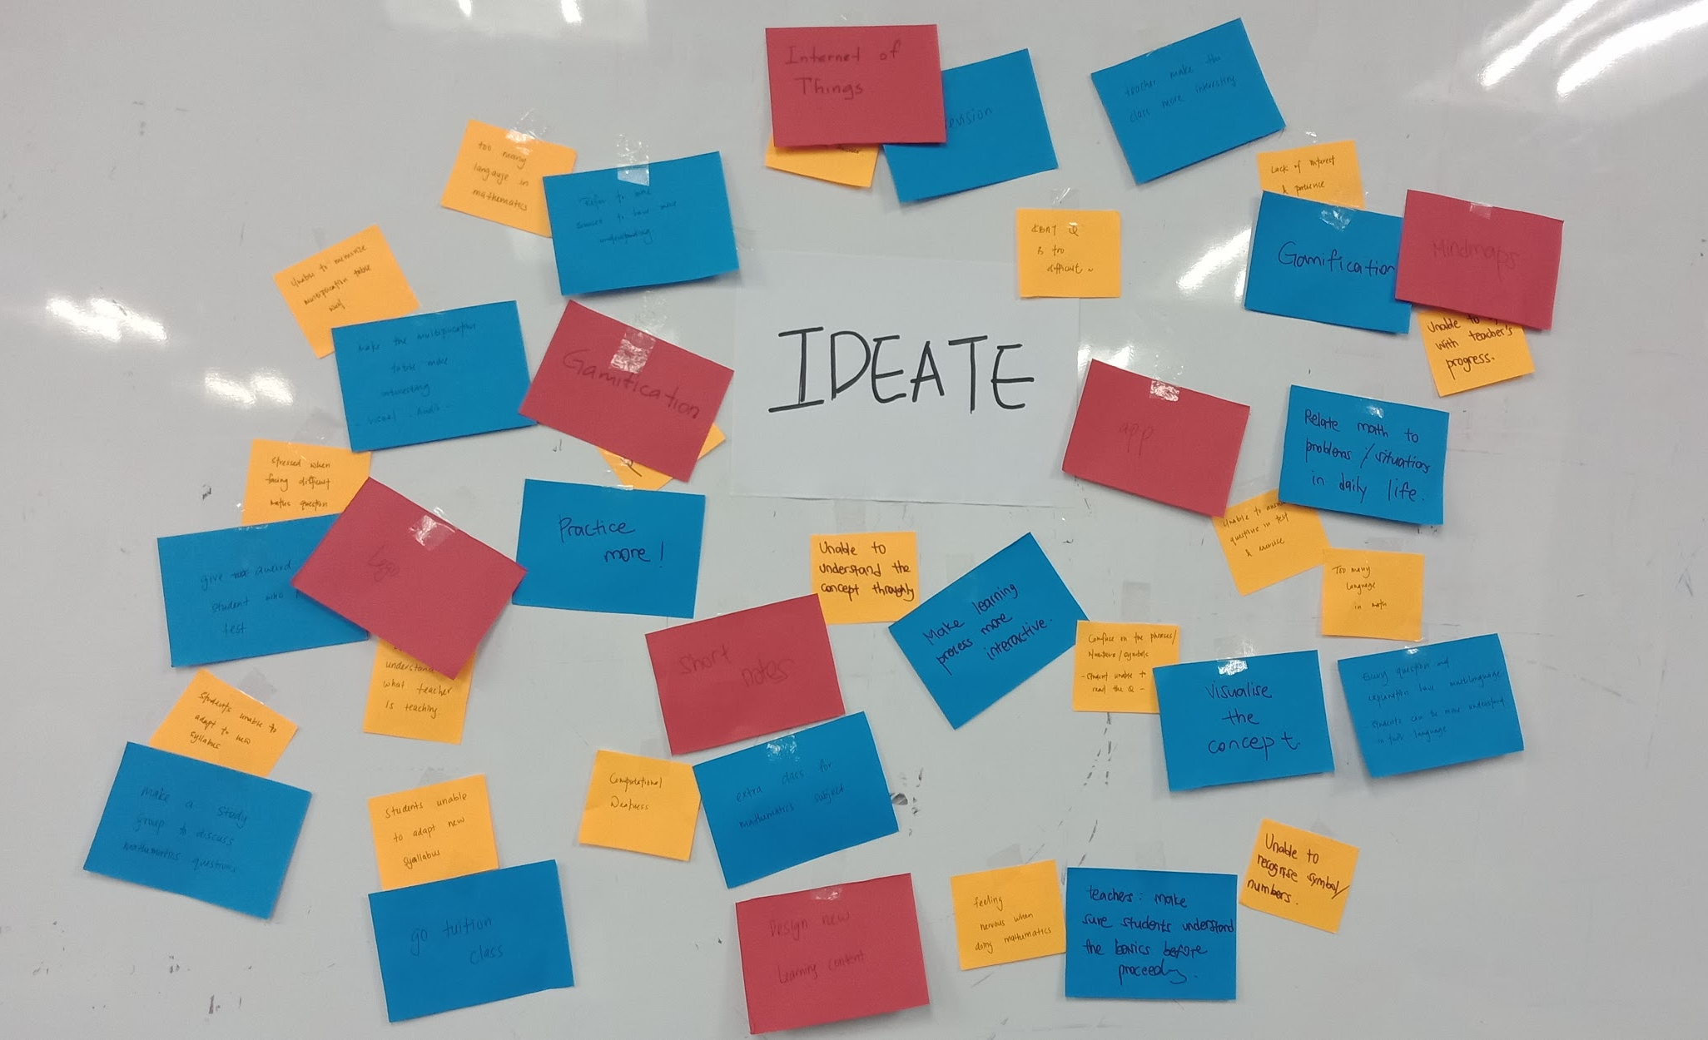
( Diagram 5 : Solutions of the problem )
Prototype
After we got the solutions, we started to bring out the solutions into version by design an app for parents and students. We create a rough prototype named Fundamental Mathematics by putting in the solutions to the test and highlighting any constraints and flaws. In our prototype, we create two phases,one is for children and the other is for mentor. In children phase, we try to make it as gaming app to attract the interest of children to use our app and learn Mathematics thought this app. They can get some informations when playing the app. On the other hand, we produce the solutions to solve the Mathematics questions in mentor’s phase. We also provide some teaching techniques in the app for parents to learn how to teach their children in an interesting way.

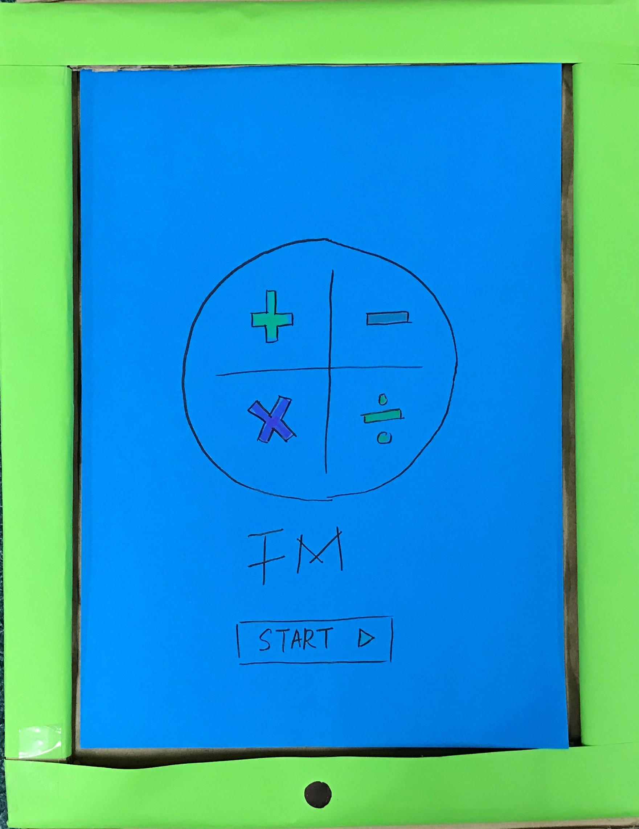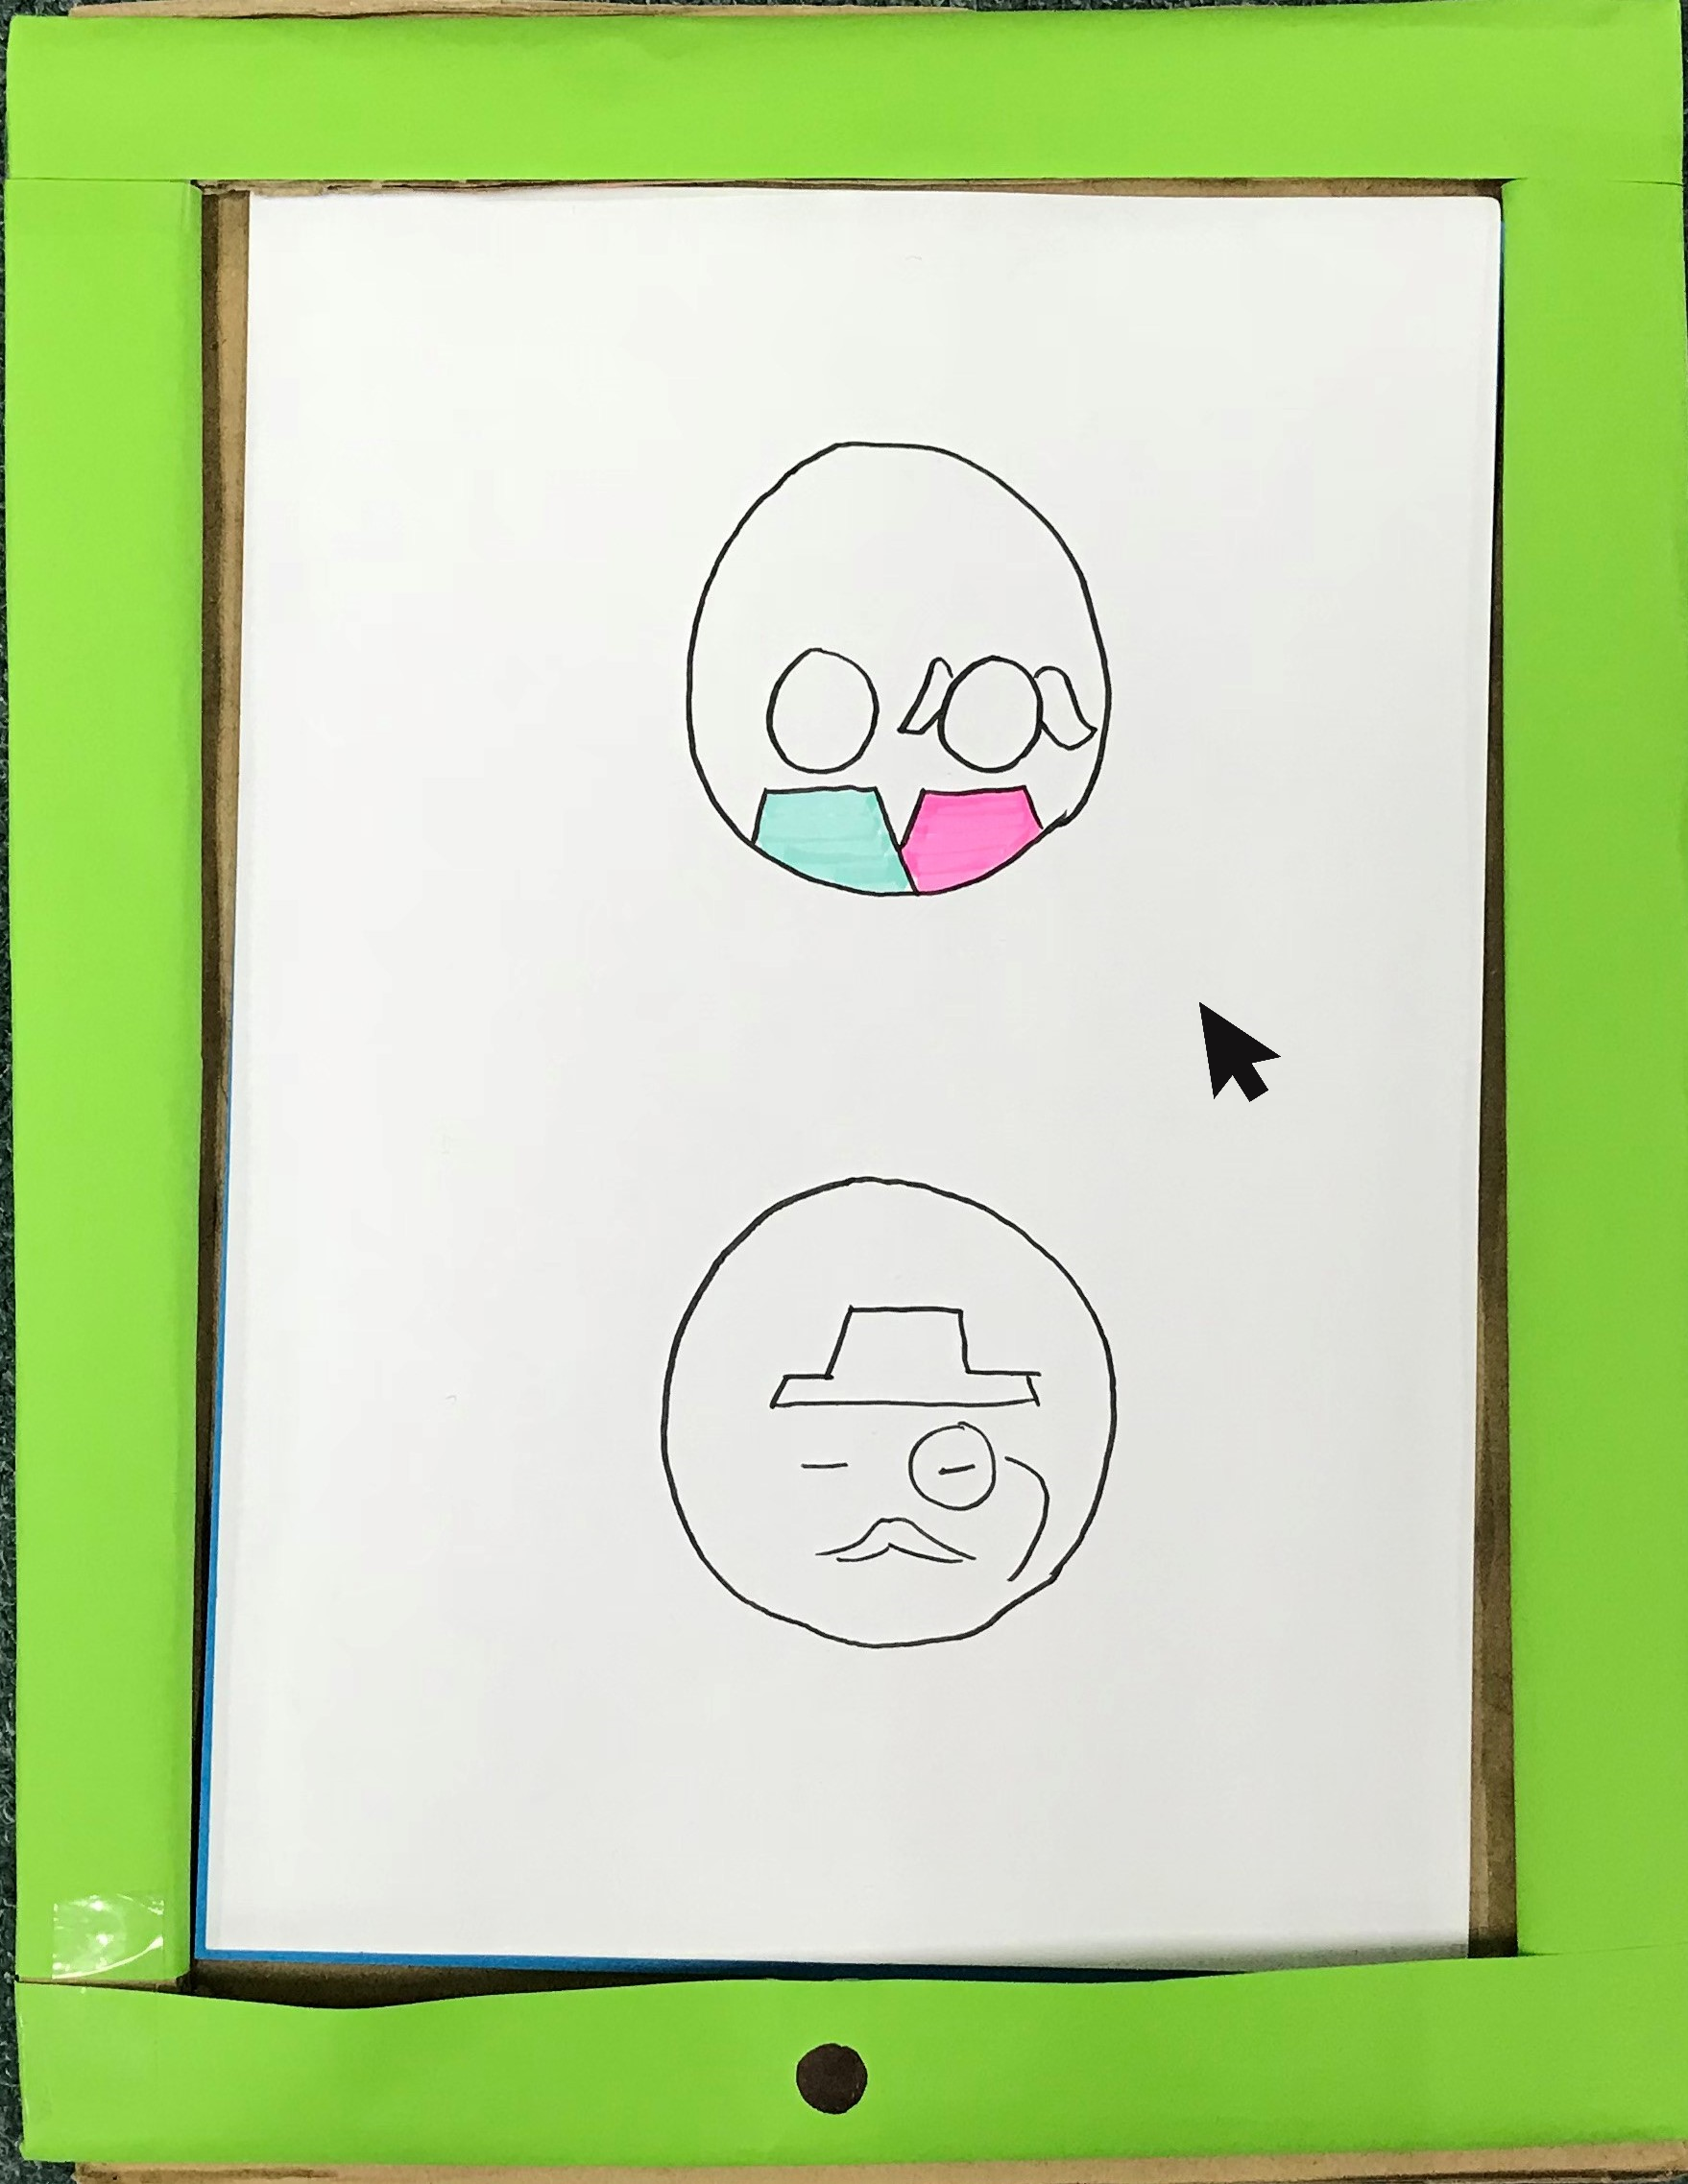
( Diagram 6 : Interphase of prototype ) ( Diagram 7 : Different phases for users )

Detailed Description (Problem, Solution and Team Working)

The problems that all of us had discussed is about the different type of learning style to learn mathematics and some of the difficulties faced during learning mathematics. There are 7 types of learning styles which are visual, aural, verbal, physical, logical social and solitary. Everyone will have their own dominant style of learning with far less use of the others styles. People who like to learn through visual are those who prefer using pictures, image and spatial understanding while other who prefer learning through aural are those who like to use music and sound to make them be focus. People who use verbal as their dominant style of learning like to use words and those who are logical style prefer using logic, reasoning and systematic thinking. Physical style person likes to use their sense of touch to learn. Social style person likes to learn in group and interact with others while solitary person prefers to learn alone in a quiet environment.

Learning Style
Sosial
(Interpersonal)
Solitary
(Intrapersonal)
Visual
(Spatial)
Logical
(Mathematical)
Physical
(Kinesthetic)
Aural
(Auditory-Musical)
Verbal
(Linguistic)
( Diagram 8 : Learning Style )

Part of the difficulties and problems faced in learning mathematics is that the new syllabus is unable to be adapted and understood by students. Students are unable to understand the concept of each and every chapter and lack of practices which makes them feel nervous and stress during answering the questions. Students are also lack of interest in mathematics and the HOTS ( High order of thinking skills ) questions are very hard to be understood.
After defined all the problems, all of the members brainstorm together to find out the suitable ways and solutions to solve these problems faced in learning mathematics. Since our main focus is on primary students so our ideas of solving are based on the students’ situation and learning styles. The solution that we prefer is creating a website or mobile application which included visual, aural and physical as the main types of learning style. This is because students who are below 12 years old can absorb information easily by using images, animation, sound effect and physically interacting with their environment. After we had analyzed all the possibility of problem and solution, we finally came out a final decision which is creating a mobile apps which can always be updated with all the syllabus and related information, enable the parents to understand the weakness of their children and keep track on their studies.
Although our group members had some small argument and dispute during our discussion, but all of us are willing to listen and accept other members’ point of view and come out a conclusion and product which all of us are satisfied. After that, we distributed all the task to every member like someone will be in charge of video making and others preparing the prototype and written report. Our spirit of team working make this project to be progressed and to be done on time.

Design Thinking Assessment Point

If we conducted a design thinking without any assessment or evaluating our outcome of discussions, we may end up with a poor decision or product. Especially, when we work as a team which may lead to groupthink. Groupthink is a phenomenon that occurs when the members are desire for group harmony but result in dysfunctional decision-making outcome which does not align with the original problem statement. Hence, allocation of assessment point is very important to encounter this problem. Assessment point can be conducted during the end of the project demonstration or the transition between design thinking phrases. In our case, assessment point was being conducted in between the phrases.

Since our target for this design think project is primary students, so we decided to interview some primary students about the problem faced. Later on, we found that we should also interview the parents and teachers of the students so as to understand more and well about their situation. This can help us to come out with suitable ideas and outcome.
During this phrase, we should analysis and synthesis the problems that were gathered after doing empathize phrase in order to make a clear problem statement. Initially, we define the problem as “How can we improve primary students’ mathematics result.” After we evaluate our outcome again, we decided to use “How can we develop and elevate students’ learning interest in mathematics.” instead of that.
During the ideate phrase, we firstly brainstorm to come out the solution and then filter off irrational ideas. For example, we unable change the syllabus to make it easier for the students although this is the main problem faced. However, we can find some ways to improve their learning through using the suitable learning styles.
After that, we started to make our prototype which is a mobile application which consists of different types of learning style which mostly suitable for primary students. In the process of making, we make sure that the product is align with our main ideas and it is functioned according to the outline. We also evaluated our prototype after it is done and found out that there are some functions and the interface of our apps can be modified for a better user experience.
( Table 2: The Assessment Point during The Transition of the Phrases )

During the end of the project, reflections are being carried out to verify whether the results and outcomes were hit our initial intention and problems.
In a conclusion, assessment point is very essential in a group thinking or design thinking so it can be functioned as a guideline for us to make sure that we are on the right track.
Design Thinking Evidence

a. The sample work by students working to solve the design challenge

Through our investigation, we found out that primary students nowadays are exposed to technology gadgets. They spend a lot of times of digital gadgets such as smartphones and tablets. Therefore, we decided to create an educational mobile application not only to allow students to learn mathematics in a fun way, but also allow parents to concern about their children’s academic performance.

b. Record for each phase

In the first phase of the design thinking challenge, we need to determine the problem faced by primary students nowadays in learning math, we managed to find all three communities which are related to the problem we investigate, which are students, teachers and parents, and had an interview with them to determine their problems regarding to our study.

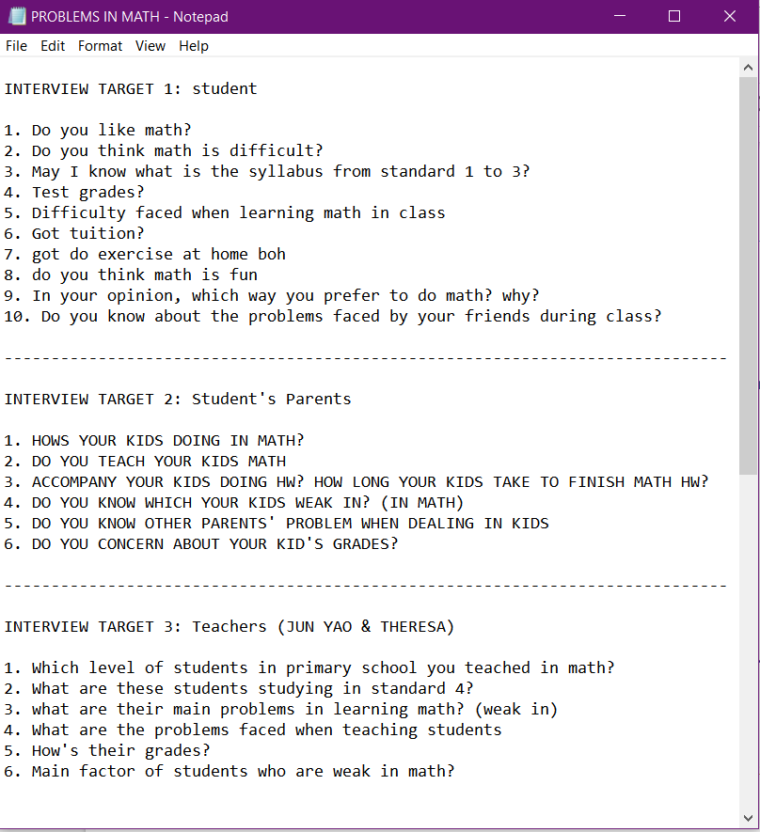

Diagram 9: (List of Questions for the Interviewees)

After that, in phase 2 which is define, we list out all the problems we obtained from different sources, we put all the problems together by using post-it, and start to define the main cause of the problem.

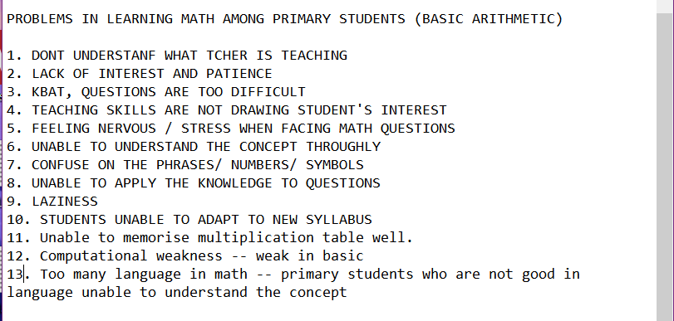

Diagram 9: (List of the Causes of the Problems We Listed Out)

In phase 3, we started to have brainstorm to think about the best solution. All the ideas are wrote on the blue colour memo and put it around the questions memo. After that, we refine the ideas we have using red memos, and come out with a final solution: a mobile application.

In phase 4, we created a prototype. We made a tablet case with cardboards and draw the app interfaces with A4 papers. We decided to use tablet as our selected “digital gadget” just to improve the visualisation of the interface. Lastly, in the prototype test, we show how this application works by arranging the interfaces into the “tablet”.

As an evidence, a short video clip on the whole process of design thinking have been made. We took some footages when going through all the process of design thinking, from empathy until the prototype test. Most of the video is recorded by Ng Jing Jie, Rachel and Tan Rouxuen in charged of progress planning, while You Kah Hoo is in charge of video editing.
Reflection

What is your goal/dream with regarding to your course/program?
Regarding to the courses we are studying which is data engineering, our main goal is to become a successful data engineer in the future. We hope to become a successful data engineer that equip with all the requirements a successful data engineer should have. For example, having deep knowledge of SQL database design, multiple programming languages and familiarity with data administration. We are looking forward to work as a part of analytics team, to provide a platform for modelling data and help enterprise to achieve their business goals. Also, we want to contribute our efforts to develop our country through digital technology.

How does this design thinking impact on your goal/dream with regard
to your program?
After we got involved in this design thinking project, it further strengthen our goal to become a data engineer. In this new digital era, there is no doubt that the demand of Big Data will increase surprisingly in the future. Throughout this design thinking process, we found out that this is the best way to provide a solution-based approach in solving real life problems. Undergoing the stages in design thinking which included empathise, define, ideate, prototype and test, we gained an insight on what is the job scope of a data engineer. This further strengthen our convictions which is to become a data engineer that can contribute our efforts to the people needed. By mastering all these skills, we really hope we can use our skill to help people out there by using the data we have collected.

What is the action/improvement/plan necessary for you to improve you potential in the industry?
We should have a mindset that never stop learning as there is many knowledge out there waiting for us to explore. Also, keep updating ourselves and master the skills that is needed for us to become a skillful data engineer. We also plan to enhance our skills on various aspects such as SQL, data architecture, data warehousing and database solutions. We believe that by keep improving our skills and self-value, we are able to improve our potential in the industry.

Reference
- https://careerfoundry.com/en/blog/ux-design/what-is-design-thinking-everything-you-need-to-know-to-get-started/
- https://think360studio.com/what-is-design-thinking-and-design-thinking-process/
- https://learning-styles-online.com/overview/
- https://www.brighthubeducation.com/teaching-methods-tips/18846-review-of-primary-learning-styles/

