Recently, Centre of Information and Communication Centre (CICT) of Universiti Teknologi Malaysia (UTM) has organized a briefing on ICT Services and Regulations for Under-Graduate Students. The program was being organized on 1 October 2018 at D07, Centre of Information and Communication Centre (CICT) of Universiti Teknologi Malaysia. Thus, we as the student of Information System and Technology from group 1 of section 5 were going for our industrial visit to CICT of UTM with the lecturer of our section, Dr. Nor Azizah Bintin Sa’adon as well as the other lecturers from other section. There are about three sections that involved in this industrial visit including our section. For our section, there are around twelve groups where each group contains around four to five members. So, there are around 48 students from our section that involved in this industrial visit. The industrial visit took around 2 hours from 4 p.m. until 6 p.m. during our Information System and Technology classes. The speaker for the briefing during our industrial visit was En. Mohd Zahari Bin Zainal Abidin, an assistant of IT officer, from infrastructure operation management (IOM) of CICT.

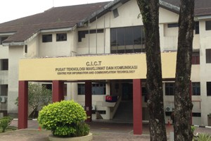

Basically, CICT is located at Block D07, Lingkaran Ilmu, Universiti Teknologi Malaysia (UTM). Their organization structure generally led by the director which is PM. Dr. Mohd Shahizan Othman, and assist by many departments which is Application Development Management (ADM), Corporate Management (CM), Infrastructure and Operation Management (IOM), Business Development, Strategic Management, and CICT KL. Generally, CICT is responsible for ensuring that staffs and students have access to teaching, learning, and research ICT resources by providing the university’s IT infrastructure, acquiring, developing and supporting new and emerging technologies and systems as well as providing access to digital resources across the University's campuses. There are many objective of CICT which are to increase the adoption of Information Technology in all university activities, to provide guaranteed ICT infrastructure and facilities, to become a reference center in ICT services in the university, to become the center of software and application development in the university, to explore new technologies in ICT services and implementation, and to increase ICT competencies of the university’s community. Basically, their main function is as a support unit that offers and delivers ICT services for the university (staffs and students) especially in ICT infrastructure, system development and academic/administrative activities.
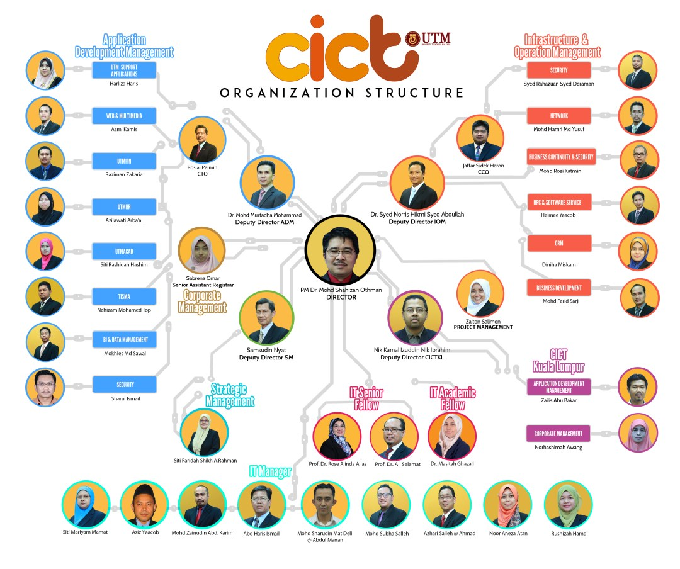
There are a lot of facilities provided by CICT for student use such as computers that operate in many different Operating System. There are Windows Platform, Mac OS, Thin Client (LINUX) and the amount is 382, 52, 20 computers respectively. The other facilities are Project Discussion Area, printing, scanning, CD/DVD burning, binding, laminating, and Specialize Multimedia & Content Authoring Production Lab (SMAL). There are various kind of software available in SMAL for student use including Final Cut Pro, DVD Studio Pro, Sound Track Pro, Color, Aperture, Motion, iWork, iLife, Adobe Suite, Roxio Toast and SDK. There are also whisper room, mixer, DVD printer and Lighting & Chroma Key.
Next, the fundamental for today generation which is wireless/UTM Wi-Fi zone. This is also one of the service provided by CICT. It is a really important service as everyone in UTM need to have the access to the Internet to complete the assignment, access the coursework and communicate with each other. UTM students are very lucky because this Wi-Fi service provided had covered the whole UTM, thus everyone can gain the access to the Internet. It is really handful for students because they can save up their money for something else instead of buying mobile data on their own. However, the quota for Internet usage per user (based on UTM ID) is limited to a maximum of 5GB per month per device (computer, laptop, smart phone, etc) and is up to 4 devices which is 20GB per month.
Other than that, CICT also provided Academic Computing ID (ACID) which is a unique User ID for UTM community to login to most of University main application system. Next, we have Virtual Private Networking (VPN) for accessing intranet services such as UTMOnline, software repository and databases from UTM library. After that, CICT also established a portal named E-Learning. It is an educational portal that assist students and lecturers in the teaching and learning process to be more effective and flexible. Students also have been provided with MyLine which stands for Online Resource for Learning in English. It is a self-access learning resource developed specifically for students at tertiary level to enhance their English language communication skills. The self-access mode of learning allows students flexibility in managing their own leaning within their busy schedule. There are also a few more services covered by CICT for UTM students such as E-PPP, E-Portfolio, Massively Open Online Courses (MOOC), Open CourseWare (OCW), Edutainment, UTM-MIT Blossoms, UTMotion and UTMShare.

