

SCHOOL OF COMPUTING,

FACULTY OF ENGINEERING,
UNIVERSITI TEKNOLOGI MALAYSIA,
81310 UTM JOHOR BAHRU, JOHOR.

GROUP 6: NEW ACADEMIA LEARNING INNOVATION (NALI 2018)

NAME OF GROUP MEMBERS | - SHAHED ISLAM SHOVON  - NUR ADILA FARAHIYAH BINTI AZMAN  - NURUL HUDA BINTI SHAIJI  - MUHAMMAD AIMAN HAKIM BIN AHMAD RIDZO  - MUHAMMAD DANIAL BIN JEFRI
LECTURER | DR. AZURAH BINTI ABDUL SAMAH
DATE OF  SUBMISSION | 7TH OCTOBER 2018

TABLE OF CONTENT

PAGE | TABLE OF CONTENT
1 | Front page
2 | Table of Content
3 | Introduction
4 - 5 | The Use of Video Recording via Telegram Application as an Effective Tool to Improve Oral Presentation skills
6 - 7 | Using Toy Bricks as an Innovative Teaching Technique In Operation Management
8 – 10 | Monsoonsim Business Simulation: Enhancing LearningThrough Gamification
11 | Conclusion

INTRODUCTION

On 26 September 2018, at 12 in the noon, Group 6 had a visit at an exhibition which is called New Academia Learning Innovation (NALI2018) at Dewan Sri Iskandar, Universiti Teknologi Malaysia. The purpose of our visit is to explore more regarding on, how can we improve the process of learning with the usage of technology.
The first visit, Group 6 went to the booth “The Use of Video Recording Via Telegram Application as Effective Tool to Improve Oral Presentation Skills”. The telegram is one of the popular communication apps, and it could be used to improve one of the important soft skills which is communication, that is necessary to get a job.
Next, Group 6 went to the second booth, which is “Using Toy Bricks as Innovative Teaching in Operation Managements”. Before the usage of Toy bricks, the student usually would get average results. Since the usage of toy bricks, there has been increment number of student that achieved excellent result.
Last but not least, booth with the title “Monsoonsim Business Simulation: Enhancing Learning Through Gamification”. This booth was interesting since their learning process in business is through gaming. People usually have interest in gaming and some players could learn at least a few things through games.

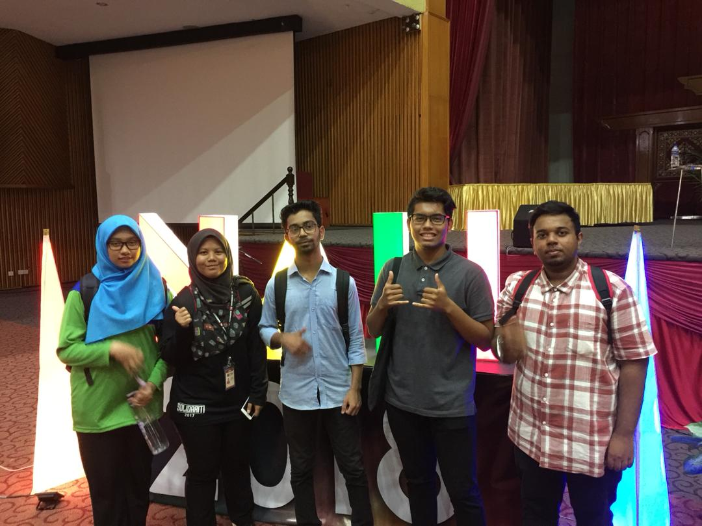

The Use of Video Recording via Telegram Application as an Effective Tool to Improve Oral Presentation skills

Nowadays, in this world of information at your fingertips, things have become a lot easier for people to do things. Therefore, the use of social media such as Telegram is one of the medium that make things easier for people. In connection, Telegram can be used as an effective tool for students and also other people to improve oral presentation. Our group has interviewed the presenter of this project at booth 13. This project shows us how to use Telegram application as a medium to improve ourselves in oral presentation. (instant learning time), synchronizes learning, learning is done outside of the classroom, collaborative learning and flexibility learning.
The objectives of this project are to enable self-observation via Telegram application to improve student’s oral presentation skill, provide practice of oral presentation frequently and demonstrate the ability to engage in every learning activity.
There’s a lot of creativity of this project such as mobile learning because of using of devices, can learn anywhere and anytime (instant learning time), synchronizes learning, learning is done outside of the classroom, collaborative learning and flexibility learning.

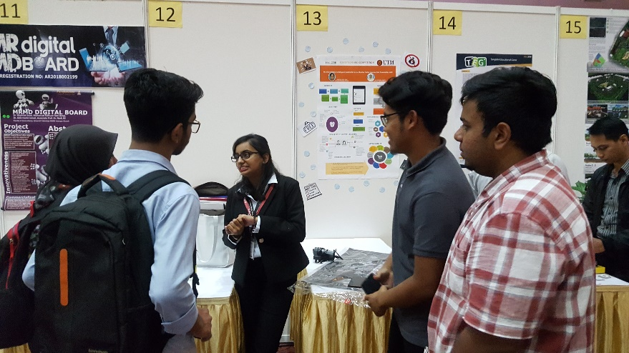

In conclusion, from what we observed about the project during exhibition, we can say that this project is quite impressive and can be more recognizable among students and also other people. This is one of the simplest and cheaper ways for everybody to improve themselves in oral presentation skills. Why use a more complicated and expensive ways when you can choose a better one. So, this project should be introduced more in future.

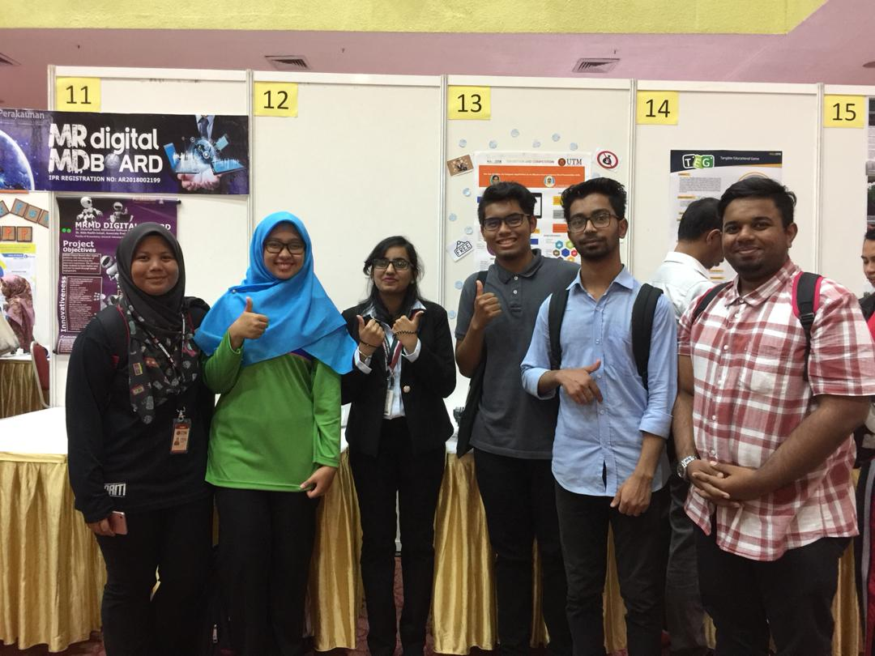

USING TOY BRICKS AS AN INNOVATIVE TEACHING TECHNIQUE IN OPERATIONS MANAGEMENT

This is an innovative of the technique of teaching an Operations Management course using toy bricks simulation game. This course (Operations Management) is typically delivered through lectures, discussions, videos and case studies. The toy bricks simulation game was introduced in class to simulate a production scenario. In order to get some feedback on the effectiveness of this technique, the survey has been conducted in investigating the students’ perspectives. Findings from the survey show that the majority of the students agreed that this technique increases their interest and understanding of the subject. It is as valuable tool in learning Operations Management course and should be incorporated into the future business curriculum.
These ideas came out because of problems that they had. Among the problems faced by them is such Operations Management is compulsory for business studies. That means students must find solution to pass this subject, though it is quite difficult. After that, typical learning involves team working, group discussion and leadership. So, with this technique of teaching all the modules can lead students to proficient the tasks. Lastly, students fail to capture reflection-in-action and reflection-on-action if they still with the old one technique of teaching. Then, innovative teaching using toy bricks is a solution for those problems. For example, students must work together with their teammates to finish up the project of toy bricks. From that, they can learn how to involve in team working and leadership. Other than that, they must think further to complete their task. Toy bricks are not an easy game because of their tiny parts of bricks. So to settle it students must think wisely. Then the output are students know what is the reflection that they can get from the toy bricks either in or on action.

Table below show what the impacts and benefits from this technique of teaching:
Impact | Benefit
- Promotes change in educational practice by applying theoretical knowledge through ‘reflection-on-action’ and ‘reflection-in-action’ in the task given. | - Better integration of operation.
- Illuminates the students’ thinking and reflection on knowledge they acquired in class | - Skills transferred:  - Procurement and material movement in warehouse.  - Produce MRP report Quality Check.  - Product Bill.  - Inventory Management Porduct Tree.
- Embraces the process of learning and valuing among students and instructor. | - Skills tranfered:  - Teamworking  - Decision making.

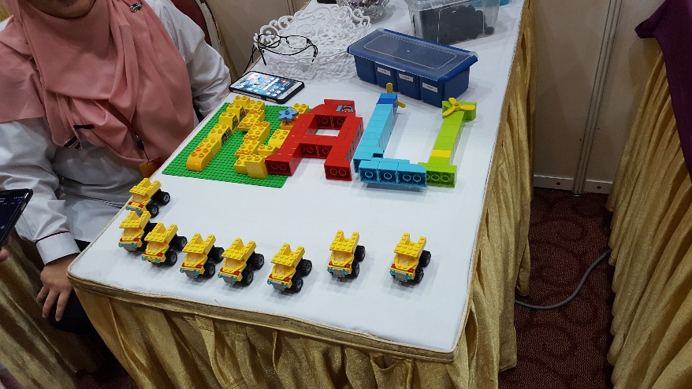

MONSOONSIM BUSINESS SIMULATION: ENHANCING LEARNING THROUGH GAMIFICATION

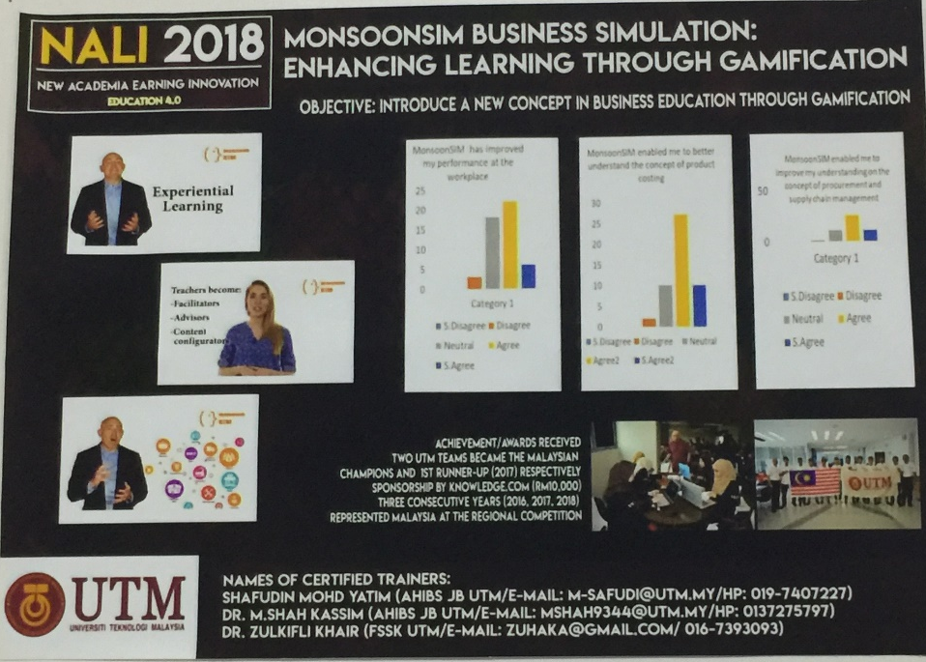

The Monsoonsim simulation project was explained to us by Dr. Zulkifli Khair. Monsoonsim is a business simulation that is played / run in a form of a game. The objective of the game is to decisively make an effective and efficient decision based on the given situation or scenario. Monsoonsim simulation was created by Monsoon Academy and this application is the only application in Malaysia to be recognized by SAP, “System, Application and Product”, which is a German-based software development company.

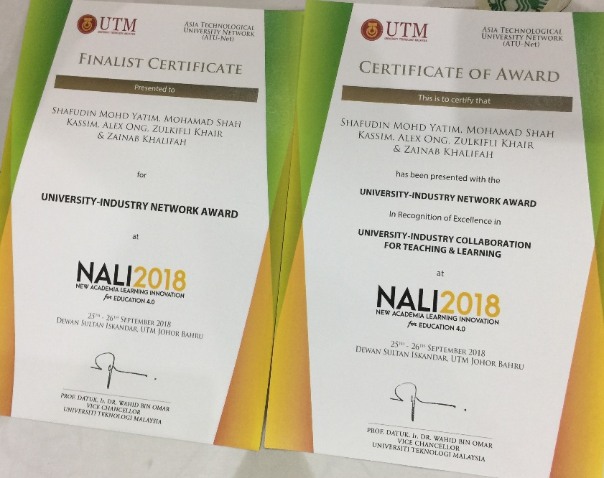
UTM student, better known as “Budak Getah”, has been representing Malaysia in region level for 3 years and manage to earn first place in one of the competition. One of the benefits of using this simulation is that it teaches the player important knowledge regarding business from a different aspect or sector. For example, in this simulation, you will be playing as different staff from different sectors, e.g. finance, human resource and marketing. Therefore, you will get hands on experience being in that specific sector as well as see how and what decision each sector have to make. In addition, having a Monsoonsim certification can improve your resume and increase your likelihood of getting hired. This is because this certification shows and confirms that you have the knowledge and business skills to make effective decisions.

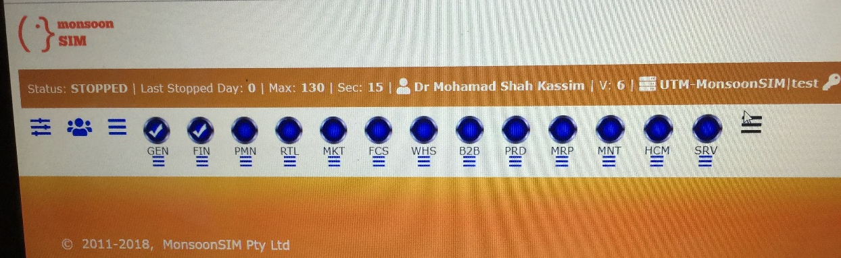

The game is played in a group. You are given an initial capital and usually 3 products to sell in different countries and you will win the game if you earn the highest profit, beside of certain specific criteria. During the simulation, the player must learn to adapt their decision based different situation, for example price may fluctuate due to the holiday season or increase in demand. Furthermore, you will learn how different type of business can have an impact on your income. For example, you can earn a lot of income from doing “B2B” rather than small retail business. Each member of the group is assigned to a specific sector like financial, maintenance or human resource to effective decision.
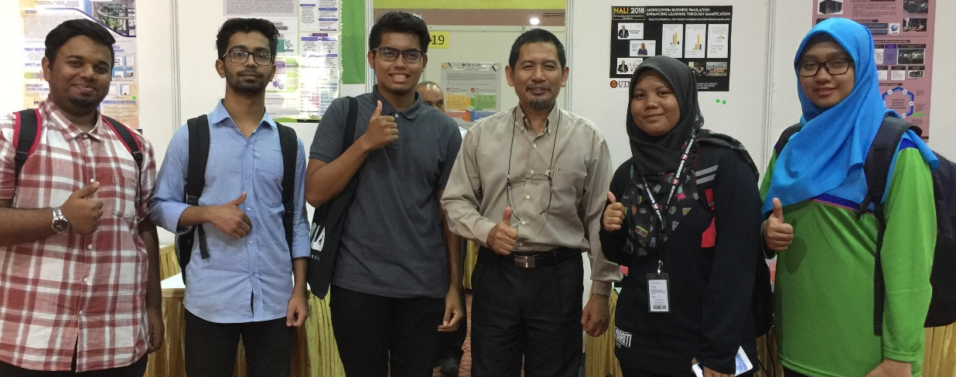

The Monsoonsim application is not only for business student but rather for anybody who wants to learn in more details regarding how a business is operate and manage. If you want to open a business but have little knowledge and experience in this sector, the simulation will teach you and show real life issues that may occur when running a business. For example, most businesses will have employee and sometime, an employee may be absent, whether due to sickness or abruptly quitting the job. You as the player must make the right decision based on this situation to continue operating without it affecting the productivity of the business.

CONCLUSION

However, it goes without saying that ,this sort of new innovative programs are really give the creative shaking on the mind of students or some those who are actually wants something to change on their surroundings .In NALI there had lots of new important and creative projects but we select three project as asked though it was tough decision to select only three among those huge interesting context these are “Telegram application, Toy Bricks and Monsoonsim Business Simulation” in shortly.In accordingly ‘Telegram application’ it can be part of growing educational skill or prestation skill for anyone. By the uses of ‘Toy bricks’ get to develop their thinking skill and swiftly taking decision skill and finally ‘Monosoonsim Simulation Business’ it is an amazing totally recent innovation to do for learning operate business and earning money through on kind a game. Though every new project has some initial limitations without that all projects of “NALI” undoubtedly be the part of next creative, inventive and efficient world.

