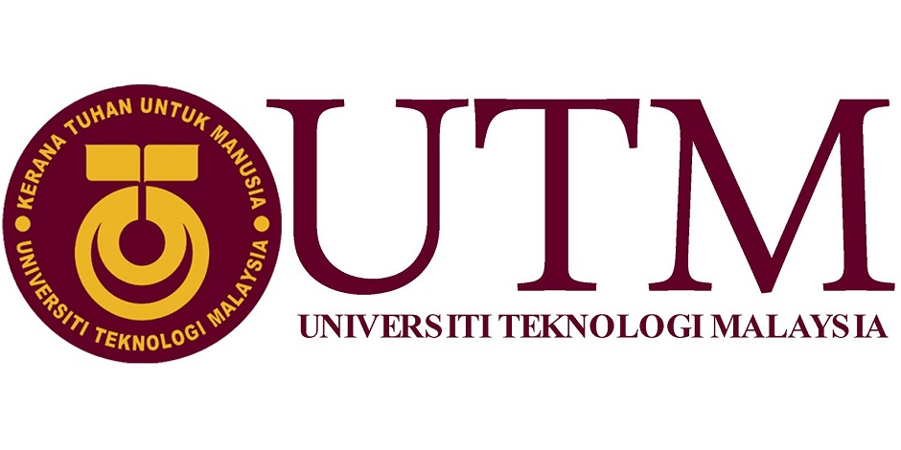

SCHOOL OF COMPUTING,

FACULTY OF ENGINEERING,
UNIVERSITI TEKNOLOGI MALAYSIA,
81310 UTM JOHOR BAHRU, JOHOR.
GROUP 6: INDUSTRY VISIT:CENTRAL FOR INFORMATION AND COMMUNICATION TECHNOLOGY(CICT)

NAME OF GROUP MEMBERS | - SHAHED ISLAM SHOVON  - NUR ADILA FARAHIYAH BINTI AZMAN  - NURUL HUDA BINTI SHAIJI  - MUHAMMAD AIMAN HAKIM BIN AHMAD RIDZO  - MUHAMMAD DANIAL BIN JEFRI
LECTURER | DR. AZURAH BINTI ABDUL SAMAH
DATE OF  SUBMISSION | 14TH OCTOBER 2018

PAGE | TABLE OF CONTENT
1 | Front page
2 | Table of Content
3 - 4 | Abstract and Introduction
5 - 8 | Central For Information and Communication (CICT)
9 - 10 | Student’s Lab  - Specialized Multimedia & Content Authoring Production Lab
11 - 15 | CICT Gallerium  - Mainframe Computer Gallery
16 | Reflection Regarding On Our Visit To CICT
17 | Summary

ABSTRACT

The main purpose of this industry visit to Computing Information Center Technology (CICT) is to study the background of the center, services provided, IT infrastructure and job opportunity (criteria and requirements needed).

INTRODUCTION

On 1st October 2018, all School of computing students who enrolled in Technology Information System had visited CICT for industrial visit. The program started at 13.50p.m and ended at 16.00p.m. All students were asked to wait at the seminar hall at level 4 of N28a before the event started. The event starts with a talk given by Mr Mohd Zahari Bin Abidin. Mr Mohd Zahari is a CRM officer and he was stationed at master desk at level 1 of CICT. He talked about organization of CICT, all services that they provided to all students and staffs of UTM, explained about the function of every level of the CICT block building and also some tips about information technology and job opportunity at the center.

Before we go deeper into what’s the function of CICT, first of all we need to know what is Information and Communication Technology (ICT). ICT means the technologies that provide access to information through telecommunications. It focuses mainly on communication technologies. This includes the Internet, mobile phones, wireless networks and other communication mediums. ICT could relate to many fields because of its ability to connect to everything. One of the fields is education. ICT plays one of the biggest roles in education field because it is very useful to students, teachers and staffs to be connected with each other.
So, in connection with CICT at our Universiti Teknologi Malaysia (UTM) campus, the center provides all matters connected with ICT. The center was established in the year of1975. It was named as Computer Centre at first but then at the year of 1981, it was combined with Computer Science department to established science computer department under the department of science. The center was then upgraded again in the year of 1984 to be Science Computer Institute. Later on, at year of 2004, computer institute was changed into Technology and Communication center. At last, recently, the Computer Center was then changed Computing Information Centre Technology, CICT in 2016.

Lately, CICT has increased its function but it first started with act as a system to process workers salary with the use of equipment and mainframe such as IBM 390 in the year of 1975. Now the services provided by CICT varies to all everything connected with Internet, infrastructure and security such as ICT security and high performance computing, application development such as system development and mobile apps, ICT support, web management and so many more.

After the talk given by Mr Mohd Zahari has ended, all of the students were showed around the CICT building by him. First we went to the PPICIP or best called as student’s lab near level 2 of CICT. The space and PC provided can be used up to one hundred students at the same time. Sometimes the lab also been used as a place for the lecturer to do online test. And then, after we have finished exploring the lab we went to our last destination which is CICT galleria. We could see a lot of antique devices that was used before modern time nowadays. We could see the evolution of older computer version until the latest version and for sure we could also see a variety of mainframe (IBM)

CENTRAL FOR INFORMATION AND COMMUNICATION TECHNOLOGY (CICT)

Report contents: Introduction, Details of Journey/Work Plan, Detailed Descriptions include organization structure, services, achievements, information systems that have been developed and maintained by CICT etc.

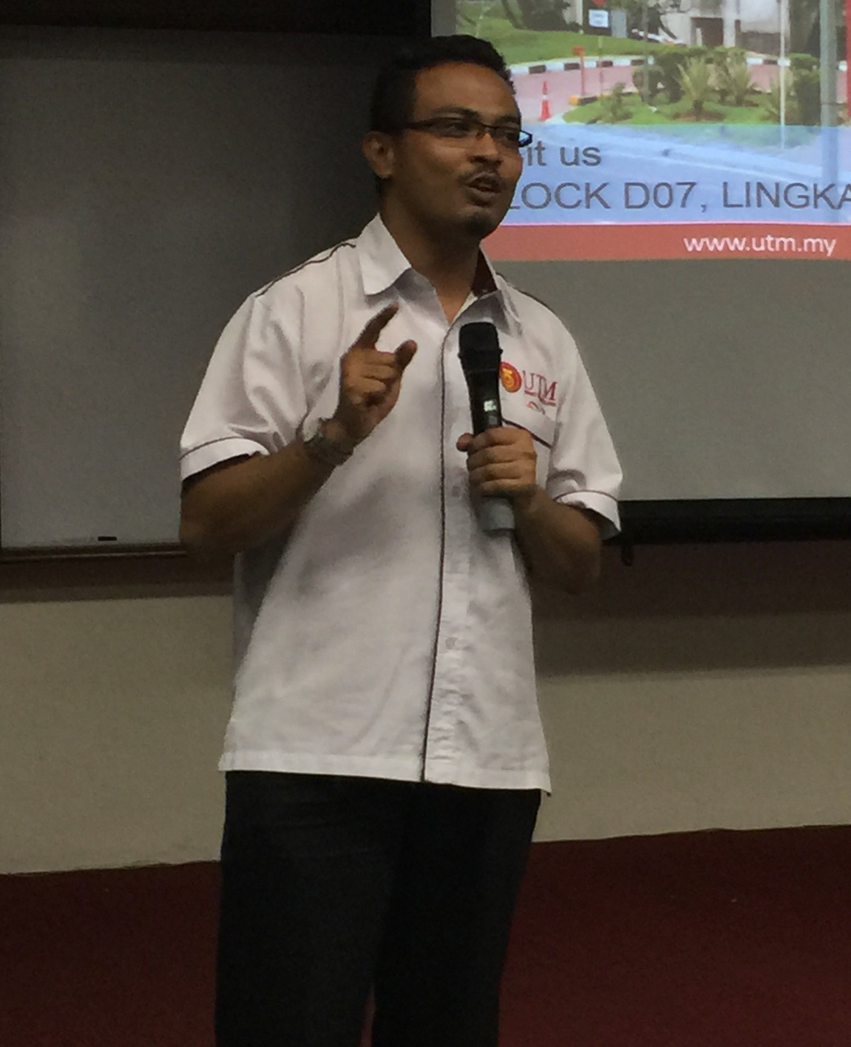

On 1/10/2018, we were invited to a talk regarding Centre for Information and Communication Technology (CICT). The talk was held at the seminar hall inside CICT building itself. The industrial talk was carried out by Mr. Mohammad Zahari Bin Zainal Abidi and he is the CRM Office for CICT.

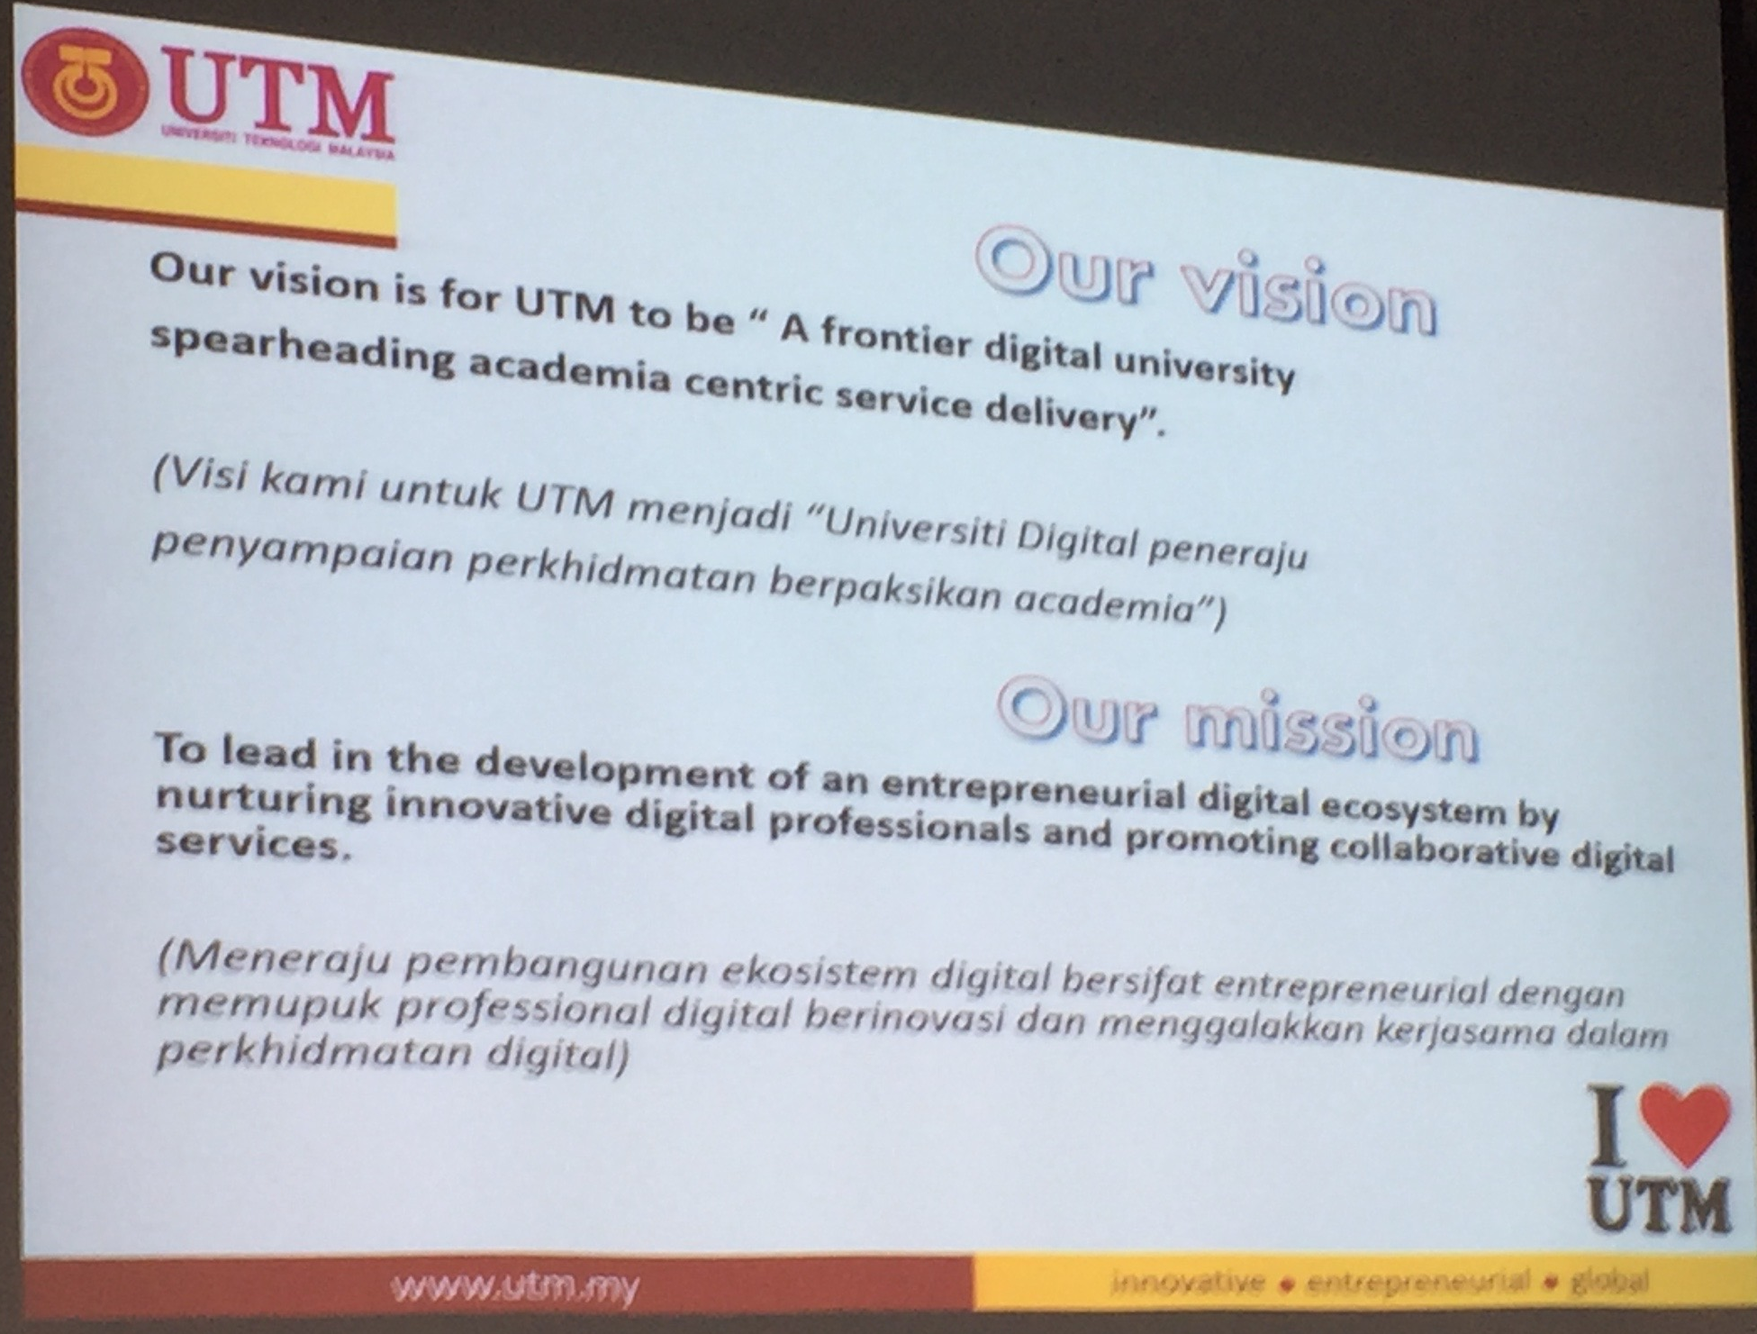

CICT is a ‘support unit’ with the sole purpose to provide and deliver ICT support and/or services for UTM staffs and students. Although CICT provides different services, they mainly focuses on provide support regarding the ICT infrastructure, system development and academic/administrative activies. Their vision and mission for UTM is “A frontier digital university spearheading academia centric service delivery” and “To leadin the development of an entrepreneurial digital ecosystem by nurturing innovative digital professionals and promoting collaborative digital services”.

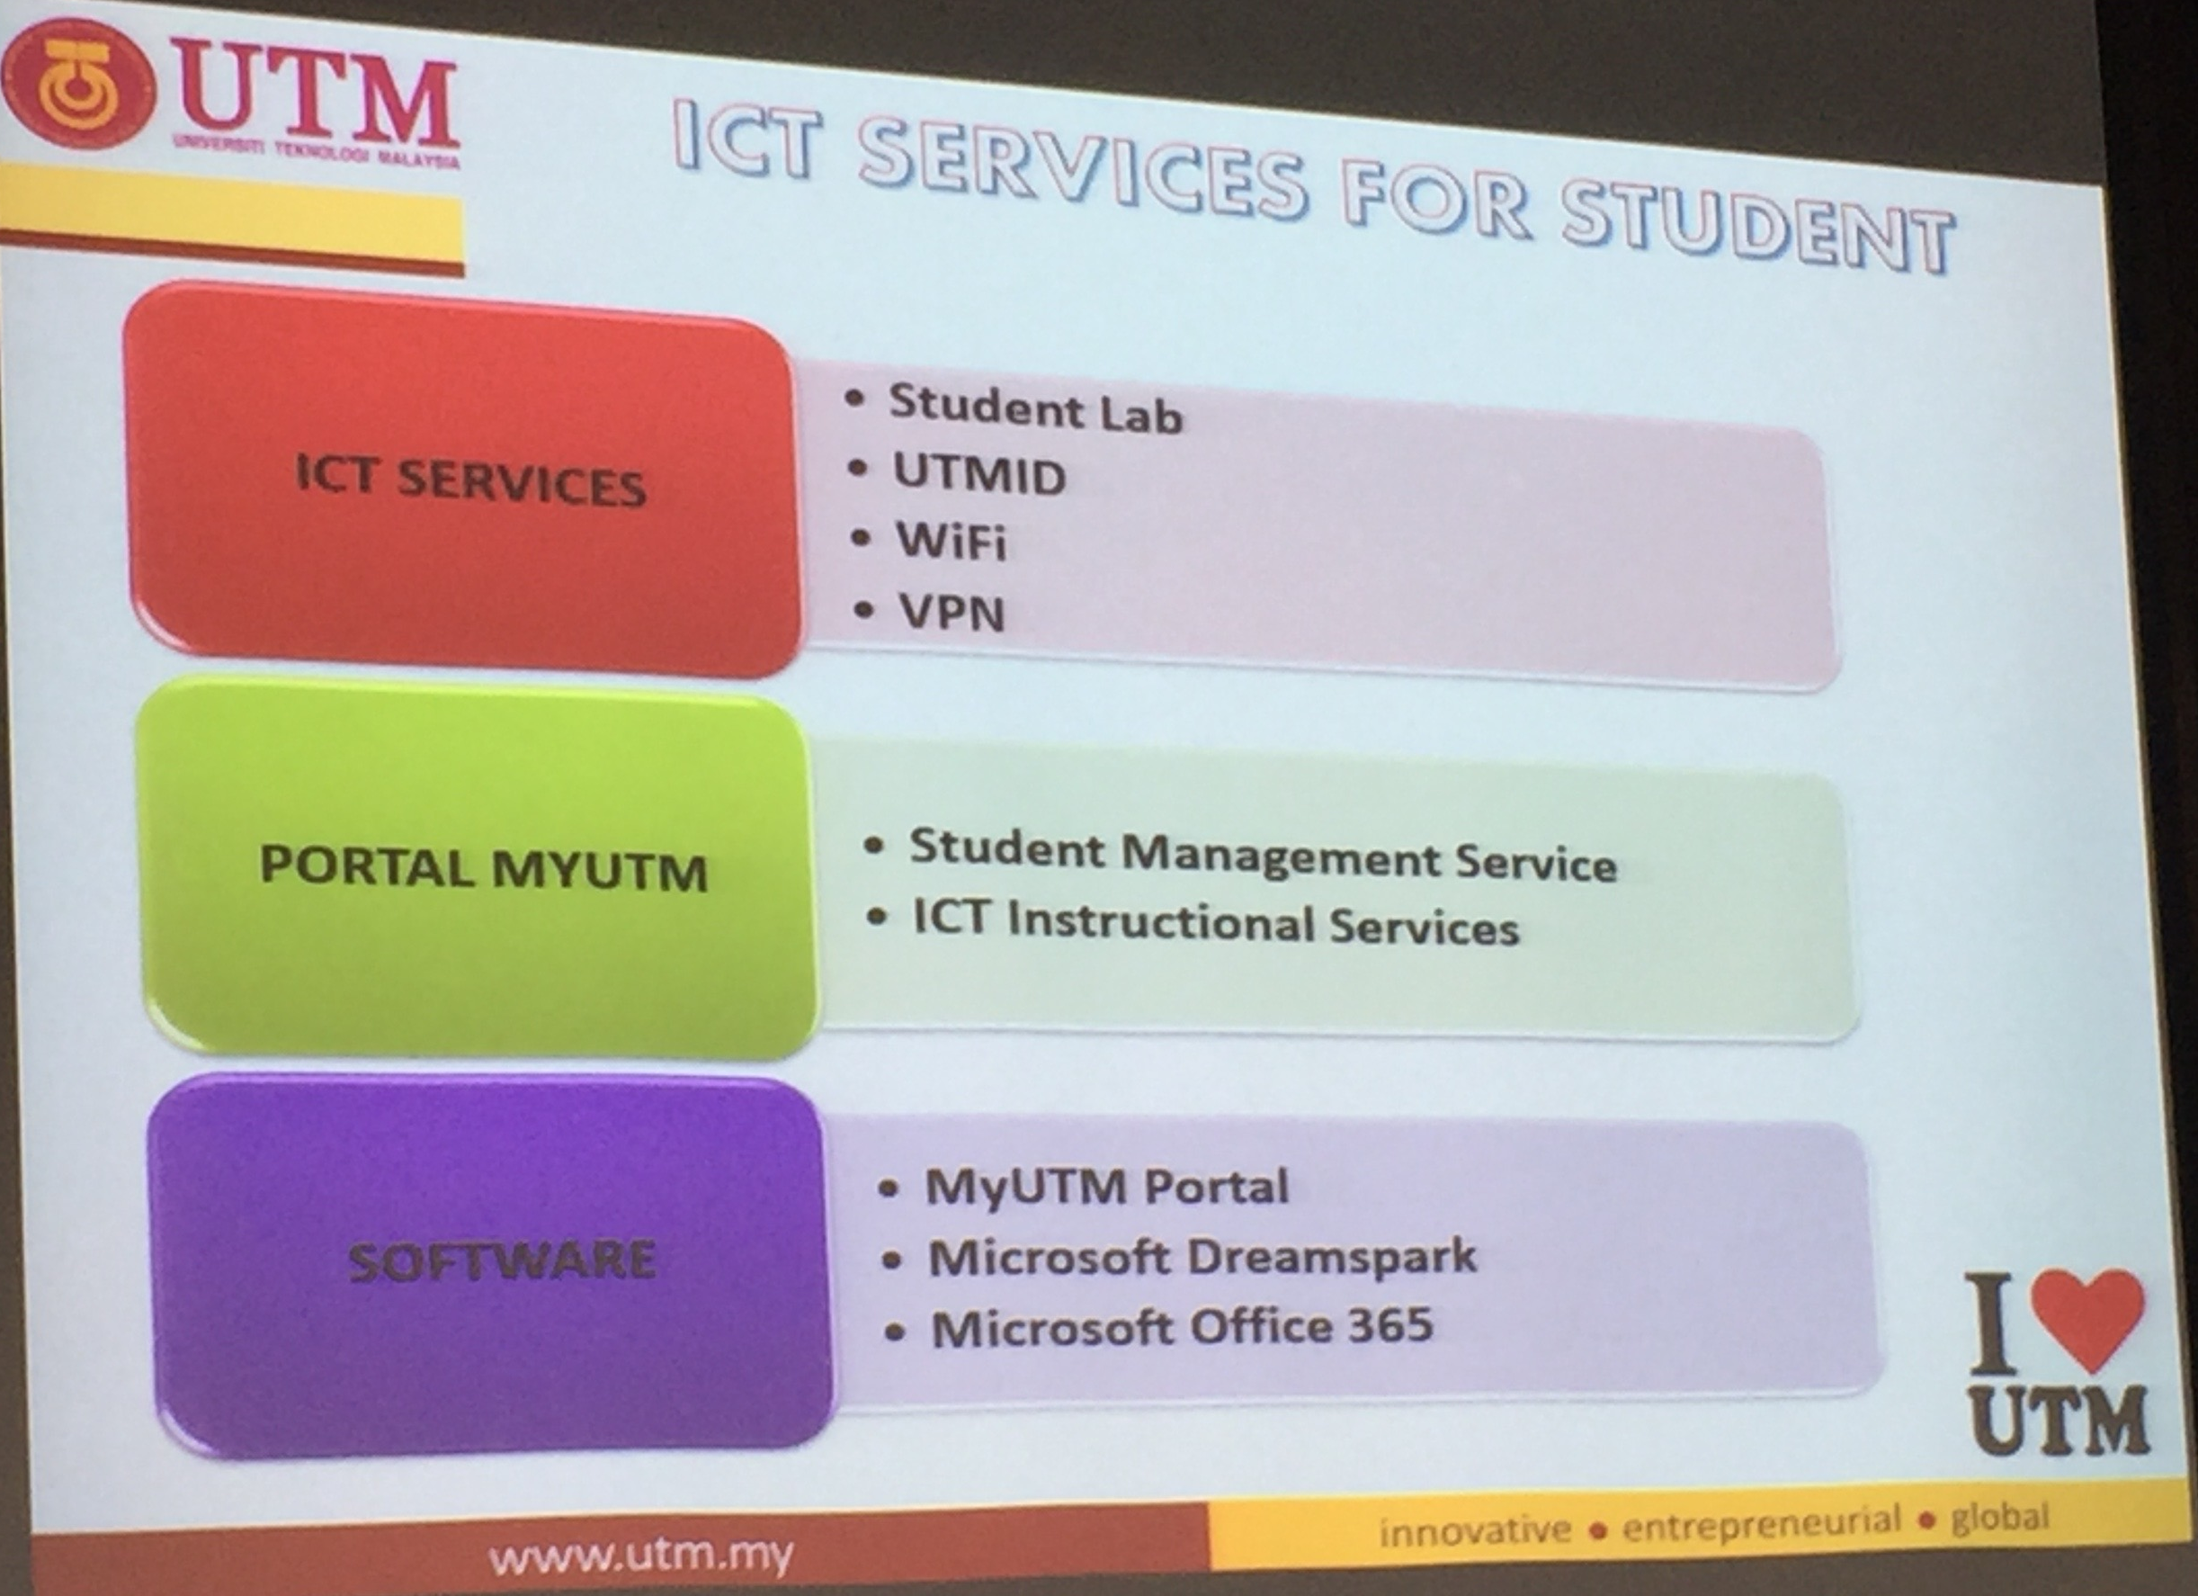

In terms of providing support and/or services, CICT is dividend into two section, level 1 and level 3. When a staff or student has a IT problem, they must first go to Level 3. If Level 3 is unable to solve the issue, only then will they ask the individual to process to level 1 (Master Desk). Within these two levels, CICT provide three main services: ICT services, Portal MyUTM and Software. ICT services cover issues relating to student lab, UTMID, Wifi and VPN. Portal MyUTM covers Student Management service and ICT Instructional service. Lastly, Software relates to MyUTM portal and other softwares that are provided by UTM to every students.

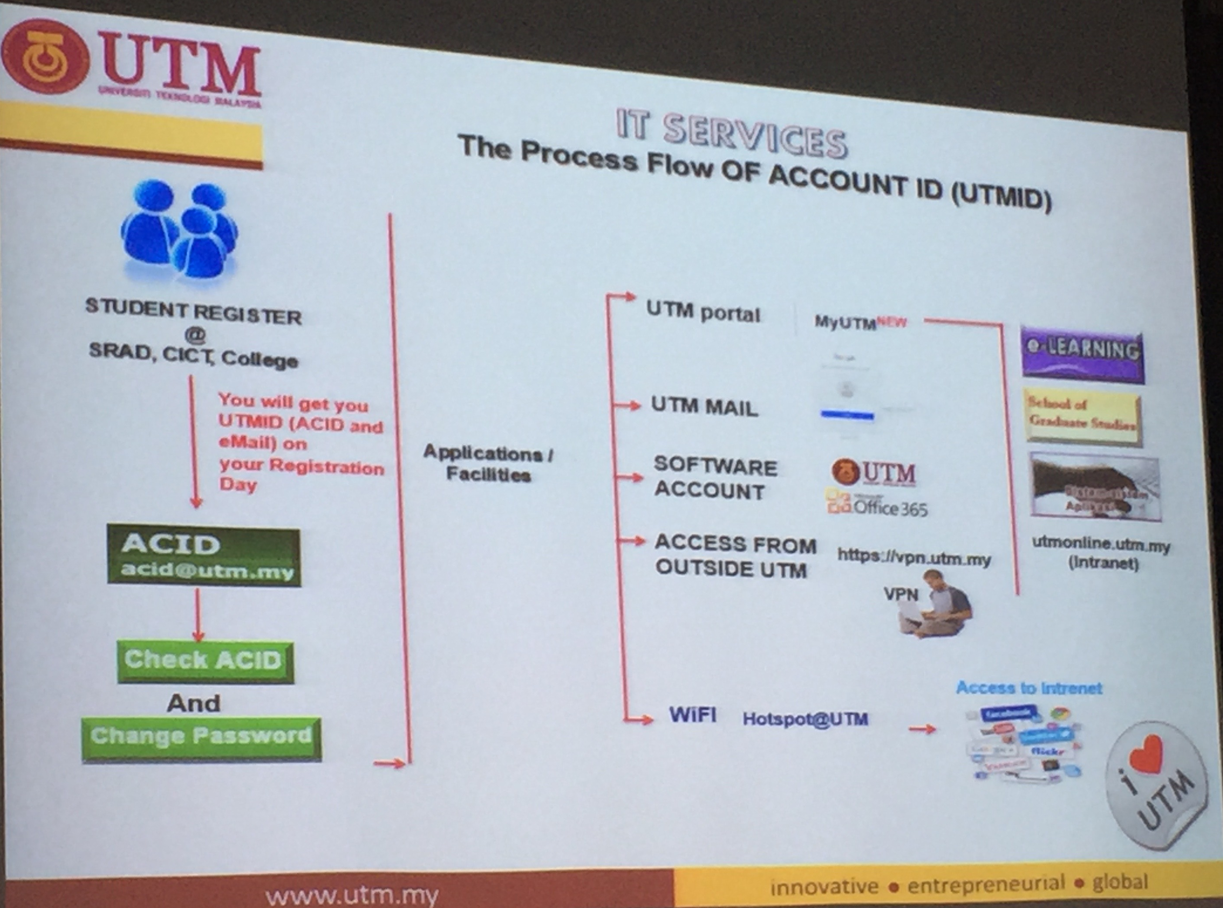

As stated before, one of the system that is provided by CICT is MyUTM portal. MyUTM portal is a website that enables students and staffs to collect and/or share information regarding the academic or other activities for example gathering resource used in class from E-learning or adding activities carried out by the student in Activity list.

The MyUTM portal uses SSO technology, which stands for ‘Single Sign On’. This means that students only needs to enter their userID and unique password once for different system. Within MyUTM portal, there exist different type of virtual server which enable the users to enter into different system
from one location and example of these system are E-Learning, Hostel and Mswipe.

However, the one drawback of MyUTM portal is that, even though it has SSO, it does not have the ability to automatically sign you out of all the system that you enter. Therefore, user must manually log out of all the system that they have enter/open.

Other function that CICT provide to UTM staffs and students is Intranet system. For any individual that wish to access their MyUTM portal from outside of UTM, they have the ability to do so with VPN. All the users have to do is login into vpn.utm.my with their userID and password, then they will be able to access UTM intranet.

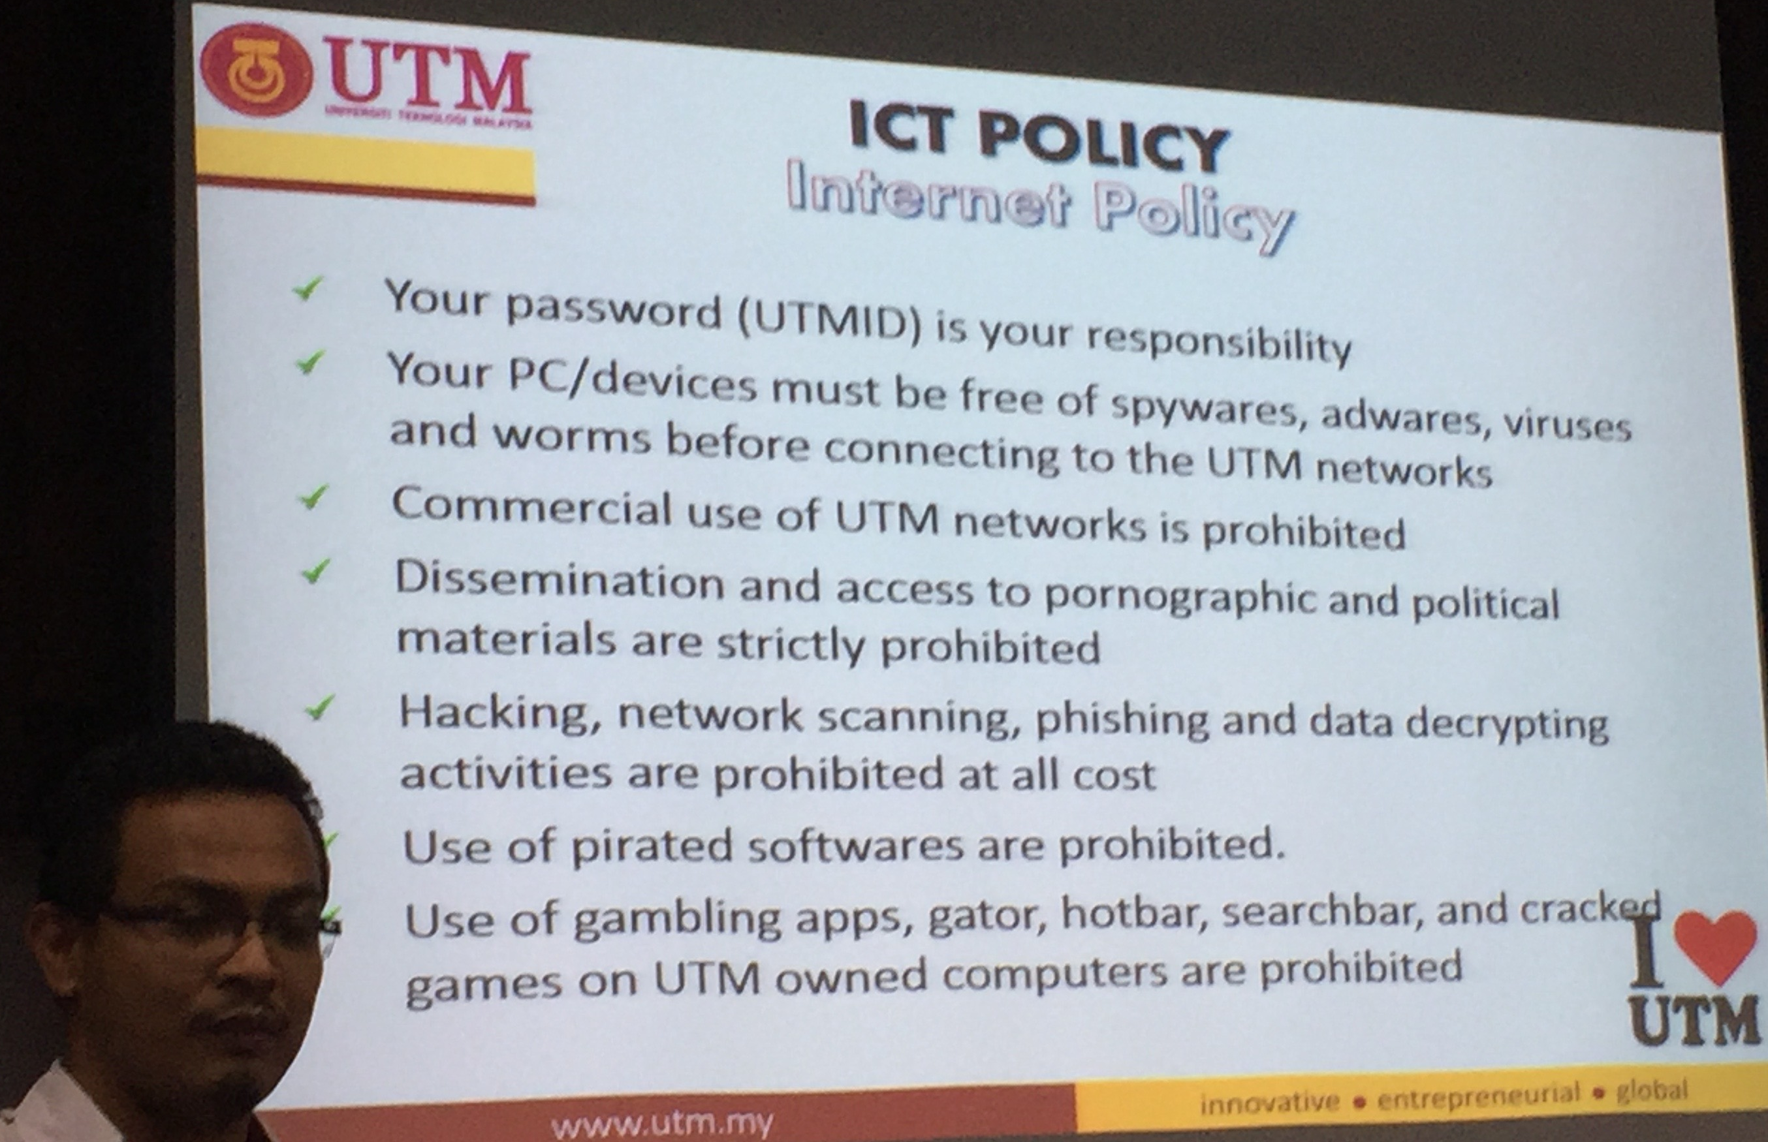

CICT has a very strict rules and policies that every UTM students must follow. One of the most important policy is that every student must has their matric card visible at all time when they are inside CICT buidling. If not, CICT staff has the right to fine the student RM30. Furthermore, all computers that are connected to UTM system must be free of viruses and other malicious items that can post a potential threat to their system. UTM does have the right to retract the user’s right and ban him/her from use their wifi and system. Lastly, any illegal activities like pirating, hacking, phishing and other activities are prohibited and would get you in trouble if caught doing. All students must have these policies in order to use CICT services.

STUDENT’S LAB

Student’s lab is one of the service that is offered by CICT to student of Universiti Teknologi Malaysia. It is located at level 3, in the CICT’s building.

At the Student Lab, there are 100 computers for students to use in accomplishing their assignment and other computing activities. There are also printing, scanning and CD/DVD burning facilities which are very much helping student’s life since they do not have to go far to find these facilities.

Next, CICT also provide some private place for students to have discussion. There are 3 separates area. Students can use this area after signing up their name at the front desk of PPICTP.

- Specialize Multimedia & Content Authoring Production Lab (SMAL)

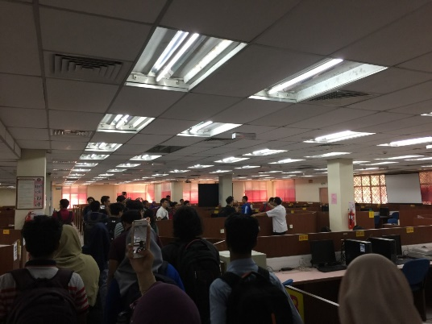
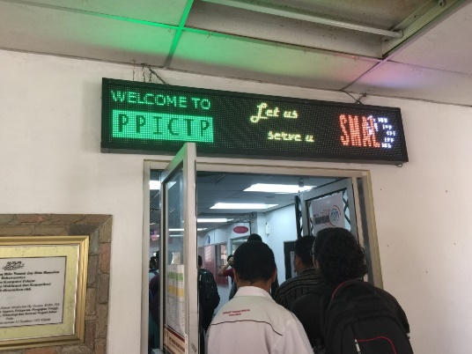

Specialize Multimedia & Content Authoring Production Lab (SMAL) is facility that is specialized for students especially who take multimedia course. Multimedia assignment generally required them to have some special software to complete it. Since the only place that provide these special software is SMAL, multimedia students now can go to CICT to complete their assignment. Not only multimedia students, this software also available to all UTM students if they have project that required this special software.

Not to forget that SMAL also provide some facilities like lighting and chroma key, whisper room and mixer.

CICT has strict policy that every student much abides to. Students need to wear matric cards when they are inside the CICT’s buildings since it is compulsory when using CICT’s facilities. Students will be fine as much as RM 30 if students are fail to abide the rules. Next, UTM Dress Code is strictly observed. Hence, the students need to wear proper dress. If the students wore an improper dress such as mini skirt, tight mini shirt, slippers, students will be fined as well.

CICT Gallerium

At the Johor Bahru Campus of UTM (Universiti Teknologi Malaysia), the CICT (Center for Information & Communication Technology) launched an Information Technology Galleria in 25 October, 2015. The Deputy Vice-Chancellor, Prof. Dr. Azlan Abdul Rahman officially opened the Galleria in coexistence with CICT’s Open Day 2015.

We visited the CICT Gallerium where we got a chance to see the revolution of computers from the past time until now. There we saw the collection such as Mainframe Terminal, Controller, Mainframe Data Storage, Magnetic Tape Unit, IBM Tape Control Unit and so on. It is very crucial for us to know about the early computer equipment used by UTM. From that we can create more understanding and awareness, especially among the younger generation on the initial equipment that was used to carry out administration work on campus. All components in computer developed into smaller pieces with reasonable prices. We were allowed to take picture of the things displayed.

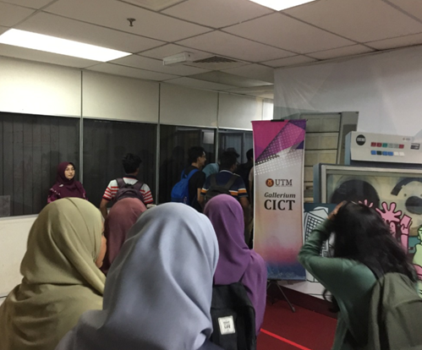
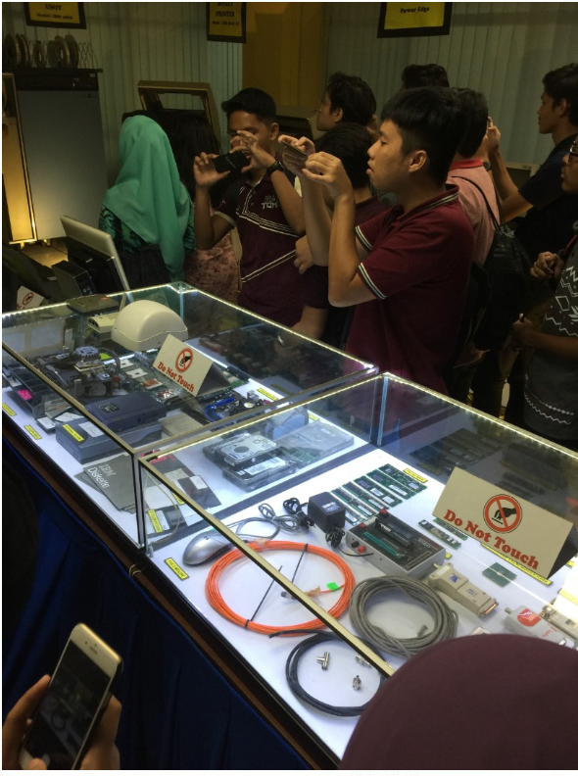

- Mainframe Computer Gallery
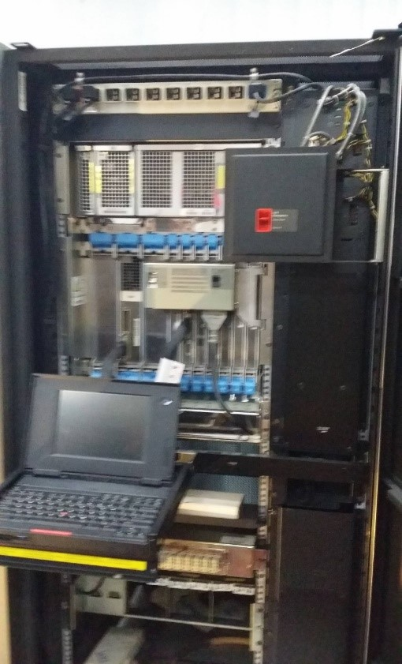

In the mainframe computer gallery, some of the IBM mainframe computer include its component was exhibited. This include mainframe CPU, Desktop computer 286, Laptop Pentium, IBM diskette, IBM Controller (Model: IBM 3274 41D), mainframe terminal (Model: IBM3471 Info Window), IBM Data Storage, IBM Tape Drive System, IBM Magnetic Tape Unit, IBM Control Unit, IBM printer, Rack Server and Tower Server.

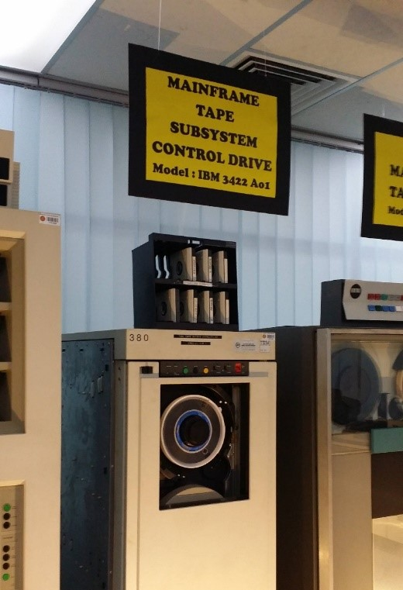

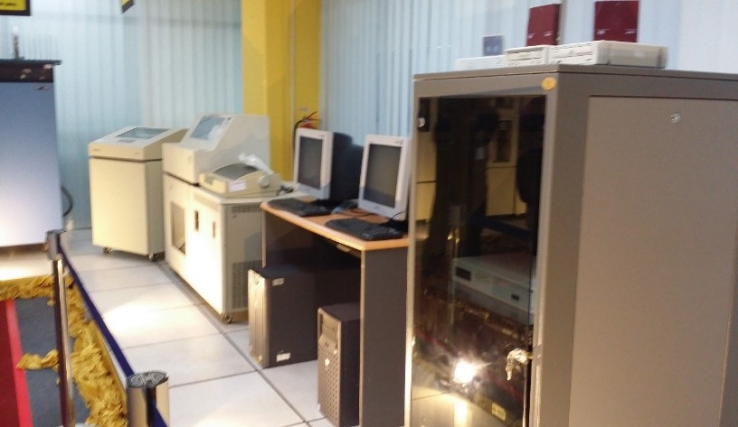

The exhibition allowed participants to observe the hardware which play important role in the Information System. All of the model was obsolete and outdated models. From the observation, all model is hulky and complicated in design with different from the latest technology, tiny and portable. However, the guide explained mainframe CPU able to handle huge data and process with high speed. Mainframe CPU also benefited from backward compatible, which running the old model software. To store huge data and information, IBM Data Storage can prevent overload and sufficient size for computer.

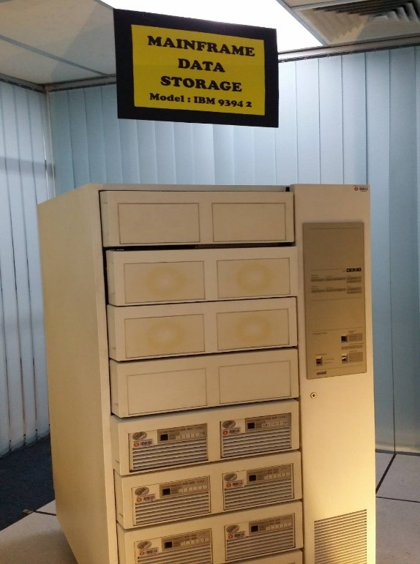

But, the mainframe computer is not been used in the information system of CICT due to its expensive maintenance cost. Besides, Server and Storage method is more relevant in nowadays technology. The other storage hardware include IBM Tape Drive system and Magnetic Tape Unit which is more likely to store audio recording.

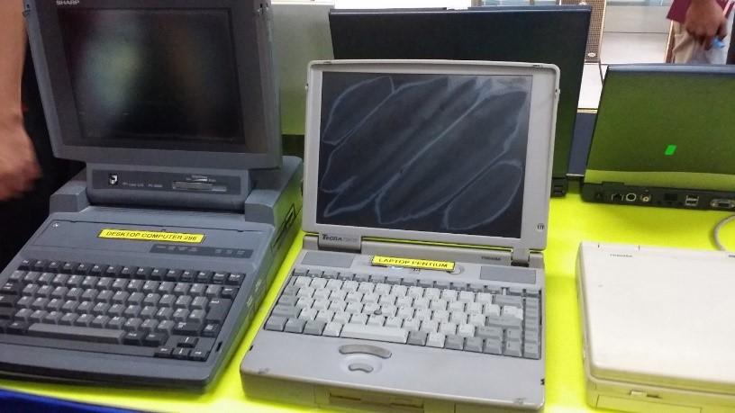

There were also displayed many small gadgets such as old model RAM, variety of cables and motherboards. All components in computer developed into smaller but cheaper. RAM with slow speed as 256 MB but expensive in past compared with 2GM RAM priced in hundred ringgits in nowadays.

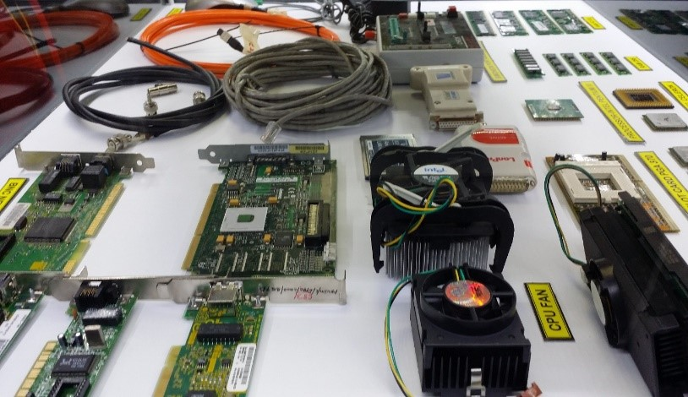

REFLECTION REGARDING ON OUR VISIT TO CICT

So here is our reflections that we got from the industry visit. We hope the CICT can provide fairly accurate service to all staff and students in our course. This is because with good service it will be able to facilitate all who are involved in our field. After we attended the industry visit, we saw a positive impact on our expectations of CICT before. We hear a briefing that tells us everything from history to information on any equipment used in this CICT. So we believe it can provide the best service for everyone in this course up to one university.

In addition, we get some knowledge after joining this industry visit especially UTM students like us. Among the benefits is that we are able to access the internet for free as CICT has provided Wi-Fi services across UTM for all UTM citizens. So we do not have to waste our money to buy internet data.
We are also simplified because CICT also provides services to repair all equipment involving computers such as laptop repairs. We do not have to bother to get out to repair a laptop in the laptop store.

So, our action to improve our potential in this industry is to engage in this field either directly or indirectly. For example, we are taking course of computer science. Indirectly we have our services to learn about the computing system that the industry is currently providing to us. Most likely we will be sent to our practical industry in this manner to get us familiar. Otherwise, we can provide this service in an area that does not exist in this industry anymore. So, we can expand this industry again in the interior to make it easier for the people there.

SUMMARY

CICT is a very important industry in the world today. This is because the world is increasingly advanced and most of the work will be done online. So we know the existence of CICT is to provide services to users in a certain place. Additionally, it can make the platform for people skilled in the Infomation System (IT) and freshgraduate in the field of computing to get jobs. Therefore, if it is a large industry, there should be a lot of infrastructure that plays a role in providing services such as WiFi to users such as UTM Skudai citizens. Infrastructures at CICT are very important and people skilled in handling such tools are indispensable in this indutry. CICT also provides a gallerium where all CICT equipment is displayed to CICT visitors. There are tools from the very beginning of the creation of computer tools to the latest equipment with better function. Each tool shown is accompanied by the description and functions of each tool.

