

SCSP 1513
SECTION 6
TECHNOLOGY AND INFORMATION SYSTEM

Industrial Talk 2-NALI

LECTURER:
DR. NORBAHIAH BINTI HAJI AHMAD

GROUP 1 (TECHNOCRATS):
SEOUL HOSSAIN A18CS4017
RAYHAN SHARIF APON A18CS4010
TIARA AFDELY PUTRI A18CS0332
NUR QAMARINA BINTI TUAH A18CS0200
PUA LEE LING A18CS0234

Table of Contents

Executive Summary ……………………………………………………………………..….1
Introduction ……………………………………………………………………………........2
Content …………………………………………………………………………………..…..3-6
Trends in NALI ……………………………………………………………………………..7
Reflection ………………………………………………………………………………….....7
References ...............................................................................................................................8

- Executive Summary:
New Academia Learning Innovation (NALI) 2018 is a celebration for innovative teaching and learning practices which is held in UTM. We gained a lot of knowledge from three booths that we had visited. We visited ‘Form Six’s Soft Skill Framework’ booth. At this booth, we were told about soft skills application among Form Six students. All of these skills will help the students to build their self-confidence without getting nervous especially when they do presentation in front of audiences. They have been taught by their teachers during schools so that they can apply these skills in the future.
Moreover, we were introduced about ‘Dojoing 21st Century Traits in Classroom. Nowadays, lecturers and students can use a gamification style application during lessons. Students and lecturers must connect to the internet each other so that lecturers can keep tracking students’ performance and behaviour. Besides that, we went to GAIMOOC booth. Students can become focus when they are in the class. Thus, we should know that we live in the era of technology, where most people are tend to depends on gadgets every single time.

- Introduction:
New Academia Learning Innovation (NALI) was introduced in UTM. It is a framework that includes student-centred and blended learning philosophy, multiple learning modes and materials to achieve entrepreneurial academia. This model emphasizes the concept of blended learning. Blended learning combines the active and systematic strategy by using digital teaching materials in class.
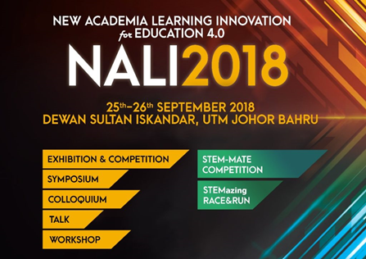
Fig-1(intro.)
Under the New Academia Learning Innovation Model, there are 2 modes namely Learning Mode (Pedagogy/Andragogy) and Learning Materials (Digital Resources).
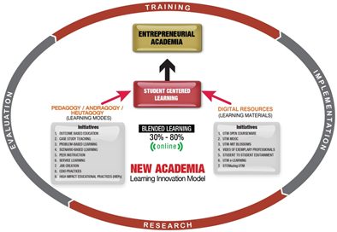
Fig-2(intro)
The exhibition and competition are organized to be a platform for sharing and recognize NALI research and innovation products in teaching and learning. By organizing NALI talk series and workshops, it improves educators’ competency in practicing teaching and learning in the 21st- century. It also improves STEM awareness among educators in practicing NALI.

- Content:

- BOOTH VISIT-01:
During New Academia Learning Innovation (NALI) 2018 organized by the Centre for Teaching and Learning (CTL), UTM at Sultan Iskandar Hall, UTM, we visited booth 16 which was ‘Dojoing’ 21st Century Traits in Classroom. We were introduced to the information about ‘Dojoing’ 21st Century Traits in Classroom by Prof. Dr. Norli Ali.
‘Dojoing’ 21st Century Traits in Classroom is a handbook which provides guidelines for lecturers to apply gamification style application known as Class Dojo in the classroom. Class Dojo enables lecturers to produce real-time feedback on students’ developmental skills as prescribed by 21st-century holistic traits such as social responsibility professionalism, critical thinking, teamwork, communication and interpersonal skills. This application allows lecturers to give positive feedback to students in real time when they perform good effort in a task or activity and it is important to check whether there is a regression in students’ performance or behavior.

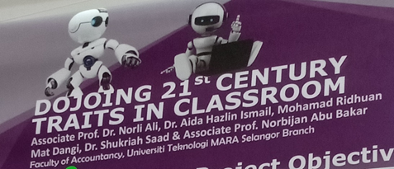
Fig-1.1
The objective of ‘Dojoing’ 21st Century Traits in Classroom is to show the steps that can act as the user manual for Class Dojo.

Furthermore, there is some innovativeness of Class Dojo. For example, Class Dojo enhances the students with the positive and 21st century skills by engaging the 21 days’ theory. It can transform every individual to a positive manner when they do the parallel things for 21 times or 21 days consecutively. By using the handbook, user can set up their class based on the individual student or by group depending on the objective of the classroom setting. Users will be guided to determine the ‘needs work’ point and positive points so that rewarded points can be accumulated for the incentive.
There are also some novelty and creativity of Class Dojo. Educators worldwide can use innovative educational mobile apps in their classroom activities such as Class Dojo. It is based on the real integration of ICGPA in the classroom which has been tested in the examination questions..

- BOOTH VISIT-02:
Other than that, we also visited booth 53 which was ‘GAIMOOC’ Adapting Gamification Approach in Massive Open Online Courses to Improve User Engagement. We were told by Pn. Sarina Sulaiman about GAIMOOC.
Through gamification, users can become focus towards online learning and they will feel fun with this method. One of the benefits of GAIMOOC is to identify the gamification elements that are suitable for Open learning MOOC. For example, we can learn our lessons through Kahoot! Website and it can be more understanding through this website because the design of website is interesting and colourful. Besides that, GAIMOOC want to apply gamification elements in OpenLearning MOOC for increasing the learner’s engagement level. GAIMOOC want to measure the learner’s engagement level towards MOOC by comparing analytics results between MOOC that applied gamification elements and MOOC without implementation of gamification elements.
GAIMOOC has a plan for future use, which is Potential Market GAIMOOC Commercialization for users, especially for students. This is because they want to make GAIMOOC becomes successful and can be used among the students so that they can be more active and excellent in academic and co-curricular.
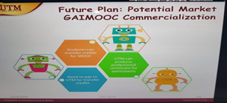
Fig-2.1
In addition, there is some impacts of GAIMOOC for students’ learning. Gamification elements improve students’ engagement toward the course by including game mode in learning method. It makes students feel excited in learning the course and makes learning way becomes fun. More progress of completion was done by the group with gamification elements and students’ social participation increased when gamification elements applied.
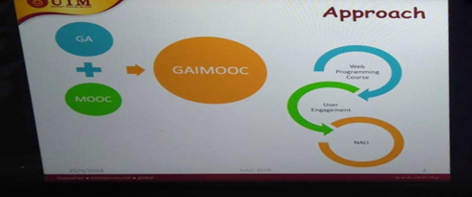
Fig-2.2

- BOOTH VISIT-03:
After visiting two booths, in the end, we visited booth 46 which was Form Six’s Soft Skill Framework. Mazlina bt Mat Isa defined us about the importance, the significance of soft skill and to train up the Form 6 students. If this formula is implemented on Form 6 students, they will be aware of many soft skills which will be a part and parcel of their social life as well as the individual.

- Soft skill:
Soft skill is a sort of skill which makes professional status more valuable and essential. This is the combination of many attributes including people skills, communication skills, social intelligence skills, and emotional intelligence.
- Communication Skill:
Communication skills are important in almost everywhere in our life. We will likely need to communicate with people, whether they are clients, customers, employers, vendors and so on. We will need to have that skill to speak politely with people in person, over the phone, in writing and even oral communication. Presentation, report writing, discussion, current issue study these are the part of communication skill.

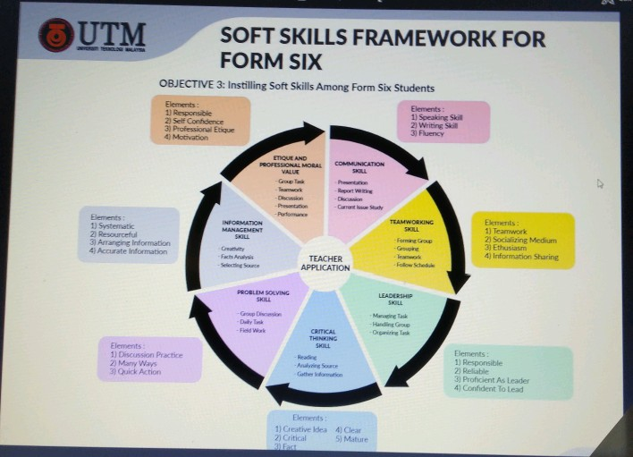
Fig-3
- Teamwork Skill:
To complete a work or a project with a group is called teamwork which is mandatory in professional life. Teamwork skills enable a person to work with others to be perfect and professional.

- Leadership skill:
Leadership provides the ability to make decisions instantly when pressure comes to shove and manage situations and people.

- Critical thinking:
Critical thinking and visualization power of everybody is not the same. It makes people able to understand problems, think critically, and come up with proper solutions. These skills related to creativity, flexibility, and curiosity.

- Trends in NALI
One of the trends in NALi is digital learning. Digital learning is a type of learning that is accompanied by technology or by instructional. It encompasses the application of a wide spectrum of practices including blended and virtual learning. Moreover, we also found that NALI is towards to the Learning through play. It is a term used in education and psychology that children can learn to make sense of the world around them. Through play, children can develop social and cognitive skills, mature emotionally, and gain the self-confidence required to engage in new experiences and environments

- Reflection- Motivation and insights on how innovation is used in teaching and learning:
As we know, education becomes one of the most important aspects in this modern era. There are a lot of students who do not get an appropriate education as the others. Yet, some students who already become a student still got a low enthusiasm for studying. Some of them are basically caused by unnecessary facilities, a full-time studying or even the way of teaching which is given by the teachers. From this case, we can conclude that the main changes the teacher should do are making the method of teaching become stress-less and interesting. At least the students become well excited about studying something new. This made an idea to create other methods of learning which can increase students’ excitement in studying and also their social participants. NALI comes to change it by offering various learning methods which are really important for the development of education. From the exhibition, we knew a lot and the visitors of that programme were inspired immensely. We informed about a lot of quality and soft skills from this programme. Companies, professionals and industry experts came here to explain their mission and vision to encourage the visitors. As a result, we got several innovative, global and entrepreneurial thinking from that exhibition.

References:
- Dr. Nur Arina Bazilah Aziz. (n.d.) New Academia Learning Innovation (NALI). Retrieved from https://science.utm.my/arina/new-academia-learning-innovation-nali/
- Dr. Abdul Halim Bin Abdullah. (2017, June 5). New Academia Learning Innovation (NALI). Retrieved from https://educ.utm.my/halim/new-academia-learning-innovation-nali/
- New Academia Learning Innovation. (n.d). Retrieved from http://utmlead.utm.my/new-academia-learning-innovation/
- New Academia Learning Innovation (NALI). (n.d). Retrieved from http://ctl.utm.my/nali/

- Soft skills’ idea was generated from these websites-
- https://en.wikipedia.org/wiki/Soft_skills
- https://www.wikijob.co.uk/content/interview-advice/competencies/soft-skills
3. https://www.thebalancecareers.com/what-are-soft-skills-2060852

