Digital Economy by eRezeki

Tiara Afdely Putri (A18CS0332)

REPORT ASSIGNMENT
SUBJECT : Technology and Information System (Section 06)
Lecturer : Dr Nor Bahiah Ahmad

TABLE OF CONTENT

INTRODUCTION 1
DEFINITION AND THE BENEFITS OF E-REZEKI 2
TYPES OF EREZEKI JOB 3
1. Digital Micro Task 3
2. Digital Works 3
3. Digitally-Enabled Task 3
THE REQUIREMENTS AND HOW TO REGISTER 4
SELF REFLECTION 5
SUMMARY 5
CREDIT 5

INTRODUCTION

As we know, the advancement of technology offering various alternative ways in interaction method. Not only for the social aspect but also in economy and marketing. For example, the digital economy. The digital economy is known as ‘business and economy activity’ that based on digital technology. In other words, it is an easy way to do economy and business activity, because it is held over the internet and world wide web (www), so everyone can easily access it.
One of the popular digital economy corporations in Malaysia is MDEC (Malaysia Digital Economy Corporation). MDEC belongs to the government agency which was launched in 1996 to lead the change of Malaysia’s digital economy. MDEC pursues the success of a digital future that opens the value of significant economic, environmental, and social within the nation. In the effort to reach those goals, in 2015, MDEC created a digital platform that can be accessed easily by people in order to increase their income. It is known as eRezeki.
eRezeki is one of the inventions by MDEC that allows people to earn additional income digitally. It is easy to use because people only have to sit around in their own house and do a digital job. In addition, there are no worries for those who are not the expert in ICT, because there is a training for citizens before doing the real job.


Credit: https://bmblogr.blogspot.com/

The explanation about eRezeki was explained by Mohd Ihsanuddin Jamhari who is the Global Online Workforce Master Trainer. The industrial talk went well and there was no problem happened. The industrial talk was held on Monday, September 24th, 2018 and took place in N28a Seminar Hall, Faculty of Computing.

DEFINITION AND THE BENEFITS OF E-REZEKI
eRezeki is one of the digital platforms that was built by MDEC which came with their special service in order to serve the local consumers in gaining their own extra income through it. This program specifically enables local citizens, especially low-income groups (with a monthly income of RM4,000), generate supplementary income by doing simple digital task via online. The eRezeki participants will be trained and matched with digital work in line with their own skills.
This program is more beneficial than another business method because it is easier to do and conveniently lead people into bigger additional income. Moreover, it is also profitable for those who are a student, housewife, or anyone who has another work to do. Since they just have to open their gadget and connect it to the internet, then they are ready to work.
This program becomes less-stressful and convenient at the same time. Not only because the workplace is flexible, but also the ability to set the working hours. In addition, the process to be the participant is so simple. People do not need to meet the job provider, they just have to do it through online on this platform. Once they are hired, they will be trained and matched to skills they had.
Furthermore, there are no interviews, no application forms, and even no fees needed. Just register, train, qualify for the work you want to perform and start earning extra income.

THE IMPACT OF EREZEKI TO MALAYSIAN PEOPLE
eRezeki has its own purposes which can connect Malaysians to digital income opportunities and make them become a part of a competitive digital workforce. It also wants to make Malaysians become a smart freelancer, so they can survive in the economy area. Furthermore, it has a big role for Malaysia economy, since this platform provides various job from a local company and even an international company. This connects to the advancement of Malaysians currency, because of the income from another county.
To conclude, eRezeki has a lot of good impact for Malaysians, so Malaysians do not have to worry about making eRezeki as their secondary job, or even primary job.

TYPES OF EREZEKI JOB
There are 3 types of eRezeki job :
- Digital Micro Task
This type consists of a simple task involving data entry, processing images or actions that required a non-specific high level of skills to perform. Tasks can be completed within a few minutes.
- Digital Works
This type is an online platform for freelancers to get hired and get paid. The freelancer can be an individual, an enterprise or private limited company. After registration, people can choose a ton of jobs to place their bid. Once hired and completed the job, the payment will then be transfer to their bank account. It guarantees no pressure at the working place, and they can choose any job suits with their skills and expertise.
- Digitally-Enabled Task
This type requires works/tasks such as survey, running errands or domestic services which online but has to be performed offline / on-site.

These are the tasks of the types above :
Digital Micro Task | Digital Works | Digitally-Enabled Task
Data entry of online forms  Removing duplicated data  Photo/image review  Download-Install tasks  SEO related tasks | Development of a website  Mobile application development  Creation of logo  Graphic designs  Software testing  Audio/video transcription work  Document format conversion | Conducting survey  Products price watch  Event part-time crews  Running errands  Plumber  Electrician  Cleaners
Credit: https://www.erezeki.my/

THE REQUIREMENTS AND HOW TO REGISTER
This program is open for local people above 18 years old who has a monthly income of RM4,000 or below. It does not matter, if the participant is a student, retires, housewife, etc. As long as they want to work continuously and independently. Thus, there are no specific requirements.
The step to register :
- Register at www.erezeki.my or come to eRezeki center nearby.
- Join the work training at the eRezeki center to know the types of offered tasks and the steps that you need in doing digital tasks.
- If you already fit with your job, access the platform to choose what task you want to do, and follow the direction that given to prepare your task.
- Last but not least, you will get your salary after your task is ready.

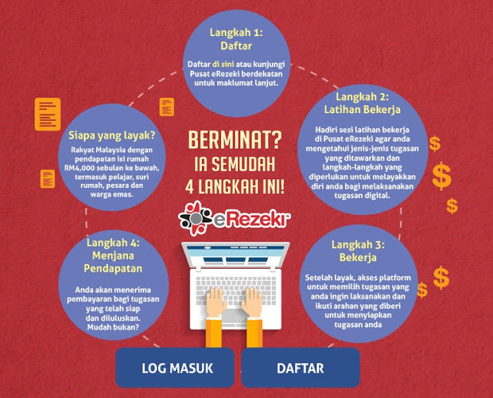
Credit: https://bmblogr.blogspot.com/

SELF REFLECTION
From the explanation above, I can say that in this digital era, everything can be done easily and no time wasted. So you do not have to worry about losing a job, low income, and other economic problems. All you have to do just place yourself in the most comfortable area in your house and do this flexible job.
The other thing that I learned about this is you have to be an independent, responsible, and also discipline person. In addition, do not ever try to give up over everything you started because hard work paid off.

SUMMARY
Overall, eRezeki is one of the platforms which is created by MDEC in order to pursue the success of Malaysia’s economy. Moreover, it is convenient because the participants just have to do the register through online, without worrying about going somewhere. Once the task you have done is pretty good, the money will be transferred to your bank account. It is easy, and profitable.

CREDIT
https://www.erezeki.my
https://www.mdec.my
https://www.ajarekonomi.com/2017/01/digital-economy-ketika-perekonomian-dan.html
https://bmblogr.blogspot.com/2015/06/jana-pendapatan-online-pekerja-kerajaan-erezeki.html

