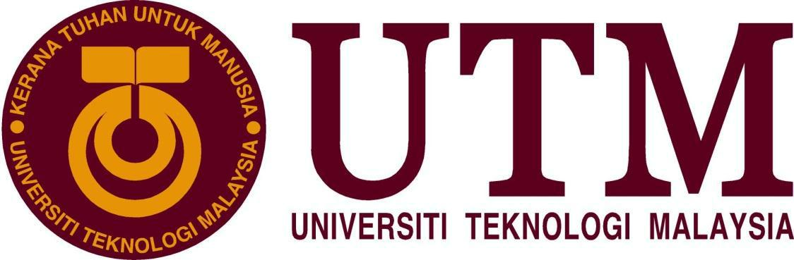
SCHOOL OF COMPUTING
Faculty of Engineering


INDUSTRIAL TALK 2 – NALI SYMPOSIUM

Subject:
SCSP 1513-06
(Technology and Information System)
Lecturer Name: Dr. Nor Bahiah Binti Hj.Ahmad
Location: Dewan Sultan Iskandar, UTM, Johor Baharu
Visit Date: Tuesday, 25 September 2018
Composed by:
Ruby Bot Group 5
1. Nanda Azka Mulia A18CS0316
2. Raziela Binti Rosli A18CS0240
3. Taufiq Bin Noor Azman A18CS0262
4. Wilbert Harianto A18CS5138
5. Nurul Zahfiah Binti Mohd Hamzah A18CS0228
Universiti Teknologi Malaysia

- Introduction to NALI 2018
New Academia Learning Innovation (NALI) held an exhibition and competition at Sultan Ismail Hall, UTM on 25th September 2018.These exhibition is brought by UTM Academic Leadership (UTM lead) in collaboration with School of Education, Faculty of Social Sciences & Humanities UTM and Asia Technology University Network (ATU-NET). There were 86 booths in total, however we were required to visit at least 3 booths during the exhibition. The objective of this NALI 2018 is to be the platform for sharing of research and innovation products.
Besides, it helps to improve educator competency in learning process for the future of education. A keynote has been held while the event is in progress on 11am delivered by Prof Dr. Mushtak Al-Atabi, CEO and Provost, Herriot-Watt University Malaysia. The topic of the keynote was Education 4.0: New Paradigm of Education.
NALI in general is an exhibition where the booth is representing ideas for new modes, material and presentation of learning which is student-centred. This program is a method used to find a more effective of learning approach towards the 4th industrial revolution where human and machine works together to enable new possibilities. These program is also a new vision for learning towards education of 4.0, where people need knowledge or skill rather than learning things theoretically without having to experience it. NALI is amazing they use learning mode (pedagogy/andragogy), learning materials (digital resources) and blended learning. Why is the topic is education 4.0 and what is the relation with NALI 2018? NALI 2018 have concept blended learning model, this learning have a combination study in good ways with digital teaching materials in class.
Year by year NALI always develop the ways in the trend of what world in progress and increasing finding new innovation for the future to deliver to new generation to recognize that world industrial trends always increase year by year to always make a new invention of studying, skill and hard work mentality to find new source for the future.
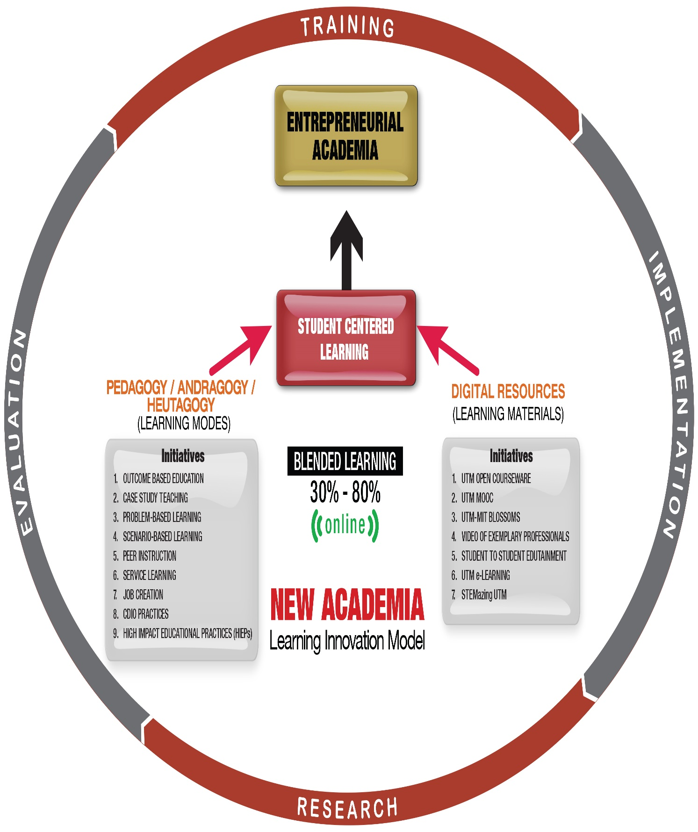

- Flash Flood Detector booth
The first booth that we chose at NALI is The Flash Flood Detector booth. This booth were handled by 2 representative, Ms.Nur Asyikin Zailan and Ms.Mariani Tain. This booth is introducing a more effective way to deliver Archimedes’ principle by created a flash flood detector according to the exhibitor. Archimedes’ principle is a scientific law that explained why objects sink and float. This detector is used to detect water level when the water reaches a certain level that has been fixed by user. People can adjust the dangerous level according to their references. The detector would give a warning when the water level is reaching its dangerous phase. These detector is different from the Japan tsunami detector. In Japan, the technology detects the tsunami by using wavelength index whereas these detector focusing more to the water level. These flash flood detector helps students to experience and understand the concept more rather than just imagine the concept from the references books. This method also helps to reduce and smoothen learning process towards a certain concept. From this booth we realized that a lot of new method can be used to deliver a subject. We were inspired to produce a better product by combining Archimedes and Hydrologic to develop a new detector that can be used for the convenience of new generation. From this booth, we can learn how to implement modern science to our daily life. For example, this invention has already been implemented in so much river all around the world. The sensor can help human to know where is the height limitation for every river. By using this sensor, we can also prevent flood that might happen in several hours later on.
So, here is the working method of Flash Flood Detector:
1. First, put the maximum height for the sensor.
2. Locate the sensor at the side/bridge of canal/ river/ sea.
3. Connect the sensor to Alarm and Speaker System.
4. Observe and see if there is any sound from the alarm, to know where is the height of water level.

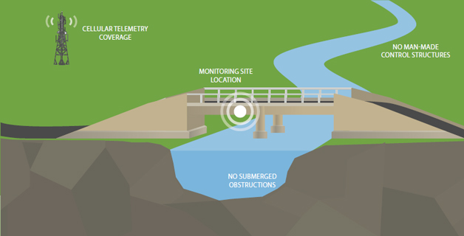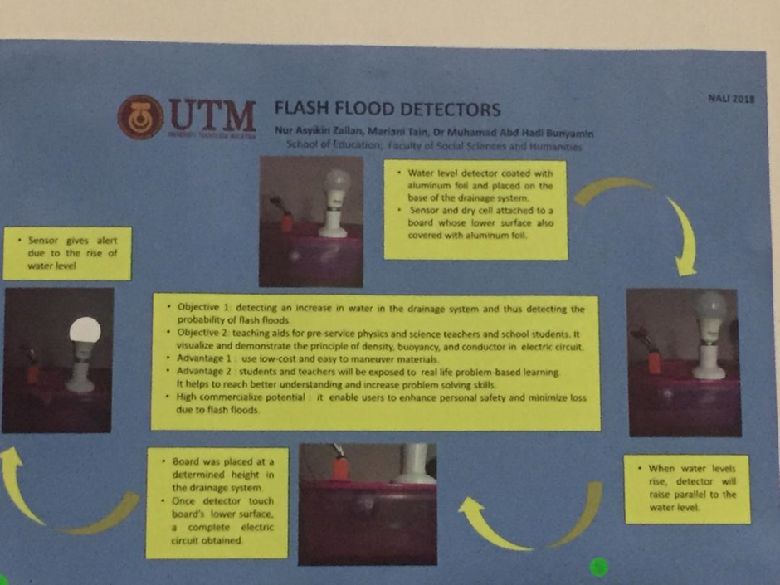

- Monsoon SIM business simulation: Enhancing learning through gamification
MONSOON SIM Monsoon SIM actually is the short form for Monsoon Simulation. Dr Zukilfi Khair (The trainer) said Monsoon SIM is the cyber-game based learning concept was developed with the collaboration of Monsoon Academy to enhance students' skills in business. The game is suitable for adults and older children. It can be played by a group of between 30 and 200 people but the ideal number is 40 – 70 people. In this era, most business simulations are designed to be played by real players rather than real players and not against computers or artificial intelligence. This program creates creative thinking players to ensure they are on the right path to achieve high profits, as there is no way for players to predict how their competitors will behave. They may follow a bold investment weight strategy or try to circumvent others by setting their prices lower than the market average. Indirectly, players will feel like they are in the real world of business, and this causes them to draw up and strategize for unforeseen situations and be ready to rotate if necessary.
Nowadays, business is very important to country economy like China, United States, Japan, Germany and Arab Saudi, but for Malaysia we need people to explore new approaches to make students with business mindset. Thus, monsoon sim is a good experiential learning platform for business studies. It is a good education platform covering business concepts ready to be discovered by a student through the competitive simulations. One of the universities in Malaysia that has been committed to forming young entrepreneurs is UTM. Universiti Teknologi Malaysia is committed to development of human resource as well as science and technology through innovation and indirectly make the student have creative and critical thinking in a business. Next, monsoon sim provides some important aspects in the entrepreneurial world such as finance, procurement, retail, marketing, warehouse (Distribution), wholesales, forecast (planning), MRP, production, maintenance and human resources.
In our opinion, Monsoon Simulation makes us learn some new terms in the entrepreneurial world for example strategic thinking, decision making, problem solving, financial analysis, market analysis, operations and this game makes us honed our soft skill such as teamwork and leadership which is it shows your attitude and intuition. In addition, players will learn the complex business processes, industry best practices and basic accounting through fun, involving, business simulation competition. For your knowledge, the program has international competitions that are participating from various countries such as Malaysia, Singapore, Indonesia, Thailand, Philippines and Hong Kong.
Here is the Example of the website display, how Monsoon SIM makes Business Simulation:

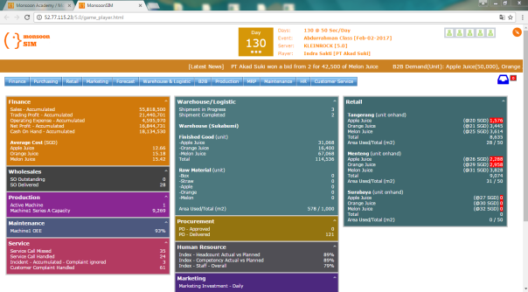

We can use the Simulation to make a prediction how our business will flow, and know the result of our fund circulation in our business. We can try to use this system to avoid and prevent bankruptcy. By using this system, we can also help those with small company/trader to develop their business to be larger and arrange their company circulation.
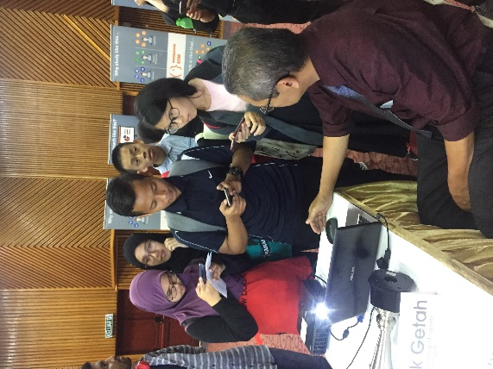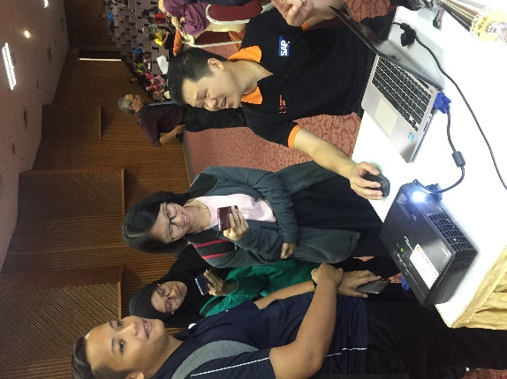

• Data analytics of blended learning for data structure subject through MOOC
What is MOOC? MOOC is massive open online courses, develop by UTM lectures Dr. Nor Bahiah Hj. Ahmad, Assoc. prof. Dr. Dayang Nor Hayati Abang Jawawi, Dr. Norsham Idris, Dr. Sarina Sulaiman and Ms. Nadirah Mohammad. MOOC is blended learning which integrates online learning, MOOC for the data structure subject has been implemented using blended learning approach for the past three years. Why is implemented using blended learning? because NALI 2018 model is a framework comprising student centre and blended learning philosophy. Blended learning is a combination of studying with the use of digital teaching so the student still can get the same experience like studying in class just the difference is they study by digital teaching this also encourage them. Now, they can study everywhere they want by getting the same materials that studied in class. The data structure subject through MOOC is not only for the student even if the citizen of Malaysia and people around the world can use it for studying, nowadays everyone can feel the feel of studying not only that MOOC also can use for discussing about the subject or materials that is studied in class by digital teaching. The analysis data about MOOC that we see in the exhibition trend is good always increasing, there is a large benefit from MOOC how we could say that people all around the world can exchange ideas thru forum and knowledge sharing.

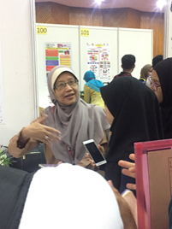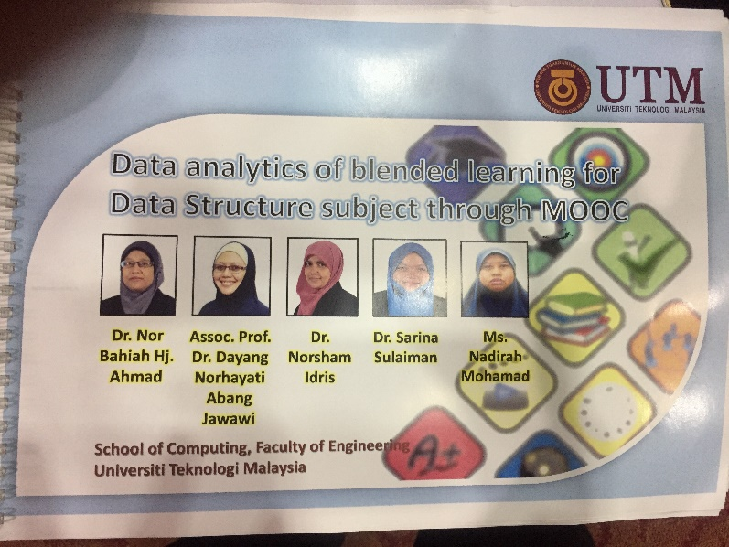

- Conclusion
By participating in this NALI event, we can understand and know how quick technology has affected our life. We can see that technology has already become important things in our life. Nowadays, technology has developed and improved rapidly in our life. We can see there are so many technology invention and innovation that found every day. All of us also gain some inspiration from this event. We can learn how to implement our science knowledge in our daily life. For example, we can see how Archimedes innovation is applied in water level system. By developing the innovation, we can prevent the disaster of flood that might be happened in some lowland countries. By Combining sensor and alarm system, we can see how the system will work when the water has already reached the maximum water level.
Besides that, we can also see there is a technology innovation in another part of applied science. MOONSON SIM is one of the example. The system which is developed by MOONSON SIM might help those in their business to avoid bankruptcy and make some prediction in the future. We can also use the system to help low-economy country to help them survive by using this system. The system is very useful for export and import traders which this system can help them to arrange their company money circulation. So, hopefully they can get better income and money circulation.
Technology also has already affected our academic system. Nearly, all of university in the world have already used e-learning to develop their academic system to be more modern. By using e-learning, we can help to reduce the usage of paper. Besides, we also can make our study time more flexible and efficient. In the future, we might see that class won’t be used anymore. Lecturing might be happened in our house. We won’t need go to university to join the class. But, we can do it anywhere and anytime. So, hopefully we can learn and invent another technology that will help us to make our life easier especially by implementing our computing knowledge to develop some new invention.
MOOC is something great for this era when people can study everywhere they want not only in class, this also help them to encourage the capability of studying by discussing from another student or maybe people all around the world by making their own cohort, exchanging ide thru forum also help think more critical when they make new ideas they get innovation for the future of industrial or maybe the global world of living.

Refrence
- https://www.google.com/url?sa=i&rct=j&q=&esrc=s&source=images&cd=&cad=rja&uact=8&ved=2ahUKEwijmKjgjvLdAhUKLo8KHao_BQsQjRx6BAgBEAU&url=https%3A%2F%2Fcatatanis.wordpress.com%2F2017%2F02%2F03%2Fmengasah-management-skill-melalui-monsoon-simulation%2F&psig=AOvVaw20s12cPiLuwpdgF26DPpWM&ust=1538925595687547
- https://www.google.com/url?sa=i&rct=j&q=&esrc=s&source=images&cd=&cad=rja&uact=8&ved=2ahUKEwjUlvfhmfLdAhXYEHIKHR5PBAMQjRx6BAgBEAU&url=https%3A%2F%2Fwww.fondriest.com%2Fenvironmental-measurements%2Fenvironmental-monitoring-applications%2Fflood-warning-systems%2F&psig=AOvVaw1ybO1Wb6WVYqCbftGUIYO5&ust=1538924904788338
- http://ctl.utm.my/nali2018/exhibition/
- https://water.usgs.gov/edu/hydrology.html
- http://www.thegeniusworks.com/2017/01/future-education-young-everyone-taught-together/
- https://study.com/academy/lesson/archimedes-principle-definition-lesson-for-kids.html
- http://www.monsoonacademy.com/guide.html?stage=MSIM_REVIEW
- http://ctl.utm.my/nali/
- https://www.openlearning.com/utm
- http://www.pengertianmenurutparaahli.net/pengertian-simposium-dan-contohnya/
- https://dosen.perbanas.id/pendidikan-4-0-heutagogy/

