Report on Industrial Talk 2 – NALI Symposium
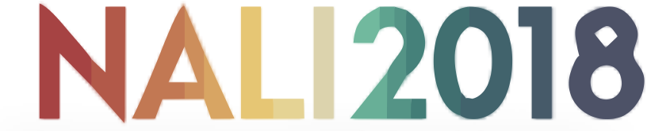

Group: The Honey Badger
Name: - Putera Muhammad Syabil Bin Sarianto
- Nurul Aneesha Bt Md Zin
- Seyyed Naquib Al Faruqi
- Nur Ilham Muhammad Shahfilzuah
- Tan Jun Han

Subject: Technology and Information Systems (SCSP1513)
Section: 06
Lecturer: Dr Nor Bahiah Ahmad

Introduction
We were given a task to make a report form NALI 2018 that was held on 25th-26th September 2018 at Dewan Sultan Iskandar in Universiti Teknologi Malaysia,
What is NALI?
NALI Stands for New Academia Learning Innovation (NALI) is one of UTM’s yearly event that is a celebration for innovative teaching and learning practices, NALI 2018 have some keynotes from high-profile speaker that intended to be of interest to everyone at the conference and a there were competition for participant (educators) who given a booth to showcase their project. According to NALI official Portal, NALI is in line with the National Higher Education Strategic Plan (PSPTN) because one of NALI main objective is to align UTM teaching and learning models, activities, materials, environments and systems with PSPTN.

According to the book “Akedemia Baru Invoasi Pembelajaran” NALI main objectives consist of 4 Main Objective:
- To align UTM teaching and learning with the Malaysian National Higher Education Strategic Plan, the needs of employers and the requirements of good accreditation.
- To emulate best teaching and learning practises from the world’s best universities
- To develop UTM’s own identity related to teaching and learning systems
- To create meaningful and interactive learning
History?
NALI was first ideated and written in the book titled New Academia in 2012 to document UTM’s commitment towards forming new thinking, philosophy, and higher education framework through new pedagogy that can nurture students to be competitive at international level. From this mindset, UTM set to develop the NALI Framework that proposed the integration of technologies in innovative teaching and learning methods (source: https://news.utm.my/2018/06/new-academia-learning-innovation-nali-2018-symposium)

Details of Journey
On 25th and 26th September 2018 NALI was held at Dewan Seri Iskandar. The program starts at 8.00AM in the morning where all the participant needs to register at the registration booth and by 8:30AM, the exhibition will be open. We decided to go to the exhibition at 10:00 AM because by 9:15AM is where the judging begin and there will be a talk by Prof. Dr. Mushtak Al-Atabi CEO and Provost of Heriot-Watt University Malaysia. There are certain aspect that we realised where all the candidates need to apply at their project. For example, where poster of their project must contain some information such as their abstract, project objectives and many more. The prizes will be given at the end of 26th September where the groups will be categorised. There are Gold Medalists, Silver Medalists and Bronze Medalists.

BOOTH 36: MONSOONSIM BUSINESS SIMULATION: ENHANCING LEARNING THROUGH GAMIFICATION.
MonsoonSIM is an Enterprise Simulation & Experiential Education Platform that was founded in 2008 by the ex-SAP head of consulting SAP Indonesia and ex-SAP Education manager. MonsoonSIM’s objective is to introduce a new concept in business education through gamification. It is also designed to educate stuffs and employees of an organization through experiential learning to understand how to work better using an Integrated Computerised (ERP) System. This system is basically to let a person knows how every departments work, how a person’s job is related to the other departments and how the job affects the departments after that, for example, logistics or even our consumers.

To start a session of MonsoonSIM, few teams must be formed to compete with each other. All teams will run a fast-growing virtual business. Initially, the team will buy and sell some goods like apple, orange and melon juice to a few retail stores in different countries. But sooner, you will find out there is competition between teams, so a marketing department is formed to invest in marketing and marketing intelligence. After your business grows, a team will increase its turnover by having its own warehouse and logistics department. Soon after the business grows bigger, cost will be an issue to compete with other teams. Therefore, production and wholesales will be implemented and some supporting departments such as Material requirements planning (MRP) and forecasting department to help the business to avoid any miscalculations that will affect the business. Machines in the production floor must also be maintained to achieve the optimal throughputs. In the end, your customer grows and a service department must be added to receive any complaints and provide additional services to customers. The figure below shows the flow of the business:
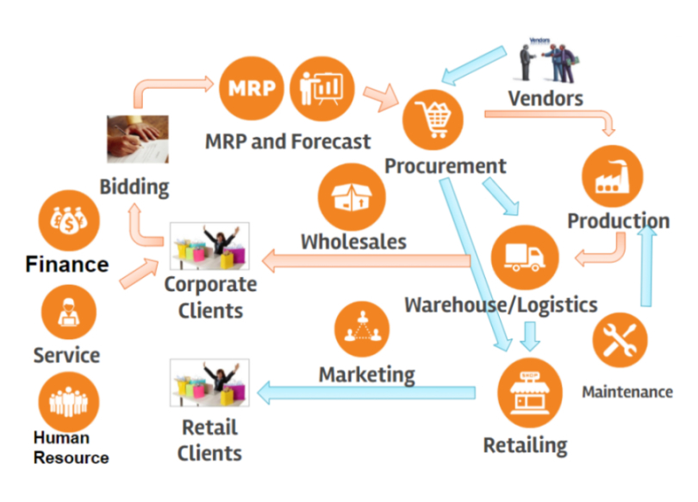

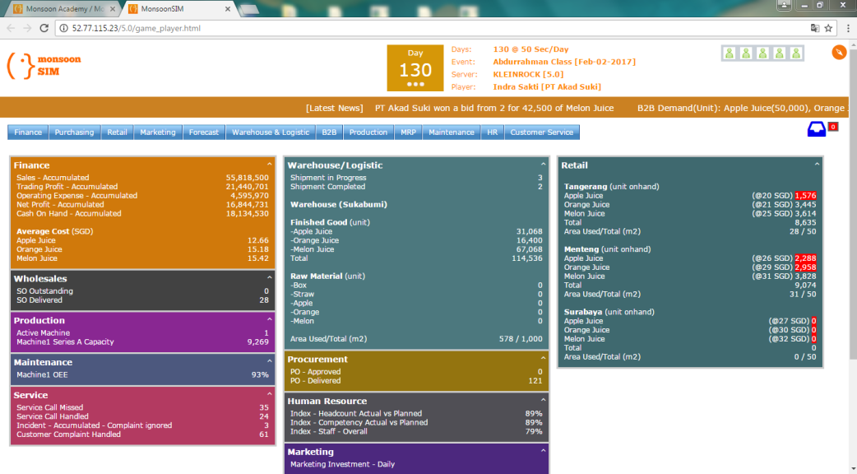

According to the exhibitor, the trends of MonsoonSIM in NALI is to enhance and develop 21st century skills, for instance:
- Creative & innovative thinking skills.
- Problem solving skills.
- Leadership and collaboration skills.
- Communication skills.
- Employability.

Below are the graphs of surveys done by them showing how MonsoonSIM helped people.

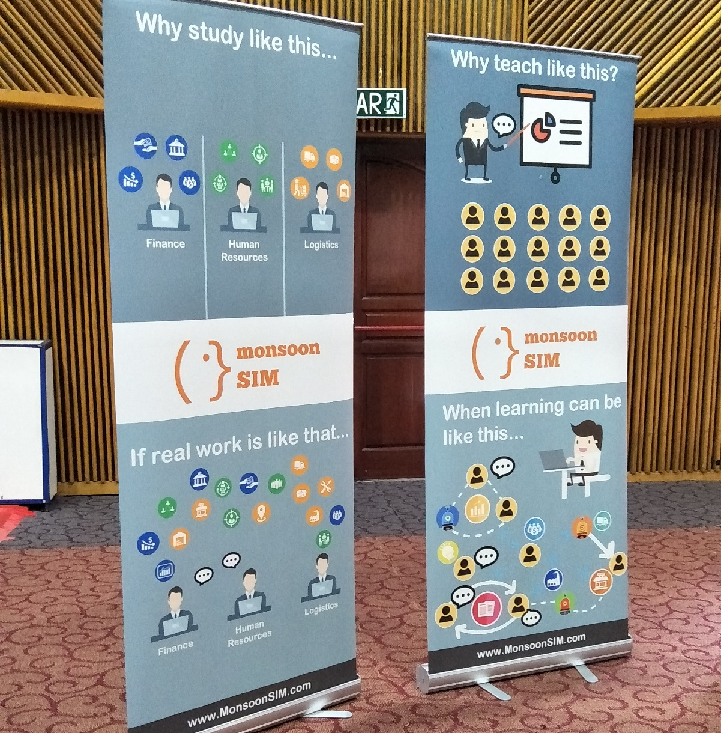

In my opinion, MonsoonSIM provides a good platform for building teamwork among team members, it does not only restrict for employees in a company but also for students to train us work better in a team and produce a higher quality assignment. It also gives a chance to fresh graduates for them to learn how to run a business through experiential learning before they start a real business. This will reduce the chance of getting bankrupt for a new company due to lack of experience and facing obstacles to find the root cause of the problem. Furthermore, the program also provides business analytics features which the team can analyze every departments through tables and graphs after the virtual business ends and find out where to improve to get a better results next time. MonsoonSIM is not only for business students but also for non-business students. By playing the game, it can train their entrepreneurial skills by handling different departments and make them the future leader of our nation.

BOOTH 70: CULTIVATING SOCIAL ENTREPRENEURS THROUGH EXPERIMENTAL
EDUCATION: A MULTI-STAKEHOLDER COLLABORATION.

Booth 70 is prepared by Phuah Kit Teng, Siti Intan Nurdiana Wong, Bernard Lim Jit Heng and Umi Kaisom Kassim. The objective for this program is to inspire the students to make a difference towards social issues by collaborating with multi-stakeholders. Besides, they want to engage students in experiential learning and lifelong-learning skills.
Multi-stakeholder collaboration is to encourage the students to communicate not just among themselves but to other people as well. It means the university introduce two theory or ideology which is social entrepreneur and service learning. For social entrepreneur are you do not just pursuit your economy benefit but also contribute as society through service learning. The aim for social entrepreneur is to provide experiential learning opportunities through social entrepreneurial projects by come out with an assessment that actually resulting to practicalbility of the student. By service learning as providing service at the same time learning something meaningful that lead to actual understanding of academic concept. Besides, it provides substantial experiences creating perplexity or dissonance.

In term of creativity, the students must do something for the greater impact in limited period of time. They need to think out of the box or to make a new thing for someone or a group of people to make a change in any community with hope to make a change or find a solution to the social issues. The students are given learning plan and objectives by their lecturer. By that they can choose their project theme. The lecturer will mentor the students and gives them guideline. For example, how to get a sponsor. At the end of the day, the students will reflect what they have done and analyse their future from the impact. They will go through many challenges as they are making their project. MAMABOX is one of the projects that were made successfully by their student. The objective of the project is to bring a healthy and good food to the customer. But the chef is a single mother. Thus, with this kind of help, the social issues in an area will be reduced.
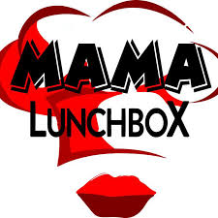
In my opinion, this programme is a great initiative for the lecturers and the students. Because of the novelty. This programme provides an actual application of their studies and give the opportunity for the students to apply what they learnt in a real-world settling. It also helps the student develop greater soft skill like teamworking, report writing, leadership, photoshop and build a better connection amongst the community. with a larger network, solving social problem is easier than do it alone. With this kind of attitude and discipline, it will help the student to become more employable because of the good attributes that develop in the process of making the project. Therefore, this skill will help the industry be more competitive and it will also make Malaysia become a developed country more than before.

Other attributes:
Motivation, disposition
Skill:
Domain specific skill, creative processing skills
Knowledge:
Basic specific expertise, broad knowledge base

Innovative ideas from students
Creative potential

Abilities:
Intelligence, divergent thinking

BOOTH 17: PEDAGOGICAL BENEFITS OF YOUTUBE IN IMPROVING HAIR STYLING PERFORMANCE AND INTEREST AMONG LEARNING DISABILITY STUDENTS
Youtube is a tool used as a Blended Learning method which has potential to increase the performance and interest among learning disability students in vocational school. Accordingly, there have no studies conducted on the application of Youtube in learning hair-styling among learning disability students. The objective of this study is to enhance the students’ performance in hair styling after using Youtube and so identity the students’ interest in learning hair-styling skills. Youtube was used towards 10 students in a single group is pre and past-test research designs. The findings proved that Youtube has high potential as an instructional tool in teaching hair-styling skills, in line with the current trends of Blended Learning in education.
Youtube has been used in vocational education. Which provides online access in vast quantities of free public video in a broad spectrum of topics. This research emphasises on student-centered instructional method that implements the Case Based Learning (CBL) approaches in accordance with NALI. Many researches used Youtube in mainstream education rather than special need education. The students have become more productive, creative, and innovative when Youtube was adopted in T&L activities. CBL is proven able to engage students in active learning and in solving problem creatively and collaboratively. The students will able to understand the problem better when they use different sources to get the answers, which involve critical thinking, and simultaneously able to improve their soft skills, engaging problem-solvers, as well as continuous and self-directed learners. At the same time, it will also foster the development of students’ thinking and improve their abilities in learning. CBL has also proven able to facilitate thinking and problem solving, assist the mastery learning, inspiring, and engaging the students
CBL PROCESS

Novelty
- Application of Youtube among learning Disability Students
- Applied Theory Gagne Nine Steps (1985) and Theory Interest Hidi (2006)
- Given Case
- Analysed by Groups & Brainstorming
- Formulate Learning Objectives & Find Solutions
- Students Share Ideas
- Access Students Learning is Multiple Ways

Creativity
- Design of ideas
- Implementing Youtube with CBL approaches

Research Methodology

- Pre and post-test single group of students
- 10 learning disability students
- Taking hair-styling course
- Two instruments (performance test; work process, outcomes, and interest observation form: eight items).
- Analysed using Wilcoxon test

Conclusion
- Has implications on the T&L in improving students’ performance & increased interest
- Youtube can be used to enchance the basic knowledge in hair styling

From what we can see, using youtube as a teaching method is a great idea especially for disability students in vocational school because it has potential to increase the performance and interest among the learners. Youtube has visual and audio so it easily gains attention among the students then make students more interested in learning.
Learning through YouTube may engage students in active learning, so the students have become more productive, creative, and innovative. The students will able to understand the problem better when they use different sources to get the answers or when using Youtube as a learning source. Learning via Youtube is a great method due to easy access, exciting and easy to understand.

Conclusion
At the end of the exhibition, we have learned a lot of teaching and learning systems provided by 86 booths and we have chosen 3 that benefit us the most. We would appreciate it greatly if NALI can hold an exhibition again soon.

