INSUTRIAL REPORT 1: MDEC e-Rezki
Prepared By: Putera Muhammad Syabil Bin Sarianto
Matrix Number: A18CS0235
INTRODUCTION
24 September 2018, Malaysia Digital Economy Corporation(MDEC) were given the opportunity to give a talk at UTM, Skudai, Johor About e-Rezeki between 4:00 PM to 6:00PM . The speaker, Nor Ashikin Binti Halil is from Kangkar Pulai, Skudai Johor Malaysia did Diploma Office Management and Technology at Universiti Teknologi MARA at Melaka. She was an executive personal assistant for high level for a year. And currently she is a freelancer and also a master trainer for GLOW.
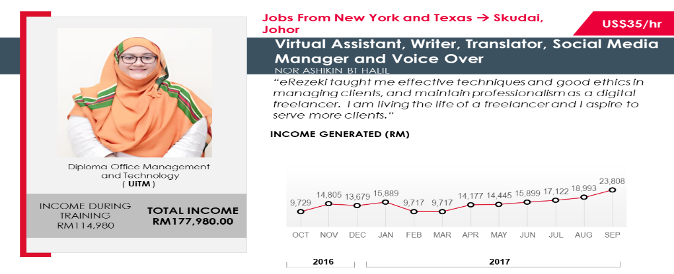
Figure 1
WHAT IT IS?
MDEC is one of the government’s intuition that is responsible for the management of the Special Economic Zone and high-technology business district. MDEC has made some initiative for digital workers such as e-Rezeki, GLOW, eUsahawan and many more. These are the platform that were introduced from the talk and it gives anyone to generate income whether it is passive or not and it is done online. The talk were focusing more on Global Online Workforce (GLOW) and the main aim of the program is to create a community of digital workers amongst Malaysian. This program is government initiative to create more visibility and awareness to the Malaysian public to make full time freelancing as an alternative career path. Thus, freelancing in Malaysia is becoming more colourful, diverse and increasingly important to the economy than ever before because it makes money from all around the world come to the country. It also makes the offer a lucrative income alongside greater flexibility of time and more. Entrepreneurship has also become one of the most important field in Malaysia that were mention from the Malaysian government. Not only it helped the user to generate money to survive in this era, but it also gives the government profits and it create jobs for another user. Thus, freelancing proven is one of the important field or role in the industry and also for the country itself.
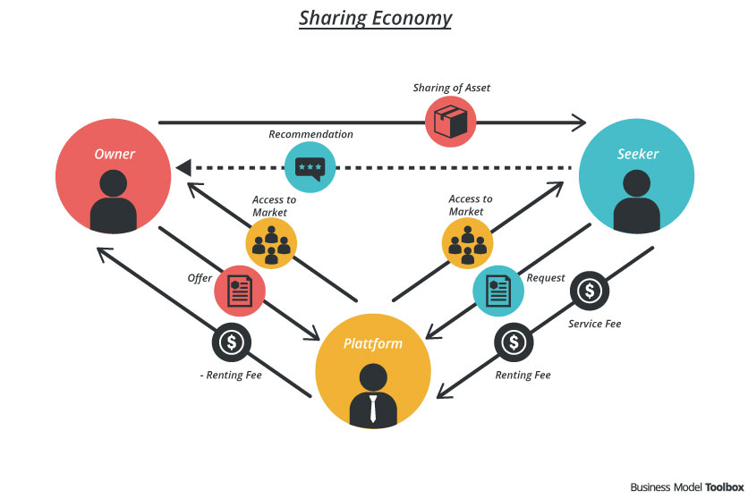
Figure 2
GLOW use a system based on the Sharing Economy Concept. Sharing Economy is a concept that in which IT products and services are use, share and leased to individuals and organization. It targets individuals and organizations that cannot afford the costs of buying and maintaining IT solutions. It allow multiple end users to collectively develop and consume IT services and applications, versus purchasing and maintaining them on an individual basis. The sharing economy also known as the peer economy and mesh economy collaborative economy. A lot of big, successful and popular company used this concept on their platform such as Facebook, Airbnb, Alibaba, Amazon, Uber, and apparently GLOW is also using this concept on their platform. GLOW is a platform that is more focussing on skills. For example, if a person can speak multiple languages, he can be a translator to make a subtitle for a video or a movie.
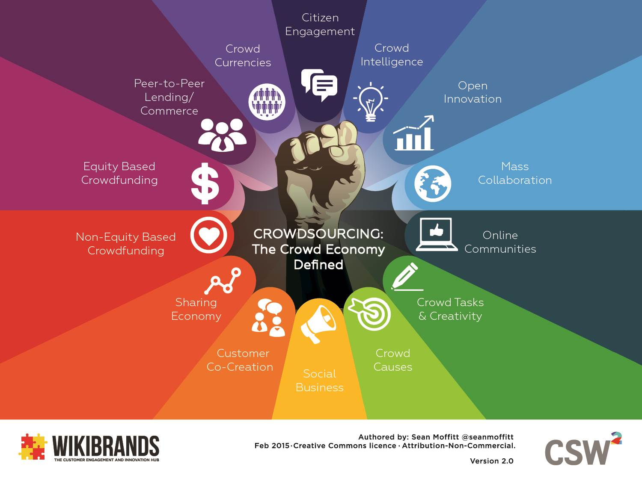
Figure 3
GLOW also use the concept of Crowdsourcing. Crowdsourcing is the practice of engaging a ‘crowd’ or group for a common goal. They could be innovation, problem solving, or efficiency. This concept can provide organization with access to new ideas and solution, deeper consumer engagement, opportunities for co-creation, optimization of task and reduced costs. For example, if a person would want a website about himself. He can pay a web-developer that can do it for him other than paying a company to do it for him. It will also cost less than the company. Crowdsourcing touches across all social and business. It’s changing the way of the industry. For example, the way we work, hire, market and many more. Thus, GLOW is an alternative for a Malaysian to create more income that is selling skill and not product. Skills that can be used in GLOW is programming, translation, digital marketing, graphic design, web developer, virtual assistant, data entry, writer and many more.
In this era, to finding or get a job can be difficult. MDEC use various methods to attract user to be entrepreneur or freelancer or fresh graduates. One of them is they made a talk about these platforms and also they make advertisement. MDEC open this platform to Malaysian that age 18 and above and currently living in Malaysia that wanted to be in freelancing industry can join by using this domestic platform. To join eRezeki is free of charge and it required MyKad number. And for GLOW there are certain criteria that are required to join GLOW member. The user needs to know some skills that are in IT, creative design or linguistic field. It brings many benefits for the user because of the flexibility it provides to the user.
IMPACTS
There are many impacts of the program to our country Malaysia especially in this digital revolution era, people would rather work at home. This means, the people rather being self-employed than being employed by a company. As we can know, a small-business growth can lead to a boost in wages. The rise in self-employment will inevitably increase wages. And if the money is from another country, the user will have to pay taxes to the country. This programme also taught Malaysian freelancer to maintain their ethics and professionalism. This will make Malaysian mindset change slowly to be more open-minded and think globally towards the industry. With this positive mindset, attitude and ethics will promote more client from another country that Malaysian freelancer or entrepreneur is reliable and trustworthy. This programme also open the eye of certain Malaysian that without a education certificate the user can still generate money and this help the user to utilize the skills that they learn by themselves other than university. For example, their hobby could be their job and it will make the user produce a quality product because they’re passionate with their works. This proves that this GLOW program will help Malaysia produce more quality freelancer and entrepreneur.
CONCLUSION
In my opinion, the programme is a good initiative by the government. It aimed to create more competitive future generation that is equipped with the relevant skills to thrive in a digital economy. As the technology becomes more advance each day, especially during the fourth industrial revolution, people are able to connect to anyone globally and this program will guide the user or freelancer to improve their skills, employability and soft skill in a global context. This programme allows the low-income citizen or B40 individuals to generate additional, trustworthy income by performing simple digital-based tasks. Thus, this programme is a good way to let the newbie to start their own career as freelancer by teaching them with their tips like how to build a good profile, how to avoid scams, and many more.

REFERENCE
- http://www.synthetron.com/crowdsourcing-is-changing-possibilities/
- https://www.mdec.my/building-an-inclusive-digital-future
- https://crowdsourcingweek.com/what-is-crowdsourcing/
- https://glowmalaysia.com/kisah-kejayaan/
- https://glowmalaysia.com/soalan-lazim/
- https://www.mdec.my/about-mdec
- https://mdec.my/blog/?p=173
- https://www.forbes.com/sites/bernardmarr/2016/10/21/the-sharing-economy-what-it-is-examples-and-how-big-data-platforms-and-algorithms-fuel/#15c4a38c7c5a
- https://www.investopedia.com/terms/s/sharing-economy.asp
- https://erezeki.my/faq

