

SCSP 1513
TECHNOLOGY AND INFORMATION SYSTEM

DESIGN THINKING

LECTURER:
Dr Azurah Abd Samah

SUBMITTED BY:
Tang Kuan Yew (A18CS0261)
Irfan Azim Ismail bin Ismawi (A18CS0077)
Md. Farhad Ahmed Rinku (A18CS4015)
Shazwani Farzana binti Saharudin (A18CS0243)
Reihan Rexy Osa Putra (A18CS0322)

Semester 1 2018/2019

AQUA INTELLIGENT BOTTLE
Team members’ name: Tang Kuan Yew, Irfan Azim Ismail bin Ismawi, Md. Farhad Ahmed Rinku, Shazwani Farzana binti Saharudin, Reihan Rexy Osa Putra
School of Computing, Faculty of Engineering
UniversitiTeknologi Malaysia, 81310 Skudai,
Johor Bahru, Malaysia

ABSTRACT
This paper describes an application embedded smart water bottle named Aqua Intelligent Bottle which provide solutions to common problems faced by public to keep themselves hydrated. Background of users and problems faced by users are also discussed to give a better understanding on the real problems faced by different individuals. Analysis of user study is presented in this paper to justify the problems surrounding the needs of Aqua Intelligent Bottle. Results of analysis shows that the features in Aqua Intelligent Bottle address and accommodate most of the common problems faced by the users in their daily lives.

- INTRODUCTION
Keeping our bodies hydrated is one of the most important thing to do in our daily lives. Our bodies depend on water to survive as 75% of our bodies are composed of water. Every cell, tissue and organ in our bodies require adequate water to work and function properly. Water is not only needed for overall good health, meanwhile, dehydration in some extreme cases could lead to coma and death.
In fact, many people do not realize that how important it is to keep their bodies hydrated, especially when they lead an active lifestyle in Malaysia. In such hot and humid condition, our bodies need to be hydrated from time to time as we perspire more, which increase the water loss.
Drinking water regularly should be practiced in our daily life. Most of the people have been told that drinking 6 to 8 glasses of water every day is sufficient to hydrate our bodies. However, different individuals actually need different amounts of water to stay hydrated. But then, most of the people will only drink water up to the level when they have dry mouth or feel thirsty.

- PROBLEM BACKGROUND
During the busy and hectic life, all of us from different ages, may it be children, teenagers or adults tend to find ourselves with only a little pinch of time. This makes us easily to forget about all the little yet important things in our lives, for example, drinking water.
What makes this condition worse is that when people are engaged in certain task, they tend to forget drinking water regularly. Drinking water has become a minor and optional task to do as long as they don’t feel thirsty. As a result, people might only drink less than 1 liter of water at the end of the day.
There is also problem where some people do not even know how much water they should consume every day to keep their body hydrated. Many people have been told that 2 liter of water is the standard amount of water to be consumed every day since they were young. However, every person should drink water based on their body weight. Hence, some people might need to drink more than 2 liter of water while some do not.

- METHODOLOGY
Empathize Mode
Observation
Based on our observations, many people tend to forget of drinking water when they are focusing on certain task. For example, when students are doing task that requires high concentration such as programming, they are more likely to forget of drinking water. This can be observed by seeing their water bottles are still almost full after they complete their tasks.
Engage
For better understanding of users’ problems and requirements, interviews are conducted through both scheduled and short spontaneous (intercept encounter). Generally, most interviewees show that they do not have acknowledge on how exact amount they should at least drink every day. In fact, they will only drink water when they feel thirsty. They are comfortable with the Aqua Intelligent Bottle as long as it will not interrupt and bring troublesome to their daily lives. Some of them concern about the size of the bottle so it is easy to carry around and suit for daily routine.
Immerse
To experience the problem what users are having, we have challenged ourselves to drink water regularly for every hour. However, we find it very difficult to fulfil as we always forget when we are concentrating on other tasks. We are only able to remind ourselves for drinking water when we happen to come across with the scenario of people around us drinking water or when we feel thirsty.
Define Mode
To develop a deep understanding of our users and the design space, all group members of five have undergone analysis, research and discussion. We have come up with an actionable problem statement with our points of view that focuses on the users. After we have uncovered the needs of users in the empathize mode, we find out that a constant reminder is needed for user to solve this problem. We have come to an agreement that we need to craft a design that can be implemented in water bottle and connected to smart devices as the solution.
Ideate Mode
We kicked off our designing and crafting by brainstorming ideas. We have discussed the main features of the Aqua Intelligent Bottle and managed to come up with some workable ideas. For the designing part, each group member has sketched the few desirable designs. In idea selection phase, each team member has voted based on a few categories including the most rational and workable idea, the personal favourite, the most likely to be executed and the long shot (having the slightest chance of succeeding). To finalise our choices, the idea with most votes regardless the category (except the long shot category) is chosen.
Prototype Mode
In this phase, we have made our ideas into a physical form. For user to understand the concept of this design, we have made a mock application to show some features. We also made a water bottle prototype using cardboard. In the early stage, the prototype was rough to allow us to make amendments and investigate in other possibilities.
Test Mode
To refine the design and make it better, we have explained our product to the user for responses. We asked for users’ experiences in order to establish a more comprehensive way to solve the problem. Test mode helps us to identify previously unconsidered problems.

- FEATURES OF PRODUCT
Problems faced by users have motivated the development of Aqua Intelligent Bottle, a smart water bottle that is linked to an application in smart devices such as smartphones, smart watches and tablets. By using the application, users are able to calculate the amount of water they need to drink everyday by entering their body weight. Next, users can choose how the signal is given as a reminder, either by notification from their smart devices or the LED light bulb installed at the bottom of the water bottle. Users can also customised their daily routine, for example, their sleeping routine so that it will not bring inconveniences to their lives.
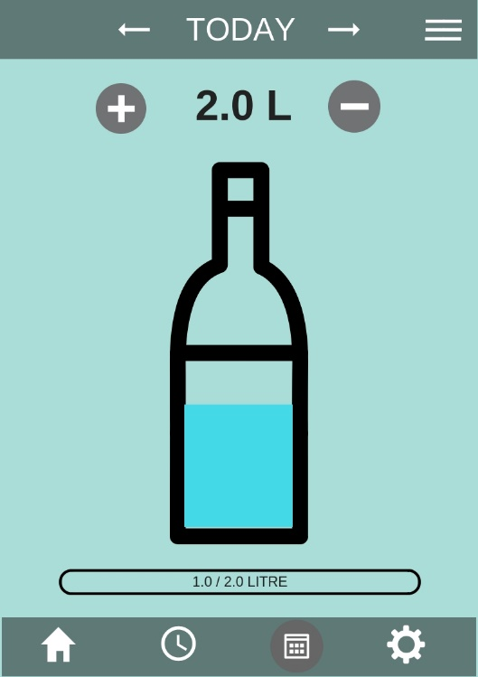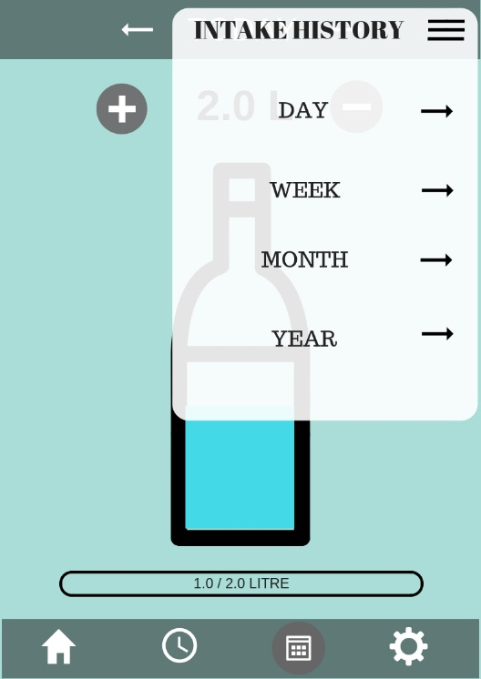
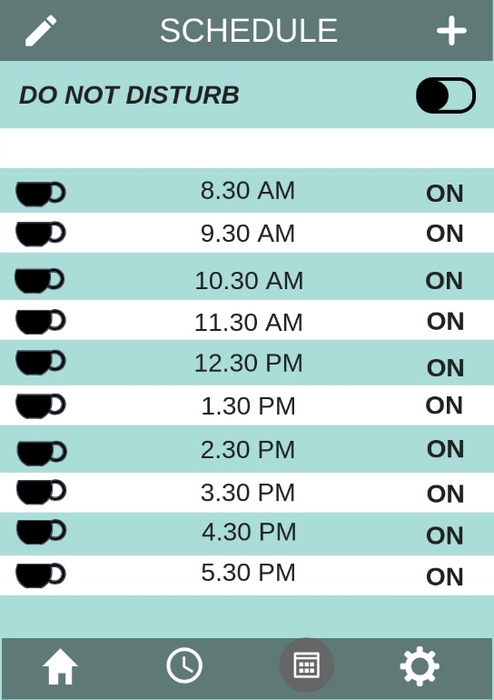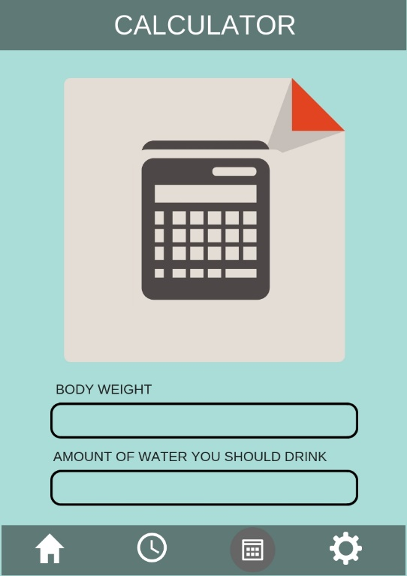
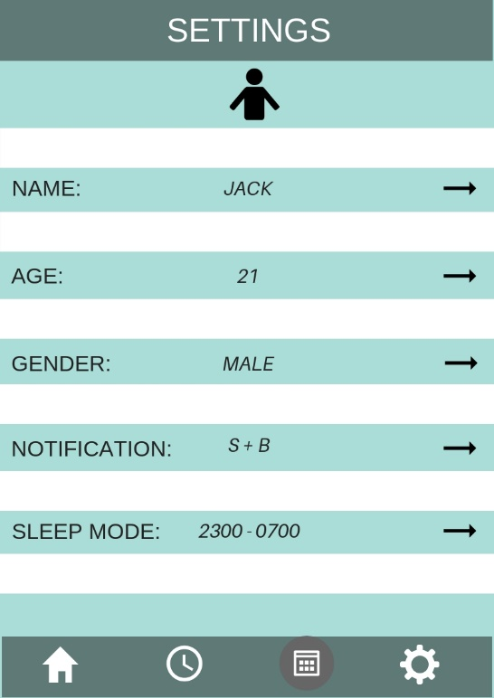
Figure 1: Screenshots of Features in Aqua Intelligent Bottle Application
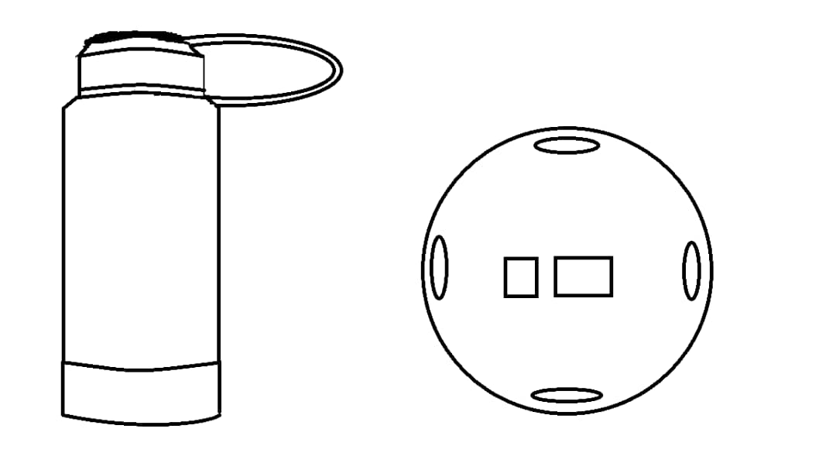
Figure 2: Design of Aqua Intelligent Bottle
- USER STUDY
To further investigate the users’ problem and requirements, interviews are conducted through both scheduled and short spontaneous (intercept encounter). The interviews are conducted with two groups of individuals: public and targeted interviewees. Interviews are conducted to get information of the users’ needs. Apart from the users’ need, we also interviewed students from Mechanical Engineering to get their opinions on industry-related issues, their acknowledgement on similar products, the designing of product.
Findings and Discussion Obtained from Interview
Background of Interviewees
Interviewees are divided into two major groups: public (intercept encounter) and students from Mechanical Engineering (scheduled and targeted). A total sample of 20 interviewees, age ranging from 19 to 60 is involved in this user study. As shown in Figure 1, the interviewees are from different occupation background which indicates the Aqua Intelligent Bottle is designed for all walks of life regardless their age group or occupation.

Figure 3: Background Study of Interviewees
Identifying Problems Faced by Public Related to Drinking Water
The most common problem that faced by most of the interviewees is that they tend to forget of drinking water when they are focusing on certain tasks. Problem that matters them the most is that they do not have the acknowledgments of how many exact water to drink everyday yet they only drink water when they feel thirsty due to forgetfulness. This can be observed by seeing their water bottles are still almost full after they have completed certain task.
Industry-Related Issues
The idea was analyzed by the targeted interviewees. Based on the interviews from Mechanical Engineering students, the interviewees have provided us some opinion on the materials that we should use in this product. The interviewees have suggested us to use BPA-free plastic in our product as it is considered low cost, light and safe to be used. They also suggested some common problems such as handgrip point so that users can easily grip their bottles firmly. Some of them show concern to the position of microchip to be implemented in this product to ensure its safeness and user friendliness.
Acknowledgement of Similar Products
From the user study, majority interviewees from both groups were not aware of any similar products to Aqua Intelligent Bottle. Some of them have awareness on mobile application that act as an alarm to reminder oneself of drinking water. There are also smart water bottles that will records the amount of water filled in everyday to indicate the amount of water that one drank. However, they have never heard of an embedded application that is connected to the water bottle so that user can customized their own routine.
User Feedback
Most of the interviewees show their interests and concern on the given idea. They are comfortable with the idea and think that it should be executed in the future. However, there are some concerns and worries from the users. They are willing to use the products as long as it will not interrupt and bring troublesome to their daily lives especially for those who are schooling and working. Some of them show concern on the size of the water bottle so it is easier to carry around.
- BUSINESS ANALYSIS
Evaluation of Aqua Intelligent Bottle continues with business analysis using SWOT (strengths, weaknesses, opportunities, threats) approach.
Strengths | Weaknesses
- User-friendly as it can be customized  - Ease the forgetfulness in drinking water | - High cost due to implementation of microchips in water bottle
Opportunities | Threats
- Can be further improved to be commercialized | - The microchips can be spoilt if users did not take care it properly

- CAPACITY BUILDING AND SOFTSKILLS DEVELOPMENT
Throughout this program, we have gained many experiences and soft skills which help us for better adapting in this fast-changing world. We have gained leadership skills when we are leading our group members in particular task that we are good at. We learned how to build teams, resolve conflicts and create the desired culture. We also learned how to work in a team and appreciate the value of joining forces to accomplish our same goal. We understand how important it is to work in partnership with others instead of working alone.
We also understand that communication skills are very important in our lives, may it be verbal communication or nonverbal communication. We learned how to speak clearly to deliver our message precisely to both our group members and the users. We also realized that projecting the positive body language and facial expressions are very important, too.
- REFLECTION AND CONCLUSION
In this project, we manage to strengthen our soft skills, competencies and abilities so we can achieve our personal goal and potentially overcome the causes our exclusion and suffering. We learned to be more flexible and adaptable. We are willing to go for the extra miles to show our commitment in this project and to perform our works with excellence.
During the discussion, we have gained the ability to build and maintain relationships, be tolerant, develop rapport and use diplomacy. While conducting interviews, we also learned how to accept constructive criticism, be respectful regarding opinions of others and empathize with them.
The discussion on Aqua Intelligent Bottle and the application reveal the contribution of this innovative product to the users’ problem. First and foremost, it gives clue users for better understand of the amount of water they should drink every day. Aqua Intelligent Bottle can also ease the problem of users’ forgetfulness in drinking water due to over concentrating on certain task. This can prevent them from getting themselves dehydrated. Features offered in this product offer assistance and solutions to the existing problems that might bring harm to our body health.

