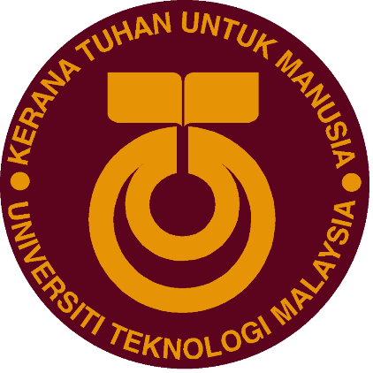

SCSP 1513
TECHNOLOGY AND INFORMATION SYSTEM

INDUSTRIAL VISIT 1:
CENTRE FOR INFORMATION AND COMMUNICATION TECHNOLOGY (CICT)

LECTURER:
Dr Azurah Abd Samah

SUBMITTED BY:
Tang Kuan Yew (A18CS0261)
Irfan Azim Ismail bin Ismawi (A18CS0077)
Md. Farhan Ahmed Rinku (A18CS4015)
Shazwani Farzana binti Saharudin (A18CS0243)

Semester 1 2018/2019
1.0 INTRODUCTION
As one of the top-tier research universities in Malaysia, Universiti Teknologi Malaysia (UTM) prides itself to provide the best quality education and services to all of its students. Nowadays, internet and its infrastructures are considered as the utmost important components to complement students’ virtual and online learning process in order to keep up with the growth and changes that happened nearly every second in our world.
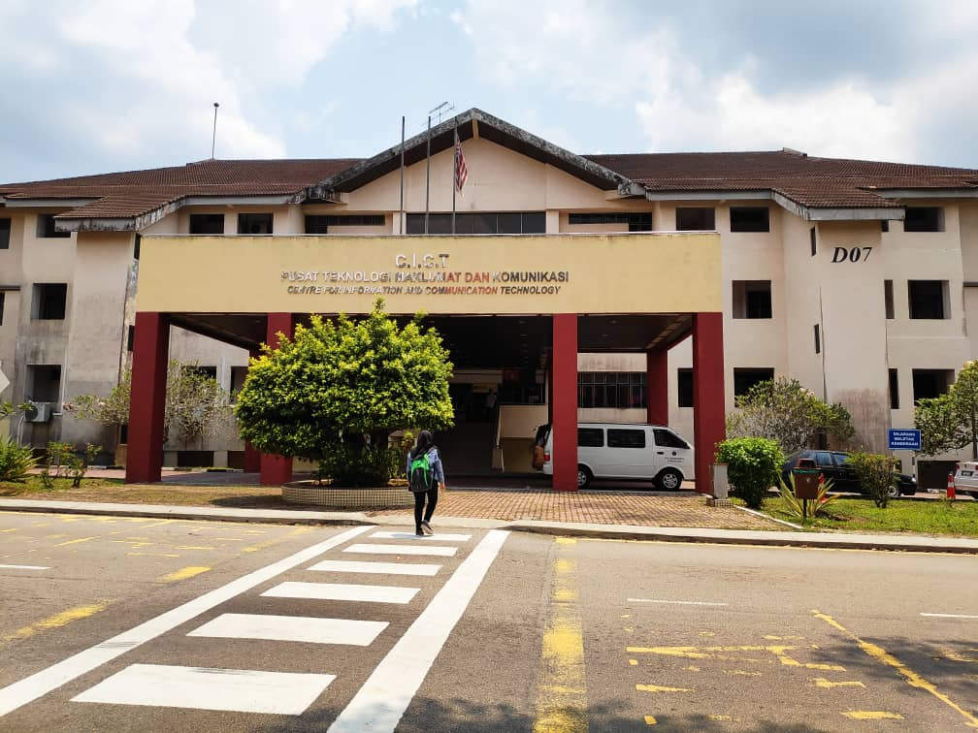
Figure 1: Front Building of CICT
Centre for Information and Communication Technology (CICT) started its operation as a computer center in 1975 where it used only IBM 390 framework. After a while, the framework was upgraded to IBM 4341 to cater the needs of university and to run system VM/SP5. In 1988, the center was temporarily located in Faculty of Built Environment. After 2 years of surveying and testing, CICT once again upgraded the framework to IBM 3090-12J with various new added systems such as student financial system, student exam system and etcetera.

CICT is built not only to serve, facilitate and provide UTM students with all-rounder ICT infrastructures and services but they also have plethora of other responsibilities to develop information and communication technologies. During our industrial visit, we learn that CICT also offers and delivers ICT services to UTM staffs for example system to support administrative works and academic activities.
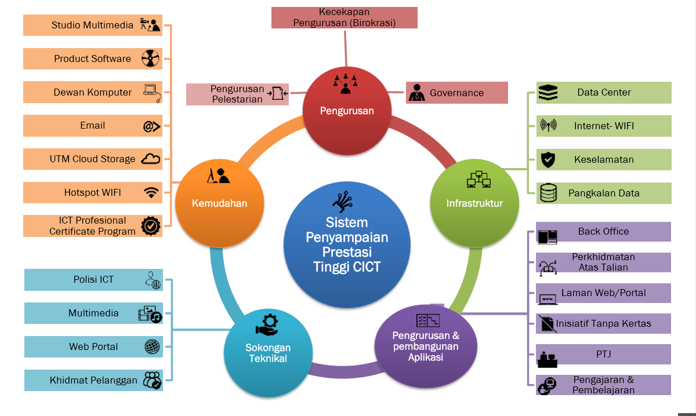
Figure 2: An overview of CICT system
In addition, CICT is also responsible for the system development of the web application that widely used by the both UTM students and staffs like UTM portal, UTMACAD, UTMFIN, UTMHR and others to cater the needs of UTM students and staffs. This is just a general overview of how CICT works. Additional aspects and responsibilities of CICT that will be further discussed in details below.

2.0 DETAILS OF JOURNEY
At 2 in the afternoon, all students are required to gather in Seminar Hall which located at Level 4 in CICT and register each of our matric card for attendance purposes. Our industrial visit started at around 2.15 p.m. and was begun with a short briefing about CICT. Our visit was leaded and guided by Mr. Mohd Zahari Zainal Abidin, an assistant IT officer in Infrastructure and Operation Management-Customer Relationship Management Department and at the same time a member of the helpdesk team.
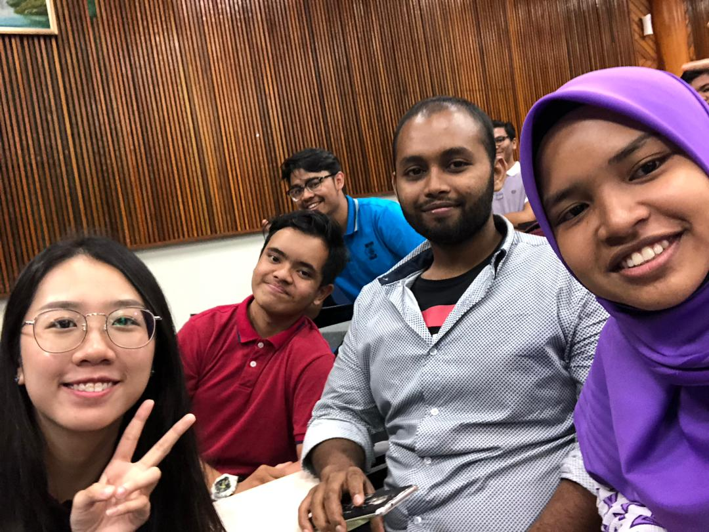
Figure 3: Our group in CICT seminar hall
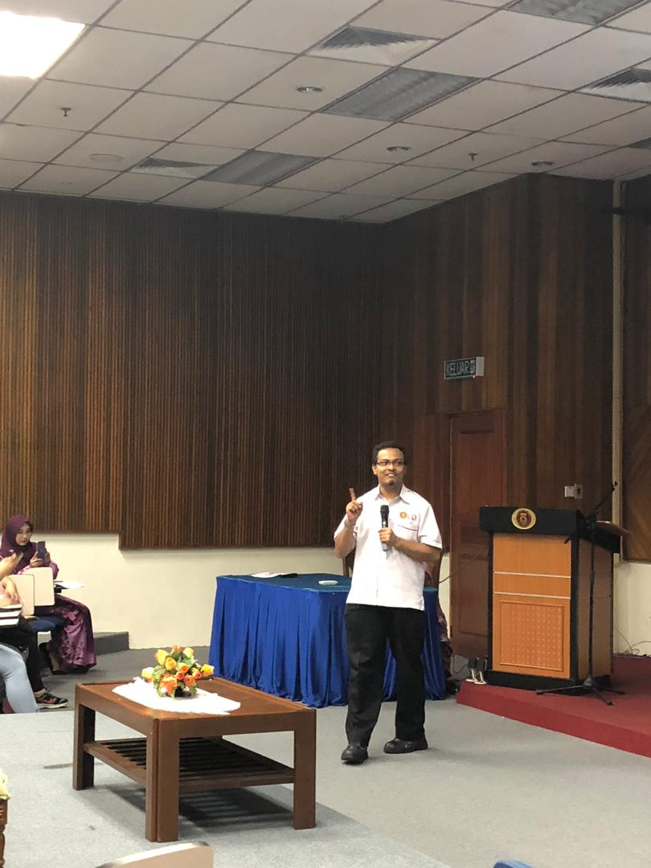
Figure 4: Mr. Zahari was giving opening speech

Firstly, he talked about the services that offered by CICT such as UTM official student email, what is and how to use Virtual Private Network (VPN), how to acquire a software account, an overview of UTM software center, the process flow of account ID and Wi-Fi zone. On top of that, CICT offers all kinds of facilities available for students such as student lab filled with 100 windows-based computers, project discussion area, printing, scanning, CD/DVD burning services and Specialize Multimedia & Content Authoring Production Lab (SMAL). Mr Zahari stressed and highlighted about the ICT policy and all students should be responsible and obey every policy. Or else, there will be a chance that they will be suspended or kicked out from the university. Hacking, data encrypting activities, use of gambling apps, access to pornographic materials and likewise are strictly prohibited. Then, he explained about the current state of installation progress for UTM hotspot around the campus and the Wi-Fi expansion project that will be executed in the future.
After the short briefing, all of the students were instructed to go to PPICTP (Computer Laboratory) which is located at Level 3. Mr Zahari explained about the overall operation of PPICTP which is for both UTM students and staffs and closes at around 5 p.m. Students can come over here to use the computer facilities for their assignment, homework and discussion with their mates.
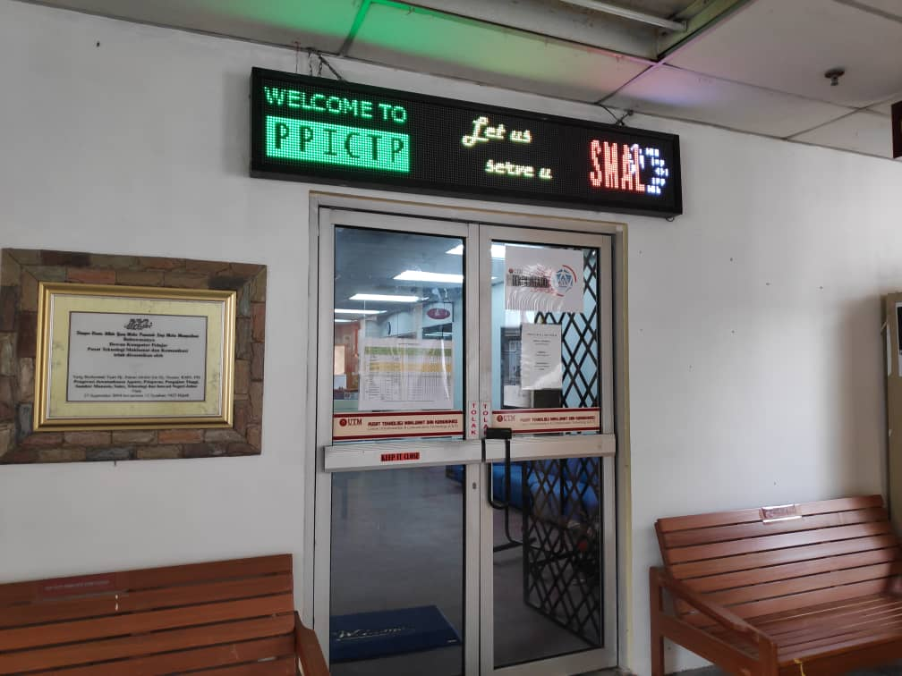
Figure 5: Entrance of PPICTP
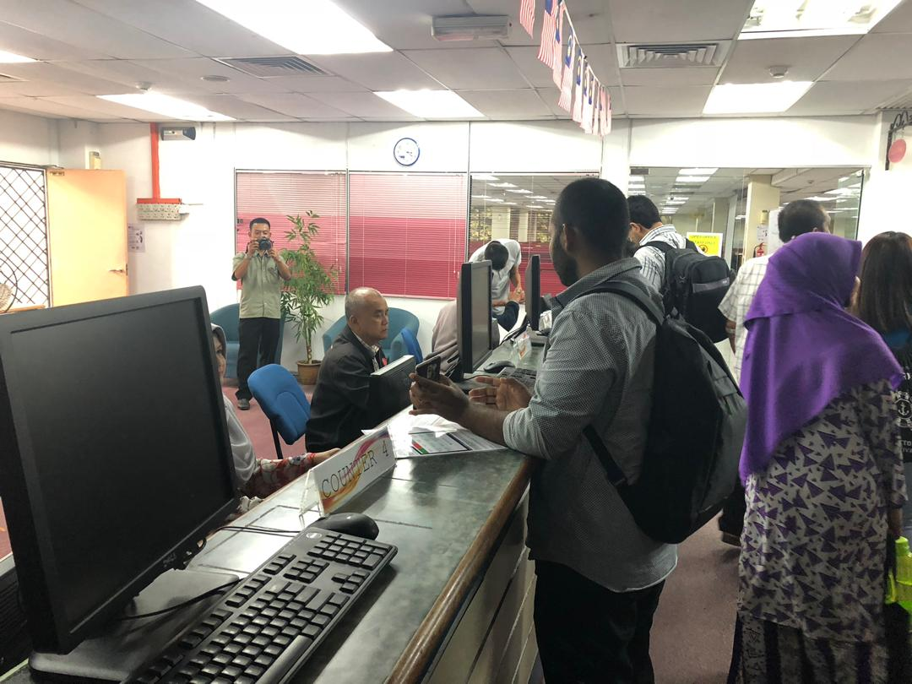
Figure 6: Counter of PPICTP
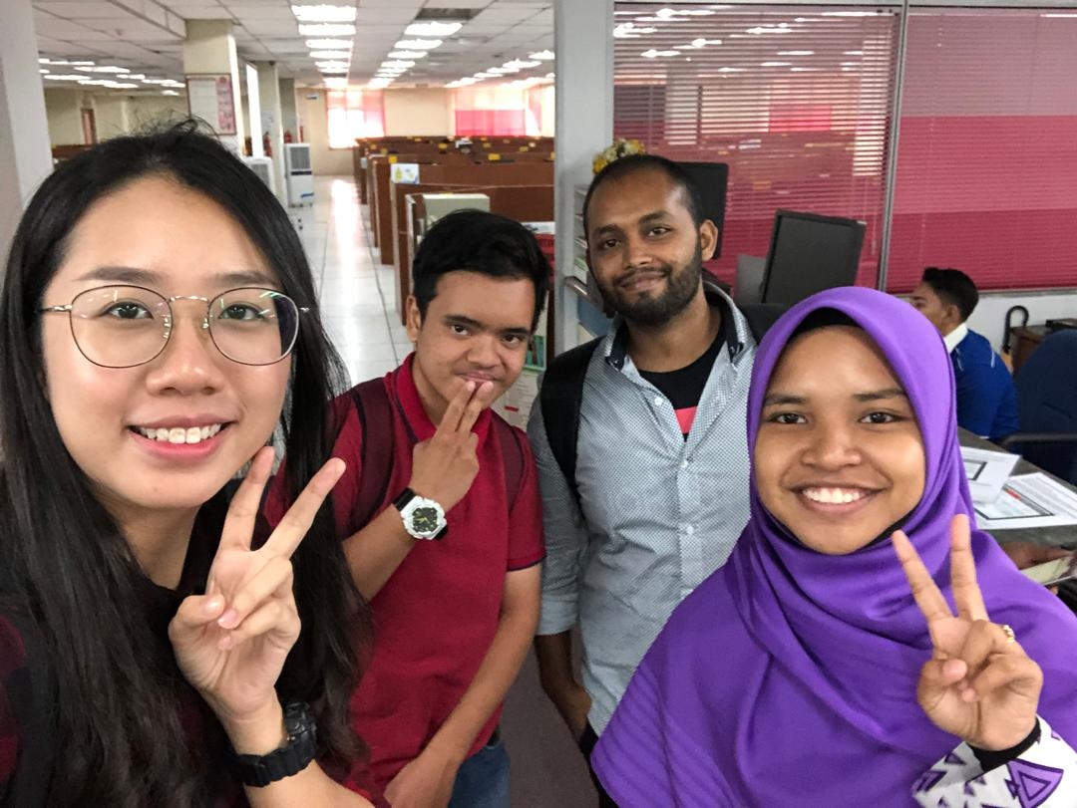
Figure 7: Our group in PPICTP

He mentioned that the PPICTP can be crowded or even fully occupied during exam season. PPICTP also offers free software installation which comes with a license key for all UTM students and staffs. Students or staffs will be required to have a software account and bring their own laptop here. After the approval by CICT staffs, they will install software application that are offered with respective to their needs.

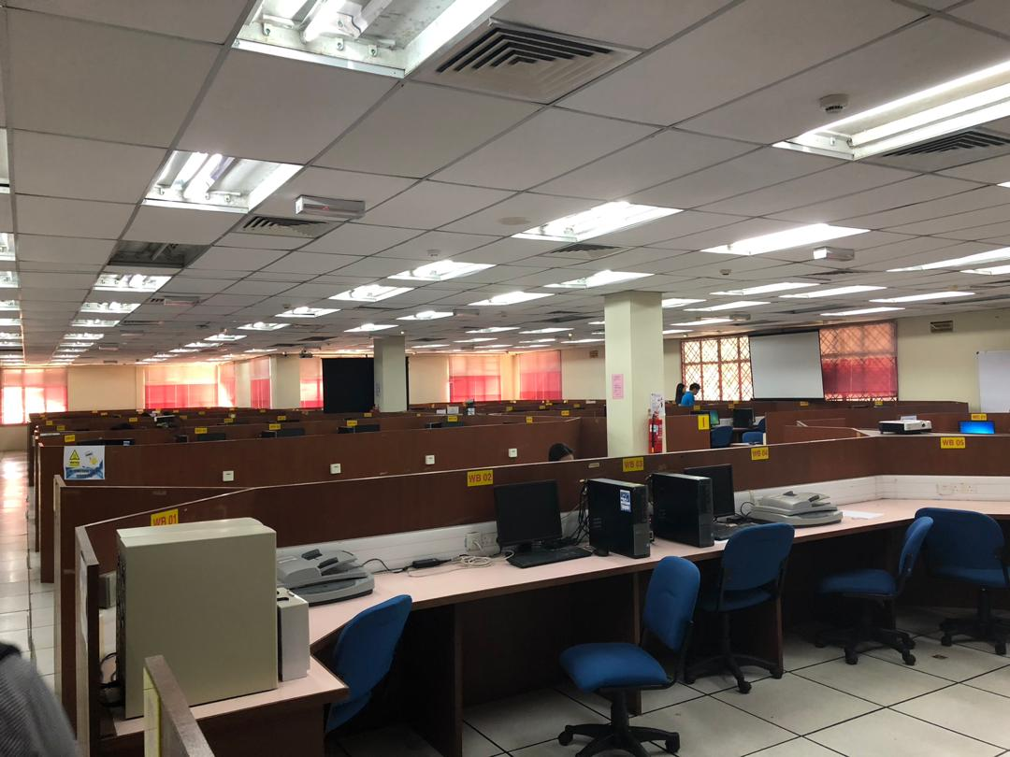
Figure 8: Interior of PPICTP
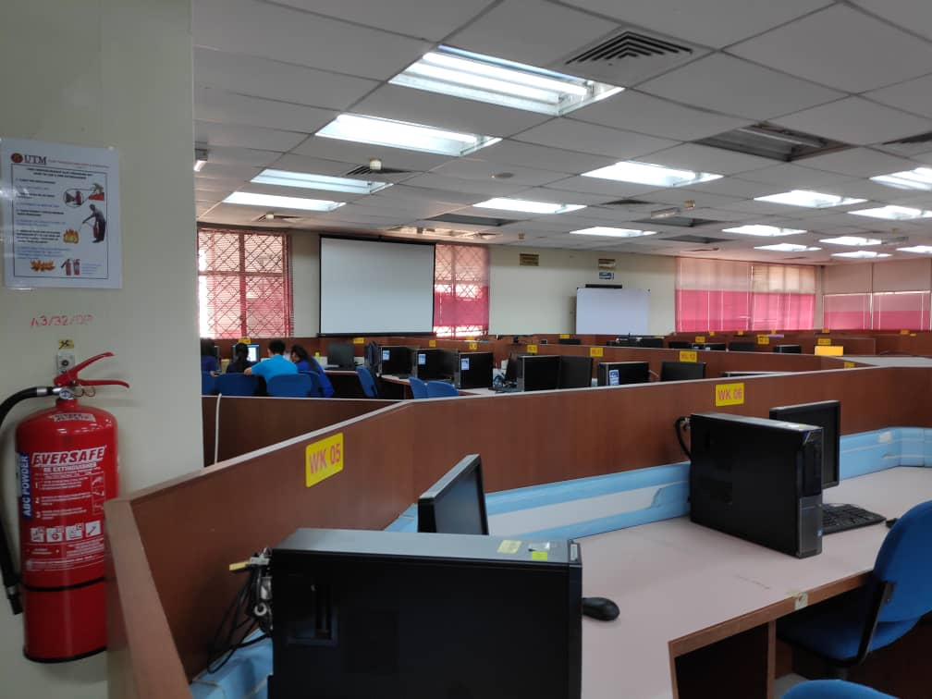
Figure 9: Interior of PPICTP

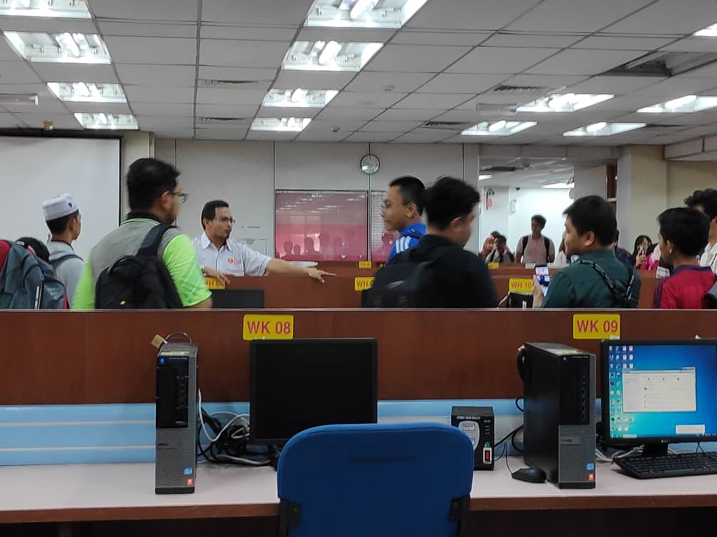
Figure 10: Mr Zahari talked about PPICTP
Next, we marked our last stop of this visit at Gallerium CICT, a gallery with all computer hardware. Here, we managed to feast our eyes with the various kinds of computer components, from classic to modern. There were also some very old model of laptops like the classic Macintosh Powerbook 170, Toshiba Tecra 730CDT, Toshiba Satellite T2400CS and many more.
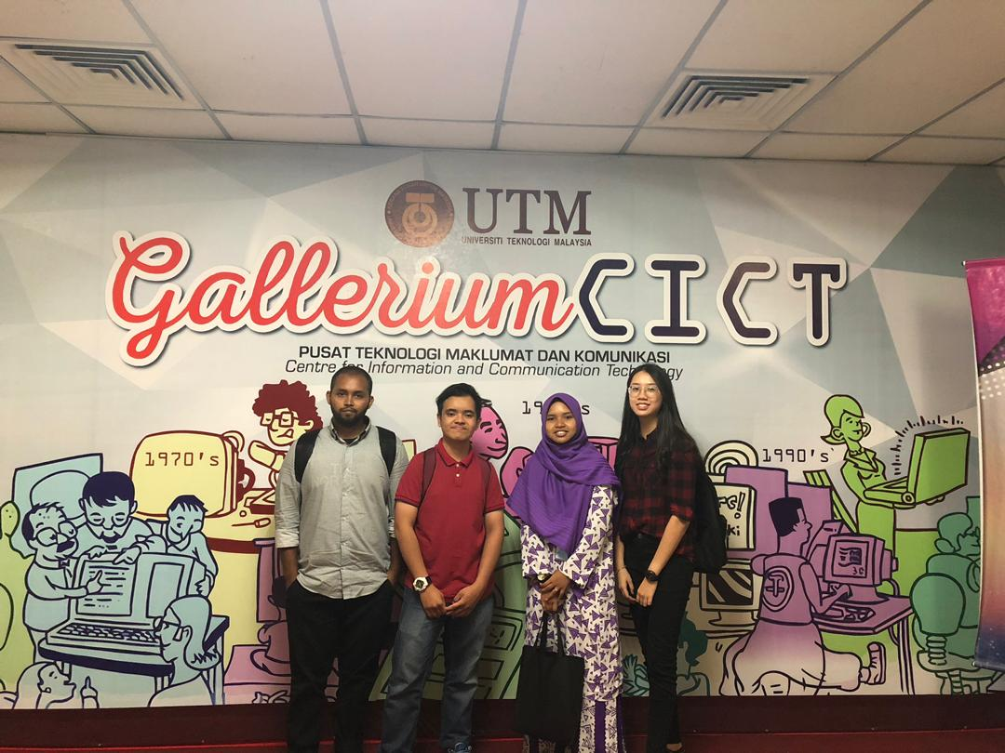
Figure 11: Our group in front of Gallerium CICT

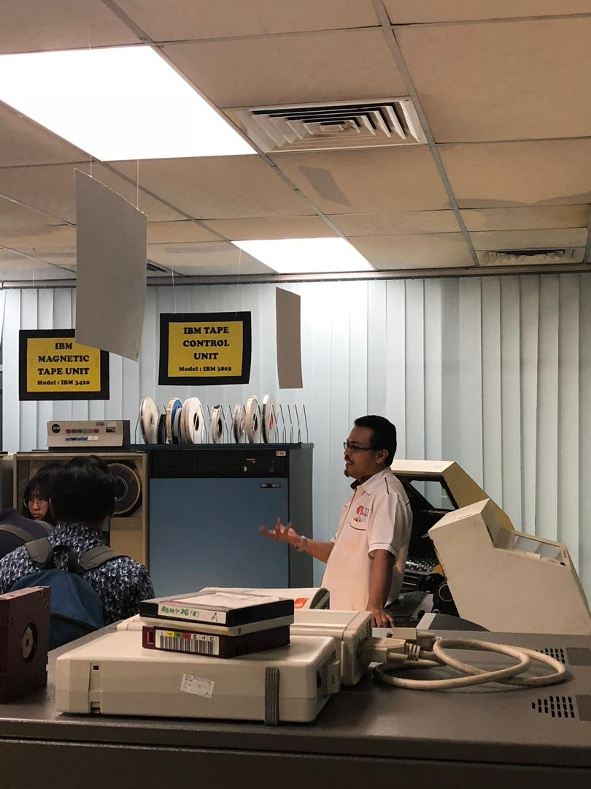
Figure 12: Mr Zahari talked about the evolution of printer
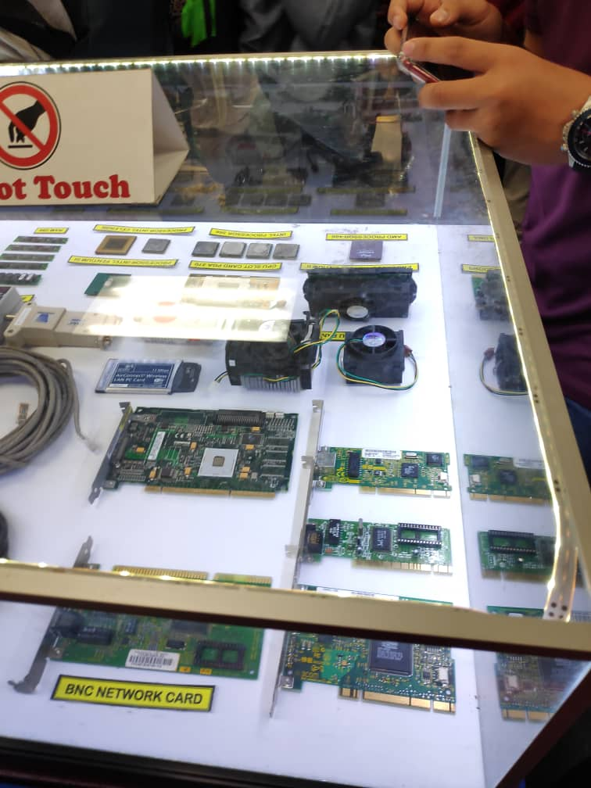
Figure 13: BNC Network Card
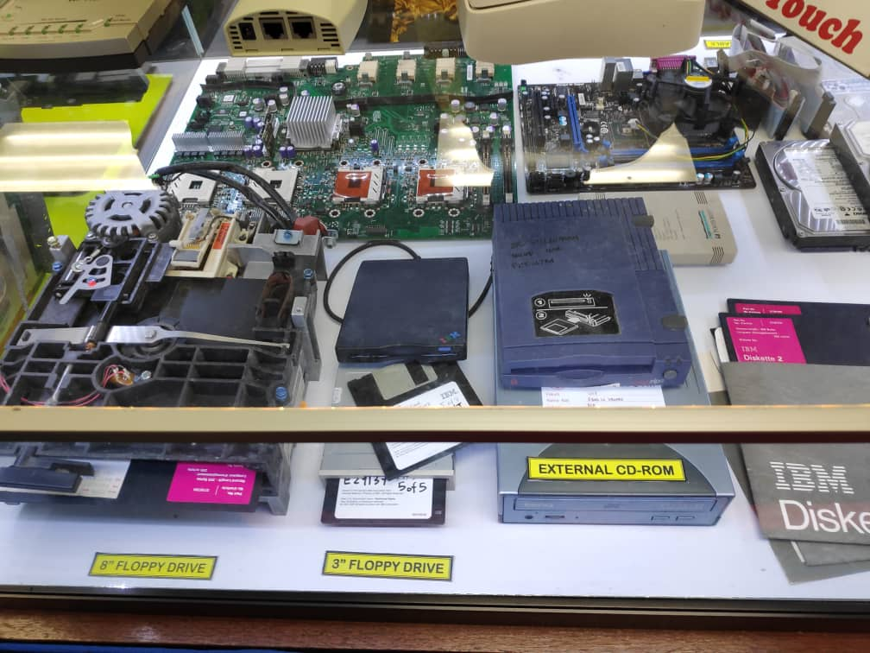
Figure 14: Floppy drives and external CD-Rom

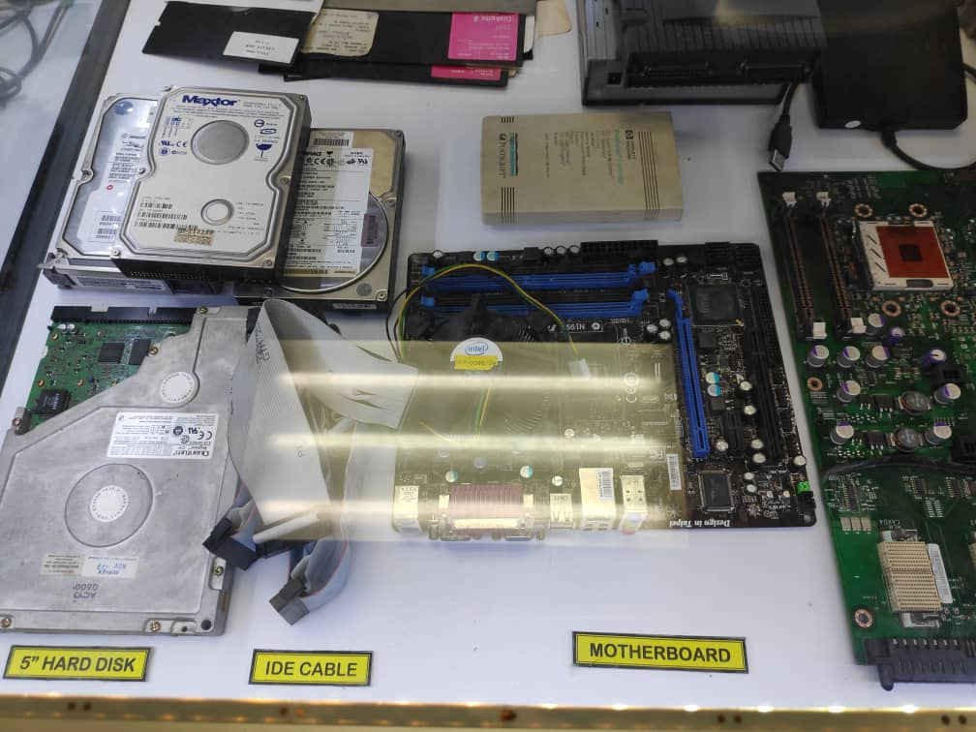
Figure 15: Internal computer components
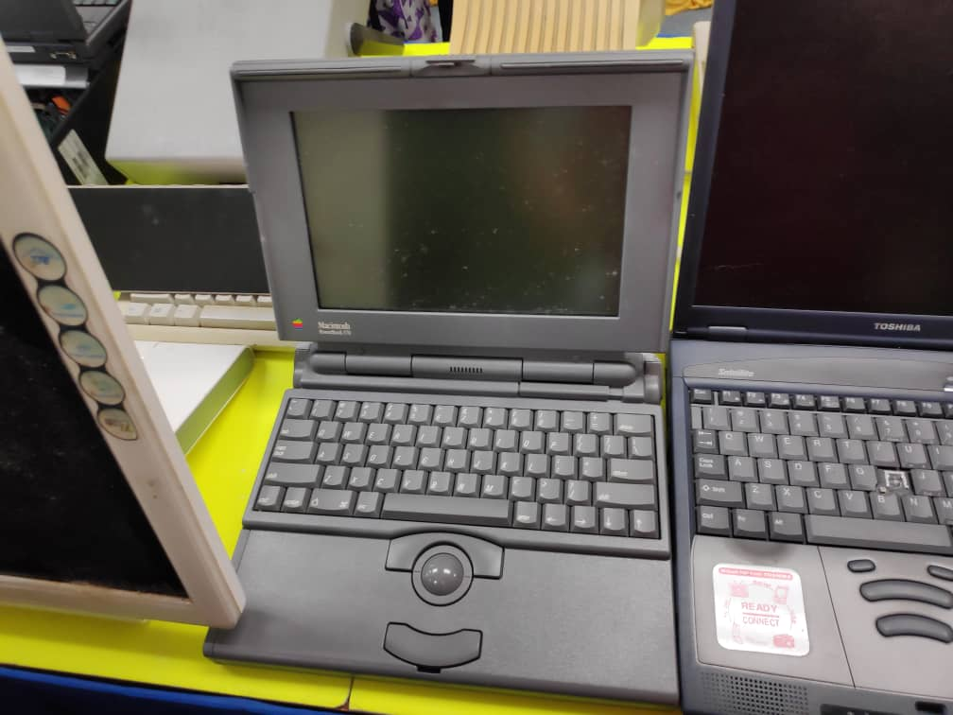
Figure 16: Macintosh Powerbook 170

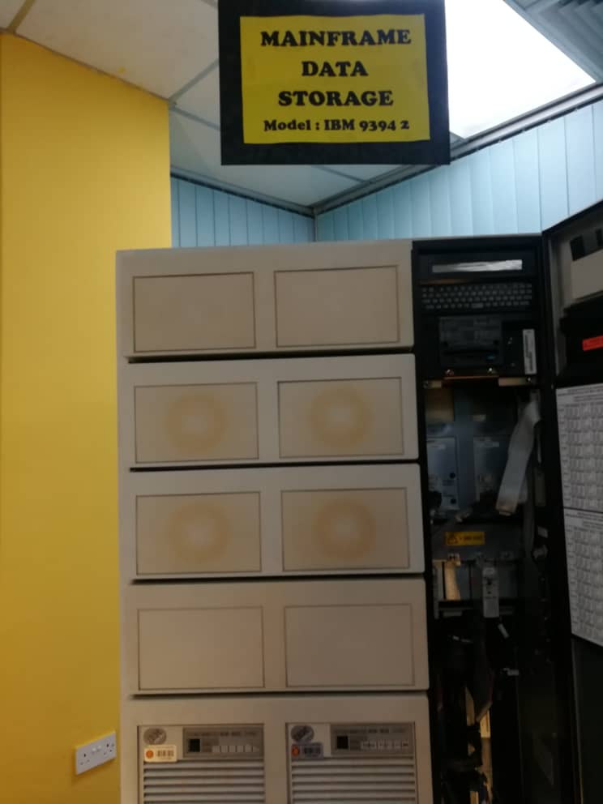
Figure 17: Mainframe Data Storage
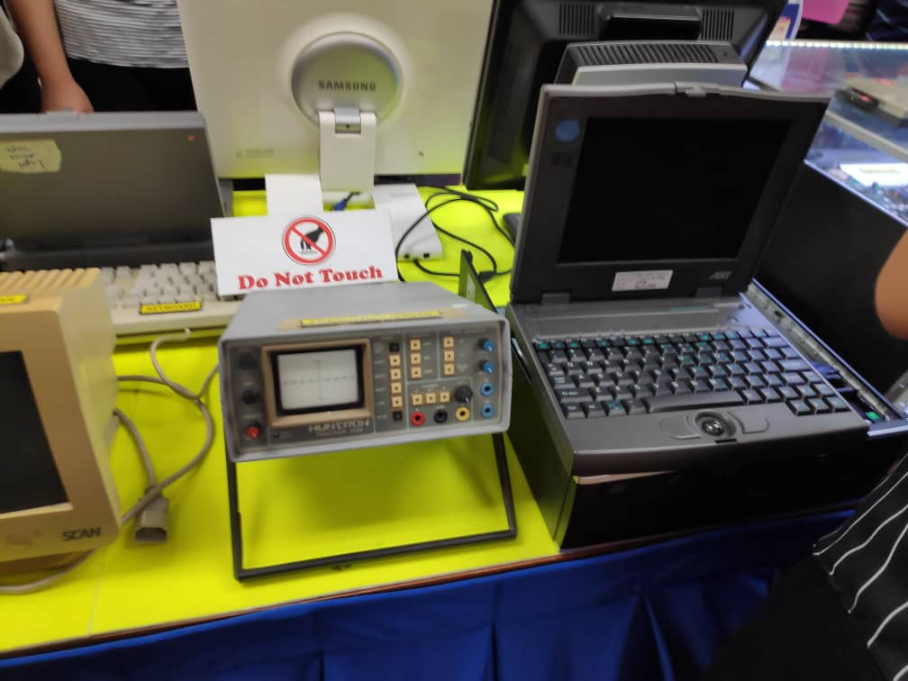
Figure 18: Oscilloscope and laptop
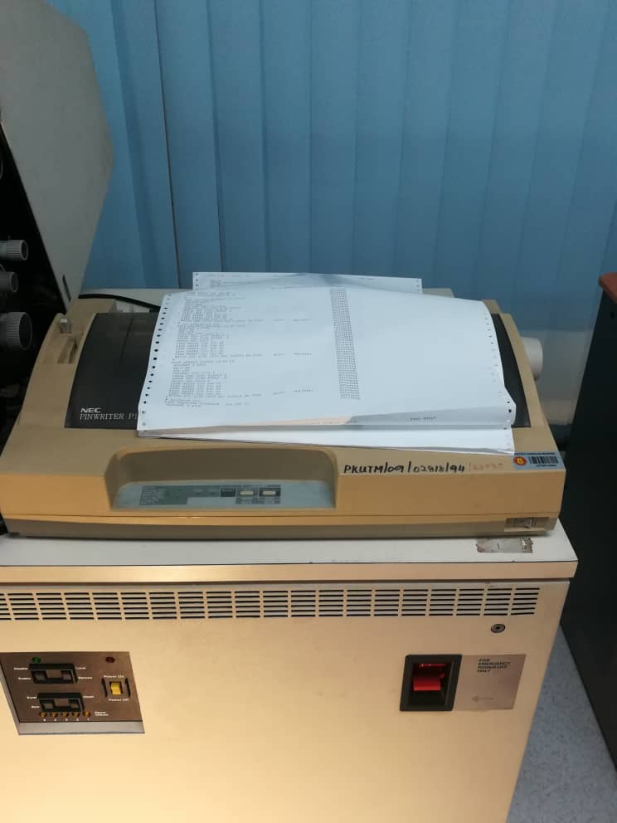
Figure 19: Classic Printer

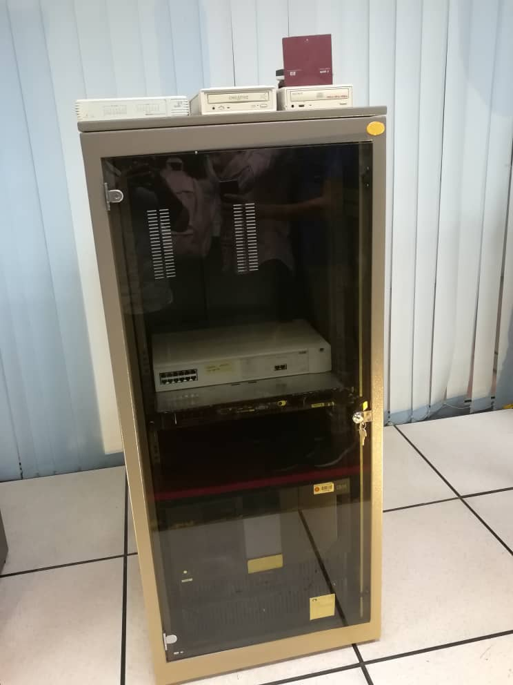

Figure 20: Mount Server Rack

4.0 ORGANIZATION STRUCTURE
CICT is directed by Professor Madya Dr. Mohd Shahizan Bin Othman, who is also the Chief Information Officer (CIO). It is well-organised under different departments including Top Management, Project Management Office (PMO), Strategic Management (SM), Infrastructure and Operation Management (IOM), Application Development Management (ADM), Business Development Office (BDO), Corporate Management (CM), Synergy Staff, IT Manager, IT Academic Fellow and CICT Kuala Lumpur Campus. All departments are leaded by different person-in-charged and are assigned with different tasks and job to ensure the quality of work as certified by ISO 9001:2015.

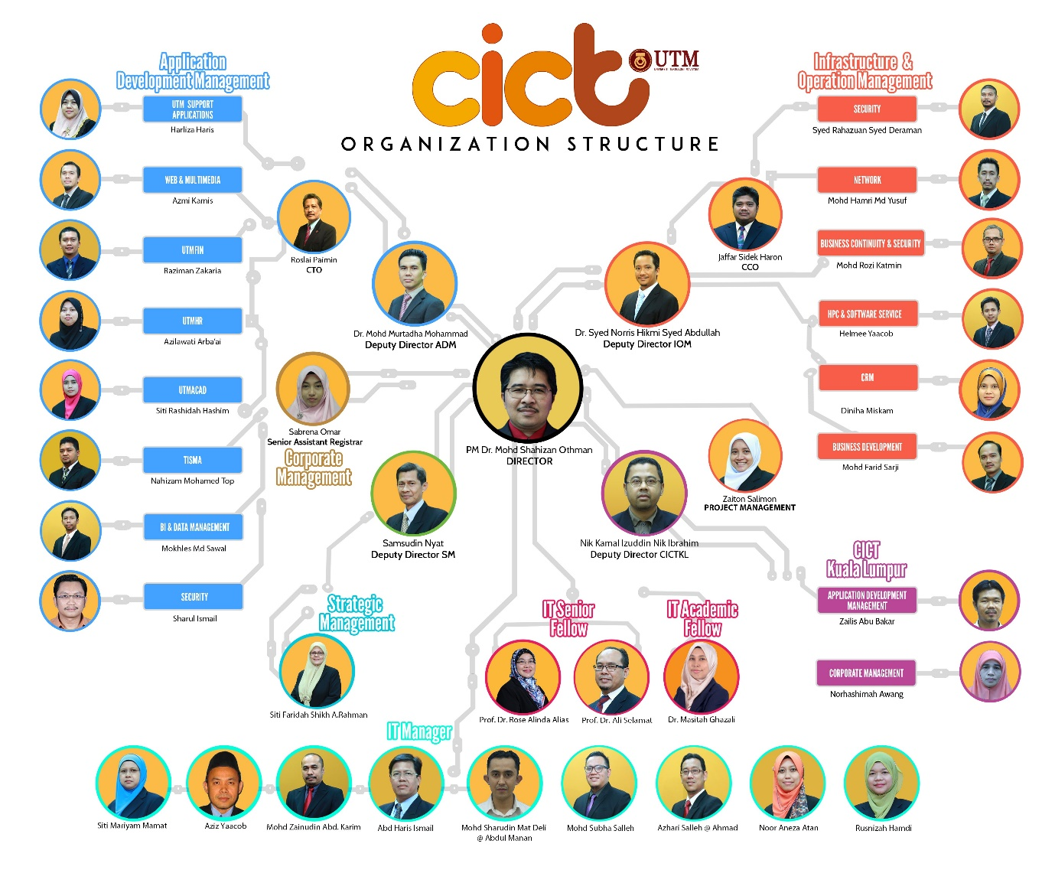
Figure 21: Organization Structure of CICT (source: http://cict.utm.my/organization-structure/)

5.0 SERVICES PROVIDED BY CICT
Generally, services provided by CICT is divided into 4 major categories, which are infrastructure & security, application development, software and facilities to serve all staffs and students. Students from UTM get to enjoy services from CICT in many aspects.
5.1 Student Lab
One of the students’ most frequent used facilities in CICT is Student Lab. In Student Lab, dress code of all students is strictly observed and wearing of matric card is compulsory. Student Lab provides over 100 Windows Platform Computer for students to deal with their stuff, 3 project discussion areas, and also printing, scanning and CD/DVD burning services. There is even a Specialize Multimedia & Content Authoring Production Lab (SMAL) for students to do quality filming and editing.

Figure 22: Facilities and Software Available in SMAL CICT

5.2 UTM ID / ACID
From batch of 2017/18 onwards, each new UTM student entitled to get once registration for their UTM ID (as known as ACID), UTM email and software account under CICT. On registration day, students will get to register their UTMID which will then be used to access Portal MyUTM (my.utm.my), UTM mail, software account, access from outside UTM (VPN) and UTM Wi-Fi. Once students have activated their software account, they can download all UTM license software for free such as EndNote, Matlab, Simul8, Mathematica and etcetera.

Figure: UTM ID Used to Access Others Features

5.3 UTM Wi-Fi
Starting from mid-2018, CICT has been working hard on the Wi-Fi expansion project at each UTM residential colleges. Up to 31 August 2018, CICT manages to create 100% coverage of Wi-Fi accessibility with total of 1600 access points. CICT’s effort is to make sure the Wi-Fi service provided is enough to sustain the high demand bandwidth and quota usage. Office of CICT monitors the Wi-Fi network connection of all users for security, legal and troubleshooting purposes.

5.4 Virtual Private Network (VPN)
CICT develops a VPN (vpn.utm.my) for staffs and students to access UTM intranet services from outside UTM campus. All registered students can access UTM intranet services such as UTMOnline, software repository and databases from UTM library via VPN if they are located out of the campus. Users have to input their own UTMID to login to the VPN.

5.5 Portal MyUTM
Portal MyUTM is a one stop student service maintained by CICT to access services including E-learning, activity list, college parcel, Graduate Studies Management System (GSMS), hostel, E-Portfolio, student evaluation of teaching, student registration, software centre and job on campus. All students have their own distinctive User ID (ACID) once they have registered their program through respective faculty. The User ID allows them to login to Portal MyUTM (my.utm.my) before they could proceed to further access of other services.
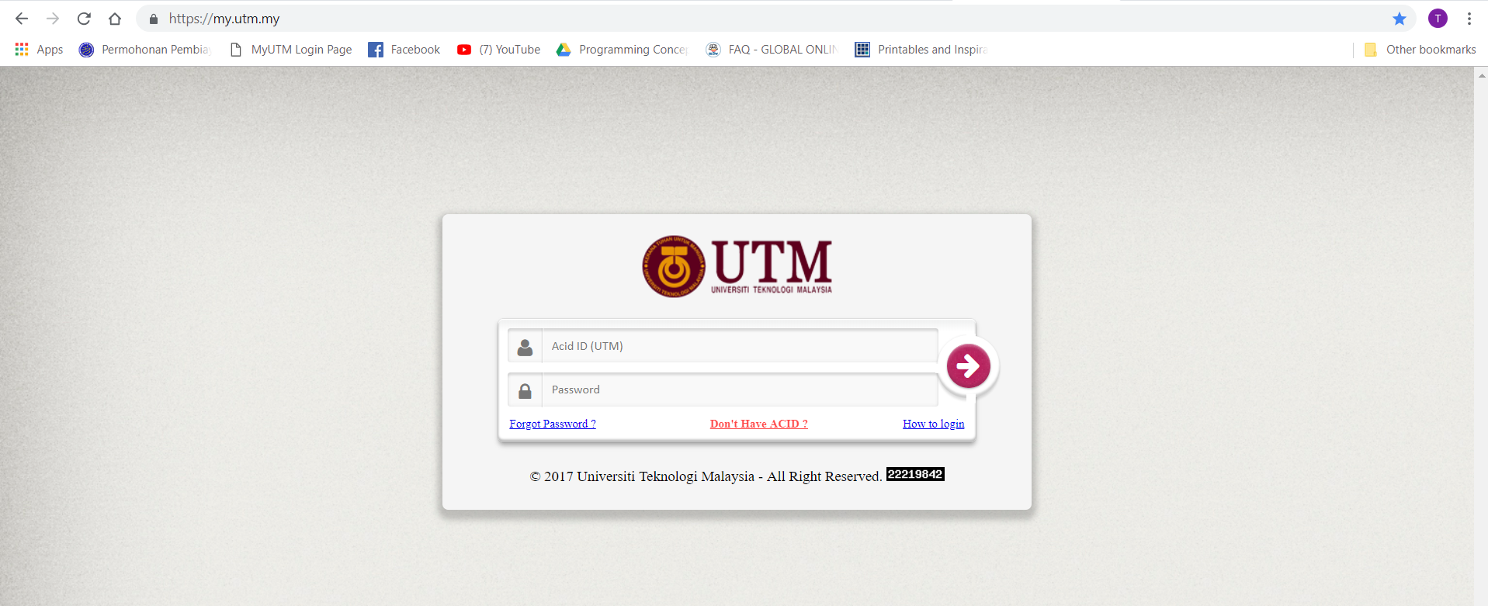
Figure 23: Portal MyUTM (source: https://my.utm.my/)
One of the most important features in Portal MyUTM is E-learning. E-learning act as a connecting bridge between lecturers ad students in the university. Lecturers can upload their teaching slides in case students need to revise their past lessons after class. Meanwhile, students can also summit their assignments to respective lecturers via E-learning.
To assist students by setting up their own portfolio, CICT provides E-portfolio as a platform for online compilation of all documents which act as evidences to show students’ development. Students get to report their achievements on academic, technical and generic skills and plan their personal development.
CICT also introduces Lecturer’s Teaching Evaluation (E-PPP), a web application for all full time and part time students to evaluate their lecturers and give comments based on the teaching performances. E-PPP allows students and lecturers to build a more comfortable teaching and studying environment together.

6.0 ACHIVEMENTS
Since the establishment of CICT, they have received several awards which act as a benchmark for their services’ quality and the team effort of all staffs. Achievements by CICT are as following:
- SIJIL PEMATUHAN SAGA (Standard Accounting System for Government Agencies) 2017 from Jabatan Akauntan Negara Malaysia
- PTJ Paling Aktif Senamrobik Perdana Siri 2/2017 bagi Zon Arcturus

7.0 INFORMATION SYSTEMS DEVELOPED / MAINTAINED BY CICT
CICT has built and managed Administrative, Support, Multimedia, Teaching and Learning Applications for UTM to improve university’s quality and efficiency in service delivery. CICT develop new application in mobile or web form such as UTM Smart and UTM Bus Tracker to fulfil the needs of staffs and students.
CICT also maintain the current UTM application base upon request of UTM Management. For example:
- UTM Acad
  - Applications related to the announcement of UPU result
  - Online Admission Applications to a postgraduate program
  - Applications for former students to print their online academic transcript
  - Applications related to the management of academic governance, undergraduate and postgraduates students
- UTM Fin
  - UTM Financial Management System services
  - Student Account Management System services
  - Online Payment System
- UTMHR
  - Registrar Office system services
- UTM Support System
  - Teaching and Learning Counter Statistic Information
  - PHB system services
  - HEMA system services
  - UTM Lead system services

Figure 24: Key Feature of systems developed / maintained by CICT

Figure 25: Tools & Technology Used by CICT

8.0 JOB OPPORTUNITY
As the information and communication technologies evolved aggressively from days to days, the expertise and specialist needed also changed. CICT will always need roles like IT technician, web developer and computer scientist to maintain, develop and improve the facilities and services offered but the prominent and important roles like computer or technical support specialist need to provide technical support and resolve any common problem by troubleshooting the problem because it involved the relation and customer feedback. Parallel to the CICT future plan to be involved in Industrial Revolution 4.0 that consists of Internet of Thing (IoT) platform, cloud computing , augmented reality and big data, CICT might need other new job roles in any form or kind to successfully accomplish and implemented all of these features in the future. These are some of the specifications and the job opportunities that requirements in IT career in CICT.

8.1 IT Technician
IT technicians diagnose computer problems, monitor computer processing systems, install software and perform tests on computer equipment and programs. Technicians may also set up computer equipment, schedule maintenance and teach clients to use programs. Other job duties can include minor repairs and computer parts ordering.
IT technicians need strong knowledge of computers and how they operate, which includes having a broad understanding of hardware and software, operating systems and basic computer programming. Familiarity with electronic equipment, Internet applications and security may also be required. Technicians may also need good communication skills because this position requires frequent interaction with clients.
Many employers prefer to hire an IT technician who has some level of formal training. Future IT technicians can find certificate, associate and bachelor's degree programs in computer science, information technology or computer information systems. Coursework in these programs may cover computer security, hardware configuration and technical support. Students can also learn about database programming, operating systems and software installation.
Required Education | Associate's or bachelor's degree or certificate
Certification | Voluntary; options include A+ certification,  Linux+ certification,  Microsoft certified IT professional certification,  Cisco certified network associate certification,  International information systems security certification consortium certification
Projected Job Growth (2014-2024) | 12% for all computer support specialists
Average Annual Salary (2018)* * | RM 13,289 - RM 47,227
Source: * U.S. Bureau of Labour Statistics, ** Pay scale Malaysia
8.2 Technical support specialist
Technical support specialists provide technical support, advice, and assistance to consumers and businesses with technical, hardware, and software system problems. Specialists generally deal directly with end users and must effectively communicate answers in a way they can understand. The most common problem technical support specialists deal with are connection problems, inabilities to access data, slow performance, and inefficient programs. Some specialists may work on site to modify, install, clean, and repair computer software and hardware.
Technical support specialists must have excellent analytical and problem-solving skills. Having interpersonal skills allows technical support specialists to communicate with customers and solve technical-related problems quickly and efficiently. They also need to have great teamwork skills like being able to help co-workers when needed and working in tandem with co-workers on big projects. On top of that, good memory is crucial to remember hardware and systems specifications and procedures. Excellent time management skills and ability to work under pressure while assessing issues in a timely manner and meeting deadlines is also one of the requirements to be a technical support specialist.
Education | Bachelor's in computer science or related field
Job Duties | Provide technical support, advice, and assistance to customers
Annual Salary (2018)** | RM 23,385 - RM 131,383
Job Growth (2014-2024)* | 12%
Source: * U.S. Bureau of Labour Statistics, ** Pay scale Malaysia
8.3 Network Administrator
Network administrators are responsible for the upkeep of computer hardware and software systems. They usually focus on the network components within their company. In some cases it is the responsibility of network administrators to design and implement new networks. Although some of the responsibilities for network administrators may vary depending on the size and locations of the company they work for, there are still some common responsibilities that all administrators will share.
They are generally in charge of network address assignments, management and implementation of protocols. They also handle the maintenance of networks and file servers. When working for smaller companies, network administrators are also usually in charge of conducting maintenance on computers, printer, routers, smartphones, etc.
Their duties include network monitoring, testing for weaknesses, handling updates, installing and implementing security programs, and evaluating network management software. Network administrators are also responsible for ensuring that the network used by the organization is working effectively and is properly maintained.
Administrators who work for smaller companies also have the responsibility of making sure that licenses are paid for and up to date, checking for security breaches, and maintaining proper installations and applications. In order to become a network administrator it is important to have extensive technical knowledge. It is also important to have a bachelor’s degree in computer science, information systems, mathematics, or another related field.

Required Education | Bachelor's degree in a computer-related field
Certification | Vendor-specific networking certification may be preferred
Projected Job Growth (2014-2024)* | 8% for all network and computer systems administrators
Average annual Salary (2018)** | RM 24,730 - RM 83,589
Source: * U.S. Bureau of Labour Statistics, ** Pay scale Malaysia

REFLECTION
As networking and security students, we are not only dealing with software and programs, but also computer hardware. We need to know how a computer operate, from understanding of hardware and software, operating system to programming. Directly, it will affect our prospects towards our future career as most of us dream to become network security engineers, networking support specialist and etcetera. In this visit to CICT, we get to know how CICT provide services to all UTM staffs and students. We can see how the computer and its ecosystem evolved and improved to be better like today.
It was truly a fruitful and memorable experience for us especially as Computer Security and Network students. From virtual software to real visible hardware, examples shown in CICT give us more pictures and ideas about how a real system works. We have got the chance to know more on how to develop and maintain an organised system or network to handle such a large amount of end-users.
As UTM students, CICT provides us IT services and computer facilities to facilitate our studies. Meanwhile, CICT is also a platform for students to learn beyond the book as we can see real life computer system and hardware in Gallerium CICT. When we are handling a huge project where we need high performance computers or a studio to produce video and montage, we can seek for help from CICT, too.
Through CICT visit, we understand that if we want to improve our potential in the industry, we must sharpen both our soft skills and hard skills. All staffs in CICT are role models to us for their affability and helpfulness which shows that they have a good work ethic. As we can see from CICT, computer systems and information technologies change from time to time. Hence, we must also improve our hard skills by attending training to keep it up to date so that we will not be eliminated.

