

SCSP 1513
TECHNOLOGY AND INFORMATION SYSTEM

INDUSTRIAL TALK 2:
NEW ACADEMIA LEARNING INNOVATION (NALI) 2018

LECTURER:
Dr Azurah Abd Samah

SUBMITTED BY:
Tang Kuan Yew (A18CS0261)
Irfan Azim Ismail bin Ismawi (A18CS0077)
Md. Farhan Ahmed Rinku (A18CS4015)
Shazwani Farzana binti Saharudin (A18CS0243)

Semester 1 2018/2019
1.0 INTRODUCTION
On 26 September 2018, members from Group 4 had visited the New Academia Learning Innovation (NALI) Exhibition and Competition 2018 organised by the Center for Teaching and Learing (CTL) in Dewan Sultan Iskandar (DSI), UTM. NALI 2018 is a platform for the sharing of innovative products in teaching and learning from Malaysia as well as other countries. NALI promotes student-centred learning, multiple learning modes and materials to be in parallel with the learning practices in the 21st Century.
In this year, there are 86 participants from different universities including Universiti Teknologi Malaysia (UTM) as host, Universiti Putra Malaysia (UPM), Universiti Malaysia Pahang (UMP) and others joining this exhibition. From virtual mobile applications to tangible games and prototypes, participants share large varieties of their researches and products.
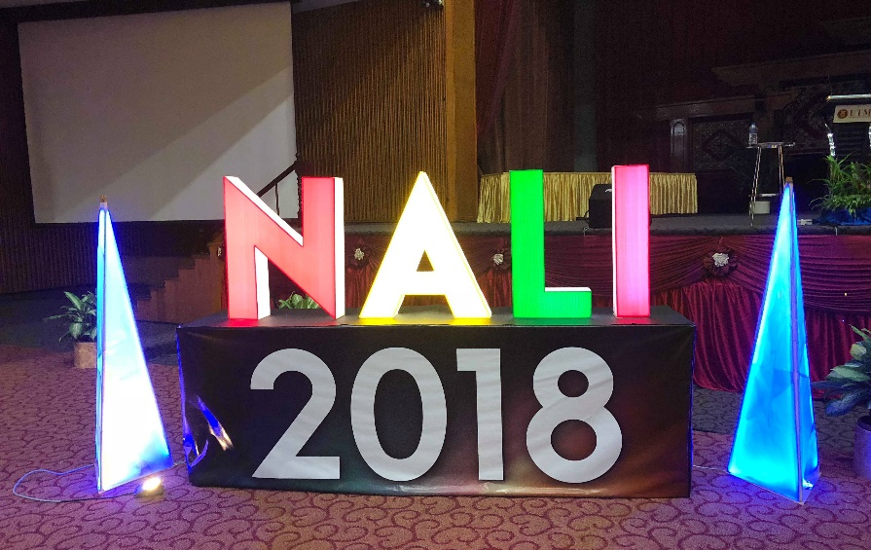
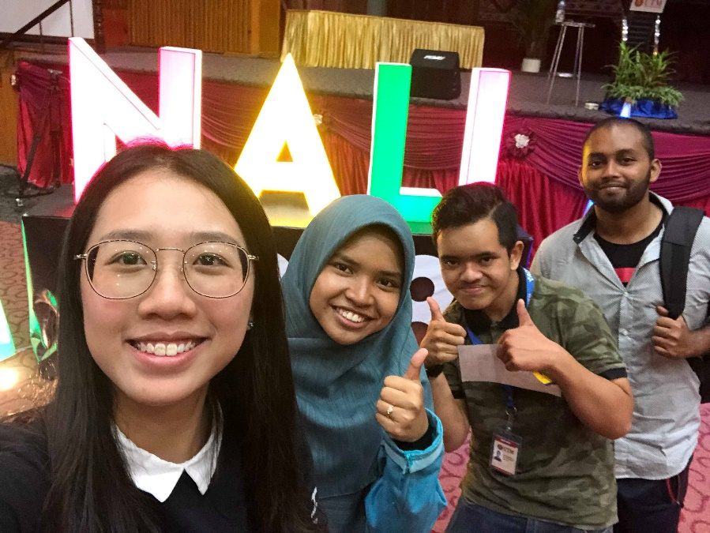
Figure 1 & 2: Visiting NALI 2018
2.0 SUMMARY
NALI 2018 successfully presents spirit of emulation into teaching models and practices. It also provides a platform and framework for all the participants to display their own version of teaching models from all kinds of academic fields in a meaningful and interactive way. The general trend that we are able to observe in NALI 2018 is that most of the learners start to go digital and utilize the resources from the Internet to deliver more efficient and quality education practices to masses. We can also see that some of the projects use augmented and virtual reality technology to increase the students engagement in learning the materials provided.
We can see that each of the projects in NALI 2018 does not compete with each other but intended to complement with each other and to educate as many people as possible no matter their background, races and ages. For example, the Kembara Nombor targets children with mental disability, Google App Online Classroom targets students who currently in their tertiary education and Tangible Education Game targets children currently in their early education. They differ in demographics targeted, levels of education and how each of the projects itself works.

Figure 3: Objectives of NALI 2018

3.0 CONTENT
3.1 EDUTAINMENT MOBILE APPLICATION: KEMBARA NOMBOR
This mobile application was developed in order to facilitate the learning process of primary school students especially those who suffer from intellectual disabilities. The mobile application emphasized the principle of gamification, hence suitable for those who are able to handle a device.
The mobile application had undergone lab test with the targeted users which is primary school students under the monitor of tutors. Based on the analysis, the developer found that the students were more engaged to the using of own avatar. To fulfil the needs of students, the developer had created two avatars to represent male and female. The users can also enter their own names for the avatars. In the design stage, the interface was sketched as storyboard. Further development was made using Adobe Flash, Adobe Photoshop as well as AIR programming.
In this mobile application, there were three stages including learn, game and quiz in order to let the students to recognise number from 0 to 9. As Malay language was used as main language in this application, students learnt not only digit but also the spelling of it in Malay. Specific games were designed to help students differentiate between the most commonly confused numbers such as 6 and 9. To test the students’ understanding, they can go through the quiz where each level of quiz was created based on different level of difficulties. In order to proceed to the next level, they must passed the current level within certain time limit.
Kembara Nombor is ready to be commercialized. It is still waiting for its copyright to be completed. Once it is launched, public can buy it through Play Store and Apps Store with the lowest price, which is targeted to be lower than RM 1.

Figure 4: Kembara Nombor’s App Flow
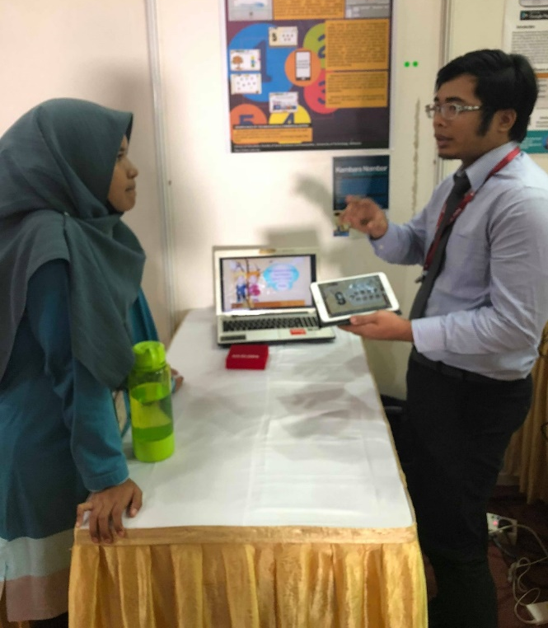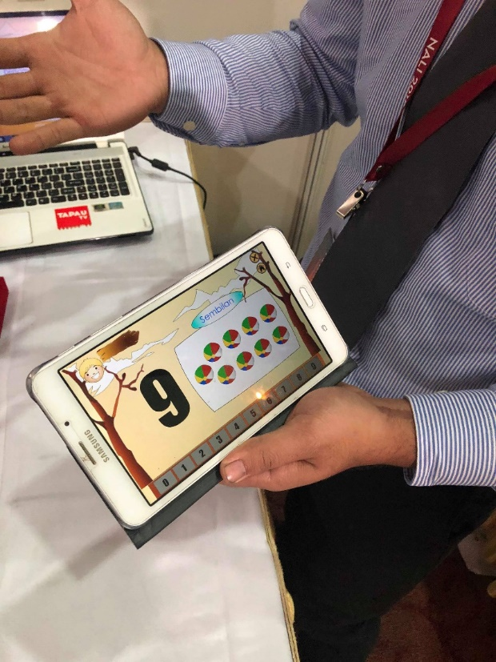

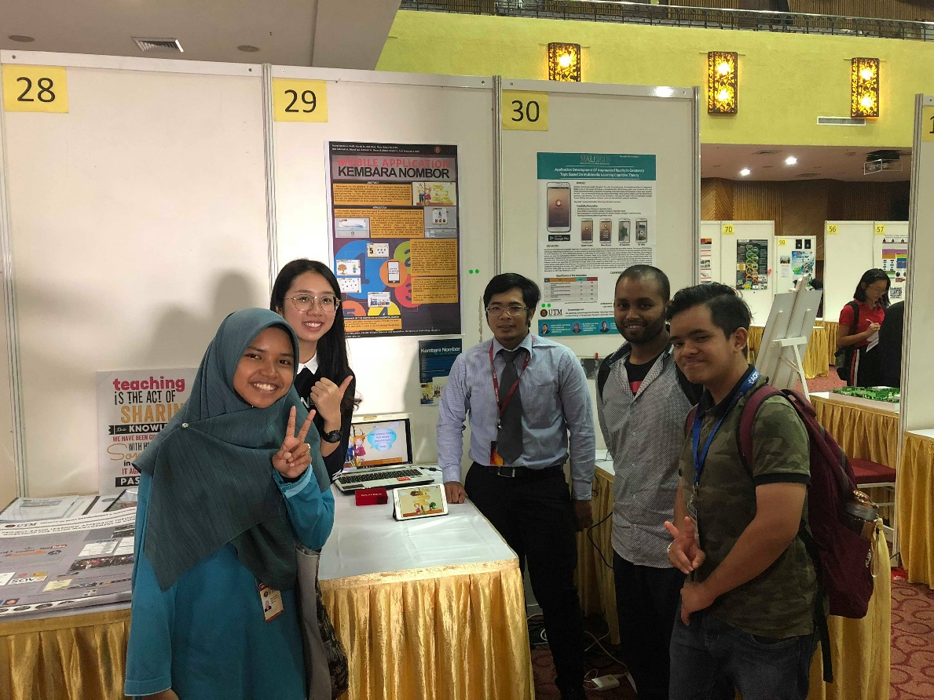
Figure 5, 6, 7: Visiting Kembara Nombor (Booth 29)

3.2 GOOGLE APPLICATION ONLINE CLASSROOM (GAP OC)
Google Application Online Classroom takes an initiative to transform the traditional teacher-centered learning mechanism into a modern student-centered learning to increase the engagement between teachers and students. The objectives of the app is to promote personalized, creative and collaborative student-centered learning model and to empower the students to be able to show off their novelty, creativity and innovative.
The app can be accessed with a personal computer, laptop, mobile phone, tablet or any other gadgets that support Wi-Fi or internet connection. This has allowed teachers and students to be connected and communicated wherever and whenever they need. The registration of account for this app can easily be made with an email and a phone number. This app features class virtualization which will enable lecturers to create virtual class if needed to not only save time and energy but will also allow them to maximize the resources that can be used on the internet. Lecturers can also upload their teaching slides in case students need to revise their past lessons after class.
With this application, students will be able to can help and share information with each other. They can chat and do meeting in hangout or forum. They can even easily create personal group for their assignment to truly focus on the given task. With the built-in schedule and time manager, students will learn directly to effectively manage their time. If students have difficulty in certain subject or need a deeper understanding for a specific topic, they can also have 1-on-1 personal lecture with their lecturers.
GAP OC is available to public and some of the universities in the world have embedded the app into their learning portal. In future, there will be more features for this app to keep up with the times.
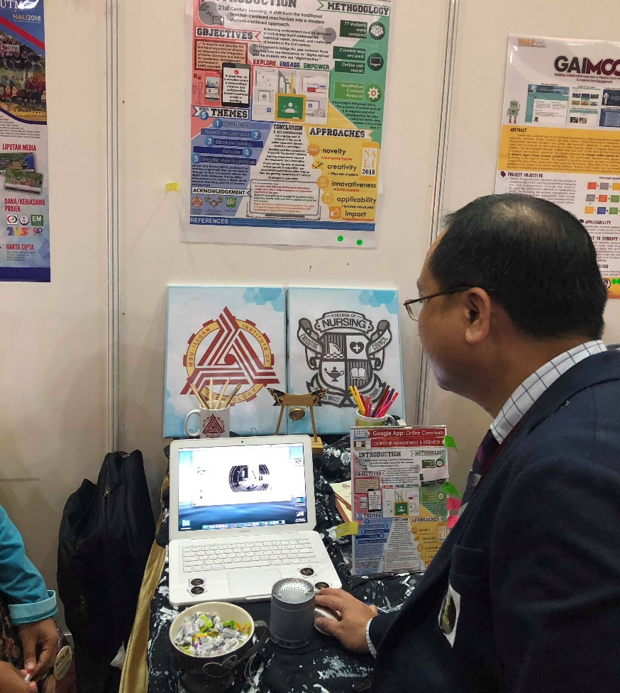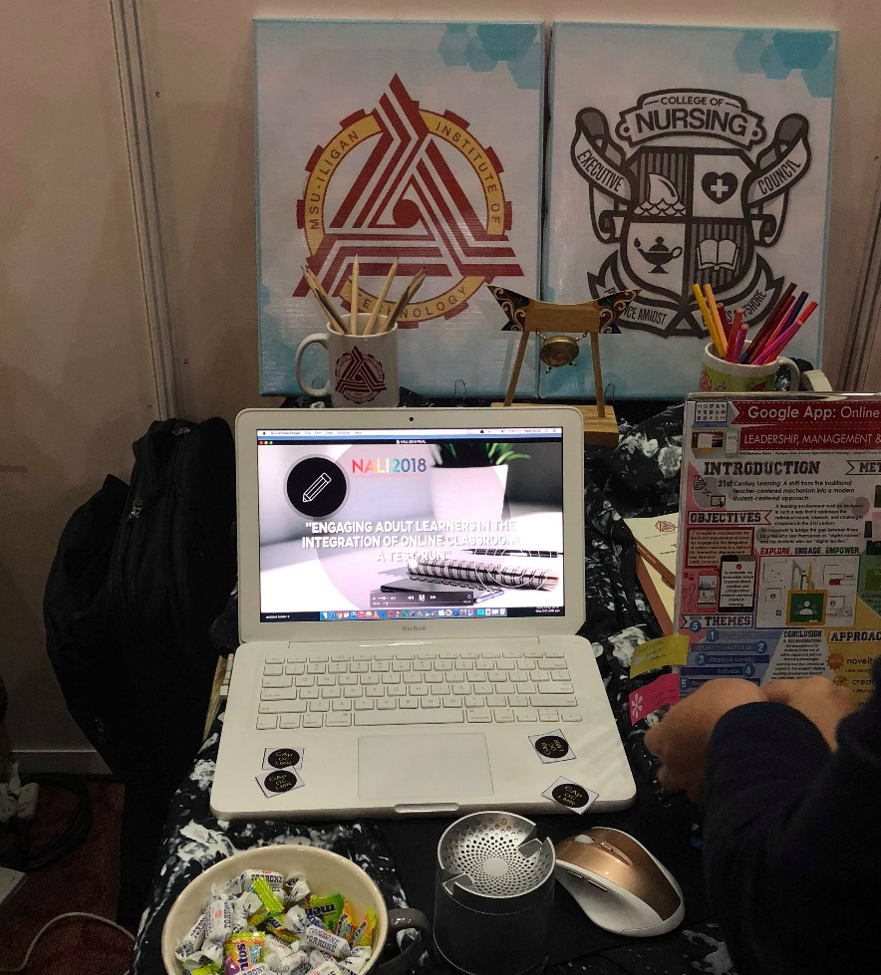
Figure 8, 9: Visiting GAP OC (Booth 52)
3.3 TANGIBLE EDUCATIONAL GAME (TEG)
Tangible Educational Game (TEG) is a physical play set targeted for children who is in early education. It integrates tangible objects with mobile application with a concept that allow kid to play beyond the screen. TEG uses augmented reality as the core of the mobile-based games application that combines with mobile devices as display.
This application is affordable for most families because the physical game instrument is targeted to be sold at RM 29.90 and the application will be free to download via Apps Store and Play Store. TEG helps children to use their imaginary and creative thinking skills to solve the problem using fun way in this application. TEG also encourage children to work as a team where they can play with their friends instead of playing alone.
This game is very straightforward yet interesting word game. The developers design distinctive pattern for each card to indicate different characters (same as the concept of QR code). It uses a mirror as a reflector and mobile gadget built-in camera as a scanner to scan each card to distinguish the input from each card. Players have to spell the correct word shown in picture by putting the correct alphabet in sequence under the reflector. In current stage, the application can read English alphabet, Jawi alphabet and digit.
This application is still in the stage of development and has not officially released yet. This is a very useful game and undoubtedly will give tremendous benefits for kids to learn vocabulary and spelling as well as memorising them, too. Many lab tests have been done by Dr. Farhan Mohamed, one of the UTM lecturers and his team to make improvement so that the application parallel to its objective in order to support student centered learning.

Figure 10: Concept of TEG
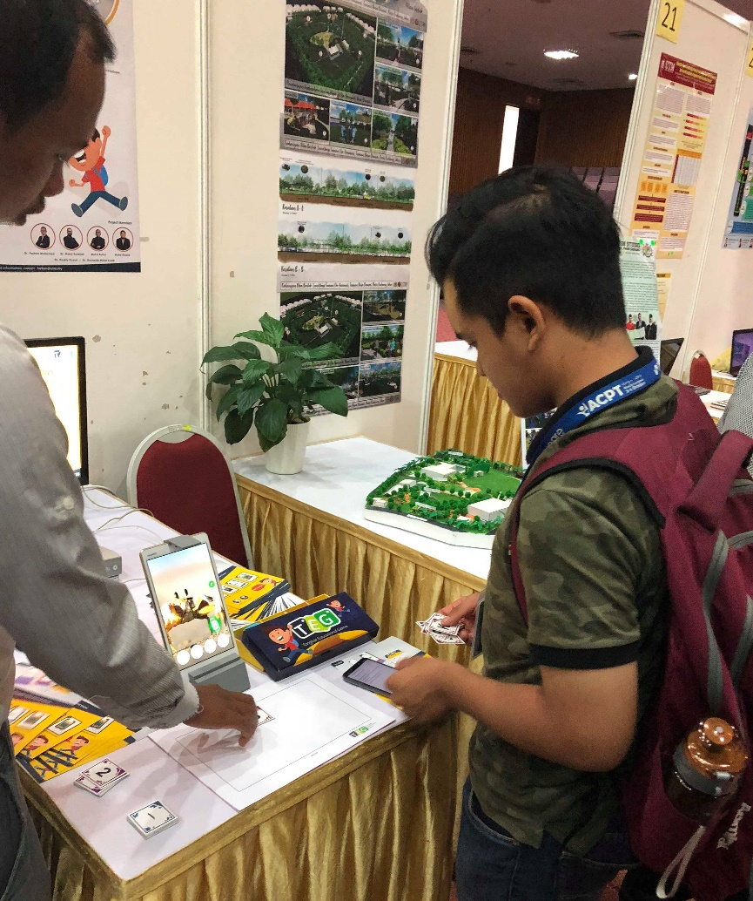
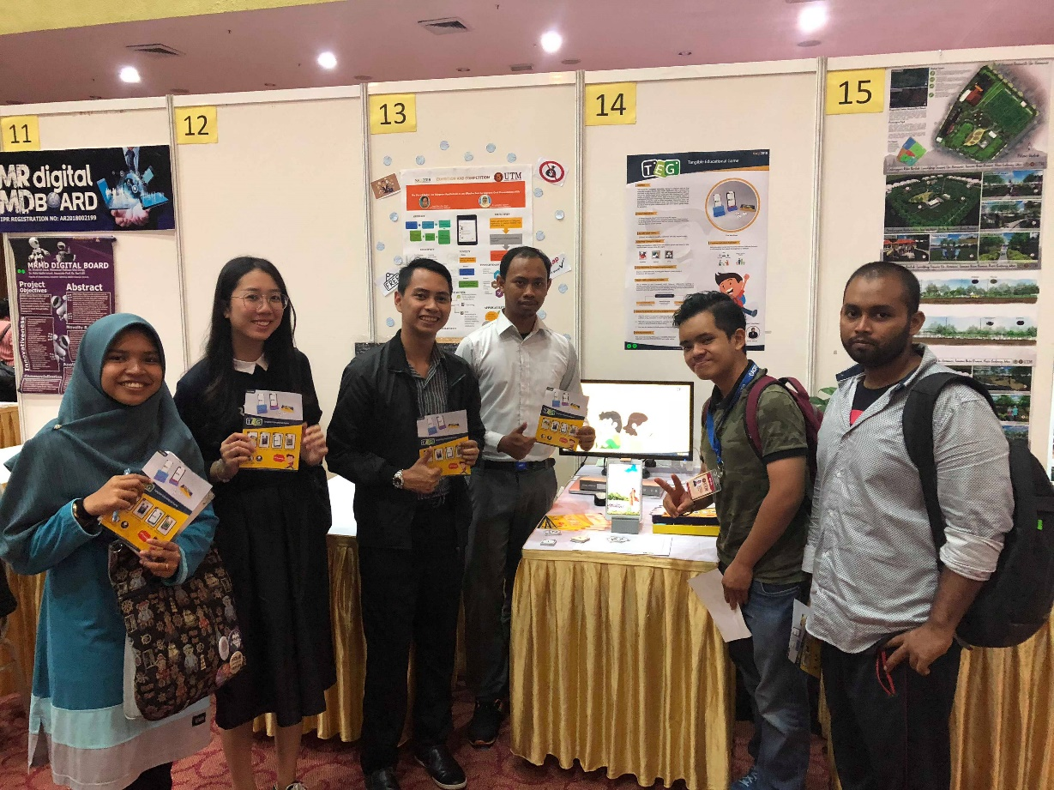
Figure 11, 12: Visiting TEG (Booth 14)
4.0 REFLECTION
From our visit to NALI 2018, we gain some insights on how our education industry begin to improve by involving digital platform in our educational system. As we shift towards the modernization, automation and online platform for nearly all aspects of our lives such as business, communication and economy, it is only natural to take the same step further for our education industry. It is really an unforgettable experience from what we initially thought to be a regular industrial visit. It turns up to become an information-filled event that makes each of the members of our group that started with zero knowledge about the on-going trend of our education industry to become intrigued by the innovations behind it.
All the participants of NALI 2018 are really friendly and helpful to deepen our understanding the specifics and details of their projects. We gain knowledge about the implementation of digital education and how it will complement with its physical counterparts. We hope that this event motivates each one of us to become hard working in our current studies and hopefully able to contribute to the education industry and conceivably to join the future NALI Symposium.

