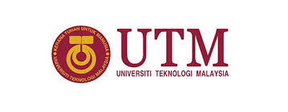
Individual Report on Global Online Workforce(GLOW) Talk



NAME: SHAZWANI FARZANA BINTI SAHARUDIN
MATRIC NUMBER: A18CS0243
I/C NO: 990502-02-6688
LECTURER: DR. AZURAH BTE A SAMAH

DUE DATE: 7th OCTOBER 2018
TABLE OF CONTENTS

NO. | CONTENTS | PAGE
1 | EXECUTIVE SUMMARY | 3
2 | INTRODUCTION | 4
3 | About GLOW | 5
4 | Careers in IT | 6
5 | Benefits of GLOW | 6
6 | How MDEC get People to Join Them and Who can Join the Program? | 7
7 | The Impact of The Program to Malaysia | 8
8 | MY REFLECTION | 9
9 | References | 10

EXECUTIVE SUMMARY

Malaysia is moving towards achieving Vision 2020 which has been introduced by the current Prime Minister of Malaysia, Mahathir Mohamad during the sixth Malaysia Plan on 1991. It was a Malaysian ideal to call for the nations to achieve a self-sufficient industrialised nation by the year 2020. In order to fulfilling the ideals, a big local digital company, Malaysia Digital Economy Corporation Sdn. Bhd. (MDEC) has created a platform to all of the Malaysians to start their own digital career, as well as achieveing their objectives in pursuing a digital future that opening up significant economic, environmental and social opportunities within the country.
In their ways to achieve those visions, MDEC always stand with these four guiding principles to support the digital economy which is; first, attracting investors, globalising local tech champions, second, catalysing industry-driven digital ecosystem, third, building critical enablers of the digital economy, and last but not least, driving inclusive adoption of technology.
This company also wants to help Malaysian including the people (rakyat) and the businesses by developing awareness on digital economy, creating credible talents for the industry, and encouraging digital technology adoption among them.


INTRODUCTION:

On Monday, 24th of October 2018, a talk on Global Online Workforce (GLOW) has been given to all of the first year students of School of Computing from 4:00p.m. until 5:00 p.m. in Seminar Hall, located in the N28a building. The speaker is one of the successful person from e-Rezeki programme which is under GLOW itself named Miss Nor Ashikin binti Halil, a graduate from Universiti Teknologi Mara (UiTM) in diploma Office Management and Technology. Now, she has being a part of company and she works as a virtual assistant, writer, translator, social media manager and voice over once at a time. She is gaining US$35 per hour and her monthly income could reach RM23 808. As during her training only with e-Rezeki, she generated her income in about RM114 980. She said that, e-Rezeki taught her effective techniques and good ethics in managing clients, and in maintaining professionalisms as a digital freelancer. Below is her generated incomes in this chart:

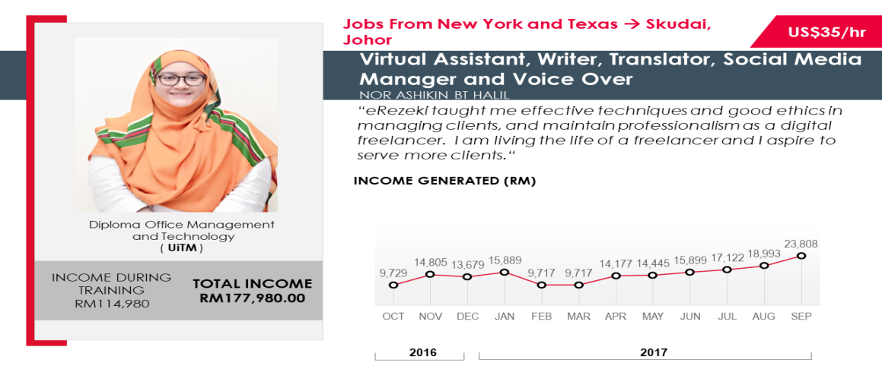
Figure 1

About Glow:

Global Online Workforce is one of the programme developed by Malaysia Digital Economy Corporation (MDEC) which previously known as Multimedia Development Corporation sdn. Bhd. There are three platforms created for Malaysians by MDEC, eUsahawan, eRezeki and obviously Global Online Workforce (GLOW). Generally, the main purpose of this GLOW program is to assist Malaysian by coaching, mentoring and nurturing on leverage crowdsourcing platforms in generating their own digital income consistently, and on a full time basis.
The concept used in this program is ‘Sharing Economy’- an economic system which assets or services are shared between private individuals, either free or for a fee, typically by means of the internet(definition by google dictionary). As in this program, they provide a platform for us, Malaysian in offering our own skills to be shared and used by people or company in need. Not just our skills, but also our spaces and stuffs. So basically, GLOW is one of the alternative ways to earn money digitally. They are earning not just through the domestic platform; such as Kerja Digital, 123RF LIMITED, Supahands.com, Ezyspark but also international platform; such as Freelancer International Pty. Limited, Upwork Global Inc.
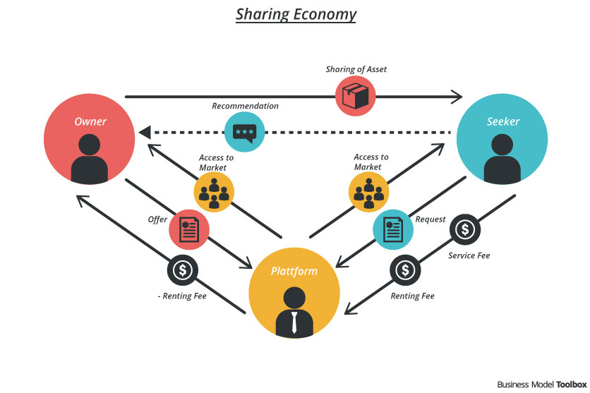
Sharing Economy 1



123RF LIMITED 1
Kerja Digital 1


Careers In IT
Upwork Global Inc. 1
Freelancer International Pty. Limited 1
There are some examples of selling skills in GLOW such as programming skills, web developer, digital marketing, writer, data entry, virtual assistant, graphic design, translation and others beneficial skills that we have.

Benefits of Global Online Workforce (GLOW) Programme
If you want to be a freelancer in this programme, you would be trained in just two days by a professional mentor individually, and for the rest 10 days, you are just having online monitoring. There are some faculties provided the laptop/facilities, but to be assured, you need to bring your own laptop, and during the training periods, they also provide meals for all of the trainers.
As a freelancer, you can work anytime and anywhere you want to. Based on the official website of Freelancer, there are about 14 738 669 jobs has been posted in the website and it increased 5 jobs per minute. In this platform, you can choose whatever kind of job you want as they provides a lot of categories of job such as data entry, logo design, mobile application, excel, 3D modelling and others. Besides earning by yourself, it also could effect the economy positively as it raise up their earnings.

How MDEC Get People To Join Them And Who Can Join The Program?

“After MDEC launched the eUsahawan and eRezeki programmes in 2015, the agency continued with its digital campaign, #YOUCANDUIT to reach the youths, Small and Medium Enterprises (SMEs), the Bottom 40 and digital entrepreneurs. eRezeki provides opportunities for individuals and low-income households to generate income through digital methods and technologies. Under the programme, individuals are given training to do appropriate tasks and become part of a competitive digital workforce. eUsahawan, meanwhile, is a digital entrepreneurship programme for vocational college students and micro entrepreneurs who are keen to move their business into the digital platform.”-New Straits Time,March 26, 2018.
As for GLOW itself, this programme centred on the experienced crowd workers/freelancers in local and global crowd sourcing platforms. Not just that, they also preferred the freelancers those has offline nd face-to-face experiences. Besides, this programme also can be join by those with the capabilities and qualifications in various disciplines such as ICT(e.g. programming, web developer), language(e.g translator, writer) creative and design,and others. The retrenched workers and unemployed graduates also should join this startup platform.

The Impact Of The Program To Malaysia
Global Online Workforce (GLOW) program has produced so many Malaysian who had successfully transformed their life from such a different type of background story and most of them were just a university student in our country. The first person I want to share is a beginner of this program as he managed to earn RM2000 in his first month of working, February 2017 as a programmer and transriber. He is Norman bin Dambul, a master student of UiTM in Computer Science. The highest income earned by the freelancer in this program was recorded as RM23 808 on September 2017. She is our speaker of this talk who get paid US$35 per hour or in Ringgit Malaysia, she might get RM145.15 per hour. She started her first job in this programme as a ghost writer and got US$20 for the job. As her second job, she just post some quotes on social media and she managed to get US$700. And now, she is working on her ongoing job in a contract with a company from Korea to translate the film and drama script to English.
From those examples of successful person in GLOW, some of them travel around this country to share their inspiring story to inspired Malaysian out there and help them getting the job. From this program, we can see Malaysia is going forward in achieving Vision 2020 with this kind of program.

MY REFLECTION FROM THE INDUSTRIAL TALK
First of all, I have already knew about Malaysia Digital Economy Corporation sdn. Bhd. (MDEC) since my matriculation last year. They came to my college, Kedah Matriculation College and give a talk to all of the module II students; students those who took Computer Science . After that program, honestly, I dreamed to further my study in UTM because they said that they partnered with UTM and some of the IPTS. I knew that this company is gonna make a big change in my life,and help me to be employed after my graduation.
As on 24th September 2018, me once again got a chance to meet MDEC but in that day, I have got new knowledge about a program, Global Online Workforce as known as GLOW. From this industrial talk, I think that Malaysia has a big potential to achieve the Vision 2020 in 2 more years as they, MDEC is really running on the path. They helped a lot of Malaysian out there to survived in this challenging millennium era especially for people like me, those who studied in Computer Science and Information Technology courses. We don’t have to worry about our future careers as there are already millions kind of jobs available in our scope of studies. I hope that MDEC would always going higher to drive Malaysia to achieve Vision 2020.

REFERENCES:

https://en.wikipedia.org/wiki/Wawasan_2020
https://www.google.com/url?sa=i&rct=j&q=&esrc=s&source=images&cd=&cad=rja&uact=8&ved=2ahUKEwjowP_eyfHdAhXYQ30KHUA_CcIQjRx6BAgBEAU&url=https%3A%2F%2Fwww.truelancer.com%2Ffreelancer%2Fashikinhalil&psig=AOvVaw316cfMKAac4B6T3WhRpS2m&ust=1538907077036541
https://glowmalaysia.com/success-story/?lang=en
https://www.nst.com.my/lifestyle/bots/2018/03/349416/mdecs-erezeki-and-eushawan-initiatives-are-revolutionising-local
https://www.google.com/search?ei=NLm4W7jjHsb6rQHSxbWoAg&q=what+is+the+meaning+of+sharing+economy&oq=what+is+sharing+economy&gs_l=psy-ab.1.2.0i67k1j0i7i30k1l9.355900.357761.0.360601.8.8.0.0.0.0.221.854.0j4j1.5.0....0...1c.1.64.psy-ab..3.5.851....0.xnsqyTcRDgA
https://www.mdec.my/directory
https://glowmalaysia.com/what-is-global-online-workforce-freelancer/?lang=en
https://www.freelancer.com/

