OneMaker Medini Report
Group 7: The Honey Badger
Name: - Putera Muhammad Syabil Bin Sarianto
- Nurul Aneesha Bt Md Zin
- Seyyed Naquib Al Faruqi
- Nur Ilham Muhammad Shahfilzuah
- Tan Jun Han

Introduction
In this Industry visit, we had visited 2 places which are Forest City and OneMaker Medini. OneMaker workshop will talk about technologies and future trending topics.Furthermore, Forest City is a city development project carried out by China developer by implementing the combination of future cities and the ecosystem (forest and sea). It also runs with Malaysia My Second Home (MM2H) programme, supporting foreigners immigrate to Malaysia as their second home. The property sold at a quarter of Singapore’s house price and it is located next to Johor’s second bridge. This place is also recommended for students studying abroad, medical treatment and retirees.
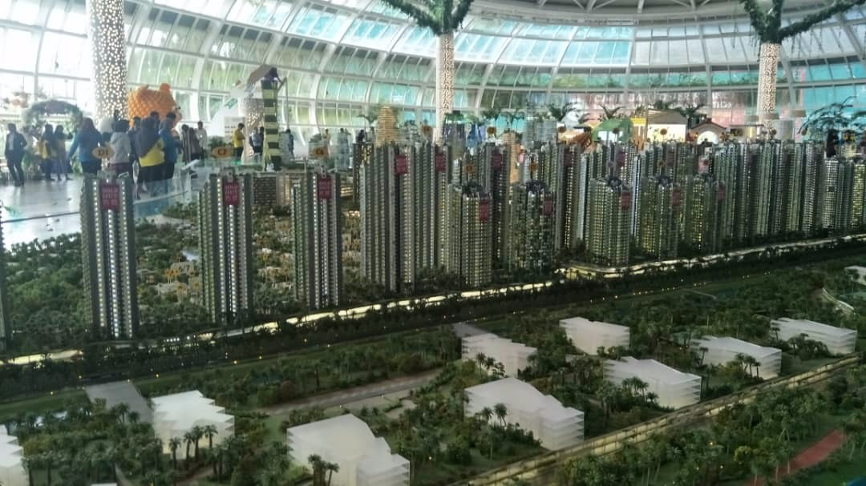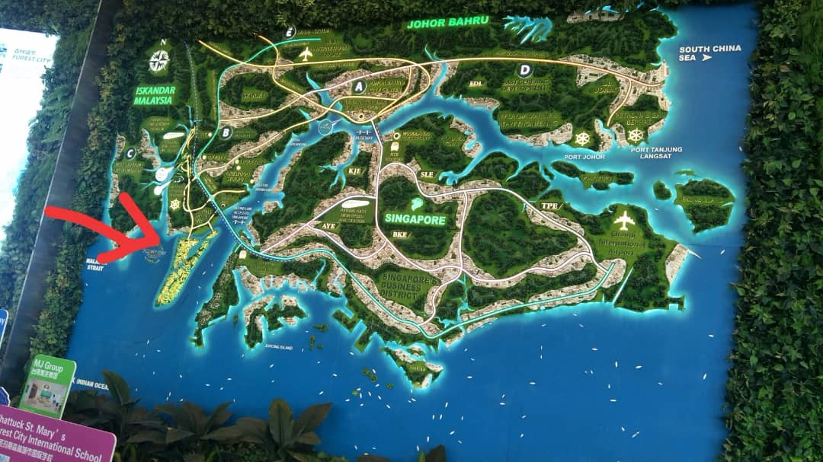
The arrow in figure above shows the location of the Forest City.
Figure above shows the 3D tower model of Forest City.

Details of Visits
On 24th of November 2018, all of the students gathered in front of N24 at 8.00am. We ticked our attendance and had our breakfast there. At 8.30am, we went aboard the bus and reached Forest City after an hour of the journey. After 30 minutes of sight tour, we are again heading to the OneMaker workshop at Medini Iskandar Puteri. All of the students arrived there at around 10.30am. Students were divided into 2 groups attending a different session. For our group, we were assigned to the second group and the workers there give us a brief talk about Virtual Reality (VR) and Mixed Reality (MR). At 11.00am, a QuirkyBot competition was carried out by building 1 our own and compete with others. This section ended at 12.30pm. After cleaning up, we had our lunch and also prayer. At 2.00pm sharp, we started our Disruption of Technologies Learning Journey, talking about Artificial Intelligence (AI), 3D Printing, Drone, 3D design and Line following robot. At 4.30pm, we had our break and prayer, then started our Design Thinking & Making session. It takes 2 hours for this session and the visit ends at 7.30pm following with another prayer for the Muslims. We are heading back to UTM at 8.00pm.

Organization Structure, Services and Achievements of OneMaker
Organisation Structure

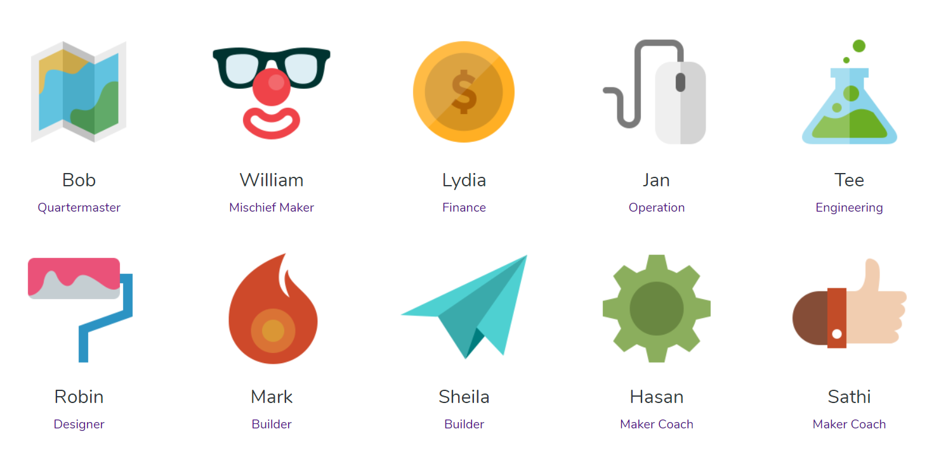
Figure above shows the organization structure of the OneMaker Team.

(source: https://www.onemakergroup.com/)

(source: https://www.onemakergroup.com/)

The biggest achievement that they achieved is that they are able to give out certification for those students after attending their training session, for instance Arduino CTC 101 and also partnering with Fast Lane Asia and giving out professional certifications for their IT training.
Achievements
Detailed Description

Virtual Reality Talk & QuirkyBot Making
For the virtual reality session, it was delivered by Syukri Radzi. Syukri Radzi is the Co-Founder Gini Technology Sdn. Bhd. He is the alumni of UTM student. So basically, virtual reality is a term used to describe a three-dimensional, computer generated environment which can be explored and interacted with a person. This could help the world in many industries especially things related to education and entertainment. It is because virtual reality enhances their experience making the person feels they’re in real situation. As we all know we human learn more things through experience or example, VR can help the student to experience the impossible other than sitting in class and learning about the theory. The next part is the QuirkyBot. For the QuirkyBot session, in a group of two person, we were given a motor and a battery. And we need to create a robot by using recycled item such as plastic bottle, paper cup and cardboard. And after the we build the robot, we need to compete with each other. This session encourages the student to think critically because the student needs to create the robot in limited amount of time.

Disruption of Technologies Learning Journey

Artificial Intelligence
Specifically, AI at that session was google assistant. This AI can respond to anything either questions or commands. That time we were told to ask simple questions and orders to this AI. Then we try to ask about "who is the president of America" and the AI answers it correctly, then when we ask to play a song and the AI plays it. We also can interact with the AI like a normal conversation.
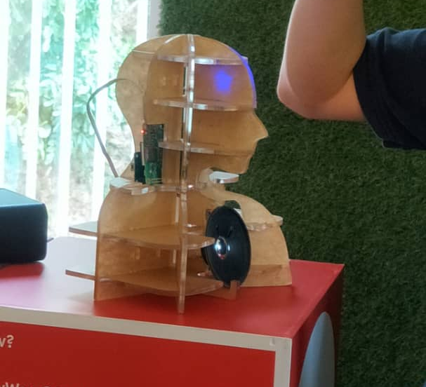
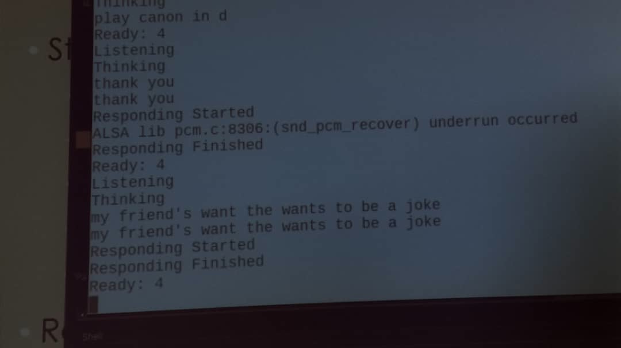

Figure above shows how AI works in console.
Figure above shows the AI (google assistant in robot figure.

Drone Programming
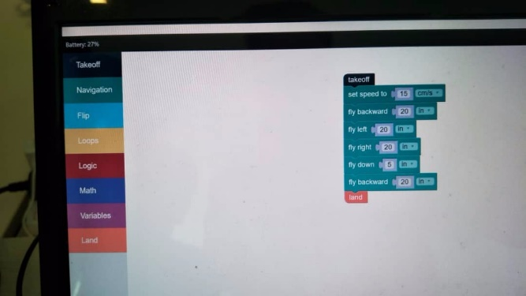
Next one is the Drone. Unlike most Drones, which are generally escorted by a controller device. This drone is escorted by software with WIFI connection. We only give orders to this drone through software and connect via WIFI then this drone will do something based on our commands. These include simple commands like ascend, descent, fly forward or backward and it can do cool tricks like frontflip and backflip. It also can do more complex commands.
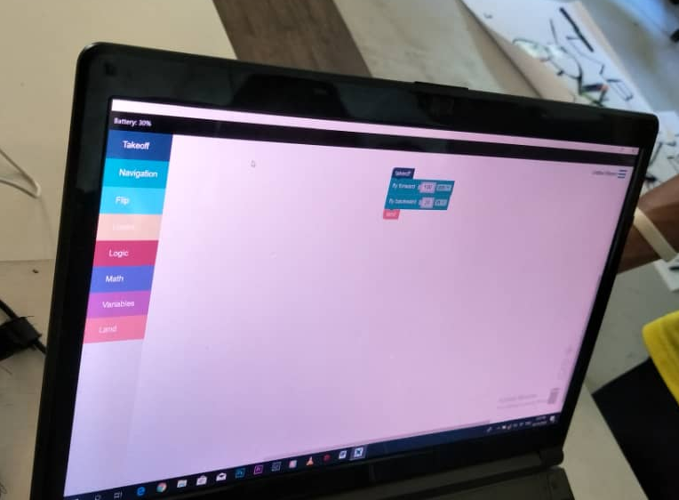
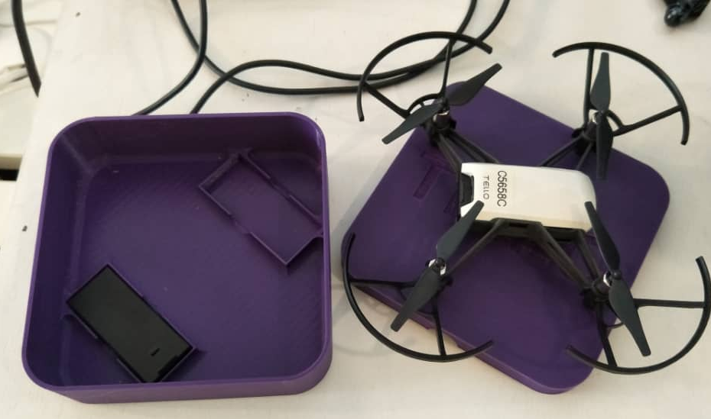

Figure above shows the drone that we are going to use
Figure above shows the software to give commands to the drone.

3D Printing
As the name implies, this machine prints three-dimensional objects. On that session we were told to design something simple then print it through 3D printer. We decided to design a name plate and it took about 5 minutes to print. We are satisfied with the results, it is good and well detailed. In addition, 3D printers also can print more complex objects.
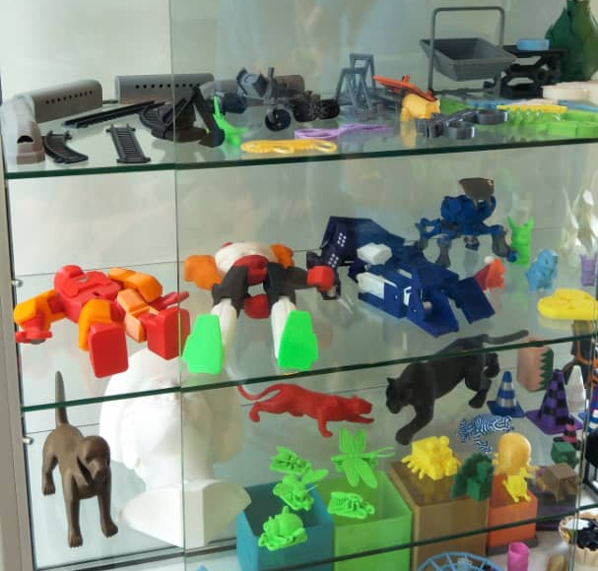
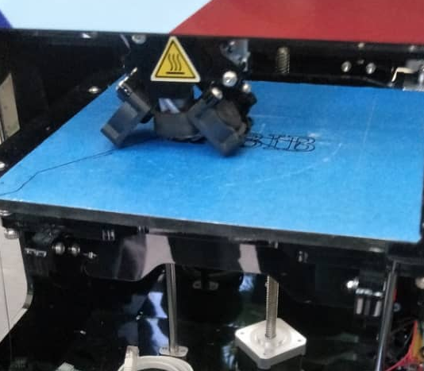

Figure above shows the 3D printing process
Figure above shows the example of objects created by 3D printer

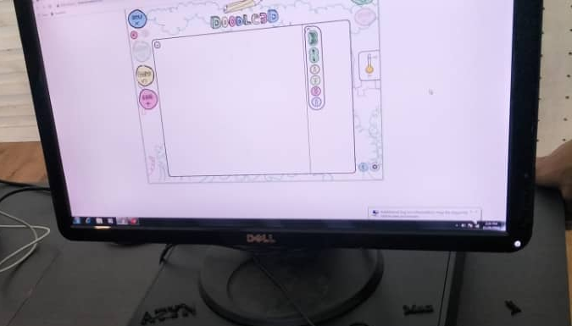

Computer-Aided Design Challenge
Figure above shows the software to design objects for 3D printing
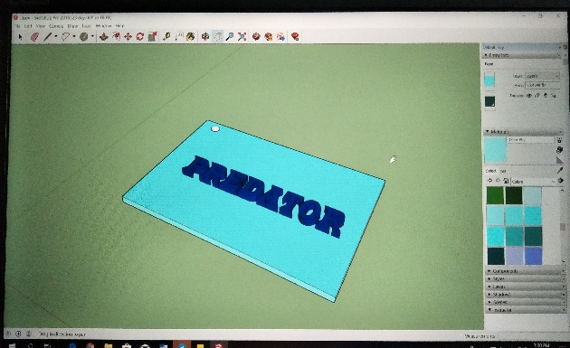
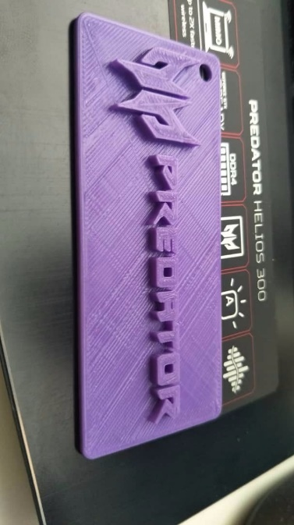
In this section, we learned how to design 3D models using an application name SketchUp Pro 2018. They taught us how to use some simple tools in that application to design our models. A simple 3D model was shown for us to have an idea on how to design our own model. They also use that application to design stuff with greater complexity and print it out using 3D printer.
Figure above shows the 3D model that we designed.
Figure above shows the 3D model that OneMaker gave.

Colour/ Line Following Robot Demo
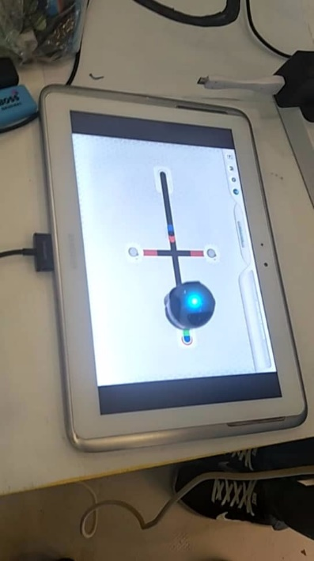
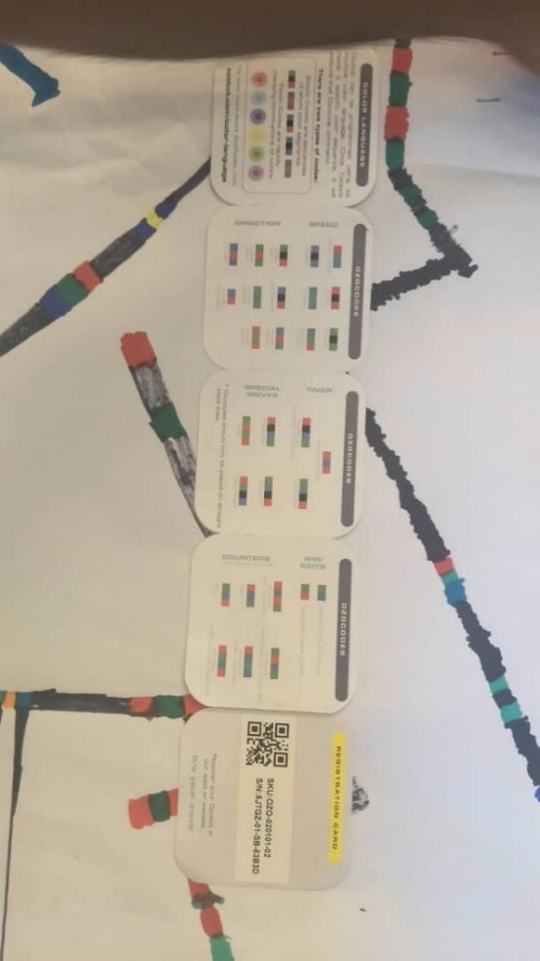
Ozobot is a robot that can follow lines and can recognize colours. There is an application for it where you can draw your own path and place it on the tablet screen for it to follow. You can also guide it by giving commands in colours form so that it knows where to turn left and right, U-turn, increase speed and many more. The path can also be drawn on a piece of paper using colour markers and it will follow the line you designed.
Figure above shows the types of commands using different colours.

Figure above is the Ozobot following the path on the tablet

Design Thinking & Making
The last session is design thinking and making. We were combined with another group to form a team. The facilitator asks us on what school in the future will looks like. And with the provided materials from One Maker, we must make a part of the future school. Then we will combine every part from every group to make a complete school. Our team decided that we make a book museum, clock tower, pavilion, and hyperloop.

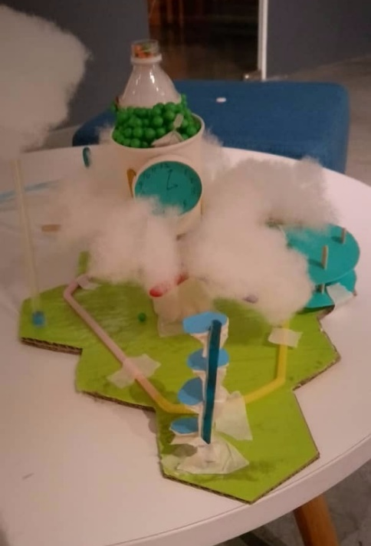
In our imagination, the book museum if for the books and newspaper. It’s not the same as library. In the future there will be no more books or paper anymore since the technologies will take over. The students will hold tablets or laptop. Book museum is for the students to not forget about books. For the clock tower it is one of the landmarks in the school because clock tower is a classic landmark. In the clock tower there are student’s activity rooms where they can discuss and hang out with them. In the pavilion, there is a food court where students can find any food they want from every country. For the hyperloop, it makes the students to go to other places easily. We finished this session at around 7.30 in the evening.
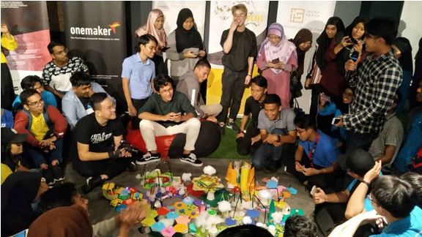
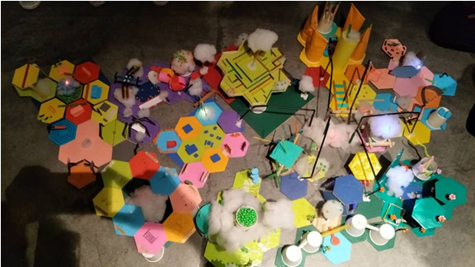
Figure above is the combination of every group’s future school
‘s
Diagram above is our group’s final product.
Reflections
- Tan Jun Han
In my point of view, this visit had broadened my perspective towards the technological world, especially at the Artificial Intelligence (AI) section. It inspired me on how a program can interact with humans by using only lines of codings. I need to study hard in this 4 years and strengthen my programming skills in order to be an AI creator just like Sundar Pichai, who created Google Assistant. Nowadays, creative and logical thinking is necessary especially for computer science students, so that we can invent something that others cannot think of. This can be done by reading more fiction books, brainstorming by solving complex questions and keep trying new things.

- Putera Muhammad Syabil Bin Sarianto
In my opinion, this visit is truly a eye opening to the student towards the industry. The student can finally realize that we’re moving to the Fourth Industry Revolution by all the technologies that were introduced by OneMaker. Personally, I was fascinated by the line follower robot because for me it’s something new and it got potential to become new programming language for the human or at least for their understanding. Other than that, the design thinking session has inspired me because one of the facilitators told us that he is a carpenter, and the session encourage us to become creative by imagine a future school and we need to build our imagination school by recycled item. This activity made me realized that we need to create something different in the future, something that never had been done before.

- Nurul Aneesha Bt Md Zin
When I was told that the whole class will go to One Maker, Medini mall, I was very excited. I learned and discover a lot of technologies which I usually could search in the internet but that day I can see it on my own. When we arrived at Medini Mall, I was amused by the input they gave to us. They explained to us in a fun way which is great. When they showed us technologies such as AI, drone, 3D printing and color- line robot.
After the visit, I became interested to find more information about technologies. The one that I fond into is VR. Because it is a really cool gadget which I just found out during the visit that it has been existed in 70’s. It was a good program because you can receive a lot of information while having fun.
I really hope that in the future, many students enrolled in science computer courses to improve the potential of our country. The government also give more fund in this field.

- Nur Ilham Muhammad Shahfilzuah
After visited OneMaker few days ago, I was able to learn new things from all sessions that held by OneMaker, as well as refreshing up my memory on things that I already knew, or just learn more about it.
The most exciting for me were VR and AI. These were impactful for me because I kinda interested to be VR or AI developer in the future. It is interesting to know that VR technology is already this far. We always thought that it would be cool if we can enter the world of games, fantasies and other kind of simulations. Well now we can do that through VR. AI, is also cool but somehow terrifying. Well, I want to explore and learn more about these two things and hopefully I can contribute in these two technologies in the future. All the things that happened when we visited OneMaker from VR until the last one which is design thinking were also many that were useful and well-informed.

- Seyyed Naquib Al Faruqi
It was so grateful to be part of this trip; besides it reduces our stressful feeling. it gave us knowledge how to dealt with it in the future also an idea that technology can be such a huge aspect of our lives in the future, During this workshop I learned a great deal about technology and what I can do to improve my presence in the technology itself , however I know have a better understanding of how to use these new techniques effectively. Attending this workshop gave me the confidence to experiment with it and use digital technology, therefore we can create so many innovation that can make this world better.

