INDUSTRIAL VISIT 1
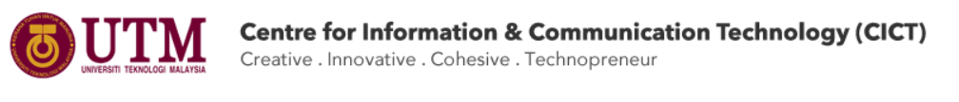Group: The Honey Badger
Name: - Putera Muhammad Syabil Bin Sarianto
- Nurul Aneesha Bt Md Zin
- Seyyed Naquib Al Faruqi
- Nur Ilham Muhammad Shahfilzuah
- Tan Jun Han

TABLE OF CONTENTS
Topics | Page
- Introduction | 1
- Summary | 2
- Details of Visits | 2
- Detailed Descriptions
- Organization Structure | 3
- Services | 6
- Achievements | 7
4.4. Information systems that have been developed or maintained by CICT | 9
- Reflections | 11

1.0 INTRODUCTION
We were given a task to write a group report on Industrial Visit 1: CICT that was held on 1/10/18 at D07-UTM JB.

CICT
CICT stands for Centre for Information & Communication Technology, CICT in University Technology of Malaysia (UTM) is purposes help the university towards achieving its vision and mission in line with the development goals and progress.
In order to achieve such wish, the university provides Information and Communication Technology (ICT) services to the campus community for improving the quality of teaching, learning, activities.
There’s two ICT centre: 1. Block D07, Universiti Teknologi Malaysia JB
2. Jalan Semarak, UTM International Campus KL
At the moment all ICT’s database are maintaining in UTM international Campus KL, because there’s a problem with Block D07 ICT database.

CICT SERVICES
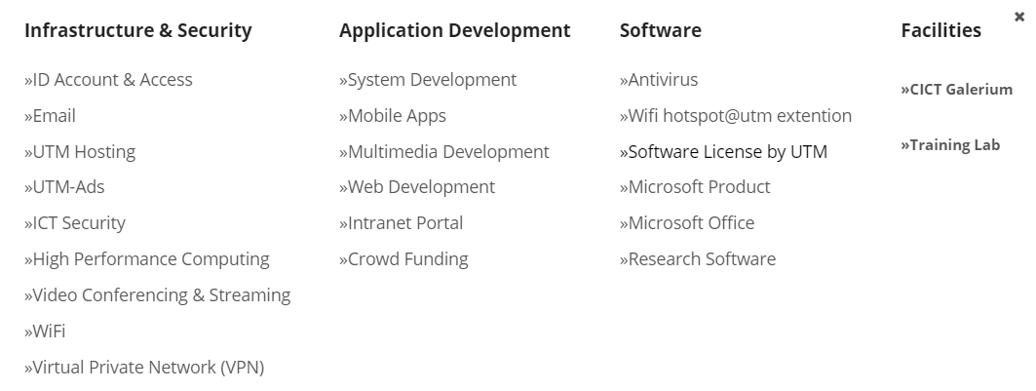
(source:cict.utm.my)

2.0 SUMMARY
CICT is a support unit that offers and delivers ICT services for the university (staffs and students) especially in ICT infrastructure, system development and academic/administrative activities. CICT is responsible for ensuring that staffs and students have access to teaching, learning and research ICT resources by such as, providing the University's IT infrastructure. Acquiring, developing and supporting new and emerging technologies and systems. Providing access to digital resources across the University's campuses. When we did our industrial visit to CICT we’ve learned so many things related to the industry. This experience has helped us to see clearly how a company actually try their best to serve their customer. Thus, this report is to state all things we’ve learned and our vision in choosing career in the future.

3.0 DETAILS OF VISITS
At 1st of October 2018, every section was brought to the Centre of Information and Communication Technology (CICT) of University Teknologi Malaysia. We gathered with other groups in front of Block N24 with our lecturers at 4pm. CICT is located at D07, 81310, UTM Campus Johor Bahru, which is the opposite of Block N24. We walk to the Seminar Hall in CICT after everyone was there. The talk was about briefing on ICT services and regulations for under-graduate students and was given by Mr Mohd Zahari Bin Zainal Abidin. After the talk ended, the speaker brought us to a show room where every old servers, machines and components were kept nicely for display purpose. The speaker briefly explained about every components and functionality of them. The visit ended on 6pm where everyone had gained a lot of knowledge on how CICT works in UTM.
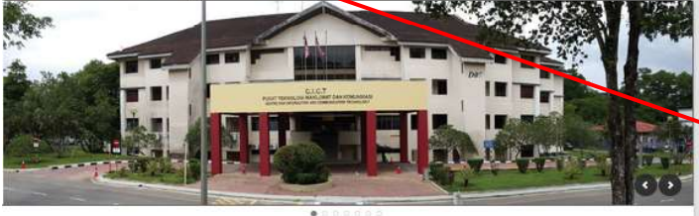
Image of CICT, UTM
4.0 DETAILED STRUCTURE
4.1 ORGANIZATION STRUCTURE
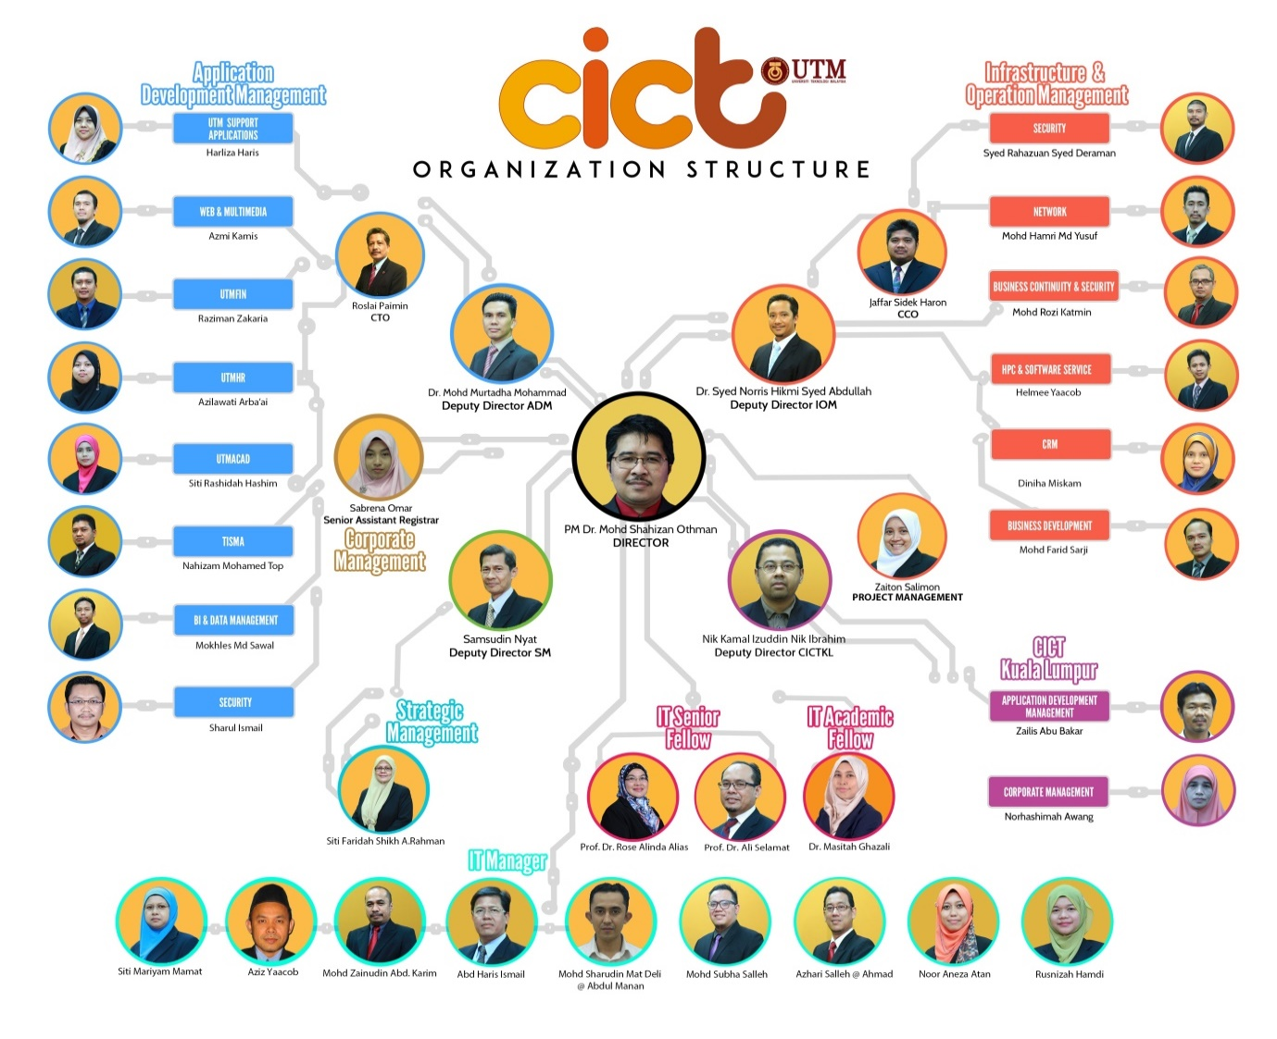
Departments Functions

Management & Development Application (ADM)
- Application Development
- UTMHR
- UTMFin
- UTMAcad
- Support Application Development Multimedia & Web
- Mobile Development Apps
- Data & BI Management
Infrastructure & Management Operation (IOM)
- Data Center
- ICT security
- Infrastructure
- UTM Hosting
- UTM-Ads
- High Performance Computing
- Video Conferencing & Streaming
- Customer services
- UTM Cert

Office Management Strategic (SMO)
- F Center
- Staff Management Attachment & Ambassador
- Reporting and Planning Strategic
- Quality management and Branding CICT
- Training Management & Staff Competence

Office Development Business (BDO)
- Management Business Generation CICT
- Management Business Opportunity
- Build Business Model

Management Project Unit
- Management ICT project
About the Chief Information Officer (CIO)
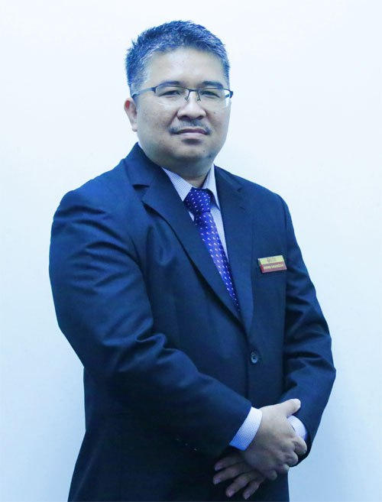
Pm Dr Mohd Shahizan Bin Othman
Mohd Shahizan Othman is a Senior Lecturer in the Department of Information Systems, Faculty of Computing, UTM. Beginning on October 1, 2015 and up to now, he serves as Deputy Director (Computing), at the CICT, UTM. He has graduated Diploma in Computer Science and a Bachelor of Computer Science at the University of Technology Malaysia in 1995 and 1998. In 2000, he has continued his studies at Universiti Kebangsaan Malaysia and obtained Master of Information Technology (Computer Science) in 2001. He received his Ph.D. Information Science from Universiti Kebangsaan Malaysia in 2008.

Sources: (http://cict.utm.my )
(http://cict.utm.my/organization-structure/)
(https://comp.utm.my/shahizan/)

4.2 SERVICES
There are many services that CICT provided to user. And the services is divided to 4 group which is infrastructure and security, application development, software and last but not least is the facilities. The first thing the student entered UTM, they will be provided the student ID account and e-Mail that is registered by the CICT. This account will help the student to get access to the Wi-Fi, the universities portal, eLearning and many more. It will be easier for the student and also for the lecturer to communicate with each other or to submit assignments. CICT also provide the internet in the UTM. This allow the student to communicate or help them do assignment by searching the answers in the internet. Even the internet is not that fast, but for the basic necessities, it is enough for almost all party in UTM. The email will help the lecturer or department to deliver message to the students. CICT also provide a platform for everyone that want to promote their product brand at the eLearning. This will help the them to promote or deliver message to everyone in the campus. They also make mobile app for the student to help the student to take the attendance. This will help the lecturer to identify the student who did not come to the class. They also provide an app to help the student to identify bus in UTM. The app, or Bus UTM is an app that will show the student the location of the bus, so students can manage their time to come to the bus stop. CICT also encourages all students to use licensed software. So, they provide the students for free some software like the Microsoft product, Microsoft Office 365, Antivirus, Autodesk and HPC. They also provide supports for the user and they make teams for it such as Business Intelligent, Data Management, ICT Training, ICT Consultation and Customer Relationship Management. These team will help the student information or help the student to a place for their internship. CICT provide hosting server for the user to help the user to promote their club, the association activities or special events that the user can afford with affordable price.
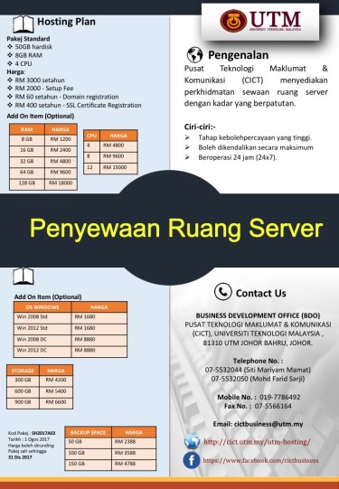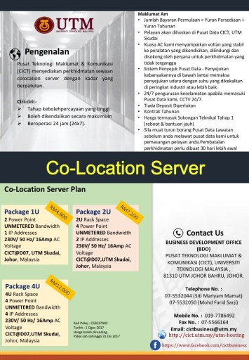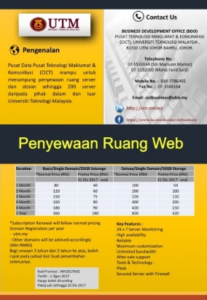
Diagram shows the hosting package that CICT provide for students
4.3 ACHIEVEMENT
- Achieved the best technical documents and bring the University Received SAGA (Standard Accounting System for Government Agencies) AWARD 2017
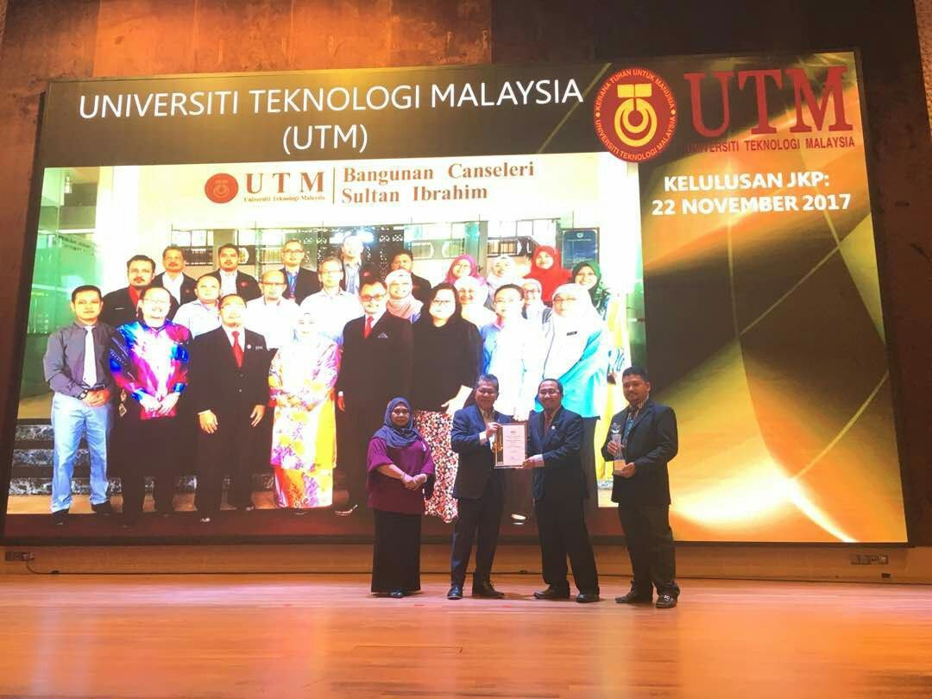
(source:cict.utm.my)

CICT has successfully achieved the best technical documents and bring the University received the SAGA (Standard Accounting System For Government Agencies) Award 2017 which was given by the Accountant General of Malaysia on November 22, 2017.
UTM is among 59 of 416 agencies that have successfully received SAGA Compliance Certificate recognition.

- UTM is the 1st cloud services for the government sector in Malaysia
UTM have the 1st Tier III data center for education in malaysia and CICT has provided Cloud Services for the government sector in Malaysia that will enable the government to rapidly deliver innovative public sector services to the rakyat without incurring high levels of capital expenditure to invest in IT infrastructure (source: Speaker)

- Being the most active PTJ Intramuretics Series 2/2017
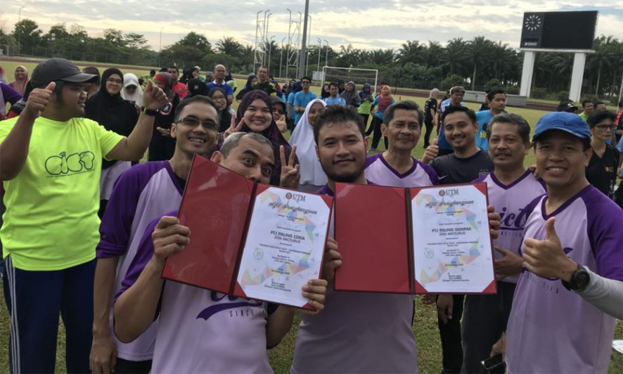
(source:cict.utm.my)

CICT has successfully achieved certificate for being the most active PTJ Senam Robik Perdana Siri 2/2017 which was held on 7 February 2017, at Azman Hashim Stadium UTM Johor Bahru.
The attendance of CICT staff was 50 out of 123 people, which contributed to the attendance statistics of 40.7% of all CICT staff.

3.4 INFORMATION SYSTEMS THAT HAVE BEEN DEVELOPED OR MAINTAINED BY CICT
There are a lot of information systems that were developed by the CICT. For examples, student’s matric card, eLearning, ACID, UTM Wi-Fi and VPN.
For UTM WiFi, it can be accessed by all colleges. For admin or academic network mostly use wired in Faculty and Admin Offices. For colleges network mostly WiFi or wired in certain blocks. To access UTM intranet and internet for UTM Skudai Campus just select “WiFiUTM” from wireless list, open internet browser and key in ACID account.

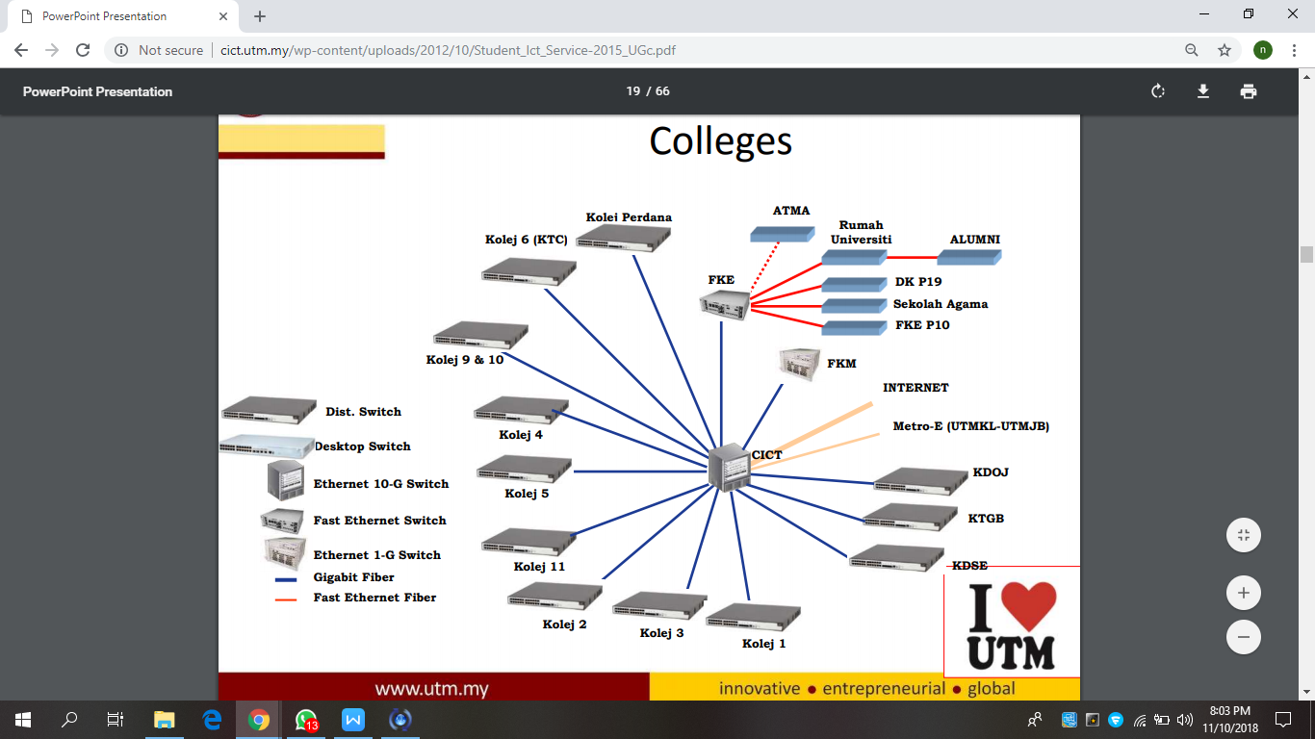

ACID or Academic Computing ID is an unique user ID for UTM community to login to most of University main application system. It is used by all full-time and part-time students. ACID will only be available one day after the programme registration.

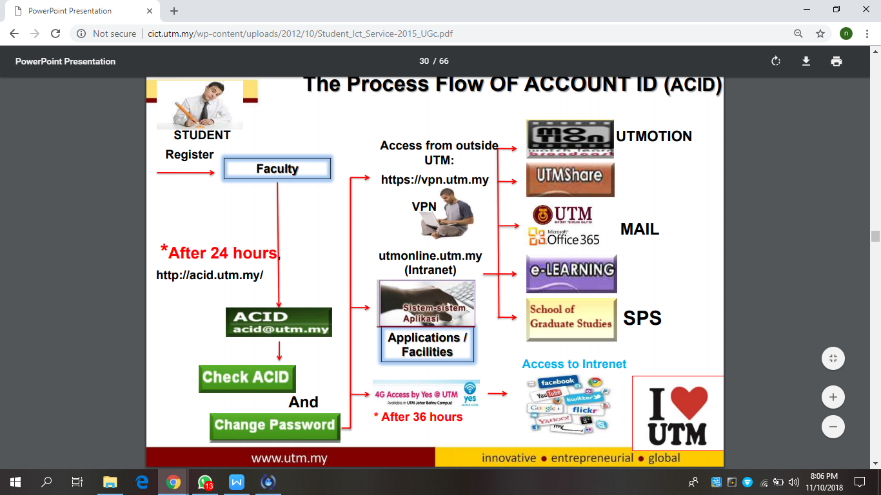

VPN, Virtual Private Network is actually to access UTM intranet services from outside UTM campus. Students can used VPN for accessing intranet services such as UTMOnline, software respository and databases from UTM library. It is for all registered students only.

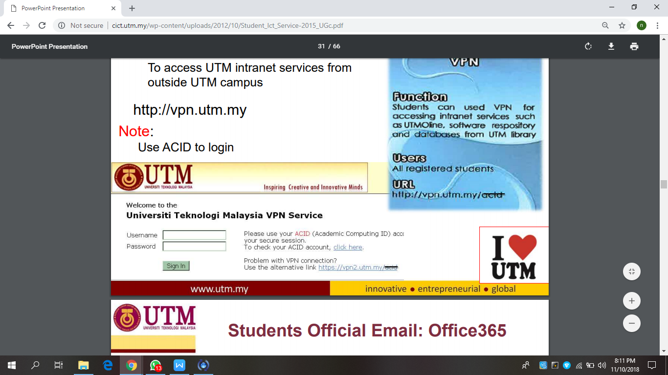

Another information system developed by the CICT is E-Learning which is an educational portal that assist students and lecturers in the teaching and learning process to be more effective and flexible and it is for all full-time and pert-time students.

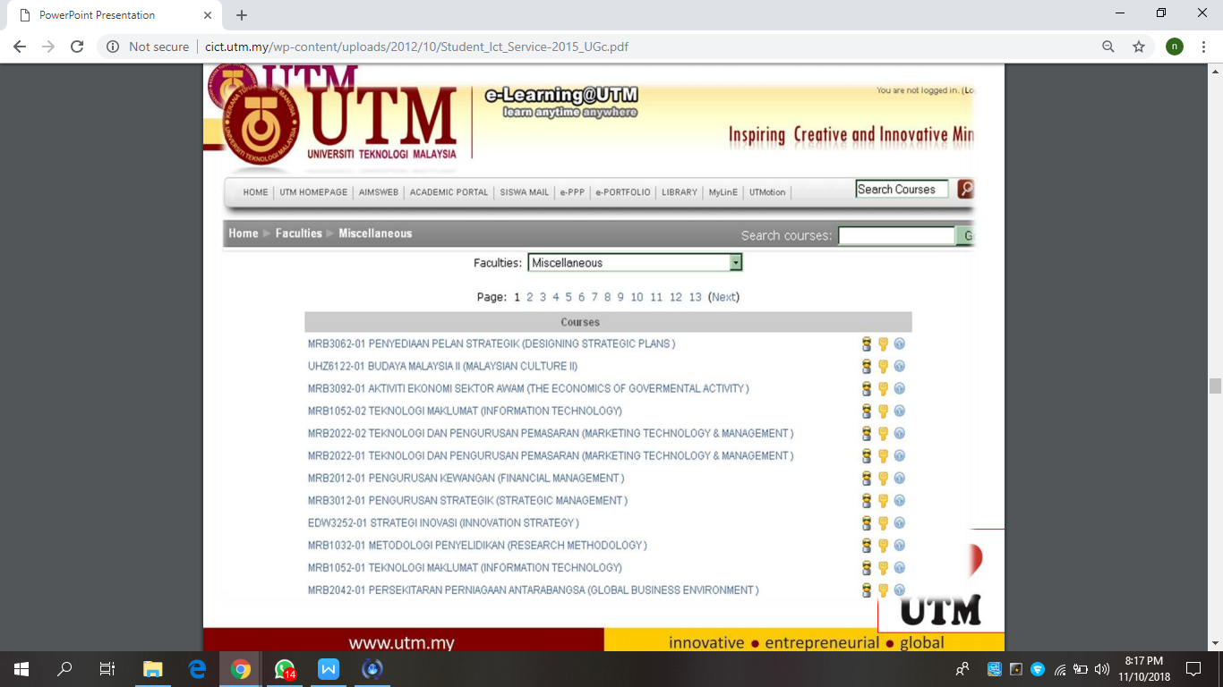

REFLECTIONS
In this era of globalization, Artificial Intelligence (AI) have become more and more advance as the technology in this world is growing exponentially. Experts have created lots of AI bots’ speaker that have extraordinary human likeness and facial expressions, but there is a huge problem they didn’t realise which is AI bots don’t know how to differentiate between good and bad. For instance, Sophia, the AI bot that said she wants to destroy humans and Phillip that said he want to create a “human zoo”. So that’s why I chose Software Engineering and one of my life goals is to become a machine learning engineer and fix that problem before the world fully utilise AI bots in our future society.
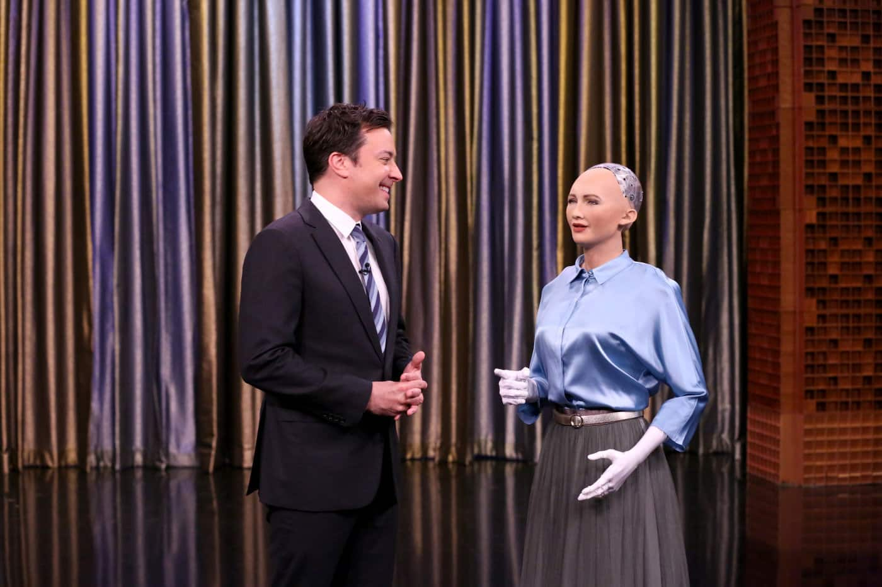
Figure above shows Sophia the AI bot (right) is chatting with the host named Jimmy (left) in a show.
(Source: http://www.hansonrobotics.com/robot/sophia/)

After visiting CICT UTM, I found that security is also one of the issues where everything can be hacked if the infrastructure doesn’t have a strong security system. Which is the same when the problem is fixed in the future but hackers can still hack into the AI bots and change their programs in whatever ways they want. This will bring our world into abyss if the intruder abuses the system of the AI bot and order it to do something bad like participate in robbery. At the end of the visit, the speaker shows us all kinds of components, machines and servers that have been used in the data center. The explanation given by the speaker on each of the servers have greatly increase my knowledge as this will be useful in the future where I need to work in large company as a machine learning engineer.

Lastly, CICT also provides Microsoft Imagine which is a huge platform for us to learn new things to improve our potential in the industry. Microsoft Imagine provides online training (Microsoft Virtual Academy) which I’m planning to attend for. Microsoft partners will help us to build our technical skills so that we can excel in our carrier. There are all kinds of programming languages, app and database development. It will be a cut above the rest if a computer science student knows most of the technical skills in it. Developing mental skills like spatial perception, logical and innovative thinking will also improve my potential as it is very useful for inventing new stuffs. This can be done by stay focus and curious on everything happen in our daily life.

In conclusion, CICT UTM have done a great job by providing all sorts of services and learning opportunities for students in UTM. We are so grateful that CICT have given us this speech.

