
TECHNOLOGY AND INFORMATION SYSTEMS
SCSP 1513 (SEC-08)

SCHOOL OF COMPUTING
UNIVERSITI TEKNOLOGI MALAYSIA, 81310, JOHOR BAHRU
JOHOR, MALAYSIA

REPORT
INDUSTRY VISIT – SENAI AIRPORT
3RD DECEMBER 2018

PREPARED FOR
Dr. AZURAH BTE A SAMAH
PREPARED BY
MUHAMMAD ALIEMEEN FARHAN BIN RAMZEE

INTRODUCTION

Senai airport or previously known as Sultan Ismail International Airport was officially opened for commercial operation to serve the southern region of Malaysia. The Airport was previously managed by The Department of Civil Aviation (DCA) and later by Malaysia Airport Holding Berhad (MAHB) in the year 1992.On 2003 Senai Airport Terminal Sevices Sdn Bhd tookover the management of Senail International Airport.On 2004 -2006 Senai Airport has extent their space from 3354 metre to 3800 metre and also has construct cargo terminal that can hadle up to 80000 tones cargo per annum.

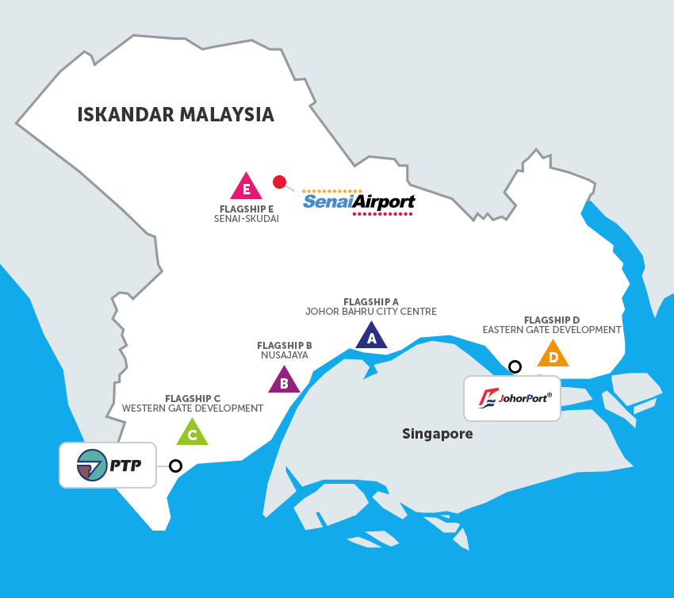

In 2009, Senai Airport was acquired 100% by MMC Corp Berhad and became a family of MMC.Senai Airport has excellent achievement as they now handle 630 flight weekly,with average of 90 flight movement consist of International and domestic flight.Airlines operating here include Malaysia Airlines, AirAsia, Firefly, Malindo Air and Jin Air.

Statistic has shown that 250% passenger growth since the inception of Senai Airport Terminal Services Sdn Bhd ,passenger throughput has been steadily climbing from 0.8 million in 2003 to 2.8 million in 2016. The highest jump in terms of passenger movement was in 2013 with 44.3% passengers increase, the highest among other Malaysian airports.

In 2010,Aeromall was completed build in Senai Airport and became a first stand alone external airport mall in Malaysia.They also retail space such as Starbuck,Subway ,Famous Amos and others so that they will have better shopping experience with wise choice to shop and dine.

Visit Journey

1.45 pm -we rushing to the bus stop opposite CICT building at N24 because Dr Azurah ask us to wait for the bus at there and also be punctual so that our visit can run smoothly.Most of us also missed our lunch as we have only about half an hour to gather there. Althought,the bus arrived late around 2.15 p.m we all have a nice conversation with our classmates consist of International and also locals student.In,the bus Dr Azurah ask help from JK to collect Rm 10 from everyone for the bus fees.

2.45 pm- we arrived safely at the airport and we follow Dr Azurah to the tunnel inside the building where the It department located.We were welcomed by one of the officer Airport named Miss Fatin.She brought us to the meeting room for give us input and explanation about Senai Airport. Miss Fatin explained a little bit about history airport and the organization of the airport.Next,Miss Mazwah came and explain about use of IT in Senai Airport and also scope of work that available in Senai Airport related to IT.For your information, she is our senior from SCSV .

3.50 pm-Miss Mazwah and Miss Fatin brought us to the It department to have some visit.We also get changes to visit their server which located in a small room that cold with temperature below 16 celcius.After that she let us to enter the department hall which need us to go throught security to make sure us dont bring any forbidden item .
4.30 pm-Last but not least we take a group photo as memorable memory with Miss Mazwah and Miss Fatin. Then Dr Azurah let us free before the bus arrive.

IT related in Senai Airport

Airports today has become crucial for everyone for sake of travelling .Today Senai Airport are investing more financial resource into technology than before and it will rapidly over the year.As technology has advanced in Senai airport information technology (IT) departments have become the backbone of the business, supporting systems and processes that reach all areas of operation.

In Senai Airport ,the IT department has provide many of facilities to make flow of Senai Airport run smoothly.It is for ease the customer and also staff in Airport .The IT department provided the PC for the customer so that they can used for Bourding purpose and also surfing Internet.There also provide information board that display depart time of flight therefore customer can know exacly time for they flight and get prepare.

IT department also provide a free wifi to the customer and also staff .By providing the wifi to the customer, they can easily to access the internet to check their flight and they can use the wifi to spend their leisure time while waiting for their flight.While ,for the worker Internet can help them overcome in daily day task.

All maintenance job ,is be done by IT department such as electronic devices ,Information board,wifi and also the server of airport.They need to make sure all of this is in good condition by check it using coding every morning.The maintenance is consist of hardware and software.They also secure the Wifi using Firewall from any virus of hacker so the user can used it safely.Every 5 hour they will keep monitoring to check the temperature of the room and also the server is in good condition.The server need in a cold temperature so that the server is not overheating .

All CCTV in the airport were organize by IT department for the use if there is some accident occurs or maybe a crime might occurs. The recording were save in the room that we entered during the visit. The CCTV is very important at the public place like airport to avoid any crime.
REFLECTION

IT and Senai Airport cannot be separate as we know the important part of the IT in the airport.Through this visit I learned that the Important of IT in our daily life.IT can be significant help in our daily life.They also a very big scale of job that related to IT in the airport.This can be a good opportunity for the fresh graduate to do intern in the Senai Airport although allowance is not provide.

