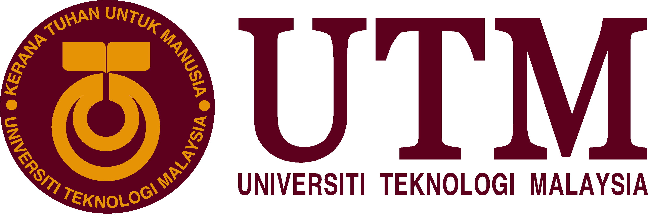

SCSP 1513
SECTION 6
TECHNOLOGY AND INFORMATION SYSTEM

PEPARED FOR:
DR. NORBAHIAH BINTI HAJI AHMAD

CENTRE FOR INFORMATION & COMMUNICATION CENTRE (CICT)

PREPARED BY:
SUNG SHEAU HUI A18CS0248
NUR FATIN BINTI ROZADIN A18CS0191
SIFRA MANALU A18CS0327
UMI HAIZA BINTI MAHAMUD A18CS0270
SALMAN MOHAMED IBRAHIM AHMED IBRAHIM A18CS0356
CONTENTS

INTRODUCTION 3
CICT ORGANIZATION STRUCTURE 3
SERVICES 4
ACHIEVEMENT 5
SYSTEM DEVELOPMENT 5
REFLECTION 6
REFERENCE 7

INTRODUCTION

On 1st October 2018, the under-graduate students in UTM had been given a talk about ICT Services and Regulations by the Centre for Information & Communication Centre (CICT) at Block D07, Lingkaran Ilmu. The Centre for Information & Communication Centre (CICT) is on the hook to make sure that every staff and student owns the admittance to teach, learn, and research on ICT resources by preparing the university IT infrastructure, bringing in, developing and promoting latest technologies and systems, and providing access to digital resources across the university campuses. The purposes of CICT are to:
- Boost the adoption about Information Technology in all university activities.
- Provide secured ICT infrastructure and facilities.
- Explore latest technologies in ICT utilities.
- Boost ICT capabilities of the university community.
- Turn into a reference center in ICT Services and Center of Software and Application development in the university.
In addition, CICT also can be called as a platform that contributes the ICT services for the staffs and students in the university especially in ICT infrastructure, system development and intellectual or administrative activities.

CICT ORGANIZATION STRUCTURE
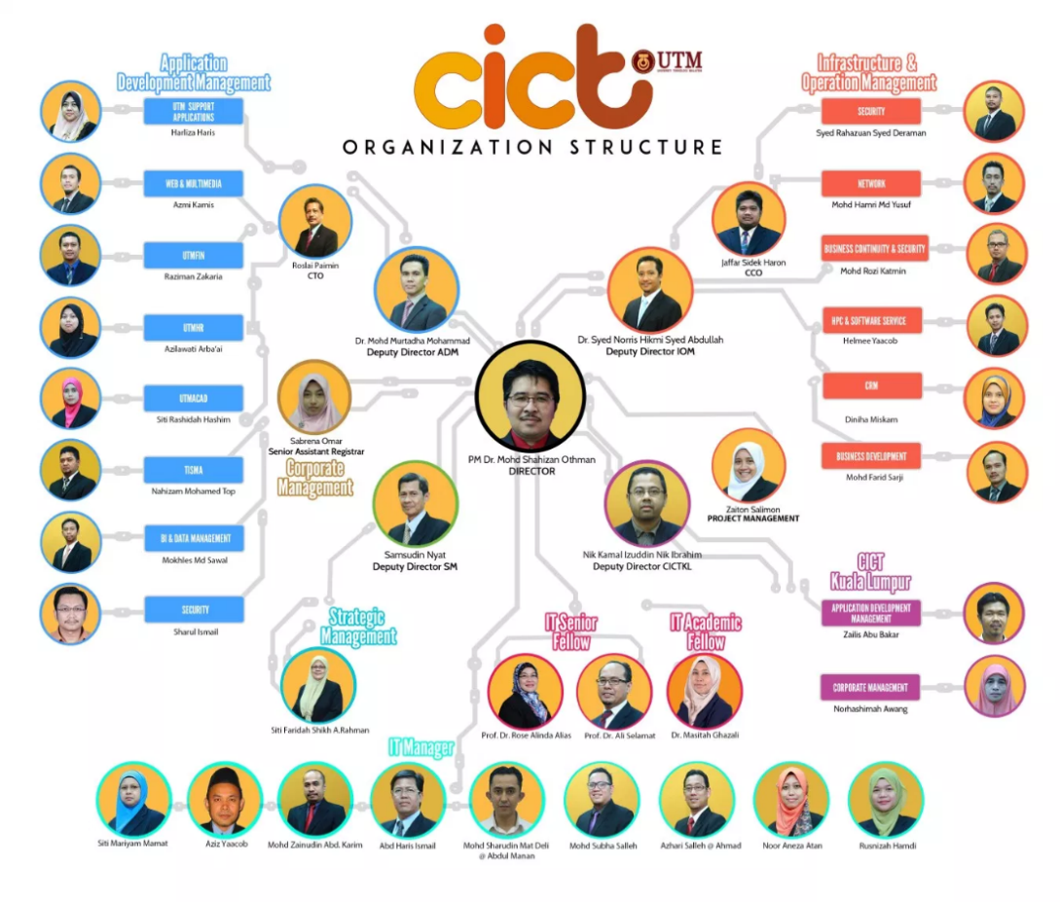
Figure 1 Organization Structure
The director of CICT is PM. Dr. Mohd Shahizan Othman. There are eight departments under the CICT which are Application Development Management, Infrastructure and Operation Management, Corporate Management, Strategic Management, IT Manager, IT Senior Fellow, IT Academic Fellow and CICT Kuala Lumpur. The director There are 38 workers work for CICT UTM.

SERVICES

BASIC ICT SERVICES
- Student ICT service Centre
Student ICT service Centre (PPICTP) has provided several facilities available such as
- Computers
- windows: 382 computers
- Mac 0S : 52computers
- Thin client: 20 computers
- 3 area of Project discussion area
- Printing, scanning and CD/DVD burning
- Binding and laminating
- Specialize Multimedia and Content Authoring Production Lab (SMAL)

- UTM WIFI
All the students and staffs can access the internet anywhere in UTM. There also has hotspot within the university which is Hotspot @UTM. 3G and 4G internet services are provided in UTM. The students need to key in their ACID account to access WiFi UTM.

- ACID
ACID is the unique user ID through authentication from server to log in to university systems. All students have their own user ID after registering the program through their respective faculties. The students have to use ACID account in access the e-Learning.
- VPN
Student can use vpn for the internet to access from outside UTM campus by using this web, http://vpn.utm.my.

- E-LEARNING
E-learning is an educational portal assists student and lecturer in the teaching and learning. To enter the website, log in by using your ACID username and password at this web, http://elearning.utm.my.
- e-PPP
The Lecturer’s Teaching Evaluation is a web application which enables students to rate and give opinion on lecturer’s teaching performance by access this URL, http://aimsweb.utm.my/eppp.

ACHIEVEMENT

Center for Information and Communication Technology (CICT) has achieved the grateful achievements. This achievement as a benchmark of quality and productivity of group work outsourcing all users. CICT UTM has successfully receive Saga Compliance Certificate as they have prepared the best technical documents and bring the University Received the SAGA (Standard Accounting System For Government Agencies) Award 2017 which was submitted by the Accountant General of Malaysia on November 22, 2017. UTM is among of 59 out of 416 agencies that have successfully received SAGA Compliance Certificate recognition compared to USM, UPSI, UMP, UPNM, UNISZA, UTHM and UPM. It will be a catalyst for all CICT citizens to continue to provide excellent services to CICT and the University.
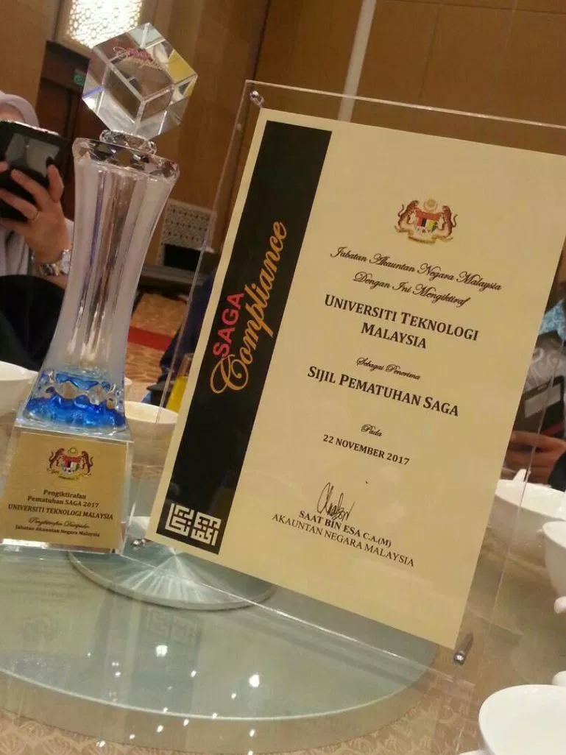
Figure 2 CICT Achievements

SYSTEM DEVELOPMENT

Description
CICT build and manage Administrative, Support, Multimedia, Teaching and Learning Applications to improve the university’s service and quality. Because, it will be so much easier if the student, lecturer, even staff to get or give any information by an application. CICT also develop new application (web base and mobile) and maintain the current UTM application base on request by PTJ in term of data requirement.
Key Features
- Administrative Applications Development Tools/Technology
- Teaching and Learning Applications Development
- Support Applications Development
- Web Applications Development
- Montage and Video Production
- User Requirement Spesification
- Documentation preparation
- Mobile & Web Programming
Tools/Technology
- PHP, HTML5, JavaScript, JQuery Mobile, PhoneGap, ASP.Net and Java Programming
- Android Studio, XCode, AppBridge, Ionic Framework
- HTML5, JavaScript, JQuery Mobile, PhoneGap
- MySql, Oracle, XAMPP

REFLECTION

From the talk, I believed that I have more understanding about the scope of my program. I always thought that being a software engineer only brought you to the world of programming. However, it also let you explore other new things especially in the world of technology where having a data engineer and graphic design is as important as having a programmer. By this exposure, I have a clearer vision of what I wanted to be in the future. So how does this program affect me? First and foremost, the program helps me widen my passion in computer science as it shows me the wonders of technologies that have been used in the world. Next, it acts as an eye-opener as it makes me realized that careers in IT is much bigger than what I expected. Besides, I always wanted to become a software engineer with good programming skills. Therefore, I can able to write software by my own in the future. I want to create software that can help to improve the people’s life. Nowadays, the world of information technology keeps changing and everything that I learned including the programming skills will be obsolete in the future. It is important to keep upgrade myself by learning the latest trends and technologies to improve my potential in the computer science industry. I can learn them by watching the videos on YouTube. The videos on YouTube will help me stay informed about the new products or services that would upcoming in the future. Besides, I should keep improve my soft skill. Soft skill is very important for my future career. The employers are always looking for the employee with soft skills. These skills allow me to work effectively and communicate well with employers and the colleagues. Therefore, it can improve my potential in the industry.

REFERENCE

- http://cict.utm.my/web-development/

