Industrial Visit 1 – CICT UTM

When we think about education,we should think primarily on some of the things that are the courses, facilities and services available at the university.However, the fact that student choice to study at a university has a complete facility and has a significant impact on their education level.On October 1st 2018,we from school of computing made a visit to the Center for Information and Communication Technology (CICT), UTM. CICT is actually located on the D07 block facing the N24 building and there is a river through the CICT building which makes this building unique from the rest. The objective of this exhibiton is to students will be able to find out more about the services available in CICT such as internet,infrastructure and security,application development,web management,software,ict support .In fact,it is a support unit that offers and delivers ICT services for the university,staffs and students especially in ICT infrastructure, system development and academic activities.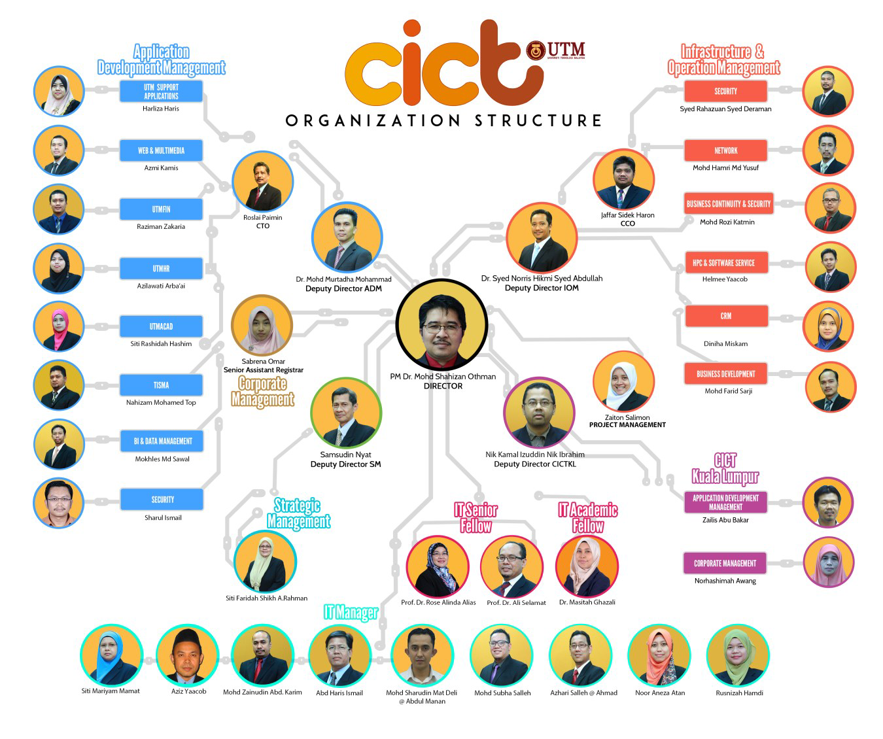
FIGURE 1:Organization structure

A visit to CICT on 1st October help to open our eyes on how computer changes from old generation to new generation. As we go through a lot of component that was in the show room, we can see that some components were upgrade from big to one that is a little bit easier to be remove and take care of. All of the components are update and improve from time to time to help certain task to be perform a lot easier compare to before. Our generation were introduced to cloud computing where we are not able to see the real components of the cloud computing but we were asked to be able to see its usage. According to the speaker “Cloud” for him means just like cloud the server of the data inside cloud can be anywhere, there is no specific location of the server. Cloud computing have a lot of usage which is convenience and attractive for the user.

These visit helps to motivate us so that we can create a better and convenience programme such as cloud to help new generation in computing. As we are moving toward 21st century, new generations are tend to use technology in their daily life for most of the time. Unlike old generation, hardware nowadays are improve to be a lot easier to be carry around such as smartphone, personal computer and wearable hardware. These also means a program need to be develop as convenience and more advance compared to old generation. Besides, this visit also help us to be more determine of our goals and dream toward achieving a better world of IT for our country so that we don’t need other country’s skill to perform certain task involve programming.CICT in 2017 wins as the best provide technical document and at once brings the university to receive the best standard accounting system for government agencies 2017 by the Accountant General of Malaysia. This achievement is something amazing from over 416 agent UTM won the 59 rank among the others. UTM also win as the most active and happy aerobic gymnastic.
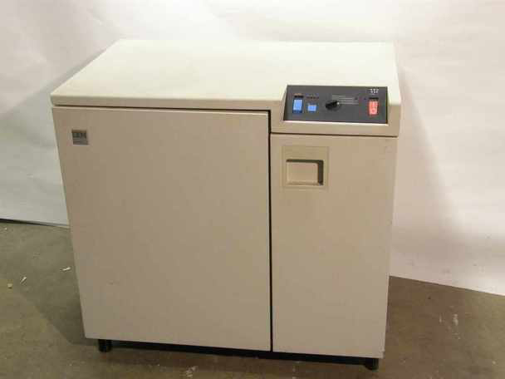

FIGURE 2:The IBM 3274 Control Unit provides the capability of controlling up to a maximum cluster of 32 terminals consisting of display stations, and/or printers. This is an old printer that UTM have since a 7 years ago still looking heavy, big and hard to bring anywhere

My dream regard to my course software engineering is to create something that can be useful to the new generation. I hope something that I can create in the future can bring revolution to this world and be the inspiration to other to create a better product. What can I see in this develop era is, in Malaysia we don’t have enough workers in IT section. You can see in Malaysia we use skill from other country like India in Cyber Jaya to do programming because we don’t have enough workers and professional in this field. Almost everyone especially old generation cannot see what job their children can get if they involve in IT and me as a student don’t choose this course because worried about can I get job if I graduate in this area but after I do research I can see many opportunity for me to get job. Outside of Malaysia like Japan they are proud about their IT and many of their citizen involve in IT but in Malaysia only a few of people involve. They know IT is important to them. Malaysia can be like that too because we have many Malaysian that venture into IT and have skill comparable to international platform but sometime better than that.

What I hope regarding for this program that student can open their eyes and mind to see career in this area and together help to develop this area.By participating in this CICT Visit, we can understand and know how quick technology has affected UTM’s technology and information system. Technology has been developed and improved rapidly in UTM’s system. We can find it by comparing the database machine that was used between 1900’s and 2000’s.All of us also gain some inspiration from this visit. We can learn how to implement our science knowledge in our daily life, especially in the future industry. We must encourage ourself to be more innovative by developing our own potential. We must prepare it now. Why? Because future industry will be more tight and competitive.As we know our country are lack of IT intellectual and need support from other country such as Japan and India. We need to change and have more professional of this field so that one day our country will also be acknowledge by the world.

By knowing our own potential in the future, we have an ability to compete with another competitor in the future industry. We can start it by improving our knowledge in our different dominant sector. Besides, We must also try to implement and learn all of the knowledge in the sector that we can involve in. We should also study harder to achieve our dream. By doing that, we can get a job easier in the future industry. Moreover, we must understand and learn the realtime technology which is the latest and most popular right now.Beside knowledge, we must also have good attitude and habits. Nowadays, most of the industry company require employee to have good ethic and good ability in controlling their emotional and spiritual behavior. They don’t want to recruit an employee that couldn’t maintain and improve their company’s quality. So, what should we do now? We must change our bad habits and ethics that we still maintain until now. If not, it will be hard for us to find a job and compete with another employee in the future industry.

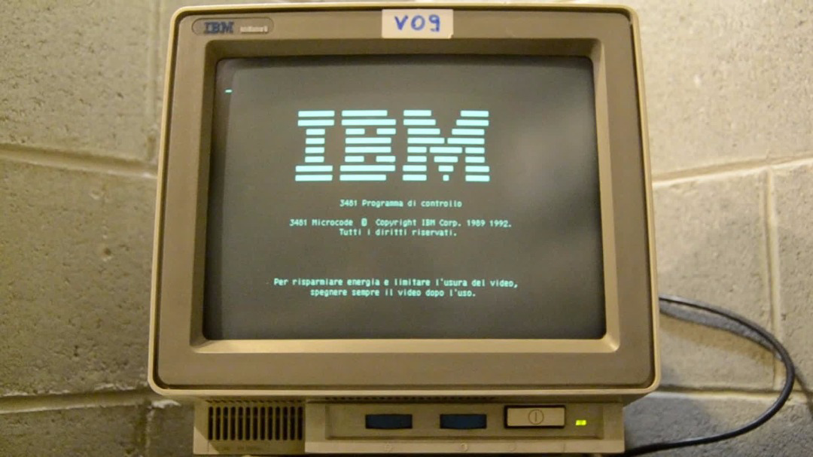
FIGURE 3:Mainframe terminal model: IBM 3471 info Window

In conclusion, we can say that all of us need to be more initiative to improve our own ability, behaviour and potential. We must do that to face a problem that might be happened in the future industry. We must also become a competitive and an innovative person. How?We can easily become that kind of person by trying to invent a new and a useful technology that we can implement in our daily life.CICT have several kinds of service in UTM they have infrastructure & security, application development and software, for example infrastructure & security have ID Account & Access this function is for the student to do anything they want to do in UTM it is an authentic ID and password they gave to us from the first time we register. Everything that’s is about your studying is recorded in this account. They also make a new application is that amazing we as a student can also make something new like that and maintain the UTM current application. Software also give a nice service called antivirus Symantec endpoint 14 for UTM staff,student and laboratory could you imagine if UTM doesn’t provide this kind of antivirus, this antivirus also the most endpoint security on the planet.

REFERENCE:
1)http://cict.utm.my/ict-knowledge-repository-2/
2)http://cict.utm.my/organization-structure/

GROUP MEMBERS:4(Rubby Bot)
1.Nanda Azka
2.Taufiq
3.Raziela
4.Wilbert H
5.Zafiyah

